# Assignment #5: Greedy穷举Implementation

Updated 1939 GMT+8 Oct 21, 2024

2024 fall, Complied by <mark>同学的姓名、院系</mark>

**说明：**

1）请把每个题目解题思路（可选），源码Python, 或者C++（已经在Codeforces/Openjudge上AC），截图（包含Accepted），填写到下面作业模版中（推荐使用 typora https://typoraio.cn ，或者用word）。AC 或者没有AC，都请标上每个题目大致花费时间。

3）提交时候先提交pdf文件，再把md或者doc文件上传到右侧“作业评论”。Canvas需要有同学清晰头像、提交文件有pdf、"作业评论"区有上传的md或者doc附件。

4）如果不能在截止前提交作业，请写明原因。

## 1. 题目

### 04148: 生理周期

brute force, http://cs101.openjudge.cn/practice/04148

num=0
while True:
p,e,i,d=map(int,input().split())
if d==p==e==i==-1:
break
p=p%23
e%=28
i%=33
t=d+1
while (t-p)%23!=0 or (t-e)%28!=0 or (t-i)%33!=0:
t+=1
time=t-d
num+=1
print(f'Case {num}: the next triple peak occurs in {time} days.')

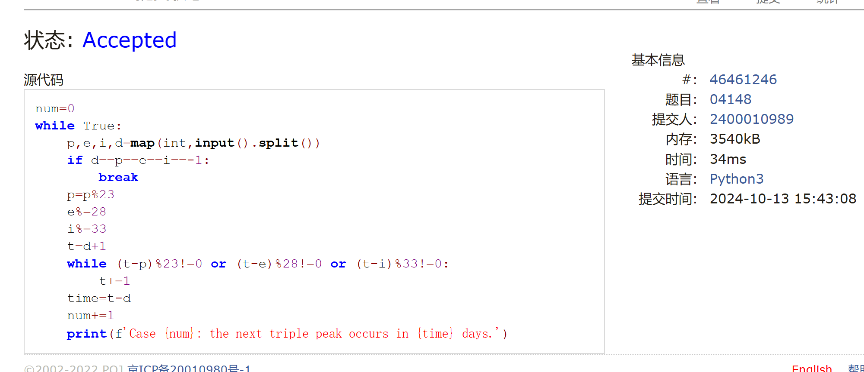

### 18211: 军备竞赛

greedy, two pointers, http://cs101.openjudge.cn/practice/18211
开始意识到了在题目中用双指针
p=int(input())
q=list(map(int,input().split()))
q.sort()
n=len(q)
a=0
l=0
r=n-1
while l<=r:
if q[l]<=p:
a+=1
p-=q[l]
l+=1
else:
if l==r:
break
a-=1
p+=q[r]
if a<0:
a=0
break
r-=1
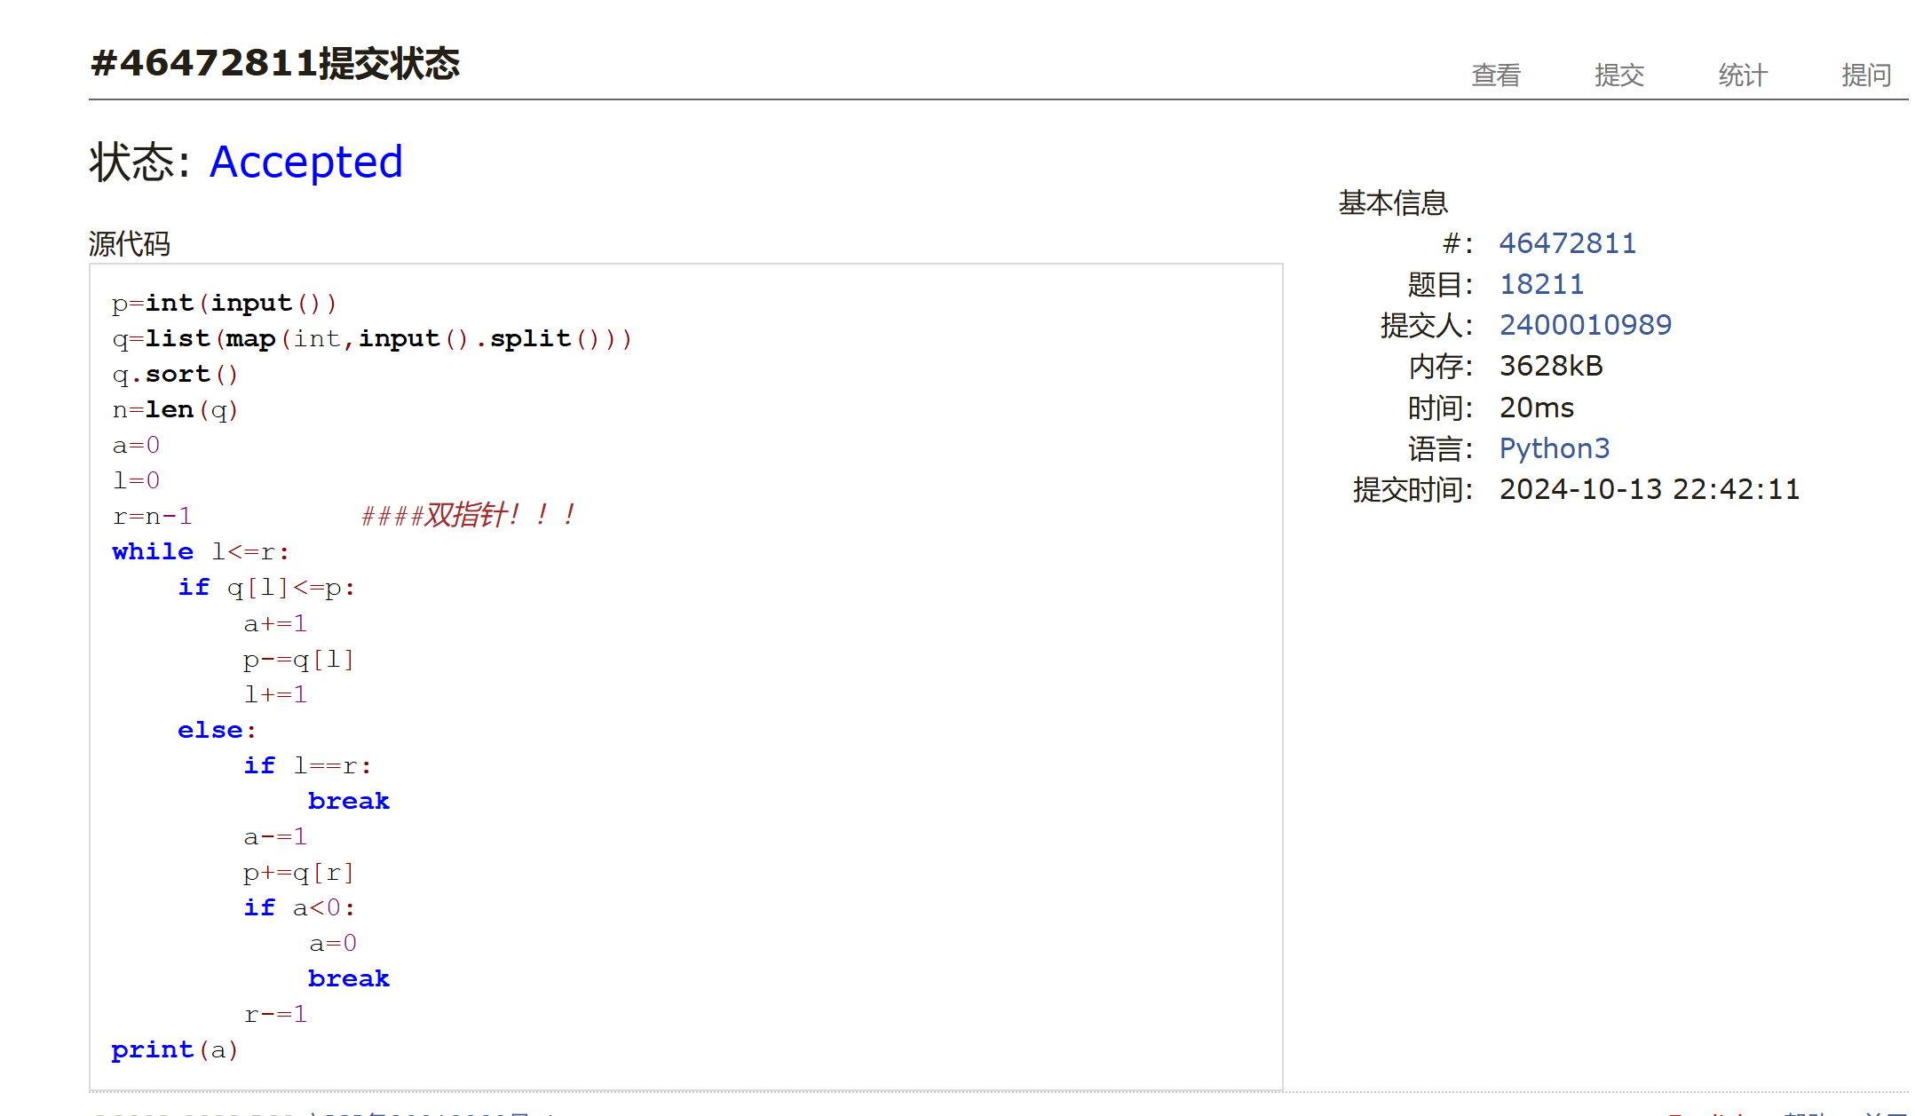

print(a)### 21554: 排队做实验

greedy, http://cs101.openjudge.cn/practice/21554

n=int(input())
dic={}
m=list(map(int,input().split()))
for i in range(n):
dic[i+1]=m[i]
dic1=sorted(dic.items(),key=lambda item:item[1])
dic2=[dic1[i][0] for i in range(n)]
print(' '.join(map(str,dic2)))
t=0
for i in range(n):
t+=sum(dic[dic2[j]] for j in range(i))
print('{:.2f}'.format(round(t/n,2)))

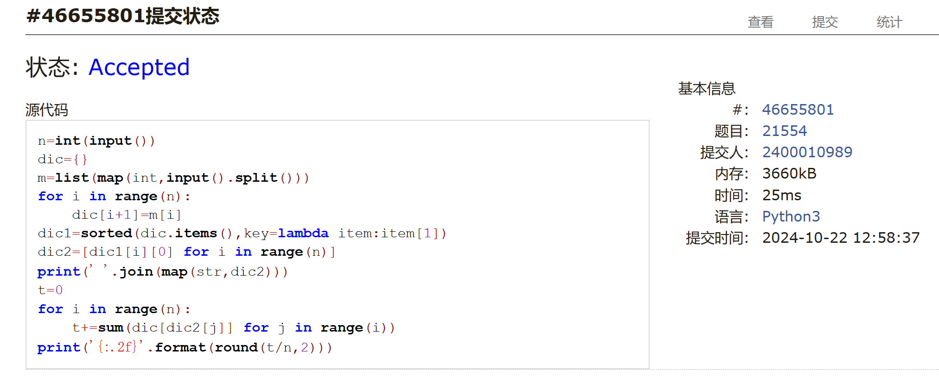
### 01008: Maya Calendar

implementation, http://cs101.openjudge.cn/practice/01008/
Haab={"pop": 0,"no": 1,"zip": 2,"zotz": 3,"tzec": 4,"xul": 5, "yoxkin": 6, "mol": 7, "chen": 8, "yax": 9, "zac": 10, "ceh": 11, "mac": 12, "kankin": 13, "muan": 14, "pax": 15, "koyab": 16, "cumhu": 17, "uayet": 18}
Tzolkin={0:"imix", 1:"ik", 2:"akbal", 3:"kan", 4: "chicchan", 5: "cimi", 6: "manik", 7: "lamat", 8: "muluk", 9: "ok", 10: "chuen", 11: "eb", 12: "ben", 13: "ix", 14: "mem", 15: "cib", 16: "caban", 17: "eznab", 18: "canac", 19: "ahau"}
n=int(input())
print(n)
for _ in range(n):
d,m,y=input().split()
d=int(d.rstrip('.'))
days=d+Haab[m]*20+int(y)*365
a=days%13+1 ###a不能为0，且有13
b=Tzolkin[days%20]
c=days//260
print(a,b,c)

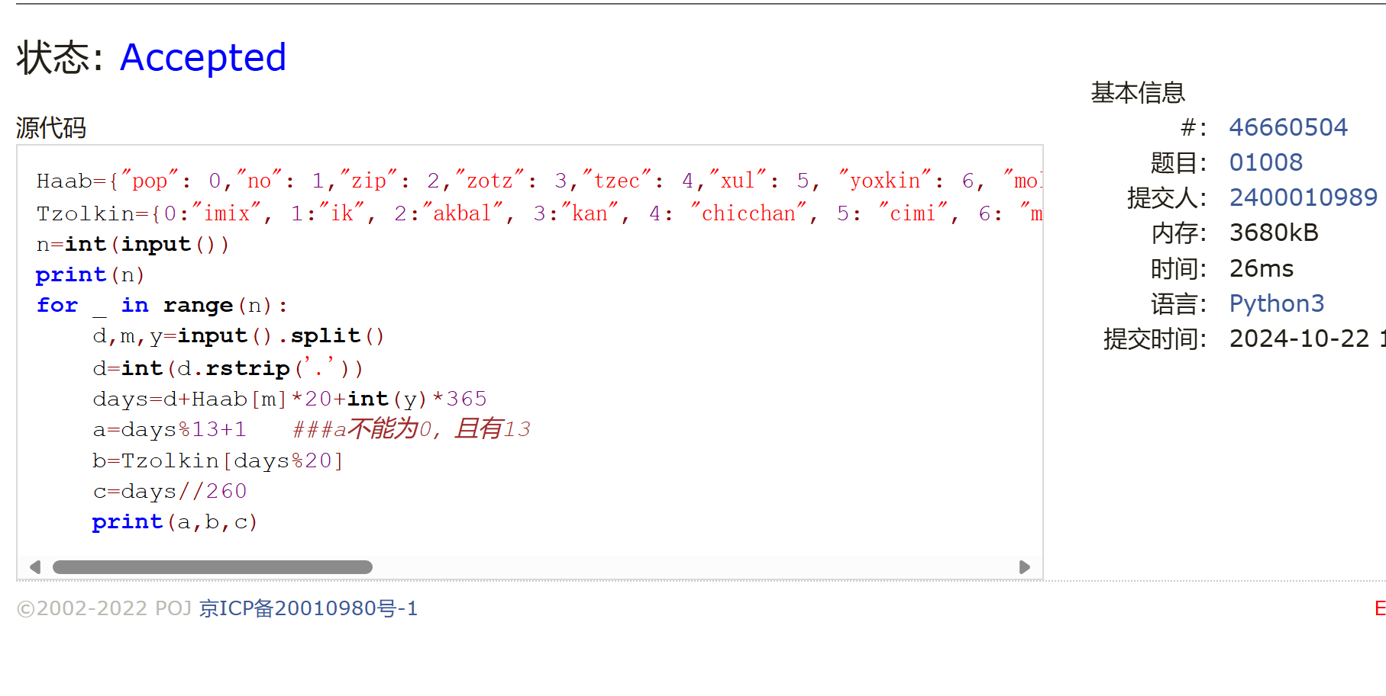

### 545C. Woodcutters

dp, greedy, 1500, https://codeforces.com/problemset/problem/545/C

n=int(input())
x=[]
h=[]
for _ in range(n):
_x,_y=map(int,input().split())
x.append(_x)
h.append(_y)
if n<=2:
print(n)
else:
num=2
q=x[0]
for i in range(1,n-1):
if x[i]-q>h[i]:
num+=1
q=x[i]
continue
elif x[i+1]-x[i]>h[i]:
num += 1
q=x[i]+h[i]
continue
q=x[i]
print(num)
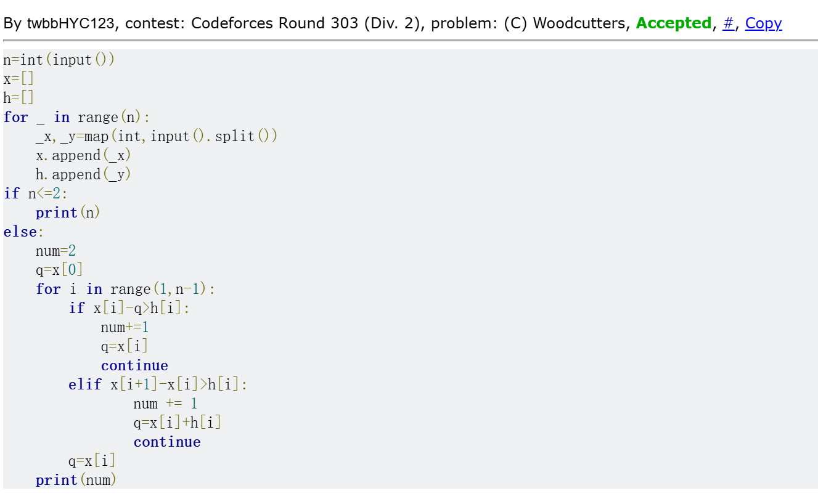

### 01328: Radar Installation

greedy, http://cs101.openjudge.cn/practice/01328/
import math
m=0
while True:
n,d=map(int,input().split())
if n+d==0:
break
m+=1
qj=[]
pd=0
for i in range(n):
x,y=map(int,input().split())
if y>d:
pd+=1
else:
qj.append([x-math.sqrt(d**2-y**2),x+math.sqrt(d**2-y**2)])
if pd>0:
print(f'Case {m}: -1')
input()
continue
qj.sort(key=lambda x:x[1])
s=1
l=qj[n-1][0]
for i in range(n-2,-1,-1):
if qj[i][1]<l:
s+=1
l=qj[i][0]
elif qj[i][0]>l:
l=qj[i][0]
elif qj[i][0]<=l<=qj[i][1]:
continue
print(f'Case {m}: {s}')
input()
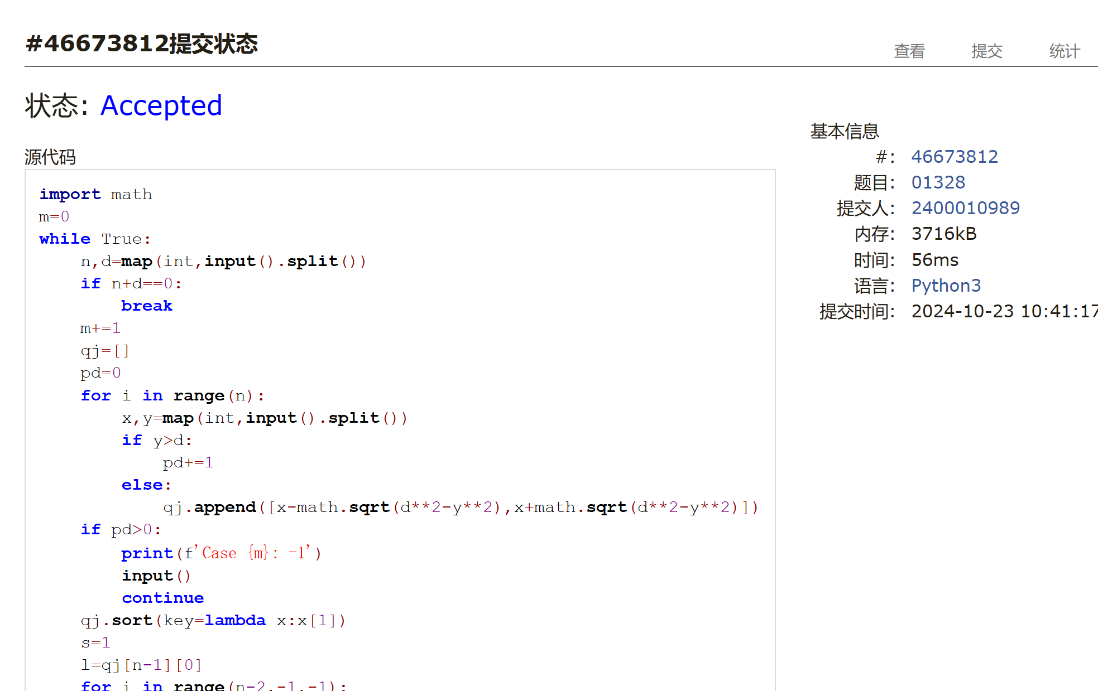

## 2. 学习总结和收获

<mark>如果作业题目简单，有否额外练习题目，比如：OJ“计概2024fall每日选做”、CF、LeetCode、洛谷等网站题目。</mark>

感觉好多题会在小地方上掉坑，雷达这个盯了小一小时都不知道怎么会RE，悲夫！
这几周也是接触了许多种算法，希望能在题目中找到各自适合的吧。
每日选做得尽量跟上

