# Assignment #7: Nov Mock Exam立冬

Updated 1646 GMT+8 Nov 7, 2024

2024 fall, Complied by <mark>韩宇宸工学院1小时AC了3个</mark>
## 1. 题目

### E07618: 病人排队

sorttings, http://cs101.openjudge.cn/practice/07618/
代码：
n=int(input())
r=[[]]*nfor i in range(n):
r[i]=list(map(str,input().split()))
old={}
y=[]for i in range(n):
if int(r[i][1])<60:
y.append(r[i][0])
else:
old[r[i][0]]=int(r[i][1])
o=sorted(old.items(),key=lambda x:x[1],reverse=True)
ol=[]for i in o:
ol.append(i[0])
shunxu=ol+yfor i in shunxu:
print(i)
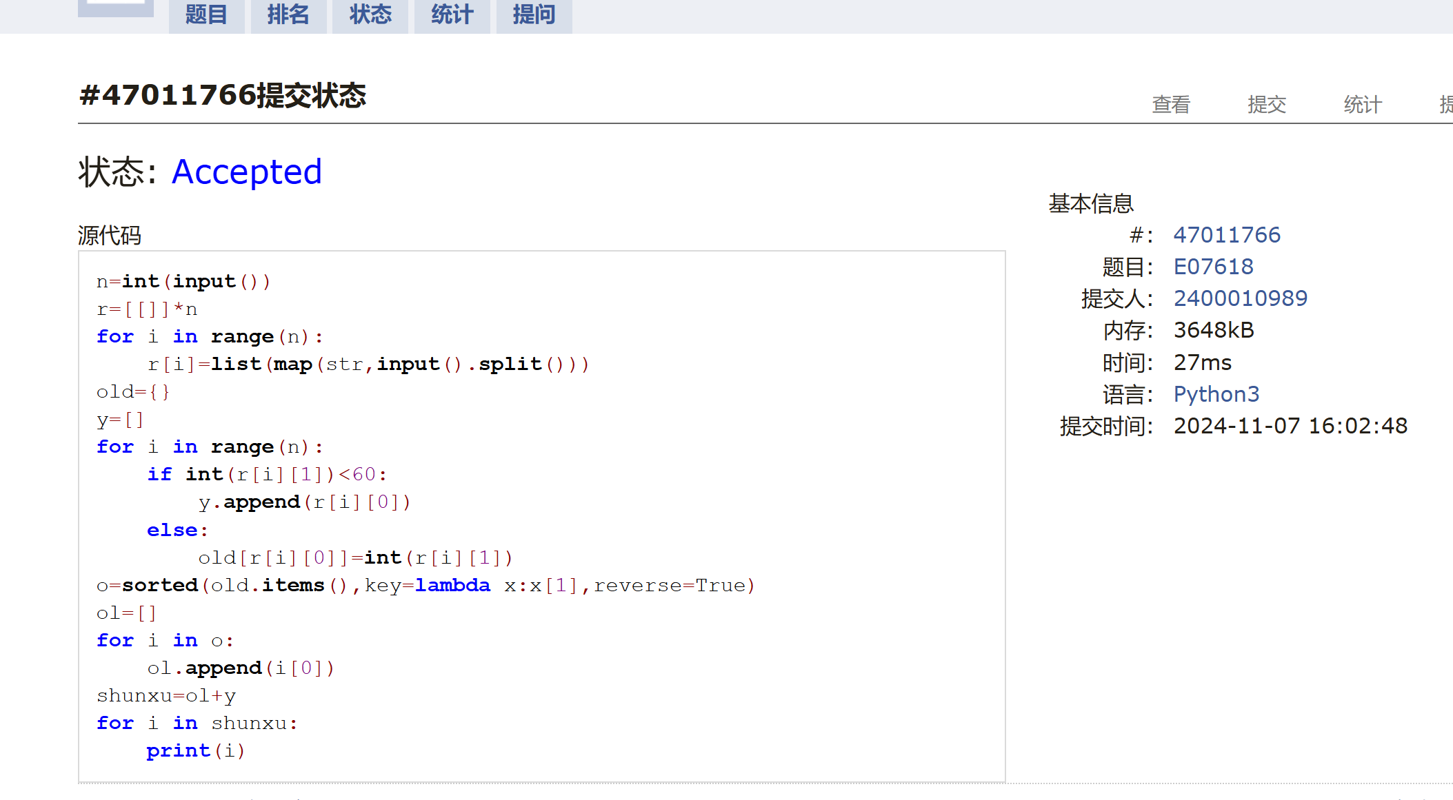

### E23555: 节省存储的矩阵乘法

implementation, matrices, http://cs101.openjudge.cn/practice/23555/

n,m1,m2=map(int,input().split())x=[[0]*n for _ in range(n)]y=[[0]*n for _ in range(n)]for i in range(m1): a,b,c=map(int,input().split()) x[a][b]=cfor i in range(m2): a,b,c=map(int,input().split()) y[a][b]=cxy=[[0]*n for _ in range(n)]for i in range(n): for j in range(n): for k in range(n): xy[i][j]+=x[i][k]*y[k][j]for i in range(n): for j in range(n): if xy[i][j]!=0: print(i,j,xy[i][j])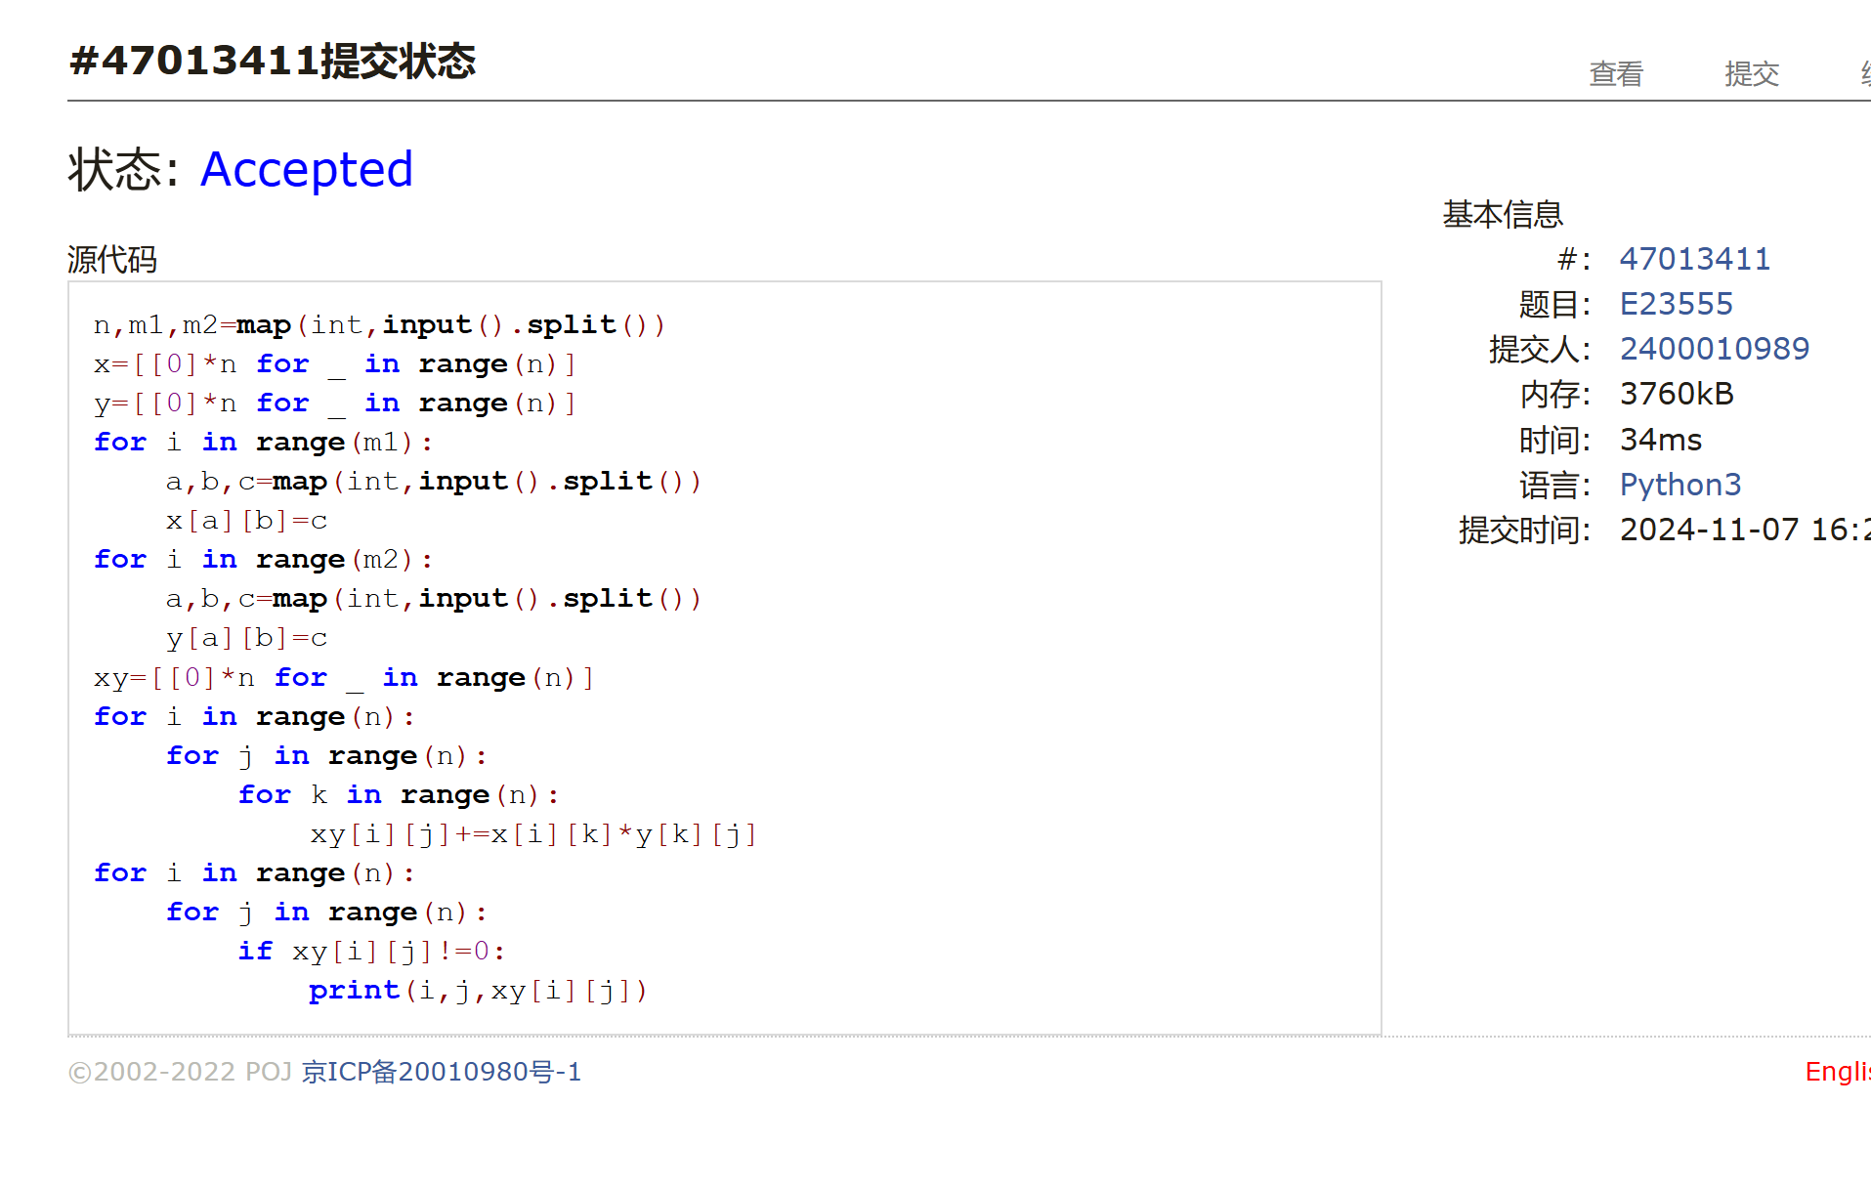
### M18182: 打怪兽

implementation/sortings/data structures, http://cs101.openjudge.cn/practice/18182/

N=int(input())for _ in range(N): n,m,b=map(int,input().split()) tx=[] for _ in range(n): t1,x1=map(int,input().split()) tx.append((t1,x1)) tx.sort() time=0;cs=0 for i in range(n): if tx[i][0]==time and cs==m: b+=tx[i-m][1] b-=tx[i][1] else: b-=tx[i][1] if tx[i][0]!=time: cs=1 else: cs+=1 time=tx[i][0] if b<=0: break if b>0: print('alive') else: print(time)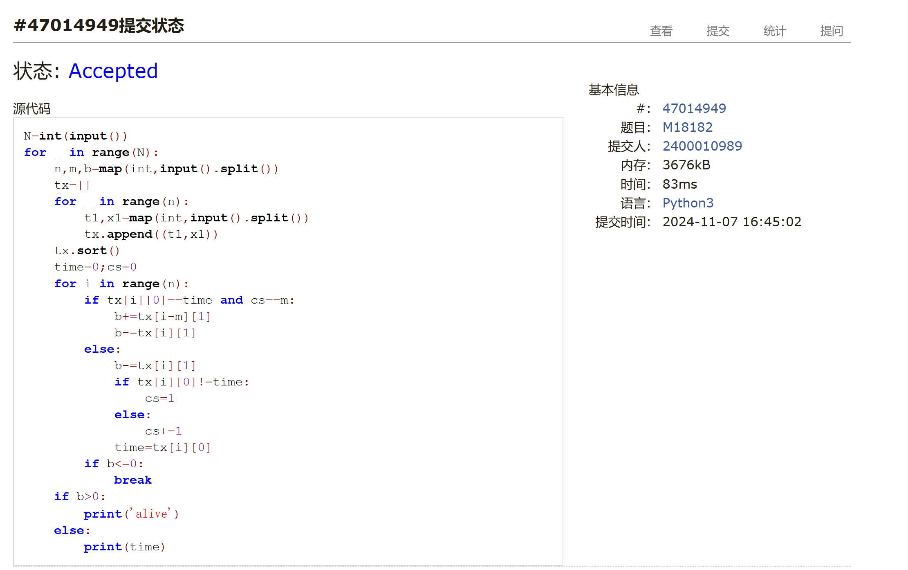### M28780: 零钱兑换3

dp, http://cs101.openjudge.cn/practice/28780/
一开始放正无穷的那里不大清楚要放啥，后来想到放正无穷就清晰很多

import bisectn,m=map(int,input().split())face=list(map(int,input().split()))face.sort()coins=[0]+[float('inf')]*mfor i in range(1,m+1): w=bisect.bisect_right(face,i) if w!=0: coins[i]=min(coins[i-face[k]] for k in range(w))+1 else: continueif coins[-1]!=float('inf'): print(coins[-1])else: print(-1)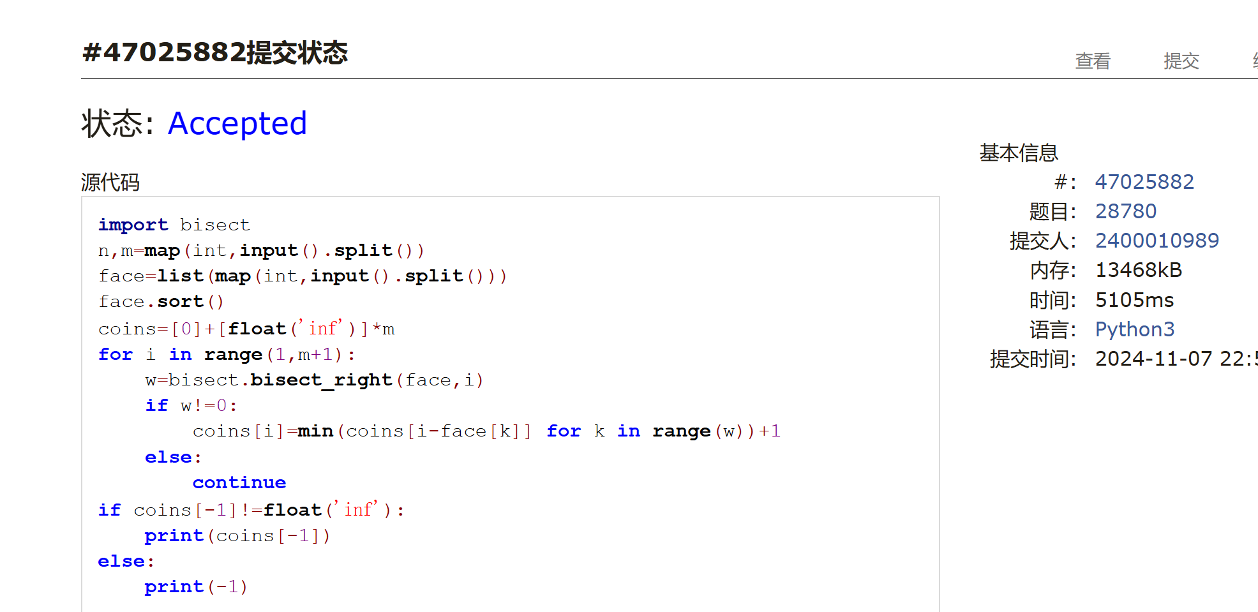### T12757: 阿尔法星人翻译官

implementation, http://cs101.openjudge.cn/practice/12757

思路：这个题坑了我n次
dic={'negative':-1, 'zero':0, 'one':1, 'two':2, 'three':3,'four':4,'five':5,'six':6,'seven':7,'eight':8,'nine':9,'ten':10,'eleven':11,'twelve':12,'thirteen':13,'fourteen':14,'fifteen':15,'sixteen':16,'seventeen':17,'eighteen':18,'nineteen':19,'twenty':20,'thirty':30,'forty':40,'fifty':50,'sixty':60,'seventy':70,'eighty':80,'ninety':90,'hundred':100,'thousand':1000,'million':1000000}eng=input().split()ans=0def f(eng): s1=0;s2=0;s3=0 ##记住百和千 s=0 for i in range(len(eng)): if eng[i]!='hundred' and eng[i]!='thousand' and eng[i]!='million': s1+=dic[eng[i]] elif eng[i]=='hundred': s2+=dic[eng[i]]*s1 s1=0 elif eng[i]=='thousand': s3+=(s1+s2)*dic[eng[i]] s1=0;s2=0 elif eng[i]=='million': s+=(s1+s2+s3)*dic[eng[i]] s1=0;s2=0;s3=0 s+=s1+s2+s3 return sif eng[0]!='negative': ans=f(eng)else: ans=(-1)*f(eng[1:])print(ans)
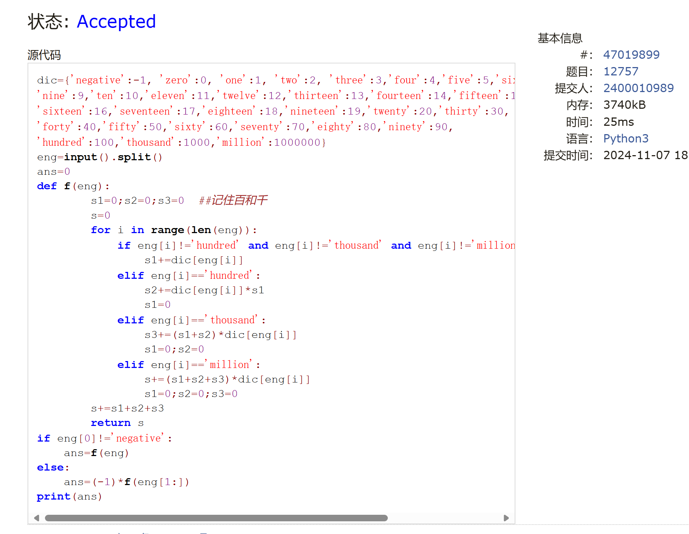

### T16528: 充实的寒假生活

greedy/dp, cs10117 Final Exam, http://cs101.openjudge.cn/practice/16528/

import bisectn=int(input())se=[]for i in range(n): s1,e1=map(int,input().split()) se.append((s1,e1))se.sort(key=lambda x: x[1])ac=[0]*(n+1)l=-1for i in range(n): if se[i][0]>l: ac[i]=ac[i-1]+1 l=se[i][1] else: w=bisect.bisect_right(ac,l) ac[i]=max(ac[w-1]+1,ac[i-1]) if ac[w-1]+1>ac[i-1]: l=se[i][1] else: continueprint(max(ac))
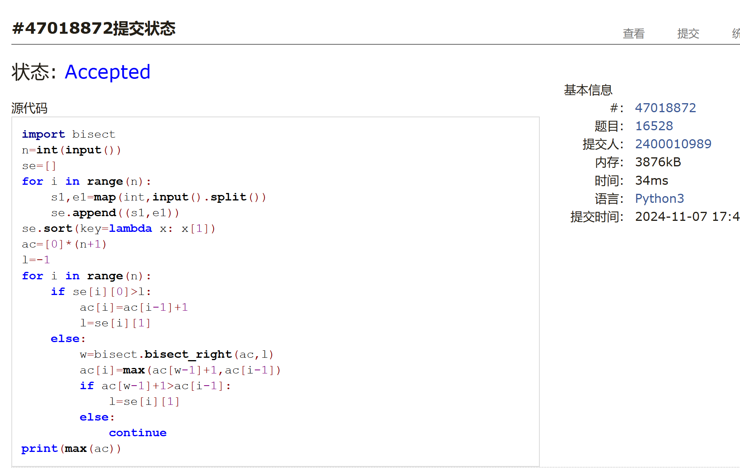## 2. 学习总结和收获

<mark>如果作业题目简单，有否额外练习题目，比如：OJ“计概2024fall每日选做”、CF、LeetCode、洛谷等网站题目。</mark>

这次的月考比上次稍微好做点，dp的题很难直接想到对的方法，总是错几次才能找到。
这次月考4点才开始做，如果按2小时算可能是4到5道。

