# Assignment #D: 十全十美

Updated 1254 GMT+8 Dec 17, 2024

2024 fall, Complied by <mark>同学的姓名、院系</mark>

## 1. 题目

### 02692: 假币问题

brute force, http://cs101.openjudge.cn/practice/02692

n=int(input())for _ in range(n): re_coins=[];h_coins=[];l_coins=[];h_steady=[];l_steady=[] for _ in range(3): a=input().split() if a[2]=='even': re_coins.append(a[0][0]);re_coins.append(a[0][1]);re_coins.append(a[0][2]);re_coins.append(a[0][3]) re_coins.append(a[1][0]);re_coins.append(a[1][1]);re_coins.append(a[1][2]);re_coins.append(a[1][3]) elif a[2]=='up': h_coins.append(a[0][0]);h_coins.append(a[0][1]);h_coins.append(a[0][2]);h_coins.append(a[0][3]) l_coins.append(a[1][0]);l_coins.append(a[1][1]);l_coins.append(a[1][2]);l_coins.append(a[1][3]) elif a[2]=='down': l_coins.append(a[0][0]);l_coins.append(a[0][1]);l_coins.append(a[0][2]);l_coins.append(a[0][3]) h_coins.append(a[1][0]);h_coins.append(a[1][1]);h_coins.append(a[1][2]);h_coins.append(a[1][3]) pd=1 for i in h_coins: s=h_coins.count(i) if s>1 and i not in re_coins: print(f'{i} is the counterfeit coin and it is heavy.') pd=0 break if i not in re_coins: h_steady.append(i) else: continue if pd: for i in l_coins: s=l_coins.count(i) if s>1 and i not in re_coins: print(f'{i} is the counterfeit coin and it is light.') pd=0 break if i not in re_coins: l_steady.append(i) else: continue if pd: if len(h_steady)+len(l_steady)==1: if len(h_steady)==1: print(f'{h_steady[0]} is the counterfeit coin and it is heavy.') else: print(f'{l_steady[0]} is the counterfeit coin and it is light.')
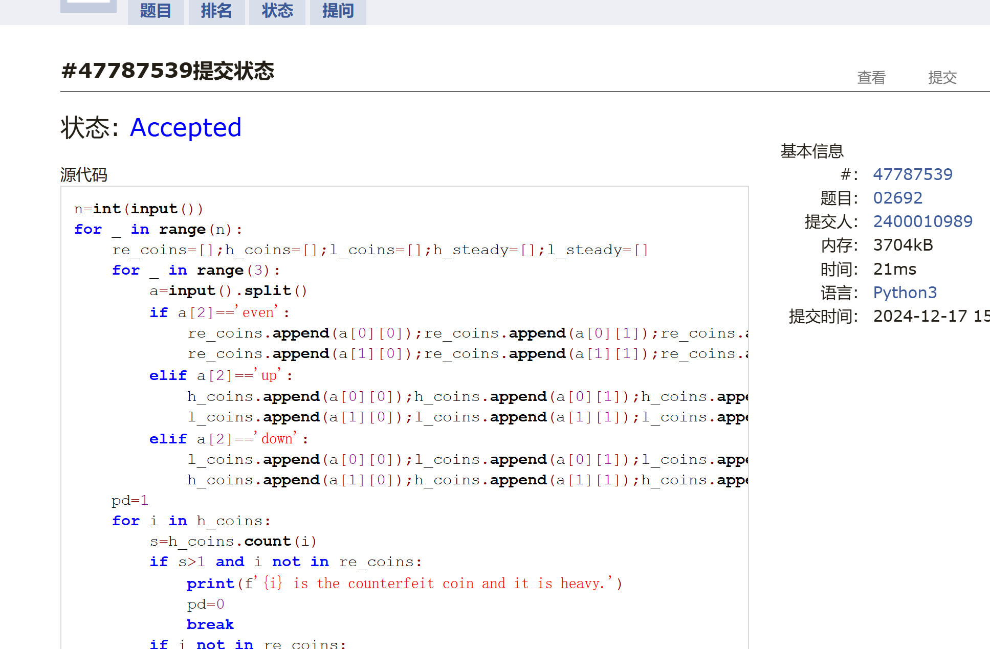

### 01088: 滑雪

dp, dfs similar, http://cs101.openjudge.cn/practice/01088
import syssys.setrecursionlimit(10**9)r,c=map(int,input().split())snow=[]for _ in range(r): snow.append(list(map(int,input().split())))def dfs(x,y,snow): global note move=[[1,0],[0,1],[-1,0],[0,-1]] if note[x][y]>0: return note[x][y] else: l=1 for i in range(4): nx,ny=x+move[i][0],y+move[i][1] if 0<=nx<r and 0<=ny<c and snow[x][y]>snow[nx][ny]: l=max(l,dfs(nx,ny,snow)+1) note[x][y]=l return lnote=[[0]*c for _ in range(r)]ans=0for i in range(r): for j in range(c): ans=max(ans,dfs(i,j,snow))print(ans)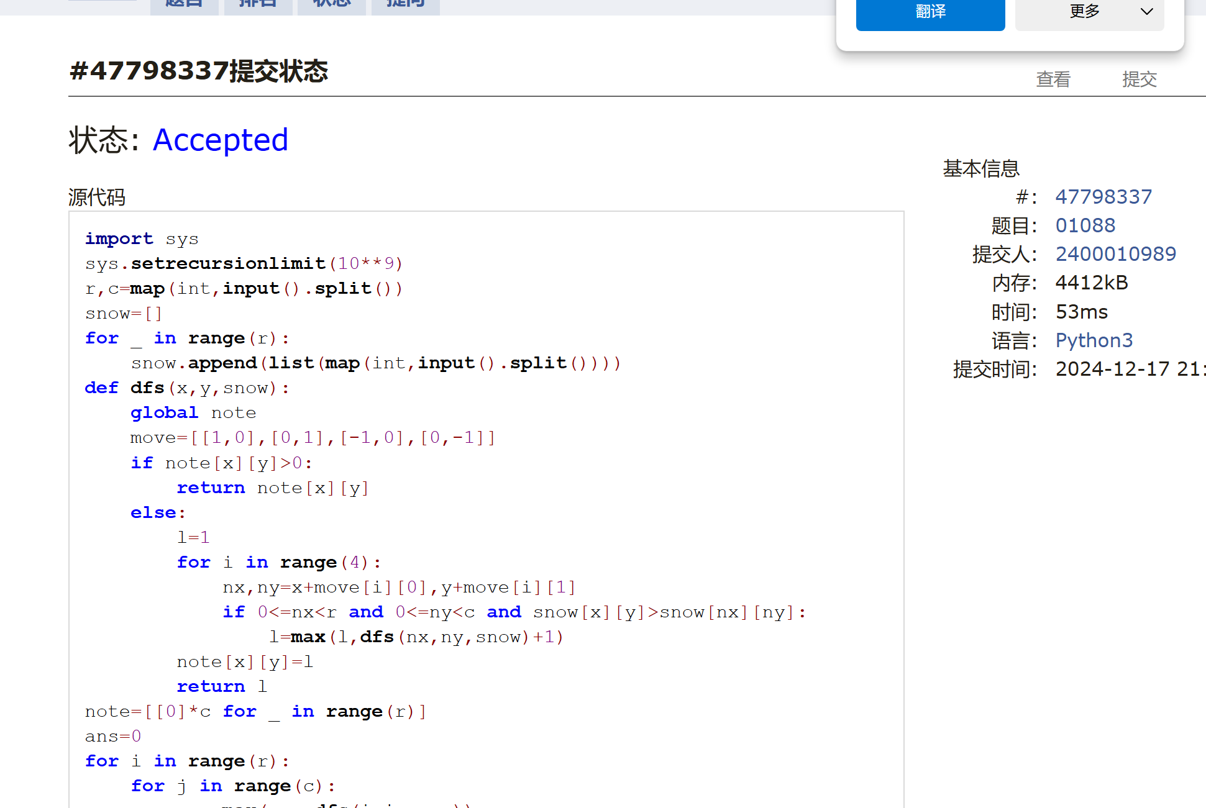

### 25572: 螃蟹采蘑菇

bfs, dfs, http://cs101.openjudge.cn/practice/25572/

from collections import dequen=int(input())maze=[]for i in range(n): maze.append(list(map(int,input().split())))def bfs(x01,y01,x02,y02,maze,gone): q=deque() q.append((x01,y01,x02,y02)) gone[x01][y01]=True move=[[1,0],[0,1],[-1,0],[0,-1]] while q: x1,y1,x2,y2=q.popleft() for i in range(4): nx1,ny1,nx2,ny2=x1+move[i][0],y1+move[i][1],x2+move[i][0],y2+move[i][1] if 0<=nx1<n and 0<=nx2<n and 0<=ny1<n and 0<=ny2<n and maze[nx1][ny1]!=1 and maze[nx2][ny2]!=1 and not gone[nx1][ny1]: if maze[nx1][ny1]==9 or maze[nx2][ny2]==9: return 'yes' else: gone[nx1][ny1]=True q.append((nx1,ny1,nx2,ny2)) return 'no'gone=[[False]*n for _ in range(n)]ans='';flag=Falsefor i in range(n): for j in range(n): if maze[i][j]==5: if j<=n-2 and maze[i][j+1]==5: ans=bfs(i,j,i,j+1,maze,gone) flag=True break if i<=n-2 and maze[i+1][j]==5: ans=bfs(i,j,i+1,j,maze,gone) flag=True break if flag: breakprint(ans)
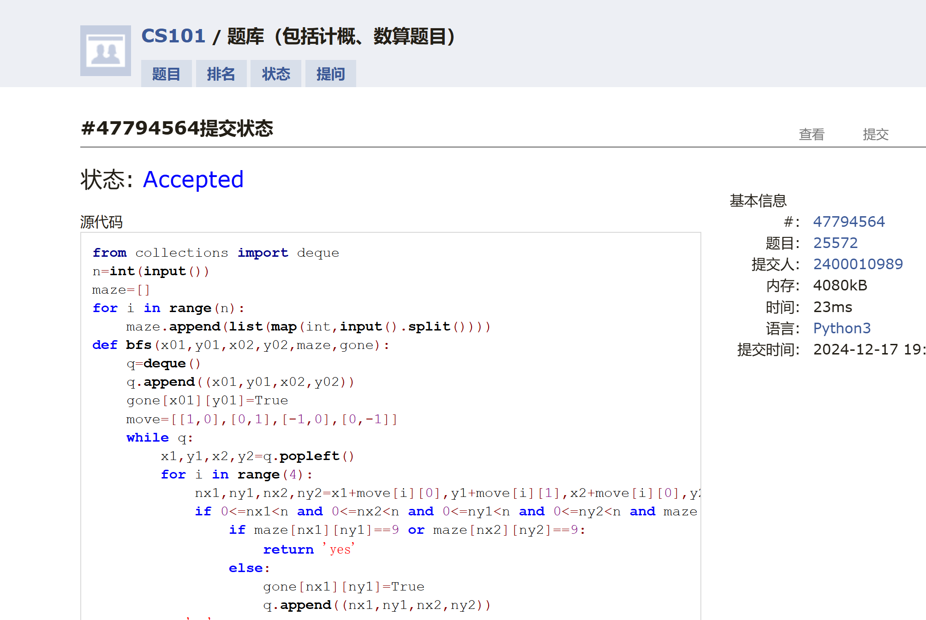

### 27373: 最大整数

dp, http://cs101.openjudge.cn/practice/27373/
啊哈，忘了string可以直接排序了
m=int(input())n=int(input())nums=input().split()for i in range(n): for j in range(i-1,-1,-1): if nums[j+1]+nums[j]>nums[j]+nums[j+1]: nums[j],nums[j+1]=nums[j+1],nums[j]l=[]for i in nums: l.append(len(i))dp=[['']*(m+1) for _ in range(n+1)]def pd(x): if x=='': return 0 else: return xfor i in range(1,n+1):##能从后向前取nums的几个 for j in range(1,m+1):##j位 if l[n-i]>j: dp[i][j]=dp[i-1][j] else: dp[i][j]=str(max(int(pd(dp[i-1][j])),int(nums[n-i]+dp[i-1][j-l[n-i]])))print(dp[n][m])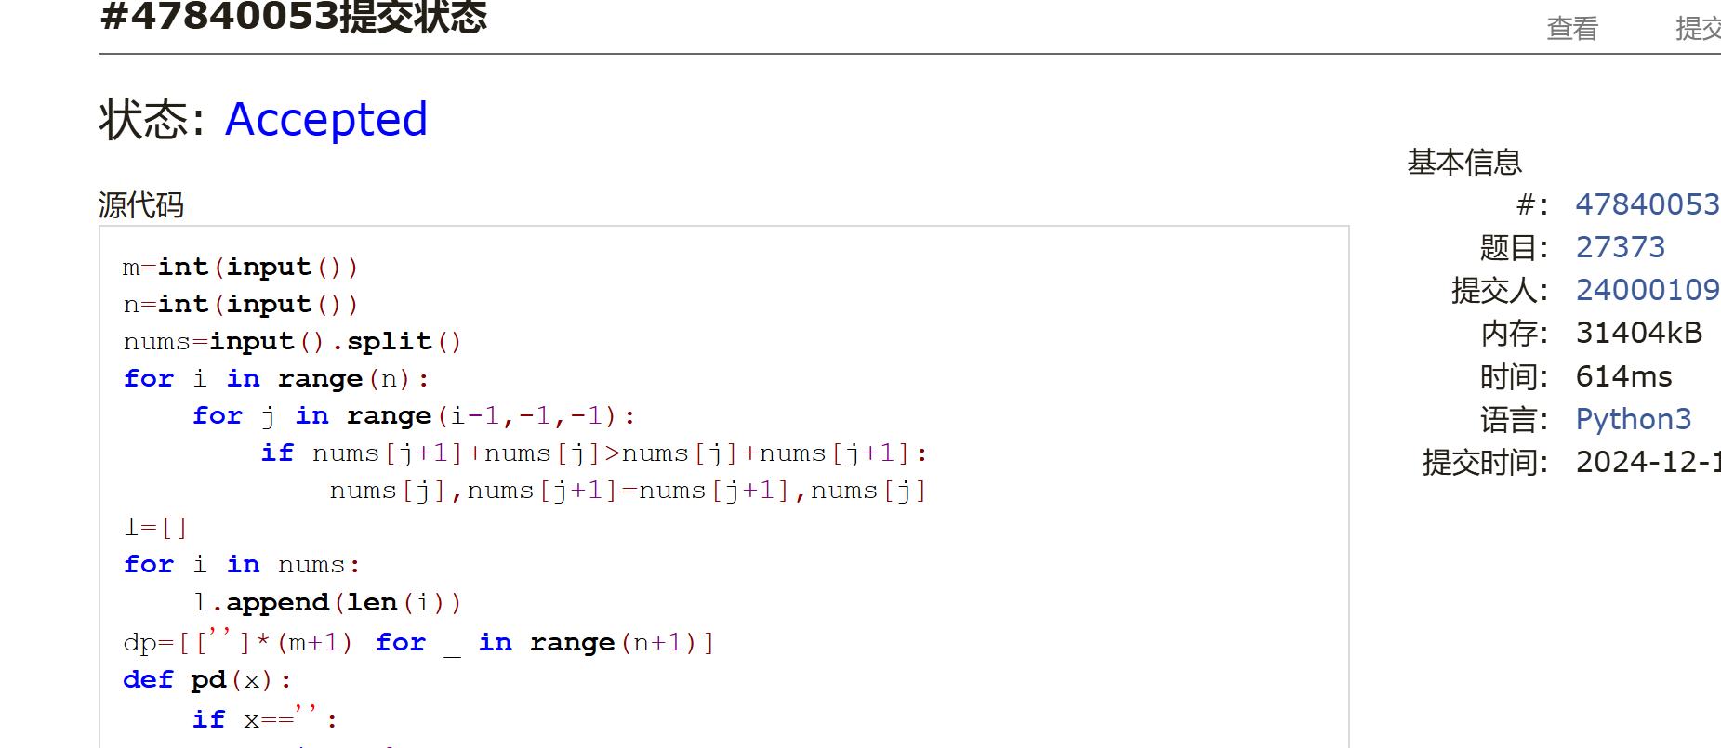

### 02811: 熄灯问题

brute force, http://cs101.openjudge.cn/practice/02811
深拷贝
import itertoolsimport copylights=[]for i in range(5): lights.append(list(map(int,input().split())))def put(x,y): global n_lights n_lights[x][y]=1-n_lights[x][y] if x>=1:n_lights[x-1][y]=1-n_lights[x-1][y] if y>=1:n_lights[x][y-1]=1-n_lights[x][y-1] if x<4:n_lights[x+1][y]=1-n_lights[x+1][y] if y<5:n_lights[x][y+1]=1-n_lights[x][y+1]all_comb=list(itertools.product([0,1],repeat=6))x0=[]for comb in all_comb: x0.append(list(comb))for i in range(2**6): press=[] press.append(x0[i]) n_lights=copy.deepcopy(lights) for x in range(6): if x0[i][x]==1: put(0,x) for j in range(1,5): xj=[] for y in range(6): if n_lights[j-1][y]==1: put(j,y) xj.append(1) else: xj.append(0) press.append(xj) if n_lights[4]==[0,0,0,0,0,0]: for c in range(5): print(*press[c]) break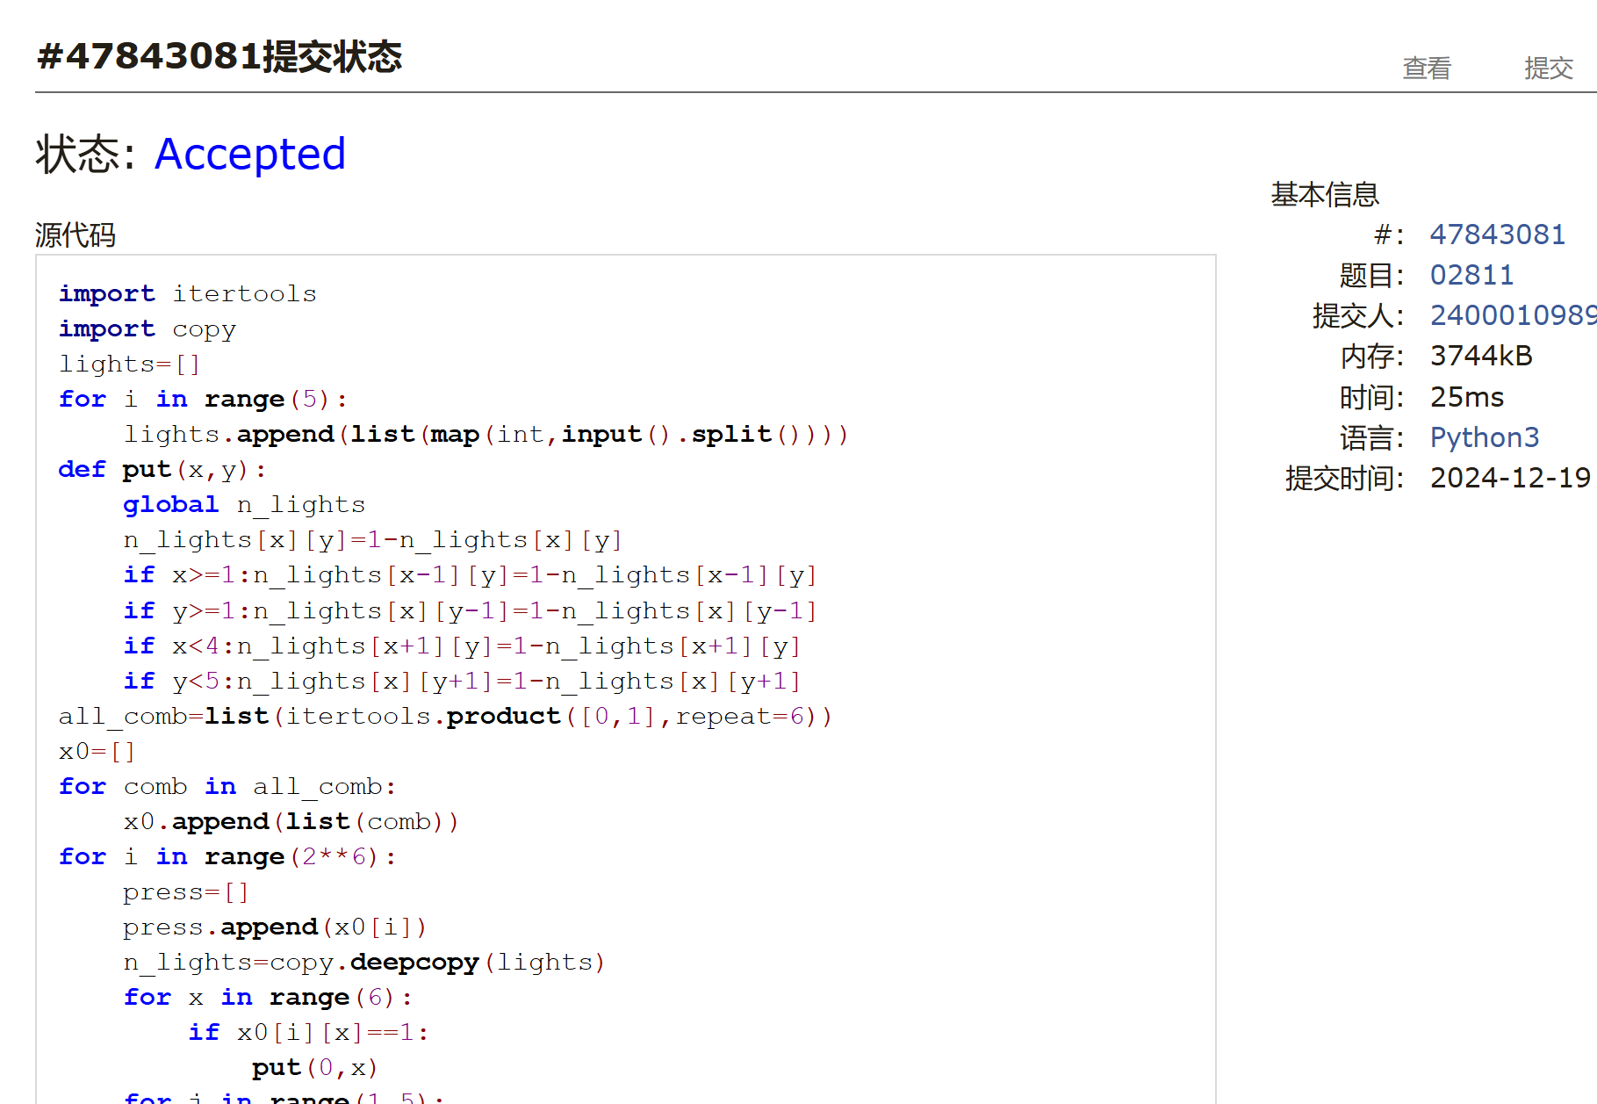
### 08210: 河中跳房子

binary search, greedy, http://cs101.openjudge.cn/practice/08210/

l,n,m=map(int,input().split())house=[0]for i in range(n): house.append(int(input()))house.append(l)def remove(x): s=0;flag=0 for i in range(1,n+2): if house[i]-flag<x: s+=1 else: flag=house[i] if s>m: return True else: return Falsel0=0;r=l+1ans=0while l0<r: length=(l0+r)//2 if remove(length): r=length else: l0=length+1 ans=lengthprint(ans)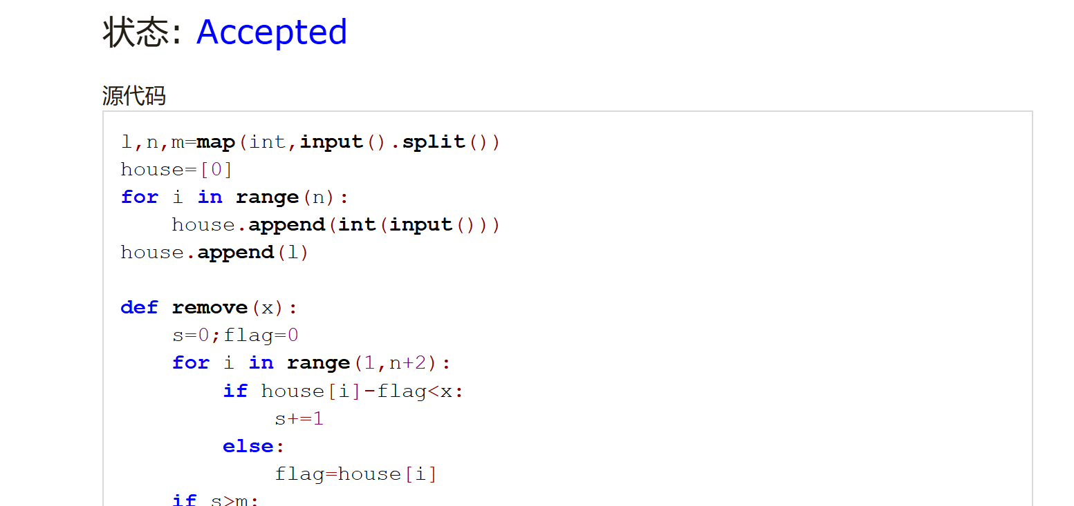
## 2. 学习总结和收获

<mark>如果作业题目简单，有否额外练习题目，比如：OJ“计概2024fall每日选做”、CF、LeetCode、洛谷等网站题目。</mark>

不知不觉，期末机考已经来到我们面前。这个学期学习计概，有怎么做都不对的破防，有终于AC的兴奋，苦乐兼半。尽管知道自己的思路、反应速度与能一小时AK的大佬们有很大的差距，但还是想要努力一下。
计概和数分是这个学期最耗时的学科，而且都没学明白，不过回顾已经做过的小200题，也算是给自己一个答卷吧，希望下周机考画上个能说的过去的句号。
还是不要立Flag了，只能说加油了，还望老师手下留情。

