**ES_HW04_07598064**

**蔡宗哲**

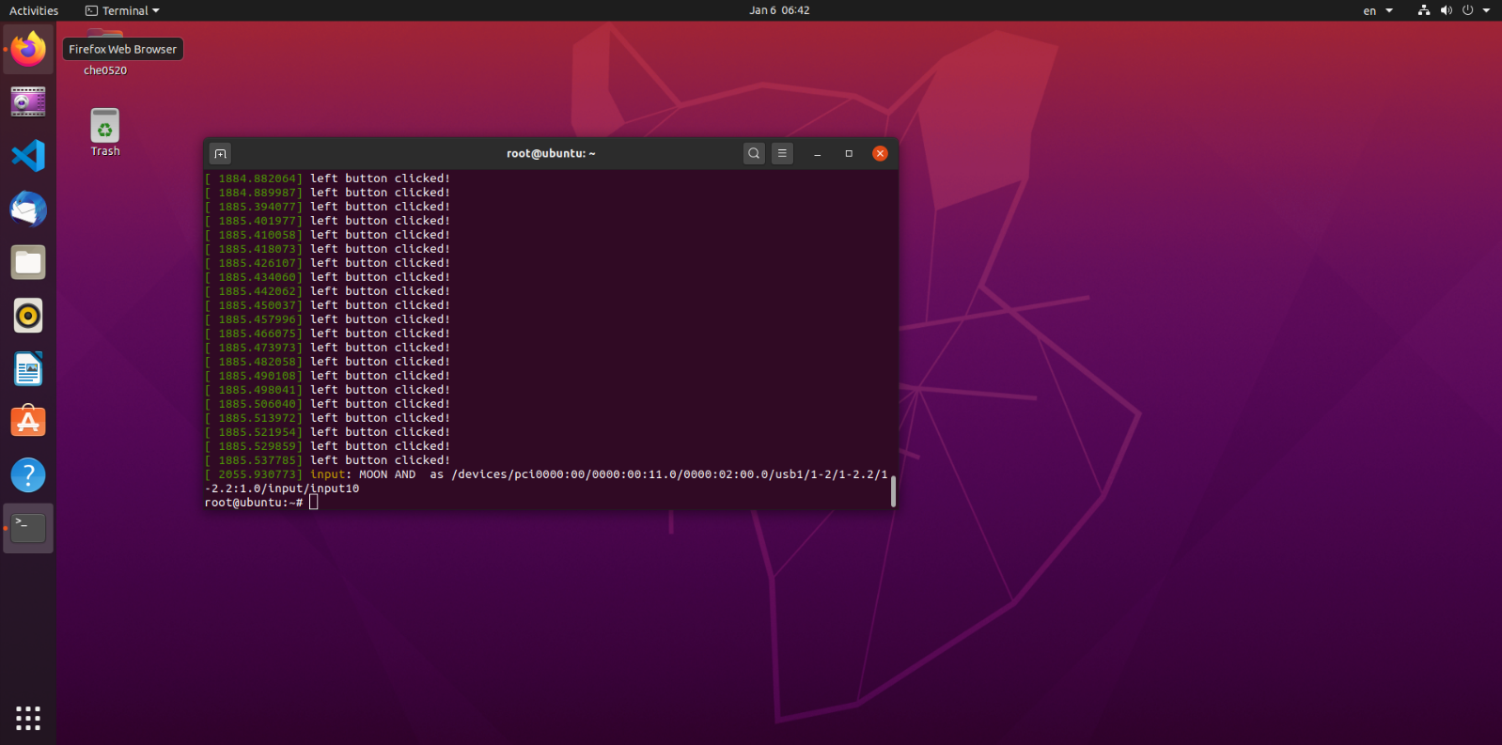**Part 1：Screenshot of your dmsg**