ES_HW04_107598064
蔡宗哲
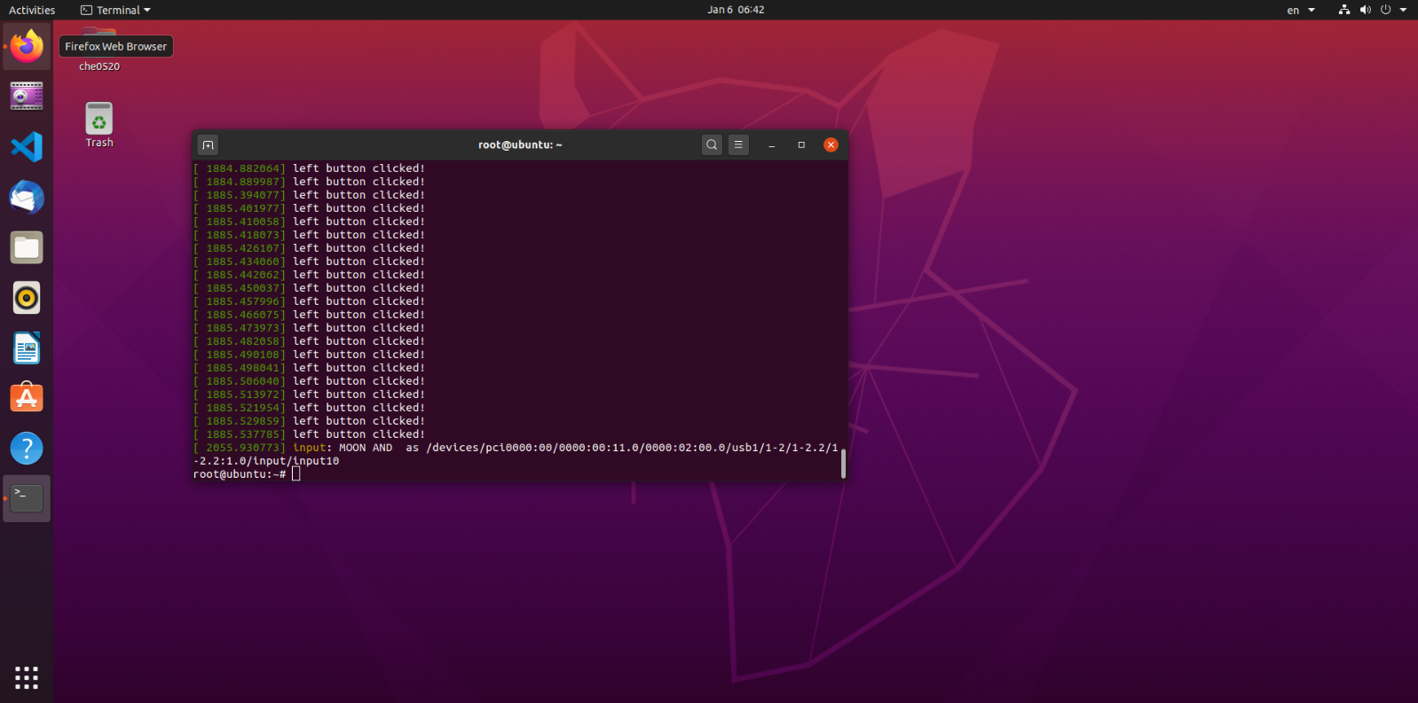
Part 1：Screenshot of your dmsg

