> library(Stat2Data)

> library(MASS)

> #Question 2

> bears <- read.table("/home/thomas/git/datascience/MSDataSci/MATH550/data/Bears.csv",header=TRUE,sep=",")

> attach(bears)

The following objects are masked from bears (pos = 3):

ChestGirth, Weight

The following objects are masked from bears (pos = 4):

ChestGirth, Weight

The following objects are masked from bears (pos = 5):

ChestGirth, Weight

> #Part A

> plot(ChestGirth, Weight, pch = 16, cex = 1.3, col = "blue", main = "Weight plotted against Chest Girth", xlab = "Chest Girth (inches)", ylab = "Weight (pounds)")

> lm(Weight ~ ChestGirth)

Call:

lm(formula = Weight ~ ChestGirth)

Coefficients:

(Intercept) ChestGirth

-278.75 12.97

> abline(lm(Weight ~ ChestGirth))

> modelA <- lm(Weight ~ ChestGirth)

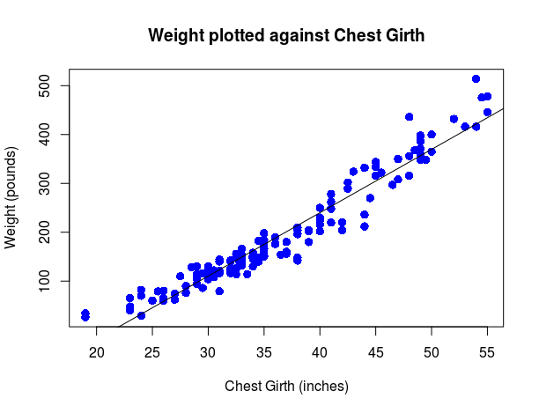

> plot(modelA)

Hit <Return> to see next plot:

Hit <Return> to see next plot:

Hit <Return> to see next plot:

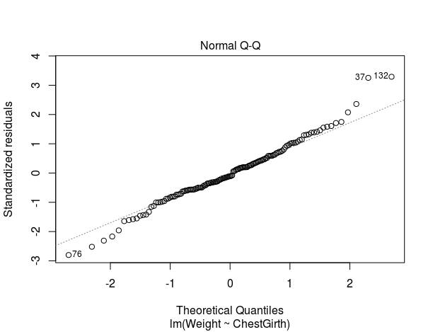Hit <Return> to see next plot:

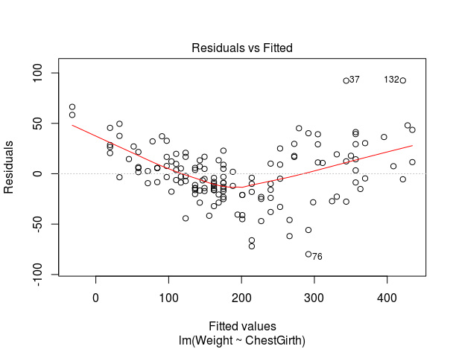

**The results do not seem entirely adequate. It is easy in the data and in the residuals plot that a line does not pass through the points evenly. It seems to over predict the middle of the data and under predict the extremes. This organization in the residuals alludes to a different model.**

> #Part B

> ChestGirth2 <- ChestGirth^2

> plot(ChestGirth2, Weight, pch = 16, cex = 1.3, col = "blue", main = "Weight plotted against Chest Girth^2", xlab = "Chest Girth^2 (inches^2)", ylab = "Weight (pounds)")

> lm(Weight ~ ChestGirth2)

Call:

lm(formula = Weight ~ ChestGirth2)

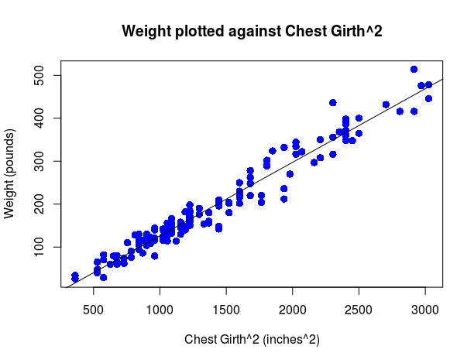

Coefficients:

(Intercept) ChestGirth2

-45.4369 0.1714

> abline(lm(Weight ~ ChestGirth2))

> modelB <- lm(Weight ~ ChestGirth2)

> par(mfrow = c(2,2))

> plot(modelB)

Hit <Return> to see next plot:

Hit <Return> to see next plot:

Hit <Return> to see next plot:

Hit <Return> to see next plot:

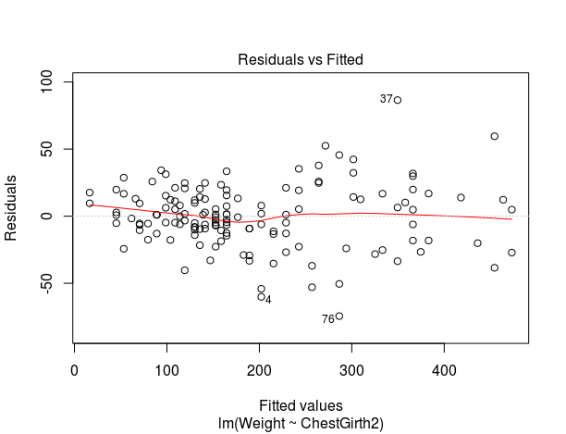

**This model fits much better than the simple linear model before. However, it looks like there may be a problem with constant variance. Also, intuition is telling me that a quadratic may not be the best model because it is empirical. It has no physical meaning to the data.**

> #Part C

> logChestGirth <- log(ChestGirth)

> logWeight <- log(Weight)

> plot(logChestGirth, logWeight, pch = 16, cex = 1.3, col = "blue", main = "log(Weight) plotted against log(Chest Girth)", xlab = "Chest Girth (inches)", ylab = "Weight (pounds)")

> lm(logWeight ~ logChestGirth)

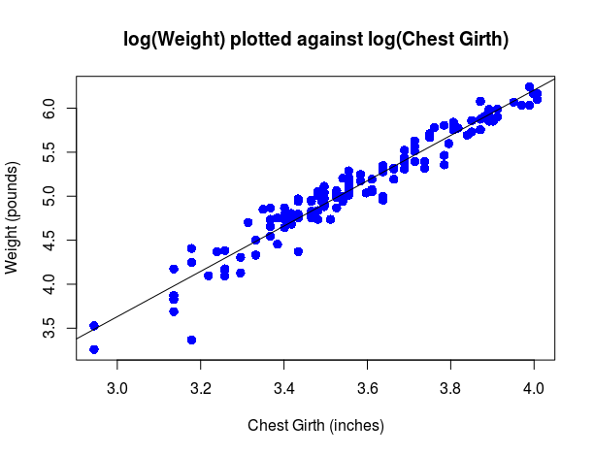Call:

lm(formula = logWeight ~ logChestGirth)

Coefficients:

(Intercept) logChestGirth

-4.092 2.574

> abline(lm(logWeight ~ logChestGirth))

> modelC <- lm(logWeight ~ logChestGirth)

> par(mfrow = c(2,2))

> plot(modelC)

> plot(modelC,pch=19,col=10,which=c(1,2,3,4))

> standres<-stdres(modelC)

> plot(standres~modelC$fitted.values,pch=19,col=12)

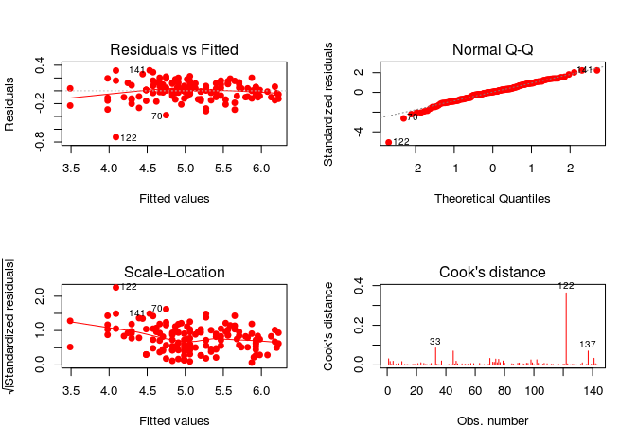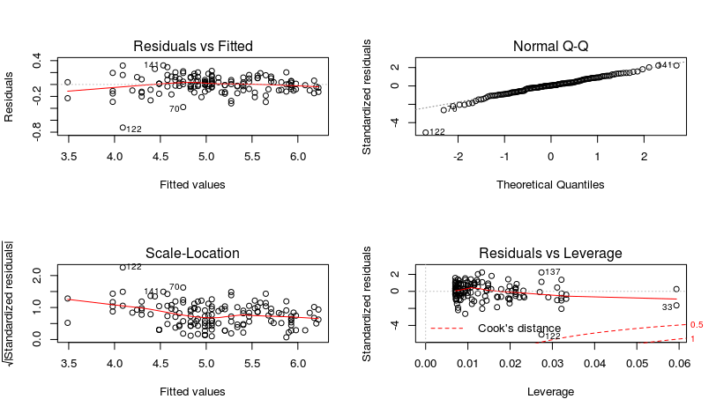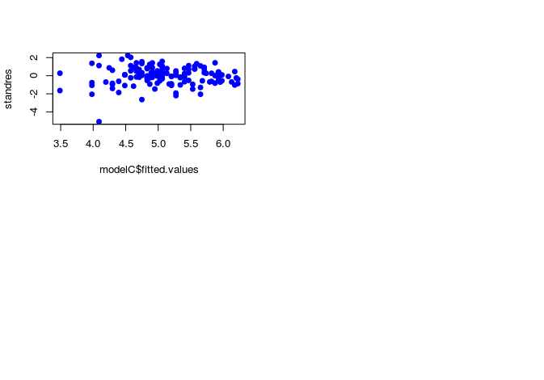**Point 122 is showing up as an unusual point. Relative to the other points, it has a large absolute standard residual. I would imagine that in the field, this could represent a malnourished bear. Perhaps one that is dying or just out of hibernation whose chest may be a normal size because of their ribcage, but low in weight.**

> #Part D

> round(confint(modelC,level=0.95),3)

2.5 % 97.5 %

(Intercept) -4.467 -3.717

logChestGirth 2.470 2.679

> newdata = data.frame(ChestGirth=log(38))

> predict(modelC,newdata,interval="predict")

**This is a little frustrating. I somehow had the predict working before I made this writeup, but now I cannot get it to function and I am running out of time. I remember the results making sense however.**

**This is the error I keep getting:**

Warning message:

'newdata' had 1 row but variables found have 143 rows

> #Question 3

> #Part A

> data(PalmBeach)

> palm<-PalmBeach

> palm.lm<-lm(Buchanan~Bush,data=palm)

> plot(Buchanan~Bush,data=palm,col="purple",pch=19)

> plot(Buchanan~Bush,data=palm,col="purple",pch=19)

> abline(palm.lm,lwd=2)

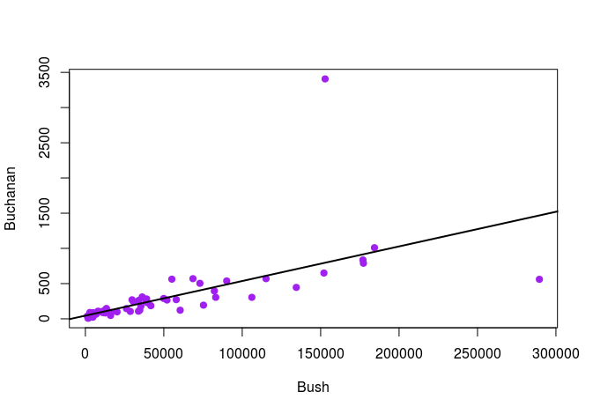

> standres<-stdres(palm.lm)

> plot(standres~palm.lm$fitted.values,pch=19,col=12)

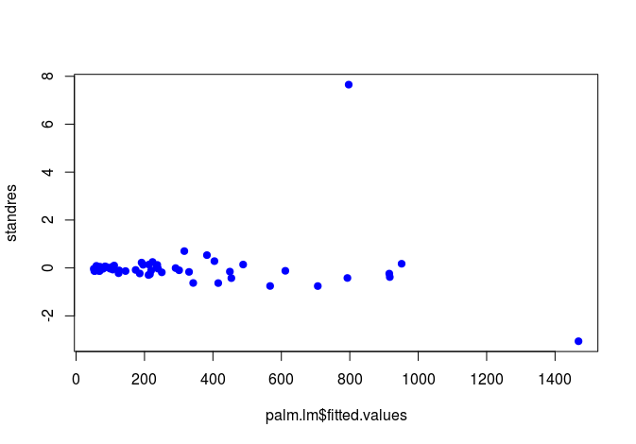

**The Standard Residuals plot immediately draws attention to two outliers. Palm and Dade County. The rest of the points naturally look related except for these two.**

> #Part B

> plot(palm.lm)

Hit <Return> to see next plot:

Hit <Return> to see next plot:

Hit <Return> to see next plot:

Hit <Return> to see next plot:

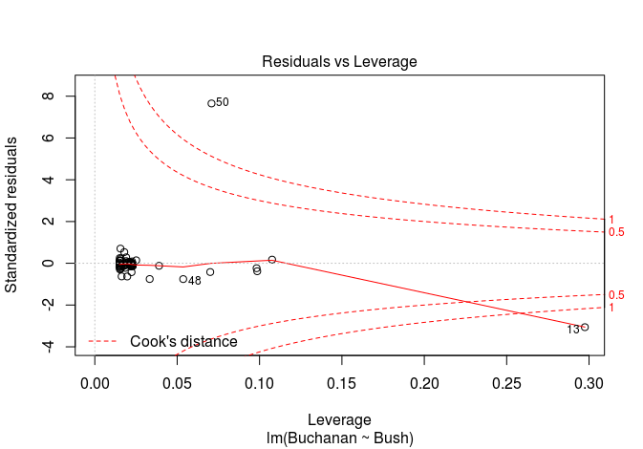

**Number 13 has a very high leverage relative to the other points. It is because this point is located by itself so much farther away from all of the other points that it has the ability to drastically pull the fitting line in one direction or another. In this case, its lower than expected y value pulls the line downwards.**

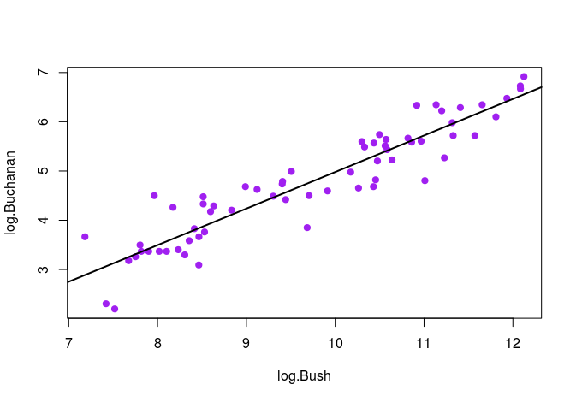

> #Part C

> palm.removed <- palm[- c(13,50),]

> log.Buchanan <- log(palm.removed$Buchanan)

> log.Bush <- log(palm.removed$Bush)

> plot(log.Buchanan~log.Bush,col="purple",pch=19)

> palm.lm2<-lm(log.Buchanan~log.Bush)

> abline(palm.lm2,lwd=2)

> plot(palm.lm2)

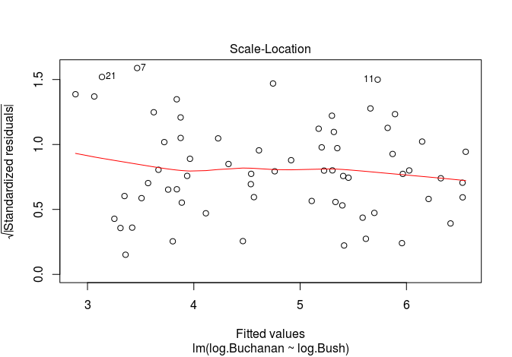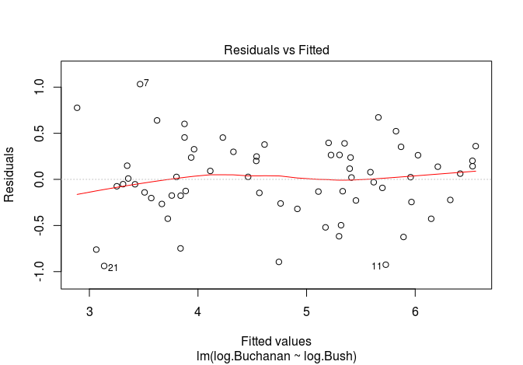

**The new residual plots are looking much better with a log log transformation.**

**The residual line has flattened and the variance has calmed down a bit. Overall I would be happy with this model as compared to the previous linear model without the outliers removed.**

> #Part D

> round(confint(palm.lm2,level=0.95),3)

2.5 % 97.5 %

(Intercept) -3.170 -1.724

log.Bush 0.669 0.816

> newdata <- data.frame(Bush=log(palm$Bush[50]))

> predict(palm.lm2,newdata,interval="predict")

> newdata <- data.frame(Bush=log(palm$Bush[13]))

> predict(palm.lm2,newdata,interval="predict")

**Again, this is frustrating. I had the predict working for both test points before I made this writeup, but now I cannot get it to function and I am running out of time. I don’t know what I changed to mess it up. The comparison of the predicted values to the actual values was what you would have though would happen. Under the improved model in a log log transformation and with the two outlier counties removed, it visually made a good prediciton.**

**This is the error I keep getting:**

Warning message:

'newdata' had 1 row but variables found have 65 rows