> library(Stat2Data)
> library(MASS)
> #Question 2
> bears <- read.table("/home/thomas/git/datascience/MSDataSci/MATH550/data/Bears.csv",header=TRUE,sep=",")
> attach(bears)
The following objects are masked from bears (pos = 3):

ChestGirth, Weight

The following objects are masked from bears (pos = 4):

ChestGirth, Weight

The following objects are masked from bears (pos = 5):

ChestGirth, Weight

> #Part A
> plot(ChestGirth, Weight, pch = 16, cex = 1.3, col = "blue", main = "Weight plotted against Chest Girth", xlab = "Chest Girth (inches)", ylab = "Weight (pounds)")
> lm(Weight ~ ChestGirth)

Call:
lm(formula = Weight ~ ChestGirth)

Coefficients:
(Intercept) ChestGirth
-278.75 12.97

> abline(lm(Weight ~ ChestGirth))
> modelA <- lm(Weight ~ ChestGirth)
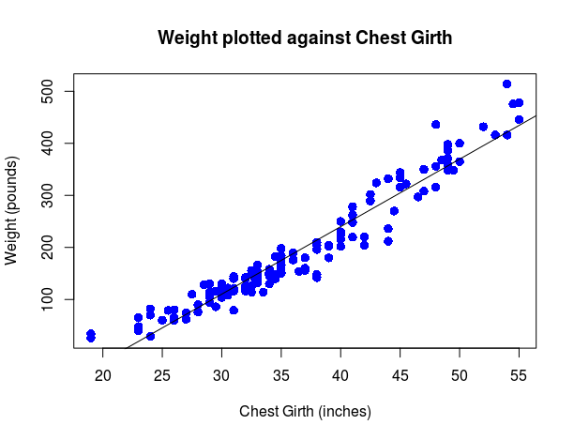

> plot(modelA)
Hit <Return> to see next plot:
Hit <Return> to see next plot:
Hit <Return> to see next plot:
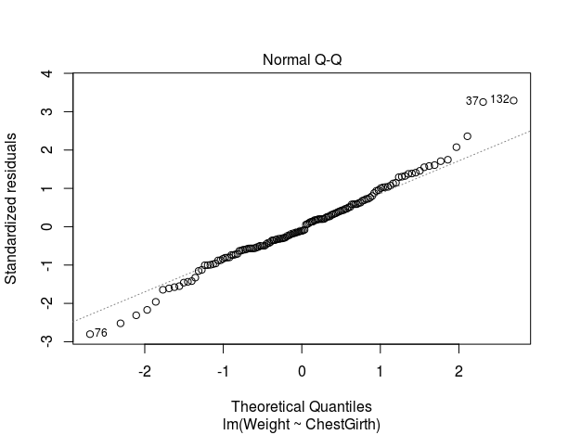
Hit <Return> to see next plot:
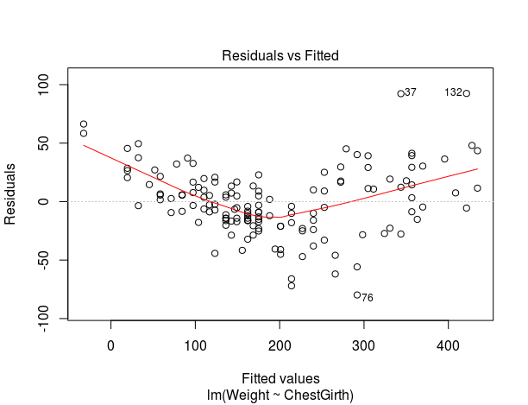

The results do not seem entirely adequate. It is easy in the data and in the residuals plot that a line does not pass through the points evenly. It seems to over predict the middle of the data and under predict the extremes. This organization in the residuals alludes to a different model.

> #Part B
> ChestGirth2 <- ChestGirth^2
> plot(ChestGirth2, Weight, pch = 16, cex = 1.3, col = "blue", main = "Weight plotted against Chest Girth^2", xlab = "Chest Girth^2 (inches^2)", ylab = "Weight (pounds)")
> lm(Weight ~ ChestGirth2)

Call:
lm(formula = Weight ~ ChestGirth2)

Coefficients:
(Intercept) ChestGirth2
-45.4369 0.1714

> abline(lm(Weight ~ ChestGirth2))
> modelB <- lm(Weight ~ ChestGirth2)
> par(mfrow = c(2,2))
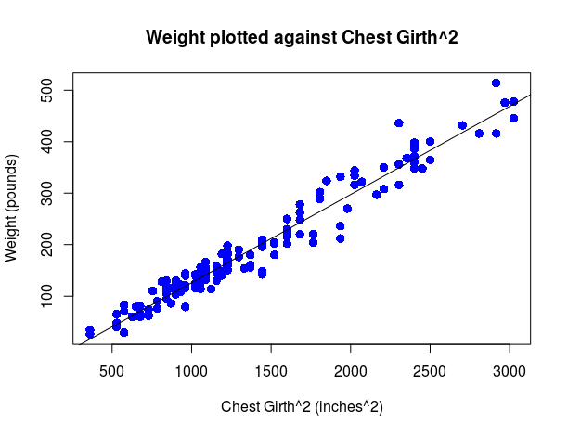

> plot(modelB)
Hit <Return> to see next plot:
Hit <Return> to see next plot:
Hit <Return> to see next plot:
Hit <Return> to see next plot:
