1. Please add Account for “Sales Partner”

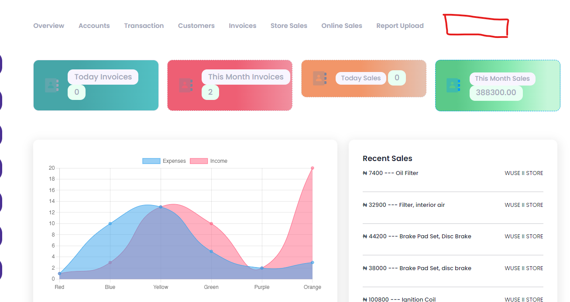  
    I. Account should be able to manage invoices from the sales partner’s portal and see their profits and account, to be able to pay their money (bonus) and clear their invoice.

No help > ChatBot

NEWER CORRECTIONS

1. WAREHOUSE TO STORE TRANSFER >   
   Iv. Include the search bar

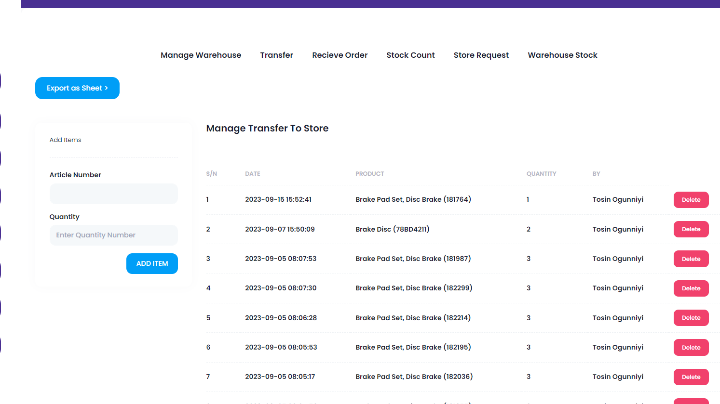

NEWER FIXES STILL  Please Provide Images

1. On payment || ON live

1. Add “Delivery method”  
   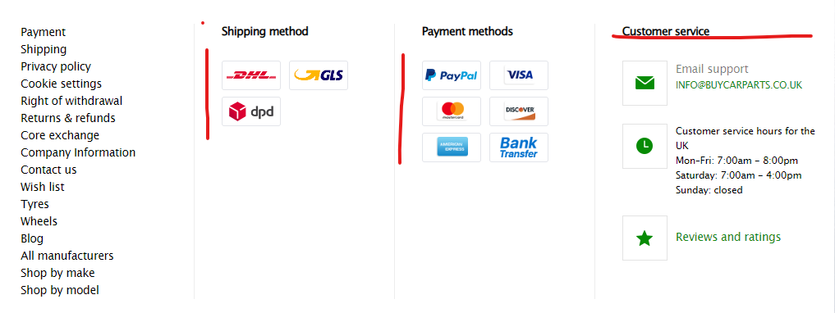

SALES PARTNER / fixing otp

1. Still showing a blank page:

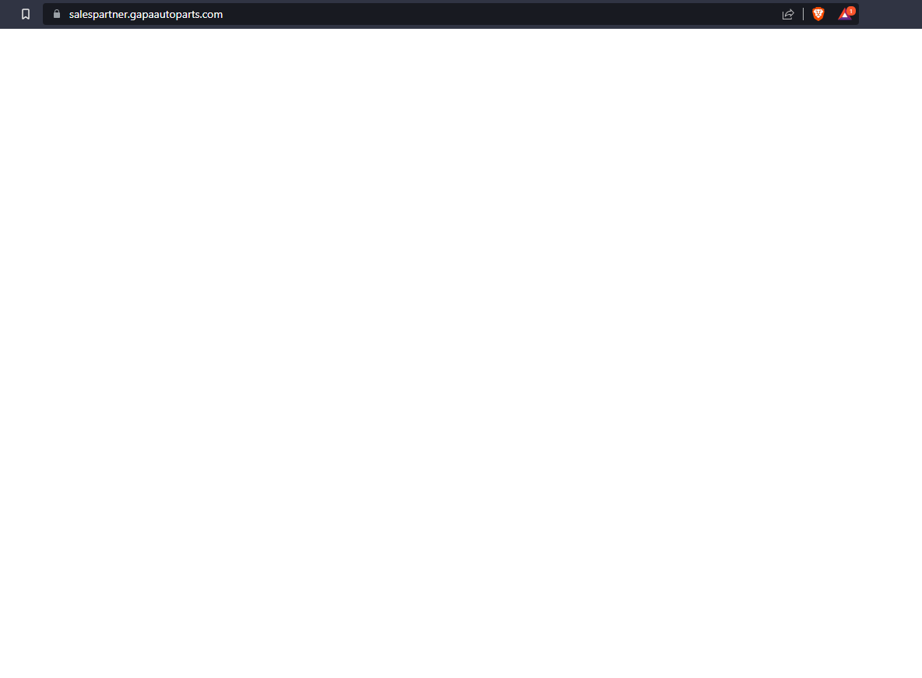

24082023  Awaiting Testing and Done

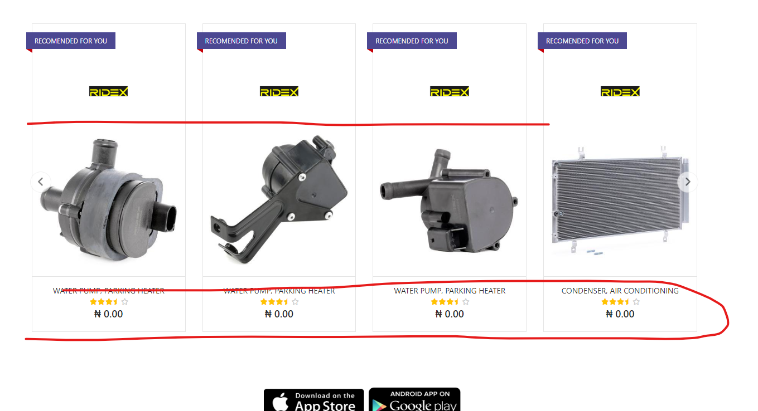

This is the error page you get when you click on any of the products without prices -

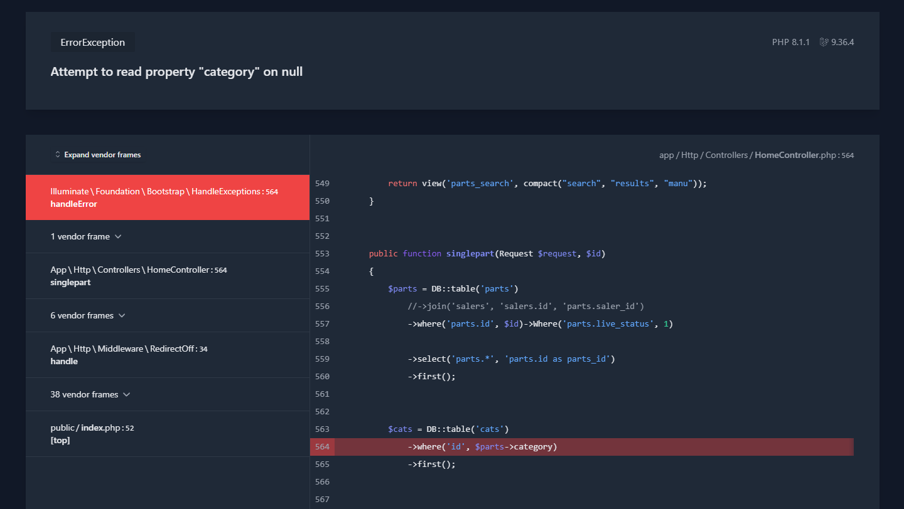

1. No delivery email from GAPA Naija on purchase - only from Payment providers