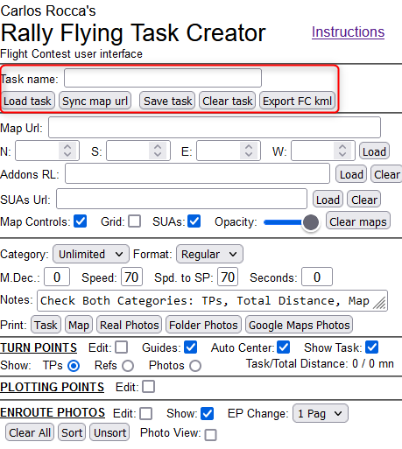 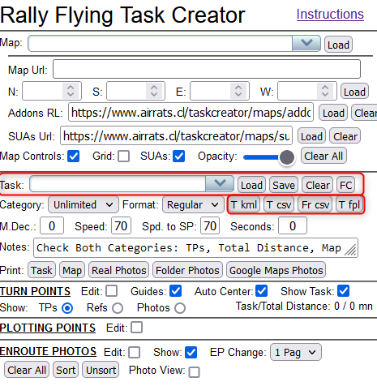

Modifications

Task line

Task -> Task name new control at top without DB connection

Load deleted (load from database)

Save deleted (save to database)

Clear -> Clear task moved to top

FC -> Export FC kml moved to top

Category line / Admin buttons

Fr csv -> Load task moved to top

T csv -> Save task moved to top

T kml deleted (export Google Earth kml)

T fpl deleted (export Garmin fpl)