OU Bankcard App - Developer’s Guide

Contents
OU Bankcard App - Developer’s Guide 1
Prerequisites 1
OpenJDK 17 64bits 1
Sencha ExtJS 7.6+ 1
Sencha CMD 7.6+ 1
Virtual Studio Code 1
Tomcat 9+ 1
NetBeans 12 1
Putty 1
GitLab 1
JIRA 1
Confluence 1
Setup the server project in NetBeans 1
Setup the client project 1
Use Sencha Architect for Developing the frontend app (Old) 1
Use Visual Studio Code for developing frontend app (Current) 1
Other things related to development 1

Prerequisites

OpenJDK 17 64bits
- download it from oracle website. make sure to download the OpenJDK, not Oracle’s JDK
- unzip it to a preferred location
- for windows, edit the environment settings to include it in the path
- set a JAVA_HOME (optional)
- check online for details on how to install it if needed
- to verify, open a command line window and type java -version, then enter to see if the correct version shows.
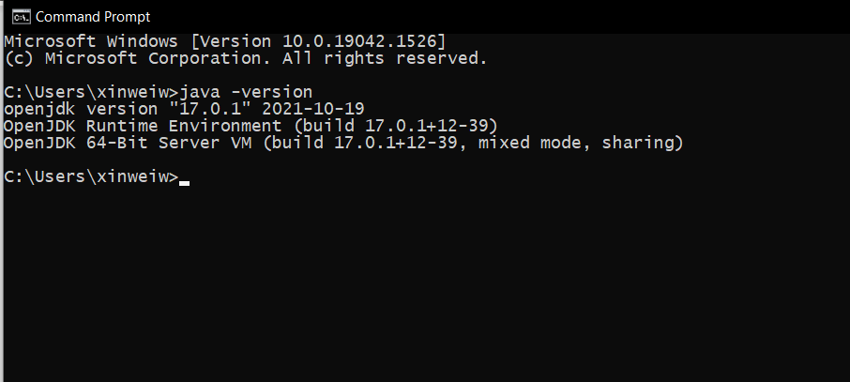

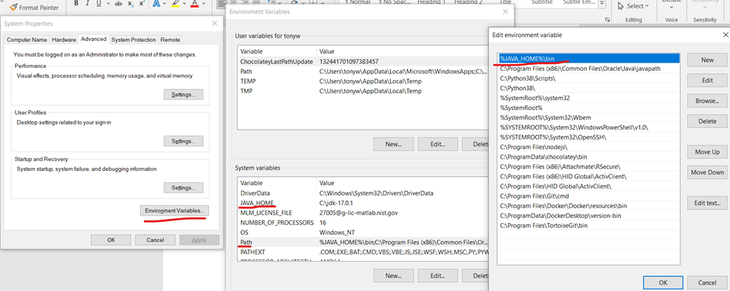

Sencha ExtJS 7.6+
- We use the Sencha ExtJS framework to build our frontend application
- Each developer for the project will be provided with a sencha license. The developer can register an account at https://support.sencha.com/ and download the licensed copy of the Sencha libraries and tools
- Download both ExtJS v7.6 and ExtJS Premier Addon

Sencha CMD 7.6+
- We use Sencha CMD to build and package our frontend app
- Download and install sencha CMD
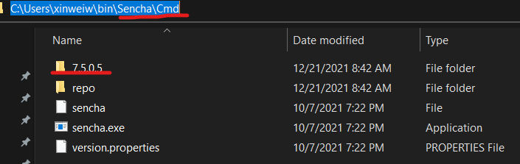

Virtual Studio Code
- We use Virtual Studio Code as our JavaScript IDE to code the frontend app
- Download and install Virtual Studio Code
- Install the recommended Extensions
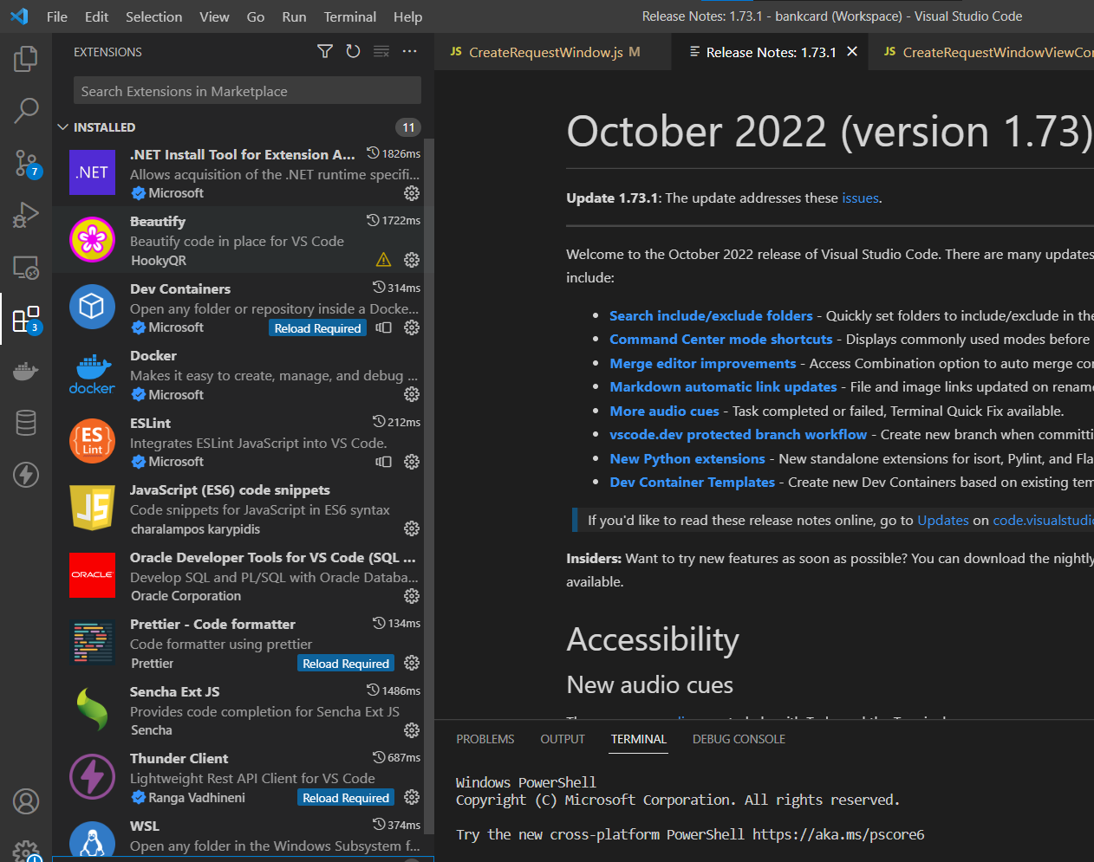

Tomcat 9+
- Download Tomcat (at least version 9, best to be the same version as what prod env use. Currently, we use 9.0.58)
- Note: do not install Tomcat 10+ as the lib dependencies changes and the code use libs for v9, not v10
- Unzip it to a preferred location
- Edit the context.xml to add DB connection resource
<Resource name="jdbc/bcws"
auth="Container"
type="javax.sql.DataSource"
username="BCPMS_OWNER"
password="{password}"
driverClassName="oracle.jdbc.OracleDriver"
url="jdbc:oracle:thin:@127.0.0.1:12001:mml2dvi"
maxTotal="100"
maxIdle="10" />
- 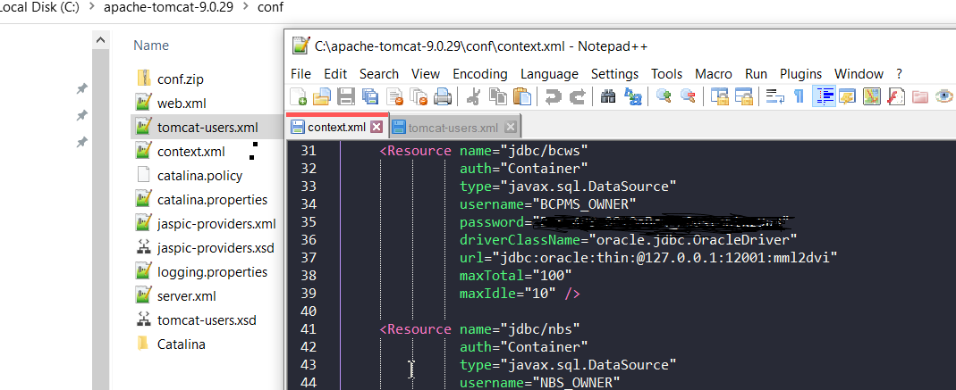

- Edit the tomcat-users.xml to add a user used to start Tomcat (this can be down in Netbeans IDE too in a later step)
- 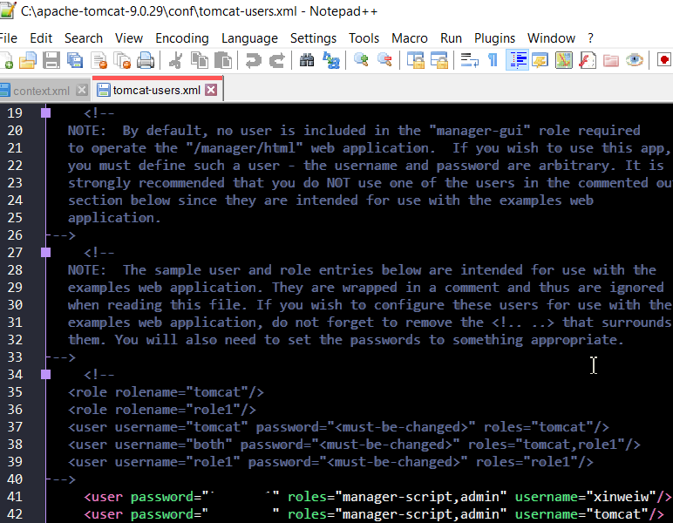

- Add the Oracle JDBC driver to the lib folder. The jar file can be downloaded at Oracle website
- 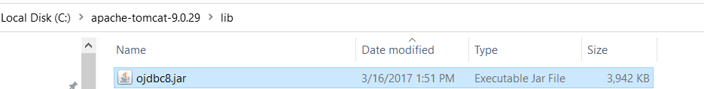

NetBeans 12
Note: pictures used in this section may show older versions.
  - Remove any previously install netbeans, including any folder left the “program files” and “<user>/AppData/Local” and “<user>/AppData/Roaming” after uninstall.
  - Install a fresh copy of Netbeans 12, open it and see if it complains about any error.
  - If you have multiple JDK/JRE installed, you can specify which to use to run Netbeans by modify the conf file.
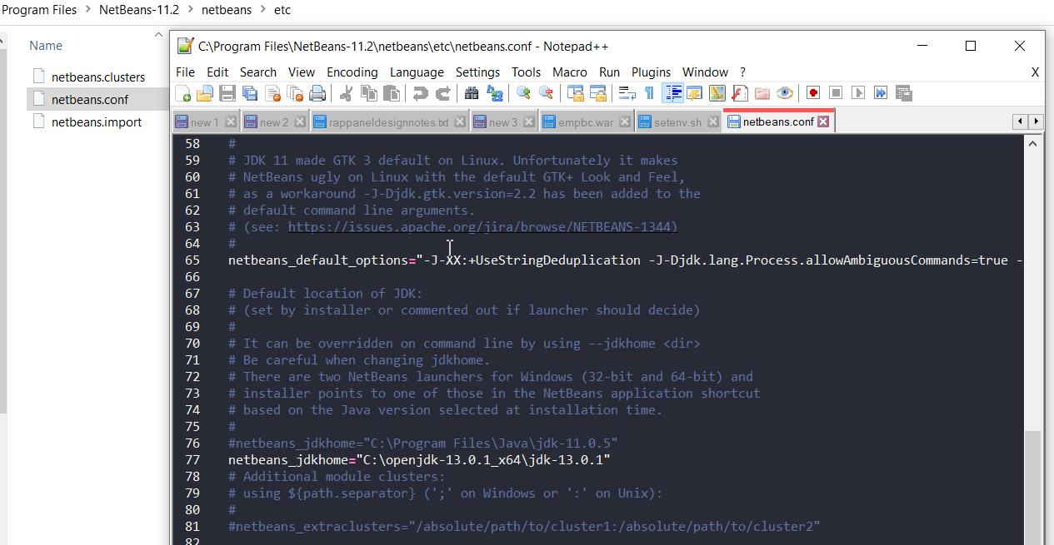
  - When open it, if it finds and asks you to import previous workspace, choose “no” to start fresh.
  - Add a Tomcat 9 server in Netbeans
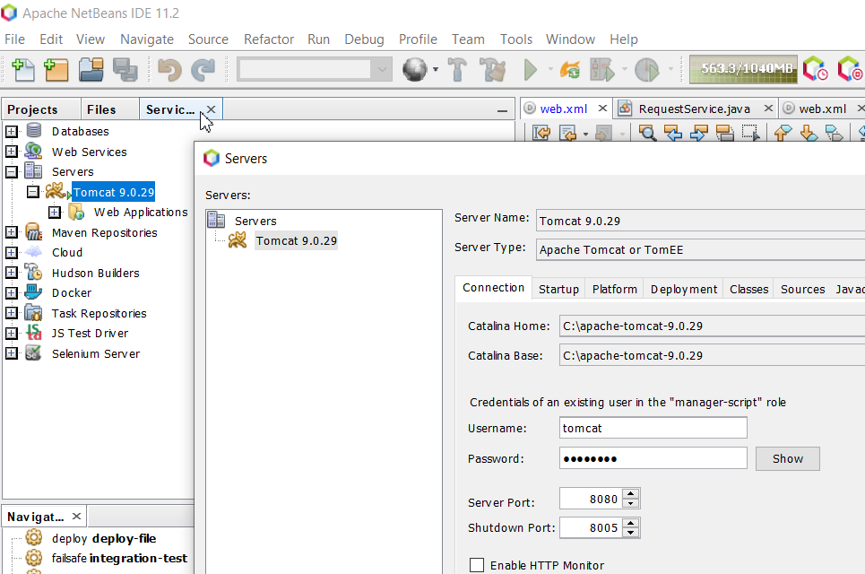
  - in tomcat server properties -> platform, add --enable-preview in VM-Options
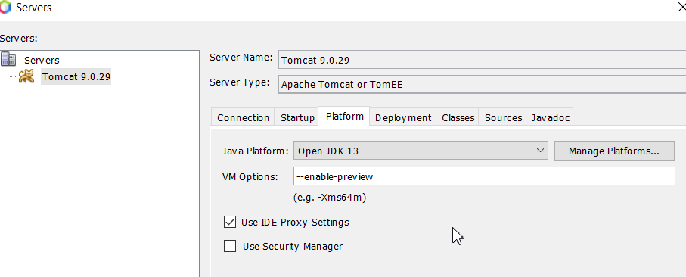
  - Other settings need to setup for the project are showing below:

Decide source/binary format, we currently use 17
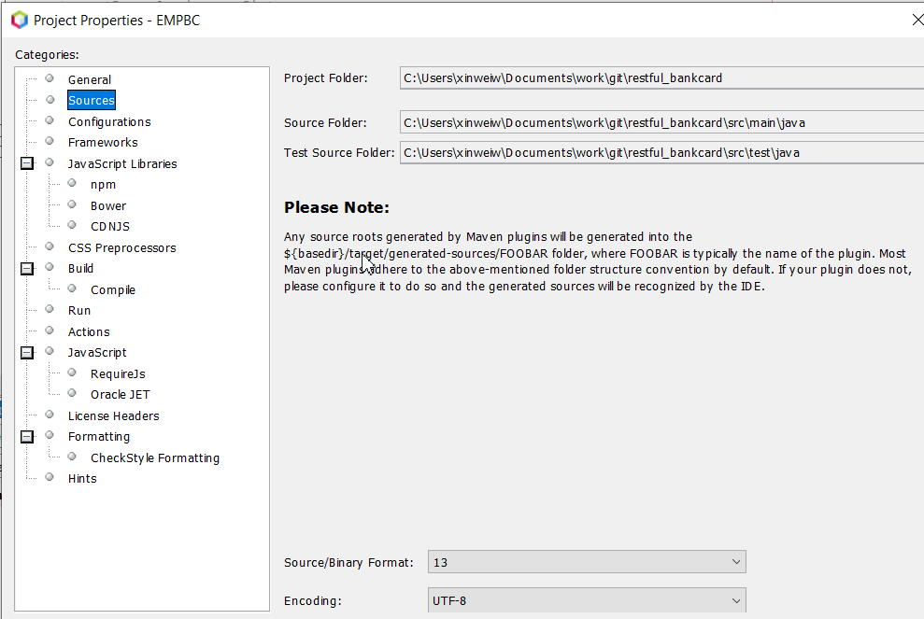

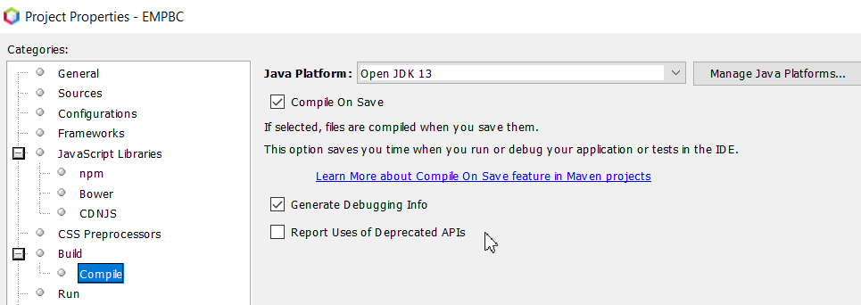
Decide which JDK is used to compile the project. We currently use openJDK17

Decide which app server to deploy the project to. We currently use Tomcat 9.0.58, Java EE 8 Web. There’s a plan to move it to Tomcat 10 in the future.
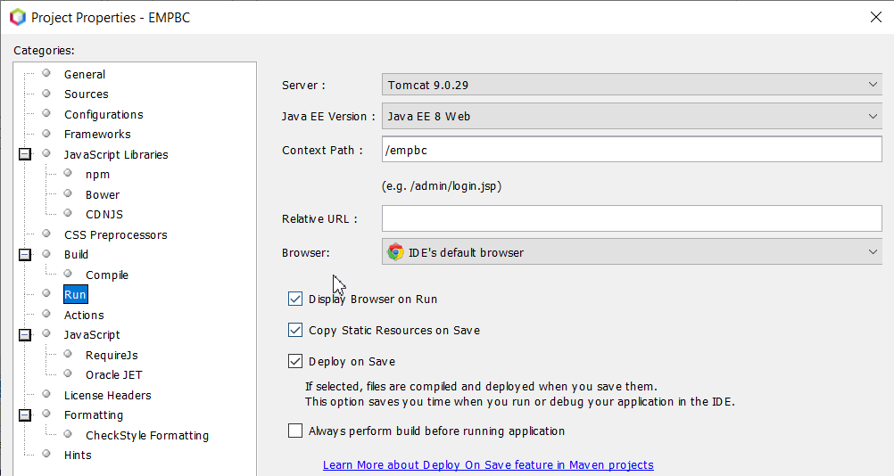

Putty
Note: in order for us to connect to the dev database server from local machine, we need to use putty to Setup SSH tunneling. Below are the Dev, Test and Prod DB info:
- Dev Database
Dev DB server: dodb4b.nist.gov
Port: 2001
Database/SID: mml2dvi

- Test Database
Test DB server: dodb4b.nist.gov
Port: 2002
Database/SID: mml2tsi

PROD DB Server:
Note: no direct access allow. To access Prod DB, use Citrix by going to https://snas.nist.gov, log in and open TOAD for oracle
Port: 2001
Database/SID: mml2pdi

DB usernames/passwords will be sent to you via secure file transfer or encrypted email. Please keep it securely.

- Request a functional account if you don’t have one
- Make sure your functional username is in the group of developers used by the Linux SA to enable access to the DB server. If not in it, ask Bill (William Turner) to add you.(submit a ServiceNow ticket to request access to the DB server, fill and sign an user behavior agreement). After access granted and user account created, try the steps below. If still cannot login, contact the Linux SA.
- The screenshot below is for Reflection(a ssh client). Putty has similar configure screens. You need to create connection, define tunneling, try to connect and save the profile for later use.
- 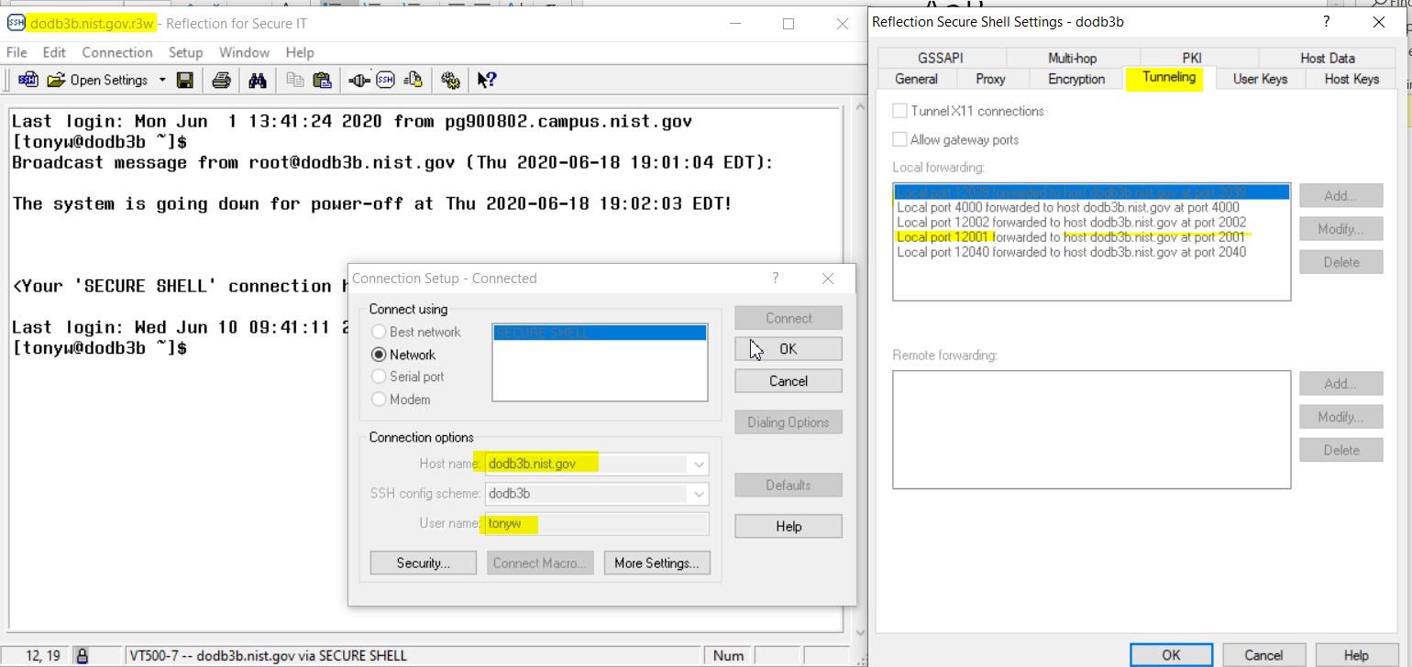
- Make sure the local port you setup matches what you use in the db resource in the context.xml (see Tomcat server setup steps above)

GitLab
- We use GitLab for source control. Make sure have access to the Bankcard application in the NIST Gitlab. Otherwise, contact the Bankcard primary support for access.

JIRA
- We use JIRA for Issue & Project tracking
- http://mml.nist.gov:8080/browse/BANK

Confluence
- We use Confluence for documentation, user guides, meeting minutes and etc.
- http://mml.nist.gov:8090/display/MMLAdminPortal/OU+Bankcard+Application

Setup the server project in NetBeans
- Clone the bankcard project from git at https://gitlab.nist.gov/gitlab/mmlhq/Bankcard.git
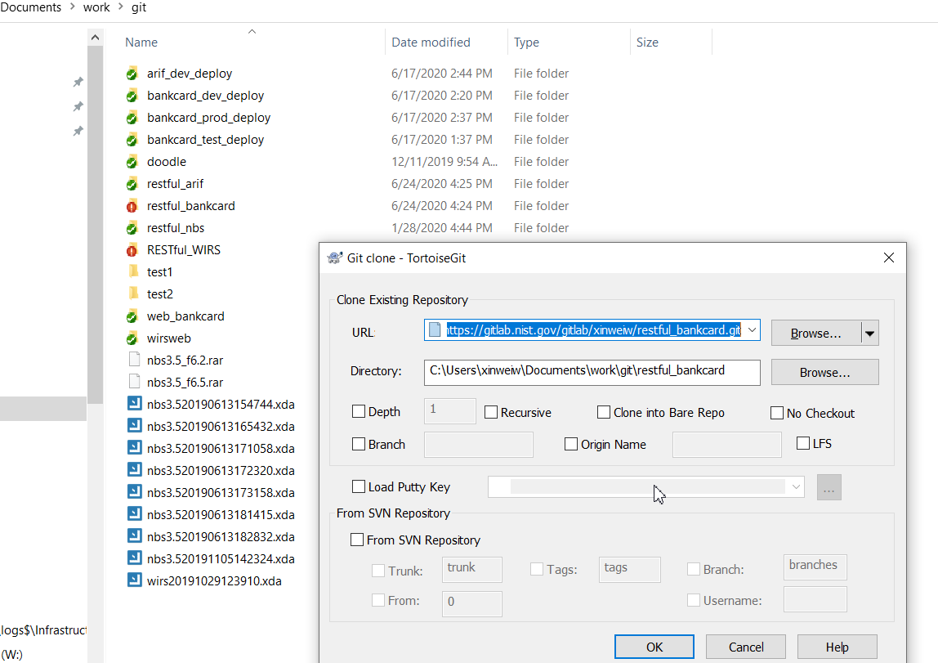

- Open the project in NetBeans by navigate to the cloned project’s \backend folder
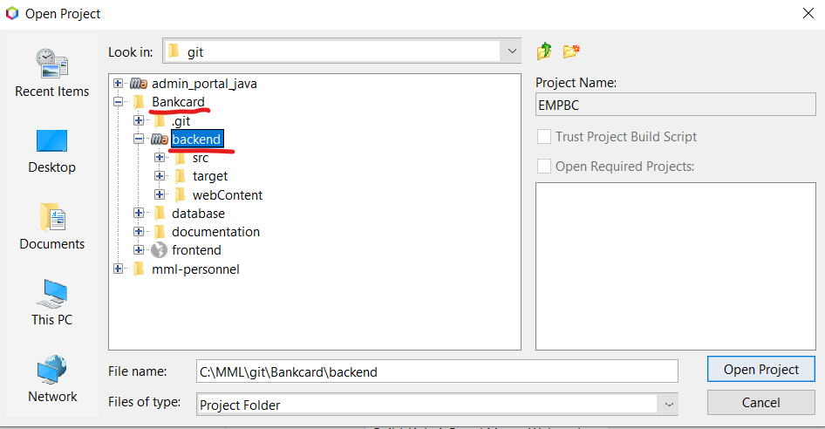

- Comment out the single sign-on settings in the web.xml file because the local server doesn’t have the ability to do Kerberos authentication
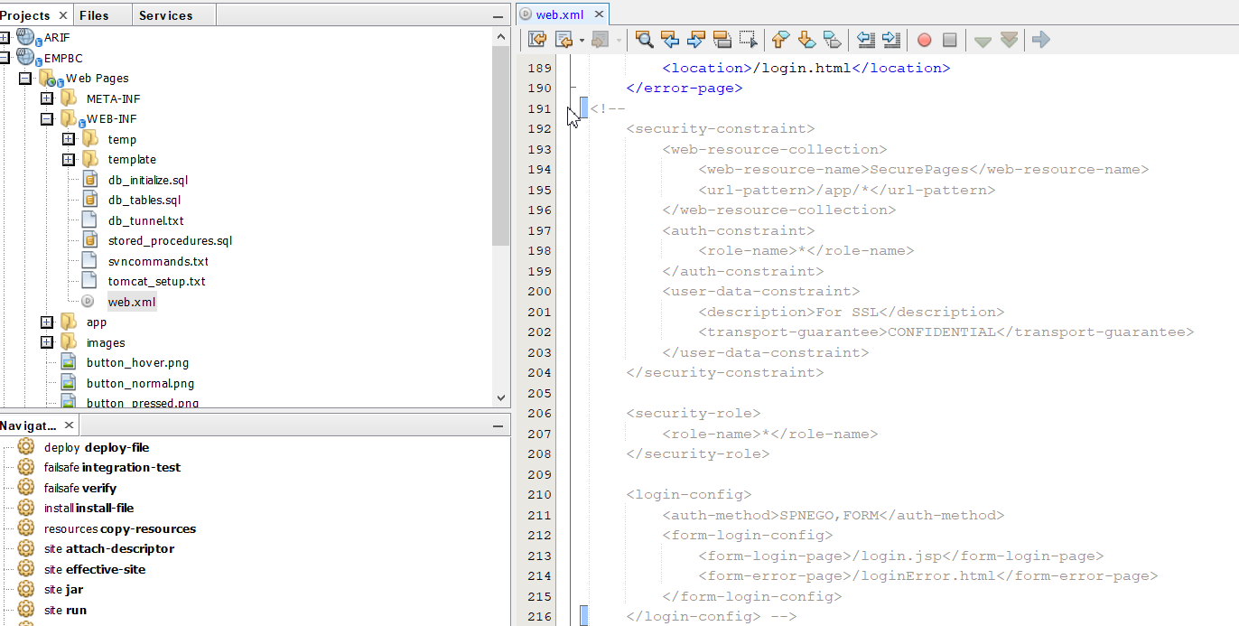

- Enable the fake authentication in the same web.xml
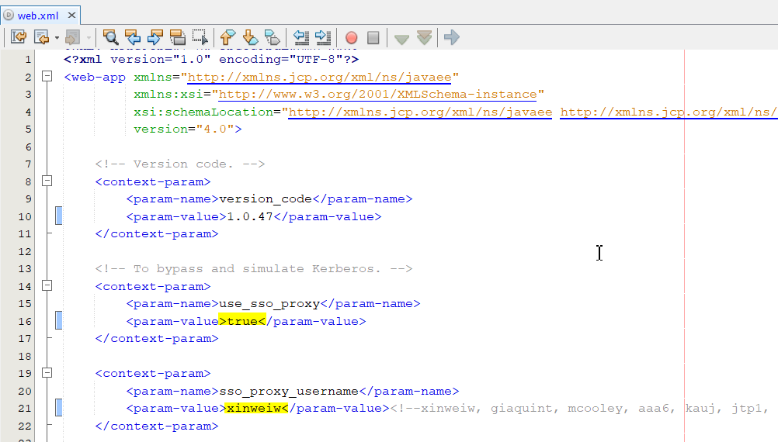
- When doing local development, you can change the sso_proxy_username to a different username to test our users with different roles.
- NOTE: there are settings in this file to enable/disable notifications or integration with external app and settings for authentication. Check java doc for each, and make sure the settings are suitable for the environment. For example, to build a production build, make sure the fake authentication is turned off, the real single sign-on setting is not commented out, the notifications are on and etc…
- Build the server project and check for error in the log.
  - The project use Maven to build. The required libs are defined the pom.xml and should be auto downloaded when build starts. If for some reasons, some lib cannot be downloaded, try to download the lib manually and installed them manually
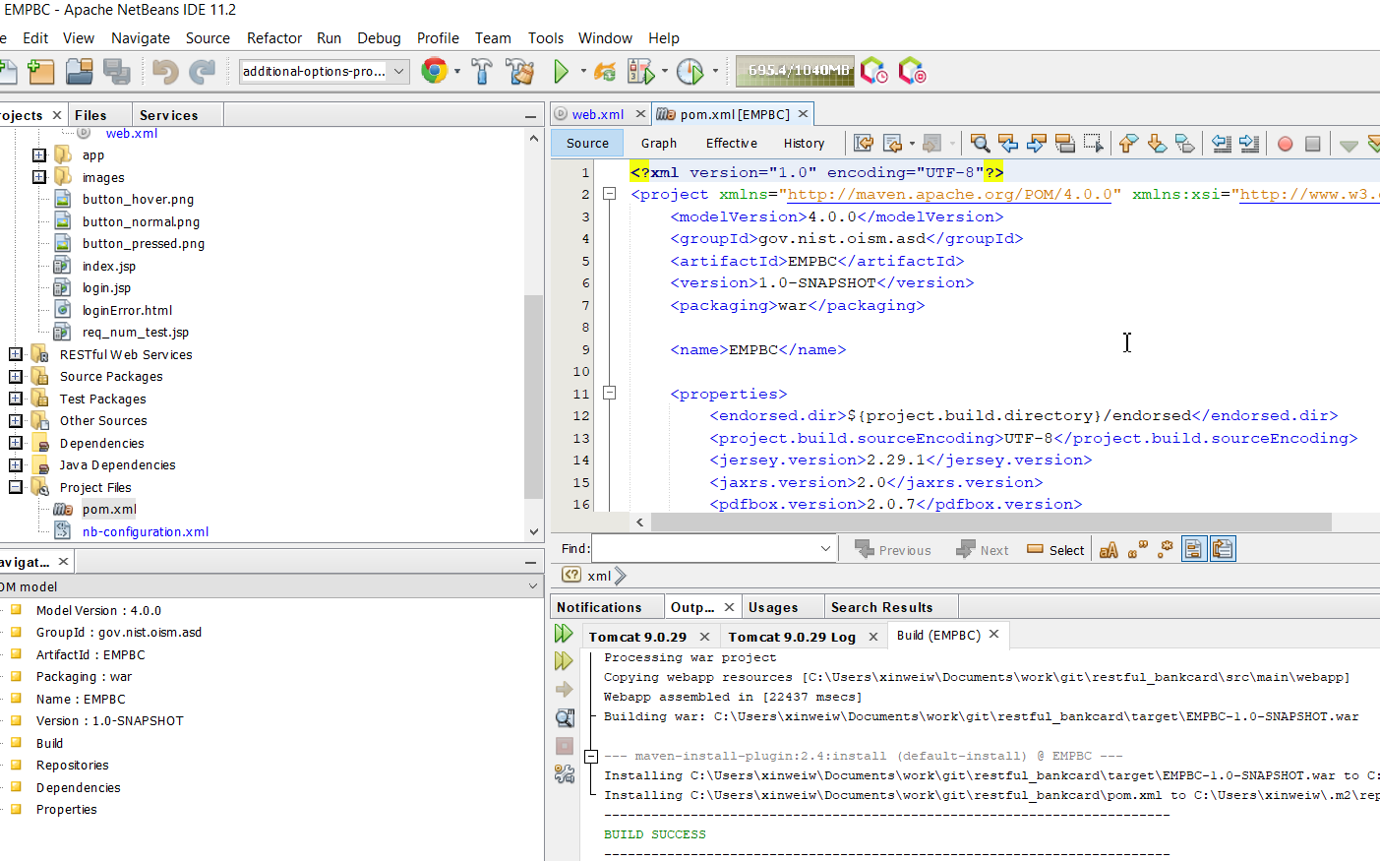
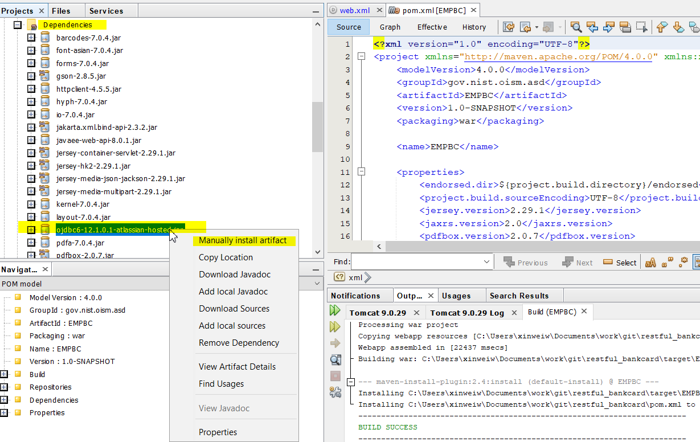
- If the build is successful, right click the project and run it. it should open a browser window with some info shows as below
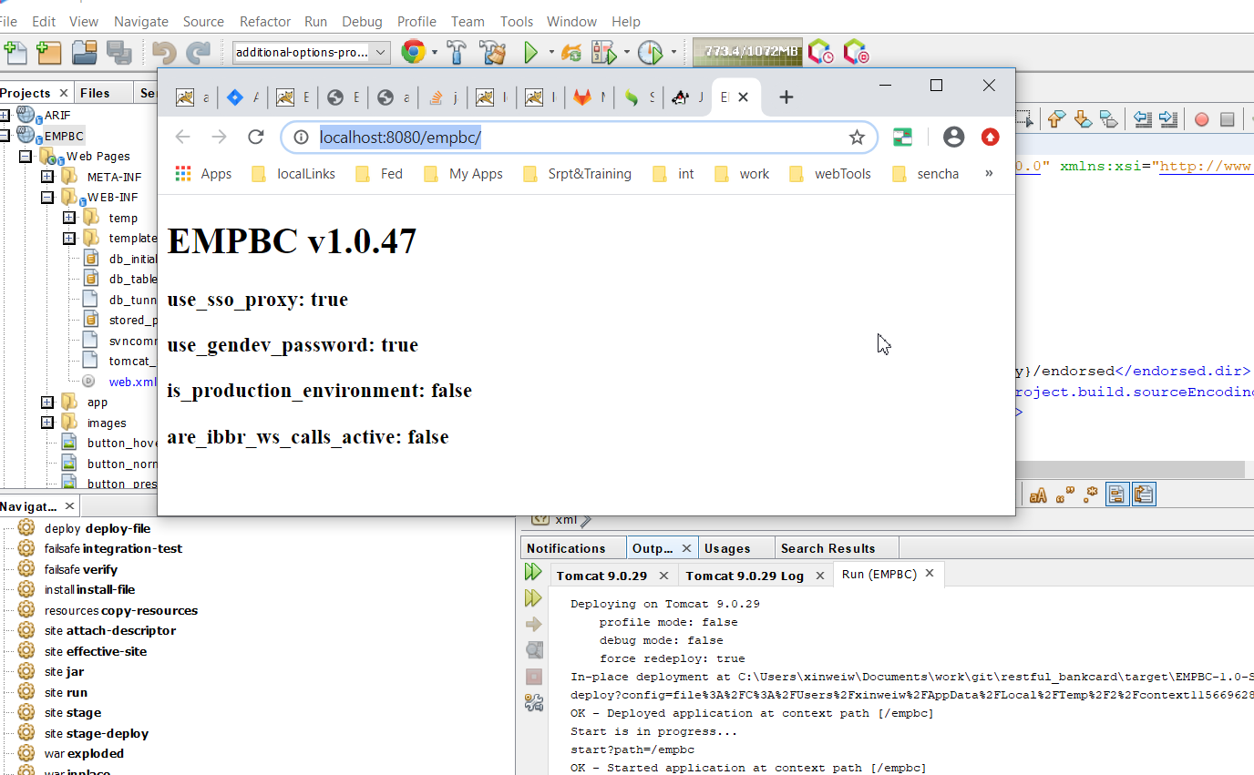
- For local, the 4 variables show in the browser window should be true, true, false, false
- For Dev and Test, they should show as false, true, false, false
- For Prod, they should show as false, false, true, true
- The different results are based on the param settings in the web.xml as explained in previous steps

Setup the client project
- Git clone a copy of the bankcard project from git at https://gitlab.nist.gov/gitlab/mmlhq/Bankcard.git
  - The server, client and document are in subfolders. For just getting the client project, we cannot do a simple clone. We need to use the following code to clone only the client subfolder and put it into the bcpweb folder in the webapps folder in Tomcat:
    - Go to webapps folder in Tomcat, create a folder “empbcweb” and go to it
    - Open a CMD, cd to this folder and run
      - git init
      - git remote add -f origin https://gitlab.nist.gov/gitlab/mmlhq/Bankcard.git
      - git config core.sparseCheckout true
      - echo 'frontend/*' >> .git/info/sparse-checkout
      - git pull origin master

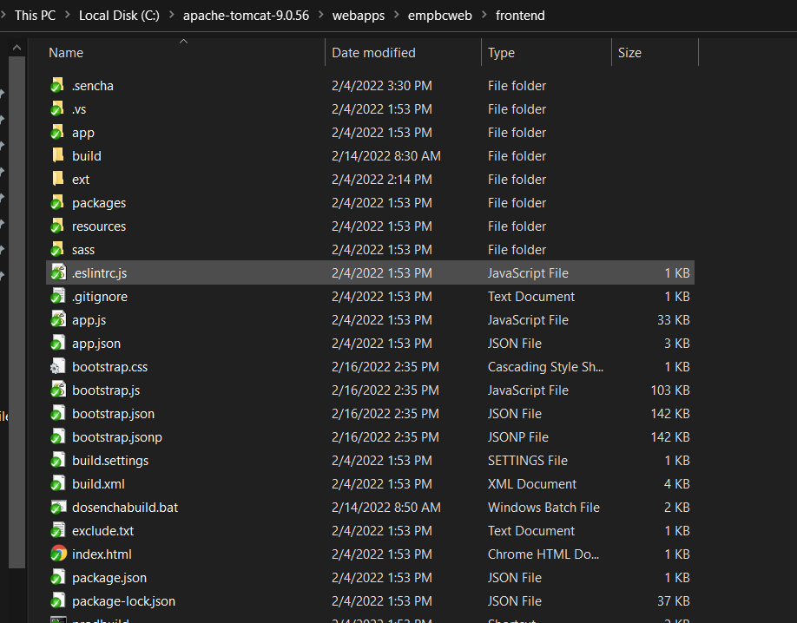
- the ext source folder is not in git so use the downloaded the extjs libs (in prerequisites) and unzip a copy of extjs source code to the ext folder under the project.
  - Download and unzip Sencha ExtJS (v7.6) and ExtJS Premier Addon.
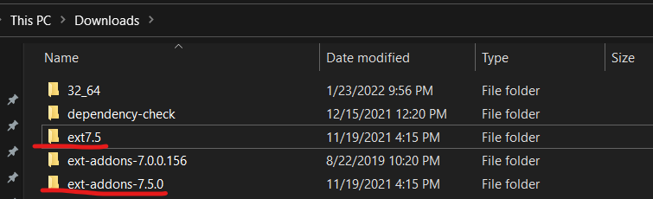

Use Sencha Architect for Developing the frontend app (Old)
This section talks about using Sencha Architect. Since we now switched to use Visual Studio Code, you can ignore this section.
install Sencha Architect, use it to open the BCP.xds file
- check the preference and project settings and make necessary changes. For example, under build settings, I have choose to publish prod build files to C:\Users\xinweiw\Documents\work\git\restful_bankcard\src\main\webapp\app, which is where my server project’s source code exists. It’s easy this way to combine the client and server projects into one war file to deploy to Dev/Test/Prod. Each user’s path maybe different, so make adjustment when necessary. The settings will be save to build.settings and the .xds files. So add these to the ignore list on commit to prevent commit your local settings to git. Other files that rarely changes are the bootstrap files. You can also add them to the ignore list on commit.
- build the project, check the Command Output tab for errors. it will generate necessary files to run locally.
- if premium addon is used, for example, the exporter, then install the addon in the Architect and do a build. one file named Archive.js in the exporter will have problem being copied to the webapps if your client project is not check out in the webapps folder and need to publish changes. this is because the name of the file is used somewhere in the build script and the publish ignore it somehow. if you have this issue, check the chrome debug view to see what file has 404 error, the location and get a copy of it from the premium addon source code and manually copy the file over to the project folder.
- if use sencha CMD to build the project, make sure all developers in the project use sencha CMD as well because changes made not using the architect will not be visible in Architect based development since Architect has metadata file for each source code folder that is used by the IDE. Sencha CMD do not use metadata file so mix use of CMD and Architect won't work.
- Use Chrome, open developer view, then try http://localhost:8080/bcpweb/index.html#dashboard and check for error in the console log and also the network tab.
- If everything works, the app will load can the dashboard view will show.
- Now your local env setup is done and you can start development now.

Use Visual Studio Code for developing frontend app (Current)
- Makes sure to install ESLint and Sencha Ext JS extension in VSC
- Activate the ExtJS extension with your sencha license
- Open the bankcard client project in VSC, run “sencha app watch” in the Command Prompt so it monitors any change you make in the client code
  - If it doesn’t recognize “sencha” as a command, make sure the Sencha Command installation’s /bin folder is in the path in Environment Variables
- Open dosenchabuild.bat in the client project’s root folder, check the settings and make necessary changes based on your dev environment (paths)
- Open another Command Prompt, run “dosenchabuild” to build the client app and generate files that will be included in the server project.
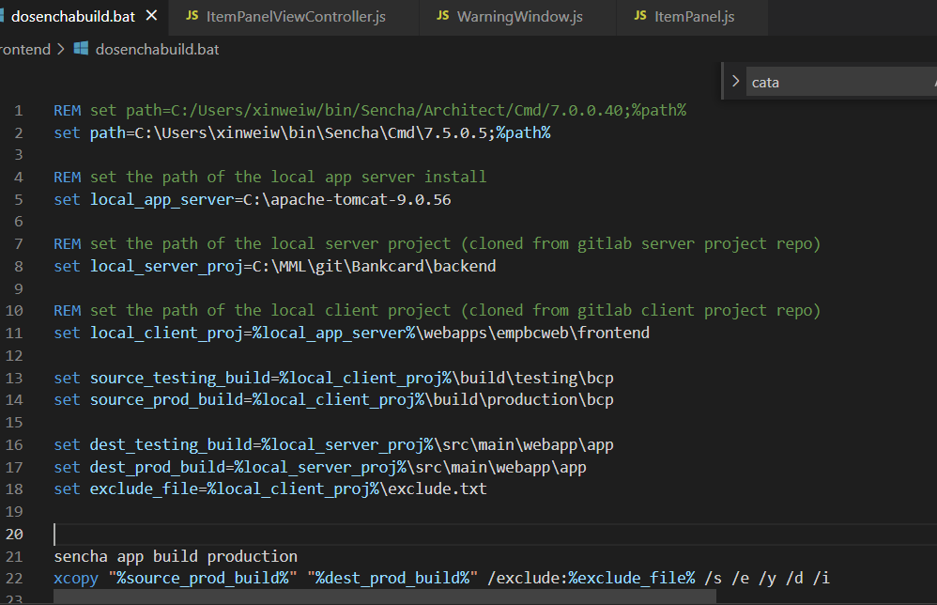

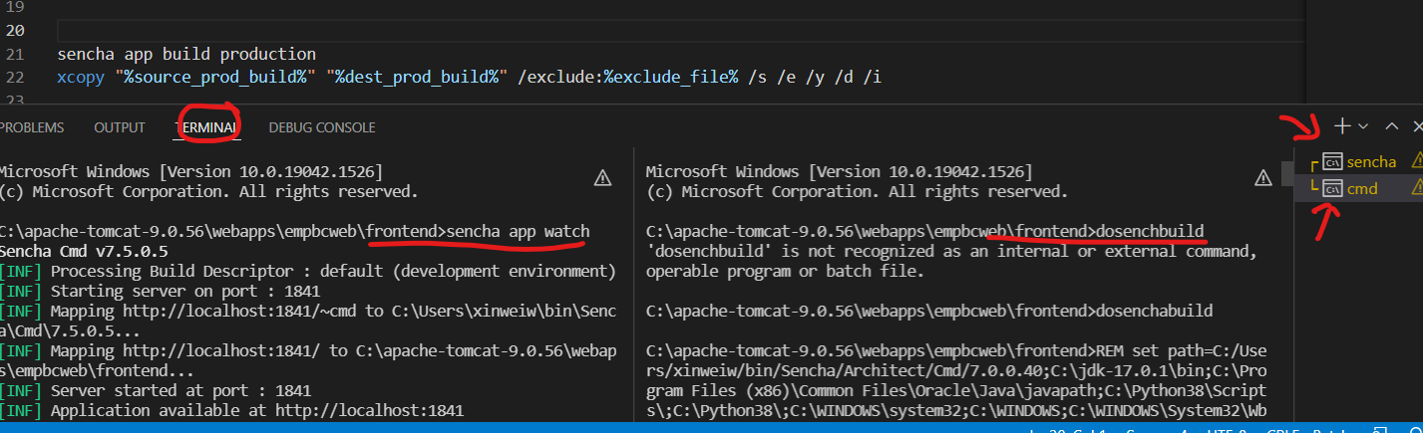

Other things related to development
- After making changes to source code, before push, always to a pull from git first so you won’t running into merge issue which is hard to resolve sometimes.
- When commit, select changed files that are code related to commit. For not code related, such as changes related to local settings in client project or web.xml in the server project, select these files, add them to ignore on commit list. So, you won’t accidently commit these changes to GitLab and cause problems for other developers. I recommend using TortoiseGit or SourceTree, which gives a UI interface and better control.
- Commits often to save progress locally.
- When a task is finished, do a pull first, then push the changes to GitLab. (make sure this action would not cause problem for other dev users after they pull your changes. For example, you task include 3 file changes in the client project and 1 change in the server project. If you only pushed 2 client files or forgot to push the server change, after other dev users did their pull and try to run the project locally, they will get error and won’t be able to run)
- Client code changes should take effect immediately since the source code is in the tomcat’s webapps folder (deployed web projects).
- Server code changes usually triggers the IDE to compile and then deploy changes in NetBeans. Occasionally, changes may not auto deploy, or some changes require a clean build, when that happens, try to delete the deployed code under tomcat’s /work/Catalina/localhost/[server project], do a clean and build in NetBeans.

