

**Dark Matter**

**Todd Wenker**

**September 29, 2016**

Planet sprite from opengameart.org. User: Viktor.Hahn@web.de

Ship sprite from opengameart.org. User: pzUH

**Game Summary**

As the pilot of an experimental spacecraft, it is up to you to defeat an encroaching alien fleet, hell bent on assaulting humanity’s home worlds. In front of you are waves of enemy fighters. The heart of the enemy fleet is the alien capital ship, equipped with a Concentrated Dark Matter Generator. This dark matter acts as a smokescreen, blocking the view of the player as enemy ships dive towards you. The player must utilize their finite number of flares to illuminate the screen to help them fire lasers and destroy enemy ships. The player ship, enemy ship explosions, and lasers fired by both the player and enemies will give off an amount of light as well, but it will not be enough to adequately see the screen. To reach the enemy capital ship, a series of waves need to be destroyed, with each wave being more difficult than the last. The player has three lives to reach the end. However, the player’s ship can only take a single laser blast before dying, creating a tense and hectic atmosphere.

**Table of Contents**

I. Story and Theme -------------------------------------------------------------------------- 4

II. General Look and Feel ------------------------------------------------------------------- 4-5

III. Gameplay Description -------------------------------------------------------------------- 5-6

IV. Information Architecture and Mock-ups ----------------------------------------------- 6-8

V. Specific Features -------------------------------------------------------------------------- 8-10

VI. Work Timeline ---------------------------------------------------------------------------- 10

VII. Concept Art -------------------------------------------------------------------------------- 10-12

**Game Story and Theme**

Story: After a millennium of colonizing the Milky Way Galaxy, humankind feels safe, if alone, bounded by the black expanse that separates galaxies. However, from this colorless void, an alien entity invades, using advanced technology to create a field of concentrated dark matter to conceal itself. The player will need to utilize their flares and the light given off by their lasers to guide them as they combat the enemy fleet. The player will need to react quickly to dodge enemy fighters as they dive and fire at the player.

Theme: The game will be reminiscent of early arcade shooters but will have the added twist of darkness. This will increase the tension and make combat with enemy ships a hectic affair, requiring the player to stay on their toes and use flares effectively to avoid death. The target audience will be all ages.

**General Look and Feel**

The game will borrow heavily from the styles of early arcade shooters, specifically Galaxian and Galaga. Firefights will be hectic and exciting, as the enemy ships and the player are destroyed in a single shot. The enemy waves will array themselves at the top of the screen before select units will dive bomb towards the player.

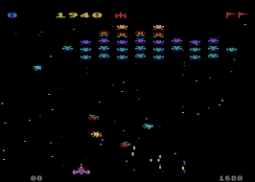

*Galaxian on the Atari.*

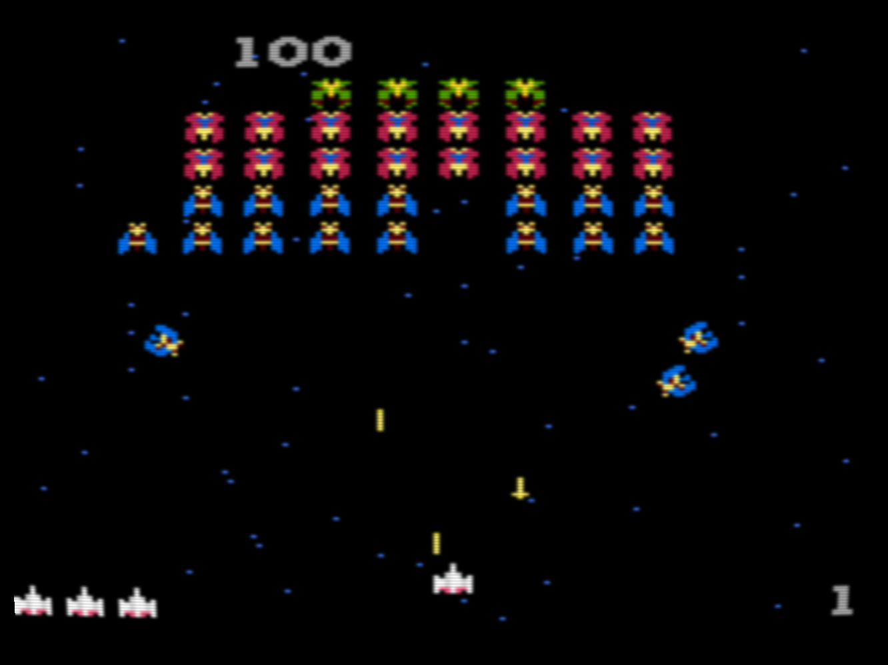

*Galaga on the Atari.*

**Gameplay Description**

Title Screen: The game will open with a title screen, displaying “Game Start”, “How to Play”, and “Quit”.

Game Start: After selecting game start, the title screen will fade away and the player’s ship will appear at the bottom of the screen and a wave of enemy ships will spawn at the top of the screen. Then, the screen will fade to black as the enemy’s Dark Matter Generator occludes the screen. The player will then need to destroy every enemy in the wave before the next wave will spawn. After defeating four waves, the fifth wave will have the alien capital ship that will be more difficult to destroy.

How to Play: Selecting “How to Play” will take the player to a screen showing the player the controls and general rules of the game. By hitting the “Back” button, the player will be taken back to the title screen.

Quit: Hitting the quit button will end the application.

**Information Architecture and Mock-ups**

Flow chart:

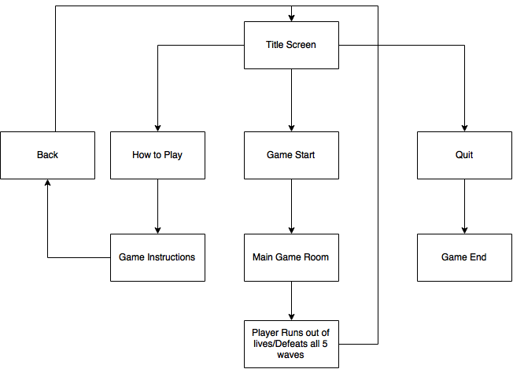

Game Screen mock up:

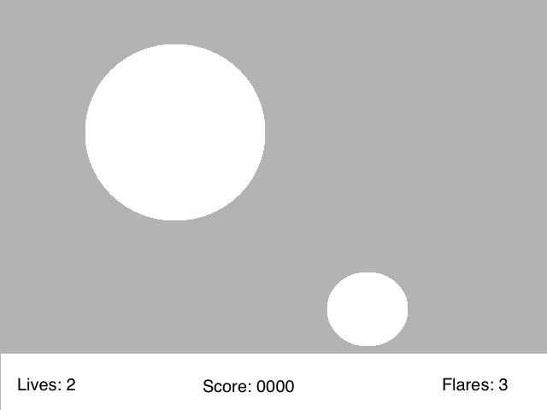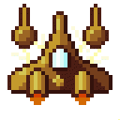

**Specific Features**

Space shooter Features:

* Player Features:
  + Move right: D
  + Move left: A
  + Fire laser: Space
  + Fire flare: Shift
* Enemy Features:
  + Three basic enemy fighters
    - Type 1: makes up a majority of each wave. Attacks in a simple downward motion.
    - Type 2: a faster and more agile fighter. Stays in the back lines of the enemy formation and makes fast, sweeping attacks at the player.
    - Type 3: a ship that stays in the back lines before charging at the player, aiming to ram them.
  + Alien Capital Ship
    - Takes up a large portion of the back of the formation and fires a spray of lasers at the player intermittently. Takes multiple laser shots from the player to destroy.
* GUI
  + Lives: the player will start with three lives and will lose one for each time they get hit.
  + Flare count: the player will be given three flares at the start of each wave.
  + Score: Each enemy destroyed will provide the player a specific number of points
  + Wave number: displays which wave, out of the five total, the player is on.
* Light Sources
  + The player’s and the enemy’s lasers
    - Will only provide a small amount of light
  + The player ship
    - Will provide a medium amount of light
  + Enemy ships exploding
    - Will provide a small to medium amount of light and will quickly dissipate.
  + Flares
    - The player will only have a small number each wave. They will provide a large circle of light.
* Background Environment
  + Small stars and planets will pass by the player, giving the impression of forward movement.

**Work Timeline**

* Week 1 and 2
  + Code simple scrolling screen (small stars and planets sprites moving downwards).
  + Code basic movement and collision for the player object and enemy ships.
* Week 3 and 4
  + Build score keeping.
  + Build user interface on the game screen.
* Week 5 and 6
  + Work on enemy ship movement, both diving towards the player and movement in formation.
* Week 7 and 8
  + Build lighting engine.
* Week 9
  + Touch up any parts of the game that are sub par.

**Concept Art**

Background planet sprites:

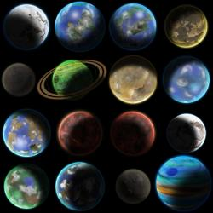

Planet sprites from opengameart.org. User: [Viktor.Hahn@web.de](mailto:Viktor.Hahn@web.de)

Enemy ship sprites:

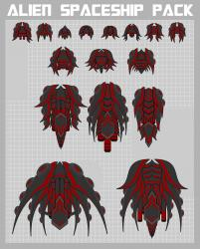

Ship sprites from opengameart.org. User: pzUH

Player/enemy ship sprites:



Ship sprites from opengameart.org. User: Jull