

XXXXXX

Project Report

4/10/18

4/18/18

Todd Wenker

Table of Contents

1 Introduction 1

1.1 Purpose 1

1.2 Tasks Identified 1

1.3 Assumptions 1

2 Analysis 1

2.1 Personas 1

2.2 Task Analysis Tools 1

2.3 Task #1 2

2.3.1 Task Detail #1 2

2.3.2 Task #1 Analysis 2

2.3.3 Task #1 Discussion 2

2.4 Task #2 2

2.4.1 Task Detail #2 2

2.4.2 Task #2 Analysis 2

2.4.3 Task #2 Discussion 2

3 Prototype and Design 2

3.1 Overview of Prototype and Design Features 2

3.2 Task #1 2

3.2.1 Task #1 Design 2

3.2.2 Task #1 Design Justifications 3

3.2.3 Task #1 Prototype 3

3.2.4 Task #1 Prototype Rational 3

3.3 Task #2 3

3.3.1 Task #1 Design 3

3.3.2 Task #1 Design Justifications 4

3.3.3 Task #1 Prototype 4

3.3.4 Task #1 Prototype Rational 5

4 A/B Testing 5

4.1 Participants 5

4.2 Scenarios 6

4.3 Equipment 7

4.4 Subjective Metrics 7

4.5 Quantitative Metrics 7

4.6 Test results 7

5 Conclusions 9

5.1 Discussion of Results 9

5.2 Lessons Learned 9

5.3 Conclusion 9

6 Appendixes 10

6.1 Heuristic Evaluation 10

6.2 Cognitive Walk-through 10

6.3 New GUI snapshots 11

6.4 Instructions for participants 12

6.5 Researcher guidelines 13

6.6 Background questionnaire 13

6.7 Post-session questionnaire 13

6.8 Dropbox Link 13

# Introduction

## Purpose

The goal of this project is to improve the website of KaleidoscopeJuice.com. This website allows users to order juice cleanses, which are a set of juices that the customer consumes exclusively over the course of a day. The guiding questions were how easy could the user find the correct information they are looking for and how easily can order juices that meet specific qualifications. The focus was to improve the user's experience when it came to ordering a custom cleanse. This will require the user to be able to view the descriptions and ingredients of specific juices while they are in the process of designing their cleanse and have the route to order page be more direct.

## Tasks Identified

The task of this project is trying to order a specific set of juices as easily and effectively as possible. This means that the user must be able to view the juice descriptions and ingredients while they are ordering and make it easy to navigate to the page needed to order.

## Assumptions

In case the website changed its format in between the start of the project and the actual testing phase, a mock up of the original site was made. The assumption is that being made is that the results gathered with the mock up will be applicable to the real site.

# Analysis

## Personas

1. Jessica: Someone new to cleanses and is interested in learning about them. Does not have specific goals or ideas in mind. Wants an easy way to evaluate different juices.
2. Justine: Experienced in doing cleanses. She wants a way to design her own cleanses to fulfill her specific needs. Has a set idea of what she wants.
3. Jim: Just wants to buy tasty juice. Not interested in health benefits or anything. Wants to quickly browse and order juice.

## Task Analysis Tools

To analyze the control website, a heuristic evaluation (appendix: 6.1) and a cognitive walkthrough (appendix: 6.2) were performed. Both of these studies noticed that KaleidoscopeJuice.com's webpage had two major problems in that the path to get to juice cleanse ordering page was not clear as there was no direct route from the 'Juice' page to the page where said juices could actually be ordered. The second was that the ordering page did not have the juice's description on it, meaning that the user would have to leave the ordering page and go to the 'Juice' page to review the juices before heading back to the order page to make an order.

## Task #1

### Task Detail #1

The old webpage has a major navigation issue when it comes to ordering juice. The site's tool bar as a 'Juice' entry, which contains a list and description of all the various juices, and a 'Cleanse' entry, which as two pre-designed cleanses and a 'Build Your Own Cleanse' option for the user to order. However, the 'Juice' page has no direct way to get to the 'Cleanse' section.

### Task #1 Analysis

During the cognitive walkthrough, the user's natural choice when they want to order juice is head to the 'juice' page. However, as this page lacks the ability to actually order juice, this is the wrong choice. The heuristic evaluation found this problem as well.

### Task #1 Discussion

The lack of clear cut route to order is flaw in the original website.

## Task #2

### Task Detail #2

The current website lacks the ability to view the juice descriptions and ingredients before actually ordering them.

### Task #2 Analysis

The heuristic evaluation found that ordering a custom cleanse is needlessly difficult. The page where the user designs the cleanse lacks any description for the user to make a decision. As such, the user is forced to back out of this page and head to the 'Juice' page, decide what they want their cleanse to contain, and head back to the page to actually order it.

### Task #2 Discussion

The page where the user designs their custom cleanse needs to provide the user with all the information they need to make that decision.

# Prototype and Design

## Overview of Prototype and Design Features

The prototype has only redesigned sections that pertain to the ordering of a custom juice cleanse. The focus was to make a site that quickly directed users to the page needed to order and to give them the information needed so they could quickly design a custom cleanse that met the specific needs of the user.

## Task #1

### Task #1 Design

The first design is focused on getting the user to the order page in a direct manner. The original website has a 'Juice' and 'Cleanse' entry on the toolbar. The new design combines these two items into just 'Juice Cleanse'. This takes them a page that provides them with a short description of how they make their juice. On this page is a button that brings them to the page where they select their cleanse (Original, Advance, or Custom). Selecting the 'Custom' one will bring them to the page where they can design their own cleanse. (The first two images from Appendix: 6.3)

### Task #1 Design Justifications

This new design will satisfy the flaws found in the heuristic evaluation and the cognitive walkthrough. It also provides the users an unambiguous path to the information they are looking for.

### Task #1 Prototype

The original website toolbar:



The new website toolbar:



The original version has both Juice and Cleanse entry. The new one combines them so users do not have to go back and forth. The new site has a way to travel straight to the order page while the old one does not.

### Task #1 Prototype Rational

Combining the Juice and Cleanse entries means that there is no ambiguity when the user is trying to order a cleanse.

## Task #2

### Task #1 Design

The second change was to fix the separation between juice information and the juice ordering page. In the original design, the user uses a sequence of drop-down menus that only contain the name and the category type of the juice. The updated version provides the user with a way to iterate through the four categories and view the different juices in them while still on the page that the user orders from.

### Task #1 Design Justifications

The major flaw found in the heuristic evaluation was the disconnect between the juice information and the page where the user creates their order. By giving the user the ability to browse the juices as they design their order, this flaw will be fixed.

### Task #1 Prototype

The old design using drop downs to select juice and lacking any in depth information:

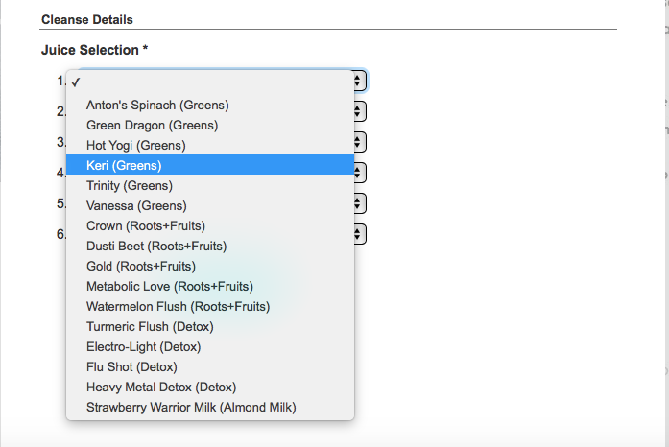

The new design:

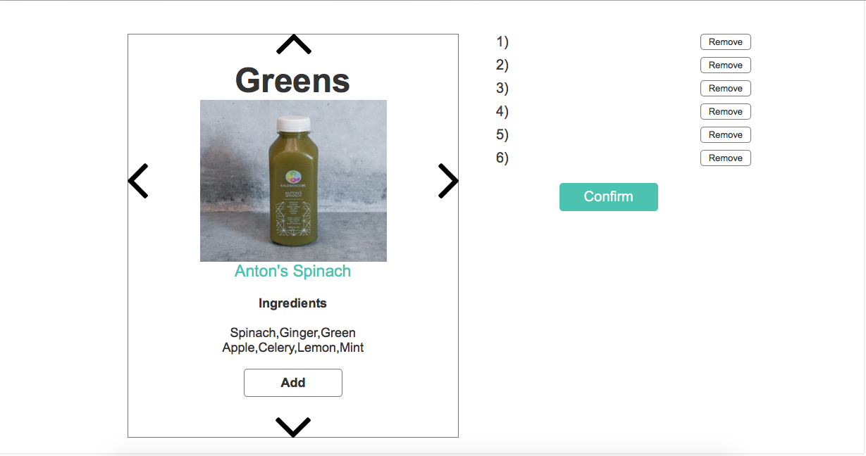

The left and right buttons iterate through juices in the same category while the up and down arrows change the type of category. This page is how the user builds their cleanse with the confirm button sending them to the shopping cart page for them to checkout or keep shopping.

### Task #1 Prototype Rational

The prototype design has all the juice descriptions in a tight package and provides the user the easy ability to cycle through the juices.

# A/B Testing

## Participants

The testing was done with a total of 10 participants, selected from among my family, friends, and classmates based on convenience. They were then split evenly between the A and B tests. Before the test, they were given a questionnaire (Appendix: 6.6). The results were as follows:

Test A Participants:

|  |  |  |  |
| --- | --- | --- | --- |
| Participant\Question | Age | Gender | Comfort with online shopping |
| 1 | 56 | M | Very |
| 2 | 20 | F | Moderate |
| 3 | 20 | F | Very |
| 4 | 26 | M | Very |
| 5 | 21 | M | Very |

Test B Participants:

|  |  |  |  |
| --- | --- | --- | --- |
| Participant\Question | Age | Gender | Comfort with online shopping |
| 1 | 54 | F | Moderate |
| 2 | 26 | M | Very |
| 3 | 21 | F | Moderate |
| 4 | 24 | M | Very |
| 5 | 21 | M | Moderate |

## Scenarios

The scenario given to the participants was to use the website in front of them (either the control A site or the experimental B site) and order a set of juices that contain a specific set of ingredients. The subject was given a seat in front of a laptop with the webpage open and with a wireless mouse to use. The instructions were read to them by the researcher before handing them a written copy (Appendix: 6.4), along with a piece of scratch paper and a pencil. The subjects were then given a countdown to when they could start and the timer would begin. When the subject reached the checkout page, the timer was stopped.

Researcher Guidelines:

First, the researcher will set the subject in front of the laptop with the webpage they will be using on the Safari browser. They will then read the instructions (Appendix:6.4) before handing them the copy. The research will then tell the subject to get ready before starting the screen capture and the timer on the stopwatch. The researcher will not engage with the subjects unless they were breaking the rules (This only happened once when a subject misunderstood the instructions and was going to checkout without ordering the correct juices). When the the user finishes the task, the timer is stopped and the subject is given the post-session questionnaire (Appendix: 6.6). The subject is then queried about their thoughts on the website.

## Equipment

The test were run with the following equipment:

* 13-inch Macbook Pro
* Safari web browser to display the webpages
* built-in stopwatch application on an iPhone 6s
* a Microsoft brand wireless mouse
* a pen and paper to record subject information and provide written instructions
* a scratch pad and pencil for the subjects to use during the test
* Quicktime Player application to record the screen while the subject took went through the task

## Subjective Metrics

The subjects were given a background questionnaire (Appendix: 6.6) that polled their age, gender and comfort with online shopping. After taking the test, were asked their opinions on the site if they had any.

## Quantitative Metrics

There were four metrics captured from the tests. The first was the time it took the user to reach the end of the site, captured with a stopwatch. The other three, ease of navigation, ease of ordering, and lack of annoyance were collected using a post-session questionnaire (Appendix: 6.7) and are on a one to five scale. The goal of the experiment is to create a site that delivers a more satisfying user experience by being faster, more efficient, and less of a hassle.

## Test results

Qualitative Results

Test A (Control):

|  |  |  |  |  |
| --- | --- | --- | --- | --- |
| Participant\Metric | Time(minutes) | Ease of Navigation(1-5 scale) | Ease of Ordering(1-5 scale) | Lack of Annoyance(1-5 scale) |
| 1 | 9.4 | 2 | 4 | 2 |
| 2 | 11.317 | 2 | 4 | 2 |
| 3 | 6.867 | 4 | 5 | 4 |
| 4 | 6.267 | 4 | 3 | 2 |
| 5 | 4.45 | 3 | 2 | 3 |

Test B (Experimental):

|  |  |  |  |  |
| --- | --- | --- | --- | --- |
| Participant\Metric | Time(minutes) | Ease of Navigation(1-5 scale) | Ease of Ordering(1-5 scale) | Lack of Annoyance(1-5 scale) |
| 1 | 5.467 | 3 | 3 | 3 |
| 2 | 6.183 | 2.5 | 3 | 2 |
| 3 | 3.15 | 3 | 5 | 4 |
| 4 | 3.5 | 3 | 3 | 4 |
| 5 | 3.717 | 3 | 4 | 3 |

Results of an independent sample t-test, two-tailed and with an alpha of .05:

Null hypothesis: the mean of Group A = the mean of Group B

Alternative hypothesis: the mean of Group A != the mean of Group B

Time:

Mean time of Group A = 7.6602

Mean time of Group B = 4.4034

t = 2.41, p = .042305 < .05

As such, we can reject the null hypothesis and accept the alternative hypothesis. These findings are statistically significant.

Ease of Navigation:

Mean value of Group A = 3

Mean value of Group B = 2.9

t = .22, p = .832723 > .05

As such, we cannot reject the null hypothesis. These findings are not statistically significant.

Ease of Ordering:

Mean value of Group A = 3.6

Mean value of Group B = 3.6

t = 0, p = 1 > .05

We cannot reject the null hypothesis. These findings are not statistically significant.

Lack of Annoyance:

Mean value of Group A = 2.6

Mean value of Group B = 3.2

t = -1.09545, p = .305201 > .05

We cannot reject the null hypothesis. These findings are not statistically significant.

Subjective Results

Group A: Every member of Group A expressed an annoyance at having to go to a different page to view the descriptions of juices while they were trying to order.

Group B: Three out of five participants stated that they wanted a way to go straight to the order page from the homepage to speed things up.

# Conclusions

## Discussion of Results

After testing was done, the inferential statistics showed that the new site too less time to use, although the three other metrics, ease of navigation, ease of ordering, and lack of annoyance, showed to statistically significant difference between the two sites. Ultimately, the subjects using the new site were still not entirely satisfied with it. Some of them expressed a desire to be able to go straight to the cleanse order page straight from the homepage instead of having to move through a multiple pages. The new site's selection worked well as users were able to quickly view the selection of juices but the ability to view all of the juices at once in a large pane may have been faster than manually scrolling through them. Failing to find a statistically significant difference in regards to post-session questionnaire questions was also a surprise as I considered the new website to be much better than the old one.

## Lessons Learned

This project focused mostly on the disconnect between ordering a product without there being a description at the ready for the user to see and consider before finalizing the order. Making the site easier to navigate would have helped users to get to where they needed to go quicker. The lack of progress in regards to the post-session questionnaire criteria shows just how important it is to test these things on real people. In my mind, I considered the new site to be far superior in these metrics to the old site and yet the test subjects thought otherwise.

## Conclusion

Using statistical inference, the newly designed site was shown to be faster than the old one. However, the site could still be improved in multiple ways. A way to get straight to ordering from the front page would be a good first step. A login system that allows users to save sets of juices they like for cleanses would also be helpful for returning users to reorder cleanses they already have had.

# Appendixes

## Heuristic Evaluation

KaleidoscopeJuice.com scored an 86 out of 100 on the Usability Review Template, making in fairly good overall. The web design has a good color palate with a good use of space and applicable images. The score was dropped due to two major flaws. The first is that the page that lists what juice the company has to offer does not have an immediate way to order said juice. Instead, the user has to navigate to the cleanses page before they can actually order juice. This flaw means that users will waste their time on the juice page before realizing that they need to go to a different page to order. The second flaw is that when the user is actually ordering juice, there are no descriptions on the page to guide them. Instead, they need to travel back to the juice page, decide which ones they want, go back to the order page, and then enter what juice they want. Without having descriptions alongside the order page, users have nothing to guide them as they make their order and may be forced to waste time going back and forth. Both of these issues would be solved by having the juice descriptions on the same page when the user is ordering.

## Cognitive Walk-through

Cognitive Walkthrough:

Task: Order a set of six juices from KaleidoscopeJuice.com

1. Navigate to the Choose Your Cleanse page.
   1. No. The natural selection is to pick the Juices page but you cannot actually order juice from this page.
   2. Yes. Although it will take some time.
   3. No. Selecting cleanses instead of juices is the natural choice.
   4. Yes.
2. Choose the Build Your Cleanse selection.
   1. Yes.
   2. Yes.
   3. Yes.
   4. Yes.
3. Select the juices desired for the cleanse.
   1. Yes.
   2. Yes.
   3. Yes.
   4. Yes.
4. Checkout
   1. Yes.
   2. Yes.
   3. Yes.
   4. Yes.

## New GUI snapshots



The new toolbar.

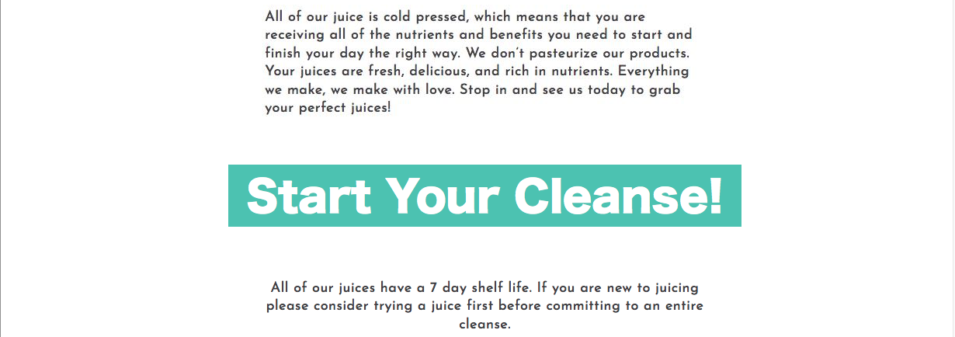The button connecting the user from the juice page to the cleanse ordering page.

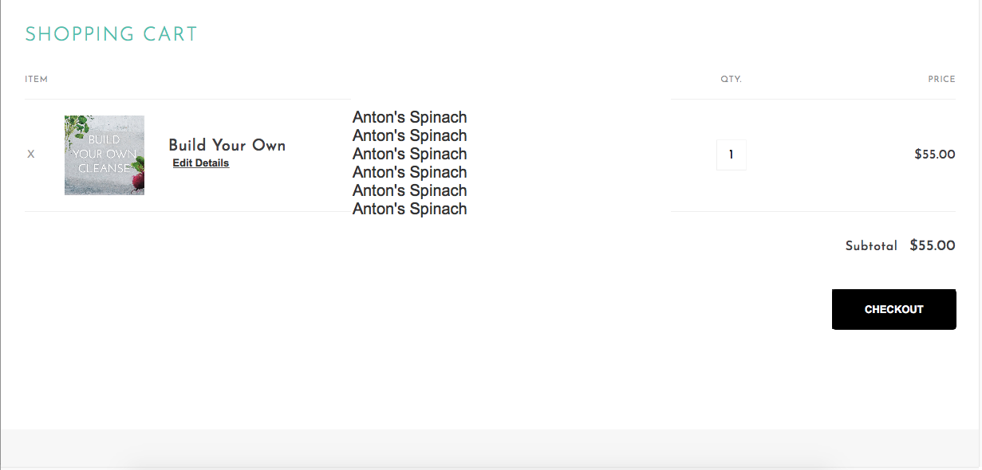The shopping cart that lists the juices included in the designed cleanse.



The new method for selecting juices in a custom cleanse.

## Instructions for participants

The following instructions were given to the participants on a piece of paper so they could refer back to it during the test:

Your task is to use the website in front of you to order a custom one-day cleanse. A one-day cleanse is a collection of six juices. The juices need to have these ingredients respectively:

1. Kale, Parsley, Cucumber, Celery, Green Apple, and Mint.
2. Spinach, Parsley, Celery, Cucumber, Lemon, and Mint.
3. Beet, Spinach, Celery, Green Apple, Lemon, and Ginger.
4. Watermelon, Lemon, and Mint.
5. Cilantro, Parsley, Chlorophyll, Lemon, and Ginger.
6. Almonds, Protein Powder, Strawberries, Stevia, and Water.

The order does not need to be exact.

## Researcher guidelines

First, the researcher will set the subject in front of the laptop with the webpage they will be using on the Safari browser. They will then read the instructions (Appendix:6.4) before handing them the copy. The research will then tell the subject to get ready before starting the screen capture and the timer on the stopwatch. The researcher will not engage with the subjects unless they were breaking the rules (This only happened once when a subject misunderstood the instructions and was going to checkout without ordering the correct juices). When the the user finishes the task, the timer is stopped and the subject is given the post-session questionnaire (Appendix: 6.6). The subject is then queried about their thoughts on the website.

## Background questionnaire

Age:

Gender:

Comfort with online shopping? None, moderate, very.

## Post-session questionnaire

The following questions were scored on a scale of 1 to 5, with 1 being strongly disagree and 5 being strongly agree:

1. The website was easy to navigate.
2. It was easy to order on the website.
3. The website was not annoying to use.

## Dropbox Link

Link contains a folder with screen recordings of participants, the time and post-session questionnaire data, and the heuristic evaluation in full.

Dropbox link: https://www.dropbox.com/sh/jdig889frsfjgi1/AAB7pzxafFvO6HIHlurKvS2za?dl=0