Advanced Natural Language Processing
Assignment 1

1 Zipf's law:

Zipf's law says that a text corpus there are a few words that appear very frequently and many words that only have a medium or low frequency. Mathematically this can be described as
c = f_{w}*r
C is a constant f_{w} is the relative frequency for word w and r is the rank of the word.

Ordering words by occurrence count in the 4 given documents, one can see that Zipf's law holds true across documents and languages (english, bulgarian, turkish). In a linear plot the occurrence count drops exponentially with growing rank for all documents. The loglog plot on the other hand is, although not perfect, close to a straight line.

On the following pages you can see the plots and a listing for the top 10 words for each corpus.

I observed that for the King James Bible and the bulgarian SE Times the average c is way off the c for the first 10 examples. For the turkish SE Times and the jungle book this is not the case. The average c for those two corpora is closer to the c for the first 10 examples. Having a look at the loglog plots of the first two corpora I noticed that the slope starts off declining slowly but drops faster at higher ranks. For the latter two corpora the slope at the start stays more or less the same through the ranks.

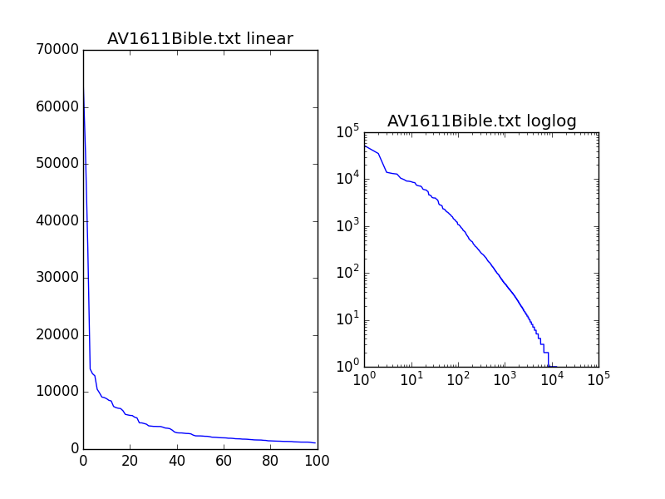

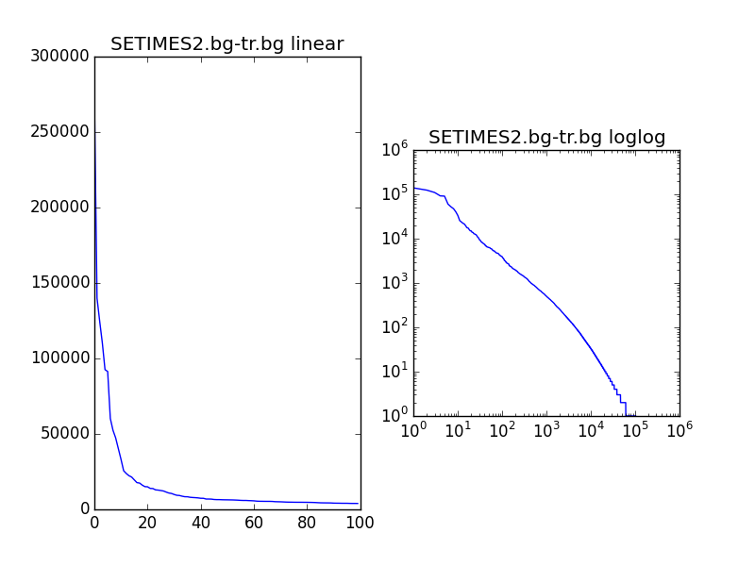

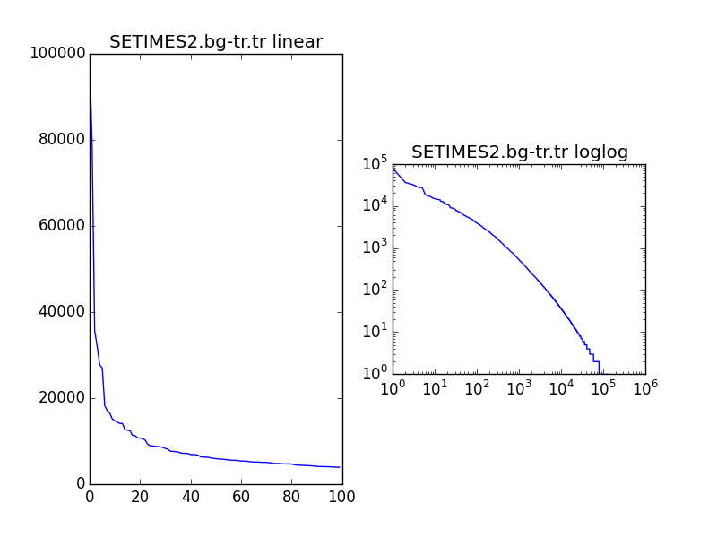

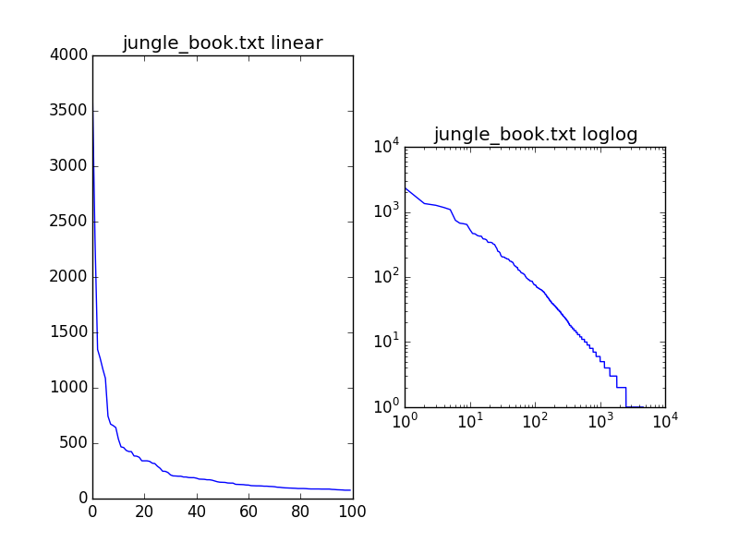

2 Random Text Generation

I used the King James Bible to train bi-gram, tri-gram and quad-gram models to generate the following texts from those:

bi-grams:

sons of Egypt died: of meat from the people fall, and commander charged them, his favour to my son, at her, saying, even of bondage; therefore hear his deeds were about upon the LORD God? 12 1 These are God's. 22 And whatsoever thing that side and upright on against the things concerning Moab, whereas ye out my Lord GOD. 15 Of the son of the burnt offerings were a desolation, and came to Tarshish, Get you plainly of the King Agrippa, even to Rebekah, and will I have

tri-grams:

the Son of man trouble them any more. 6 Sigh therefore, that possesseth an inheritance unto the house? And he arose, and that were with the oil tree; 18 The pins of the LORD that hath caused me to do service in the night, and to him saluted him. 16 These things spake Jesus to their transgressions: her strong rods were broken and cease, whilst that I spake unto them, and shall sing aloud upon their business: but give you flesh, and the glorious appearing of Jesus might be destroyed from remaining in

quad-grams:

Philippi by Stephanas, and Fortunatus, and Achaicus, and Timotheus. THE SECOND EPISTLE GENERAL OF PETER CHAPTER 1 1 Simon Peter, and James, and Joses, and the name of the first year for a sin offering. 23 And he shall put off their broidered garments: they shall possess it: ye shall pass before them, to frustrate their purpose, all the flock, and burn incense unto Baal, and Nadab, 31 And said, Whose daughter art thou? And I said unto you, saying, May we know what we worship:

To me it seems that the quality of the grammar and of the semantics rises with larger n. For example, this passage from the bigrams is quite confusing: “And whatsoever thing that side and upright on against the things concerning Moab [...]”, whereas the quad-grams in general generated results closer to real language: “ye shall pass before them”.
On the other hand the creativity will decline with a raising n. With the quad-grams the sentences are combinations of existing phrases from the bible. Going up to say 10 or 100 grams such a system will be more likely to just recombine existing sentences, paragraphs. This in turn does not necessarily create new meaningful stories.

3 Statistical Dependence

