吉林大学本科毕业设计（论文）外文文献翻译

|  |  |  |  |  |  |  |
| --- | --- | --- | --- | --- | --- | --- |
| 学 院 | 计算机科学与技术学院 | | | | 专业 | 计算机科学与技术 |
| 学生姓名 | 孟政元 | | | | 学号 | **21140821** |
| 指导教师 | 王康平 | | | | 职称 | **讲师** |
| 合作导师 |  | | 职称 |  | 单位 | 计算智能 |
| 设计（论文）题目 | | 网易云音乐用户数据的分析和可视化技术研究与实现 | | | | |
| 外文文献翻译（翻译字数不少于3000字）  **基于D3.js的大数据可视化框架**  Fan Bao  Dalian Maritime University  Dalian, China  [310311901@qq.com](mailto:310311901@qq.com)  Jia Chen  Dalian Maritime University  Dalian, China  chen j ia8080@sina.com  **摘要:**  数据仓库，云计算和大数据的概念已经在数据洪水时代提出。 通过回顾数据仓库研究当前的进展，本文介绍了一个框架，以实现更好的大数据可视化。 该框架可以通过将数据分为子数据集并分别对其进行可视化来降低构建大数据仓库的成本。 同时，基于D3.js强大的可视化工具，以全零件原理为导向，可以通过丰富的统计图形向不同维度的用户展示当前数据。  关键词：组件;D3.js;可视化; 数据仓库 简介 数据仓库，云计算和大数据在最近二十年中已经提出。在大数据背景下，数据仓库已成为研究领域的热门话题。典型的数据仓库使用不同的数据源通过ETL过程将数据转换为数据仓库。它将使用OLAP服务在最后实现数据转换和分析[1]。但是，使用这种方式来移动和整合数据非常昂贵。当我们构建数据仓库时，硬件的高需求不容忽视。数据仓库的主要目的是执行数据分析和需求分析。数据仓库存储各种原始数据。数据将被计算，加载，然后（如有必要）进行分析。数据仓库的计算速度有限。它会消耗资源的数量。如果需要再次分析，将重复计算不同的数据源。如果可以在数据源的服务器中分别计算和计算这个计算值，那么通过使用数据访问接口将有助于减少重复计算大量数据的开销。本文介绍了大数据的数据可视化框架，并使用Web可视化展示工具-D3.js实现统计图形化。也许这样可以降低构建大型数据仓库的总成本。基于这个想法“首先给出一个合适的尺寸，正确筛选的总结，然后显示所需的细节”，交互式可视化图形将从不同的维度分析中显示出来。在本文中，交互式可视化图形将通过书籍类别维度，时间维度和其他维度来演示。 II. 基本概念 **A. D3.js**  D3.js是一个基于数据处理文档的JavaScript库[2]。 它通过数据加载，数据绑定，分析转换元素和过量元素实现可视化展示。 与Excel不同的是，d3为用户提供了一个自定义的映射规则。 根据需要，用户可以确定图形的映射值，如显示颜色，大小。 D3不支持旧版本的浏览器，所以它可以使d3代码变得干净。 D3通过Web上的CSS3，超文本标记语言和可缩放矢量图形显示图形。 D3目前是最新版本3.4.4。  D3很擅长处理SVG，这是World Wide Web Consortium规范  指定的网络矢量图形标准[3]。 SVG严格遵守XML语法并使用文本格式的描述语言来描述图像内容。 它是一种独立于分辨率的矢量和图像格式[4]。 使用SVG实现视觉正在成为一种新趋势。  **B. 数据仓库**  数据仓库是一个面向主题，集成，时间特征和稳定的数据收集点，以支持流程中的管理决策[5]。 数据仓库中的数据量非常大，人们可以从不同的维度（即事务观察角度）查看数据。 数据仓库正在使用多维数据模型来存储数据。 多维数据模型包括维度表，事实表等。 维度表用于指导事实表中不同角度的数据选择。 在多维数据模型中，用户可以从不同的维度在事实表中找到所需的数据。 可视化工具将帮助人们组织和显示数据。  **C. 数据可视化**  数据可视化技术的基本思想是将每个数据项的数据库作为单个像素元素表示，然后大量数据集构成数据图像[6]。同时利用多维数据来表示数据的每个属性值，可以从不同维度观察数据，并进行更深入的观察和分析。数据可视化的主要目的是通过使用图形工具传达信息并清晰有效地进行通信。由于数据的程度不同，数据可视化必须实现缩放功能。同时，用户可以使用动态响应图形[7]浏览或具体了解数据集的相关知识。用于数据可视化的标准Web技术允许通过使用较新版本的浏览器查看不同操作系统上的统计信息的用户。  目前，可视化技术在Web前端具有JavaScript，Flash，Java Applet等。根据不同的需求，人们可以选择合适的需求开发工具。例如，要生成一个简单的图表，Data Wrapper不是一个不错的选择。地图的映射可以使用Kartofraph。由于JavaScript不需要任何插件，用户体验更好，所以我选择了JavaScript。 III. 可视化分析框架 在大数据背景下，笔者提出了一种数据可视化数据的请求方法，如下所示，通过对数据仓库成本和构造的研究和分析。 如图1所示。    Figure 1. visual framework  每个数据源可以是图1中的一个小型数据仓库。它们的主题设置情况相同。 每个数据源都可以根据需求进行可视化和统计。 在统计总量时，人们会首先提出需求。 然后每个数据源根据需求计算统计数据并提供访问界面。 最后，数据将被返回并汇总并显示在浏览器中并存储在数据仓库中。 这样可以降低建立大型数据仓库的成本。 通过界面，原始数据值也可以被隐藏。 所以数据和用户之间是透明的，不像d3那样透明。 基于这个想法，可以实现数据计算和可视化的数据源。 IV. 用D3实现数据可视化 目前，有各种各样的行业销售数据。 数据庞大而复杂。 单一，静态的传统“面向导向”视觉展示已经无法满足商业决策者的需求。 通过对数据仓库维度的思考，图书销售数据的交互图将从书籍类别维度和时间维度中显示出来。 这些结果将帮助管理人员找到图书销售法律并适应当前的市场需求。  通过使用D3.js，可以很好地实现数据可视化并使用直观的矢量来替换传统的表单。 本文基于图书销售数据，通过选择不同的统计维度，使用饼图显示整体概况，条形图显示每个维度下的具体销售情况。  **A.** **方案设计**  在数据存储设计期间，数据分为书类分类和时间分类。 图书销售表包含销售编码，图书类别，图书子类，图书名称，价格和销售时间六个字段。 我们为书籍类别和书籍子类设计了分类代码表。 对于D3.js而言，这是一个重要的想法，并不是隐藏原始数据。 当页面被加载时，它会将书籍销售所需的所有数据推送给客户端，并筛选和集成用户选择的数据库。 无需每次选择都发送请求，这可以减轻服务器的负担。 销售数据表的结构如表3所示  TABLE I THE TABLE OF SALES DATA   |  |  |  |  | | --- | --- | --- | --- | | **Field name** | **Type Length** | **Field** | **Description** | | Order_no |  | int | Order Number | | Sub_no |  | int | Categories Number | | Book_name | 50 | varchar | Book name | | sales |  | float | Selling price | | time |  | datetime | Sales of the time |   通过“sub_no”，我们可以在代码表和事实表之间进行连接，以确定书籍的类别。 图2所示的具体流程：    Figure 2. visual processing B. 具体实现和数据展示 当数据传输到前端时，我们在C＃中创建一个.ashx文件，使用List（T）类访问销售数据，并通过JavaScriptSerializer方法将数据转换为JSON，然后通过Ajax请求获取 所有销售表事实数据。 首先，创建BookSales类，包括Book _cat，Sub_cat，Book_name，Sales和S时间字段。 在从数据库中获得图书销售数据的事实后，我们创建一个listList list = new List（SalesJength）;  我们可以调用ToJson（list）函数将变量列表转换为JSON格式，并将其传递到首页。  **public string ToJson (object 0)**  **{**  **JavaScriptSerializer servializer JavaScriptSerializer 0;**  **return servializer. Serialize (0);**  **}**  通过以下代码，您可以在前端获得图书销售信息：  **$(document).ready (function()**  **{**  **$.post ("request.ashx", function (data)**  **{**  **Sjson=eval ("(" + data + ")");**  **} );**  **});**  在前端，在使用D3.js之前，我们应该添加一个像这样的引用：<script src =“/ js / D3.js”> </ script>  当我们在书籍类别和年份进行分析时，我们使用饼图来显示主要类别中的总销售额百分比。  首先，我们需要根据类别对数据进行排序，并将数据组织为“分层模型”结构，其中包含根类别，末尾为“结束”。  然后为每个馅饼事件添加一个侦听器，页面将根据用户的需求通过条形图显示所选类别的详细信息。当有组织的数据传输到sequence.js进行可视化显示时，它还应该传输细节数据，以便实现对派的细节。  在这篇文章中，BookCatg和Years都使用饼图的方式来显示条形图。  例如，当点击书籍类别以查看时，实现代码和效果如下所示，并且其中分类1 c1assifY2可以被复用到不同的类别。  **aryjs = 0;**  **var m = "Book_catg";**  **jsonsort(m);f**  **for (var i = 0; i < 1; i++) {**  **f += parseInt(Sjson. Data[i].Sales);**  **if (i + 1 < I) {**  **sl = Sjson. data[i].Book _ catg;**  **s2 = Sjson.data[i + l].Book_catg;**  **c1assiJYl (f, sl, s2);**  **} else if (i+ 1==1) {**  **}**  **s 1 = Sj son.data[i] .Book _ catg;**  **s2 = Sjson.data[i - l].Book_catg;**  **c1assiJY2(f, i, s I, s2);**  **else{ json_txt += '{ "A":'"**  **+Sjson.data[i].Book_catg +'-'+'end'+ '" , "B":'" + f + '" } ]}';}**  **} Ilfor**  Results shown in Figure3:  在图1中，当选择BookCatg类并将鼠标放在每种不同颜色上时，我们可以看到“商业与金钱”一书在左上角占总销售额的46.8％。点击颜色，你 会得到如下所示的条形图。 它记录了每本图书在“商业与金钱”类别下的具体销售额。当鼠标悬停在酒吧上方时，您会看到它属于“商业与金钱”类别下的经济学。 结果如图4所示：    Figure 4. Result after clicking  当我们选择月份进行分析时，将根据年份安排前端数据，然后每年的月度数据进行统计分析，以不同颜色显示的月份年销售额的不同方式进行散点图，如图所示 图5：    Figure 5. Result of month  如上所示，不同的年份将用不同的颜色来描述。 用户可以直观地比较当月的不同销售额，并且我们可以看到每年的销售额波动。 如通过2014年的地图[2,443]，你可以知道2014年2月的销售额是443美元。  最后，查看详细的总体类别可以从总销售额的每个比例中分别查看，如图6所示：    Figure 6. View of overall  当我们从导航栏中的图中看到，这本书被命名为“Proof of Heaven”，销售额占总数的0.460％。  通过分析不同的维度，用户可以从不同角度查看图书销售额和收入。 基于50种图形显示和销售趋势，它可以帮助管理人员优化销售管理并提高销售额。 V. 总结 数据统计方法多种多样。用户可以选择他们自己的视觉展示方法逐一进行。原因  为什么提出的视觉框架主要基于选择  原因如下：  1. D3.js是一个JavaScript库。在使用D3.js时可视化，他可以直接升级到更新的浏览器版本而不是首先安装插件。  2. D3.js用于生成解释数据。用户可以通过提取的一些规则传达重要信息数据从数据视图。  3.图形的优点是显示统计数据根据需求从整体到细节。因此，这图形将交互式可视化。  4.使用SVG图形将不允许图形细节视图放大和扭曲。虽然原始数据不会被D3.js隐藏，但是方法，使用拟议框架的文本来实现半透明的数据，不仅可以使其更容易用户统计数据，同时也减少了资源和成本构建大型数据仓库。这个数据可视化，数据挖掘和框架的框架统计方法不全面，可能不符合用户的所有需求。但是，基于这个想法文章，用户可以根据他的建立框架需求然后制定视觉约束，选择不同的数据维度到统计数据。 参考文献 [I] M. Schneider, "A general model for the design of data warehouses,"  Int. J. Production Economics, Vol. 112, pp.309-325, 2008. (Pubitemid  351179609)  [2] http//d3js.org/, retrieved on May 13th, 2014.  [3] Scott Murray, Interactive Data Visualization for the Web, United  States of America, 2010 [11].  [4] Dailey D,Frost J,Strazzullo D.Building Web Applications with  SVG[MlMicrosoft Press,2012.  [5] Prat N, Comyn-Wattiau I, Akoka J. Combining objects with rules to  represent aggregation knowledge in data warehouse and OLAP  systems. Data & Knowledge Engineering, 2011, 70(8) 732-752.  [6] Keim, Daniel A. "Information visualization and visual data mining."  Visualization and Computer Graphics, IEEE Transactions on 8.1  (2002) 1-8  [7] Zhao Vue, Chen Zhiwei,Cai Shuhui,et al.Dynamic Web  Visualization of Large Scientific Computing Data. Modern Computer,  2012(5)3-6 | | | | | | |

**注：**1.专业一定要填写全称。[专业名称：计算机科学与技术、计算机科学与技术（网络与信息安全）、物联网工程、理科试验班（唐敖庆计算机班）]

2.附外文文献。

**Visual framework for big data in d3.js**

Fan Bao

Dalian Maritime University

Dalian, China

[310311901@qq.com](mailto:310311901@qq.com)

Jia Chen

Dalian Maritime University

Dalian, China

chen j ia8080@sina.com

**Abstract:**

The concepts of Data Warehouse, Cloud Computing and Big Data have been proposed during the era of data flood. By reviewing current progresses in data warehouse studies, this paper introduces a framework to achieve better visualization for Big Data. This framework can reduce the cost of building Big Data warehouses by divide data into sub dataset and visualize them respectively. Meanwhile, basing on the powerful visualization tool of D3.js and directed by the principle of Whole-Parts, current data can be presented to users from different dimensions by different rich statistics graphics.

Keywords-component; D3.js; Visualization; Data Warehouse

## INTRODUCTION

Data Warehouse, Cloud Computing, and Big Data have proposed within latest two decades. In the background of the Big Data, the data warehouse has become a hot topic in the research area. A typical data warehouse uses different data source to transform the data into a data warehouse through the process of ETL. And it will use OLAP services to achieve the data conversion and analyze at the last [1]. However, using this way to move and consolidate data is expensive. The high-demand of hardware cannot be ignored when we build a data warehouse. The main purpose of the data warehouse is to perform data analysis and requirements analysis. The data warehouse stores all kinds of raw data. The data will be calculated, loaded and then (if necessary) come the analysis. The calculating velocity of data warehouse is limited. It will consume with the number of resources. And calculating different data sources would be repeated if needed analysis again. If this calculation can be broken down and computed respectively in the data source's server, it will help to reduce the overhead of double counting huge data by using a data access interface. This article introduces a data's visual framework for Big Data and uses the Web visual presentation tool- D3.js to achieve statistics graphical. Maybe this way can reduce the total cost of constructing a large data warehouse. Based on this idea"First give a right size, properly screened summary, and then display the details needed", interactive visualization graphics will be shown from a different dimension analysis. In the paper, interactive visualization graphics will be demonstrated by the book category dimension, time dimension and other dimensions.

## II. BASIC CONCEPTS

**A. D3.js**

D3.js is a JavaScript library for manipulating documents based on data [2]. It achieves visualization show by data loading, data binding, analytic transformation elements and excessive element. It is different with Excel, d3 to provide users with a customized mapping rule. According to the needs, users can determine the mapping values to the graphic, such as display color, size. D3 does not support older versions of the browser, so it can make the d3 code clean. D3 is displayed graphical by using CSS3, Hyper Text Markup Language and Scalable Vector Graphics on the Web. D3 is currently the latest version 3.4.4.

D3 is a good at dealing with SVG, which is the World Wide Web Consortium specification

specified network vector graphics standard [3]. SVG strict observes XML syntax and use text format's description language to describe the image content. It is a resolution-independent vector and image graphics format [4]. Using SVG to achieve the visual is becoming a new trend.

**B. Data Warehouse**

A data warehouse is a subject-oriented, integrated, timecharacterized and stable point of data collection to support management decision-making in the process [5]. The amount of data in data warehouse is very large, People can be from different dimensions (i.e., the angle of observation of the transaction) to view the data. Data warehouse is using multidimensional data model to storage data. Multidimensional data model includes dimension tables, fact tables and so on. Dimensional table is used to guide the selection of data from different angles in the fact table. In the multidimensional data model, the user can find the required data in the fact table from different dimensions. Visualization tools will help people organize and display data.

**C. Data visualization**

The basic idea of data visualization technology is the database for each data item as a single pixel element represents, then a large number of data sets constitute image of data [6]. Meanwhile using multi-dimensional data to represent each attribute value of data, the data can be observed from different dimensions and used more in-depth observation and analysis. The main purpose of data visualization is to convey information by using graphical tools and communicating clearly and effectively. Due to the different degrees of data, Data visualization must implement the zoom feature. At the same time, users can browse or specific knowledge about the data set using the dynamic response graphics[7]. Standard Web technologies for data visualization allow the user who views the statistics on different operating systems by using the newer versions of browsers.

Currently, the visualization techniques have JavaScript, Flash, Java Applet, etc. in the Web front-end. According to different demand, people can select the appropriate demand development tools. For example, to generate a simple chart, Data Wrapper is not a bad choice. Map's mapping can be used Kartofraph. Because JavaScript does not require any plug-in and the user experience is better, so I chose JavaScript.

## III. THE FRAMEWORK OF VISUAL ANALYSIS

In the background of large data, I proposed request method of a data visualization data, as shown below by research and analysis of data warehouse costs and construction. As shown in Figurel.

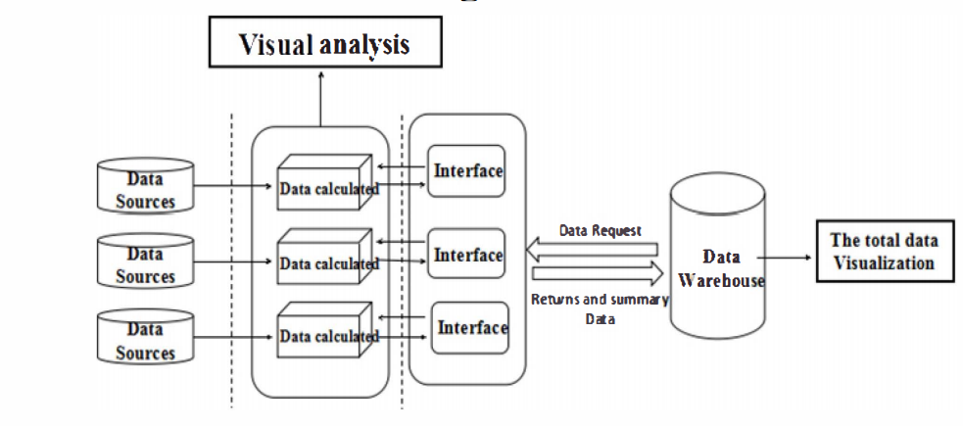

Figure 1. visual framework

Each data source can be a small data warehouse in Fig. 1. Their situation of theme settings is the same. Each data source can be visualized and statistics according to demands. When making the total statistics, people will propose demands in the first. Then each data source calculates statistical data according to the demands and provide access interface. At the last, data will be returned and summarized and displayed in the browser and stored in the data warehouse. This way can reduce the cost of setting up a large data warehouse. Through the interface, the original data values can also be hidden. So between the data and the user is translucent, not like d3 that is transparent. Based on this idea, a data source for data calculation and visualization can be achieved.

## IV. THE IMPLEMENT OF DATA VISUALIZATION IN D3.JS

Currently, there are a lot of various industry sales data. Data are huge and complex. Single, static tradition "chartoriented" visual display has been unable to meet the needs of business decision-makers. Through the thought of the data warehouse dimension, interaction diagram of Book sales data will be shown from the books category dimension and time dimension. The results will help managers find book sales law and adapt the present market demand.

By using D3.js, data visualization will be well achieved and use intuitive vector to replace the traditional form. This article is based on book sales data, by selecting different statistical dimensions, using a pie chart shows the overall profile, with a bar graph showing the specific sales under each dimension.

**A.Scheme Design**

During data storage design, the data are divided into book-categories dimensions and time dimensions. Book sales table contains sales encoding, book-categories, books-subclass, book name, price, and sales time six fields. We designed classification code tables for book categories and book sub-classes. It is an important idea for D3.js is not hiding the original data. When the page is loaded, it will push all the data required for book sales to the client, and screening and integrating data base on user's choice. There is no need to sending the request every time you select, this can reduce the burden on the server. The structure of Sales data table is shown in Table 3

TABLE I THE TABLE OF SALES DATA

|  |  |  |  |
| --- | --- | --- | --- |
| **Field name** | **Type Length** | **Field** | **Description** |
| Order_no |  | int | Order Number |
| Sub_no |  | int | Categories Number |
| Book_name | 50 | varchar | Book name |
| sales |  | float | Selling price |
| time |  | datetime | Sales of the time |

By "sub_no "we can make the connectIOn between the code table and the fact table to determine the categories of books. Specific processes shown in Figure2:

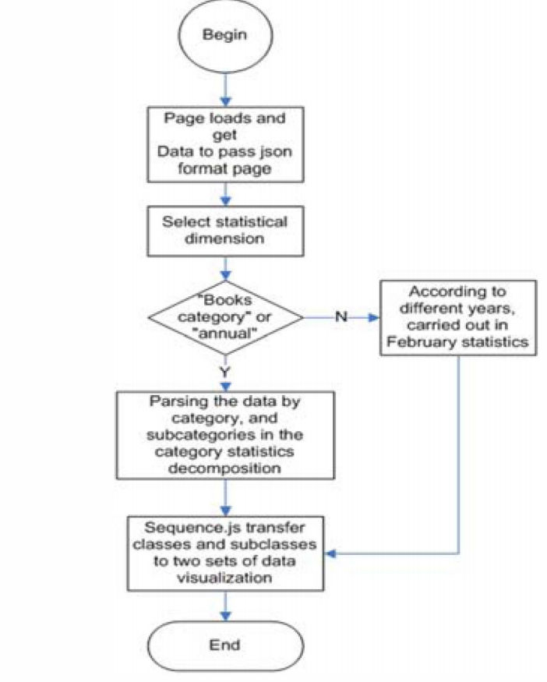

Figure 2. visual processing

## B. Implementation and Image display

When data is transmitted to the front-end, we create a .ashx files in C #, using List (T) class to access the sales data, and through the method by JavaScriptSerializer transforming data into a JSON, then through Ajax request to obtain all the sales table facts data. First, create a BookSales class, including Book _ catg, Sub _ catg, Book_name, Sales and S time field. After obtaining the fact that book sales data from the database, we create a listList list = new List (SalesJength);

We can call ToJson (list) function to convert the variable list to JSON format, and pass it on to the front pages.

**public string ToJson (object 0)**

**{**

**JavaScriptSerializer servializer JavaScriptSerializer 0;**

**return servializer. Serialize (0);**

**}**

By the following code you can get book sales information in the front-end:

**$(document).ready (function()**

**{**

**$.post ("request.ashx", function (data)**

**{**

**Sjson=eval ("(" + data + ")");**

**} );**

**});**

On the front-end, before using D3.js , we should add a reference like this: <script src="/js/D3.js"></script>

When we do the analysis in the book category and year, we use a pie chart to display the percentage of total sales in major categories.

First, we need to sort the data according to categories and organize the data as "hierarchical model" structure, with categories for the roots, and "end" for the end.

Then add a listener to each pie incident, the page will display the detail of selected category through a bar chart based on users' demand. When the organized data transmit to sequence.js for visual display, it should also transmit the detail data that is in order to achieve seeing details of the pie.

In this article BookCatg and Years are both using a way of pie chart to bar chart to display.

For example, when clicking the book category to view, the code of implementation and the effect is shown below, and wherein classifY 1 c1assifY2 can be multiplexed to different categories.

**aryjs = 0;**

**var m = "Book_catg";**

**jsonsort(m);f**

**for (var i = 0; i < 1; i++) {**

**f += parseInt(Sjson. Data[i].Sales);**

**if (i + 1 < I) {**

**sl = Sjson. data[i].Book _ catg;**

**s2 = Sjson.data[i + l].Book_catg;**

**c1assiJYl (f, sl, s2);**

**} else if (i+ 1==1) {**

**}**

**s 1 = Sj son.data[i] .Book _ catg;**

**s2 = Sjson.data[i - l].Book_catg;**

**c1assiJY2(f, i, s I, s2);**

**else{ json_txt += '{ "A":'"**

**+Sjson.data[i].Book_catg +'-'+'end'+ '" , "B":'" + f + '" } ]}';}**

**} Ilfor**

Results shown in Figure3: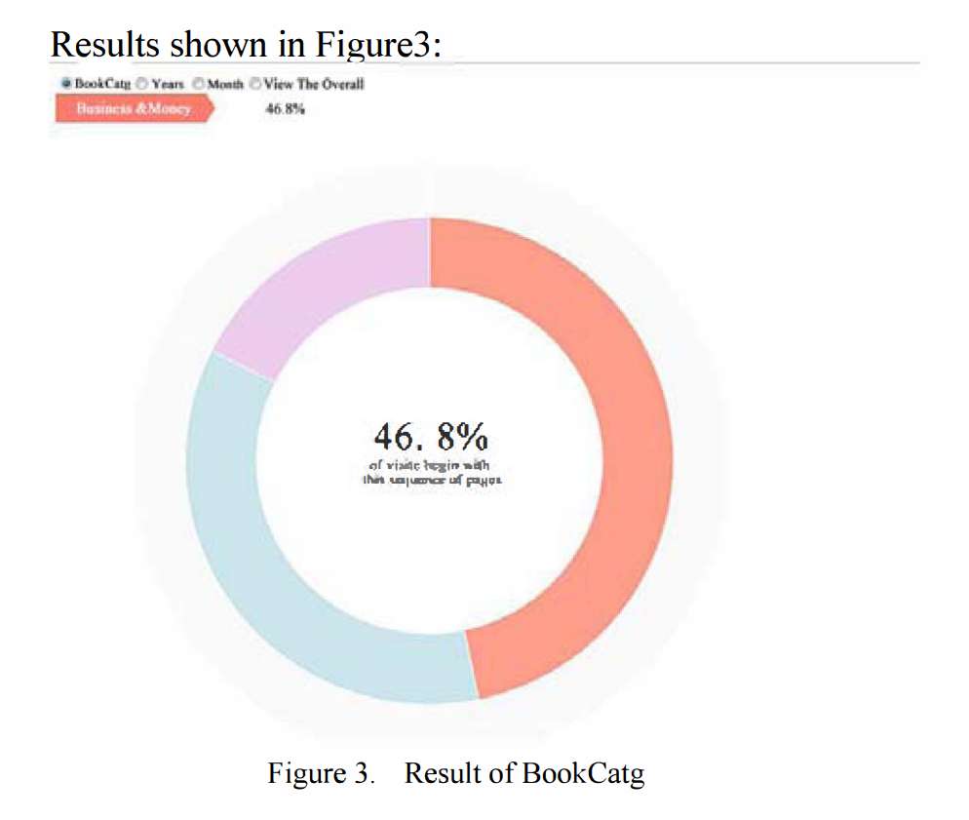

In the Fig.l, when selecting BookCatg class and putting the mouse on each of the different colors, we can see the book of "Business & Money" accounted for 46.8% of total sales in the upper left corner .Clicking the color, you will get a bar graph shown below. It records the specific sales of per books under the category of "Business & Money" .When the mouse over the bar, you'll see that it belongs Economics that is under the "Business & Money" category. Results shown in Figure 4:

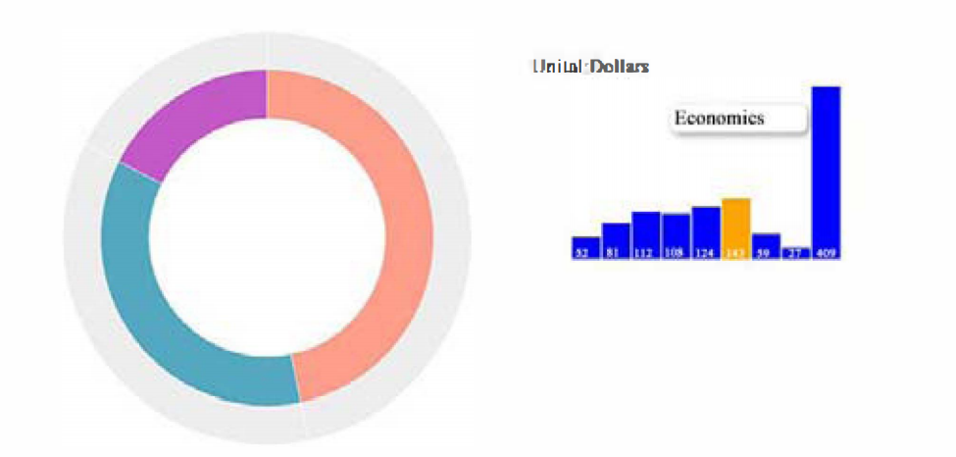

Figure 4. Result after clicking

When we select Month dimensional analysis performed, front-end data will be arranged according to the year, and then every year's monthly data for statistical analysis to scatter plot a different way to the annual sales of the month with different color display, as shown in Figure 5:

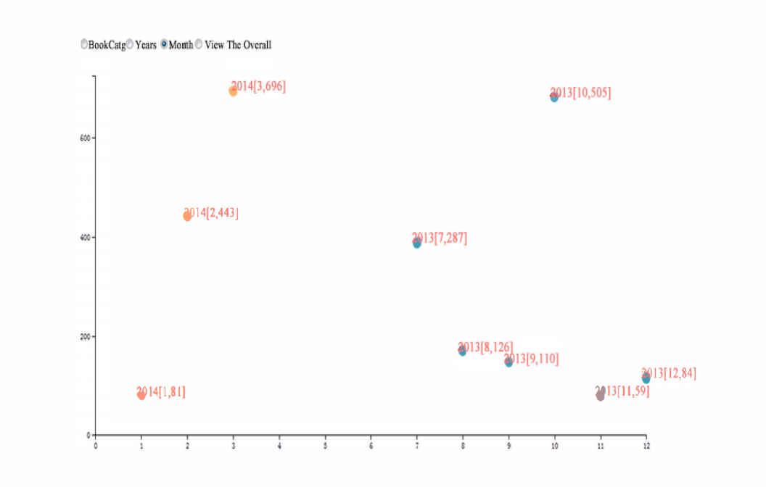

Figure 5. Result of month

As shown above, different years will be described with different colors. Users can visually compare the month's different sales, and we can see the fluctuations in sales annually. Such as through the map2014[2,443], you can know the February 2014 sales is 443 dollar.

Finally, View the Overall categories to detail can be viewed separately from each of the proportion of total sales, as shown in Figure 6:

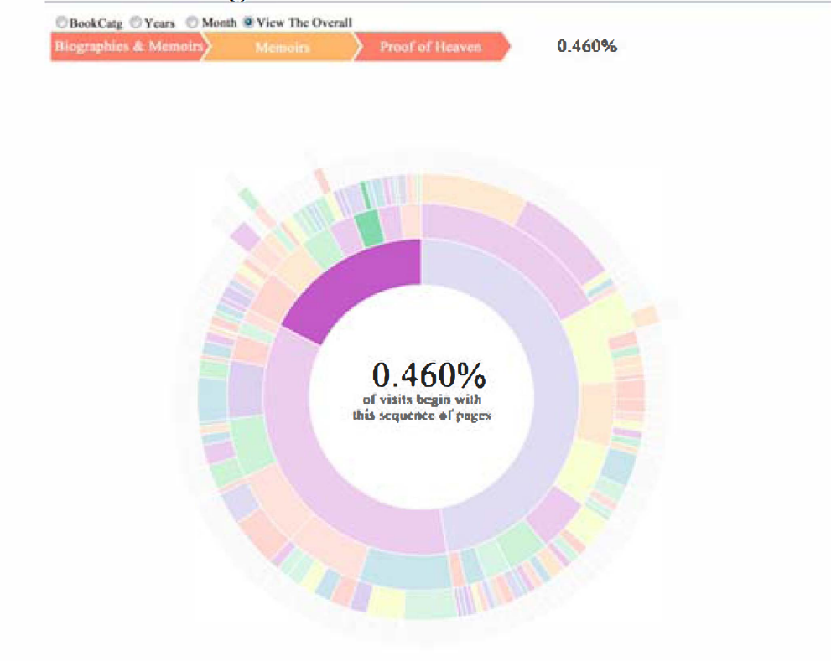

Figure 6. View of overall

When we see from the figure in the navigation bar, this book is named "Proof of Heaven" sales accounted for 0.460% of the total.

By analyzing different dimensions, users can view book sales and income from different angles. Based on the 50 displaying of graphics, sales trends, it can help managers to make sales management optimization and increase sales.

## V. SUMMARY

Statistical methods of data are diverse. Users can choose

their own visual display method case by case. The reason

why the proposed visual framework is chosen mainly based

on the following reasons:

1. D3.js is a library of JavaScript. When using D3.js to

visualize, he can directly upgrade to a newer browser version

instead of installing plug-ins in the first place.

2. D3.js is used to generate interpreted data. Users can

convey important information data by some rules extracted

from the data view.

3. The advantage of graphic is to display the statistics

from the whole to the details according to demand. Thus this

graphic will be interactive visualized.

4. Using SVG graphics will not allow graphic detail view

enlarged and distorted.

5. While the original data will not be hidden by D3.js, the

approach, using the text of the proposed framework to

achieve the translucent data, can not only make it easier for

users to statistic data but also reduce the resources and costs

to build large-scale data warehouse.

This framework for data visualization, data mining and

statistical methods is not comprehensive and may not meet

all the needs of users. However, based on the idea in this

article, the user can build a framework according to his

demand and then develop visual constraints, choose different

data dimensions to statistic data.

## REFERENCES

[I] M. Schneider, "A general model for the design of data warehouses,"

Int. J. Production Economics, Vol. 112, pp.309-325, 2008. (Pubitemid

351179609)

[2] http//d3js.org/, retrieved on May 13th, 2014.

[3] Scott Murray, Interactive Data Visualization for the Web, United

States of America, 2010 [11].

[4] Dailey D,Frost J,Strazzullo D.Building Web Applications with

SVG[MlMicrosoft Press,2012.

[5] Prat N, Comyn-Wattiau I, Akoka J. Combining objects with rules to

represent aggregation knowledge in data warehouse and OLAP

systems. Data & Knowledge Engineering, 2011, 70(8) 732-752.

[6] Keim, Daniel A. "Information visualization and visual data mining."

Visualization and Computer Graphics, IEEE Transactions on 8.1

(2002) 1-8

[7] Zhao Vue, Chen Zhiwei,Cai Shuhui,et al.Dynamic Web

Visualization of Large Scientific Computing Data. Modern Computer,

2012(5)3-6