|  |  |
| --- | --- |
| **Title：** | **Welcome&Farewell MRD** |

|  |  |  |  |
| --- | --- | --- | --- |
| **Version** | **Date** | **Document Owner** | **Changes** |
|  | 01-08 | PanJuan | 初稿 |
|  | 1-15 | PanJuan | 加入SPSS中的各状态变化关系的流程图，便于理解中控屏的显示状态。 |
|  |  |  |  |
|  |  |  |  |
|  |  |  |  |
|  |  |  |  |
|  |  |  |  |

目录

1 需求介绍 2

2 需求内容 3

2.1 车型配置及差异 3

2.2 流程图（Flow chat） 3

2.3 功能描述 3

2.3.1 Welcome/Farewell State and Sub-state determination欢迎/告别状态和子状态的定义 3

2.3.2 Accessory Protocol Interface Module (APIM/SYNC) requirements功能要求 8

3 系统边界 10

# 需求介绍

本文件规定了SYNC模块的Welcome&Farewell各状态下图像显示以及显示屏的强度和背光等级。参考的文档有：

1. WelcomeFarewell_Spec v2.pdf

另外，缺少文档（H22g_SYNC3_Welcome_Power_Modes_RELEASED_v2_20 ）

# 需求内容

## 车型配置及差异

|  |  |  |  |  |  |  |  |
| --- | --- | --- | --- | --- | --- | --- | --- |
|  | CD542 | | CX727 | U725 | P702 | U554 | U625ICA |
| 功能 | Ambient/Trend | Titanium/ST Line | Mid/High | Ford Bronco SUV | Ford Raptor F-150  Pickup truck | Lincoln Navigator  Large SUV (3 row seat) | Explorer |
|  |  |  |  |  |  |  |  |
|  |  |  |  |  |  |  |  |
|  |  |  |  |  |  |  |  |
|  |  |  |  |  |  |  |  |

## 流程图（Flow chat）

无

## 功能描述

### Welcome/Farewell State and Sub-state determination欢迎/告别状态和子状态的定义

#### 欢迎/告别的状态：

**Welcome欢迎状态:**

State that shall be active as a vehicle user is entering the vehicle until either the ignition is started (transition to “Ignition Run/Start” state), vehicle bus goes to sleep (“Null” sub-state) or the vehicle is locked from the exterior (“Vehicle Locking” sub-state).

当车辆用户进入车辆时激活欢迎状态，直到点火启动（过渡到“点火运行/启动”状态）、或者车辆总线进入休眠（“空”子状态）或车辆从外部锁定（“车辆锁定”子状态），这期间是欢迎状态。

**Ignition Run/Start运行/启动状态:**

State that shall be active from the time ignition is in Run/Start (includes accessory) until the ignition transitions to OFF (“Illuminated Exit” sub-state)

从点火开关为运行/启动Run/Start(包括 acc)时开始到点火开关关闭OFF（“Illuminated Exit”子状态），这期间是运行/启动状态。

**Farewell告别状态:**

State that shall be active as the vehicle user is leaving the vehicle after transitioning the ignition to OFF (“Illuminated Exit” sub-state) until either the ignition is re-started (transitioning back to “Ignition Run/Start” state), vehicle bus goes to sleep (“Null” sub-state) or the vehicle is locked from the exterior (“Vehicle Locking” sub-state).

在车辆用户将点火开关转换到关闭（“Illuminated Exit”子状态）时进入Farewell告别状态，直到点火重新启动（转换回“Ignition Run/Start”状态），或者车辆总线进入休眠（“Null”子状态）或者车辆从外部锁定（“Vehicle Locking”子状态）时，这期间是告别状态。

**Null空状态:**

Null state from where the Welcome/Farewell State Determination initialize and transition to due to time-outs or when the state determination function is no longer active.

从欢迎/告别状态确定初始化并过渡到由于超时或状态确定功能不再活动时。

#### 欢迎/告别的子状态：

**Approach Detection:**

Keyfob or Phone-as-a-key (PaaK) Device is within detection zone around vehicle (currently set to 2.5m)

Keyfob或Phone-as-a-key（PaaK）设备位于车辆周围的检测区域内（当前设置为2.5m）

**Illuminated Entry:**

Vehicle unlocked using either a Key-Fob, PaaK. Door Keypad code or any other means from the exterior of the vehicle while the ignition is OFF

当点火开关关闭时，从车辆外部通过钥匙或其他方式解锁车辆。

**Courtesy Lighting - All:**

A vehicle entry door transitioning to Ajar while the ignition is OFF, applicable to both Exterior and Interior lighting elements

当点火开关关闭状态时，车辆一个入口门转换为半开时，适用于外部和内部照明元件。

**Courtesy Lighting Delay- All:**

All vehicle entry door equaling closed after an ajar door(s) transitioned to closed, applicable to both Exterior and Interior lighting elements

在车辆有微开门转换为关闭后，且所有入口门均处于关闭状态时，适用于外部和内部照明元件。

**Courtesy Lighting - Extended:**

A vehicle entry door transitioning to Ajar while the ignition is OFF, applicable to just Interior lighting elements

当点火开关关闭状态时，车辆的一个入口门转换为半开时，仅适用于内部照明元件。

**Courtesy Lighting Delay- Extended: All:**

All vehicle entry door equaling closed after an ajar door(s) transitioned to closed, applicable to just Interior lighting elements

在车辆有微开门转换为关闭后，且所有入口门均处于关闭状态时，仅适用于内部照明元件。

**Ignition Run/Start:**

Vehicle Ignition is in Run or Start state

车辆点火处于运行或启动状态

**Illuminated Exit:**

The vehicle transmission has transitioned from non-OFF to OFF

车辆变速器已从非关闭状态转换为关闭状态

**Vehicle Locking:**

The vehicle was locked using either a Key-Fob, PaaK. Door Keypad code or any other means from the exterior of the vehicle while the ignition is OFF

在点火开关是OFF状态时，用钥匙或其他方式从车辆外部锁车时。

**Null:**

Null state

空状态

#### 状态变化关系图：

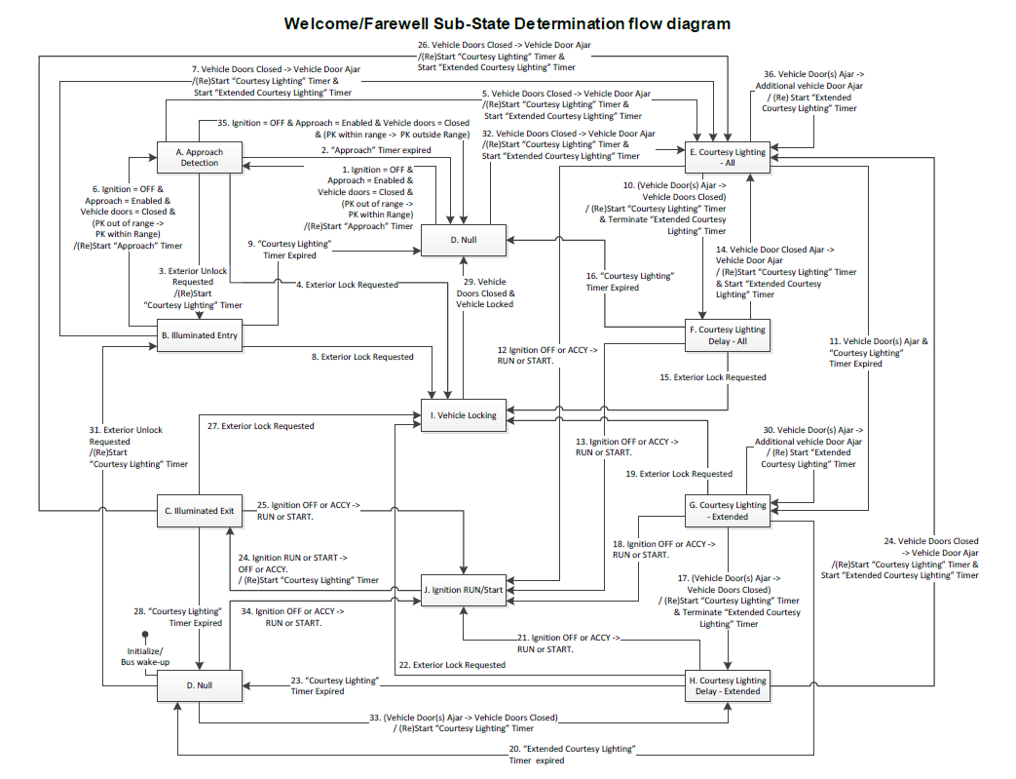

\***NOTE** – Even though the diagram above has two separate “Null” states called out, they are referring to the same “Null” state.

|  |
| --- |
| **D -> A.1**: “Approach” timer initialized. Timer set to 25 seconds by default  Transition as written applied to “Unlocked” configurable variant of Approach Detection. For “Locked” variant of Approach Detection, vehicle must have been locked using an exterior means.  **Welcome/Farewell State:** Don’t care -> Welcome |
| **A -> D.2**: “Approach” timer expired. Timer set to 25 seconds by default  **Welcome/Farewell state:** Don’t care -> Null |
| **A -> B.3:** “Courtesy Lighting” timer initialized. Timer set to 25 seconds by default. “Approach” timer terminated.  **Welcome/Farewell state:** Don’t care -> Welcome |
| **A -> I.4:** Terminate any active timers  **Welcome/Farewell state:** Don’t care -> Welcome |
| **A -> E.5:** “Courtesy Lighting” timer restarted at first door ajar transition. Shall not reset with each additional door ajar thereafter.  “Extended Courtesy Lighting” timer initialized at first door ajar transition. Timer set to 10 minutes by default. Shall reset with each additional door ajar thereafter.  **Welcome/Farewell state:** Don’t care -> Welcome |
| **A -> D.35:** “Approach” timer terminated on transition to “Null”. PK range and detection speed varies depending on number of antennas on vehicle and antenna scan sequence/rate  **Welcome/Farewell state:** Don’t care -> Null |
| **B -> A.6:** “Approach” timer re-initialized. “Courtesy Lighting” timer terminated.  Transition as written applied to “Unlocked” configurable variant of Approach Detection. Shall not occur for “Locked” variant of Approach Detection  **Welcome/Farewell state:** Don’t care -> Welcome |
| **B -> E.7:** “Courtesy Lighting” timer restarted at first door ajar transition. Shall not reset with each additional door ajar thereafter.  “Extended Courtesy Lighting” timer initialized at first door ajar transition. Timer set to 10 minutes by default. Shall reset with each additional door ajar thereafter.  **Welcome/Farewell state:** Don’t care -> Welcome |
| **B -> I.8:** Terminate any active timers  **Welcome/Farewell state:** Don’t care -> Farewell |
| **B -> D.9:** “Courtesy Lighting” timer expired. Timer set to 25 seconds by default  **Welcome/Farewell state:** Don’t care -> Null |
| **C -> J.25:** Any active timers terminated. Vehicle behavior must follow legislative in-drive requirements.  **Welcome/Farewell state:** Farewell -> Ignition Run/Start |
| **C -> E.26** “Courtesy Lighting” timer restarted at first door ajar transition. Shall not reset with each additional door ajar thereafter.  “Extended Courtesy Lighting” timer initialized at first door ajar transition. Timer set to 10 minutes by default. Shall reset with each additional door ajar thereafter.  **Welcome/Farewell state:** remain in Farewell if interior door handle used to open driver door. Farewell -> Welcome if exterior door handle used to open door |
| **C -> I.27** Terminate any active timers |
| **Welcome/Farewell state: remain in Farewell** |
| **C -> D.28** “Courtesy Lighting” timer expired. Timer set to 25 seconds by default  **Welcome/Farewell state:** Farewell -> Null |
| **D -> B.31** Courtesy Lighting” timer initialized. Timer set to 25 seconds by default. “Approach” timer terminated.  **Welcome/Farewell state:** Null -> Welcome |
| **D -> E.32** “Courtesy Lighting” timer started at first door ajar transition. Shall not reset with each additional door ajar thereafter.  “Extended Courtesy Lighting” timer initialized at first door ajar transition. Timer set to 10 minutes by default. Shall reset with each additional door ajar thereafter.  **Welcome/Farewell state:** Null -> Welcome |
| **D -> H.33** “Courtesy Lighting” timer started after all ajar vehicle entry doors transition to closed.  **Welcome/Farewell state:** Null -> Welcome |
| **D -> J.34** Vehicle behavior must follow legislative in-drive requirements.  **Welcome/Farewell state:** Null -> Ignition Run/Start |
| **E -> F.10:** “Courtesy Lighting” timer restarted after all ajar vehicle entry doors transition to closed.  “Extended Courtesy Lighting” timer terminated.  **Welcome/Farewell state:** Keep previous state (Welcome or Farewell) |
| **E -> G.11:** “Courtesy Lighting” timer expired. Timer set to 25 seconds by default  Transition has no impact on active “Extended Courtesy Lighting” timer (continue counting down)  **Welcome/Farewell state:** Keep previous state (Welcome or Farewell) |
| **E -> J.12:** Any active timers terminated. Vehicle behavior must follow legislative in-drive requirements.  **Welcome/Farewell state:** Don’t care -> Ignition Run/Start |
| **E -> E.36:** “Extended Courtesy Lighting” timer reset with each additional door ajar transition.  “Courtesy Lighting” timer restarted at first door ajar transition. Shall not reset with each additional door ajar thereafter.  **Welcome/Farewell state:** Keep previous state (Welcome or Farewell) |
| **F -> J.13:** Any active timers terminated. Vehicle behavior must follow legislative in-drive requirements.  **Welcome/Farewell state:** Don’t care -> Ignition Run/Start |
| **F -> E.14** “Courtesy Lighting” timer restarted at first door ajar transition. Shall not reset with each additional door ajar thereafter.  “Extended Courtesy Lighting” timer initialized at first door ajar transition. Timer set to 10 minutes by default. Shall reset with each additional door ajar thereafter.  **Welcome/Farewell state:** Keep previous state (Welcome or Farewell) |
| **F -> I.15** Terminate any active timers  **Welcome/Farewell state:** Don’t care -> Farewell |
| **F -> D.16** “Courtesy Lighting” timer expired. Timer set to 25 seconds by default  **Welcome/Farewell state:** Don’t care -> Null |
| **G -> H.17** “Courtesy Lighting” timer restarted after all ajar vehicle entry doors transition to closed.  “Extended Courtesy Lighting” timer terminated.  **Welcome/Farewell state:** Keep previous state (Welcome or Farewell) |
| **G -> J.18** Any active timers terminated. Vehicle behavior must follow legislative in-drive requirements.  **Welcome/Farewell state:** Don’t care -> Ignition Run/Start |
| **G -> I.19** Terminate any active timers  **Welcome/Farewell state:** Don’t care -> Farewell |
| **G -> D.20** “Extended Courtesy Lighting” timer expired. Timer set to 10 minutes by default |
| **G -> G.30** “Extended Courtesy Lighting” timer reset with each additional door ajar transition |
| **H -> J.21** Any active timers terminated. Vehicle behavior must follow legislative in-drive requirements.  **Welcome/Farewell state:** Don’t care -> Ignition Run/Start |
| **H -> I.22** Terminate any active timers  **Welcome/Farewell state:** Don’t care -> Farewell |
| **H -> D.23** “Courtesy Lighting” timer expired. Timer set to 25 seconds by default  **Welcome/Farewell state:** Don’t care -> Null |
| **H -> E.24** “Courtesy Lighting” timer restarted at first door ajar transition. Shall not reset with each additional door ajar thereafter.  “Extended Courtesy Lighting” timer initialized at first door ajar transition. Timer set to 10 minutes by default. Shall reset with each additional door ajar thereafter.  **Welcome/Farewell state:** Keep previous state (Welcome or Farewell) |
| **I -> D.29** Transition occurs after vehicle lock is confirmed  **Welcome/Farewell state:** Don’t care -> Null |

### Accessory Protocol Interface Module (APIM/SYNC) requirements功能要求

#### APIM Welcome/Farewell Graphics

APIM应该利用以下功能来支持欢迎/告别动画转换，Ford车辆的文件参考“RQT-002004-021878 DNA Welcome-Farewell Strategy Rev. XX”，林肯车辆的文件参考“RQT-002004-022094 Lincoln Embrace Welcome and Farewell Behavior Rev. XX”，显示屏的参考本文**“Welcome/Farewell State and Sub-state determination”**章节和**“LE_WF_Welcome/Farewell Display”**章节。

|  |  |  |
| --- | --- | --- |
| **CAN Inputs** | | **LE_WF_Welcome/Farewell Display** |
| **VehWlcmFrwl_D_Stat** | **VehWlcmFrwlMde_D_Stat** | **Welcome/Farewell Animation Request** |
| WELCOME | APPROACH | Wake-up display |
| WELCOME | ILLUMINATEDENTRY | Wake-up display (stay awake) |
| WELCOME | COURTESYLIGHTINGALL | Welcome Animation1 |
| WELCOME | COURTESYLIGHTINGDELAYALL | Welcome Animation1 |
| WELCOME | COURTESYLIGHTINGEXTENDED | Off (stay awake) |
| WELCOME | COURTESYLIGHTINGDELAYEXT | Off (stay awake) |
| WELCOME | NULL | Off (Sleep) |
| RUNSTART | Don’t care | Vehicle Start Animation3 then transition to in-drive display |
| FAREWELL | ILLUMINATEDEXIT | Farewell animation1 |
| FAREWELL | COURTESYLIGHTINGALL | Off (stay awake) |
| FAREWELL | COURTESYLIGHTINGDELAYALL | Off (Sleep) |
| FAREWELL | COURTESYLIGHTINGEXTENDED | Off (Sleep) |
| FAREWELL | COURTESYLIGHTINGDELAYEXT | Off (Sleep) |
| FAREWELL | NULL | Off (Sleep) |
| NULL | NULL | Off (Sleep) |

Note 1: Specific animation owned by HMI and Studio group.

#### APIM Display Intensity and Backlighting显示强度和背光

APIM应利用以下功能控制显示器和所有其他发光源的照明，即开关背光等（ Ford车辆参考“RQT-002004-021878 DNA Welcome-Farewell Strategy Rev. XX”，林肯车辆参考“RQT-002004-022094 Lincoln Embrace Welcome and Farewell Behavior Rev. XX”）：

· Subscribe to “Dimming_lvl” published by BCM via CAN.

o Additionally subscribe to “Litval” to meet “Smooth Dimming” requirements

· “LE_WF_Illumination Requestor”, section 5.3, with the following default values:

o Fade On = 40ms

o Fade Off = 40ms

· “LE_WF_Illumination Response”, section 5.4.

|  |  |  |  |  |
| --- | --- | --- | --- | --- |
| **CAN Signals** | | | **显示和背光照明“LE_WF_Illumination_ Requestor” 摘要 1** | **照明强度 2** |
| **Dimming_lvl** | **Ignition_Status** | **HMI_HMIMode_St (Extended Play)** |
| Off/ unused / invalid / missing (on reset) | Not-OFF | Don’t’ Care | “Fade On” or “On/Embrace” | Night_12 |
| Night_1 ... Night_12, Day_1 … Day_6 | Not-OFF | Don’t’ Care | “Fade On” or “On/Embrace” | Night_1 ... Night_12, Day_1 … Day_6 |
| Night_1 ... Night_12, Day_1 … Day_6 -> Missing | Not-OFF | Don’t’ Care | “Fade On” or “On/Embrace” | Night_1 ... Night_12, Day_1 … Day_6 |
| Night_1 ... Night_12, Day_1 … Day_6 | OFF | Don’t Care | “Fade On” or “On/Embrace” to intensity | Night_1 ... Night_12, Day_1 … Day_6 **2** |
| Night_1 ... Night_12, Day_1 … Day_6 -> Missing | OFF | Don’t Care | “Fade On” or “On/Embrace” to intensity | Last non-OFF value:  Night_1 ... Night_12, Day_1 … Day_6 **3** (until “OFF” is received) |
| Off/ unused / invalid / missing (on reset) | OFF | Off | “Fade Off” or “Off” | Off |
| Off/ unused / invalid / missing (on reset) | OFF | Not-OFF | “Fade On” or “On/Embrace” | Last non-OFF value:  Night_1 ... Night_12, Day_1 … Day_6 **3** |

Note 1: 此处摘要只是概述，详细的说明Ford车辆参考“RQT-002004-021878 DNA Welcome-Farewell Strategy Rev. XX”，林肯车辆参考“RQT-002004-022094 Lincoln Embrace Welcome and Farewell Behavior Rev. XX”。

Note 2: 还应根据Litval的变化监测和调整照明强度，以满足ES-H1BT-1A278-AA-VXX最新版本中列出的“驾驶舱照明/平滑调光”要求。

Note 3: 仅适用于音频控制开关/旋钮背光。剩余的背光可以关闭。如果无法确定先前的调光等级值（非OFF值），则点亮至夜间12等级。

# 系统边界

请参考表格xx（外部表格文档后续补充）