# LIN RGB Specification for functional requirements of ambient light

**（secret）**

|  |  |  |
| --- | --- | --- |
| Revision: |  | V0.1_0525 |
| Date: |  | 2021-05-25 |
| Status: |  | Draft |
| Department: |  | PMT 2 |
|  |  |  |
|  |  |  |
| Document Owner: |  | Sun Qiming |
| Project: |  | CDX707 |

**Historical version**

| Version NO | Elaborate | Sign | Date |
| --- | --- | --- | --- |
| V0.1 | Initial release |  |  |
|  |  |  |  |
|  |  |  |  |
|  |  |  |  |
|  |  |  |  |
|  |  |  |  |
|  |  |  |  |

**Examine and Verify**

| Role | Name | Sign | Date |
| --- | --- | --- | --- |
|  |  |  |  |
|  |  |  |  |
|  |  |  |  |
|  |  |  |  |
|  |  |  |  |
|  |  |  |  |
|  |  |  |  |
|  |  |  |  |

**目录**

LIN RGB Specification for functional requirements of ambient light 1

1 Document description 6

1.1 Purpose 6

1.2 Scope of application 6

1.3 Reference documentation 6

1.4 Design and test standards 6

1.4.1 Design Standards 6

1.4.2 Test standards 6

2 Systems definition 7

2.1 Principle of components 7

2.3 LED zoning 8

2.4 Connector illustration 14

2.4.1 Connector model number 14

2.4.2 PIN Define 14

2.5 Input-output signal characteristics 14

2.5.1 Input signal characteristics 14

2.5.2 Output signal characteristics 17

2.6 Power management 17

2.6.1 Supply Voltage 17

2.6.2 Working current 18

2.6.3 Grounding requirements 18

2.7 Network Management 18

2.7.1 Wake up mode 18

2.7.2 Sleep mode 19

3 Function requirement 19

3.1 Work state 19

3.1.1 Wake up state 19

3.1.2 Sleeping state 20

3.1.3 Sleep Command 20

3.1.4 Welcome/Farewell Function 21

3.1.6 Radar alarm 30

3.1.7 Driver Mode 33

3.1.8 Static mode 36

3.1.9 Music mode 39

3.1.10 Dynamic color 41

3.1.11 Customize mode 47

3.1.12 Rest mode 49

3.1.13 Door-Ajar alarm 53

3.1.14 Intensity define 54

3.2 ALM LIN feedback 56

3.3 ALM Priority definition 56

4 Color and Brightness define 59

5 Communication Interface 59

5.1 LIN communication 59

5.1.1 Interface type 59

5.1.2 Peripheral circuit 60

6 Environmental performance requirements 61

6.1 Temperature 61

6.2 Mechanical sector indicators 61

6.3 Appearance and mechanical structure 62

6.4 Fundamental performance parameter 62

6.5 EMC 62

6.6 Environmental suitability 62

6.7 Vibration test 62

6.8 Drop test 62

6.9 Mechanical impact test 62

6.10 Temperature and humidity resistance cycle 62

6.11 Switch durability 62

6.12 Normal voltage cycle 62

6.13 Waterproof and dustproof test 63

6.14 Resistance to abnormal power supply voltage 63

7 Other requirements 63

Terminology

|  |  |  |
| --- | --- | --- |
| **Abbreviation** | **Full_name** | **Remarks** |
| CAN | Controller Area Network | CAN bus |
| LIN | Local Interconnect Network | LIN bus |
| PWM | Pulse Width Modulation | pulse duration modulation |
| TBD | To Be Determined | TBD |
| NA | Not Applicable | not applicable |
| …… | …… | …… |

# Document description

## Purpose

This document is a functional specification for the Ford Automotive Ambient light Module. It describes in detail the functions, component interfaces, technical parameters and dimensions of the Ambient light Module.

## Scope of application

This document is applicable to the design, develop and testing stages of CDX707 vehicle project; during the implementation of the ford motor project, if there is any violation of this specification, it must be approved by ford motor.

## Reference documentation

| **Label** | **Title** | **Version/Modify Data** |
| --- | --- | --- |
| 1 |  |  |
| 2 |  |  |
| 3 |  |  |

## Design and test standards

### Design Standards

|  |  |  |
| --- | --- | --- |
| Num | Standard Name | Standard Number |
| 1 |  |  |
| 2 |  |  |
| 3 |  |  |
|  |  |  |

### Test standards

|  |  |  |
| --- | --- | --- |
| Num | Standards Name | Standard Number |
| 1 |  |  |
| 2 |  |  |

# Systems definition

RGB Inner block of light head：

rgbled

GND

LIN

VCC

PIN1

PIN3

PIN2

ASIC

Rb

Rg

Rr

## Principle of components

1、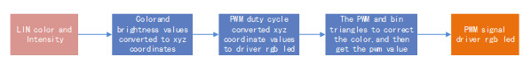

2、√

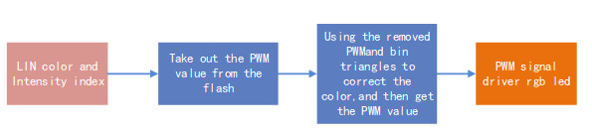

*Principle of components*



## LED zoning



In low configuration, there are 18 LEDs:

Door Group:

* Front Left Door 3 LEDS;
* Front Right Door 3 LEDS;

IP Group:

* IP Left 2 LEDS;
* IP Right 2 LEDS;

Foot Group:

* Front Left Footage 1 LED;
* Front Right Footage 1 LED;
* Rear Left Footage 1 LED;
* Rear Right Footage 1 LED;

Pocket Group:

* Front Left Pocket 1 LED;
* Front Right Pocket 1 LED;
* Rear Left Pocket 1 LED;
* Rear Right Pocket 1 LED;

Maximum match 18 LEDS，Front Left Door、IP Left、Front Left Footage、Front Left Pocket、Rear Left Footage、Rear Left Pocket、Front Right Door、IP Right、Front Right Footage、Front Right Pocket、Rear Right Footage and Rear Right Pocket allocation independent ID.

Front Left Door*3、IP Left*2、Front Left Footage*1、Front Left Pocket*1、Rear Left Footage*1、Rear Left Pocket*1 total 9 LEDs area shared the LIN1_LEFT.

Front Right Door*3、IP Right*2、Front Right Footage*1、Front Right Pocket*1、Rear Right Footage*1、Rear Right Pocket*1 total 9 LEDs area shared the LIN2_RIGHT.



In middle configuration, there are 24 LEDs:

Door Group:

* Front Left Door 3 LEDS;
* Front Right Door 3 LEDS;
* Rear Left Door 3 LEDS;
* Rear Right Door 3 LEDS;

IP Group:

* IP Left 2 LEDS;
* IP Right 2 LEDS;

Foot Group:

* Front Left Footage 1 LED;
* Front Right Footage 1 LED;
* Rear Left Footage 1 LED;
* Rear Right Footage 1 LED;

Pocket Group:

* Front Left Pocket 1 LED;
* Front Right Pocket 1 LED;
* Rear Left Pocket 1 LED;
* Rear Right Pocket 1 LED;

Maximum match 24 LEDS，Front Left Door、Rear Left Door、IP Left、Front Left Footage、Rear Left Footage、Front Left Pocket、Rear Left Pocket、Front Right Door、Rear Right Door、IP Right 、Front Right Footage、Rear Right Footage、Front Right Pocket and Rear Right Pocket allocation independent ID.

Front Left Door*3、Rear Left Door*3、IP Left*2、Front Left Footage*1、Rear Left Footage*1、Front Left Pocket*1、Rear Left Pocket*1 total 12 LEDs area shared the LIN1_LEFT.

Front Right Door*3、Rear Right Door*3、IP Right *2、Front Right Footage*1、Rear Right Footage*1、Front Right Pocket*1、Rear Right Pocket*1 total 12 LEDs area shared the LIN2_RIGHT.



In high configuration, there are 28 LEDs:

Door Group:

* Front Left Door 3 LEDS;
* Front Right Door 3 LEDS;
* Rear Left Door 3 LEDS;
* Rear Right Door 3 LEDS;

IP Group:

* IP Left 2 LEDS;
* IP Right 2 LEDS;

Foot Group:

* Front Left Footage 1 LED;
* Front Right Footage 1 LED;
* Rear Left Footage 1 LED;
* Rear Right Footage 1 LED;

Pocket Group:

* Front Left Pocket 1 LED;
* Front Right Pocket 1 LED;
* Rear Left Pocket 1 LED;
* Rear Right Pocket 1 LED;

Logo Group:

* Front Left Logo 1 LED;
* Front Right Logo 1 LED;
* Rear Left Logo 1 LED;
* Rear Right Logo 1 LED;

Maximum match 28 LEDS，Front Left Door、Rear Left Door、IP Left、Front Left Footage、Rear Left Footage、Front Left Pocket、Rear Left Pocket、Front Left Logo、Rear Left Logo、Front Right Door、Rear Right Door、IP Right 、Front Right Footage、Rear Right Footage、Front Right Pocket、Rear Right Pocket、Front Right Logo and Rear Right Logo allocation independent ID.

Front Left Door*3、Rear Left Door*3、IP Left*2、Front Left Footage*1、Rear Left Footage*1、Front Left Pocket*1、Rear Left Pocket*1、Front Left Logo*1、Rear Left Logo*1 total 14 LEDs area shared the LIN1_LEFT.

Front Right Door*3、Rear Right Door*3、IP Right *2、Front Right Footage*1、Rear Right Footage*1、Front Right Pocket*1、Rear Right Pocket*1、Front Right Logo*1、Rear Right Logo*1 total 14 LEDs area shared the LIN2_RIGHT.

## Connector illustration

### Connector model number

### PIN Define

## Input-output signal characteristics

### Input signal characteristics

Hardline signal

|  |  |  |
| --- | --- | --- |
| Signal | Signal description | effective value |
| VCC | Power supply for ambient light | voltage range：9~16V  rated voltage：12V |
| LIN | LIN communication signals |  |
| GND | GND supply for ambient light | 0V |

LIN BUS Signal:

|  |  |  |  |  |
| --- | --- | --- | --- | --- |
| **Signal Name** | **Signal Desc** | **Lent** | **value** | **FROM** |
| **(bit)** |
| Aux_Static_Intensity_Value | 静态亮度设置 | 7 | 0-100(%) | IVI |
| Aux_Static_Color_Value | 静态颜色设置 | 8 | 0-255(color num) | IVI |
| Aux_IP_Intensity_Value | IP group亮度设置 | 7 | 0-100(%) | IVI |
| Aux_IP_Group_Set | IP group是否打开 | 1 | 0:close 1:open | IVI |
| Aux_IP_Color_Value | IP group颜色设置 | 8 | 0-255(color num) | IVI |
| Aux_Door_Intensity_Value | Door group亮度设置 | 7 | 0-100(%) | IVI |
| Aux_Door_Group_Set | Door group是否打开 | 1 | 0:close 1:open | IVI |
| Aux_Door_Color_Value | Door group颜色设置 | 8 | 0-255(color num) | IVI |
| Aux_Foot_Intensity_Value | Foot group亮度设置 | 7 | 0-100(%) | IVI |
| Aux_Foot_Group_Set | Foot group是否打开 | 1 | 0:close 1:open | IVI |
| Aux_Foot_Color_Value | Foot group颜色设置 | 8 | 0-255(color num) | IVI |
| Aux_ALM_Set | 室内氛围灯开关 | 2 | 0:invalid 1:close 2:open | IVI |
| Aux_Color_Mode | 颜色模式设置 | 2 | 0:invalid  1:static  2:dynamic  3:customize  4:music | IVI |
| Aux_Dynamic_Color | 动态颜色设置 | 3 | 0:invalid 1:surprise me 2:ocean heart 3:deep forest 4:Moden city 5:warm heart | IVI |
| Aux_AmbLghtDrvMde_D_Rq | IVI颜色模式 | 1 | 0:manual 1:auto | IVI |
| Aux_SelDrvMdeHmi03_D_Rq | 驾驶模式时的颜色索引 | 2 | 1:normal-TBD  2:sport-TBD  3:eco-TBD | BCM |
| Aux_WelcomeFarewell_State | Farewell | 2 | 0:null  1: welcome  2: farewell  3: run_start | BCM |
| Aux_WelcomeFarewell_Substate | SubFarewell | 3 | 0:NULL  1:Approach  2:IlluminatedEntry  3:CourtesyLightingAll  4:CourtesyLightingDelayAll  5:CourtesyLightingExtended  6:CourtesyLightingDelayExt  7:IlluminatedExit | BCM |
| Aux_Day_Night_Status | 白天夜晚状态 | 2 | 0:NULL 1:Day 2:Night 3:NotUsed | BCM |
| Aux_ClrExitAsstMsgTxt_D_Rq2 | 雷达报警状态 | 4 | 0:No Info/Warning  1:Rear Left  2:Rear Right  3:Front Left  4:Front Right  5:Rear Left And Rear Right  6:Front Left And Front Right  7:Rear Left And Front Right  8:Front Left And Rear Right | ADAS |
| Aux_DF_Door_Ajar_Status | 左前门 | 1 | 0:closed 1:AJAR | BCM |
| Aux_PF_Door_Ajar_Status | 右前门 | 1 | 0:closed 1:AJAR | BCM |
| Aux_Music_Rate_Level | 音乐律动频率等级 | 4 | 0:0-63hz  1:64-127hz  2:128-255hz  3:256-511hz  4:512-1023hz  5:1023-2047hz  6:2048-4095hz  7:4096-8191hz  8:8192-16383hz  9:Reserved  10:Reserved  11:Reserved  12:Reserved  13:Reserved  14:Reserved  15:Reserved | IVI |
| Aux_Music_Range_Level | 音乐律动幅度等级 | 3 | 0:0-15  1:16-31  2:32-47  3:48-63  4:64-79  5:80-95  6:96-111  7:112-127 | IVI |
| Aux_DR_Door_Ajar_Status | 左后门 | 1 | 0:closed 1:AJAR | BCM |
| Aux_PR_Door_Ajar_Status | 右后门 | 1 | 0:closed 1:AJAR | BCM |
| Aux_Sync_Signal | 同步信号 | 6 | 0-63(tick) | AUX |
| ClrExitAsst_D_Stat | 雷达状态是否有效标记 | 2 | 0:Null  1:Disabled  2:Enabled | ADAS |
| Aux_Screen background color | 大屏背景颜色 | 2 | 1:color 1-tbd  2:color 2-tbd  3:color 3-tbd  4:color 4-tbd | IVI |

### Output signal characteristics

## Power management

### Supply Voltage

rated voltage：12V；

test voltage：13.5V±0.2V

Working condition：

|  |  |  |
| --- | --- | --- |
| Voltage Range | Voltage Description | Functional description at different voltages |
| Volt <6V | Ultra-low Vol mode | All functions prohibited |
| 6V≤Volt<9V | low Vol mode | LED light lose all functions，Communication function is normal |
| 9V≤Volt<16V | normal Vol mode | All functions is normal |
| 16V≤Volt＜18V | High Vol mode | LED light lose all functions，Communication function is normal |
| 18V≤Volt | Ultra-High Vol mode | All functions prohibited |

Note: The data provided by the supplier shall prevail.

### Working current

|  |  |
| --- | --- |
| Current | Current value |
| Rated current（LED ON） |  |
| MAX current |  |
| Quiescent current （LED OFF） |  |

Note: The data provided by the supplier shall prevail.

### Grounding requirements

N/A

## Network Management

### Wake up mode

any node in a dormant lin cluster state can request a wake-up program (the host can send an interval symbol, for example, a normal frame header, as the interval will act as a wake-up pulse). Wake-up requests can be generated by leaving the bus in a dominant state μs 250 to 5 ms,. each slave node (connected to the power supply) shall be able to detect a wake-up request (the main pulse is not longer than 150μ), and will be waiting for the bus command within 100 ms. ms 100 is calculated from the termination edge of the main pulse. Hosts are woken up, and it takes 100 ms when the slave node is ready (starting with the wake-up), unless the host has additional information, for example, that the reason for the wake-up is simply because one of the slave in the cluster. ), the host node starts sending the frame header and starts probing the cause of the wake-up request release. if the host does not send the frame header within 150 ms of receAuxng the wake-up request, then the node that sent the request can attempt to send a new wake-up request. After three requests (all failed), the node should wait at least 1.5 seconds before sending the fourth wake-up request.

From sleep mode to wake-up mode when any of the following conditions are satisfied:

1. controlled by aux module power supply, and the ambient light module works after power on.
2. A wake-up signal sent by the Aux module is received from the node;

### Sleep mode

all slave nodes in the active cluster are forced into sleep mode by sending a diagnostic host request frame (identifier of the frame =0 x3c)(sleep state only covers the cluster. applications within nodes are still activated). the first data byte of the request frame is equal to 0(normally, the first data byte is interpreted as a node address, i.e. nad; address is not allowed to be zero). If the lin bus has been inactive for more than 4 seconds, the slave node automatically enters sleep mode.

Go to sleep mode when any of the following conditions are satisfied:

1. Aux module After the power is disconnected, the ambient light module stops working.
2. Aux module sends sleep signals to slave nodes；

# Function requirement

## Work state

### Wake up state

#### Function description:

Wake up：wake up when the ambient light module detects bus actAuxty.

#### Signal description:

There are messages on the bus.

#### 3.1.1.3 Functional logic/specific functional description:

1. **Enabling conditions：(A＆B＆C&D)**

A. Power Auxply voltage within normal operating range.

B. LIN communication normal.

C. LED function normal.

D. Temperature within normal range

1. **Trigger conditions：**
2. Bus from inactive to transmitted
3. **Execute output：**

The ambient light module wakes up and enters the working state.

### Sleeping state

#### Function description:

Sleeping：after receiving the sleep command or the LIN bus has been inactive for more than 4 seconds, enter hibernation state.

#### Signal description:

Sleep message sent or the LIN bus has been inactive for more than 4 seconds.

#### 3.1.2.3 Functional logic/specific functional description:

1. **Enabling conditions：(A＆B＆C&D)**

A. Power supply voltage within normal operating range.

B. LIN communication normal.

C. LED function normal.

D. Temperature within normal range

1. **Trigger conditions：**
2. Bus sleep message.
3. **Execute output：**

The ambient light module enters sleeping state.

### Sleep Command

#### Function description:

The ambient light module into sleeping state.

#### Signal description:

1. Bus input signal as follows:

| **Signal Name** | **Signal Desc** | **Signal len** | **Signal len desc** | **note** |
| --- | --- | --- | --- | --- |
| **ID** | **addr** | **1 byte** |  |  |

#### Functional logic/specific functional description:

1. **Enabling conditions：(A＆B＆C&D)**

A. Power supply voltage within normal operating range.

B. LIN communication normal.

C. LED function normal.

D. Temperature within normal range

1. **Trigger conditions：**

Aux module send sleep message on the bus.

1. **Execute output：**

Go to sleep mode.

### Welcome/Farewell Function

#### Welcome Start：

Function description: Welcome mode start

* IP Left - Front Left Door - Rear Left Door(IP Right - Front Right Door - Rear Right Door) :

从IP-左前门-左后门（IP -右前门-右后门）每个灯以0.2S的时间间隔启动依次点亮至100%亮度后渐灭至低亮度，完成本轮整体流动周期后进入第二轮循环…总共6次循环，总动态效果时间约为15秒；持续点亮7 秒后3S渐灭；

* Front Left Footage，Rear Left Footage，Front Right Footage，Rear Right Footage，Front Left Pocket，Rear Left Pocket，Front Right Pocket and Rear Right Pocket ，Front Left Logo，Rear Left Logo，Front Right Logo，Rear Right Logo: 氛围灯 4秒渐亮至100%亮度，21 秒后4S渐灭；

Signal description:

Bus input signal as follows:

|  |  |  |  |  |
| --- | --- | --- | --- | --- |
| **Signal Name** | **Signal Desc** | **Signal Len** | **Signal Value Desc** | **note** |
| Aux_WelcomeFarewell_State | Welcome | 2 | 0:invalid  1: welcome  2: farewell  3: run_start | BCM |
| Aux_WelcomeFarewell_Substate | CourtesyLightingAll | 3 | 0:NULL  1:Approach  2:IlluminatedEntry  3:CourtesyLightingAll  4:CourtesyLightingDelayAll  5:CourtesyLightingExtended  6:CourtesyLightingDelayExt  7:IlluminatedExit | BCM |

1. Enabling conditions：（**A＆B＆C&D**）

1. Power supply voltage within normal operating range
2. LIN communication normal
3. LED function normal
4. Temperature within normal range
5. Trigger conditions：（**A＆B**）
6. Aux_WelcomeFarewell_State = Welcome
7. Aux_WelcomeFarewell_Substate = CourtesyLightingAll

3. Execute output：

A. All Ambient Lighting Ambient light ouput

* IP Left - Front Left Door - Rear Left Door(IP Right - Front Right Door - Rear Right Door) ：氛围灯从车前向车后流动（15S）；持续点亮10 秒后4S渐灭；
* Front Left Footage，Rear Left Footage，Front Right Footage，Rear Right Footage，Front Left Pocket，Rear Left Pocket，Front Right Pocket and Rear Right Pocket，Front Left Logo，Rear Left Logo，Front Right Logo，Rear Right Logo：氛围灯 4秒渐亮至100%亮度，21 秒后4S渐灭；

B. Selected Color &Intensity

* IP Left - Front Left Door - Rear Left Door(IP Right - Front Right Door - Rear Right Door)：默认冰蓝色，亮度随流水变化而变化；

Flow功能运行示意图：

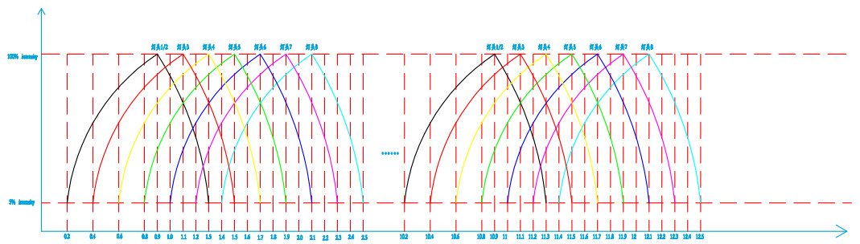

图1 1-5 cycle

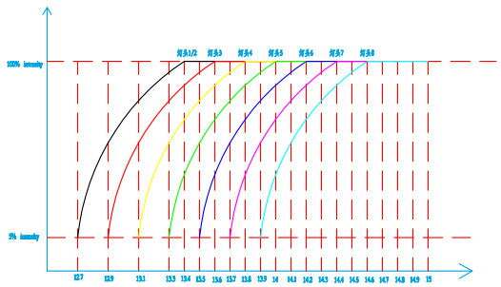

图2 6 cycle

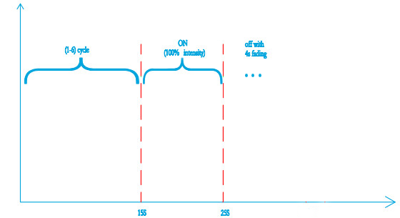

图3 Flow(25S)

* Front Left Footage，Rear Left Footage，Front Right Footage，Rear Right Footage，Front Left Pocket，Rear Left Pocket，Front Right Pocket and Rear Right Pocket，Front Left Logo，Rear Left Logo，Front Right Logo，Rear Right Logo：默认冰蓝色，亮度100%；

C. If the door close in 25s(Aux_WelcomeFarewell_Substate=4:CourtesyLightingDelayAll),Ambient Lighting keep on

D.If the door doesn’t close more than 25s(Aux_WelcomeFarewell_Substate=5:CourtesyLightingExtended),Ambient Lighting off immedately

E.If the door close after it opened more than 25s(Aux_WelcomeFarewell_Substate=6:CourtesyLightingDelayExt),Ambient Lighting ~~fade~~ on immediately

4. Flow chart：



#### Welcome Stop：

Function description：Welcome mode stop

Signal description:

Bus input signal as follows:

|  |  |  |  |  |
| --- | --- | --- | --- | --- |
| **Signal Name** | **Signal Desc** | **Signal Len** | **Signal Value Desc** | **note** |
| Aux_WelcomeFarewell_State | run start | 2 | 0:invalid  1: welcome  2: farewell  3: run_start | BCM |
| Aux_WelcomeFarewell_Substate | NULL | 3 | 0:NULL  1:Approach  2:IlluminatedEntry  3:CourtesyLightingAll  4:CourtesyLightingDelayAll  5:CourtesyLightingExtended  6:CourtesyLightingDelayExt  7:IlluminatedExit | BCM |

1. Enabling conditions：（**A＆B＆C&D**）

1. Power supply voltage within normal operating range
2. LIN communication normal
3. LED function normal
4. Temperature within normal range
5. Trigger conditions: (**A or B**）

A. Aux_WelcomeFarewell_State = run_start

3. Execute output：

1. All Ambient Lighting OFF (1.5s).
2. Selected Color at 0% Intensity

Backup: Then display according to user’s settings(1.5s),.

#### 3.1.4.3 Farewell（Start）：

Function description: Farewell mode start

Function description: Welcome mode start

* IP Left - Front Left Door - Rear Left Door(IP Right - Front Right Door - Rear Right Door) :

从IP-左前门-左后门（IP -右前门-右后门）每个灯以0.2S的时间间隔启动依次点亮至100%亮度后渐灭至低亮度，完成本轮整体流动周期后进入第二轮循环…总共6次循环，总动态效果时间约为15秒；持续点亮10 秒后4S渐灭；

* Front Left Footage，Rear Left Footage，Front Right Footage，Rear Right Footage，Front Left Pocket，Rear Left Pocket，Front Right Pocket and Rear Right Pocket，Front Left Logo，Rear Left Logo，Front Right Logo，Rear Right Logo : 氛围灯 4秒渐亮至100%亮度，21秒后4S渐灭；

Signal description:

Bus input signal as follows:

|  |  |  |  |  |
| --- | --- | --- | --- | --- |
| **Signal Name** | **Signal Desc** | **Signal Len** | **Signal Value Desc** | **note** |
| Aux_WelcomeFarewell_State | Farewell | 2 | 0:invalid  1: welcome  2: farewell  3: run_start | BCM |
| Aux_WelcomeFarewell_Substate | IlluminatedExit | 3 | 0:NULL  1:Approach  2:IlluminatedEntry  3:CourtesyLightingAll  4:CourtesyLightingDelayAll  5:CourtesyLightingExtended  6:CourtesyLightingDelayExt  7:IlluminatedExit | BCM |

1. Enabling conditions：（**A＆B＆C&D**）

A. Power supply voltage within normal operating range.

B. LIN communication normal.

C. LED function normal.

D. Temperature within normal range

2．Trigger conditions:（**A＆B**）

1. Aux_WelcomeFarewell_State = Farewell
2. Aux_WelcomeFarewell_Substate = IlluminatedExit

3．Execute output:

A. All Ambient Lighting Ambient light ouput

* IP Left - Front Left Door - Rear Left Door(IP Right - Front Right Door - Rear Right Door) ：氛围灯从车前向车后流动（15S）；持续点亮10 秒后4S渐灭；
* Front Left Footage，Rear Left Footage，Front Right Footage，Rear Right Footage，Front Left Pocket，Rear Left Pocket，Front Right Pocket and Rear Right Pocket，Front Left Logo，Rear Left Logo，Front Right Logo，Rear Right Logo : 氛围灯 4秒渐亮至100%亮度，21 秒后4S渐灭；

B. the Color &Intensity Ambient like”3.1.4.1Welcome start”

C. If the door opened with in 25s(Aux_WelcomeFarewell_Substate=3:CourtesyLightingAll),Ambient Lighting keep on

D.If the door not opende more than 25s (Aux_WelcomeFarewell_Substate=0:NULL),Ambient Lighting fade off 4s

E.If the door opened after keep close more than 25s(Aux_WelcomeFarewell_Substate=3:CourtesyLightingAll),Ambient Lighting keep on

F. If the door close in 25s(4:Aux_WelcomeFarewell_Substate=4:CourtesyLightingDelayAll),Ambient Lighting keep on

G.If the door doesn’t close more than 25s(Aux_WelcomeFarewell_Substate=5:CourtesyLightingExtended),Ambient Lighting off immedately

H.If the door close after it opened more than 25s(Aux_WelcomeFarewell_Substate=6:CourtesyLightingDelayExt),Ambient Lighting on immedately

4. Flow chart：



#### 3.1.4.4 Farewell Stop：

Function description: farewell for lock

Signal description:

Bus input signal as follows:

|  |  |  |  |  |
| --- | --- | --- | --- | --- |
| **Signal Name** | **Signal Desc** | **Signal Len** | **Signal Value Desc** | **note** |
| Aux_WelcomeFarewell_State | farewell | 2 | 0:null  1: welcome  2: farewell  3: run_start | BCM |
| Aux_WelcomeFarewell_Substate | NULL | 3 | 0:NULL  1:Approach  2:IlluminatedEntry  3:CourtesyLightingAll  4:CourtesyLightingDelayAll  5:CourtesyLightingExtended  6:CourtesyLightingDelayExt  7:IlluminatedExit | BCM |

1. Enabling conditions：（**A＆B＆C&D**）

A. Power supply voltage within normal operating range.

B. LIN communication normal.

C. LED function normal.

D. Temperature within normal range

2. Trigger conditions：（**A &B**）

1. Aux_WelcomeFarewell_State = Farewell
2. Aux_WelcomeFarewell_Substate = NULL

3. Execute output:

A、All Ambient Lighting Fade OFF 4S

### 3.1.6 Radar alarm

Function description:

Alarm when anyone of radar is ON when door is ajar.

Signal description:

Bus input signal as follows:

|  |  |  |  |  |
| --- | --- | --- | --- | --- |
| **Signal Name** | **Signal Desc** | **Signal Len** | **Signal Value Desc** | **note** |
| ClrExitAsstMsgTxt_D_Rq2 |  | 4 | 0:No Info/Warning  1:Rear Left  2:Rear Right  3:Front Left  4:Front Right  5:Rear Left And Rear Right  6:Front Left And Front Right  7:Rear Left And Front Right  8:Front Left And Rear Right | ADAS |
| ClrExitAsst_D_Stat |  | 2 | 0:Null  1:Disabled  2:Enabled | ADAS |
| Aux_DF_Door_Ajar_Status |  | 1 | 0:closed  1:AJAR | BCM |
| Aux_PF_Door_Ajar_Status |  | 1 | 0:closed  1:AJAR | BCM |
| Aux_DR_Door_Ajar_Status |  | 1 | 0:closed  1:AJAR | BCM |
| Aux PR_Door_Ajar_Status |  | 1 | 0:closed  1:AJAR | BCM |

Function description:

1. Enabling conditions：（**A＆B＆C&D**）

A. Power supply voltage within normal operating range.

B. LIN communication normal.

C. LED function normal.

D. Temperature within normal range

2. Trigger conditions：（**A＆(B||C||D||E||F||G||H||I)**）

A. ClrExitAsst_D_Stat= Enabled

B. ClrExitAsstMsgTxt_D_Rq2= Front Left&& Aux_DF_Door_Ajar_Status= AJAR

C. ClrExitAsstMsgTxt_D_Rq2= Front Right && Aux_PF_Door_Ajar_Status= AJAR

D. ClrExitAsstMsgTxt_D_Rq2= Rear Left&& Aux_DR_Door_Ajar_Status= AJAR

E. ClrExitAsstMsgTxt_D_Rq2= Rear Right && Aux_PR_Door_Ajar_Status= AJAR

F. ClrExitAsstMsgTxt_D_Rq2= Rear Left and Rear Right && (Aux_DR_Door_Ajar_Status= AJAR|| Aux_PR_Door_Ajar_Status= AJAR)

G. ClrExitAsstMsgTxt_D_Rq2= Front Left and Front Right && (Aux_DF_Door_Ajar_Status= AJAR|| Aux_PF_Door_Ajar_Status= AJAR)

H. ClrExitAsstMsgTxt_D_Rq2= Rear Left and Front Right && (Aux_DR_Door_Ajar_Status= AJAR|| Aux_PF_Door_Ajar_Status= AJAR)

I. ClrExitAsstMsgTxt_D_Rq2= Front Left and Rear Right && (Aux_DF_Door_Ajar_Status= AJAR|| Aux_PR_Door_Ajar_Status= AJAR)

3. Execute output:

A.The door with alarm 4hz red(255,0,45) breathing

B. 100% intensity

4. Flow chart：



### 3.1.7 Driver Mode

Function description:

Set RGB LED’s color

Bus input signal as follows:

|  |  |  |  |  |
| --- | --- | --- | --- | --- |
| **Signal Name** | **Signal Desc** | **Signal Len** | **Signal Value Desc** | **note** |
| Aux_Static_Intensity_Value | Set intensity | 7 | 0-100(%) | IVI |
| Aux_Day_Night_Status | Day Night Status | 2 | 0:NULL 1:Day 2:Night 3:NotUsed | BCM |
| Aux_ALM_Set | open | 2 | 0:invalid  1:close  2:open | IVI |
| Aux_AmbLghtDrvMde_D_Rq | auto | 1 | 0x0: manual  0x1：auto | IVI |
| Aux_Screen background color | colors | 2 | 1:color 1-TBD  2:color 2-TBD  3:color 3-TBD  4:color 4-TBD | IVI |

Function description:

1. Enabling conditions：（**A＆B＆C&D**）

A. Power supply voltage within normal operating range.

B. LIN communication normal.

C. LED function normal.

D. Temperature within normal range

2. Trigger conditions：

A. Aux_ALM_Set = open

B. Aux_AmbLghtDrvMde_D_Rq = auto

C. Aux_Screen background color=1,2,3,4.

3. Execute output:

A.All Ambient Lighting Fade ON (1s) , default Color= White（255,255,255）, Intensity = (Static_Intensity_Value& Day_Night_Status)

B. Selected Color :

If Aux_Screen background color =1, Selected Color= TBD

If Aux_Screen background color=2, Selected Color= TBD

If Aux_Screen background color=3, Selected Color=TBD

If Aux_Screen background color=4, Selected Color=TBD

4. Flow chart：



### 3.1.8 Static mode

Function description

Turn on and off static mode

Signal description

Bus input signal as follows:

|  |  |  |  |  |
| --- | --- | --- | --- | --- |
| **Signal Name** | **Signal Desc** | **Signal Len** | **Signal Value Desc** | **note** |
| Aux_Day_Night_Status | Day Night Status | 2 | 0:NULL 1:Day 2:Night 3:NotUsed | BCM |
| Aux_ALM_Set | open | 2 | 0:invalid  1:close  2:open | IVI |
| Aux_AmbLghtDrvMde_D_Rq | manual | 1 | 0x0: manual  0x1：auto | IVI |
| Aux_Color_Mode | static | 4 | 0:invalid  1:static  2:dynamic  3:customize  4:music | IVI |
| Aux_Static_Intensity_Value | 0-100 | 7 | 0-100(%) | IVI |
| Aux_Static_Color_Value | 0-127 | 8 | 0-255(color num) | IVI |

Function description

1. Enabling conditions：（**A＆B＆C&D**）

A. Power supply voltage within normal operating range.

B. LIN communication normal.

C. LED function normal.

D. Temperature within normal range

2. Trigger conditions：

A. Aux_ALM_Set = open

B. Aux_AmbLghtDrvMde_D_Rq = manual

C. Aux_Color_Mode =static

3. Execute output:

A. All Ambient Lights set color= Aux _Static_Color_Value, Intensity = (Aux_Static_Intensity_Value& Aux_Day_Night_Status)

B. Fade on 1s.

4. Flow chart：



### 3.1.9 Music mode

Function description

Turn on and off music mode

Signal description

Bus input signal as follows:

|  |  |  |  |  |
| --- | --- | --- | --- | --- |
| **Signal Name** | **Signal Desc** | **Signal Len** | **Signal Value Desc** | **note** |
| Aux_Day_Night_Status | Day Night Status | 2 | 0:NULL 1:Day 2:Night 3:NotUsed | BCM |
| Aux_ALM_Set | open | 2 | 0:invalid  1:close  2:open | IVI |
| Aux_AmbLghtDrvMde_D_Rq | manual | 1 | 0x0: manual  0x1：auto | IVI |
| Aux_Static_Intensity_Value | 0-100 | 7 | 0-100(%) | IVI |
| Aux_Color_Mode | music | 3 | 0:invalid  1:static  2:dynamic  3:customize  4:music | IVI |
| Aux_Music_Rate_Level | 音乐律动频率等级 | 4 | 0:0-63hz  1:64-127hz  2:128-255hz  3:256-511hz  4:512-1023hz  5:1023-2047hz  6:2048-4095hz  7:4096-8191hz  8:8192-16383hz | IVI |
| Aux_Music_Range_Level | 音乐律动幅度等级 | 4 | 0:0-15  1:16-31  2:32-47  3:48-63  4:64-79  5:80-95  6:96-111  7:112-127 | IVI |

Function description

1. Enabling conditions：（**A＆B＆C&D**）

A. Power supply voltage within normal operating range.

B. LIN communication normal.

C. LED function normal.

D. Temperature within normal range

2. Trigger conditions：

A. Aux_ALM_Set = open

B. Aux_AmbLghtDrvMde_D_Rq = manual

C. Aux_Color_Mode =music

3. Execute output:

A. All Ambient Lights join effect

B. Aux_Music_Rate_Level contrnol Intensity,Aux_Music_Range_Level control color

C. Select 9 levels Intensity

|  |  |
| --- | --- |
| Aux_Music_Rate_Level | Intensity |
| 0 | (Aux_Static_Intensity_Value&Aux_Day_Night_Status)*1/9 |
| 1 | (Aux_Static_Intensity_Value&Aux_Day_Night_Status)*2/9 |
| 2 | (Aux_Static_Intensity_Value&Aux_Day_Night_Status)*3/9 |
| 3 | (Aux_Static_Intensity_Value&Aux_Day_Night_Status)*4/9 |
| 4 | (Aux_Static_Intensity_Value&Aux_Day_Night_Status)*5/9 |
| 5 | (Aux_Static_Intensity_Value&Aux_Day_Night_Status)*6/9 |
| 6 | (Aux_Static_Intensity_Value&Aux_Day_Night_Status)*7/9 |
| 7 | (Aux_Static_Intensity_Value&Aux_Day_Night_Status)*8/9 |
| 8 | (Aux_Static_Intensity_Value&Aux_Day_Night_Status)*1 |

D.Select 8 colors from all of 128 colors=TBD

E. if music is pause,ambient light keeps current color until music start

F.if music is pause from very beginning,ambient light set color=TBD, Intensity=50%*( Aux_Static_Intensity_Value&Aux_Day_Night_Status).

4. Flow chart：



### 3.1.10 Dynamic color

Function description

The ambient light chooses the dynamic color mode, and the ambient light color changes with the change of the dynamic mode.

Signal description:

Bus input signal as follows:

|  |  |  |  |  |
| --- | --- | --- | --- | --- |
| **Signal Name** | **Signal Desc** | **Signal Len** | **Signal Value Desc** | **note** |
| Aux_Day_Night_Status | Day Night Status | 2 | 0:NULL 1:Day 2:Night 3:NotUsed | BCM |
| Aux_ALM_Set | open | 2 | 0:invalid  1:close  2:open | IVI |
| Aux_AmbLghtDrvMde_D_Rq | manual | 1 | 0x0: manual  0x1：auto | IVI |
| Aux_Color_Mode | dynamic | 3 | 0:invalid  1:static  2:dynamic  3:customize  4:music | IVI |
| Aux_Static_Intensity_Value | 0-100 | 7 | 0-100(%) | IVI |
| Aux_Dynamic_Color | 1-5 | 3 | 0:invalid  1:surprise me  2:ocean heart  3:deep forest  4:Moden city  5:Warm heart | IVI |

Function description

1. Enabling conditions：（**A＆B＆C&D**）

A. Power supply voltage within normal operating range.

B. LIN communication normal.

C. LED function normal.

D. Temperature within normal range

2. Trigger conditions：（A&B&C&D）

A. Aux_ALM_Set = open

B. Aux_AmbLghtDrvMde_D_Rq= manual

C. Aux_Color_Mode = dynamic

D. Aux_Dynamic_Color = 1-5

3.Execute output:

1. When the dynamic color is selected surprise me mode, the all ambient lights select random color from all of 128 colors. The cycle time of each color is 4s. The brightness stays the same.
2. When the dynamic color is selected ocean heart mode, the all ambient lights are cycled in accordance with the color in the 128 color table from 20 to 1, then 1 to 20. The cycle time of each color is 4s. The brightness stays the same.

|  |  |  |  |  |
| --- | --- | --- | --- | --- |
| 1 | 0 | 80 | 255 |  |
| 2 | 0 | 90 | 255 |  |
| 3 | 0 | 100 | 255 |  |
| 4 | 0 | 110 | 255 |  |
| 5 | 7 | 111 | 255 |  |
| 6 | 0 | 130 | 255 |  |
| 7 | 0 | 140 | 255 |  |
| 8 | 0 | 150 | 255 |  |
| 9 | 0 | 160 | 255 |  |
| 10 | 0 | 170 | 255 |  |
| 11 | 23 | 174 | 255 |  |
| 12 | 0 | 190 | 255 |  |
| 13 | 0 | 200 | 255 |  |
| 14 | 0 | 210 | 255 |  |
| 15 | 0 | 220 | 255 |  |
| 16 | 0 | 230 | 255 |  |
| 17 | 0 | 240 | 255 |  |
| 18 | 0 | 255 | 255 |  |
| 19 | 0 | 255 | 243 |  |
| 20 | 0 | 255 | 231 |  |

1. When the dynamic color is selected deep forest mode, the all ambient lights are cycled in accordance with the color in the 128 color table 24 to 44, then 44 to 24. The cycle time of each color is 4s. The brightness stays the same.

|  |  |  |  |  |
| --- | --- | --- | --- | --- |
| 24 | 0 | 255 | 183 |  |
| 25 | 0 | 255 | 171 |  |
| 26 | 0 | 255 | 159 |  |
| 27 | 0 | 255 | 147 |  |
| 28 | 0 | 255 | 135 |  |
| 29 | 0 | 255 | 123 |  |
| 30 | 0 | 255 | 111 |  |
| 31 | 0 | 255 | 99 |  |
| 32 | 0 | 255 | 87 |  |
| 33 | 8 | 255 | 83 |  |
| 34 | 0 | 255 | 63 |  |
| 35 | 0 | 255 | 51 |  |
| 36 | 80 | 255 | 0 |  |
| 37 | 90 | 255 | 0 |  |
| 38 | 100 | 255 | 0 |  |
| 39 | 110 | 255 | 0 |  |
| 40 | 120 | 255 | 0 |  |
| 41 | 130 | 255 | 0 |  |
| 42 | 140 | 255 | 0 |  |
| 43 | 150 | 255 | 0 |  |
| 44 | 151 | 255 | 5 |  |

1. When the dynamic color is selected moden city mode, the all ambient lights are cycled in accordance with the color in the 128 color table 128 to 90 in even number, then 90 to 128 in even number. The cycle time of each color is 4s. The brightness stays the same.

|  |  |  |  |  |
| --- | --- | --- | --- | --- |
| 90 | 255 | 45 | 255 |  |
| 92 | 255 | 75 | 255 |  |
| 94 | 255 | 105 | 255 |  |
| 96 | 255 | 135 | 255 |  |
| 98 | 255 | 165 | 255 |  |
| 100 | 255 | 210 | 255 |  |
| 102 | 255 | 225 | 255 |  |
| 104 | 255 | 255 | 255 |  |
| 106 | 233 | 245 | 255 |  |
| 108 | 215 | 215 | 255 |  |
| 110 | 195 | 195 | 255 |  |
| 112 | 175 | 175 | 255 |  |
| 114 | 155 | 155 | 255 |  |
| 116 | 135 | 135 | 255 |  |
| 118 | 115 | 115 | 255 |  |
| 120 | 95 | 95 | 255 |  |
| 122 | 75 | 75 | 255 |  |
| 124 | 55 | 55 | 255 |  |
| 126 | 41 | 9 | 255 |  |
| 128 | 0 | 9 | 255 |  |

1. When the dynamic color is selected warm heart mode, the all ambient light are cycled in accordance with the color in the 128 color table 51 to 70, then 70 to 51 . The cycle time of each color is 4s. The brightness stays the same.

|  |  |  |  |  |
| --- | --- | --- | --- | --- |
| 51 | 230 | 255 | 0 |  |
| 52 | 255 | 255 | 0 |  |
| 53 | 255 | 240 | 0 |  |
| 54 | 255 | 225 | 0 |  |
| 55 | 255 | 210 | 0 |  |
| 56 | 255 | 195 | 0 |  |
| 57 | 255 | 180 | 0 |  |
| 58 | 255 | 165 | 0 |  |
| 59 | 255 | 156 | 38 |  |
| 60 | 255 | 135 | 0 |  |
| 61 | 255 | 120 | 0 |  |
| 62 | 255 | 107 | 0 |  |
| 63 | 255 | 90 | 0 |  |
| 64 | 255 | 75 | 0 |  |
| 65 | 255 | 60 | 0 |  |
| 66 | 255 | 45 | 0 |  |
| 67 | 255 | 21 | 0 |  |
| 68 | 255 | 18 | 0 |  |
| 69 | 255 | 0 | 0 |  |
| 70 | 255 | 0 | 15 |  |

F、All the dynamic mode intensity=( Aux_Static_Intensity_Value&Aux_Day_Night_Status).

4. Flow chart：



### 3.1.11 Customize mode

Function description

Turn on and off customize mode

Signal description

Bus input signal as follows:

|  |  |  |  |  |
| --- | --- | --- | --- | --- |
| **Signal Name** | **Signal Desc** | **Signal Len** | **Signal Value Desc** | **note** |
| Aux_Day_Night_Status | Day Night Status | 2 | 0:NULL 1:Day 2:Night 3:NotUsed | BCM |
| Aux_ALM_Set | open | 2 | 0:invalid  1:close  2:open | IVI |
| Aux_AmbLghtDrvMde_D_Rq | manual | 1 | 0x0: manual  0x1：auto | IVI |
| Aux_Color_Mode | customize | 4 | 0:invalid  1:static  2:dynamic  3:customize  4:music | IVI |
| Aux_IP_Intensity_Value | 0-100 | 7 | 0-100(%) | IVI |
| Aux_IP_Group_Set | 0-1 | 1 | 0:close  1:open | IVI |
| Aux_IP_Color_Value | 0-127 | 8 | 0-255(color num) | IVI |
| Aux_Door_Intensity_Value | 0-100 | 7 | 0-100(%) | IVI |
| Aux_Door_Group_Set | 0-1 | 1 | 0:close  1:open | IVI |
| Aux_Door_Color_Value | 0-127 | 8 | 0-255(color num) | IVI |
| Aux_Foot_Intensity_Value | 0-100 | 7 | 0-100(%) | IVI |
| Aux_Foot_Group_Set | 0-1 | 1 | 0:close  1:open | IVI |
| Aux_Foot_Color_Value | 0-127 | 8 | 0-255(color num) | IVI |

Function description

1. Enabling conditions：（**A＆B＆C&D**）

A. Power supply voltage within normal operating range.

B. LIN communication normal.

C. LED function normal.

D. Temperature within normal range

2. Trigger conditions：

A. Aux_ALM_Set = open

B. Aux_AmbLghtDrvMde_D_Rq = manual

C. Aux_Color_Mode =customize

3. Execute output:

A.Hide total intensity,Aux_Static_Intensity_Value not used,only use Aux_IP_Intensity_Value,Aux_Door_Intensity_Value,Aux_Foot_Intensity_Value,

B. Aux_IP_Group_Set=open,IP group light color=Aux_IP_Color_Value and Intensity=Aux_IP_Intensity_Value&Aux_Day_Night_Status.If Aux_IP_Group_Set=close,IP group light close.

C.Aux_Door_Group_Set=open,Door group light color=Aux_Door_Color_Value and Intensity=Aux_Door_Intensity_Value&Aux_Day_Night_Status.If Aux_Door_Group_Set=close,Door group light close.

D.Aux_Foot_Group_Set=open,Foot group light color=Aux_Foot_Color_Value and Intensity=Aux_Foot_Intensity_Value&Aux_Day_Night_Status.If Aux_Foot_Group_Set=close,Foot group light close.

D.Select 8 colors from all of 128 colors=TBD

E. if music is pause,ambient light keeps current color until music start

F.if music is pause from very beginning,ambient light set color=TBD, Intensity=50%*( Aux_Static_Intensity_Value&Aux_Day_Night_Status).

4. Flow chart：



### 3.1.12 Rest mode

Function description

The ambient light chooses the dynamic color mode,and the ambient light color changes with the change of the dynamic mode.

Signal description

Bus input signal as follows:

|  |  |  |  |  |
| --- | --- | --- | --- | --- |
| **Signal Name** | **Signal Desc** | **Signal Len** | **Signal Value Desc** | **note** |
| Aux_Day_Night_Status | Day Night Status | 2 | 0:NULL 1:Day 2:Night 3:NotUsed | BCM |
| Aux_ALM_Set | open | 2 | 0:invalid  1:close  2:open | IVI |
| Aux_AmbLghtDrvMde_D_Rq | manual | 1 | 0x0: manual  0x1：auto | IVI |
| Aux_Color_Mode | dynamic | 3 | 0:invalid  1:static  2:dynamic  3:customize  4:music | IVI |
| Aux_Static_Intensity_Value | 0-100 | 7 | 0-100(%) | IVI |
| Aux_Dynamic_Color | 2.3.5 | 3 | 0:invalid  1:surprise me  2:ocean heart  3:deep forest  4:Moden city  5:Warm heart | IVI |

Function description

1. Enabling conditions：（**A＆B＆C&D**）

A. Power supply voltage within normal operating range.

B. LIN communication normal.

C. LED function normal.

D. Temperature within normal range

2. Trigger conditions：

A. Aux_ALM_Set = open

B. Aux_AmbLghtDrvMde_D_Rq = manual

C. Aux_Color_Mode=dynamic

D.Aux_Dynamic_Color=2.3.5

3. Execute output:

A、When the dynamic color is selected ocean heart mode, the all ambient lights are cycled in accordance with the color in the 128 color table from 20 to 1, then 1 to 20. The cycle time of each color is 4s. The brightness stays the same.

|  |  |  |  |  |
| --- | --- | --- | --- | --- |
| 1 | 0 | 80 | 255 |  |
| 2 | 0 | 90 | 255 |  |
| 3 | 0 | 100 | 255 |  |
| 4 | 0 | 110 | 255 |  |
| 5 | 7 | 111 | 255 |  |
| 6 | 0 | 130 | 255 |  |
| 7 | 0 | 140 | 255 |  |
| 8 | 0 | 150 | 255 |  |
| 9 | 0 | 160 | 255 |  |
| 10 | 0 | 170 | 255 |  |
| 11 | 23 | 174 | 255 |  |
| 12 | 0 | 190 | 255 |  |
| 13 | 0 | 200 | 255 |  |
| 14 | 0 | 210 | 255 |  |
| 15 | 0 | 220 | 255 |  |
| 16 | 0 | 230 | 255 |  |
| 17 | 0 | 240 | 255 |  |
| 18 | 0 | 255 | 255 |  |
| 19 | 0 | 255 | 243 |  |
| 20 | 0 | 255 | 231 |  |

1. When the dynamic color is selected deep forest mode, the all ambient lights are cycled in accordance with the color in the 128 color table 24 to 44, then 44 to 24. The cycle time of each color is 4s. The brightness stays the same.

|  |  |  |  |  |
| --- | --- | --- | --- | --- |
| 24 | 0 | 255 | 183 |  |
| 25 | 0 | 255 | 171 |  |
| 26 | 0 | 255 | 159 |  |
| 27 | 0 | 255 | 147 |  |
| 28 | 0 | 255 | 135 |  |
| 29 | 0 | 255 | 123 |  |
| 30 | 0 | 255 | 111 |  |
| 31 | 0 | 255 | 99 |  |
| 32 | 0 | 255 | 87 |  |
| 33 | 8 | 255 | 83 |  |
| 34 | 0 | 255 | 63 |  |
| 35 | 0 | 255 | 51 |  |
| 36 | 80 | 255 | 0 |  |
| 37 | 90 | 255 | 0 |  |
| 38 | 100 | 255 | 0 |  |
| 39 | 110 | 255 | 0 |  |
| 40 | 120 | 255 | 0 |  |
| 41 | 130 | 255 | 0 |  |
| 42 | 140 | 255 | 0 |  |
| 43 | 150 | 255 | 0 |  |
| 44 | 151 | 255 | 5 |  |

1. When the dynamic color is selected warm heart mode, the all ambient light are cycled in accordance with the color in the 128 color table 51 to 70, then 70 to 51 . The cycle time of each color is 4s. The brightness stays the same.

|  |  |  |  |  |
| --- | --- | --- | --- | --- |
| 51 | 230 | 255 | 0 |  |
| 52 | 255 | 255 | 0 |  |
| 53 | 255 | 240 | 0 |  |
| 54 | 255 | 225 | 0 |  |
| 55 | 255 | 210 | 0 |  |
| 56 | 255 | 195 | 0 |  |
| 57 | 255 | 180 | 0 |  |
| 58 | 255 | 165 | 0 |  |
| 59 | 255 | 156 | 38 |  |
| 60 | 255 | 135 | 0 |  |
| 61 | 255 | 120 | 0 |  |
| 62 | 255 | 107 | 0 |  |
| 63 | 255 | 90 | 0 |  |
| 64 | 255 | 75 | 0 |  |
| 65 | 255 | 60 | 0 |  |
| 66 | 255 | 45 | 0 |  |
| 67 | 255 | 21 | 0 |  |
| 68 | 255 | 18 | 0 |  |
| 69 | 255 | 0 | 0 |  |
| 70 | 255 | 0 | 15 |  |

1. All the reset mode intensity=( Aux_Static_Intensity_Value&Aux_Day_Night_Status).

### 3.1.13 Door-Ajar alarm

Function description:

Alarm when door is ajar.

Signal description:

Bus input signal as follows:

|  |  |  |  |  |
| --- | --- | --- | --- | --- |
| **Signal Name** | **Signal Desc** | **Signal Len** | **Signal Value Desc** | **note** |
| Aux_WelcomeFarewell_State | run_start | 2 | 0:invalid  1: welcome  2: farewell  3: run_start | BCM |
| Aux_DF_Door_Ajar_Status |  | 1 | 0:closed  1:AJAR | IVI |
| Aux_PF_Door_Ajar_Status |  | 1 | 0:closed  1:AJAR | IVI |
| Aux_DR_Door_Ajar_Status |  | 1 | 0:closed  1:AJAR | IVI |
| Aux PR_Door_Ajar_Status |  | 1 | 0:closed  1:AJAR | IVI |

Function description:

1. Enabling conditions：（**A＆B＆C&D**）

A. Power supply voltage within normal operating range.

B. LIN communication normal.

C. LED function normal.

D. Temperature within normal range

2. Trigger conditions：(**A＆(B||C||D||E)**）

A. Aux_WelcomeFarewell_State= run_start

B. Aux_DF_Door_Ajar_Status= AJAR

C. Aux_PF_Door_Ajar_Status= AJAR

D. Aux_DR_Door_Ajar_Status= AJAR

E. Aux_PR_Door_Ajar_Status= AJAR

3. Execute output:

A.The door with alarm red(255,0,45) ,no breath

B. 100% intensity

4. Flow chart：



### 3.1.14 Intensity define

Function description

The ambient light brightness changes automatically according to the ambient illumination

Signal description

Bus input signal as follows:

|  |  |  |  |  |
| --- | --- | --- | --- | --- |
| **Signal Name** | **Signal Desc** | **Signal Len** | **Signal Value Desc** | **note** |
| Aux_Day_Night_Status | Day Night Status | 2 | 0:NULL 1:Day 2:Night 3:NotUsed | BCM |
| Aux_Static_Intensity_Value | 0-100 | 7 | 0-100(%) | IVI |
| Aux_DF_Door_Ajar_Status | 左前门 | 1 | 0:closed  1:AJAR | BCM |
| Aux_PF_Door_Ajar_Status | 右前门 | 1 | 0:closed  1:AJAR | BCM |
| Aux_DR_Door_Ajar_Status | 左后门 | 1 | 0:closed  1:AJAR | BCM |
| Aux_PR_Door_Ajar_Status | 右后门 | 1 | 0:closed  1:AJAR | BCM |
| ClrExitAsst_D_Stat | 雷达状态是否有效标记 | 2 | 0:Null  1:Disabled  2:Enabled | ADAS |
| ClrExitAsstMsgTxt_D_Rq2 | 雷达报警状态 | 4 | 0:No Info/Warning  1:Rear Left  2:Rear Right  3:Front Left  4:Front Right  5:Rear Left And Rear Right  6:Front Left And Front Right  7:Rear Left And Front Right  8:Front Left And Rear Right | ADAS |
| AUX_Color_Mode | 颜色模式设置 | 2 | 0:invalid  1:static  2:dynamic  3:customize  4:music | IVI |

Function description

1. Enabling conditions：（**A＆B＆C&D**）

A. Power supply voltage within normal operating range.

B. LIN communication normal.

C. LED function normal.

D. Temperature within normal range

2. Trigger conditions：

A、Aux_Day_Night_Status ：0x01 or 0x02

B、Aux_Static_Intensity_Value：0x0-0x64

C、ClrExitAsst_D_Stat：0x02

D、ClrExitAsstMsgTxt_D_Rq2：0x01-0x08

E、Aux_DF_Door_Ajar_Status：0x01

F、Aux_PF_Door_Ajar_Status:：0x01

H、Aux_DR_Door_Ajar_Status：0x01

I、Aux_PR_Door_Ajar_Status：0x01

J、AUX_Color_Mode：music

3. Execute output:

A. When the ambient light receives the current day signal 0x01, the ambient light selects the current actual brightness

B. When the ambient light receives the current night signal 0x02, the ambient light selects a brightness 60% of the current actual brightness

C. When the ambient light receives another signal 0x00 or 0x03, the ambient light is treated as it is during the day 0x01

Remark：

Day: User can adjust intensity 100%;

Night: If the night signal is received, the brightness is automatically adjusted to 60% of the current intensity;

音乐律动、开门变红、radar： intensity 100%（(结合最后的对手件面板，面板发光强度为10nit)）;

其他模式： intensity 100%（(结合最后的对手件面板，面板发光强度为1nit)）;

## ALM LIN feedback

* 1. communication error
  2. temperature alarm：alarm/no alarm
  3. high voltage alarm：alarm/no alarm
  4. low voltage alarm：alarm/no alarm
  5. LED error：fault /no fault

## Instruction execution interrupts the table

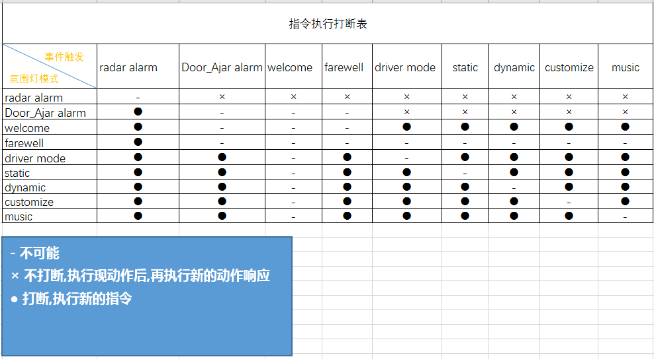

3.3.1 **principle**

1. Divide all modes into two categories, alarm mode and continuous mode. Alarm mode include radar/Door_Ajar alarm mode , welcome/farewell/normal/driver mode are continuous mode.

2.When one continuous mode changes to alarm mode, the effect will be interrupted(without fade off), alarm mode begin directly. When alarm mode stop, end the alarm effect(with fade off), select mode according to the current vehicle condition(with fade on).

3.When one continuous mode changes to another continuous mode, stop the old continuous mode(with fade off) and begin the new continuous mode(with fade on).

4.When high priority mode is running, and low priority mode’s configuration is changed, Aux should change signal automatically. For example:Aux_AmbLghtDrvMde_D_Rq=auto, the Driver changes the Aux_Color_Mode signal from static to customize, and Aux automatically changes Aux_AmbLghtDrvMde_D_Rq to manual, then the ambient lights enter normal- customize mode.

5. User change normal/driver mode param When radar alarm/welcome/farewell mode is running, ambient light save param but do not change to normal/driver mode effect, keep running radar alarm/welcome/farewell mode effect.

|  |  |  |  |
| --- | --- | --- | --- |
| **From** | **Change To** | **Effect** | **Aux Special Action** |
| welcome | welcome | - |  |
| farewell | 1.Keep effect |  |
| Door-Ajar alarm | 1.Interrupt welcome mode(without fade off) 2.Begin Door-Ajar alarm mode |  |
| radar alarm | 1.Interrupt welcome mode(without fade off) 2.Begin radar alarm mode |  |
| normal mode | 1.Stop welcome mode(fade off 1s) 2.Begin normal mode(fade on 1s) |  |
| driver mode | 1.Stop welcome mode(fade off 1s) 2.Begin driver mode(fade on 1s) |  |
| farewell | welcome | - |  |
| farewell | - |  |
| Door-Ajar alarm | 1.Interrupt farewell mode(without fade off) 2.Begin Door-Ajar alarm mode |  |
| radar alarm | 1.Interrupt farewell mode(without fade off) 2.Begin radar alarm mode |  |
| normal mode | - |  |
| driver mode | - |  |
| normal mode | welcome | - |  |
| farewell | 1.Keep effect |  |
| Door-Ajar alarm | 1.Interrupt normal mode(without fade off) 2.Begin Door-Ajar alarm mode |  |
| radar alarm | 1.Interrupt normal mode(without fade off) 2.Begin radar alarm mode |  |
| normal mode | - |  |
| driver mode | 1.Stop normal mode(fade off 1s) 2.Begin driver mode (fade on 1s) |  |
| driver mode | welcome | - |  |
| farewell | 1.Keep effect |  |
| Door-Ajar alarm | 1.Interrupt driver mode(without fade off) 2.Begin Door-Ajar alarm mode |  |
| radar alarm | 1.Interrupt driver mode(without fade off) 2.Begin radar alarm mode |  |
| normal mode | 1.Stop driver mode(fade off 1s) 2.Begin normal mode (fade on 1s) | 1. Aux set Aux_AmbLghtDrvMde_D_Rq=manaual |
| driver mode | - |  |
| radar alarm | welcome | 1.Stop radar alarm mode 2.Begin welcome mode |  |
| farewell | 1.Stop radar alarm mode 2.Begin farewell mode |  |
| Door-Ajar alarm | 1.Interrupt radar mode(without fade off) 2.Begin Door-Ajar alarm mode |  |
| radar alarm | - |  |
| normal mode | 1.Stop radar alarm mode 2.Begin normal mode(Fade on 1s) |  |
| driver mode | 1.Stop radar alarm mode 2.Begin driver mode(Fade on 1s) |  |

# Color and Brightness define

Documnet：RGB_128color.xls

# Communication Interface

## LIN communication

### Interface type

The ambient light module acts as a slave node in the lin network with a lin communication rate 10.417 kbps.

### Peripheral circuit

**Interface circuit requirements Aux module vehicle controllers are as follows:：**

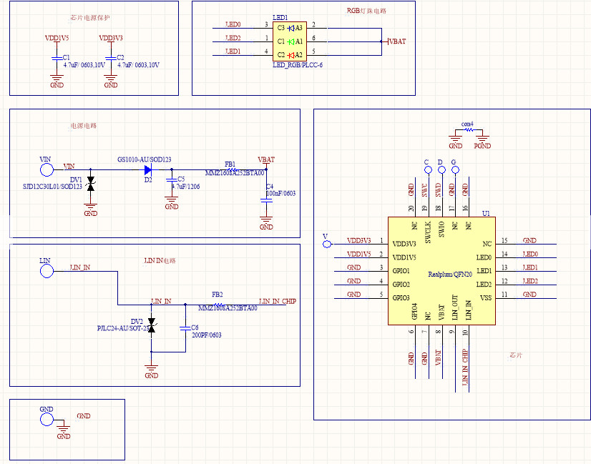

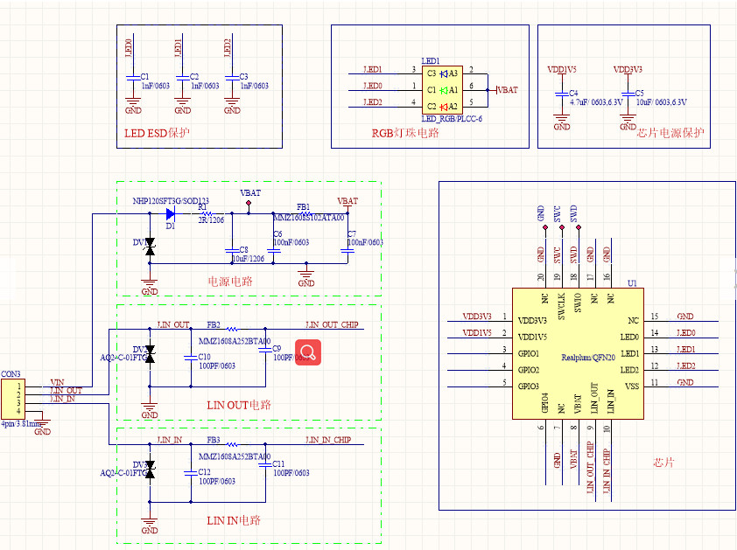

# Environmental performance requirements

## Temperature

Storage temperature：-40℃～ +90℃；

Work temperature：-30℃～ +85℃；

Humidity：5%～95%；

voltage：9-16V。

## Mechanical sector indicators

The clearance requirements meet the requirements of the vehicle clearance tolerance.

## Appearance and mechanical structure

Connectors, connectors and connectors should be reliable, electrical contacts are good, no loosening, shedding phenomenon, and should comply with the relevant provisions of Chapter 6 of the gb/t 12281-1990.

## Fundamental performance parameter

The basic performance of the product shall meet the performance requirements specified in the drawings.

## EMC

shall comply with the requirements specified in the Ford Company Test Specification.

## Environmental suitability

The environmental test shall comply with the provisions of the general test requirements for Ford components.

## Vibration test

The vibration test shall comply with the provisions of the general test requirements for Ford components.。

## Drop test

Drop test shall be in accordance with Ford parts general test requirements.

## Mechanical impact test

Mechanical impact test shall be in accordance with Ford parts general test requirements.

## Temperature and humidity resistance cycle

The temperature and humidity cycling test shall be in accordance with Ford's general test requirements for parts.

## Switch durability

No switch button.

## Normal voltage cycle

All functions of the product work normally after the voltage cycling test.

## Waterproof and dustproof test

There is no dust and water-proof requirement.。

## Resistance to abnormal power supply voltage

The abnormal voltage resistance test shall be in accordance with Ford parts general test requirements.

# Other requirements