

**Traffic Jam Assist+**

**Instrument Cluster Interface Specification**

**CGEA 1.3**

|  |
| --- |
| Issued by (dept, name, phone) |
| *EESE, Pradeep Nold, +492219032719* |

# Contents

0. Contents 2

0.1 List of Requirements: 2

0.2 List of tables 2

0.3 List of Graphics 3

1. INTRODUCTION 5

1.1 Revision history 5

2. Terminology 8

2.1 Definitions 8

2.2 Identification of requirements 8

3. TJA+ requirements 10

3.1 Functional Description 10

3.2 TJA+ Requirements 10

3.3 TJA+ Performance and Reliability 44

## List of Requirements:

CGEA13_CS_TJA+_IPCDisplay-01:Req1v8 TJA+ Primary Displays 11

CGEA13_CS_TJA+_IPCDisplay-001:Req3v10 TJA Primary Displays – combiner HUD 31

CGEA13_CS_TJA+_IPCDisplay-014:Req11v3 TJA Primary Displays – Advanced HUD 36

CGEA13_CS_TJA+_IPCDisplay-001:Req2v4 TJA+ ~~Warning~~ Information Message Displays 43

CGEA13_CS_TJA+_IPCDisplay-014:Req10v1 TJA+ Arbitration of TJA and CADS messages for HUD & IPC 44

CGEA13_CS_TJA+_IPCDisplay-001:Req4v6 TJA+ Audible Warning Settings 45

CGEA13_CS_TJA+_IPCDisplay-001:Req5v9 TJA+ Parameter Definitions 46

CGEA13_CS_TJA+_IPCDisplay-001:Req7v1 TJA+ Response Time 50

CGEA13_CS_TJA+_IPCDisplay-001:Req9v6 Enabling criteria for displaying TJA-related 50

CGEA13_CS_TJA+_IPCDisplay-001:Req8v2 TJA+ Missing Message 51

CGEA13_CS_TJA+_IPCDisplay-001:Req6v4 TJA+ Audible Warning, sound type 51

## List of tables

Table 1 Relevance of tables for certain cluster types 22

Table 2: TJA status display for thin continous display (RTT) 22

Table 3: TJA warning display for thin continous displays (RTT) 23

Table 4:TJA status display for on demand and persistent Driver Assist screen (legacy) 23

Table 25: TJA status display & warnings for on demand Driver Assist screen with LKS RTT **after** DCR 24

Table 26: Definition of display elements for persistent Driver Assist screen without LKS RTT **after** DCR 25

Table 5:TJA warning display for on demand and persistent Driver Assist screen 25

Table 15: TJA status display & warnings for persistent Driver Assist screen without LKS RTT **prior** DCR 27

Table 16: Definition of display elements for persistent Driver Assist screen without LKS RTT **prior** DCR 28

Table 17: TJA status display & warnings for persistent Driver Assist screen without LKS RTT **after** DCR 29

Table 18: Definition of display elements for persistent Driver Assist screen without LKS RTT **after** DCR 30

Table 7**:** TJA HUD textual Warning indication 33

Table 8: TJA HUD status indication (lines & steering wheel) for legacy C519 33

Table 27: TJA cHUD status indication and warnings (lines & steering wheel) 34

Table 28: cHUD Definition of display elements for persistent Driver Assist screen 35

Table 19**:** TJA aHUD textual Warning indication 38

Table 20: TJA aHUD status indication and warnings (lines & steering wheel) for Lincoln 39

Table 21: aHUD Definition of display elements for persistent Driver Assist screen without LKS RTT prior DCR 40

~~Table 22: TJA aHUD status indication and warnings (lines & steering wheel) after DCR~~ 41

~~Table 23: aHUD Definition of display elements for persistent Driver Assist screen without LKS RTT after DCR~~ 42

Table 9: Defining activation message for TJA+ 43

Table 24**:** Definition of priority between ACC S&G messages and TJA messages displayed in the text area 44

Table 10: State Chart for TJA Chimes Levels 45

Table 11: Parameter definition of CAN signal inputs 46

Table 12: Parameter definition of CAN signal outputs 46

Table 13: Parameter definition of display parameters 47

Table 14: Internal Parameter definitions 48

## List of Graphics

Graphic 1: TJA Telltale, TJA Active, Driver Assist Screen 11

Graphic 2: TJA Telltale, TJA Active, Trip Overview Screen 11

Graphic 3: Visual Hands Off Warning (W1014, W1014a 12

Graphic 4: Visual TJA Cancel Warning 12

Graphic 5: Visual Takeover Warning (W3563) 12

Graphic 6: Visual TJA Hands-off LDW on the right (W3601) 12

Graphic 7: Visual TJA Hands-off LDW on the left (W3600) 13

Graphic 8: Hands of Warning level 1 (W1014) 13

Graphic 9: Hands of Warning level 2 (W1014a) 13

Graphic 10: TJA Lines + TJA Steering Wheel 14

Graphic 11: Visual TJA Cancel Warning 14

Graphic 12: Persistent TJA Lines + TJA Steering Wheel (active) 14

Graphic 13: PersistentTJA Lines + TJA Steering Wheel (Standby) 15

Graphic 14: Persistent Visual TJA Cancel Warning 15

Graphic 15: Visual Takeover (W3563) 16

Graphic 16: Visual TJA Hands-off LDW on the right (W3601) 16

Graphic 17: Visual TJA Hands-off LDW on the left (W3600) 16

Graphic 18: Hands of Warning level 1 (W1014) 16

Graphic 19: Hands of Warning level 2 (W1014a) 17

Graphic 20: Visual Hands Off Warning (W1014) 17

Graphic 21: Visual Takeover (W3563) 17

Graphic 22: Persistent TJA Lines + TJA Steering Wheel (active, w/o LKS RTT, prior DCR) 17

Graphic 23: Persistent TJA Lines + TJA Steering Wheel (standby LKS off, w/o LKS RTT, prior DCR) 18

Graphic 24: Persistent TJA Lines + TJA Steering Wheel LKS (standby LDW active, w/o LKS RTT, prior DCR) 18

Graphic 25: Persistent TJA Lines + TJA Steering Wheel (standby LKA active, w/o LKS RTT, prior DCR) 19

Graphic 26: Persistent TJA Lines + TJA Steering Wheel (standby LKS off, w/o LKS RTT, after DCR) 19

Graphic 27: Persistent TJA Lines + TJA Steering Wheel LKS (standby LKS active, w/o LKS RTT, after DCR) 19

Graphic 28: Persistent TJA Lines + TJA Steering Wheel (active, LKS off, w/o LKS RTT, after DCR) 20

Graphic 29: Persistent TJA Lines + TJA Steering Wheel (active, LKS on, w/o LKS RTT, after DCR) 20

Graphic 30: Persistent TJA Lines + TJA Steering Wheel Warning right (w/o LKS RTT) 20

Graphic 31: Persistent TJA Lines + TJA Steering Wheel Intervention right (w/o LKS RTT) 20

Graphic 32: Visual Hands Off Warning (W1014, w/o LKS RTT) 21

Graphic 33: Persistent Visual TJA Cancel Warning (w/o LKS RTT) 21

Graphic 34: Visual Takeover persistent display (W3563) 21

Graphic 35: Visual TJA Hands-off LDW on the left persistent display (W3600) 21

Graphic 36: Visual TJA Hands-off LDW on the right persistent display (W3601) 22

Graphic 37: Visual Hard Take Over Warning in HUD (W3563), graphic update pending 31

Graphic 38: Visual TJA Cancel Warning in HUD 31

Graphic 39: TJA Lines in HUD with steering wheel, TJA Active 32

Graphic 40: Visual TJA Hands Off LDW on the right (W3601) 32

Graphic 41: Visual TJA Hands Off LDW on the left (W3600)w 32

Graphic 42: Visual Hard Take Over Warning in HUD (W3563), 36

Graphic 43: Visual TJA Cancel Warning in HUD 36

Graphic 44: TJA Lines in HUD with steering wheel, TJA Active 36

Graphic 45: Visual TJA Hands Off LDW on the right (W3601) 36

# INTRODUCTION

## Revision history

| Version | Date | Description | Responsible | Approved by |
| --- | --- | --- | --- | --- |
| 001 | 2015-09-18 | First version created | Manuel Merz |  |
| 002 | 2015-10-28 | Version 2, added HUD chapter | Manuel Merz |  |
| 003 | 2015-12-04 | Version 3, changed Req 1, 2, 31, 4, 26, and 5 | Manuel Merz |  |
| 004 |  |  |  |  |
| 005 | 2016-02-18 | Version5, updated all pictures to new assumption, updated signal names according dbc, deleted “TJA Intervention” and “TJA Warning” states (Because they are not shown anymore from TJA) | Manuel Merz |  |
| 006 | 2016-04-04 | Version 6,  -again updated all pictures to new assumption, including table 3 and table 6 -updated “TJA_Lines_On_Demand” and “TJA_Lines_HUD” to new assumptions -updated TJA_HUD_Display according ACC Cluster Spec. v24 | Manuel Merz |  |
| 007 | 2016-04-18 | Version 7:  -Updated GIS info  -Added note in CGEA13_CS_TJA+_IPCDisplay-020:Req33v2 TJA Primary Displays – HUD  - Updated Chime names in CGEA13_CS_TJA+_IPCDisplay-001:Req24v2  - Updated table 6 in CGEA13_CS_TJA+_IPCDisplay-020:Req33v3  - Updated table 3 in CGEA13_CS_TJA+_IPCDisplay-01:Req1v2  - Updated table 15 in CGEA13_CS_TJA+_IPCDisplay-001:Req5v2: TJA_Lines_On_Demand and TJA_Lines_HUD | Pradeep Nold |  |
| 008 | 2016-06-03 | Version 8: -removed “CGEA13_CS_TJA+_IPCDisplay-020:Req31v2 “ -updated “CGEA13_CS_TJA+_IPCDisplay-020:Req33v4” Table 5 -updated “CGEA13_CS_TJA+_IPCDisplay-001:Req5v3” Table 12 | Manuel Merz |  |
| 0009 | 2016-06-19 | Version 9: - Removed empty cells in various tables for better readability | Pradeep Nold |  |
| 0010 | 2016-07-08 | Version 10: - updated “CGEA13_CS_TJA+_IPCDisplay-01:Req1v3” Table 1 & Table 3 - updated “CGEA13_CS_TJA+_IPCDisplay-020:Req33v5” Table 6 - updated “CGEA13_CS_TJA+_IPCDisplay-018:Req4v2” Table 9, added - updated “CGEA13_CS_TJA+_IPCDisplay-018:Req5v3” table 13- removed config for chime on request from DI forum  HardTakeOverLevel1 line *changes highlighted in yellow | Manuel Merz |  |
| 0011 | 2016-08-15 | Version 11: - updated “CGEA13_CS_TJA+_IPCDisplay-018:Req4v2” Table 9, removed config for chime in accordance to Req5 Table13 and change Chime reference from “ACC_LOW_PRIORITY” to ”TJA_LOW_PRIORITY” -updated CGEA13_CS_TJA+_IPCDisplay-001:Req5 table 12 to refer to Message priorisation -updated “CGEA13_CS_TJA+_IPCDisplay-001:Req24v2 “ change Chime reference from “ACC_LOW_PRIORITY” to “TJA_LOW_PRIORITY” | Pradeep Nold |  |
| 0012 | 2016-11-03 | Version 12: - updated: CGEA13_CS_TJA+_IPCDisplay-01:Req1v4: changed HTO display and added TJA-hands-off-LDW -changed requirement no from req33 to req3: CGEA13_CS_TJA+_IPCDisplay-020:Req3v6: changed HTO display and added TJA-hands-off-LDW -updatedCGEA13_CS_TJA+_IPCDisplay-020:Req2v2: updated reference to CADS Cluster Interface Spec  -updated: CGEA13_CS_TJA+_IPCDisplay-018:Req4v3: added chime for TJA-hands-off-LDW -changed requirement no from Req13 to Req8: CGEA13_CS_TJA+_IPCDisplay-021:Req8v1: No change in requirement changed requirement no from Req24 to Req6:CGEA13_CS_TJA+_IPCDisplay-001:Req6v3: Added new chime status flags | Pradeep Nold |  |
| 0013 | 2017-03-28 | CGEA13_CS_TJA+_IPCDisplay-01:Req1v5: Updated for persistent displays (e.g.Sx), removed ambiguity from table 3 and table 5, moved cancel from table 5 to table 4 to separate lines and text better.  CGEA13_CS_TJA+_IPCDisplay-020:Req3v7: Updated table 7 and table 8 to separate lines and text better and removed ambiguity  CGEA13_CS_TJA+_IPCDisplay-020:Req2v3: removed in table 9 states already referenced in CADS Interface Specification  CGEA13_CS_TJA+_IPCDisplay-018:Req4v5: Updated in table 10 to new chime Status flags  CGEA13_CS_TJA+_IPCDisplay-001:Req5v6:: Updated to reflect changes from respective table (better separation of state and text and added chime status flags)  CGEA13_CS_TJA+_IPCDisplay-018:Req9v2: Updated to allow TJA information to be shown during crank and removed error detection as this is covered by CADS Cluster Interface Specification  CGEA13_CS_TJA+_IPCDisplay-001:Req6v4 : Updated to reference new chime status flags |  |  |
| 0013.1 | 2017-04-11 | CGEA13_CS_TJA+_IPCDisplay-018:Req9v3: Updated to cover crank situation also in IgnitionStatus signal  CGEA13_CS_TJA+_IPCDisplay-018:Req4v6: Updated table 10 to remove ambiguities  CGEA13_CS_TJA+_IPCDisplay-001:Req5v7: Updated table13 to contain reference to La Hands off Warning flag (La_HandsOff_Dsply_Msg_Status_Flag, La_HandsOff_Dsply_Msg2_Status_Flag) |  |  |
| 0014 | 2017-11-07 | CGEA13_CS_TJA+_IPCDisplay-01:Req1v6 updated to allow LKS interventions/warnings to be displayed according HMI simplifications.  Added table12 for persistent displays without LKS RTT.  Updated Table 2 to match current HMI. Removed in Table 5 not used TJA_CANC  CGEA13_CS_TJA+_IPCDisplay-001:Req3v8: Removed Table 6.  CGEA13_CS_TJA+_IPCDisplay-014:Req11v1: Added requirement for aHUD  CGEA13_CS_TJA+_IPCDisplay-014:Req10v1 added to define interaction to CADS messages (ACCOverride and ACCResReady)  CGEA13_CS_TJA+_IPCDisplay-001:Req8v2 Updated to define TJA display action in case of missing message  CGEA13_CS_TJA+_IPCDisplay-001:Req9v5 error handling removed and updated requirements for display enabling criteria to be consistent with CADS |  |  |
| 0014.1 | 2018-01-31 | CGEA13_CS_TJA+_IPCDisplay-01:Req1v7: Added examples from U611 (prior DCR) and U625 (after DCR) Updated table 1 to reflect U611 and U625 Added Condition for Operatioanl_Mode to tables 2, 3, 4 5 Updated tables 4, 15,to allow showing TJA information in case of certain warnings Added tables 17 and18 to match HMI after DCR  CGEA13_CS_TJA+_IPCDisplay-001:Req3v9:  Added Condition for Operatioanl_Mode to tables 7, 8 Updated table 8 to allow showing TJA information in case of certain warnings  CGEA13_CS_TJA+_IPCDisplay-014:Req11v2:  Added Condition for Operatioanl_Mode to table 19 Updated tables 20 and 22 to allow showing TJA information in case of certain warnings  CGEA13_CS_TJA+_IPCDisplay-001:Req2v4: Changed title (replaced Warning with Information) Added Condition for Operatioanl_Mode to table 9 and cleaned up table 9  CGEA13_CS_TJA+_IPCDisplay-001:Req5v8: Updated Table 11  CGEA13_CS_TJA+_IPCDisplay-001:Req9v6  Remeoved requirement on steat C and replaced with Operational_Mode |  |  |
| 0014.2 | 2018-03-19 | CGEA13_CS_TJA+_IPCDisplay-01:Req1v8:  Updated Table 2 & 4 to show Interventions and Warnings in RTT,  Added table 25 & 26 to reflect HMI change,  Updated table 15 & 16 to harmonise with LKS Updated table 17 to remove ambiguity  CGEA13_CS_TJA+_IPCDisplay-001:Req3v10:  Added table 27 & 28 to reflect HMI change Updated Table 7 to only show HO warning when TJA is active (when off or Standby this is defined in LKS-STSS/ not show HO when LKS is not selected to be displayed and TJA is <active)  Added Config parameter to be able to discriminate when to use table 8 vs table 27+28  CGEA13_CS_TJA+_IPCDisplay-014:Req11v3:  Updated table 20 to remove ambiguity and provide clarification, also harmonising with cHUD  Updated Table 19 to only show HO warning when TJA is active (when off or Standby this is defined in LKS-STSS/ not show HO when LKS is not selected to be displayed and TJA is <active)  Removed table 22 & 23  CGEA13_CS_TJA+_IPCDisplay-001:Req5v9:  Updated table 13 to reflect changes in table 2 & 4 added parameter for TJA_Lines_aHUD and TJA_Lines_cHUD Added table 14: Condition for LKS_HUD_Display, LKS_Metaphor_Cfg parameter for backward compatability |  |  |
| 14.3 | 2018-06-22 | CGEA13_CS_TJA+_IPCDisplay-01:Req1v9 : Table 1 updated Table 25, 15 and 17 updated to remove ambiguity  CGEA13_CS_TJA+_IPCDisplay-001:Req3v11: Updated Table 27 to remove ambiguity and added parameter for clarity  CGEA13_CS_TJA+_IPCDisplay-014: Req11v4: Table 20 and 21 updated to remove ambiguity to table 19  CGEA13_CS_TJA+_IPCDisplay-001:Req5v10: Updated Table 13 to reflect changes of table 20 and 21 and 27 |  |  |

# Terminology

## Definitions

| Definition | Description |
| --- | --- |
| CADS | Collision Avoidance & Driver Support |
| CC | Cruise Control (Superset of NCC and ACC) |
| TJA+ | Traffic Jam Assist+ |
| ACC | Adaptive Cruise Control |
| LCA | Lane Centering Assist aka TJA+ |
|  |  |

## Identification of requirements

**Ex. DocID-IssueIndex** : **ReqNrVersNr**

When a requirement is introduced it is given a tag including a requirement number. This tag follows the requirement throughout the development process. In this document requirements are identified using a tag consisting of two parts. The first part consists of the document ID and the document issue in which the requirement was introduced *or* updated. The second part consists of the requirement number and the requirement version. A colon separates each part. A requirement tag shall be unique, i.e. there must not exist two different requirements with the same requirement tag. The same requirement may however be used more than once (i.e. the same requirement may exist several times, even within the same document).

*<The document owner is responsible for defining a suitable document ID. Since a requirement may be used in other documents (i.e. not only in its source document) it is very important that this ID is unique and not used to identify any other document. Otherwise there is a risk that two or more different requirements will have exactly the same requirement tag. Try to define an ID that is as descriptive as possible.>*

*Example:*

*SRD-5A-001:Req4v1 This requirement was introduced in the first issue of the document with ID SRD-5A. The requirement number is 4 and it is the first version.*

*CS-FA7A-3-003:Req1v2 This requirement was updated in the third issue of the document with ID CS-FA7A-3. The requirement number is 1 and it has been updated to a second version (CS could e.g. be an abbreviation for Class Specification, FA7A could be an ID for the function area and 3 could be an ID for a class within this function area).*

*SWRS-PJB-003:Req9v1 This requirement was introduced in the third issue of document with ID SWRS-PJB. The requirement number is 9 and it is introduced for the first time in document issue 003 (PJB could e.g. be an abbreviation for an ECU).*

*<Two predefined macros are available in the SRD template to help in tagging the requirements. Insert a new requirement with the "InsertNewReq" macro and update an existing requirement with the macro "UpdateExistingReq". When running these macros a dialog box appears where the following information is to be inserted:*

*DocumentID: This field should be set to the ID you select for your document (e.g. SRD-5A, where 5A a number identifying the system). The document owner are free to choose any ID, but it is important to select one that is unique (i.e. not used by any other document) since it is this part that will make the requirement tag unique. The ID is changed from the Properties Dialogue (File -> Properties and the tab “Custom”)*

*Doc Issue: This field is set to the issue index of the document. The issue index is changed from the Properties Dialogue (File->Properties and the tab Custom).*

*ReqNr: The number of the requirement. If a new requirement is to be inserted, the macro proposes the next number according to the "HighestReqNr" property (File -> Properties and the tab “Custom”-> HighestReqNr). Otherwise this field is by default empty.*

*VersionNr: The version number of the requirement. If a new requirement is to be inserted, the version number is automatically set to 1. Otherwise this field is by default empty.*

*ContextID: This field should be set to the identifier of the domain in which you are working in (e.g. the system area for SRD or class specification, or the component for SWRS). The information is used to name the requirement styles in this document. This makes it possible for SWRS writers to automatically create lists showing changes in a new SRD releases from the previous ones.*

*When pressing OK in the dialog box the macro will automatically select or create the right styles for the requirement, create a requirement tag and create the sub sections of the requirement TJA+ording to the information in the dialog box. Please note that it is important that the styles for the requirements are not changed. Doing so may make the requirement technique and macros to malfunction.*

*The macros described are generic and used in a number of different specifications within the electrical development process. In order to get the macros to work correctly the type of specification must be specified in the property dialog box for this document (Properties Dialogue (File -> Properties and the tab “Custom”->SpecType). The coding of the field is as follows:*

*0: Specification type not defined.*

*1: FAD (Function Area Description)*

*2: SRD (System Requirement and Description)*

*3: SWRS (Software Requirement Specification*

*4: CS (Class specification)*

*5: SWDC.*

*6. Specification type not defined. >*

# TJA+ requirements

## Functional Description

The purpose of the Traffic Jam Assist+ Function is to inform the driver of Traffic Jam Assist+ status (on, off, standby), warnings to the driver and system malfunction information.

The Traffic Jam Assist+ function transmits operational mode to display the appropriate warning or INFO display in the HMI (IPC and HUD) and/or sound the appropriate chime.

## TJA+ Requirements

CGEA13_CS_TJA+_IPCDisplay-01:Req1v9 TJA+ Primary Displays

Req ID:

Purpose: [TJA+] [IPC]

Verification Method:

**Req:**

The following state charts define the graphic and textual displays for the primary TJA+ display area of the IPC. For Definitions of the Input and Output parameters in the state chart, see req5

Table 2 defines the display state for the primary Traffic Jam Assist+ feature with a thin continuous display (bottom line) and any on-demand screen (**including** Driver Assist screen)

Graphic 1: TJA Telltale, TJA Active, Driver Assist Screen

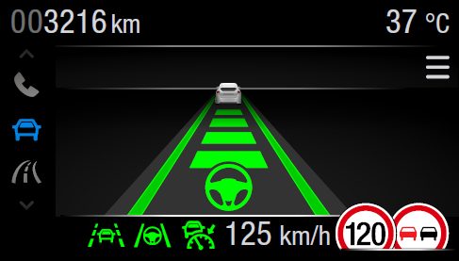

Graphic 2: TJA Telltale, TJA Active, Trip Overview Screen

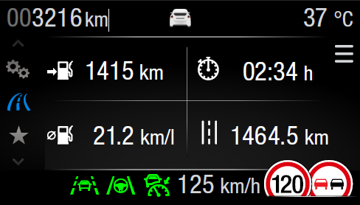

Table 3 defines the warning state for the primary Traffic Jam Assist+ feature for implementations with a thin continuous display (bottom line) and any on-demand screen (**excluding** Driver Assist screen)

Graphic 3: Visual Hands Off Warning (W1014, W1014a

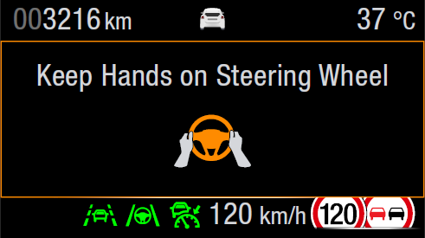

Graphic 4: Visual TJA Cancel Warning

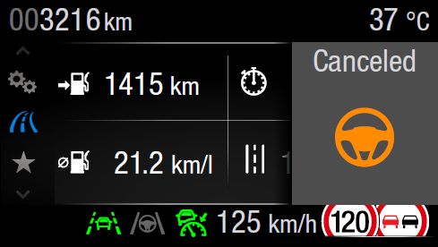

Graphic 5: Visual Takeover Warning (W3563)

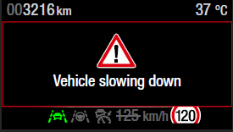

Graphic 6: Visual TJA Hands-off LDW on the right (W3601)



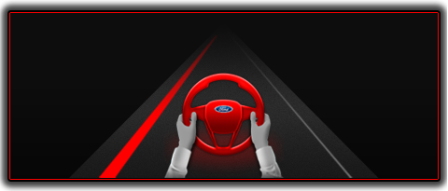Graphic 7: Visual TJA Hands-off LDW on the left (W3600)

Graphic 8: Hands of Warning level 1 (W1014)

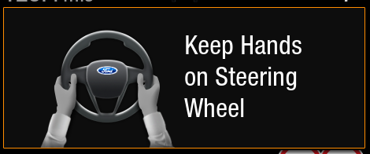

Graphic 9: Hands of Warning level 2 (W1014a)

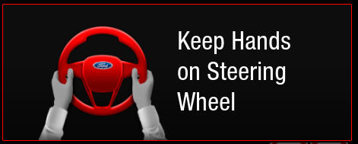

Table 4 defines the display state for the primary Traffic Jam Assist+ feature for implementations with the **Driver Assist on-demand screen** or **persistent/ permanent Driver Assist screen with dedicated LKS (LDW/LKA) RTT**

Graphic 10: TJA Lines + TJA Steering Wheel



Graphic 11: Visual TJA Cancel Warning

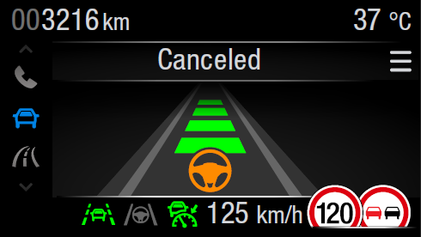

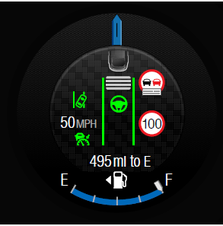Graphic 12: Persistent TJA Lines + TJA Steering Wheel (active)

Graphic 13: PersistentTJA Lines + TJA Steering Wheel (Standby)

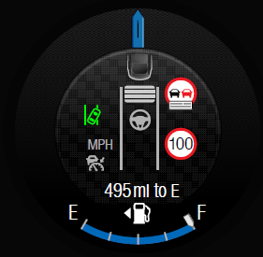

Graphic 14: Persistent Visual TJA Cancel Warning

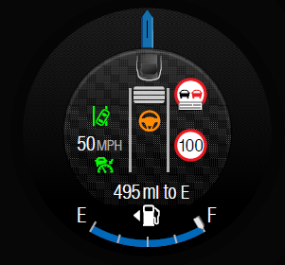

If there is line representation of TJA is shared with LKS, TJA takes priority, when TJA is in either TJA_STANDBY, TJA_ACTIVE or TJA_CANC_ODS and LKS information is displayed via the RTT/telltale

Note: The above shall have no impact on the LDW/LKA RTT behaviour and

Table 5 defines the warning state for the primary Traffic Jam Assist+ feature for implementations with the **Driver Assist on-demand screen** or **persistent/ permanent Driver Assist screen with dedicated LKS (LDW/LKA) RTT**

Graphic 15: Visual Takeover (W3563)



Graphic 16: Visual TJA Hands-off LDW on the right (W3601)

Graphic 17: Visual TJA Hands-off LDW on the left (W3600)



Graphic 18: Hands of Warning level 1 (W1014)



Graphic 19: Hands of Warning level 2 (W1014a)



Graphic 20: Visual Hands Off Warning (W1014)

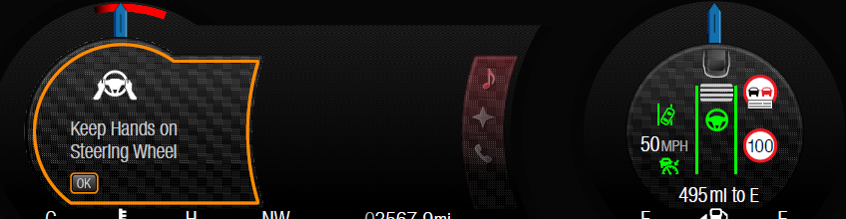

Graphic 21: Visual Takeover (W3563)

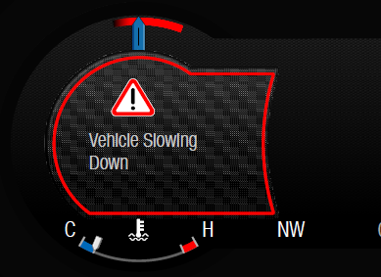

Graphic 22: Persistent TJA Lines + TJA Steering Wheel (active, w/o LKS RTT, prior DCR)

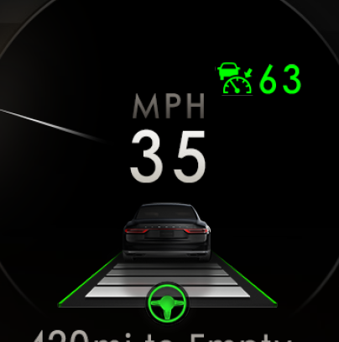

Graphic 23: Persistent TJA Lines + TJA Steering Wheel (standby LKS off, w/o LKS RTT, prior DCR)

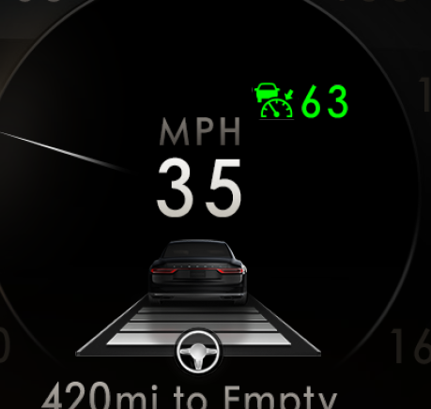

Graphic 24: Persistent TJA Lines + TJA Steering Wheel LKS (standby LDW active, w/o LKS RTT, prior DCR)

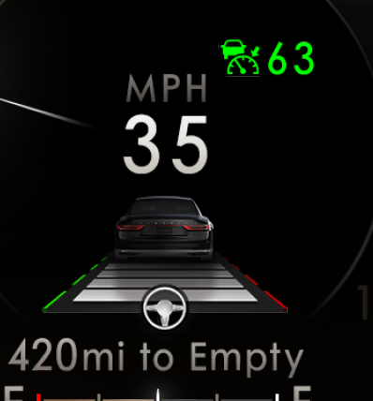

Graphic 25: Persistent TJA Lines + TJA Steering Wheel (standby LKA active, w/o LKS RTT, prior DCR)

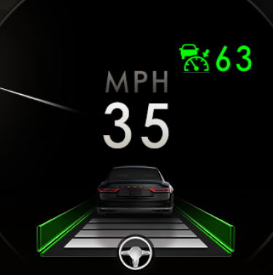

Graphic 26: Persistent TJA Lines + TJA Steering Wheel (standby LKS off, w/o LKS RTT, after DCR)

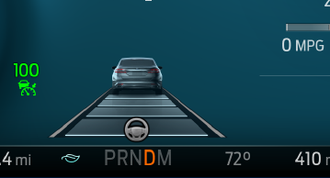

Graphic 27: Persistent TJA Lines + TJA Steering Wheel LKS (standby LKS active, w/o LKS RTT, after DCR)

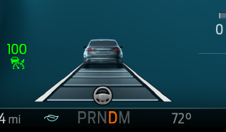

Graphic 28: Persistent TJA Lines + TJA Steering Wheel (active, LKS off, w/o LKS RTT, after DCR)

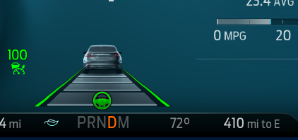

Graphic 29: Persistent TJA Lines + TJA Steering Wheel (active, LKS on, w/o LKS RTT, after DCR)

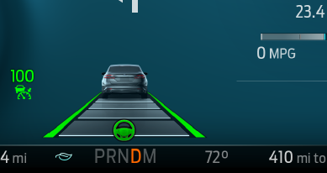

Graphic 30: Persistent TJA Lines + TJA Steering Wheel Warning right (w/o LKS RTT)

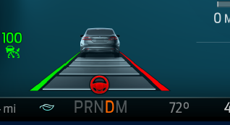

Graphic 31: Persistent TJA Lines + TJA Steering Wheel Intervention right (w/o LKS RTT)

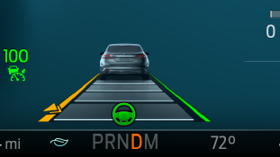

Graphic 32: Visual Hands Off Warning (W1014, w/o LKS RTT)

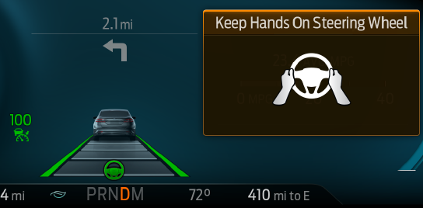

Graphic 33: Persistent Visual TJA Cancel Warning (w/o LKS RTT)

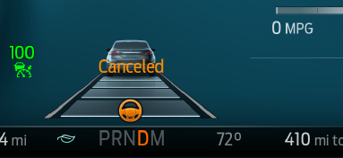

Graphic 34: Visual Takeover persistent display (W3563)

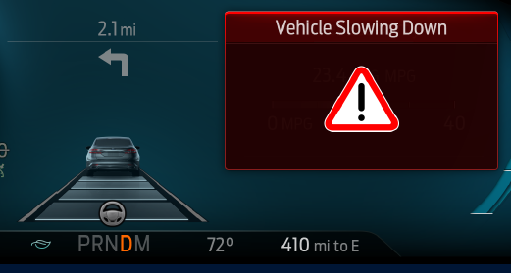

Graphic 35: Visual TJA Hands-off LDW on the left persistent display (W3600)

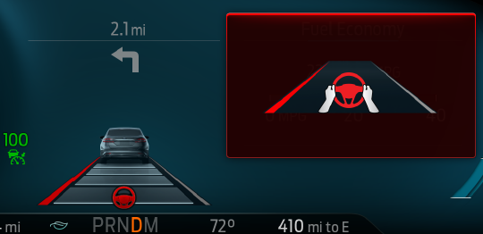

Graphic 36: Visual TJA Hands-off LDW on the right persistent display (W3601)

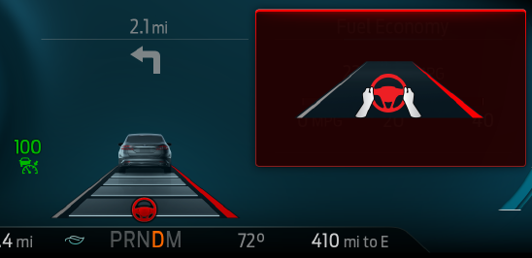

Examples for the mapping between display tables/figures and clusters/programs are shown below in Table 1.

Table 1 Relevance of Req1 tables for certain cluster types

|  |  |  |  |  |  |
| --- | --- | --- | --- | --- | --- |
|  | On demand Driver Assist Screen (S2) v1 | On demand Driver Assist Screen (S2) v2 | Persistent driver Assist Screen **with LKS RTT** (M2, M3) | Persistent driver Assist Screen **w/o LKS RTT**  ***Prior DCR***  (Sx-U540) | Persistent driver Assist Screen **w/o LKS RTT**  ***After DCR***  (Sx Cd6, Cx48x, S2.5) |
| Table 2 | Required | Required | Not Required | Not Required | Not Required |
| Table 3 | Required | Required | Not Required | Not Required | Not Required |
| Table 4 | Required | Not Required | Required | Not Required | Not Required |
| Table 5 | Required | Required | Required | Required | Required |
| Table 15/16 | Not Required | Not Required | Not Required | Required | Not Required |
| Table 17/18 | Not Required | Not Required | Not Required | Not Required | Required |
| Table 25/26 | Not Required | Required | Not Required | Not Required | Not Required |

Table 2: defines the status display state for the primary Traffic Jam Assist+ feature for implementations with a thin continuous display (bottom line/RTT or Telltale) and any on-demand screen (including Driver Assist screen)

Table 2: TJA status display for thin continous display (RTT)

|  |  |  |  |
| --- | --- | --- | --- |
| **Operational_Mode** | **Traffic_Jam_Assist_Cfg** | **Tja_D_Stat** | **TJA_Func_Disp_Thin** |
| NORMAL or CRANK | Enabled | Off (0x0) | Ina |
| Standby (0x1) | TJA_STANDBY |
| Active (0x2) | TJA_ACTIVE |
| ActiveInterventionLeft (0x3) | TJA_ACTIVE |
| ActiveInterventionRight (0x4) | TJA_ACTIVE |
| ActiveWarningLeft (0x5) | TJA_ACTIVE |
| ActiveWarningRight (0x6) | TJA_ACTIVE |
| ALL OTHER CASES | | | Ina |

Note: The above shall have no impact on the LDW/LKA RTT behaviour

Table 3 Defines the warning display states for the primary Traffic Jam Assist+ feature for implementations with a thin continuous display (bottom line/RTT or Telltale) and any on-demand screen (**excluding** Driver Assist screen)

Table 3: TJA warning display for thin continous displays (RTT)

|  |  |  |  |  |  |  |
| --- | --- | --- | --- | --- | --- | --- |
| **Driver Assist on-demand screen** | **Traffic_Jam_Assist_Cfg** | **Operational_Mode** | **LaHandsOff_D_Dsply** | **TjaWarn_D_Rq** | **Tja_D_Stat** | **TJA_Warn_Disp_Thin** |
| FALSE | Enabled | Normal or Crank | Ina (0x0) | Ina (0x0) | Not 0x5, not 0x6 | Ina |
| Level1 (0x1) | Ina (0x0) | Not 0x5, not 0x6 | TJA_HO_VIS |
| Level2 (0x2) | Ina (0x0) | Not 0x5, not 0x6 | TJA_HO_AUDIO_VIS |
| X | TrafficJamAssistCancel (0x1) | X | TJA_CANC |
| X | HardTakeOverLevel1 (0x2) | X | TJA_HTO_VIS |
| X | HardTakeOverLevel2 (0x3) | X | TJA_HTO_VIS |
| X | Ina (0x0) | ActiveWarningLeft (0x5) | TJA_HO_LDW_LEFT |
| X | Ina (0x0) | ActiveWarningRight (0x6) | TJA_HO_LDW_RIGHT |
| ALL OTHER CASES | | | | Ina |

Table 4: defines the status display state for the primary Traffic Jam Assist+ feature for implementations with the Driver Assist on-demand screen or continuous/permanent Driver Assist screen with dedicated LKS (LDW/LKA) RTT

Table 4:TJA status display for on demand and persistent Driver Assist screen (legacy)

| **Driver Assist on-demand screen** | **TJA-Metaphor_Cfg** | **Operational_Mode** | **Traffic_Jam_Assist_Cfg** | **TjaWarn_D_Rq** | **Tja_D_Stat** | **TJA_Lines_On_Demand** |
| --- | --- | --- | --- | --- | --- | --- |
| TRUE | Version1 | NORMAL or Crank | Enabled | Not 0x1 | Off (0x0) | Ina |
| Not 0x1 | Standby (0x1) | TJA_STANDBY |
| Not 0x1 | Active (0x2) | TJA_ACTIVE |
| Not 0x1 | ActiveInterventionLeft (0x3) | TJA_ACTIVE |
| Not 0x1 | ActiveInterventionRight (0x4) | TJA_ACTIVE |
| Not 0x1 | ActiveWarningLeft (0x5) | TJA_ACTIVE |
| Not 0x1 | ActiveWarningRight (0x6) | TJA_ACTIVE |
| TrafficJamAssistCancel (0x1) | X | TJA_CANC_ODS |
| ALL OTHER CASES | | | | Ina |

If there is line representation of TJA is shared with LKS, TJA takes priority, when TJA is in either TJA_STANDBY, TJA_ACTIVE or TJA_CANC_ODS and LKS information is displayed via the RTT/telltale

Note: The above shall have no impact on the LDW/LKA RTT behaviour and

Table 25 and Table 26 define the display and warnings for the Traffic Jam Assist+ feature for implementations with on demand Driver Assist screen with LKS (LDW/LKA) RTT after DCR

Table 25: TJA status display & warnings for on demand Driver Assist screen with LKS RTT **after** DCR

| **TJA-Metaphor_Cfg** | Operational_Mode | **Traffic_Jam_Assist_Cfg** | **LaActvStats_D_Dsply** | **TjaWarn_D_Rq** | **Tja_D_Stat** | **TJA_Lines** |
| --- | --- | --- | --- | --- | --- | --- |
| Version2 | NORMAL or CRANK | Enabled | X | Ina (0x0) | Off (0x0) | Ina |
| 0xC OR 0x0 OR 1E | Not 0x1 | Standby (0x1) | TJA_STANDBY |
| NOT 0xC OR 0x0 OR 1E | Not 0x1 | Standby (0x1) | TJA_STANDBY_LKS |
| Not 0x8, 0x9, 0xD, 0xE, 0x10,0x11, 0x15, 0x16 | Not 0x1 | Active (0x2) OR ActiveInterventionLeft (0x3) OR ActiveInterventionRight (0x4) | TJA_ACTIVE |
| 0x8 OR 0xD | Not 0x1 | Active (0x2) OR ActiveInterventionLeft (0x3) OR ActiveInterventionRight (0x4) | TJA_ACT_WARN_LEFT |
| 0x10 OR 0x11 | Not 0x1 | Active (0x2) OR ActiveInterventionLeft (0x3) OR ActiveInterventionRight (0x4) | TJA_ACT_WARN_RIGHT |
| 0x9 OR 0xE | Not 0x1 | Active (0x2) OR ActiveInterventionLeft (0x3) OR ActiveInterventionRight (0x4) | TJA_ACT_INTERVENE_LEFT |
| 0x15, 0x16 | Not 0x1 | Active (0x2) OR ActiveInterventionLeft (0x3) OR ActiveInterventionRight (0x4) | TJA_ACT_ INTERVENE _RIGHT |
| x | 0x0 | ActiveWarningLeft (0x5) | TJA_HO_LDW_LEFT |
| x | 0x0 | ActiveWarningRight (0x6) | TJA_HO_LDW_RIGHT |
| 0xC OR 0x0 OR 1E | TrafficJamAssistCancel (0x1) | X | TJA_CANC |
| NOT 0xC OR 0x0 OR 1E | TrafficJamAssistCancel (0x1) | X | TJA_CANC_LKS |
| ALL OTHER CASES | | | | | Ina |

Table 26: Definition of display elements for persistent Driver Assist screen without LKS RTT **after** DCR

| **TJA_Lines** | **Left Line** | **Right Line** | **Steering wheel** | **Text** |
| --- | --- | --- | --- | --- |
| Ina | No TJA information displayed follow LKS STSS | | | |
| TJA_STANDBY | Grey Solid | Grey Solid | Grey | None |
| TJA_STANDBY_LKS | LKS STSS | LKS STSS | Grey | LKS STSS |
| TJA_ACTIVE | Green Solid | Green Solid | Green | None |
| TJA_ACT_WARN_LEFT | Red Solid | Green Solid | Green | None |
| TJA_ACT_WARN_RIGHT | Green Solid | Red Solid | Green | No Text |
| TJA_ACT_INTERVENE_LEFT | Yellow Solid | Green Solid | Green | No Text |
| TJA_ACT_ INTERVENE _RIGHT | Green Solid | Yellow Solid | Green | No Text |
| TJA_HO_LDW_LEFT | Red Solid | Grey Solid | Red | “Keep Hands on Steering Wheel”(W3600) |
| TJA_HO_LDW_RIGHT | Gray Solid | Red Solid | Red | “Keep Hands on Steering Wheel”(W3601) |
| TJA_CANC | Grey Solid | Grey Solid | Amber | “Cancelled” |
| TJA_CANC_LKS | LKS STSS | LKS STSS | Amber | LKS STSS |

Table 5: Defines the warning display states for the primary Traffic Jam Assist+ feature for implementations with the Driver Assist on-demand screen or continuous/permanent Driver Assist screen with dedicated LKS (LDW/LKA) RTT

Table 5:TJA warning display for on demand and persistent Driver Assist screen

|  |  |  |  |  |  |  |
| --- | --- | --- | --- | --- | --- | --- |
| **Driver Assist on-demand screen** | **Traffic_Jam_Assist_Cfg** | **Operational_Mode** | **LaHandsOff_D_Dsply** | **TjaWarn_D_Rq** | **Tja_D_Stat** | **TJA_Warn_Disp_Thin** |
| TRUE | Enabled | NORMAL or CRANK | Ina (0x0) | Ina (0x0) | Not 0x5, not 0x6 | Ina |
| Level1 (0x1) | Ina (0x0) | Not 0x5, not 0x6 | TJA_HO_VIS* |
| Level2 (0x2) | Ina (0x0) | Not 0x5, not 0x6 | TJA_HO_AUDIO_VIS** |
| X | HardTakeOverLevel1 (0x2) | X | TJA_HTO_VIS |
| X | HardTakeOverLevel2 (0x3) | X | TJA_HTO_VIS |
| X | Ina (0x0) | ActiveWarningLeft (0x5) | TJA_HO_LDW_LEFT |
| X | Ina (0x0) | ActiveWarningRight (0x6) | TJA_HO_LDW_RIGHT |
| ALL OTHER CASES | | | | Ina |

Table 15 and Table 16 define the display and warnings for the Traffic Jam Assist+ feature for implementations with continuous/permanent Driver Assist screen without dedicated LKS (LDW/LKA) RTT prior DCR

Table 15: TJA status display & warnings for persistent Driver Assist screen without LKS RTT **prior** DCR

| Operational_Mode | **Traffic_Jam_Assist_Cfg** | **LaActvStats_D_Dsply** | **TjaWarn_D_Rq** | **Tja_D_Stat** | **TJA_Lines** |
| --- | --- | --- | --- | --- | --- |
| NORMAL or CRANK | Enabled | X | Not 0x1 | Off (0x0) | Ina |
| 0xC OR 0x0 OR 1E | Not 0x1 | Standby (0x1) | TJA_STANDBY |
| NOT 0xC OR 0x0 OR 1E | Not 0x1 | Standby (0x1) | TJA_STANDBY_LKS |
| Not 0x8, 0x9, 0xD, 0xE, 0x10,0x11, 0x15, 0x16 | Not 0x1 | Active (0x2) OR ActiveInterventionLeft (0x3) OR ActiveInterventionRight (0x4) | TJA_ACTIVE |
| 0x8 OR 0xD | Not 0x1 | Active (0x2) OR ActiveInterventionLeft (0x3) OR ActiveInterventionRight (0x4) | TJA_ACT_WARN_LEFT* |
| 0x10 OR 0x11 | Not 0x1 | Active (0x2) OR ActiveInterventionLeft (0x3) OR ActiveInterventionRight (0x4) | TJA_ACT_WARN_RIGHT* |
| 0x9 OR 0xE | Not 0x1 | Active (0x2) OR ActiveInterventionLeft (0x3) OR ActiveInterventionRight (0x4) | TJA_ACT_INTERVENE_LEFT* |
| 0x15, 0x16 | Not 0x1 | Active (0x2) OR ActiveInterventionLeft (0x3) OR ActiveInterventionRight (0x4) | TJA_ACT_ INTERVENE _RIGHT* |
| ~~NOT 0x9, 0xE~~ X | 0x0 | ActiveWarningLeft (0x5) | TJA_HO_LDW_LEFT |
| ~~0x9, 0xE~~ | ~~Not 0x1~~ | ~~ActiveWarningLeft (0x5)~~ | ~~TJA_HO_INTERVENE_LEFT*~~ |
| ~~NOT 0x15, 0x16~~ X | 0x0 | ActiveWarningRight (0x6) | TJA_HO_LDW_RIGHT |
| ~~0x15, 0x16~~ | ~~Not 0x1~~ | ~~ActiveWarningRight (0x6)~~ | ~~TJA_HO_INTERVENE_RIGHT*~~ |
| 0xC OR 0x0 OR 1E | TrafficJamAssistCancel (0x1) | X | TJA_CANC |
| NOT 0xC OR 0x0 OR 1E | TrafficJamAssistCancel (0x1) | X | TJA_CANC_LKS |
| ALL OTHER CASES | | | | | Ina |

*Not relevant for U540MCA

Table 16: Definition of display elements for persistent Driver Assist screen without LKS RTT **prior** DCR

| **TJA_Lines** | **Left Line** | **Right Line** | **Steering wheel** | **Text** |
| --- | --- | --- | --- | --- |
| Ina | No TJA information displayed | | | |
| TJA_STANDBY | Grey Solid | Grey Solid | Grey | None |
| TJA_STANDBY_LKS | LKS STSS | LKS STSS | Grey | LKS STSS |
| TJA_ACTIVE | Green Solid | Green Solid | Green | None |
| TJA_ACT_WARN_LEFT* | Red Solid | Green Solid | Green | None |
| TJA_ACT_WARN_RIGHT* | Green Solid | Red Solid | Green | No Text |
| TJA_ACT_INTERVENE_LEFT* | Yellow Solid | Green Solid | Green | No Text |
| TJA_ACT_ INTERVENE _RIGHT* | Green Solid | Yellow Solid | Green | No Text |
| TJA_HO_LDW_LEFT | Red Solid” | Green Solid | Red | “Keep Hands on Steering Wheel” |
| ~~TJA_HO_INTERVENE_LEFT*~~ | ~~Yellow Solid~~ | ~~Green Solid~~ | ~~Red~~ | ~~“Keep Hands on Steering Wheel”~~ |
| TJA_HO_LDW_RIGHT | Green Solid | Red Solid | Red | “Keep Hands on Steering Wheel” |
| ~~TJA_HO_INTERVENE_RIGHT*~~ | ~~Green Solid~~ | ~~Yellow Solid~~ | ~~Red~~ | ~~“Keep Hands on Steering Wheel”~~ |
| TJA_CANC | Grey Solid | Grey Solid | Amber | “Cancelled” |
| TJA_CANC_LKS | LKS STSS | LKS STSS | Amber | LKS STSS |

*Not relevant for U540MCA

Table 17 and Table 18 define the display and warnings for the Traffic Jam Assist+ feature for implementations with continuous/permanent Driver Assist screen without dedicated LKS (LDW/LKA) RTT after DCR

Table 17: TJA status display & warnings for persistent Driver Assist screen without LKS RTT **after** DCR

| Operational_Mode | **Traffic_Jam_Assist_Cfg** | **LaActvStats_D_Dsply** | **TjaWarn_D_Rq** | **Tja_D_Stat** | **TJA_Lines** |
| --- | --- | --- | --- | --- | --- |
| NORMAL or CRANK | Enabled | X | Ina (0x0) | Off (0x0) | Ina |
| 0xC OR 0x0 OR 1E | Not 0x1 | Standby (0x1) | TJA_STANDBY |
| NOT 0xC OR 0x0 OR 1E | Not 0x1 | Standby (0x1) | TJA_STANDBY_LKS |
| 0xC OR 0x0 OR 1E | Not 0x1 | Active (0x2) OR ActiveInterventionLeft (0x3) OR ActiveInterventionRight (0x4) | TJA_ACTIVE |
| 0x1, 0x5, 0x6, 0x7, 0xB | Not 0x1 | Active (0x2) OR ActiveInterventionLeft (0x3) OR ActiveInterventionRight (0x4) | TJA_ACTIVE_LKS |
| 0x8 OR 0xD | Not 0x1 | Active (0x2) OR ActiveInterventionLeft (0x3) OR ActiveInterventionRight (0x4) | TJA_ACT_WARN_LEFT |
| 0x10 OR 0x11 | Not 0x1 | Active (0x2) OR ActiveInterventionLeft (0x3) OR ActiveInterventionRight (0x4) | TJA_ACT_WARN_RIGHT |
| 0x9 OR 0xE | Not 0x1 | Active (0x2) OR ActiveInterventionLeft (0x3) OR ActiveInterventionRight (0x4) | TJA_ACT_INTERVENE_LEFT |
| 0x15, 0x16 | Not 0x1 | Active (0x2) OR ActiveInterventionLeft (0x3) OR ActiveInterventionRight (0x4) | TJA_ACT_ INTERVENE _RIGHT |
| x | 0x0 | ActiveWarningLeft (0x5) | TJA_HO_LDW_LEFT |
| ~~0x9, 0xE~~ | ~~Not 0x1~~ | ~~ActiveWarningLeft (0x5)~~ | ~~TJA_HO_INTERVENE_LEFT~~ |
| x | 0x0 | ActiveWarningRight (0x6) | TJA_HO_LDW_RIGHT |
| ~~0x15, 0x16~~ | ~~Not 0x1~~ | ~~ActiveWarningRight (0x6)~~ | ~~TJA_HO_INTERVENE_RIGHT~~ |
| 0xC OR 0x0 OR 1E | TrafficJamAssistCancel (0x1) | X | TJA_CANC |
| NOT 0xC OR 0x0 OR 1E | TrafficJamAssistCancel (0x1) | X | TJA_CANC_LKS |
| ALL OTHER CASES | | | | | Ina |

Table 18: Definition of display elements for persistent Driver Assist screen without LKS RTT **after** DCR

| **TJA_Lines** | **Left Line** | **Right Line** | **Steering wheel** | **Text** |
| --- | --- | --- | --- | --- |
| Ina | No TJA information displayed follow LKS STSS | | | |
| TJA_STANDBY | Grey Solid | Grey Solid | Grey | None |
| TJA_STANDBY_LKS | LKS STSS | LKS STSS | Grey | LKS STSS |
| TJA_ACTIVE | Thin Green Solid | Thin Green Solid | Green | None |
| TJA_ACTIVE_LKS | Green Solid | Green Solid | Green | None |
| TJA_ACT_WARN_LEFT | Red Solid | Green Solid | Green | None |
| TJA_ACT_WARN_RIGHT | Green Solid | Red Solid | Green | No Text |
| TJA_ACT_INTERVENE_LEFT | Yellow Solid | Green Solid | Green | No Text |
| TJA_ACT_ INTERVENE _RIGHT | Green Solid | Yellow Solid | Green | No Text |
| TJA_HO_LDW_LEFT | Red Solid | Grey Solid | Red | “Keep Hands on Steering Wheel”(W3600) |
| ~~TJA_HO_INTERVENE_LEFT~~ | ~~Yellow Solid~~ | ~~Green Solid~~ | ~~Red?~~ | ~~“Keep Hands on Steering Wheel”~~ |
| TJA_HO_LDW_RIGHT | Gray Solid | Red Solid | Red | “Keep Hands on Steering Wheel”(W3601) |
| ~~TJA_HO_INTERVENE_RIGHT~~ | ~~Green Solid~~ | ~~Yellow Solid~~ | ~~Red?~~ | ~~“Keep Hands on Steering Wheel”~~ |
| TJA_CANC | Grey Solid | Grey Solid | Amber | “Cancelled” |
| TJA_CANC_LKS | LKS STSS | LKS STSS | Amber | LKS STSS |

CGEA13_CS_TJA+_IPCDisplay-001:Req3v11 TJA Primary Displays – combiner HUD

Req ID: previously CGEA13_CS_TJA+_IPCDisplay-020:Req33v5

Purpose: [TJA+] [cHUD]

Verification Method:

**Req:**

The following state charts define the graphic and textual displays for the primary TJA display area of the ~~Advanced or~~ Combiner HUD. For Definitions of the Input and Output parameters in the state chart, see req5

Table defines the display state for the TJA Warning Indication for the HUD.

Graphic11: Visual TJA Hands Off Warning in HUD (W1014/1414a)

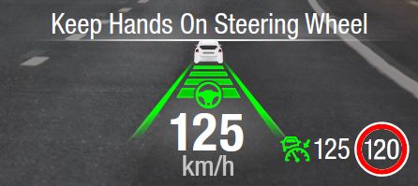

Graphic 37: Visual Hard Take Over Warning in HUD (W3563), graphic update pending

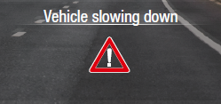

Graphic 38: Visual TJA Cancel Warning in HUD

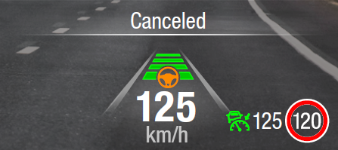

Table defines the display state for the TJA lines/status indication for the HUD

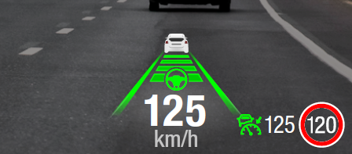

Graphic 39: TJA Lines in HUD with steering wheel, TJA Active

Graphic 40: Visual TJA Hands Off LDW on the right (W3601)

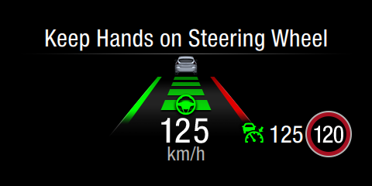

Graphic 41: Visual TJA Hands Off LDW on the left (W3600)w

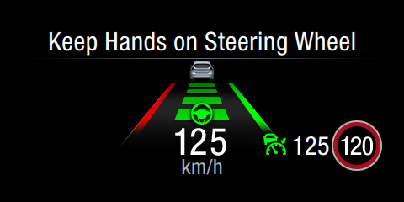

Examples for the mapping between display tables/figures and HUD/programs are shown below

.

Table 7: State Chart for the display state for the TJA Warning Text Indication.

Table 7**:** TJA HUD textual Warning indication

|  |  |  |  |  |  |  |
| --- | --- | --- | --- | --- | --- | --- |
| **Operational_Mode** | **TJA_HUD_Display** | **Traffic_Jam_Assist_Cfg** | **LaHandsOff_D_Dsply** | **TjaWarn_D_Rq** | **Tja_D_Stat** | **TJA_Warn_HUD** |
| NORMAL or CRANK | ACT | Enabled | Ina (0x0) | Ina (0x0) | X | Ina |
| Level1 (0x1) | Ina (0x0) | Off (0x0) OR Standby (0x1) | LKS_STSS |
| Level1 (0x1) | Ina (0x0) | Active (0x2) OR ActiveInterventionLeft (0x3) OR ActiveInterventionRight (0x4) | TJA_HO_HUD |
| Level2 (0x2) | Ina (0x0) | Off (0x0) OR Standby (0x1) | LKS_STSS |
| Level2 (0x2) | Ina (0x0) | Active (0x2) OR ActiveInterventionLeft (0x3) OR ActiveInterventionRight (0x4) | TJA_HO_HUD |
| X | HardTakeOverLevel1 (0x2) | X | TJA_HTO_HUD |
| X | HardTakeOverLevel2 (0x3) | X | TJA_HTO_HUD |
| ALL OTHER CASES | | | | | | Ina |

Table 8: State Chart for the display state for the TJA Lines and Steering Wheel indication.

Table 8: TJA HUD status indication (lines & steering wheel) for legacy C519

| **Operational_Mode** | **TJA_HUD_Display** | **TJA-Metaphor_Cfg** | **Traffic_Jam_Assist_Cfg** | **TjaWarn_D_Rq** | **Tja_D_Stat** | **TJA_Lines_HUD** |
| --- | --- | --- | --- | --- | --- | --- |
| NORMAL or CRANK | ACT | Version1 | Enabled | Not 0x1 | Off (0x0) | Ina |
| Not 0x1 | Standby (0x1) | TJA_STANDBY |
| Not 0x1 | Active (0x2) | TJA_ACTIVE |
| Not 0x1 | ActiveInterventionLeft (0x3) | TJA_ACTIVE |
| Not 0x1 | ActiveInterventionRight (0x4) | TJA_ACTIVE |
| Not 0x1 | ActiveWarningLeft (0x5) | TJA_HO_LDW_LEFT_HUD |
| Not 0x1 | ActiveWarningRight (0x6) | TJA_HO_LDW_RIGHT_HUD |
| TrafficJamAssistCancel (0x1) | X | TJA_CANC_HUD |
| ALL OTHER CASES | | | | | | Ina |

For programs prior to HMI simplification (TJA-Metaphor version1):

If the line representation of TJA is shared with LKS, TJA takes priority, when TJA is in either TJA_STANDBY, TJA_ACTIVE or TJA_CANC_ODS

Table 27 and Table 28: State Chart for the display state for the TJA Lines and Steering Wheel indication

Table 27: TJA cHUD status indication and warnings (lines & steering wheel)

| **Operational_Mode** | **TJA_HUD_Display** | **TJA-Metaphor_Cfg** | **Traffic_Jam_Assist_Cfg** | **LKS_HUD_Display** | **LaActvStats_D_Dsply** | **TjaWarn_D_Rq** | **Tja_D_Stat** | **TJA_Lines_cHUD** | **TJA_Warn2_cHUD** |
| --- | --- | --- | --- | --- | --- | --- | --- | --- | --- |
| NORMAL or CRANK | ACT | Version2 | Enabled | X | X | Ina (0x0) | Off (0x0) | Ina | Ina |
| Ina | X | Not 0x1 | Standby (0x1) | TJA_STANDBY | Ina |
| ACT | 0xC OR 0x0 OR 1E | Not 0x1 | Standby (0x1) | TJA_STANDBY | Ina |
| ACT | NOT 0xC OR 0x0 OR 1E | Not 0x1 | Standby (0x1) | TJA_STANDBY_LKS | Ina |
| X | Not 0x8, 0x9, 0xD, 0xE, 0x10,0x11, 0x15, 0x16 | Not 0x1 | Active (0x2) OR ActiveInterventionLeft (0x3) OR ActiveInterventionRight (0x4) | TJA_ACTIVE | Ina |
| X | 0x8 OR 0xD | Not 0x1 | Active (0x2) OR ActiveInterventionLeft (0x3) OR ActiveInterventionRight (0x4) | TJA_ACT_WARN_LEFT | Ina |
| X | 0x10 OR 0x11 | Not 0x1 | Active (0x2) OR ActiveInterventionLeft (0x3) OR ActiveInterventionRight (0x4) | TJA_ACT_WARN_RIGHT | Ina |
| X | 0x9 OR 0xE | Not 0x1 | Active (0x2) OR ActiveInterventionLeft (0x3) OR ActiveInterventionRight (0x4) | TJA_ACT_INTERVENE_LEFT | Ina |
| X | 0x15, 0x16 | Not 0x1 | Active (0x2) OR ActiveInterventionLeft (0x3) OR ActiveInterventionRight (0x4) | TJA_ACT_ INTERVENE _RIGHT | Ina |
| X | X | 0x0 | ActiveWarningLeft (0x5) | TJA_HO_LDW_LEFT | TJA_HO_HUD |
| X | X | 0x0 | ActiveWarningRight (0x6) | TJA_HO_LDW_RIGHT | TJA_HO_HUD |
| Ina | X | TrafficJamAssistCancel (0x1) | X | TJA_CANC | TJA_Cancel_Txt |
| ACT | 0xC OR 0x0 OR 1E | TrafficJamAssistCancel (0x1) | X | TJA_CANC | TJA_Cancel_Txt |
| ACT | NOT 0xC OR 0x0 OR 1E | TrafficJamAssistCancel (0x1) | X | TJA_CANC_LKS | TJA_Cancel_Txt |
| ALL OTHER CASES | | | | | | | | Ina | |

Table 28: cHUD Definition of display elements for persistent Driver Assist screen

| **TJA_Lines_cHUD** | **Left Line** | **Right Line** | **Steering wheel** | **Text** |
| --- | --- | --- | --- | --- |
| Ina | No TJA information displayed | | | |
| TJA_STANDBY | Grey Solid | Grey Solid | Grey | None |
| TJA_STANDBY_LKS | LKS STSS | LKS STSS | Grey | LKS STSS |
| TJA_ACTIVE | Green Solid | Green Solid | Green | None |
| TJA_ACT_WARN_LEFT | Red Solid | Green Solid | Green | None |
| TJA_ACT_WARN_RIGHT | Green Solid | Red Solid | Green | No Text |
| TJA_ACT_INTERVENE_LEFT | Yellow Solid | Green Solid | Green | No Text |
| TJA_ACT_ INTERVENE _RIGHT | Green Solid | Yellow Solid | Green | No Text |
| TJA_HO_LDW_LEFT | Red Solid” | Green Solid | Red | “Keep Hands on Steering Wheel” |
| TJA_HO_LDW_RIGHT | Green Solid | Red Solid | Red | “Keep Hands on Steering Wheel” |
| TJA_CANC | Grey Solid | Grey Solid | Amber | “Cancelled” |
| TJA_CANC_LKS | LKS STSS | LKS STSS | Amber | LKS STSS |

CGEA13_CS_TJA+_IPCDisplay-014:Req11v4 TJA Primary Displays – Advanced HUD

Req ID:

Purpose: [TJA+] [aHUD]

Verification Method:

**Req:** The following state charts define the graphic and textual displays for the primary TJA display area of the Advanced HUD. For Definitions of the Input and Output parameters in the state chart, see req5

Table 19 defines the display state for the TJA Warning Indication for the aHUD.

Graphic 42: Visual Hard Take Over Warning in HUD (W3563),

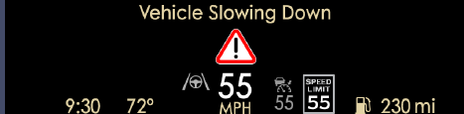

Graphic 43: Visual TJA Cancel Warning in HUD

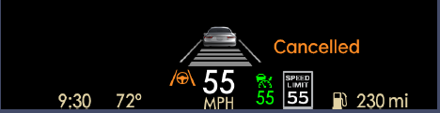

Table 20-23 define the display state for the TJA lines/status indication for the HUD

Graphic 44: TJA Lines in HUD with steering wheel, TJA Active

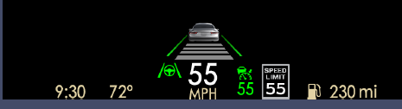

Graphic 45: Visual TJA Hands Off LDW on the right (W3601)

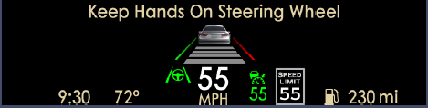

Table 19Table : State Chart for the display state for the TJA Warning Text Indication.

Table 19**:** TJA aHUD textual Warning indication

|  |  |  |  |  |  |  |
| --- | --- | --- | --- | --- | --- | --- |
| **Operational_Mode** | **TJA_HUD_Display** | **Traffic_Jam_Assist_Cfg** | **LaHandsOff_D_Dsply** | **TjaWarn_D_Rq** | **Tja_D_Stat** | **TJA_Warn_aHUD** |
| NORMAL or CRANK | ACT | Enabled | Ina (0x0) | Ina (0x0) | X | Ina |
| Level1 (0x1) | Ina (0x0) | Off (x0) OR Standby (0x1) | LKS_STSS |
| Level1 (0x1) | Ina (0x0) | Active (0x2) OR ActiveInterventionLeft (0x3) OR ActiveInterventionRight (0x4) | TJA_HO_HUD |
| Level2 (0x2) | Ina (0x0) | Off (x0) OR Standby (0x1) | LKS_STSS |
| Level2 (0x2) | Ina (0x0) | Active (0x2) OR ActiveInterventionLeft (0x3) OR ActiveInterventionRight (0x4) | TJA_HO_HUD |
| X | HardTakeOverLevel1 (0x2) | X | TJA_HTO_HUD |
| X | HardTakeOverLevel2 (0x3) | X | TJA_HTO_HUD |
| ALL OTHER CASES | | | | | | Ina |

Table 20 and Table 21: State Chart for the display state for the TJA Lines and Steering Wheel indication for Lincoln

Table 20: TJA aHUD status indication and warnings (lines & steering wheel) for Lincoln

| **Operational_Mode** | **TJA_HUD_Display** | **Traffic_Jam_Assist_Cfg** | **LKS_HUD_Display** | **LaActvStats_D_Dsply** | **TjaWarn_D_Rq** | **Tja_D_Stat** | **TJA_Lines_aHUD** | **TJA_Warn2_aHUD** |
| --- | --- | --- | --- | --- | --- | --- | --- | --- |
| NORMAL or CRANK | ACT | Enabled | X | X | Ina (0x0) | Off (0x0) | Ina | Ina |
| Ina | **X** | Not 0x1 | Standby (0x1) | TJA_STANDBY | Ina |
| ACT | 0xC OR 0x0 OR 1E | Not 0x1 | Standby (0x1) | TJA_STANDBY | Ina |
| ACT | NOT 0xC OR 0x0 OR 1E | Not 0x1 | Standby (0x1) | TJA_STANDBY_LKS | Ina |
| X | Not 0x8, 0x9, 0xD, 0xE, 0x10,0x11, 0x15, 0x16 | Not 0x1 | Active (0x2) OR ActiveInterventionLeft (0x3) OR ActiveInterventionRight (0x4) | TJA_ACTIVE | Ina |
| X | 0x8 OR 0xD | Not 0x1 | Active (0x2) OR ActiveInterventionLeft (0x3) OR ActiveInterventionRight (0x4) | TJA_ACT_WARN_LEFT | Ina |
| X | 0x10 OR 0x11 | Not 0x1 | Active (0x2) OR ActiveInterventionLeft (0x3) OR ActiveInterventionRight (0x4) | TJA_ACT_WARN_RIGHT | Ina |
| X | 0x9 OR 0xE | Not 0x1 | Active (0x2) OR ActiveInterventionLeft (0x3) OR ActiveInterventionRight (0x4) | TJA_ACT_INTERVENE_LEFT | Ina |
| X | 0x15, 0x16 | Not 0x1 | Active (0x2) OR ActiveInterventionLeft (0x3) OR ActiveInterventionRight (0x4) | TJA_ACT_ INTERVENE _RIGHT | Ina |
| X | X | 0x0 | ActiveWarningLeft (0x5) | TJA_HO_LDW_LEFT | TJA_HO_HUD |
| X | X | 0x0 | ActiveWarningRight (0x6) | TJA_HO_LDW_RIGHT | TJA_HO_HUD |
| Ina | X | TrafficJamAssistCancel (0x1) | X | TJA_CANC | TJA_Cancel_Txt |
| ACT | 0xC OR 0x0 OR 1E | TrafficJamAssistCancel (0x1) | X | TJA_CANC | TJA_Cancel_Txt |
| ACT | NOT 0xC OR 0x0 OR 1E | TrafficJamAssistCancel (0x1) | X | TJA_CANC_LKS | TJA_Cancel_Txt |
| ALL OTHER CASES | | | | | | | Ina | |

Table 21: aHUD Definition of display elements for persistent Driver Assist screen without LKS RTT prior DCR

| **TJA_Lines_aHUD** | **Left Line** | **Right Line** | **Steering wheel** | **Text** |
| --- | --- | --- | --- | --- |
| Ina | No TJA information displayed | | | |
| TJA_STANDBY | Grey Solid | Grey Solid | Grey | None |
| TJA_STANDBY_LKS | LKS STSS | LKS STSS | Grey | LKS STSS |
| TJA_ACTIVE | Green Solid | Green Solid | Green | None |
| TJA_ACT_WARN_LEFT | Red Solid | Green Solid | Green | None |
| TJA_ACT_WARN_RIGHT | Green Solid | Red Solid | Green | No Text |
| TJA_ACT_INTERVENE_LEFT | Yellow Solid | Green Solid | Green | No Text |
| TJA_ACT_ INTERVENE _RIGHT | Green Solid | Yellow Solid | Green | No Text |
| TJA_HO_LDW_LEFT | Red Solid” | Green Solid | Red | “Keep Hands on Steering Wheel” |
| TJA_HO_LDW_RIGHT | Green Solid | Red Solid | Red | “Keep Hands on Steering Wheel” |
| TJA_CANC | Grey Solid | Grey Solid | Amber | “Cancelled” |
| TJA_CANC_LKS | LKS STSS | LKS STSS | Amber | “Cancelled”, if not LKS Hands-off acc. LKS STSS |

CGEA13_CS_TJA+_IPCDisplay-001:Req2v4 TJA+ ~~Warning~~ Information Message Displays

Req ID:

Purpose: [TJA+] [IPC]

Verification Method:

**Req:** The following state chart defines the TJA-relevant graphic and textual displays for the information message for the IPC. For Definitions of the Input and Output parameters in the state chart, see req5

Table 9: Defining activation message for TJA+

| **Inputs** | | | | **Warning Parameters** | **Warning Duration** |
| --- | --- | --- | --- | --- | --- |
| **Operational_Mode** | **Traffic_Jam_Assist_Cfg** | **TjaMsgTxt_D_Dsply** | **AccMsgTxt_D2_Rq** | **TJA_Display_Warn_Req** | **Duration** |
| NORMAL or CRANK | Enabled | X | TJA_ Unavailable (0x8) | Ina (TJA_NA)* | While Condition is TRUE (Resettable) or Soft Warning |
| **~~X~~** | **~~No_Text (0x0)~~** | **~~TJA_SEL**~~** | ~~While Condition is TRUE (Resettable) or Soft Warning~~ |
| **~~X~~** | **~~ACC_Overridden (0x4)~~** | **~~TJA_SEL**~~** | ~~While Condition is TRUE (Resettable) or Soft Warning~~ |
| **Turn_On_ACC** | **No_Text (0x0)** | **TJA_ACC_ON** | While Condition is TRUE (Resettable) or Soft Warning |
| All other cases | | | | Ina | Ina |

*Note: Values in brackets are handled by the CADS Cluster Interface Specification

~~**Note2: If defined in HMI concept to show activation Pop-ups for al features~~

CGEA13_CS_TJA+_IPCDisplay-014:Req10v1 TJA+ Arbitration of TJA and CADS messages for HUD & IPC

Req ID:

Purpose: [TJA+] [IPC], [HUD]

Verification Method:

**Req:** The display of the TJA cancel shall have higher priority than ACC S&G override or Resume ready representation

Table 24**:** Definition of priority between ACC S&G messages and TJA messages displayed in the text area

| **TJA_HUD_Display** | **Traffic_Jam_Assist_Cfg** | **TjaWarn_D_Rq** | **CcOvrrdActv_B_Actl** | **AccStopRes_B_Dsplyt** | **TJA_Lines_HUD** |
| --- | --- | --- | --- | --- | --- |
| ACT | Enabled | Ina (0x0) | FALSE | FALSE | See CADS spec |
| Ina (0x0) | FALSE | TRUE | See CADS spec |
| Ina (0x0) | TRUE | FLASE | See CADS spec |
|  |  | Ina (0x0) | TRUE | TRUE | See CADS spec |
|  |  | TrafficJamAssistCancel (0x1) | X | X | TJA_CANC_HUD |
| ALL OTHER CASES | | | | | Ina |

CGEA13_CS_TJA+_IPCDisplay-001:Req4v6 TJA+ Audible Warning Settings

Req ID:

Purpose: [TJA+] [IPC]

Verification Method:

**Req:**

The following state chart defines the TJA-relevant chime and mute settings for the IPC. For Definitions of the Input and Output parameters in the state chart, see req5

Table 10: State Chart for TJA Chimes Levels

|  |  |  |  |  |  |  |  |
| --- | --- | --- | --- | --- | --- | --- | --- |
| **Inputs** | | |  | |  | **Warning Parameters** | |
| **Traffic_Jam_Assist_Cfg** | **TjaWarn_D_Rq** | **LaHandsOff_D_Dsply** | | **TJA_D_Stat** | | | **Active_Chime_Status_Flag** |
| Enabled | Ina (0x0) | Ina (0x0) | | Not 0x5, not 0x6 | | | Ina |
| HardTakeOverLevel1 (0x2) | X | | X | | | TJA_Hard_Warning_Chime_Status_Flag (W3563) |
| HardTakeOverLevel2 (0x3) | X | | X | | | TJA_Hard_Warning_Chime_Status_Flag (W3563) |
| TrafficJamAssistCancel (0x1) | X | | X | | | TJA_Low_Priority_Chime_Status_Flag |
| Ina (0x0) | X | | ActiveWarningLeft (0x5) | | | TJA_LDW_Chime_Status_Flag (W3600) |
| Ina (0x0) | X | | ActiveWarningRight (0x6) | | | TJA_LDW_Chime_Status_Flag (W3601) |
| Ina (0x0) | Level2 (0x2) | | Not 0x5, not 0x6 | | | LKS_HO_Chime_Status_Flag (W1014a) |
| ALL OTHER CASES | | | | | | Ina | |

CGEA13_CS_TJA+_IPCDisplay-001:Req5v10 TJA+ Parameter Definitions

Req ID:

Purpose: [TJA+] [IPC AND HUD]

Verification Method:

**Req:**

The CAN Inputs which are relevant to the TJA+ display strategy are defined below:

Table 11: Parameter definition of CAN signal inputs

|  |  |  |  |
| --- | --- | --- | --- |
| **CAN Inputs** | | | |
| **Signal Name** | **Defalt Value  (Startup or Batt Conn)** | **Required Receiver** | **Requirement Reference** |
| Operational_Mode | Not Defined Here | IPC, HUD | See STSS |
| Tja_D_Stat | Off (0x0) | IPC, HUD | See CAN Spec for Signal Encoding |
| TjaMsgTxt_D_Dsply | No_Text (0x0) | IPC, HUD | See CAN Spec for Signal Encoding |
| AccMsgTxt_D2_Rq | No_Text (0x0) | IPC, HUD | See CAN Spec for Signal Encoding |
| TjaWarn_D_Rq | No warning (0x0) | IPC, HUD | See CAN Spec for Signal Encoding |
| LaHandsOff_D_Dsply | No_Warning (0x0) | IPC, HUD | See CAN Spec for Signal Encoding |
| CcOvrrdActv_B_Actl | Cruise_Req_Not_Overridden(0x0) | IPC, HUD | See CAN Spec for Signal Encoding |
| AccStopRes_B_Dsply | No (0x0) | IPC, HUD | See CAN Spec for Signal Encoding |
| LaActvStats_D_Dsply | NoLeft_NoRight(0x0) | IPC, HUD | See CAN Spec for Signal Encoding |

The CAN Outputs which are relevant to the TJA+ display strategy are defined below:

Table 12: Parameter definition of CAN signal outputs

|  |  |  |
| --- | --- | --- |
| **CAN Outputs** | | |
| **Signal Name** | **Defalt Value  (Startup or Batt Conn)** | **Requirement Reference** |
|  |  |  |
|  |  |  |

The display parameters which are relevant to the TJA+ display strategy are defined below:

Table 13: Parameter definition of display parameters

| **Display Parameters** | | | | |
| --- | --- | --- | --- | --- |
| **Parameter Name** | **Definition** | **Detail Meaning** | **Default Value  (Startup or Batt Conn)** | **Req Ref** |
| TJA_Func_Disp_Thin | Defines whether the TJA+ Function Display is in one of the following formats | o Ina (0x0): Not displayed o TJA_STANDBY (0x1): TJA RTT Shown in Grey: Continuous display indication that TJA is in standby. o TJA_ACTIVE (0x2): TJA RTT Shown in Green: Continuous display indication that TJA is active.  o TJA_INTERVENTION (0x3) TJA RTT Shown in Amber/Yellow: Continuous display indication that TJA Intervention is active. o TJA_WARNING (0x4) TJA RTT Shown in Red: Continuous display indication that TJA Warning is active. | Ina (0x0) |  |
| TJA_Warn_Disp_Thin | Defines what warning is displayed when the On-Demand screen is not chosen (Thin Display Format) | o Ina (0x0): Not displayed  o TJA_CANC (0x1): small pop up “Canceled” with orange steering wheel o TJA_HO_VIS (0x2): big pop up “Keep Hands On Steering Wheel” (W1014) according Global Alerts= La_HandsOff_Dsply_Msg_Status_Flag  o TJA_HO_AUDIO_VIS (0x2a): big pop up “Keep Hands On Steering Wheel” (W1014a) according Global Alerts= La_HandsOff_Dsply_Msg2_Status_Flag  o TJA_HTO_VIS (0x3): big pop up “Vehicle Slowing Down” (W3563) and symbol , according Global Alerts  o TJA_HO_LDW_LEFT (0x04) big pop up with red continuous lane on left (W3600) according Global Alerts  o TJA_HO_LDW_RIGHT (0x05) big pop up with red continuous lane on right (W3601) according Global Alerts | Ina (0x0) |  |
| TJA_Lines_On_Demand | Defines what lines are displayed in the Driver Assist On-Demand Screen | o Ina (0x0): Not displayed o TJA_STANDBY (0x1):  Left solid line marking shown in GREY  Right solid line marking shown in GREY  Steering Wheel shown in GREY  🡪Indication that TJA is in standby. o TJA_ACTIVE (0x2):  Left solid line marking shown in GREEN  Right solid line marking shown in GREEN  TJA Steering Wheel shown in GREEN  🡪Indication that TJA is active.  o TJA_CANC_ODS (0x3):  Left solid line marking shown in GREY  Right solid line marking shown in GREY  TJA Steering Wheel shown in ABMER  🡪Indication that TJA is cancelled. | Ina (0x0) |  |
| TJA_Warn_cHUD | Defines what warning is displayed in the cHUD | o Ina (0x0): Not displayed  o LKS_STSS:  o TJA_HO_HUD (0x2): TJA warning text “Keep Hands On Steering Wheel” (W1014,W1014a) according Global Alerts = La_HandsOff_Dsply_Msg_Status_Flag, La_HandsOff_Dsply_Msg2_Status_Flag  o TJA_HTO_HUD (0x3): TJA warning text “Vehicle Slowing Down” (W3563) and red triangle with exclamation mark, according Global Alert list | Ina (0x0) |  |
| TJA_Warn2_cHUD | Defines Text to be displayed in cHUD | Ina (0x0): No text displayed  o LKS_STSS: Display Warnings according LKS STSS (no text from LCA)o TJA_HO_HUD (0x2): TJA warning text “Keep Hands On Steering Wheel” (W1014,W1014a) according Global Alerts = La_HandsOff_Dsply_Msg_Status_Flag, La_HandsOff_Dsply_Msg2_Status_Flag  o TJA_Cancel_Txt: Display Text: “Canceled | Ina (0x0) |  |
| TJA_Lines_HUD | Defines what Lines are displayed in the HUD | o Ina (0x0): No TJA displayed o TJA_STANDBY (0x1):  Left solid line marking shown in GREY  Right solid line marking shown in GREY  TJA Steering Wheel shown in GREY  🡪Indication that TJA is in standby. o TJA_ACTIVE (0x2):  Left solid line marking shown in GREEN  Right solid line marking shown in GREEN  TJA Steering Wheel shown in GREEN  🡪Indication that TJA is active  o TJA_HO_LDW_LEFT_HUD (0x3) (W3600)  Left solid line marking shown in RED  Right solid line marking shown in GREEN  TJA Steering Wheel shown in GREEN  Text: “Keep Hands On Steering Wheel””  🡪Indication that TJA is active and a LDW on the left.  o TJA_HO_LDW_RIGHT_HUD (0x4) (W3601)  Left solid line marking shown in GREEN  Right solid line marking shown in RED  TJA Steering Wheel shown in GREEN  Text: “Keep Hands On Steering Wheel”  🡪Indication that TJA is active and a LDW on the right.  o TJA_CANC_ODS (0x5):  Left solid line marking shown in GREY  Right solid line marking shown in GREY  TJA Steering Wheel shown in ABMER  Text: “Canceled”  🡪indication that TJA has been camceled  Note: none of the above shall impact the ACC graphic | Ina (0x0) |  |
| TJA_Warn_aHUD | Defines Text to be displayed in aHUD | Ina (0x0): No text displayed  o LKS_STSS: Display Warnings according LKS STSS (no text from LCA)o TJA_HO_HUD (0x2): TJA warning text “Keep Hands On Steering Wheel” (W1014,W1014a) according Global Alerts = La_HandsOff_Dsply_Msg_Status_Flag, La_HandsOff_Dsply_Msg2_Status_Flag  o TJA_HTO_HUD (0x3): TJA warning text “Vehicle Slowing Down” (W3563) and red triangle with exclamation mark, according Global Alert list | Ina (0x0) |  |
| TJA_Warn2_aHUD | Defines Text to be displayed in aHUD | Ina (0x0): No text displayed  o LKS_STSS: Display Warnings according LKS STSS (no text from LCA)o TJA_HO_HUD (0x2): TJA warning text “Keep Hands On Steering Wheel” (W1014,W1014a) according Global Alerts = La_HandsOff_Dsply_Msg_Status_Flag, La_HandsOff_Dsply_Msg2_Status_Flag  o TJA_Cancel_Txt: Display Text: “Canceled | Ina (0x0) |  |
| TJA_Lines_aHUD | Defines what Lines are displayed in the aHUD with new LKS metaphor | Defined in Table 21 | Ina (0x0) |  |
| TJA_Lines_cHUD | Defines what Lines are displayed in the cHUD with new LKS metaphor | Defined in Table 28 | Ina (0x0) |  |
| TJA_Display_Warn_Req | Defines TJA Warning messages (Text and/or Graphics) to be displayed as follows | o Ina (0x0): No TJA-specific Message o TJA_NA (0x1): "TJA NOT AVAILABLE" Warning Text (W3564)  o TJA_SEL (0x2): "TJA SELECTED" Info Text (currently not used)  o TJA_ACC_ON (0x3): "Turn on ACC” Info Text (W3565)  Note: all other states are covered by the CADS Cluster Interface Specification | Ina (0x0) |  |

The TJA+ display internal parameters which are relevant to the TJA+ display strategy are defined below:

Table 14: Internal Parameter definitions

|  |  |  |  |  |
| --- | --- | --- | --- | --- |
| **Internal Parameters** | | | | |
| **Parameter Name** | **Definition** | **Detail Meaning** | **Default Value  (Startup or Batt Conn)** | **Req Ref** |
| Active_Chime_Status_Flag | Defines the TJA feature chime request. To be used by the master chime arbiter to define the Audio Chime request and/or cluster chime driver | o Ina (0x0)  o TJA_Hard_Warning_Chime_Status_Flag (0x1)  o TJA_Low_Priority_Chime_Status_Flag (0x2)  o TJA_LDW_Chime_Status_Flag (0x3)  o LKS_HO_Chime_Status_Flag (0x4)  See Audio Generated DNA Chimes- Cluster Chime Arbitrator for detailed definitions. | Ina (0x0) |  |
| Traffic_Jam_Assist_Cfg | State Indicator for feature presence controlled via CAN at EOL at VO plant. Defaulted to Enabled at supplier manufacturing. | Enabled Disabled | Store  d Value |  |
| TJA_HUD_Display | State indication of whether (Advanced/Combiner) HUD is active and capable of displaying TJA information | Ina:  Not Equipped OR  ((HUD_ADAS_OnOff == CruiseControl&LaneKeepOFF) OR  (HUD_ADAS_OnOff == CruiseControlOFF) AND HUD_Cruise_Control == OFF) OR  HudActv_D_Stat == Inactive OR  HudActv_D_Stat == Pending OR  HudActv_D_Stat == Error**  ACT: (HUD_ADAS_OnOff == (CruiseControl&LaneKeepON OR CruiseControlOnly) OR HUD_Cruise_Control == ON)* AND HudActv_D_Stat == Active  *see HUD_Memory_Save_and_Recall STSS  **see CHUD_Welcome_Farewell_Strategy STSS | Ina |  |
| LKS_HUD_Display | State indication of whether (Combiner) HUD is active and capable of displaying TJA information | Ina:  Not Equipped OR  ((HUD_ADAS_OnOff == CruiseControl&LaneKeepOFF) OR  (HUD_ADAS_OnOff == CruiseONLY) AND HUD_ LaneKeeping == OFF) OR  HudActv_D_Stat == Inactive OR  HudActv_D_Stat == Pending OR  HudActv_D_Stat == Error**  ACT: ((HUD_ADAS_OnOff == (CruiseControl&LaneKeepON) OR HUD_ LaneKeeping == ON)* AND HudActv_D_Stat == Active  *see HUD_Memory_Save_and_Recall STSS  **see CHUD_Welcome_Farewell_Strategy STSS | Ina |  |
| TJA-Metaphor_Cfg | Config parameter to enable selection of LKS Metaphor. Only to be used when more than 1 HMI representation is used in the same product (e.g. S2 or cHUD) | Version1: for programs that use C519 base LKS metaphor (green LKS lines…)  Version2: for programs that use updated LKS metaphor introduced with U625 (white LKS lines)  Howw this config is done shall be decided by the respective DI D&R (e.g. internal config, module config, by part no…) | Version2 |  |
| ~~TJA_Cancl_Chime_Cfg~~ | ~~TJA Cancel Chime to be issued via cluster / audio unit (cluster gateway)~~ | ~~Off (0x0): No Cancel Chime~~  ~~On (0x1): With Cancel Chime~~ | ~~On (0x1)~~ |  |

## TJA+ Performance and Reliability

CGEA13_CS_TJA+_IPCDisplay-001:Req7v1 TJA+ Response Time

Req ID:

Purpose: [TJA+] [IPC] [HUD]

Verification Method:

**Req:**

The IPC shall respond to the TJA+ Audible Warnings and Mute requests, within 20 milliseconds from when the CAN-signal is received.

The IPC and HUD shall display information about TJA+ system mode and warnings within 100 milliseconds from the signal is received.

CGEA13_CS_TJA+_IPCDisplay-001:Req9v6 Enabling criteria for displaying TJA-related

Req ID:

Purpose: To ensure that the displaying of TJA+-related information and the error detection related to signals from other nodes can not be made before these nodes are expected to transmit meaningful TJA+-related signals.   
[TJA+] [IPC] [HUD]

Verification Method: Review and test

**Req:**(a) The display of TJA+-related information shall be possible if, and only if, the IPC/HUD is in OPERATIONAL_MODE = Nomal or Crank

Note Error detection is defined by the CADS Cluster Interface Spec

~~state C (as described below). Otherwise, the IPC shall provide the same information as for 'TJA+ is in the off state'.~~

~~(b) For any TJA+-related error detection mechanism that is based on CAN signals received from other nodes, error detection and resulting entry into the denied mode shall be possible if, and only if, the IPC is in state C and PwPckTq_D_Stat <> 'StartInPrgrss_TqNotAvail' (as described below). This requirement overrules any other requirement that describes when TJA+ shall be denied by the IPC.~~~~~~

Graphic 46: Enabling criteria for TJA

~~State Transition Conditions, X and Y, are defined as follows:~~

~~X = (IPC has completed its initialization) AND~~

~~(Ignition_Status == 'Run') AND~~

~~PwPckTq_D_Stat <> 'StartInPrgrss_TqNotAvail'~~

~~Y = 1 second timer~~

~~Z = (Ignition_Status >= 'Run') AND~~

~~The Advanced HUD (if equipped) shall follow the same enabling criteria as defined above for the IPC.~~

CGEA13_CS_TJA+_IPCDisplay-001:Req8v2 TJA+ Missing Message

Req ID: Previously: CGEA13_CS_TJA+_IPCDisplay-021:Req13v1

Purpose: [TJA+] [IPC]

Verification Method:

**Req:**

Is covered by CADS Interface Spec (chapter ACC)

In case of missing message being detected according CADS Interface sepc for ACC no TJA relevant information shall be displayed (off state) till messages are received again within one Ignition cycle

CGEA13_CS_TJA+_IPCDisplay-001:Req6v4 TJA+ Audible Warning, sound type

Req ID: Previously: CGEA13_CS_TJA+_IPCDisplay-001:Req24v2

Purpose: [TJA+] [IPC]

Verification Method:

**Req:**

For detailed definitions of the “TJA_Hard_Warning_Chime_Status_Flag” (Hard Warning chime) and “TJA_Low_Priority_Chime_Status_Flag” (1s chime), “TJA_LDW_Chime_Status_flag”(LDW chime 23), “LKS_HO_Chime_Satus_Flag” (Info chime) chimes, see the Warning Chime Specification/STSS