|  |  |  |  |  |
| --- | --- | --- | --- | --- |
|  |  | | |  |
|  |  | | |  |
|  | Sentinel  <<Feature>>  (F003417) | | |  |
|  |  | | |  |
| Document Type | **Feature Document (FD)** | | |  |
| Template Version | **6.0 / FFSD 7.1** | | |  |
| SysML Report Template Version | **O Beta (6/25/2019)** | | |  |
| Document ID | **sent_fd_20210305a.docx** | | |  |
| Document Location | [Sentinel_MBSE_Documents](https://azureford.sharepoint.com/:f:/r/sites/Features/Feature%20Owner%20Checklist/TZuraw%20Features%20Section/Sentinel/Modeling%20and%20Feature%20Documents/Documents%20for%20V710%20UPV1%20Gateway?csf=1&web=1) | | |  |
| Document Owner | **Ishan Gupta - igupta1 / Michael Wohlfarter - mwohlfah** | | |  |
| Document Revision | **FD2.2** | | |  |
| Document Status | **Draft** | | |  |
| Date Issued | **2020-11-26** | | |  |
| Date Revised | **2021-03-05** | | |  |
| Document Classification | GIS1 Item Number: | **27.60/35** | |  |
| GIS2 Classification: | **Confidential** | |
|  | | | | |
|  | | | | |
| Document Approval | | | | |
| Person | Role | | Email Confirmation | Date |
| Ishan Gupta | Feature Owner | | Igupta1 |  |
| Michael Wohlfahrter | Feature Owner | | mwohlfah |  |
| Timothy Zuraw | Feature Owner Supervisor | | tzuraw |  |
| Kyaw Soe | Feature Owner Supervisor | | ksoe |  |

**Auto-Generated by MagicDraw**

Printed Copies Are Uncontrolled

# Disclaimer

**This document contains Ford Motor Company Confidential information. Disclosure of the information contained in any portion of this document is not permitted without the expressed, written consent of a duly authorized representative of Ford Motor Company, Dearborn, Michigan, U.S.A.**

**Copyright, Ó 2016 Ford Motor Company**

This document contains information developed and accumulated by and for FORD MOTOR COMPANY. As such, it is a proprietary document, which, if disseminated to unauthorized persons, would provide others with restricted information, data, or procedures not otherwise available, exposing the FORD MOTOR COMPANY to potential harm.

Employees and suppliers having custody of this specification or authorized to use it must be cognizant of its proprietary nature and ensure that the information herein is not made available to unauthorized persons.

FORD MOTOR COMPANY reserves the right to protect this work as an unpublished copyrighted work in the event of an inadvertent or deliberate unauthorized publication. FORD MOTOR COMPANY also reserves its rights under copyright laws to protect this work as a published work.

This document or portions thereof shall not be distributed outside FORD MOTOR COMPANY without prior written consent. Refer all questions concerning disclosure to the author(s) or to any duly authorized representative of Ford Motor Company.

# Contents

Disclaimer 2

Contents 3

1 Introduction 5

1.1 Document Purpose 5

1.2 Document Scope 5

1.3 Document Audience 5

1.3.1 Stakeholder List 5

1.4 Document Organization 5

1.4.1 Document Context 5

1.4.2 Document Structure 6

1.5 Document Conventions 6

1.5.1 Requirements Templates 6

2 Feature Overview 7

2.1 Purpose and Description of Feature 7

2.2 Feature Variants 7

2.2.1 Regions & Markets 8

2.3 Input Requirements 9

2.3.1 Legal Requirements 9

2.3.2 Trustmark Requirements 9

2.3.3 Industry Standards 9

2.3.4 Attribute Requirements 9

2.4 Lessons Learned 9

2.5 Assumptions 9

2.6 References 10

2.6.1 Ford Documents 10

2.6.2 External Documents and Publications 10

2.7 Glossary 10

2.7.1 Parameters / Values 10

3 Feature Context 11

3.1 Feature Context Diagram 11

3.2 List of Influences 11

4 Feature Modeling 14

4.1 Operation Modes and States 14

4.2 Use Cases 14

4.2.1 Use Case Diagram 14

4.2.2 Actors 14

4.2.3 Use Case Descriptions 15

4.3 Driving and Operation Scenarios 18

4.4 Decision Tables 24

5 Feature Requirements 25

5.1 Functional Requirements 25

5.1.1 Error Handling 34

5.2 Non-Functional Requirements 34

5.2.1 Safety 34

5.2.2 Security 34

5.2.3 Reliability 35

5.3 HMI Requirements 35

5.4 Other Requirements 40

5.4.1 Design Requirements 40

5.4.2 Manufacturing Requirements 40

5.4.3 Service Requirements 40

5.4.4 After Sales Requirements 40

5.4.5 Process Requirements 40

5.4.6 Uncategorized Requirements 40

6 Functional Safety 44

6.1 System Behaviors for HARA 44

6.2 Safety Assumptions 44

6.3 Safety Goals 44

6.4 Functional Safety Requirements 44

6.4.1 Safety Goal: Prevent Hazard (Example) 45

6.4.2 Derivation of Functional Safety Requirements on Assumptions 46

6.5 ASIL Decomposition of Functional Safety Requirements 46

7 Architecture 47

7.1 Functional Architecture 47

7.1.1 List of Functions 47

7.2 Logical Architecture 47

7.2.1 Logical Interfaces 48

8 Open Concerns 51

9 Revision History 52

10 Appendix 53

10.1 Definitions 53

10.2 Abbreviations 53

**List of Figures**

Figure 2: Feature Image Here 7

Figure 4: Feature Context 11

Figure 6: Feature Use Cases 14

Figure 7: W&RC #1 Diagram – Prevent Hazard (Example) 46

Figure 9: Logical Architecture 48

**List of Tables**

Table 1: Features described in this FD 5

Table 2: Feature Variants 8

Table 3: Regions & Markets 9

Table 5: Ford internal Documents *(not specified in SysML model)* 10

Table 7: External documents and publications *(not specified in SysML model)* 10

Table 8: Parameters / Values used in this document *(Not supported by MagicDraw report generation)* 10

Table 9: List of Influences 13

Table 12: List of Actors 15

Table 13: System Behaviors for HARA 44

Table 15: Functional Safety Goals 44

Table 18: Feature Interactions 50

Table 20: Open Concerns *(Not supported by MagicDraw report generation)* 51

Table 22: Abbreviations used in this document 53

# Introduction

## Document Purpose

A Feature Document (FD) document specifies **what** the feature shall do and how it shall behave from customer perspective. It should also provide reasoning and background **why** we have the feature in the vehicle.

The FD also serves as an Item Definition as defined by ISO26262 for those features, which follow the Ford Functional Safety process.

To get more information about the concept of feature, function and component level abstraction refer to the [Ford RE Wiki](http://wiki.ford.com/display/RequirementsEngineering/Requirements+Engineering+for+SW+Enabled+Features). For details on the Ford Functional Safety (ISO26262) process refer to the [Ford Functional Safety Sharepoint](https://pd3.spt.ford.com/sites/GlobalFunctionalSafety/Pages/default.aspx).

## Document Scope

This Feature Document (FD) specifies the following features:

|  |  |  |  |
| --- | --- | --- | --- |
| **Feature ID** | **Feature Name** | **Owner** | **Reference** |
| F003417 | Sentinel  (Program(s): V710  P708  ) | Ishan Gupta - igupta1 / Michael Wohlfarter - mwohlfah |  |

Table 1: Features described in this FD

## Document Audience

The FD is written by the feature owner of Ishan Gupta - igupta1 / Michael Wohlfarter - mwohlfah. All Stakeholders, i.e., all people who have a valid interest in the feature should read and, if possible, review the FD. It needs to be guaranteed, that all stakeholders have access to the currently valid version of the FD.

**#Hint:** The FD template has the IP Classification “Proprietary” by default. IP Classification “Confidential” might be required in some cases, e.g. by Ford Functional Safety.

### Stakeholder List

For the latest list of stakeholder of the feature and their influence refer to <Put VSEM Link here>.

**#Hint:** Refer to [Ford RE Wiki – Stakeholder List](http://wiki.ford.com/display/RequirementsEngineering/Stakeholder+Analysis) on how to create a stakeholder list. The stakeholder list should be stored in VSEM in the pseudo folder “General Data Artifacts” of the corresponding feature.

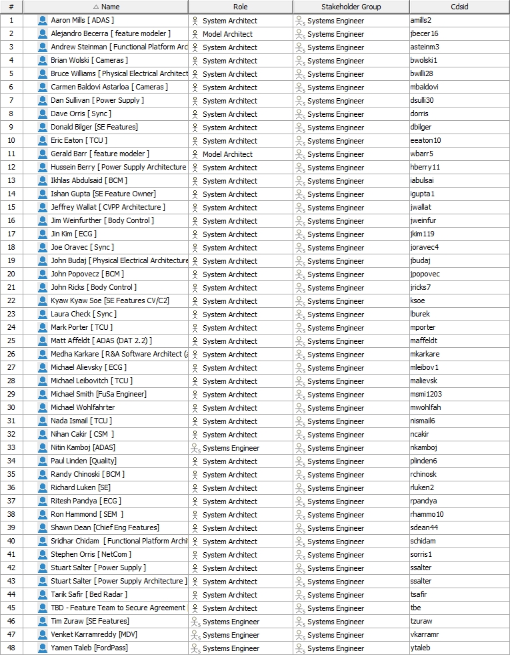

## Document Organization

### Document Context

Refer to the [Specification Structure page](http://wiki.ford.com/display/RequirementsEngineering/Specification+templates) in the [Ford RE Wiki](http://wiki.ford.com/display/RequirementsEngineering/Requirements+Engineering+for+SW+Enabled+Features) to understand how the FD relates to other Ford Requirements Documents and Specifications.

### Document Structure

The structure of this document is explained below:

**Section 1** – Introduction how to use this document including responsibilities and requisite documents. Explains the terminology. Gives a clarification of the definitions, concepts and abbreviations used in the document.

**Section 2** – Feature Description. States briefly the background and the purpose of the feature, feature variants and corresponding regions and markets. Also includes input requirements, assumptions and constraints.

**Section 3** – Feature Context describes all external entities, which have an influence on the feature.

**Section 4** – Feature Modeling. Contains Use Case, Driving Scenarios, State Charts to describe the functional behavior of the feature.

**Section 5** – Safety. Lists System Behaviors and Safety Goals of the feature.

**Section 6** – Feature Requirements. Lists functional and non-functional requirements of the feature.

**Section 7** – Architecture. Shows the coarse architecture, which the feature requirements are deployed to. Describes the elements and the boundary of the feature as well as the decomposition and distribution of associated functions.

**Section 8** – List of Open Concerns

**Section 9** – Document Change History including a list of new or modified requirements. The requirements in this document are tagged, and this section contains different types of tables listing all, new, or changed requirements by their title and page no.

**Section 10** – Appendix

**#Hint:** All sections are mandatory, unless explicitly marked by the tag “#Classification” as “optional” or as applicable e.g. to certain domains like “Functional Safety”.

## Document Conventions

### Requirements Templates

Each requirement, use case or scenario in this specification shall follow the corresponding template given in the document template *Specification_Macros.dotm* at [RE Wiki - Specification Templates](http://wiki.ford.com/display/RequirementsEngineering/Specification+templates?src=contextnavpagetreemode).

#### Identification of requirements

#### Requirements Attributes

The templates provided by *Specification_Macros.dotm* define a list of attributes for each requirement. This helps to classify the requirement. The attributes are explained at [RE Wiki - Requirements Attributes](http://wiki.ford.com/display/RequirementsEngineering/Requirements+Attributes?src=contextnavpagetreemode).

# Feature Overview

## Purpose and Description of Feature

**#Hint:** Some descriptive text to explain the purpose and functionality of the feature.

Monitoring of the area around a parked vehicle using onboard sensors. Sensors include :

vehicle tilt, vehicle acceleration, ultrasonic sensors in cabin, microphone in cabin (PHOENIX versions only), interior cameras, external cameras, bed area radar and microphone (Pick-up trucks only).

Videos and threat notifications are sent to the user via the FordPass App. Video and threat data will be stored remotely (cloud) and locally (USB jump-drive).

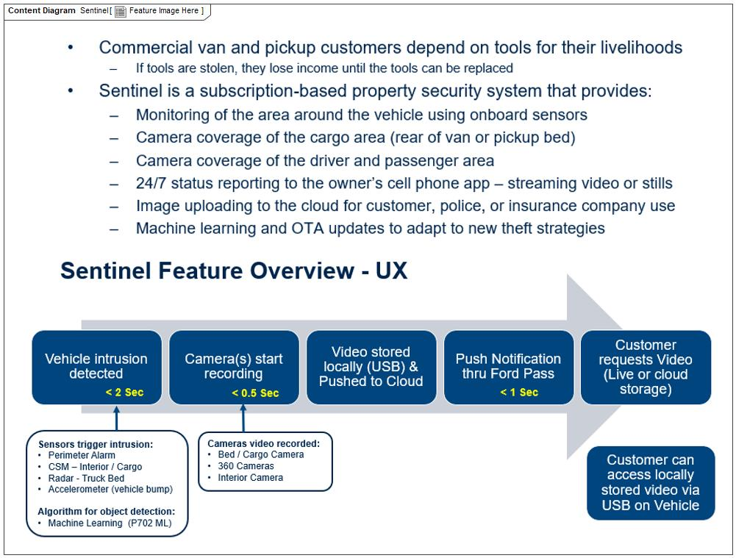

Figure 1: Feature Image Here

## Feature Variants

**#Hint:** Definitions for different variants of the feature (if applicable). Give each variant a descriptive name by which it can be referenced further on in the document. If no variant exists, state “No Feature Variants”.

The Variant Description should give a short informative text which describes the variants of the feature.

|  |  |  |
| --- | --- | --- |
| **Variant Name** | **Variant Description** | **Remarks** |
| **Cargo Van with 2 x CSM** | Cargo van version. Bed radar not installed - only for pick-up vehicles. 2 CSM units, one for cab and one for cargo area. 360 degree camera system not fitted. 1 x internal camera for cab area. |  |
| **Cargo Van with 2 x CSM and 360deg Camera** | Cargo van version. Bed radar not installed - only for pick-up truck application. 2 CSM units, one for cab and one for cargo area. 360 degree camera system fitted. 1 x internal camera for cab area. |  |
| **Pick Up Truck with bed radar** | Pick-up truck version. Bed radar used for pick-up vehicles with a cargo load bed. 1 CSM unit in cab area. 360 degree camera system not fitted. 1 x internal camera in cab area. |  |
| **Pick Up truck with bed radar and 360deg Camera** | Pick-up truck version. Bed radar used for pick-up vehicles with a cargo load bed. 1 CSM unit in cab area. 360 degree camera system fitted. 1 x internal camera in cab area. |  |
| **SUV Bus Combi with 1 x Int Camera** | SUV, Bus or Combi type vehicle. Bed radar not installed as no cargo bed area. 1 CSM unit in cab area. 360 degree camera system not fitted. 1 x internal camera in cab area. |  |
| **SUV Bus Combi with 1 x Int Camera and 360deg Camera** | SUV, Bus or Combi type vehicle. Bed radar not installed as no bed cargo area. 1 CSM unit in cab. 360 degree camera system fitted. 1 x internal camera in cab area. |  |
| **SUV Bus Combi with 2 x Int Camera** | SUV, Bus or Combi type vehicle. Bed radar not installed as no bed cargo area. 1 CSM unit in cab. 360 degree camera system not fitted. 2 x internal cameras one for front of cab and one in rear. |  |
| **SUV Bus Combi with 2 x Int Camera ans 360deg Camera** | SUV, Bus or Combi type vehicle. Bed radar not installed as no bed cargo area. 1 CSM unit in cab. 360 degree camera system fitted. 2 x internal cameras one for front of cab and one in rear. |  |

Table 2: Feature Variants

### Regions & Markets

**#Hint:** Description of purpose and functionality of the feature. If there is no variant, give feature name in first column.

|  |  |  |  |  |  |  |
| --- | --- | --- | --- | --- | --- | --- |
| **Market /**  **Region**  Variant Name | **North America** | **South America** | **Europe** | **Middle East/Africa** | **Asia / Pacific** | **China** |
| **Cargo Van with 2 x CSM** | Mandatory | Mandatory | Mandatory | Mandatory | Mandatory | Mandatory |
| **Cargo Van with 2 x CSM and 360deg Camera** | Mandatory | Mandatory | Mandatory | Mandatory | Mandatory | Mandatory |
| **Pick Up Truck with bed radar** | Mandatory | Mandatory | No | No | No | No |
| **Pick Up truck with bed radar and 360deg Camera** | Mandatory | Mandatory | No | No | No | No |
| **SUV Bus Combi with 1 x Int Camera** | Mandatory | Mandatory | Mandatory | Mandatory | Mandatory | Mandatory |
| **SUV Bus Combi with 1 x Int Camera and 360deg Camera** | Mandatory | Mandatory | Mandatory | Mandatory | Mandatory | Mandatory |
| **SUV Bus Combi with 2 x Int Camera** | Mandatory | Mandatory | Mandatory | Mandatory | Mandatory | Mandatory |
| **SUV Bus Combi with 2 x Int Camera ans 360deg Camera** | Mandatory | Mandatory | Mandatory | Mandatory | Mandatory | Mandatory |

Table 3: Regions & Markets

## Input Requirements

**#Hint:** List all input requirements, which are relevant for the feature. Typically, attribute requirements, legal requirements as well as national and international standards have to be considered.

### Legal Requirements

* : Compliance with FMVSS101
  + The Feature shall comply with FMVSS101.

### Trustmark Requirements

No Trustmark Requirements specified.

### Industry Standards

* : ISO 26262
  + The system should be developed according to Ford's implementation of Functional Safety.

### Attribute Requirements

* Proj-AR:14 : Improve Security
  + A feature to improve the security of a vehicle when parked

## Lessons Learned

**#Hint:** Additional information and lessons learned from previous development or related features. A typical source for Lessons Learned is the FMA Quality History.

**#Functional Safety:** In context of Functional Safety Lessons Learned and similar information will be used to check the completeness of the Functional Safety Goals and assumptions in the Hazard Analysis and Risk Assessment (HARA).

**#Link:** [Ford Functional Safety Sharepoint](https://pd3.spt.ford.com/sites/GlobalFunctionalSafety/Pages/default.aspx)

**Quality History Items**:

1. Limited to only one smart phone alert
2. Parking in Area with Poor Cellular Coverage
3. Sudden No Power or Lost communication
4. Sudden block or covering of camera lens
5. Cloud Failure no record of theft attack or recording stops prematurely
6. Poor quality image. Dark image, jerky image
7. Poor Detection performance in rain/snow/hail or adverse weather conditions
8. Road salt, grime, dust, foreign objects on Camera
9. Not Able To Connect Live View As It Is Happening
10. Does not power up
11. Does not respond quick enough for Crash Event
12. Difficult to set up Sentinel on my SmartPhone
13. Fleet User with Multiple Vehicles

## Assumptions

**#Classification**: Optional

**#Hint:** A list of known assumptions concerning the effects of the feature’s behavior on other features or elements (i.e., dependencies) as well as assumptions on the behavior expected by the feature (e.g. known limitations). During the course of the feature development most of those assumptions are typically either converted into actual requirements or discarded at some point – such that this chapter remains mostly empty. For assumptions, which are relevant for the Functional Safety process refer to chapter 6.2 “Safety Assumptions”

No Assumptions specified.

## References

### Ford Documents

List here all Ford internal documents, which are directly related to the feature.

| **Reference** | **Title** | **Doc. ID** | **Document Location** | **Revision** |
| --- | --- | --- | --- | --- |
|  |  |  |  |  |

Table 4: Ford internal Documents *(not specified in SysML model)*

### External Documents and Publications

The list of external documents could include books, reports and online sources.

**#Hint:** You may refer to [IEEE Citation Reference](http://www.ieee.org/documents/ieeecitationref.pdf) on how to format a reference.

| **Reference** | **Document / Publication** | **Document Location** |
| --- | --- | --- |
|  |  |  |

Table 5: External documents and publications *(not specified in SysML model)*

## Glossary

**#Hint**: Terms, concepts and abbreviations used in the document shall be defined and illustrated here. Note that changes to terms and/or concepts described in this section tend to cause major updates to this document.

The tables below have feature specific definitions and abbreviations. For additional, non-feature specific terms please refer to the [RE Glossary](http://wiki.ford.com/display/RequirementsEngineering/Glossary?src=contextnavpagetreemode)

See Appendix for Definitions and Abbreviations.

### Parameters / Values

| **Name** | **Description** | **Range / Resolution** |
| --- | --- | --- |
|  |  |  |

Table 6: Parameters / Values used in this document *(Not supported by MagicDraw report generation)*

# Feature Context

## Feature Context Diagram

**#Hint:** High level diagram of feature interactions with the environment, people or other feature or other external entities.

**#Link:** [RE Wiki - Context Diagram](http://wiki.ford.com/pages/viewpage.action?pageId=107676234&src=contextnavpagetreemode)

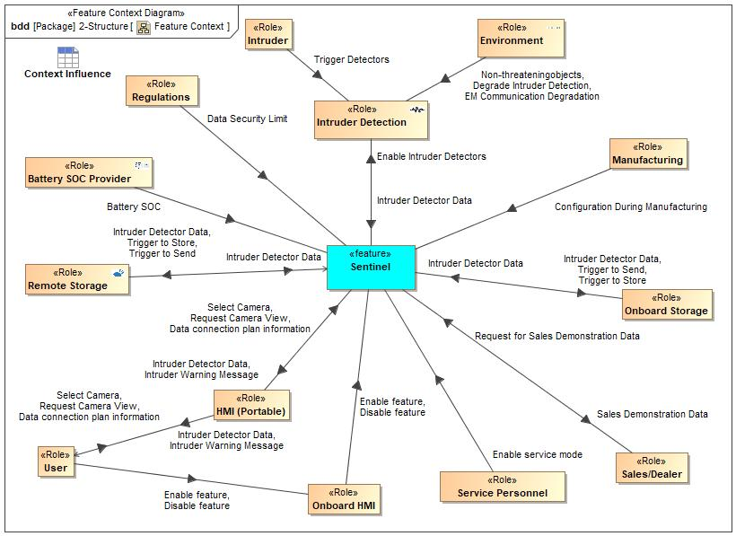

Figure 2: Feature Context

## List of Influences

|  |  |  |
| --- | --- | --- |
| **ID** | **External Entity** | **Influence Description** |
| Battery SOC | Battery SOC Provider To Sentinel | Electrical power is required by the feature. The battery state of charge (SOC) information is required as Sentinel will need to be disabled if the SOC is below a threshold value. |
| Configuration During Manufacturing | Manufacturing To Sentinel | Request to hold the Tilting Angle, unless service personnel enables tilting. |
| Data connection plan information | HMI (Portable) To Sentinel | Information to allow the data connection plan to be established. Information includes paswords and contact information. |
| User To HMI (Portable) | Information to allow the data connection plan to be established. Information includes paswords and contact information. |
| Data Security Limit | Regulations To Sentinel | There may be local legal constraints on what data can be collected and how it can be stored and transmitted, and to who. |
| Degrade Intruder Detection | Environment To Intruder Detection | Camera lenses may be obscured preventing clear view. |
| Environment To Sentinel | Camera lenses may be obscured preventing clear view. |
| Disable feature | Onboard HMI To Sentinel | The intruder detectors must be enabled. |
| User To Onboard HMI | The intruder detectors must be enabled. |
| EM Communication Degradation | Environment To Intruder Detection | Signals to the cloud may be attenuated by being in poor signal area on in an enclosed space. |
| Enable feature | Onboard HMI To Sentinel | The intruder detectors must be enabled. |
| User To Onboard HMI | The intruder detectors must be enabled. |
| Enable Intruder Detectors | Sentinel To Intruder Detection | The intruder detectors must be enabled. |
| Enable service mode | Service Personnel To Sentinel | Influence Description from Documentation field. |
| Intruder Detector Data | HMI (Portable) To User | Data from the various intruder detectors needs to be fed back to the feature. |
| Intruder Detection To Sentinel | Data from the various intruder detectors needs to be fed back to the feature. |
| Onboard Storage To Sentinel | Data from the various intruder detectors needs to be fed back to the feature. |
| Remote Storage To Sentinel | Data from the various intruder detectors needs to be fed back to the feature. |
| Sentinel To HMI (Portable) | Data from the various intruder detectors needs to be fed back to the feature. |
| Sentinel To Onboard Storage | Data from the various intruder detectors needs to be fed back to the feature. |
| Sentinel To Remote Storage | Data from the various intruder detectors needs to be fed back to the feature. |
| Intruder Warning Message | HMI (Portable) To User | Intruder warning messages will be fed to the user. |
| Sentinel To HMI (Portable) | Intruder warning messages will be fed to the user. |
| Non-threateningobjects | Environment To Intruder Detection | Wind etc may move vehicle. |
| Environment To Sentinel | Wind etc may move vehicle. |
| Request Camera View | HMI (Portable) To Sentinel | The User must request to view the camera. |
| User To HMI (Portable) | The User must request to view the camera. |
| Request for Sales Demonstration Data | Sales/Dealer To Sentinel | Influence Description from Documentation field. |
| Sales Demonstration Data | Sentinel To Sales/Dealer | Electrical power is required by the feature. |
| Select Camera | HMI (Portable) To Sentinel | The User must select which camera to view. |
| User To HMI (Portable) | The User must select which camera to view. |
| Trigger | Battery SOC Provider To Sentinel | Influence Description from Documentation field. |
| Trigger Detectors | Intruder To Intruder Detection | Intruder triggers detectors such as: door ajar, accelerometer in vehicle, Ultrasonic detector, radar detector |
| Intruder To Sentinel | Intruder triggers detectors such as: door ajar, accelerometer in vehicle, Ultrasonic detector, radar detector |
| Trigger to Send | Sentinel To Onboard Storage | The storage of data and the streaming of that data after storage remotely must be enabled and disabled. |
| Sentinel To Remote Storage | The storage of data and the streaming of that data after storage remotely must be enabled and disabled. |
| Trigger to Store | Sentinel To Onboard Storage | The storage remotely must be enabled and disabled. |
| Sentinel To Remote Storage | The storage remotely must be enabled and disabled. |

Table 7: List of Influences

# Feature Modeling

## Operation Modes and States

**#Classification:** Optional (Mandatory for Functional Safety)

**#Link:** [RE Wiki – State Charts](http://wiki.ford.com/display/RequirementsEngineering/State+Charts?src=contextnavpagetreemode)

**#Hint:** State Charts are a popular means to express feature behavior in terms of states and modes. An advantage of this state machine like approach is that consistency can be easily verified.

## Use Cases

**#Classification:** Optional

**#Link:** [RE Wiki – Use Cases](http://wiki.ford.com/display/RequirementsEngineering/Use+Cases+Overview?src=contextnavpagetreemodehttp://wiki.ford.com/display/RequirementsEngineering/Use+Cases?src=contextnavpagetreemode)

### Use Case Diagram

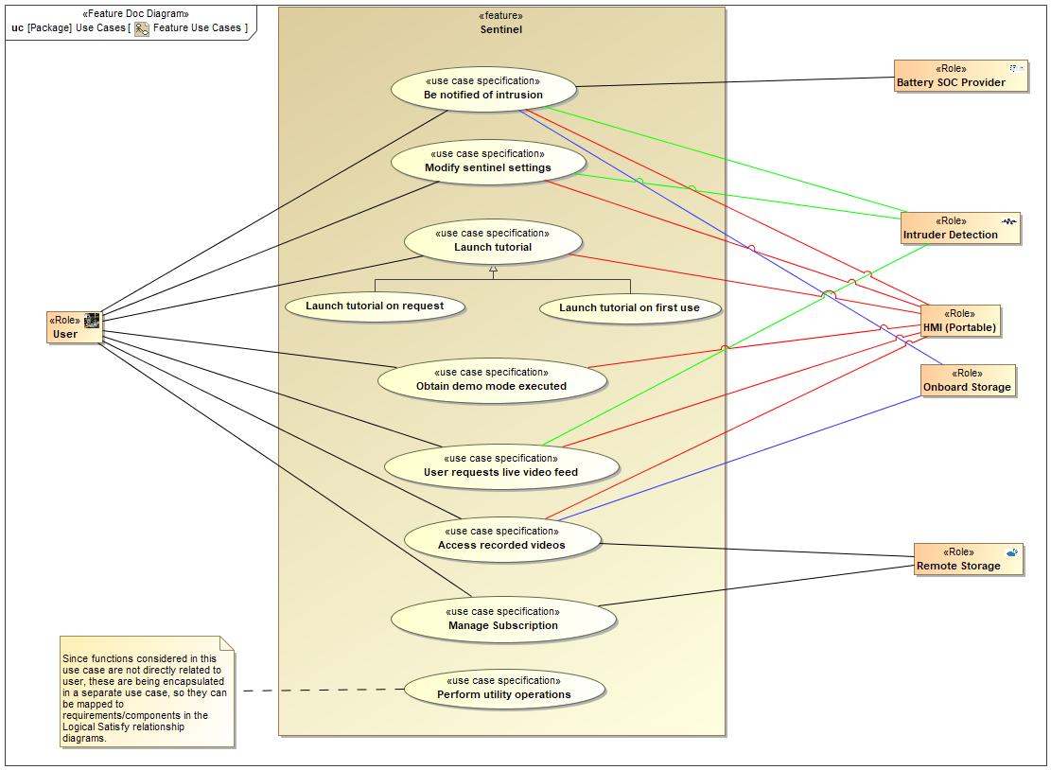

Figure 3: Feature Use Cases

### Actors

| **Actor** | **Description** |
| --- | --- |
| Battery SOC Provider | The feature requires an electrical power supply. This is important as the vehicle will be powered off during operation of the feature, thus power will be coming from the vehicle battery - battery drain is an important consideration. |
| HMI (Portable) | HMI includes on board and remote communication between the feature and the user. |
| Intruder Detection | Intruder detection includes all methods used to detect criminal activity on, in or near the vehicle. Typical detectors may be for door ajar, acceleration/vibration/sound, ultrasonic, radar and video. |
| Onboard Storage | On board storage of intruder detector data for access later by the user. This has limitations versus remote storage, but will not be limited by having good communications to the remote storage site.. |
| Remote Storage | Data from the intruder detectors will be stored remotely. This may allow increased storage capacity and less likelihood of data theft (versus storing in the vehicle). A disadvantage (versus on board storage) is that good communication is required between the vehicle and the remote storage site. |
| User | The user of the system, expected to normally be the driver or owner of the vehicle. Could also be someone involved with operating a commercial fleet of vehicles. |

Table 8: List of Actors

### Use Case Descriptions

**#Classification:** Optional

6 Access recorded videos

|  |  |  |
| --- | --- | --- |
| **Actors** |  | HMI (Portable) |
|  | Onboard Storage |
|  | Remote Storage |
|  | User |
| **Subject** |  | Sentinel |
| **Description** |  |  |
| **Preconditions** | PreC1 | Availability of video stored remotely or on USB. |
| **Triggers** | T1 | Request from user via HMI |
| **Main Flow** | M1 | User requests video view. |
| M2 | Feature presents available videoes to user. |
| M3 | User selects required video. |
| M4 | Feature plays video via HMI. |

1 Be notified of intrusion

|  |  |  |
| --- | --- | --- |
| **Actors** | Primary | HMI (Portable) |
| Secondary | User |
|  | Battery SOC Provider |
|  | Intruder Detection |
|  | Onboard Storage |
| **Subject** |  | Sentinel |
| **Description** |  |  |
| **Preconditions** | PreC1 | Sentinel feature activated.  User has activated sentinel feature.  Network signal available (or USB memory device installed)  To exit - user is already viewing live feed through a camera. |
| **Triggers** | T1 | Door ajar signal, accelerometer signal, ultrasonic signal or radar signal. To exit - Request from user to cancel video feed via app |
| **Main Flow** | M1 | Perimeter Alarm records a change in ajar status.  Sentinel begins recording video/ clicking photos. |
| M2 | Sensors record movement around the vehicle.  Sentinel begins recording video/ clicking photos. |
| M3 | Sensors record movement in the truck bed/cargo bay area.  Sentinel begins recording video/ clicking photos. |
| M4 | User exits out of the current camera feed. |
| **Alternative Flow Description** |  | Network connection not available or poor quality. |
| **Alternative Flow Description** |  | Sentinel informs driver. |
| **Alternative Flow Description** |  | Driver decides to move vehicle location or ensure USB /onboard memory device in vehicle |
| **Alternative Flow Description** |  | Sentinel armed and operating |
| **Alternative Flow Steps** | A1 | Network connection not available or poor quality. |
| A2 | Sentinel Informs driver |
| A3 | Driver decides to move vehicle for better connection or use USB |
| A4 | Sentinel armed and operating |
| **Postconditions** | PostC1 | Sentinel sends notification. To exit - user is already viewing live feed through a camera. |

7 Launch tutorial

|  |  |  |
| --- | --- | --- |
| **Actors** | Secondary | User |
|  | HMI (Portable) |
| **Subject** |  | Sentinel |
| **Description** |  |  |
| **Preconditions** | PreC1 | User needs information about the usage of the sentinel feature on app.  App acknowledges the fact that the customer is a first-time user of the feature/app.  Sentinel features acknowledges that the customer is a first-time user of the feature/app. |
| **Triggers** | T1 | First use of feature detected, or request by user. |
| **Main Flow** | M1 | User requests tutorial by selecting the appropriate option on fordpass app. |
| M2 | App acknowledges the fact that the customer is a first-time user of the feature/app. |
| M3 | User selects the option to skip the tutorial. |
| M4 | Sentinel is showing/playing the tutorial. |
| **Postconditions** | PostC1 | Sentinel feature shows/plays the tutorial.  The tutorial is skipped by the user. |

Launch tutorial on first use

|  |  |  |
| --- | --- | --- |
| **Actors** |  | HMI (Portable) |
|  | User |
| **Subject** |  | Sentinel |
| **Description** |  |  |
| **Preconditions** |  |  |

Launch tutorial on request

|  |  |  |
| --- | --- | --- |
| **Actors** |  | HMI (Portable) |
|  | User |
| **Subject** |  | Sentinel |
| **Description** |  |  |
| **Preconditions** |  |  |

Manage Subscription

|  |  |  |
| --- | --- | --- |
| **Actors** | Primary | User |
| Secondary | Remote Storage |
| **Subject** |  | Sentinel |
| **Description** |  |  |
| **Preconditions** | PreC1 | Feature available on FordPass App |
| PreC2 | Sentinel hardware and software installed on vehicle |
| **Main Flow Description** |  | Subscription set-up for feature |
| **Main Flow** | M1 | User opens FordPass App and requests feature |
| M2 | User prompted for subscription details |
| M3 | User enters subscription details |
| M4 | Information verified and subscription set-up |
| M5 | User informed that subscription is set-up |
| **Alternative Flow Description** |  | No subscription |
| **Alternative Flow Steps** | A1 | User attempts to use feature |
| A2 | Feature detects no subscription |
| A3 | Message to user "No valid subscrption - to subscribe TBE" |
| **Postconditions** | PostC1 | Subscription enabled |

5 Modify sentinel settings

|  |  |  |
| --- | --- | --- |
| **Actors** | Secondary | User |
|  | HMI (Portable) |
|  | Intruder Detection |
| **Subject** |  | Sentinel |
| **Description** |  |  |
| **Preconditions** | PreC1 | Vehicle power on and feature enabled. Vehicle is in ignition OFF condition. |
| **Triggers** | T1 | Input from driver via vehicle or mobile HMI |
| **Main Flow** | M1 | User changes feature parameter settings. New settings stored.User activates the sentinel feature on ford pass app. |
| M2 | This information from the app is conveyed to the TCU to ensure the activation of the feature. |
| **Postconditions** | PostC1 | Feature parameter settings updated. User can receive notification from phone. |

8 Obtain demo mode executed

|  |  |  |
| --- | --- | --- |
| **Actors** |  | HMI (Portable) |
|  | User |
| **Subject** |  | Sentinel |
| **Description** |  |  |
| **Preconditions** | PreC1 | Feature enabled in vehicle. |
| **Triggers** | T1 | User request demo mode. |
| **Main Flow** | M1 | User reuests demo video via HMI. Feature plays video via HMI. |
| **Postconditions** | PostC1 | Demo video played. |

Perform utility operations

|  |  |  |
| --- | --- | --- |
| **Actors** |  |  |
| **Subject** |  | Sentinel |
| **Description** |  |  |
| **Preconditions** |  |  |

3 User requests live video feed

|  |  |  |
| --- | --- | --- |
| **Actors** | Secondary | Intruder Detection |
| Secondary | User |
|  | HMI (Portable) |
| **Subject** |  | Sentinel |
| **Description** |  |  |
| **Preconditions** | PreC1 | User is already viewing live feed through another camera. |
| **Triggers** | T1 | Request from user , via app |
| **Main Flow** | M1 | User exits out of the current camera feed. |
| M2 | User selects another camera to watch live video. |
| **Postconditions** | PostC1 | User is able to change the camera for live video feed. |

## Driving and Operation Scenarios

**#Classification:** Optional (Mandatory for Functional Safety)

**#Functional Safety:** Driving and operating scenarios which impact the functionality of the feature can be used to check, if the situation analysis in the HARA is complete

**#Link:** [RE Wiki – Driving Scenarios](http://wiki.ford.com/display/RequirementsEngineering/Driving+Scenarios?src=contextnavpagetreemode)

Enable-Disable Sentinel

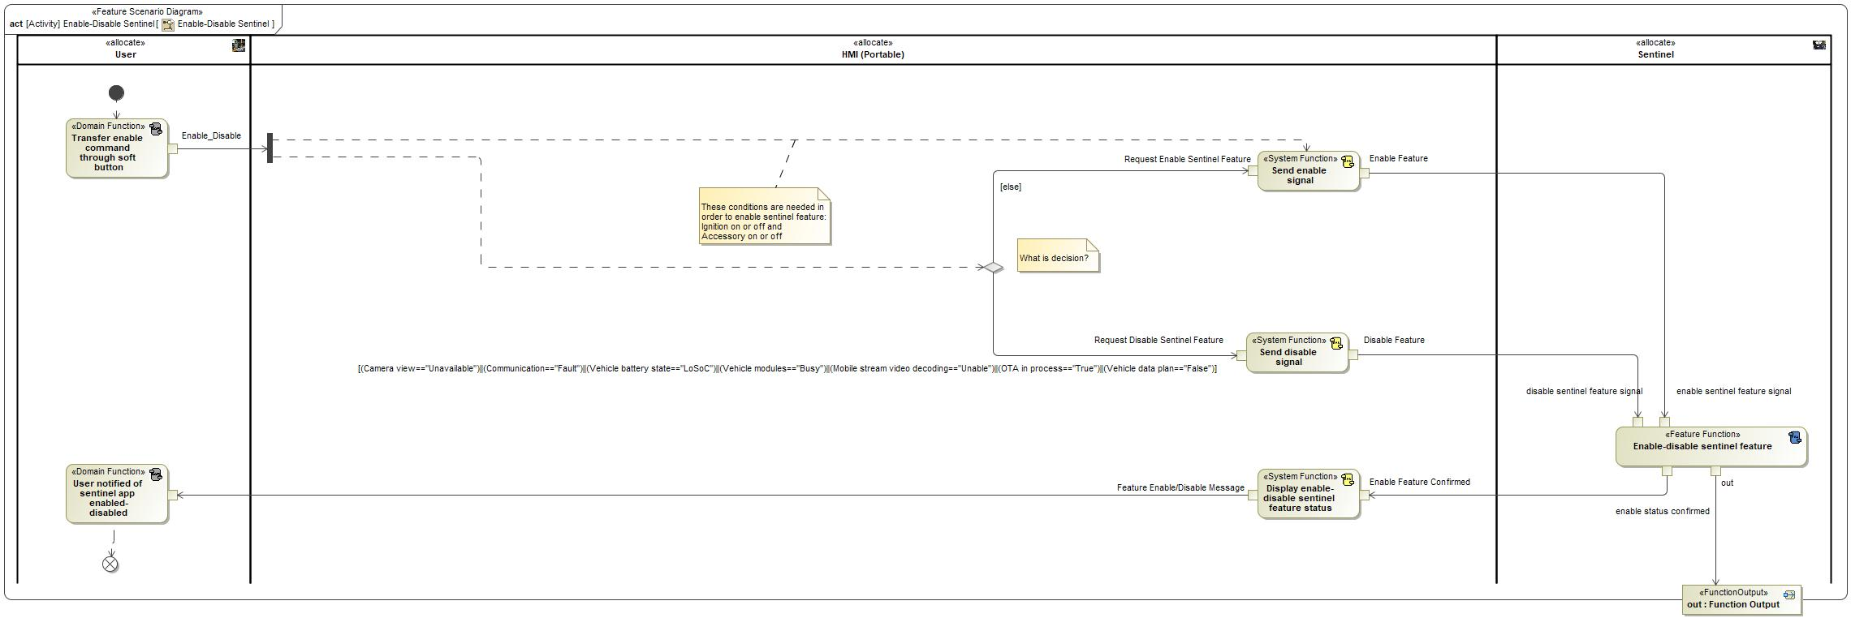

|  |  |
| --- | --- |
| **Flow of Actions** | |
| 1 |  |

Launch tutorial

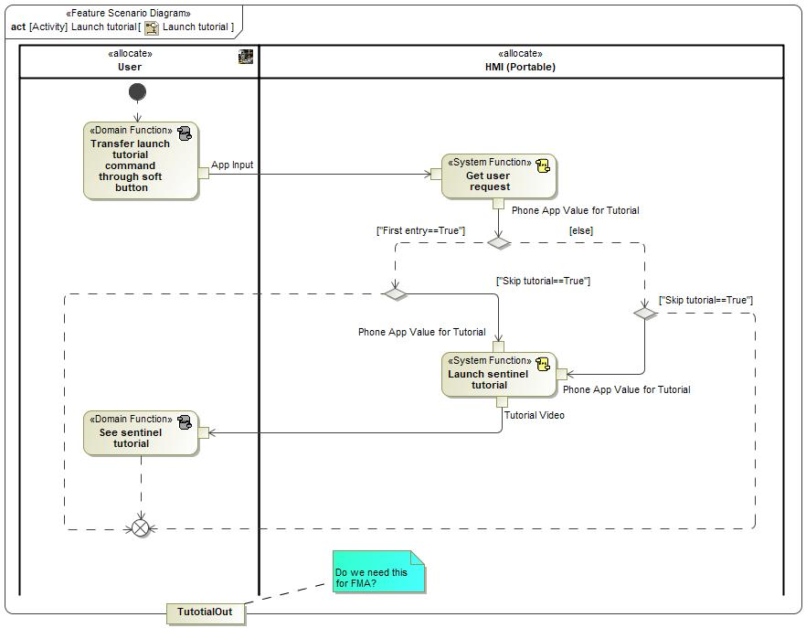

|  |  |
| --- | --- |
| **Flow of Actions** | |
| 1 |  |

Modify sentinel settings

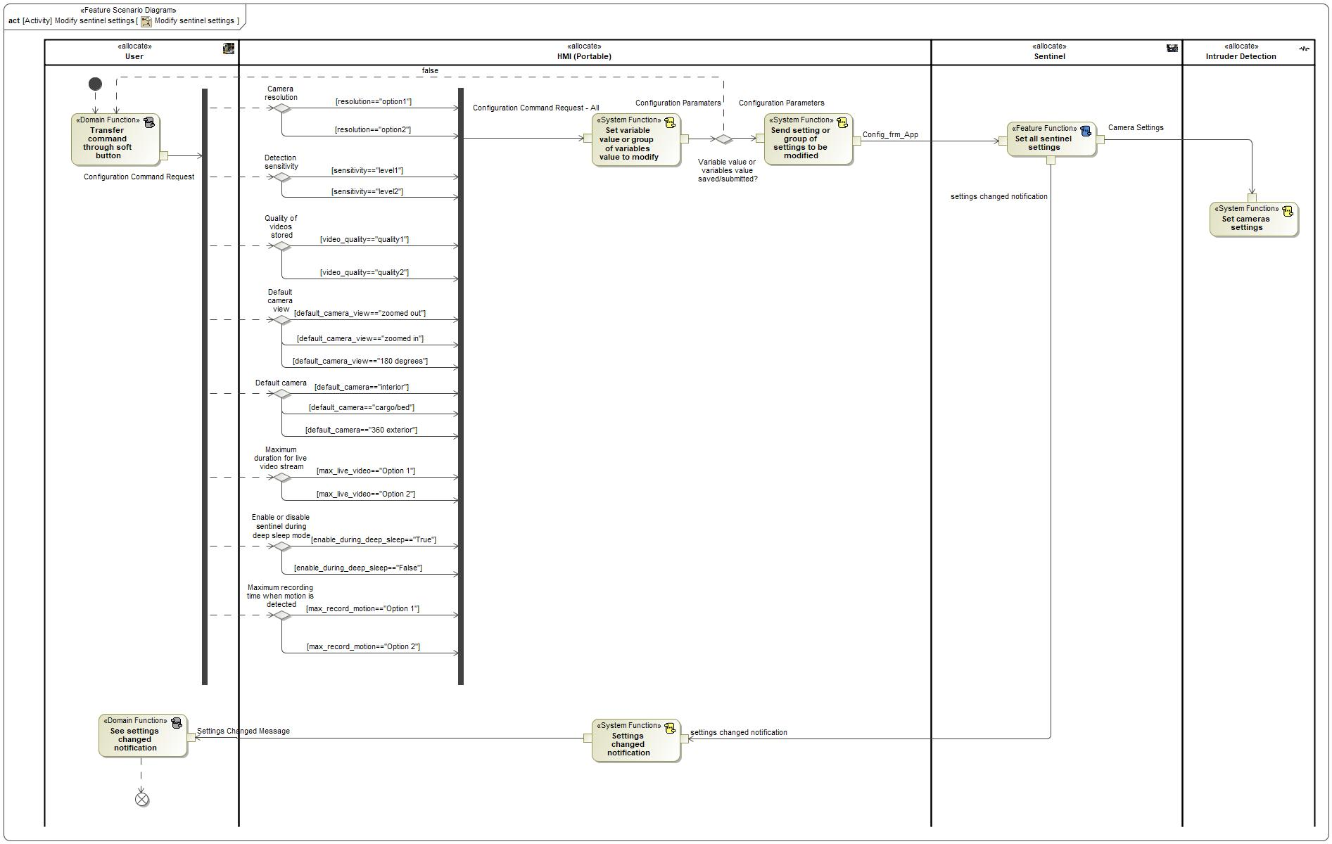

|  |  |
| --- | --- |
| **Flow of Actions** | |
| 1 |  |

Obtain demo mode executed

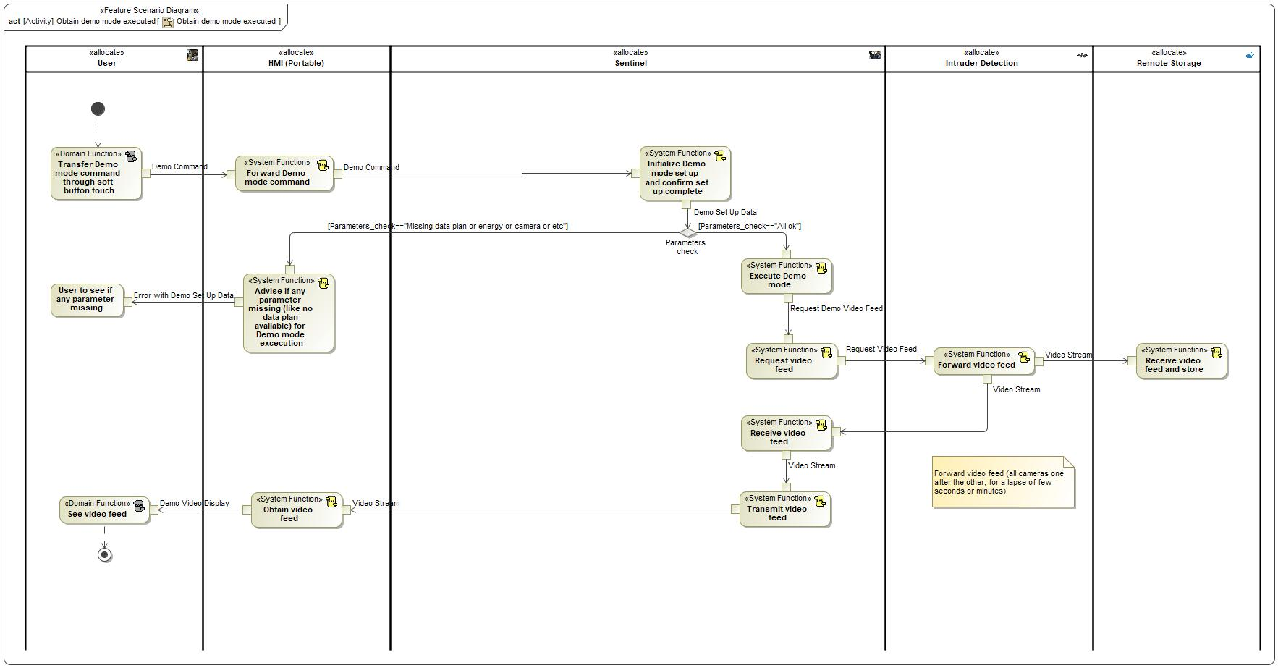

|  |  |
| --- | --- |
| **Flow of Actions** | |
| 1 |  |

Obtain vehicle camera video feed

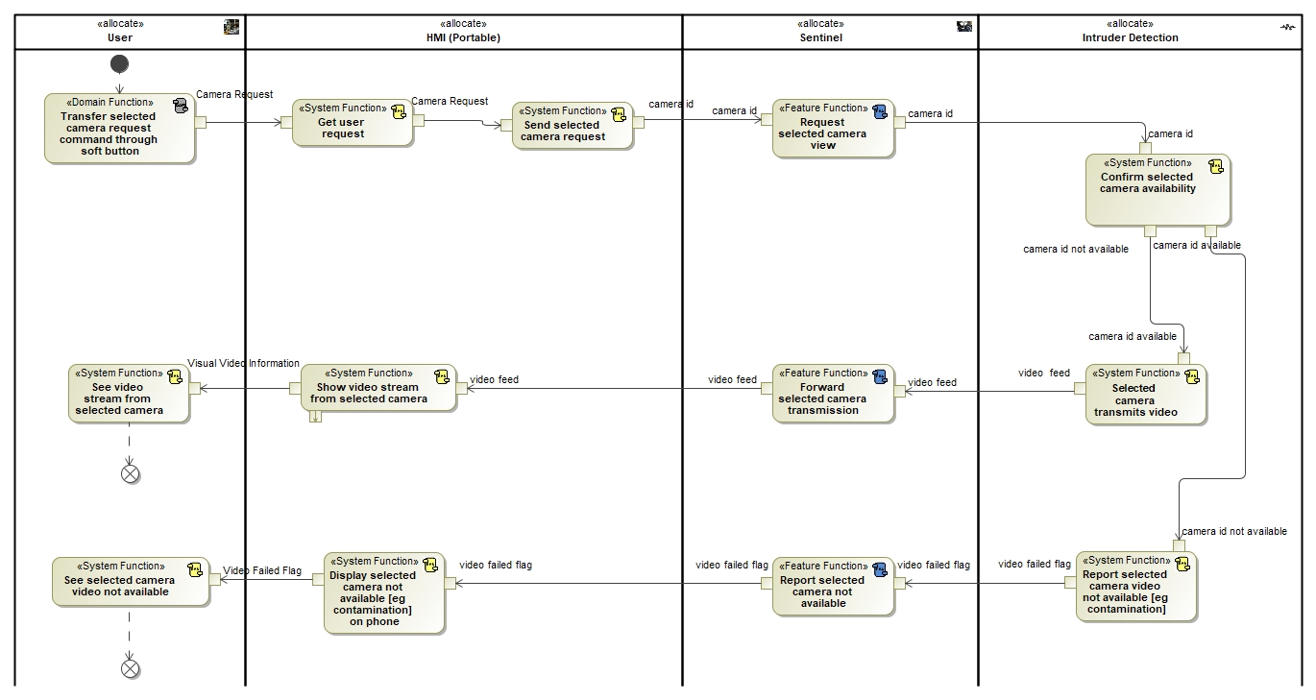

|  |  |
| --- | --- |
| **Flow of Actions** | |
| 1 |  |

Sentinel Scenarios

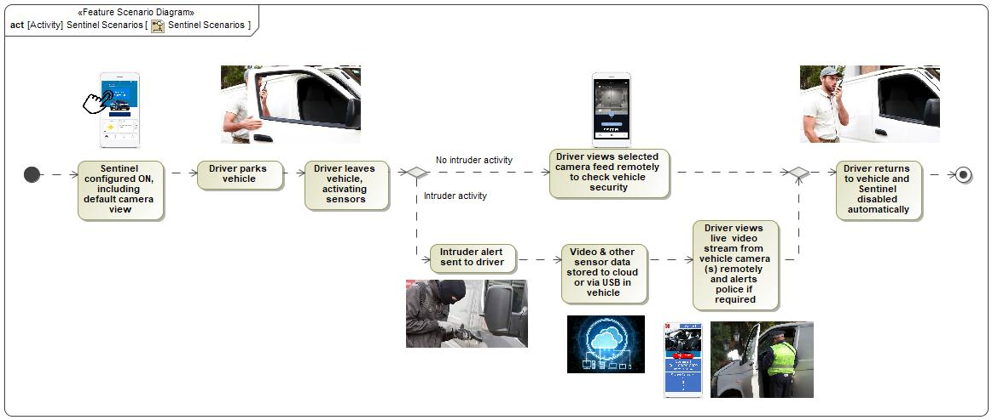

|  |  |
| --- | --- |
| **Flow of Actions** | |
| 1 | Sentinel configured ON, including default camera view |
| 2 | Driver parks vehicle |
| 3 | Driver leaves vehicle, activating sensors |

Terminate camera video feed request

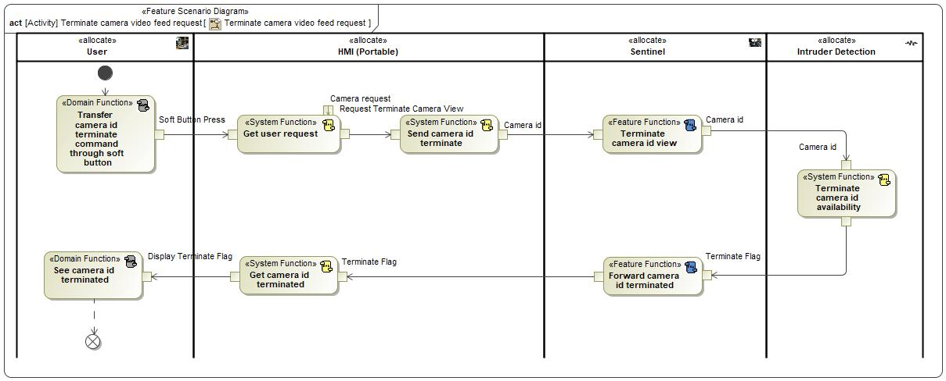

|  |  |
| --- | --- |
| **Flow of Actions** | |
| 1 |  |

## Decision Tables

**#Classification:** Optional

**#Link:** [RE Wiki – Decision Tables](http://wiki.ford.com/display/RequirementsEngineering/Decision+Table).

**#Hint:** Use decision table, if behavior is not state based (in that case prefer state chart from ch. 4.1) and based purely on current inputs.

*Not supported by MagicDraw report generation.*

# Feature Requirements

**#Functional Safety:** In general, safety requirements are not listed here. However, it is possible that later in the development process, a non-safety requirement becomes a safety requirement. In such a case it may remain on this list.

**#Link:** [RE Wiki – How to write good requirements](http://wiki.ford.com/display/RequirementsEngineering/How+to+write+better+requirements?src=contextnavpagetreemode).

## Functional Requirements

R_F_Sentinel_00004 Arm Sentinel

If enabled and no disabling conditions exist, the Sentinel feature shall automatically arm.

|  |  |  |  |  |  |  |  |
| --- | --- | --- | --- | --- | --- | --- | --- |
| Requirement ID: R_F_Sentinel_00004 | | | | | | | |
| **Rationale** | This requirement exists to allow activation and deactivation of the feature automatically when all enabling conditions exist | | | | | | |
| **Acceptance Criteria** | feature getting activated when all enabling conditions exist | | | | | | |
| **Notes** |  | | | | | | |
| **Source** |  | | | | | **Owner** | Ishan Gupta |
| **Source Req.** |  | | | | | **V&V Method** |  |
| **Type** |  | | | **Priority** |  | **Status** |  |
| [Req. Template](http://wiki.ford.com/display/RequirementsEngineering/Requirements+Attributes) Version | | 6.0 | End of Requirement | | | | |

R_F_Sentinel_00005 Intrusion Detection - Inclination Change

If an inclination vehicle event occurs and sentinel feature is armed, sentinel feature shall detect intrusion.

|  |  |  |  |  |  |  |  |
| --- | --- | --- | --- | --- | --- | --- | --- |
| Requirement ID: R_F_Sentinel_00005 | | | | | | | |
| **Rationale** | Sentinel feature receives information from the CSM including the cause of the trigger. | | | | | | |
| **Acceptance Criteria** | intrusion detected in less than 2 seconds | | | | | | |
| **Notes** |  | | | | | | |
| **Source** |  | | | | | **Owner** | Ishan Gupta |
| **Source Req.** |  | | | | | **V&V Method** |  |
| **Type** |  | | | **Priority** |  | **Status** |  |
| [Req. Template](http://wiki.ford.com/display/RequirementsEngineering/Requirements+Attributes) Version | | 6.0 | End of Requirement | | | | |

R_F_Sentinel_00006 Intrusion Detection - Perimeter Alarm

If the perimeter alarm is triggered and sentinel feature is armed, sentinel feature shall detect intrusion.

|  |  |  |  |  |  |  |  |
| --- | --- | --- | --- | --- | --- | --- | --- |
| Requirement ID: R_F_Sentinel_00006 | | | | | | | |
| **Rationale** | Sentinel feature receives information from the Door Ajar Modules including the cause of the trigger. | | | | | | |
| **Acceptance Criteria** | intrusion detected in less than 2 seconds | | | | | | |
| **Notes** |  | | | | | | |
| **Source** |  | | | | | **Owner** | Ishan Gupta |
| **Source Req.** |  | | | | | **V&V Method** |  |
| **Type** |  | | | **Priority** |  | **Status** |  |
| [Req. Template](http://wiki.ford.com/display/RequirementsEngineering/Requirements+Attributes) Version | | 6.0 | End of Requirement | | | | |

R_F_Sentinel_00007 Intrusion Detection - Radar (Bed Area)

If the bead radar system detects an intruder, the sentinel feature shall detect intrusion.

|  |  |  |  |  |  |  |  |
| --- | --- | --- | --- | --- | --- | --- | --- |
| Requirement ID: R_F_Sentinel_00007 | | | | | | | |
| **Rationale** | Sentinel feature receives information from the Radar including the cause of the trigger. | | | | | | |
| **Acceptance Criteria** | intrusion detected in less than 2 seconds | | | | | | |
| **Notes** |  | | | | | | |
| **Source** |  | | | | | **Owner** | Ishan Gupta |
| **Source Req.** |  | | | | | **V&V Method** |  |
| **Type** |  | | | **Priority** |  | **Status** |  |
| [Req. Template](http://wiki.ford.com/display/RequirementsEngineering/Requirements+Attributes) Version | | 6.0 | End of Requirement | | | | |

R_F_Sentinel_00008 Intrusion Detection Confirmed - Object in Bed Area

If an object is detected in truck bed area, sentinel feature shall detect intrusion.

|  |  |  |  |  |  |  |  |
| --- | --- | --- | --- | --- | --- | --- | --- |
| Requirement ID: R_F_Sentinel_00008 | | | | | | | |
| **Rationale** | This requirement exists to detect/confirm real threat and reduce false alert | | | | | | |
| **Acceptance Criteria** | intrusion detected in less than 2 seconds | | | | | | |
| **Notes** |  | | | | | | |
| **Source** |  | | | | | **Owner** | Ishan Gupta |
| **Source Req.** |  | | | | | **V&V Method** |  |
| **Type** |  | | | **Priority** |  | **Status** |  |
| [Req. Template](http://wiki.ford.com/display/RequirementsEngineering/Requirements+Attributes) Version | | 6.0 | End of Requirement | | | | |

R_F_Sentinel_00009 Intrusion Detection - Vibration Sensor (accelerometer)

If the vibration sensor is triggered, sentinel feature shall detect intrusion.

|  |  |  |  |  |  |  |  |
| --- | --- | --- | --- | --- | --- | --- | --- |
| Requirement ID: R_F_Sentinel_00009 | | | | | | | |
| **Rationale** | This requirement exists to detect intrusion if vehicle inclination is changed | | | | | | |
| **Acceptance Criteria** | intrusion detected in less than 2 seconds | | | | | | |
| **Notes** |  | | | | | | |
| **Source** |  | | | | | **Owner** | Ishan Gupta |
| **Source Req.** |  | | | | | **V&V Method** |  |
| **Type** |  | | | **Priority** |  | **Status** |  |
| [Req. Template](http://wiki.ford.com/display/RequirementsEngineering/Requirements+Attributes) Version | | 6.0 | End of Requirement | | | | |

R_F_Sentinel_00010 Intrusion Detection - Collision Detected (accelerometer)

If a vehicle collision is detected, sentinel feature shall notify user of intrusion.

|  |  |  |  |  |  |  |  |
| --- | --- | --- | --- | --- | --- | --- | --- |
| Requirement ID: R_F_Sentinel_00010 | | | | | | | |
| **Rationale** | This requirement exists to detect if the vehicle has experienced any collision | | | | | | |
| **Acceptance Criteria** | intrusion detected in less than 2 seconds | | | | | | |
| **Notes** |  | | | | | | |
| **Source** |  | | | | | **Owner** | Ishan Gupta |
| **Source Req.** |  | | | | | **V&V Method** |  |
| **Type** |  | | | **Priority** |  | **Status** |  |
| [Req. Template](http://wiki.ford.com/display/RequirementsEngineering/Requirements+Attributes) Version | | 6.0 | End of Requirement | | | | |

R_F_Sentinel_00011 Record Video

If triggered (by any detector), sentinel feature shall start recording video in less than 2.5 seconds. Data to be stored on cloud (unless cloud connectivity not allowed)

|  |  |  |  |  |  |  |  |
| --- | --- | --- | --- | --- | --- | --- | --- |
| Requirement ID: R_F_Sentinel_00011 | | | | | | | |
| **Rationale** | This requirement exists to implement video recording | | | | | | |
| **Acceptance Criteria** | recording starts in less than 2.5 seconds when intrusion is detected | | | | | | |
| **Notes** |  | | | | | | |
| **Source** |  | | | | | **Owner** | Ishan Gupta |
| **Source Req.** |  | | | | | **V&V Method** |  |
| **Type** |  | | | **Priority** |  | **Status** |  |
| [Req. Template](http://wiki.ford.com/display/RequirementsEngineering/Requirements+Attributes) Version | | 6.0 | End of Requirement | | | | |

R_F_Sentinel_00012 Store Video - Cloud

Once triggered, the Sentinel Feature shall store videos to cloud storage

|  |  |  |  |  |  |  |  |
| --- | --- | --- | --- | --- | --- | --- | --- |
| Requirement ID: R_F_Sentinel_00012 | | | | | | | |
| **Rationale** | This requirement exists to implement video storage in cloud storage space | | | | | | |
| **Acceptance Criteria** | video stored in cloud storage | | | | | | |
| **Notes** |  | | | | | | |
| **Source** |  | | | | | **Owner** | Ishan Gupta |
| **Source Req.** |  | | | | | **V&V Method** |  |
| **Type** |  | | | **Priority** |  | **Status** |  |
| [Req. Template](http://wiki.ford.com/display/RequirementsEngineering/Requirements+Attributes) Version | | 6.0 | End of Requirement | | | | |

R_F_Sentinel_00015 Allow Remote Start with Sentinel

When Sentinel is armed and the user requests a remote powertrain start, Sentinel shall continue to function.

|  |  |  |  |  |  |  |  |
| --- | --- | --- | --- | --- | --- | --- | --- |
| Requirement ID: R_F_Sentinel_00015 | | | | | | | |
| **Rationale** | Users may need to keep Sentinel armed whilst using the remote start functiionality | | | | | | |
| **Acceptance Criteria** | feature being disabled in KEY OFF and accessory mode operations | | | | | | |
| **Notes** |  | | | | | | |
| **Source** |  | | | | | **Owner** | Ishan Gupta |
| **Source Req.** |  | | | | | **V&V Method** |  |
| **Type** |  | | | **Priority** |  | **Status** |  |
| [Req. Template](http://wiki.ford.com/display/RequirementsEngineering/Requirements+Attributes) Version | | 6.0 | End of Requirement | | | | |

R_F_Sentinel_00016 Power Mode - Ignition Off

At anytime, the Sentinel feature shall be able to work in "ignition off" power mode.

|  |  |  |  |  |  |  |  |
| --- | --- | --- | --- | --- | --- | --- | --- |
| Requirement ID: R_F_Sentinel_00016 | | | | | | | |
| **Rationale** | This requirement specifies condition in which feature can work | | | | | | |
| **Acceptance Criteria** | sentinel feature will be active in ignition off condition. | | | | | | |
| **Notes** |  | | | | | | |
| **Source** |  | | | | | **Owner** | Ishan Gupta |
| **Source Req.** |  | | | | | **V&V Method** |  |
| **Type** |  | | | **Priority** |  | **Status** |  |
| [Req. Template](http://wiki.ford.com/display/RequirementsEngineering/Requirements+Attributes) Version | | 6.0 | End of Requirement | | | | |

R_F_Sentinel_00017 Jump Drive - Fit and Record/Pause/Stop/Resume/ Play Data

Before arming the feature, the user shall be able to plug in a USB drive in a secure vehicle location to store and later access videos. This will include record, pause, stop, play and resume video play. Meta data such as date/time and type of intrusion event will also be recorded and available to the user.

|  |  |  |  |  |  |  |  |
| --- | --- | --- | --- | --- | --- | --- | --- |
| Requirement ID: R_F_Sentinel_00017 | | | | | | | |
| **Rationale** | This requirement allows user to access videos | | | | | | |
| **Acceptance Criteria** | user being able to access videos satisfies this requirement | | | | | | |
| **Notes** |  | | | | | | |
| **Source** |  | | | | | **Owner** | Ishan Gupta |
| **Source Req.** |  | | | | | **V&V Method** |  |
| **Type** |  | | | **Priority** |  | **Status** |  |
| [Req. Template](http://wiki.ford.com/display/RequirementsEngineering/Requirements+Attributes) Version | | 6.0 | End of Requirement | | | | |

R_F_Sentinel_00025 Post Stream - Select Camera

After terminating video streaming, sentinel feature shall allow user to change camera on the Ford Pass application.

|  |  |  |  |  |  |  |  |
| --- | --- | --- | --- | --- | --- | --- | --- |
| Requirement ID: R_F_Sentinel_00025 | | | | | | | |
| **Rationale** | This requirement allows user to change vehicle camera to watch the video | | | | | | |
| **Acceptance Criteria** | user being able to change the vehicle camera | | | | | | |
| **Notes** |  | | | | | | |
| **Source** |  | | | | | **Owner** | Ishan Gupta |
| **Source Req.** |  | | | | | **V&V Method** |  |
| **Type** |  | | | **Priority** |  | **Status** |  |
| [Req. Template](http://wiki.ford.com/display/RequirementsEngineering/Requirements+Attributes) Version | | 6.0 | End of Requirement | | | | |

R_F_Sentinel_00026 Low Light Capability

Under low light / dark conditions, sentinel feature shall be able to record videos.

|  |  |  |  |  |  |  |  |
| --- | --- | --- | --- | --- | --- | --- | --- |
| Requirement ID: R_F_Sentinel_00026 | | | | | | | |
| **Rationale** | The feature needs to operate in low abient light conditions, with low light levels in the vehicle in both the cab area, bed area and in an enclosed cargo area in vans | | | | | | |
| **Acceptance Criteria** | low light (lumens) levels capability of cameras and lumens capacity of lighting | | | | | | |
| **Notes** |  | | | | | | |
| **Source** |  | | | | | **Owner** | Ishan Gupta |
| **Source Req.** |  | | | | | **V&V Method** |  |
| **Type** |  | | | **Priority** |  | **Status** |  |
| [Req. Template](http://wiki.ford.com/display/RequirementsEngineering/Requirements+Attributes) Version | | 6.0 | End of Requirement | | | | |

R_F_Sentinel_00027 Video Stream Buffering

When triggered, the Sentinel feature shall allow video storage of at least 35 seconds of digitalized video.

|  |  |  |  |  |  |  |  |
| --- | --- | --- | --- | --- | --- | --- | --- |
| Requirement ID: R_F_Sentinel_00027 | | | | | | | |
| **Rationale** | This requirement specifies the minimum duration of videos that can be buffered | | | | | | |
| **Acceptance Criteria** | videos being buffered for 35 seconds satisfies this requirement | | | | | | |
| **Notes** |  | | | | | | |
| **Source** |  | | | | | **Owner** | Ishan Gupta |
| **Source Req.** |  | | | | | **V&V Method** |  |
| **Type** |  | | | **Priority** |  | **Status** |  |
| [Req. Template](http://wiki.ford.com/display/RequirementsEngineering/Requirements+Attributes) Version | | 6.0 | End of Requirement | | | | |

R_F_Sentinel_00028 Video Stream Stitching - 360 Degree External Cameras

When triggered, the Sentinel feature shall allow streaming of the external 360-degree camera signals into a single video feed.

|  |  |  |  |  |  |  |  |
| --- | --- | --- | --- | --- | --- | --- | --- |
| Requirement ID: R_F_Sentinel_00028 | | | | | | | |
| **Rationale** | This requirement specifies the video stream stiching process of the two cameras | | | | | | |
| **Acceptance Criteria** | demonstrated video stitching capability of video processing system | | | | | | |
| **Notes** |  | | | | | | |
| **Source** |  | | | | | **Owner** | Ishan Gupta |
| **Source Req.** |  | | | | | **V&V Method** |  |
| **Type** |  | | | **Priority** |  | **Status** |  |
| [Req. Template](http://wiki.ford.com/display/RequirementsEngineering/Requirements+Attributes) Version | | 6.0 | End of Requirement | | | | |

R_F_Sentinel_00047 Modify Settings - Record Time

When user requests to change record time setting through Ford Pass Application, the Sentinel feature shall allow user to access record time setting.

|  |  |  |  |  |  |  |  |
| --- | --- | --- | --- | --- | --- | --- | --- |
| Requirement ID: R_F_Sentinel_00047 | | | | | | | |
| **Rationale** | The user may want to limit or lengthen the video clips for events. | | | | | | |
| **Acceptance Criteria** | demonstration of user being able to successfully select record time | | | | | | |
| **Notes** |  | | | | | | |
| **Source** |  | | | | | **Owner** | Ishan Gupta |
| **Source Req.** |  | | | | | **V&V Method** |  |
| **Type** |  | | | **Priority** |  | **Status** |  |
| [Req. Template](http://wiki.ford.com/display/RequirementsEngineering/Requirements+Attributes) Version | | 6.0 | End of Requirement | | | | |

R_F_Sentinel_00048 Inform User Notifications - View Unavailable

If any of the sentinel feature disabling conditions occur, the Sentinel feature shall notify customer.

|  |  |  |  |  |  |  |  |
| --- | --- | --- | --- | --- | --- | --- | --- |
| Requirement ID: R_F_Sentinel_00048 | | | | | | | |
| **Rationale** | The user needs to know if the feature is inoperative. | | | | | | |
| **Acceptance Criteria** | demonstration of user being notified if no view available | | | | | | |
| **Notes** |  | | | | | | |
| **Source** |  | | | | | **Owner** | Ishan Gupta |
| **Source Req.** |  | | | | | **V&V Method** |  |
| **Type** |  | | | **Priority** |  | **Status** |  |
| [Req. Template](http://wiki.ford.com/display/RequirementsEngineering/Requirements+Attributes) Version | | 6.0 | End of Requirement | | | | |

R_F_Sentinel_00049 Sentinel Disabled - Low Battery

If vehicle battery state of charge is low, the Sentinel feature shall disable itself and inform user.

|  |  |  |  |  |  |  |  |
| --- | --- | --- | --- | --- | --- | --- | --- |
| Requirement ID: R_F_Sentinel_00049 | | | | | | | |
| **Rationale** | The feature functions in key OFF and battery SOC doesn’t drop to a critical level | | | | | | |
| **Acceptance Criteria** | demonstration of feature disabling when SOC drops below threshold | | | | | | |
| **Notes** |  | | | | | | |
| **Source** |  | | | | | **Owner** | Ishan Gupta |
| **Source Req.** |  | | | | | **V&V Method** |  |
| **Type** |  | | | **Priority** |  | **Status** |  |
| [Req. Template](http://wiki.ford.com/display/RequirementsEngineering/Requirements+Attributes) Version | | 6.0 | End of Requirement | | | | |

R_F_Sentinel_00050 Sentinel Disabled - Module Occupied

If vehicle modules (related to sentinel feature functionality) are not available, the Sentinel feature shall disable itself.

|  |  |  |  |  |  |  |  |
| --- | --- | --- | --- | --- | --- | --- | --- |
| Requirement ID: R_F_Sentinel_00050 | | | | | | | |
| **Rationale** | The correct modules are required for the feature. | | | | | | |
| **Acceptance Criteria** | demonstration during test | | | | | | |
| **Notes** |  | | | | | | |
| **Source** |  | | | | | **Owner** | Ishan Gupta |
| **Source Req.** |  | | | | | **V&V Method** |  |
| **Type** |  | | | **Priority** |  | **Status** |  |
| [Req. Template](http://wiki.ford.com/display/RequirementsEngineering/Requirements+Attributes) Version | | 6.0 | End of Requirement | | | | |

R_F_Sentinel_00052 Sentinel Disabled - If an OTA software update is in progress.

If OTA situation/event is happening, the Sentinel feature shall disable itself.

|  |  |  |  |  |  |  |  |
| --- | --- | --- | --- | --- | --- | --- | --- |
| Requirement ID: R_F_Sentinel_00052 | | | | | | | |
| **Rationale** | The feature cannot operate in parallel with the softweare being updated. | | | | | | |
| **Acceptance Criteria** | demonstration during test | | | | | | |
| **Notes** |  | | | | | | |
| **Source** |  | | | | | **Owner** | Ishan Gupta |
| **Source Req.** |  | | | | | **V&V Method** |  |
| **Type** |  | | | **Priority** |  | **Status** |  |
| [Req. Template](http://wiki.ford.com/display/RequirementsEngineering/Requirements+Attributes) Version | | 6.0 | End of Requirement | | | | |

R_F_Sentinel_00053 Sentinel Disabled - No Sentinel Plan

If no sentinel plan is purchased/available, the Sentinel feature shall disable itself.

|  |  |  |  |  |  |  |  |
| --- | --- | --- | --- | --- | --- | --- | --- |
| Requirement ID: R_F_Sentinel_00053 | | | | | | | |
| **Rationale** | A payment plan is required to access the feature. | | | | | | |
| **Acceptance Criteria** | demonstration during test | | | | | | |
| **Notes** |  | | | | | | |
| **Source** |  | | | | | **Owner** | Ishan Gupta |
| **Source Req.** |  | | | | | **V&V Method** |  |
| **Type** |  | | | **Priority** |  | **Status** |  |
| [Req. Template](http://wiki.ford.com/display/RequirementsEngineering/Requirements+Attributes) Version | | 6.0 | End of Requirement | | | | |

R_F_Sentinel_00056 Over the Air Updates

When user approves OTA updates, the Sentinel feature shall allow OTA updates.

|  |  |  |  |  |  |  |  |
| --- | --- | --- | --- | --- | --- | --- | --- |
| Requirement ID: R_F_Sentinel_00056 | | | | | | | |
| **Rationale** | Improvements to the software can be made remotely without needed visits to service centres/dealerships by customers. | | | | | | |
| **Acceptance Criteria** | demonstration of OTA update of software | | | | | | |
| **Notes** |  | | | | | | |
| **Source** |  | | | | | **Owner** | Ishan Gupta |
| **Source Req.** |  | | | | | **V&V Method** |  |
| **Type** |  | | | **Priority** |  | **Status** |  |
| [Req. Template](http://wiki.ford.com/display/RequirementsEngineering/Requirements+Attributes) Version | | 6.0 | End of Requirement | | | | |

R_F_Sentinel_00057 Machine Learning

When performing any sentinel feature functionality, the Sentinel feature shall have in-vehicle and cloud-machine learning capabilities.

|  |  |  |  |  |  |  |  |
| --- | --- | --- | --- | --- | --- | --- | --- |
| Requirement ID: R_F_Sentinel_00057 | | | | | | | |
| **Rationale** | This will allow improved intruder detection using the available detector inputs. | | | | | | |
| **Acceptance Criteria** | demonstration of ML capability under multiple scenarions, intruder type, vehicle type, environmental conditions | | | | | | |
| **Notes** |  | | | | | | |
| **Source** |  | | | | | **Owner** | Ishan Gupta |
| **Source Req.** |  | | | | | **V&V Method** |  |
| **Type** |  | | | **Priority** |  | **Status** |  |
| [Req. Template](http://wiki.ford.com/display/RequirementsEngineering/Requirements+Attributes) Version | | 6.0 | End of Requirement | | | | |

R_F_Sentinel_00060 Record Data - Date

Upon a detected intrusion, the Sentinel feature shall record date information.

|  |  |  |  |  |  |  |  |
| --- | --- | --- | --- | --- | --- | --- | --- |
| Requirement ID: R_F_Sentinel_00060 | | | | | | | |
| **Rationale** | This may help determine the date of an intruder event | | | | | | |
| **Acceptance Criteria** | demonstration during test | | | | | | |
| **Notes** |  | | | | | | |
| **Source** |  | | | | | **Owner** | Ishan Gupta |
| **Source Req.** |  | | | | | **V&V Method** |  |
| **Type** |  | | | **Priority** |  | **Status** |  |
| [Req. Template](http://wiki.ford.com/display/RequirementsEngineering/Requirements+Attributes) Version | | 6.0 | End of Requirement | | | | |

R_F_Sentinel_00061 Record Data - Time

Upon a detected intrusion, the Sentinel feature shall record time.

|  |  |  |  |  |  |  |  |
| --- | --- | --- | --- | --- | --- | --- | --- |
| Requirement ID: R_F_Sentinel_00061 | | | | | | | |
| **Rationale** | This may help determine the time of an intruder event | | | | | | |
| **Acceptance Criteria** | demonstration during test | | | | | | |
| **Notes** |  | | | | | | |
| **Source** |  | | | | | **Owner** | Ishan Gupta |
| **Source Req.** |  | | | | | **V&V Method** |  |
| **Type** |  | | | **Priority** |  | **Status** |  |
| [Req. Template](http://wiki.ford.com/display/RequirementsEngineering/Requirements+Attributes) Version | | 6.0 | End of Requirement | | | | |

R_F_Sentinel_00062 Record Perimeter Alarm Trigger

Upon a detected intrusion, the Sentinel feature shall record perimeter alarm sensor status (eg. ajar status).

|  |  |  |  |  |  |  |  |
| --- | --- | --- | --- | --- | --- | --- | --- |
| Requirement ID: R_F_Sentinel_00062 | | | | | | | |
| **Rationale** | This may help determine the type of intruder event. | | | | | | |
| **Acceptance Criteria** | demonstration during test | | | | | | |
| **Notes** |  | | | | | | |
| **Source** |  | | | | | **Owner** | Ishan Gupta |
| **Source Req.** |  | | | | | **V&V Method** |  |
| **Type** |  | | | **Priority** |  | **Status** |  |
| [Req. Template](http://wiki.ford.com/display/RequirementsEngineering/Requirements+Attributes) Version | | 6.0 | End of Requirement | | | | |

R_F_Sentinel_00063 Record Data - Radar

Upon a detected intrusion, the Sentinel feature shall record radar status.

|  |  |  |  |  |  |  |  |
| --- | --- | --- | --- | --- | --- | --- | --- |
| Requirement ID: R_F_Sentinel_00063 | | | | | | | |
| **Rationale** | This may help determine the type of intruder event. | | | | | | |
| **Acceptance Criteria** | demonstration during test | | | | | | |
| **Notes** |  | | | | | | |
| **Source** |  | | | | | **Owner** | Ishan Gupta |
| **Source Req.** |  | | | | | **V&V Method** |  |
| **Type** |  | | | **Priority** |  | **Status** |  |
| [Req. Template](http://wiki.ford.com/display/RequirementsEngineering/Requirements+Attributes) Version | | 6.0 | End of Requirement | | | | |

R_F_Sentinel_00064 Record Data - Accelerometer

Upon a detected intrusion, the Sentinel feature shall record accelerometer status.

|  |  |  |  |  |  |  |  |
| --- | --- | --- | --- | --- | --- | --- | --- |
| Requirement ID: R_F_Sentinel_00064 | | | | | | | |
| **Rationale** | This may help determine the type of intruder event. | | | | | | |
| **Acceptance Criteria** | demonstration during test | | | | | | |
| **Notes** |  | | | | | | |
| **Source** |  | | | | | **Owner** | Ishan Gupta |
| **Source Req.** |  | | | | | **V&V Method** |  |
| **Type** |  | | | **Priority** |  | **Status** |  |
| [Req. Template](http://wiki.ford.com/display/RequirementsEngineering/Requirements+Attributes) Version | | 6.0 | End of Requirement | | | | |

R_F_Sentinel_00065 Access Videos - USB

Upon user request, the Sentinel feature shall allow user to access videos stored in USB drive (local storage).

|  |  |  |  |  |  |  |  |
| --- | --- | --- | --- | --- | --- | --- | --- |
| Requirement ID: R_F_Sentinel_00065 | | | | | | | |
| **Rationale** | To allow viweing of videos - from USB | | | | | | |
| **Acceptance Criteria** | demonstration during test | | | | | | |
| **Notes** |  | | | | | | |
| **Source** |  | | | | | **Owner** | Ishan Gupta |
| **Source Req.** |  | | | | | **V&V Method** |  |
| **Type** |  | | | **Priority** |  | **Status** |  |
| [Req. Template](http://wiki.ford.com/display/RequirementsEngineering/Requirements+Attributes) Version | | 6.0 | End of Requirement | | | | |

R_F_Sentinel_00066 Access Videos - Cloud

Upon user request, the Sentinel feature shall allow user to access videos stored in cloud storage.

|  |  |  |  |  |  |  |  |
| --- | --- | --- | --- | --- | --- | --- | --- |
| Requirement ID: R_F_Sentinel_00066 | | | | | | | |
| **Rationale** | To allow viewing of videos - from the cloud. | | | | | | |
| **Acceptance Criteria** | demonstration during test | | | | | | |
| **Notes** |  | | | | | | |
| **Source** |  | | | | | **Owner** | Ishan Gupta |
| **Source Req.** |  | | | | | **V&V Method** |  |
| **Type** |  | | | **Priority** |  | **Status** |  |
| [Req. Template](http://wiki.ford.com/display/RequirementsEngineering/Requirements+Attributes) Version | | 6.0 | End of Requirement | | | | |

R_F_Sentinel_00067 Cloud Storage - Pause Video

Upon user request, the Sentinel feature shall allow user to pause videos sored in cloud storage.

|  |  |  |  |  |  |  |  |
| --- | --- | --- | --- | --- | --- | --- | --- |
| Requirement ID: R_F_Sentinel_00067 | | | | | | | |
| **Rationale** | The user may want to pause the video, for example to study a still image in more detail. | | | | | | |
| **Acceptance Criteria** | demonstration during test | | | | | | |
| **Notes** |  | | | | | | |
| **Source** |  | | | | | **Owner** | Ishan Gupta |
| **Source Req.** |  | | | | | **V&V Method** |  |
| **Type** |  | | | **Priority** |  | **Status** |  |
| [Req. Template](http://wiki.ford.com/display/RequirementsEngineering/Requirements+Attributes) Version | | 6.0 | End of Requirement | | | | |

R_F_Sentinel_00068 Cloud Storage -Resume Video

Upon user request, the Sentinel feature shall allow user to resume viewing videos stored in cloud storage.

|  |  |  |  |  |  |  |  |
| --- | --- | --- | --- | --- | --- | --- | --- |
| Requirement ID: R_F_Sentinel_00068 | | | | | | | |
| **Rationale** | The user may want to pause the stream, then restart viewing/streaming. | | | | | | |
| **Acceptance Criteria** | demonstration during test | | | | | | |
| **Notes** |  | | | | | | |
| **Source** |  | | | | | **Owner** | Ishan Gupta |
| **Source Req.** |  | | | | | **V&V Method** |  |
| **Type** |  | | | **Priority** |  | **Status** |  |
| [Req. Template](http://wiki.ford.com/display/RequirementsEngineering/Requirements+Attributes) Version | | 6.0 | End of Requirement | | | | |

R_F_Sentinel_00069 Cloud Storage -Delete Video

Upon user request, the Sentinel feature shall allow user to delete videos stored in cloud storage.

|  |  |  |  |  |  |  |  |
| --- | --- | --- | --- | --- | --- | --- | --- |
| Requirement ID: R_F_Sentinel_00069 | | | | | | | |
| **Rationale** | This is required to free-up storage space and to help organise lists of data. | | | | | | |
| **Acceptance Criteria** | demonstration during test | | | | | | |
| **Notes** |  | | | | | | |
| **Source** |  | | | | | **Owner** | Ishan Gupta |
| **Source Req.** |  | | | | | **V&V Method** |  |
| **Type** |  | | | **Priority** |  | **Status** |  |
| [Req. Template](http://wiki.ford.com/display/RequirementsEngineering/Requirements+Attributes) Version | | 6.0 | End of Requirement | | | | |

R_F_Sentinel_00070 Cloud Storage -Filter Videos/Audio (by date/time)

Upon user request, the Sentinel feature shall allow user to filter/list videos (and audio if available) in cloud storage (based on date filters).

|  |  |  |  |  |  |  |  |
| --- | --- | --- | --- | --- | --- | --- | --- |
| Requirement ID: R_F_Sentinel_00070 | | | | | | | |
| **Rationale** | This is to help the user find the most relevant video clip - based on the date of the event. | | | | | | |
| **Acceptance Criteria** | demonstration during test | | | | | | |
| **Notes** |  | | | | | | |
| **Source** |  | | | | | **Owner** | Ishan Gupta |
| **Source Req.** |  | | | | | **V&V Method** |  |
| **Type** |  | | | **Priority** |  | **Status** |  |
| [Req. Template](http://wiki.ford.com/display/RequirementsEngineering/Requirements+Attributes) Version | | 6.0 | End of Requirement | | | | |

R_F_Sentinel_00071 Local Storage -Filter Videos/Audio (by date/time)

Upon user request, the Sentinel feature shall allow user to filter/list videos (and audio if available) in local storage (based on time filters).

|  |  |  |  |  |  |  |  |
| --- | --- | --- | --- | --- | --- | --- | --- |
| Requirement ID: R_F_Sentinel_00071 | | | | | | | |
| **Rationale** | This is to help the user find the most relevant video clip - based on the time of the event. | | | | | | |
| **Acceptance Criteria** | demonstration during test | | | | | | |
| **Notes** |  | | | | | | |
| **Source** |  | | | | | **Owner** | Ishan Gupta |
| **Source Req.** |  | | | | | **V&V Method** |  |
| **Type** |  | | | **Priority** |  | **Status** |  |
| [Req. Template](http://wiki.ford.com/display/RequirementsEngineering/Requirements+Attributes) Version | | 6.0 | End of Requirement | | | | |

R_F_Sentinel_00072 Cloud Storage -Filter Videos (intrusion method)

Upon user request, the Sentinel feature shall allow user to filter/list videos in cloud storage (based on intrusion method filters).

|  |  |  |  |  |  |  |  |
| --- | --- | --- | --- | --- | --- | --- | --- |
| Requirement ID: R_F_Sentinel_00072 | | | | | | | |
| **Rationale** | This is to help the user find the most relevant video clip - based on intrusion method. | | | | | | |
| **Acceptance Criteria** | demonstration during test | | | | | | |
| **Notes** |  | | | | | | |
| **Source** |  | | | | | **Owner** | Ishan Gupta |
| **Source Req.** |  | | | | | **V&V Method** |  |
| **Type** |  | | | **Priority** |  | **Status** |  |
| [Req. Template](http://wiki.ford.com/display/RequirementsEngineering/Requirements+Attributes) Version | | 6.0 | End of Requirement | | | | |

R_F_Sentinel_00073 Cloud Storage -Overwrite

When cloud storage is full, the Sentinel feature shall automatically overwrite old videos (based on storage capacity limit reached, date of recording).

|  |  |  |  |  |  |  |  |
| --- | --- | --- | --- | --- | --- | --- | --- |
| Requirement ID: R_F_Sentinel_00073 | | | | | | | |
| **Rationale** | The amount of data collected may exceed the available storage capacity. | | | | | | |
| **Acceptance Criteria** | demonstration during test | | | | | | |
| **Notes** |  | | | | | | |
| **Source** |  | | | | | **Owner** | Ishan Gupta |
| **Source Req.** |  | | | | | **V&V Method** |  |
| **Type** |  | | | **Priority** |  | **Status** |  |
| [Req. Template](http://wiki.ford.com/display/RequirementsEngineering/Requirements+Attributes) Version | | 6.0 | End of Requirement | | | | |

R_F_Sentinel_00074 Live Stream - Pause

Upon user request, the Sentinel feature shall allow user to pause live video streaming.

|  |  |  |  |  |  |  |  |
| --- | --- | --- | --- | --- | --- | --- | --- |
| Requirement ID: R_F_Sentinel_00074 | | | | | | | |
| **Rationale** | The user may want to pause the video, for example to study a still image in more detail. | | | | | | |
| **Acceptance Criteria** | demonstration during test | | | | | | |
| **Notes** |  | | | | | | |
| **Source** |  | | | | | **Owner** | Ishan Gupta |
| **Source Req.** |  | | | | | **V&V Method** |  |
| **Type** |  | | | **Priority** |  | **Status** |  |
| [Req. Template](http://wiki.ford.com/display/RequirementsEngineering/Requirements+Attributes) Version | | 6.0 | End of Requirement | | | | |

R_F_Sentinel_00075 Live Stream - Resume

Upon user request, the Sentinel feature shall allow user to resume live video streaming.

|  |  |  |  |  |  |  |  |
| --- | --- | --- | --- | --- | --- | --- | --- |
| Requirement ID: R_F_Sentinel_00075 | | | | | | | |
| **Rationale** | The user may want to pause the stream, then restart viewing/streaming. | | | | | | |
| **Acceptance Criteria** | demonstration during test | | | | | | |
| **Notes** |  | | | | | | |
| **Source** |  | | | | | **Owner** | Ishan Gupta |
| **Source Req.** |  | | | | | **V&V Method** |  |
| **Type** |  | | | **Priority** |  | **Status** |  |
| [Req. Template](http://wiki.ford.com/display/RequirementsEngineering/Requirements+Attributes) Version | | 6.0 | End of Requirement | | | | |

R_F_Sentinel_00076 Local Storage - Delete Videos

Upon user request, the Sentinel feature shall allow user to delete videos stored in local storage (SYNC).

|  |  |  |  |  |  |  |  |
| --- | --- | --- | --- | --- | --- | --- | --- |
| Requirement ID: R_F_Sentinel_00076 | | | | | | | |
| **Rationale** | This is required to free-up storage space and to help organise lists of data. | | | | | | |
| **Acceptance Criteria** | demonstration during test | | | | | | |
| **Notes** |  | | | | | | |
| **Source** |  | | | | | **Owner** | Ishan Gupta |
| **Source Req.** |  | | | | | **V&V Method** |  |
| **Type** |  | | | **Priority** |  | **Status** |  |
| [Req. Template](http://wiki.ford.com/display/RequirementsEngineering/Requirements+Attributes) Version | | 6.0 | End of Requirement | | | | |

R_F_Sentinel_00077 Local Storage -Overwrite

When local storage is full, the Sentinel feature shall automatically overwrite old videos (based on storage capacity limit reached, date of recording).

|  |  |  |  |  |  |  |  |
| --- | --- | --- | --- | --- | --- | --- | --- |
| Requirement ID: R_F_Sentinel_00077 | | | | | | | |
| **Rationale** | Limited storage space may casue the amount of video data captured to exceed the amount of storage space available | | | | | | |
| **Acceptance Criteria** | demonstration during test | | | | | | |
| **Notes** |  | | | | | | |
| **Source** |  | | | | | **Owner** | Ishan Gupta |
| **Source Req.** |  | | | | | **V&V Method** |  |
| **Type** |  | | | **Priority** |  | **Status** |  |
| [Req. Template](http://wiki.ford.com/display/RequirementsEngineering/Requirements+Attributes) Version | | 6.0 | End of Requirement | | | | |

R_F_Sentinel_00078 Alert Poor Signal at Park

When the vehicle is parked the Sentinel Feature shall inform the user via vehicle HMI if the network signal is poor. Check to see if USB memory device installed and inform user if not installed.

|  |  |  |  |  |  |  |  |
| --- | --- | --- | --- | --- | --- | --- | --- |
| Requirement ID: R_F_Sentinel_00078 | | | | | | | |
| **Rationale** | The feature should warn the user that the nework connection may be poor, so that they can either drive to another location or ensure that a USB memroy device is in the vehicle. A USB memory device is reagded as being less ecure than storing data to the cloud, as the USB memory device may be stolen from the vehicle. | | | | | | |
| **Acceptance Criteria** | demonstrated during test | | | | | | |
| **Notes** |  | | | | | | |
| **Source** |  | | | | | **Owner** | Ishan Gupta |
| **Source Req.** |  | | | | | **V&V Method** |  |
| **Type** |  | | | **Priority** |  | **Status** |  |
| [Req. Template](http://wiki.ford.com/display/RequirementsEngineering/Requirements+Attributes) Version | | 6.0 | End of Requirement | | | | |

### Error Handling

No Error Handling Requirements specified.

## Non-Functional Requirements

***#Hint:*** *Non-functional requirements specify some performance criteria in addition to the functional behavior given defined by the functional requirements. Timing (if not already included in the functional requirements), security details (e.g. how secure does an algorithm have to be) reliability (e.g. mean time between failure) or maintainability could be specified in this section.*

### Safety

**#Hint:** Only those safety requirements, which are not related to Functional Safety (ISO26262) should go here. For Functional Safety refer to chapter 6 “Functional Safety”.

*Not supported by MagicDraw report generation.*

### Security

R_F_Sentinel_00014 Notify User in Under 1s

If intrusion is detected, the Sentinel feature shall notify user in less than 1 second.

|  |  |  |  |  |  |  |  |
| --- | --- | --- | --- | --- | --- | --- | --- |
| Requirement ID: R_F_Sentinel_00014 | | | | | | | |
| **Rationale** | This requirement exists to notify the user of any type of intrusion | | | | | | |
| **Acceptance Criteria** | the user being notified within 1 second of an intrusion being detected will satisfy this requirment | | | | | | |
| **Notes** |  | | | | | | |
| **Source** |  | | | | | **Owner** | Ishan Gupta |
| **Source Req.** | * 1113170636.jpg R_F_Sentinel_00013 Store Video - Local | | | | | **V&V Method** |  |
| **Type** |  | | | **Priority** |  | **Status** |  |
| [Req. Template](http://wiki.ford.com/display/RequirementsEngineering/Requirements+Attributes) Version | | 6.0 | End of Requirement | | | | |

### Reliability

No Reliability Requirements specified.

## HMI Requirements

**#Hint:** Requirements in this section could specify details of e.g. the icons, the GUI or the sounds.

R_F_Sentinel_00001 Enable Disable from App

When the user requests via vehicle HMI (SYNC), the Sentinel feature shall allow the user to enable/disable the sentinel feature.

|  |  |  |  |  |  |  |  |
| --- | --- | --- | --- | --- | --- | --- | --- |
| Requirement ID: R_F_Sentinel_00001 | | | | | | | |
| **Rationale** | This requirement exists to allow activation and deactivation of the feature | | | | | | |
| **Acceptance Criteria** | feature enabled and disabled when requested by the user | | | | | | |
| **Notes** |  | | | | | | |
| **Source** |  | | | | | **Owner** | Ishan Gupta |
| **Source Req.** | * -1193000327.jpg Proj-AR:14 Improve Security | | | | | **V&V Method** |  |
| **Type** |  | | | **Priority** |  | **Status** |  |
| [Req. Template](http://wiki.ford.com/display/RequirementsEngineering/Requirements+Attributes) Version | | 6.0 | End of Requirement | | | | |

R_F_Sentinel_00002 Enable Disable from APIM

When the user requests via mobile device app, the Sentinel feature shall allow the user to enable/disable the sentinel feature.

|  |  |  |  |  |  |  |  |
| --- | --- | --- | --- | --- | --- | --- | --- |
| Requirement ID: R_F_Sentinel_00002 | | | | | | | |
| **Rationale** | This requirement exists to allow activation and deactivation of the feature | | | | | | |
| **Acceptance Criteria** | feature enabled and disabled when requested by the user | | | | | | |
| **Notes** |  | | | | | | |
| **Source** |  | | | | | **Owner** | Ishan Gupta |
| **Source Req.** |  | | | | | **V&V Method** |  |
| **Type** |  | | | **Priority** |  | **Status** |  |
| [Req. Template](http://wiki.ford.com/display/RequirementsEngineering/Requirements+Attributes) Version | | 6.0 | End of Requirement | | | | |

R_F_Sentinel_00003 Notifications

The user shall enable/disable to receive notifications in the Ford Pass Application.

|  |  |  |  |  |  |  |  |
| --- | --- | --- | --- | --- | --- | --- | --- |
| Requirement ID: R_F_Sentinel_00003 | | | | | | | |
| **Rationale** | This requirement exists to allow the user to receive notifications from Sentinel feature | | | | | | |
| **Acceptance Criteria** | user able to receive or cancel notifications would satisfy this requirement | | | | | | |
| **Notes** |  | | | | | | |
| **Source** |  | | | | | **Owner** | Ishan Gupta |
| **Source Req.** |  | | | | | **V&V Method** |  |
| **Type** |  | | | **Priority** |  | **Status** |  |
| [Req. Template](http://wiki.ford.com/display/RequirementsEngineering/Requirements+Attributes) Version | | 6.0 | End of Requirement | | | | |

R_F_Sentinel_00013 Store Video - Local

When recording and cloud storage not available, or, when recording and sentinel feature not able to store videos in cloud storage, the Sentinel feature shall store videos in local storage.

|  |  |  |  |  |  |  |  |
| --- | --- | --- | --- | --- | --- | --- | --- |
| Requirement ID: R_F_Sentinel_00013 | | | | | | | |
| **Rationale** | This requirement exists to implement a contingency video storage option if cloud is unaccessible | | | | | | |
| **Acceptance Criteria** | video stored in local storage in case of loss of communication with cloud | | | | | | |
| **Notes** |  | | | | | | |
| **Source** |  | | | | | **Owner** | Ishan Gupta |
| **Source Req.** |  | | | | | **V&V Method** |  |
| **Type** |  | | | **Priority** |  | **Status** |  |
| [Req. Template](http://wiki.ford.com/display/RequirementsEngineering/Requirements+Attributes) Version | | 6.0 | End of Requirement | | | | |

R_F_Sentinel_00018 Tutorial - On Request

At anytime, the Sentinel feature shall allow user to launch tutorial on user´s request in Ford Pass application.

|  |  |  |  |  |  |  |  |
| --- | --- | --- | --- | --- | --- | --- | --- |
| Requirement ID: R_F_Sentinel_00018 | | | | | | | |
| **Rationale** | This requirement allows user to launch tutorial | | | | | | |
| **Acceptance Criteria** | tutorial turning on satisfies the requirement | | | | | | |
| **Notes** |  | | | | | | |
| **Source** |  | | | | | **Owner** | Ishan Gupta |
| **Source Req.** |  | | | | | **V&V Method** |  |
| **Type** |  | | | **Priority** |  | **Status** |  |
| [Req. Template](http://wiki.ford.com/display/RequirementsEngineering/Requirements+Attributes) Version | | 6.0 | End of Requirement | | | | |

R_F_Sentinel_00019 Tutorial - First Use

When sentinel feature is launched for the first time the Sentinel feature shall launch tutorial on Ford Pass application.

|  |  |  |  |  |  |  |  |
| --- | --- | --- | --- | --- | --- | --- | --- |
| Requirement ID: R_F_Sentinel_00019 | | | | | | | |
| **Rationale** | Tutorial is automatically launched if user is accessing feature for first time | | | | | | |
| **Acceptance Criteria** | tutorial turning on satisfies the requirement | | | | | | |
| **Notes** |  | | | | | | |
| **Source** |  | | | | | **Owner** | Ishan Gupta |
| **Source Req.** |  | | | | | **V&V Method** |  |
| **Type** |  | | | **Priority** |  | **Status** |  |
| [Req. Template](http://wiki.ford.com/display/RequirementsEngineering/Requirements+Attributes) Version | | 6.0 | End of Requirement | | | | |

R_F_Sentinel_00020 Tutorial - Skip

At anytime, the Sentinel feature shall allow user to skip viewing tutorial on Ford Pass application.

|  |  |  |  |  |  |  |  |
| --- | --- | --- | --- | --- | --- | --- | --- |
| Requirement ID: R_F_Sentinel_00020 | | | | | | | |
| **Rationale** | This requirement allows user to skip tutorial | | | | | | |
| **Acceptance Criteria** | user allowed to skip the tutorial satisfies the requirement | | | | | | |
| **Notes** |  | | | | | | |
| **Source** |  | | | | | **Owner** | Ishan Gupta |
| **Source Req.** |  | | | | | **V&V Method** |  |
| **Type** |  | | | **Priority** |  | **Status** |  |
| [Req. Template](http://wiki.ford.com/display/RequirementsEngineering/Requirements+Attributes) Version | | 6.0 | End of Requirement | | | | |

R_F_Sentinel_00021 Stream - Select Camera

At anytime, the Sentinel feature shall allow user to request video streaming from an available vehicle camera id.

|  |  |  |  |  |  |  |  |
| --- | --- | --- | --- | --- | --- | --- | --- |
| Requirement ID: R_F_Sentinel_00021 | | | | | | | |
| **Rationale** | This requirement allows user to view video stream from desired vehicle camera | | | | | | |
| **Acceptance Criteria** | user being able to select a vehicle camera | | | | | | |
| **Notes** |  | | | | | | |
| **Source** |  | | | | | **Owner** | Ishan Gupta |
| **Source Req.** |  | | | | | **V&V Method** |  |
| **Type** |  | | | **Priority** |  | **Status** |  |
| [Req. Template](http://wiki.ford.com/display/RequirementsEngineering/Requirements+Attributes) Version | | 6.0 | End of Requirement | | | | |

R_F_Sentinel_00022 Stream - Select View

At anytime, the Sentinel feature shall allow user to request video streaming from an available vehicle camera views.

|  |  |  |  |  |  |  |  |
| --- | --- | --- | --- | --- | --- | --- | --- |
| Requirement ID: R_F_Sentinel_00022 | | | | | | | |
| **Rationale** | This requirement allows user to select a view to watch the video | | | | | | |
| **Acceptance Criteria** | user being able to select a view | | | | | | |
| **Notes** |  | | | | | | |
| **Source** |  | | | | | **Owner** | Ishan Gupta |
| **Source Req.** |  | | | | | **V&V Method** |  |
| **Type** |  | | | **Priority** |  | **Status** |  |
| [Req. Template](http://wiki.ford.com/display/RequirementsEngineering/Requirements+Attributes) Version | | 6.0 | End of Requirement | | | | |

R_F_Sentinel_00023 Stream - Terminate

At anytime, sentinel feature shall allow user to terminate video feed on the Ford Pass application.

|  |  |  |  |  |  |  |  |
| --- | --- | --- | --- | --- | --- | --- | --- |
| Requirement ID: R_F_Sentinel_00023 | | | | | | | |
| **Rationale** | This requirement allows user to close the video stream | | | | | | |
| **Acceptance Criteria** | user being able to close the video | | | | | | |
| **Notes** |  | | | | | | |
| **Source** |  | | | | | **Owner** | Ishan Gupta |
| **Source Req.** |  | | | | | **V&V Method** |  |
| **Type** |  | | | **Priority** |  | **Status** |  |
| [Req. Template](http://wiki.ford.com/display/RequirementsEngineering/Requirements+Attributes) Version | | 6.0 | End of Requirement | | | | |

R_F_Sentinel_00024 Post Stream - Select View

After terminating video streaming, sentinel feature shall allow user to change camera view on the Ford Pass application.

|  |  |  |  |  |  |  |  |
| --- | --- | --- | --- | --- | --- | --- | --- |
| Requirement ID: R_F_Sentinel_00024 | | | | | | | |
| **Rationale** | This requirement allows user to change view to watch the video | | | | | | |
| **Acceptance Criteria** | user being able to change the view | | | | | | |
| **Notes** |  | | | | | | |
| **Source** |  | | | | | **Owner** | Ishan Gupta |
| **Source Req.** |  | | | | | **V&V Method** |  |
| **Type** |  | | | **Priority** |  | **Status** |  |
| [Req. Template](http://wiki.ford.com/display/RequirementsEngineering/Requirements+Attributes) Version | | 6.0 | End of Requirement | | | | |

R_F_Sentinel_00041 Modify Settings - Camera Resolution

When user requests to change camera resolution setting through Ford Pass Application, the Sentinel feature shall allow user to access camera resolution setting.

|  |  |  |  |  |  |  |  |
| --- | --- | --- | --- | --- | --- | --- | --- |
| Requirement ID: R_F_Sentinel_00041 | | | | | | | |
| **Rationale** | Thus requirement allows user to change camera resolution settings | | | | | | |
| **Acceptance Criteria** | confirm if needed. | | | | | | |
| **Notes** |  | | | | | | |
| **Source** |  | | | | | **Owner** | Ishan Gupta |
| **Source Req.** |  | | | | | **V&V Method** |  |
| **Type** |  | | | **Priority** |  | **Status** |  |
| [Req. Template](http://wiki.ford.com/display/RequirementsEngineering/Requirements+Attributes) Version | | 6.0 | End of Requirement | | | | |

R_F_Sentinel_00042 Modify Settings -Sensor Sensitivity

When user requests to change sensor sensitivity setting through Ford Pass Application, the Sentinel feature shall allow user to access sensor sensitivity setting.

|  |  |  |  |  |  |  |  |
| --- | --- | --- | --- | --- | --- | --- | --- |
| Requirement ID: R_F_Sentinel_00042 | | | | | | | |
| **Rationale** | Due to factors such a sensor type and lighting conditions, the sensitivity of the camera images may need adjustment by the user. | | | | | | |
| **Acceptance Criteria** | confirm if needed. | | | | | | |
| **Notes** |  | | | | | | |
| **Source** |  | | | | | **Owner** | Ishan Gupta |
| **Source Req.** |  | | | | | **V&V Method** |  |
| **Type** |  | | | **Priority** |  | **Status** |  |
| [Req. Template](http://wiki.ford.com/display/RequirementsEngineering/Requirements+Attributes) Version | | 6.0 | End of Requirement | | | | |

R_F_Sentinel_00043 Modify Settings - Quality

When user requests to change quality of photos/video setting through Ford Pass Application, the Sentinel feature shall allow user to access quality of photos/video setting.

|  |  |  |  |  |  |  |  |
| --- | --- | --- | --- | --- | --- | --- | --- |
| Requirement ID: R_F_Sentinel_00043 | | | | | | | |
| **Rationale** | The quality of the image will be linked to the means compression and frame rate. | | | | | | |
| **Acceptance Criteria** | confirm if needed. | | | | | | |
| **Notes** |  | | | | | | |
| **Source** |  | | | | | **Owner** | Ishan Gupta |
| **Source Req.** |  | | | | | **V&V Method** |  |
| **Type** |  | | | **Priority** |  | **Status** |  |
| [Req. Template](http://wiki.ford.com/display/RequirementsEngineering/Requirements+Attributes) Version | | 6.0 | End of Requirement | | | | |

R_F_Sentinel_00044 Modify Settings - Default View

When user requests to change default camera view (zoom in, close up view, 180 view) setting through Ford Pass Application, the Sentinel feature shall allow user to access default camera view (zoom in, close up view, 180 view) setting.

|  |  |  |  |  |  |  |  |
| --- | --- | --- | --- | --- | --- | --- | --- |
| Requirement ID: R_F_Sentinel_00044 | | | | | | | |
| **Rationale** | In traditional rvc, sync zooms and not the camera. | | | | | | |
| **Acceptance Criteria** | confirm if needed. | | | | | | |
| **Notes** |  | | | | | | |
| **Source** |  | | | | | **Owner** | Ishan Gupta |
| **Source Req.** |  | | | | | **V&V Method** |  |
| **Type** |  | | | **Priority** |  | **Status** |  |
| [Req. Template](http://wiki.ford.com/display/RequirementsEngineering/Requirements+Attributes) Version | | 6.0 | End of Requirement | | | | |

R_F_Sentinel_00045 Modify Settings - Timeout

When user requests to change timeout condition setting through Ford Pass Application, the Sentinel feature shall allow user to access timeout condition setting.

|  |  |  |  |  |  |  |  |
| --- | --- | --- | --- | --- | --- | --- | --- |
| Requirement ID: R_F_Sentinel_00045 | | | | | | | |
| **Rationale** | Timout here refers to the time the user wants the camera to keep recording. Written from a storage standpoint | | | | | | |
| **Acceptance Criteria** | follow up with Matt Affeldt | | | | | | |
| **Notes** |  | | | | | | |
| **Source** |  | | | | | **Owner** | Ishan Gupta |
| **Source Req.** |  | | | | | **V&V Method** |  |
| **Type** |  | | | **Priority** |  | **Status** |  |
| [Req. Template](http://wiki.ford.com/display/RequirementsEngineering/Requirements+Attributes) Version | | 6.0 | End of Requirement | | | | |

R_F_Sentinel_00046 Modify Settings - Sleep Mode

When user requests via the Ford Pass Application, the Sentinel feature shall allow the user to set a sleep time.

|  |  |  |  |  |  |  |  |
| --- | --- | --- | --- | --- | --- | --- | --- |
| Requirement ID: R_F_Sentinel_00046 | | | | | | | |
| **Rationale** | Snooze till the time selected by the user. | | | | | | |
| **Acceptance Criteria** | follow up with SYNC HMI | | | | | | |
| **Notes** |  | | | | | | |
| **Source** |  | | | | | **Owner** | Ishan Gupta |
| **Source Req.** |  | | | | | **V&V Method** |  |
| **Type** |  | | | **Priority** |  | **Status** |  |
| [Req. Template](http://wiki.ford.com/display/RequirementsEngineering/Requirements+Attributes) Version | | 6.0 | End of Requirement | | | | |

R_F_Sentinel_00054 Sentinel Disabled - Environmental Contamination

If environmental contamination prevents/stops sentinel feature from working, the Sentinel feature shall disable itself.

|  |  |  |  |  |  |  |  |
| --- | --- | --- | --- | --- | --- | --- | --- |
| Requirement ID: R_F_Sentinel_00054 | | | | | | | |
| **Rationale** | If any detector (such a s acamera) becomes inoperative to to environmental contamination, the feature may be disabled. | | | | | | |
| **Acceptance Criteria** | demonstration during test | | | | | | |
| **Notes** |  | | | | | | |
| **Source** |  | | | | | **Owner** | Ishan Gupta |
| **Source Req.** |  | | | | | **V&V Method** |  |
| **Type** |  | | | **Priority** |  | **Status** |  |
| [Req. Template](http://wiki.ford.com/display/RequirementsEngineering/Requirements+Attributes) Version | | 6.0 | End of Requirement | | | | |

R_F_Sentinel_00055 Allow Exit

When user requests to exit Ford Pass application, the Sentinel feature shall allow user to exit.

|  |  |  |  |  |  |  |  |
| --- | --- | --- | --- | --- | --- | --- | --- |
| Requirement ID: R_F_Sentinel_00055 | | | | | | | |
| **Rationale** | The user will nedd to exit the application | | | | | | |
| **Acceptance Criteria** | demonstration during test | | | | | | |
| **Notes** |  | | | | | | |
| **Source** |  | | | | | **Owner** | Ishan Gupta |
| **Source Req.** |  | | | | | **V&V Method** |  |
| **Type** |  | | | **Priority** |  | **Status** |  |
| [Req. Template](http://wiki.ford.com/display/RequirementsEngineering/Requirements+Attributes) Version | | 6.0 | End of Requirement | | | | |

R_F_Sentinel_00058 Service Mode

Upon user request, the Sentinel feature shall have a service mode available (fault monitoring, repairing, debugging).

|  |  |  |  |  |  |  |  |
| --- | --- | --- | --- | --- | --- | --- | --- |
| Requirement ID: R_F_Sentinel_00058 | | | | | | | |
| **Rationale** | This is to allow determination of any faults with the system | | | | | | |
| **Acceptance Criteria** | demonstration during test | | | | | | |
| **Notes** |  | | | | | | |
| **Source** |  | | | | | **Owner** | Ishan Gupta |
| **Source Req.** |  | | | | | **V&V Method** |  |
| **Type** |  | | | **Priority** |  | **Status** |  |
| [Req. Template](http://wiki.ford.com/display/RequirementsEngineering/Requirements+Attributes) Version | | 6.0 | End of Requirement | | | | |

R_F_Sentinel_00059 Demonstration Mode

Upon user request, the Sentinel feature shall have a demonstration mode (customer centric demonstration).

|  |  |  |  |  |  |  |  |
| --- | --- | --- | --- | --- | --- | --- | --- |
| Requirement ID: R_F_Sentinel_00059 | | | | | | | |
| **Rationale** | This is to help seel the feature to potential customers. | | | | | | |
| **Acceptance Criteria** | demonstration during test | | | | | | |
| **Notes** |  | | | | | | |
| **Source** |  | | | | | **Owner** | Ishan Gupta |
| **Source Req.** |  | | | | | **V&V Method** |  |
| **Type** |  | | | **Priority** |  | **Status** |  |
| [Req. Template](http://wiki.ford.com/display/RequirementsEngineering/Requirements+Attributes) Version | | 6.0 | End of Requirement | | | | |

## Other Requirements

### Design Requirements

***#Hint:*** *Requirements of a Logical Function should be typically agnostic of their SW/HW implementation*. If for specific reasons the function owner needs to define explicitly design constraints on the solution, it can be done in this chapter.

*Not supported by MagicDraw report generation.*

### Manufacturing Requirements

No Manufacturing Requirements specified.

### Service Requirements

**#Hint:** Requirements in this section could specify, e.g. what needs to be considered, if individual ECUs are replaced or new SW is flashed to ECUs (parameter set in non-volatile memory might get inconsistent and needs also to be updated).

No Service Requirements specified.

### After Sales Requirements

**#Hint:** Requirements in this section could specify, e.g. input for the Owner’s Manual could be gathered.

No After Sales Requirements specified.

### Process Requirements

**#Hint**: Requirements in this section are relevant for the development process of the feature, e.g. ISO26262 compliance.

No Process Requirements specified.

### Uncategorized Requirements

***#Hint:*** *Requirements* in this section are in scope of this Feature Document but do not fit in any of the previous categories.

SYNC/PHOENIX Playback USB Video

It shall be possible to playback video recorded on the USB memory device via SYNC/PHOENIX

|  |  |  |  |  |  |  |  |
| --- | --- | --- | --- | --- | --- | --- | --- |
| Requirement ID: | | | | | | | |
| **Rationale** |  | | | | | | |
| **Acceptance Criteria** |  | | | | | | |
| **Notes** |  | | | | | | |
| **Source** |  | | | | | **Owner** |  |
| **Source Req.** |  | | | | | **V&V Method** |  |
| **Type** |  | | | **Priority** |  | **Status** |  |
| [Req. Template](http://wiki.ford.com/display/RequirementsEngineering/Requirements+Attributes) Version | | 6.0 | End of Requirement | | | | |

PC (Computer) Playback of USB Video

It shall be possible to playback video recorded on the USB memory device via a PC (computer)

|  |  |  |  |  |  |  |  |
| --- | --- | --- | --- | --- | --- | --- | --- |
| Requirement ID: | | | | | | | |
| **Rationale** |  | | | | | | |
| **Acceptance Criteria** |  | | | | | | |
| **Notes** |  | | | | | | |
| **Source** |  | | | | | **Owner** |  |
| **Source Req.** |  | | | | | **V&V Method** |  |
| **Type** |  | | | **Priority** |  | **Status** |  |
| [Req. Template](http://wiki.ford.com/display/RequirementsEngineering/Requirements+Attributes) Version | | 6.0 | End of Requirement | | | | |

R_F_Sentinel_00079 Allow Input of User Information

Allow input of multiple users' information and order of notification - via mobile device. Information includes: name, phone number, order to be notified of a threat event, payment details and vehicle identifier.

|  |  |  |  |  |  |  |  |
| --- | --- | --- | --- | --- | --- | --- | --- |
| Requirement ID: R_F_Sentinel_00079 | | | | | | | |
| **Rationale** |  | | | | | | |
| **Acceptance Criteria** |  | | | | | | |
| **Notes** | Allow input of multiple users' information and order of notification - via mobile device. Information includes: name, phone number, order to be notified of a threat event, payment details and vehicle identifier. | | | | | | |
| **Source** |  | | | | | **Owner** |  |
| **Source Req.** |  | | | | | **V&V Method** |  |
| **Type** |  | | | **Priority** |  | **Status** |  |
| [Req. Template](http://wiki.ford.com/display/RequirementsEngineering/Requirements+Attributes) Version | | 6.0 | End of Requirement | | | | |

R_F_Sentinel_00080 Record and Store Date/Time of Video Recordings

The date and time of any video data or threat event data shall be recorded.

|  |  |  |  |  |  |  |  |
| --- | --- | --- | --- | --- | --- | --- | --- |
| Requirement ID: R_F_Sentinel_00080 | | | | | | | |
| **Rationale** |  | | | | | | |
| **Acceptance Criteria** |  | | | | | | |
| **Notes** |  | | | | | | |
| **Source** |  | | | | | **Owner** |  |
| **Source Req.** |  | | | | | **V&V Method** |  |
| **Type** |  | | | **Priority** |  | **Status** |  |
| [Req. Template](http://wiki.ford.com/display/RequirementsEngineering/Requirements+Attributes) Version | | 6.0 | End of Requirement | | | | |

R_F_Sentinel_00081 Recording Indicator for Video/Audio

The recording of video and audio may require an indicator to warn those near-by. This requirement is market dependent.

|  |  |  |  |  |  |  |  |
| --- | --- | --- | --- | --- | --- | --- | --- |
| Requirement ID: R_F_Sentinel_00081 | | | | | | | |
| **Rationale** |  | | | | | | |
| **Acceptance Criteria** |  | | | | | | |
| **Notes** |  | | | | | | |
| **Source** |  | | | | | **Owner** |  |
| **Source Req.** |  | | | | | **V&V Method** |  |
| **Type** |  | | | **Priority** |  | **Status** |  |
| [Req. Template](http://wiki.ford.com/display/RequirementsEngineering/Requirements+Attributes) Version | | 6.0 | End of Requirement | | | | |

R_F_Sentinel_00082 Subscription and Enable

A verified subscription plan will need to be in place before the feature shall operate (fully).

|  |  |  |  |  |  |  |  |
| --- | --- | --- | --- | --- | --- | --- | --- |
| Requirement ID: R_F_Sentinel_00082 | | | | | | | |
| **Rationale** |  | | | | | | |
| **Acceptance Criteria** |  | | | | | | |
| **Notes** |  | | | | | | |
| **Source** |  | | | | | **Owner** |  |
| **Source Req.** |  | | | | | **V&V Method** |  |
| **Type** |  | | | **Priority** |  | **Status** |  |
| [Req. Template](http://wiki.ford.com/display/RequirementsEngineering/Requirements+Attributes) Version | | 6.0 | End of Requirement | | | | |

R_F_Sentinel_00083 Local Storage - GB

The local (USB) storage shall have a capacity of: TBE GB

|  |  |  |  |  |  |  |  |
| --- | --- | --- | --- | --- | --- | --- | --- |
| Requirement ID: R_F_Sentinel_00083 | | | | | | | |
| **Rationale** |  | | | | | | |
| **Acceptance Criteria** |  | | | | | | |
| **Notes** |  | | | | | | |
| **Source** |  | | | | | **Owner** |  |
| **Source Req.** |  | | | | | **V&V Method** |  |
| **Type** |  | | | **Priority** |  | **Status** |  |
| [Req. Template](http://wiki.ford.com/display/RequirementsEngineering/Requirements+Attributes) Version | | 6.0 | End of Requirement | | | | |

R_F_Sentinel_00084 Encrypt Local Video

When requested by the user the feature shall be able to encrypt the data recorded onto the local (USB) storage

|  |  |  |  |  |  |  |  |
| --- | --- | --- | --- | --- | --- | --- | --- |
| Requirement ID: R_F_Sentinel_00084 | | | | | | | |
| **Rationale** |  | | | | | | |
| **Acceptance Criteria** |  | | | | | | |
| **Notes** |  | | | | | | |
| **Source** |  | | | | | **Owner** |  |
| **Source Req.** |  | | | | | **V&V Method** |  |
| **Type** |  | | | **Priority** |  | **Status** |  |
| [Req. Template](http://wiki.ford.com/display/RequirementsEngineering/Requirements+Attributes) Version | | 6.0 | End of Requirement | | | | |

R_F_Sentinel_00085 Cloud Storage - Days/GB

The cloud storage shall have a capacity of: TBE days/ TBE GB

|  |  |  |  |  |  |  |  |
| --- | --- | --- | --- | --- | --- | --- | --- |
| Requirement ID: R_F_Sentinel_00085 | | | | | | | |
| **Rationale** |  | | | | | | |
| **Acceptance Criteria** |  | | | | | | |
| **Notes** |  | | | | | | |
| **Source** |  | | | | | **Owner** |  |
| **Source Req.** |  | | | | | **V&V Method** |  |
| **Type** |  | | | **Priority** |  | **Status** |  |
| [Req. Template](http://wiki.ford.com/display/RequirementsEngineering/Requirements+Attributes) Version | | 6.0 | End of Requirement | | | | |

R_F_Sentinel_00086 Subscription Management

When attempting to use the feature for the first time the user shall be requested to enter subscription information (subsequent subscription management may also be required)

|  |  |  |  |  |  |  |  |
| --- | --- | --- | --- | --- | --- | --- | --- |
| Requirement ID: R_F_Sentinel_00086 | | | | | | | |
| **Rationale** |  | | | | | | |
| **Acceptance Criteria** |  | | | | | | |
| **Notes** |  | | | | | | |
| **Source** |  | | | | | **Owner** |  |
| **Source Req.** |  | | | | | **V&V Method** |  |
| **Type** |  | | | **Priority** |  | **Status** |  |
| [Req. Template](http://wiki.ford.com/display/RequirementsEngineering/Requirements+Attributes) Version | | 6.0 | End of Requirement | | | | |

R_F_Sentinel_00087 Audio Deterrent (Loudspeaker)

When enabled by the user the user shall be able to send vocal audio to the vehicle to be played over the cabin loudspeakers (Phoenix systems only)

|  |  |  |  |  |  |  |  |
| --- | --- | --- | --- | --- | --- | --- | --- |
| Requirement ID: R_F_Sentinel_00087 | | | | | | | |
| **Rationale** |  | | | | | | |
| **Acceptance Criteria** |  | | | | | | |
| **Notes** |  | | | | | | |
| **Source** |  | | | | | **Owner** |  |
| **Source Req.** |  | | | | | **V&V Method** |  |
| **Type** |  | | | **Priority** |  | **Status** |  |
| [Req. Template](http://wiki.ford.com/display/RequirementsEngineering/Requirements+Attributes) Version | | 6.0 | End of Requirement | | | | |

R_F_Sentinel_00088 Cabin Audio Recording - Enable/Disable

When configuring the feature the user shall be able to enable or disable the cabin audio recording (Phoenix systems only)

|  |  |  |  |  |  |  |  |
| --- | --- | --- | --- | --- | --- | --- | --- |
| Requirement ID: R_F_Sentinel_00088 | | | | | | | |
| **Rationale** |  | | | | | | |
| **Acceptance Criteria** |  | | | | | | |
| **Notes** |  | | | | | | |
| **Source** |  | | | | | **Owner** |  |
| **Source Req.** |  | | | | | **V&V Method** |  |
| **Type** |  | | | **Priority** |  | **Status** |  |
| [Req. Template](http://wiki.ford.com/display/RequirementsEngineering/Requirements+Attributes) Version | | 6.0 | End of Requirement | | | | |

R_F_Sentinel_00089 Intrusion Detection Confirmed - Audio Detected in Cabin

If an object is detected in cabin area using an audio detector, sentinel feature shall detect intrusion.

|  |  |  |  |  |  |  |  |
| --- | --- | --- | --- | --- | --- | --- | --- |
| Requirement ID: R_F_Sentinel_00089 | | | | | | | |
| **Rationale** |  | | | | | | |
| **Acceptance Criteria** |  | | | | | | |
| **Notes** |  | | | | | | |
| **Source** |  | | | | | **Owner** |  |
| **Source Req.** |  | | | | | **V&V Method** |  |
| **Type** |  | | | **Priority** |  | **Status** |  |
| [Req. Template](http://wiki.ford.com/display/RequirementsEngineering/Requirements+Attributes) Version | | 6.0 | End of Requirement | | | | |

# Functional Safety

**#Classification**: Functional Safety only

**#Hint:** This section is dedicated to the Ford Functional Safety (ISO26262) process. For details of this process refer **#Link:** [Ford Functional Safety Sharepoint](https://pd3.spt.ford.com/sites/GlobalFunctionalSafety/Pages/default.aspx)

**#Contact:** [*RE Wiki Roles & Responsibilites page – Role: Application Functional Safety Engineer*](http://wiki.ford.com/display/RequirementsEngineering/Default+Contacts+for+Stakeholder+Roles#ApplicationFunctionalSafetyEngineer)

## System Behaviors for HARA

**#Classification**: Functional Safety only

**#Hint:** List of selected system behaviors is an input to the Hazard Analysis and Risk Assessment (HARA). There needs to be a rationale why other system behaviors / functions are not considered.

|  |  |
| --- | --- |
| **ID** | **Name** |
|  | SB04 Notify Customer of Intrusion |
|  | SB07 Disable Sentinel |
|  | SB08 Modify Sentinel Settings |
|  | SB02 Detect Vehicle Intrusion |
|  | SB01 Enable Sentinel |
|  | SB05 Record |
|  | SB06 Store Recording |
|  | SB03 Determine Valid Intrusion |

Table 9: System Behaviors for HARA

## Safety Assumptions

**#Hint:** Copy the assumptions from the document "FFSD 02 Hazard Analysis and Risk Assessment”, Tab. “2 - Assumptions” with “Ref/ID”, “Name”, “Category”, “Description”, “Purpose”. In this document, additionally a reference to the requirement ID is inserted.

**#Link:** [Functional Safety Sharepoint](https://pd3.spt.ford.com/sites/GlobalFunctionalSafety/Pages/default.aspx) – HARA

No Safety Assumptions specified

## Safety Goals

**#Classification**: Functional Safety only

**#Hint:** The list of Functional Safety Goals is an output of the Hazard Analysis and Risk Assessment (HARA) and therefore not required during the initial creation of the Feature Document.

**#Link:** [Functional Safety Sharepoint](https://pd3.spt.ford.com/sites/GlobalFunctionalSafety/Pages/default.aspx) – HARA

|  |  |  |  |  |
| --- | --- | --- | --- | --- |
| ID | Goal | | | |
|  | **Goal Name** | Prevent Hazard (Example) | | |
| **Description** |  | | |
| **Safety Goal Concept** | Safety Goal Concept:  Warning & Recovery Concept: | | |
| **ASIL** |  | **FTTI** |  |
| **Related FSR IDs** |  | | |

Table 10: Functional Safety Goals

## Functional Safety Requirements

**#Classification**: Functional Safety only

**#Hint:** The section lists the Functional Safety Requirements (FSRs) derived from

* a Safety Goal (list in subsections **Error! Reference source not found.** and following)

in this case each FSR should trace back to a safety goal in ch. 6.3

* and Assumptions (list in subsection **Error! Reference source not found.**).

in this case each FSR should trace back to an assumption in ch. 6.2.

In section **Error! Reference source not found.** “**Error! Reference source not found.**” the initial FSRs from chapters **Error! Reference source not found.** to **Error! Reference source not found.** may be decomposed, if required.

**#Link:** [Functional Safety Sharepoint](https://pd3.spt.ford.com/sites/GlobalFunctionalSafety/Pages/default.aspx) – Functional Safety Concept

[RE Wiki - Requirements Attributes](http://wiki.ford.com/display/RequirementsEngineering/Requirements+Attributes)

**#Classification**: Functional Safety only

**#Hint:** The section lists the Functional Safety Requirements (FSRs) derived from a Safety Goal and Assumptions.

The following should be noted for the use of the attribute fields for FSRs

- The “Source Req” trace link field in each FSR should have a reference to

- a safety goal in ch. 6.3 “Safety Goals” or

- an assumption in ch. 6.2 “Safety Assumptions”

**#Link:** [Functional Safety Sharepoint](https://pd3.spt.ford.com/sites/GlobalFunctionalSafety/Pages/default.aspx) – Functional Safety Concept

[RE Wiki - Requirements Attributes](http://wiki.ford.com/display/RequirementsEngineering/Requirements+Attributes)

### Safety Goal: Prevent Hazard (Example)

**Name:** Prevent Hazard (Example)

**Purpose:**

**Text:**

**ASIL:**

#### Safety Goal Concept

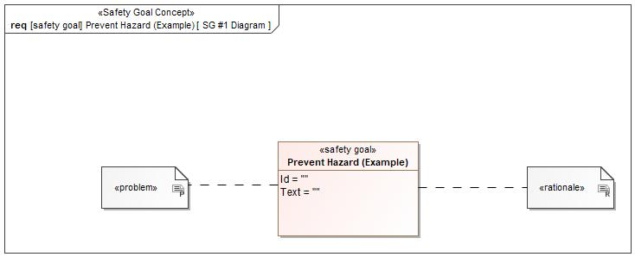

Figure 1: SG #1 Diagram – Prevent Hazard (Example)

*Note: The authoritative source for the Safety Goals is document “FFSD 02 Hazard Analysis* *and Risk Assessment”. The documentation of Safety Goals in this chapter (In the Argumentation for Safety Goal achievement) is for information purposes only.*

*The authoritative source for the Functional Safety Requirements is section 2.1.x.3: of this document. The documentation of Functional Safety Requirements in the following chapter (complete or summarised) is for information purposes only.*

#### Warning and Recovery Concept

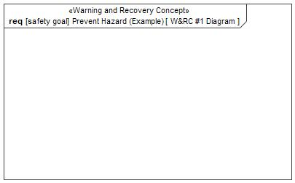

Figure 4: W&RC #1 Diagram – Prevent Hazard (Example)

### Derivation of Functional Safety Requirements on Assumptions

**#Classification**: Functional Safety only

**#Hint:** Derive requirements from the Assumptions (refer to section “Safety Assumptions”

No Functional Safety Requirements tracing to Assumptions specified.

## ASIL Decomposition of Functional Safety Requirements

***#Classification:*** *Functional Safety Only*

***#Hint:*** *For ASIL D features additional measures like a requirements decomposition might be required. Fill out the following table for each ASIL D decomposition applied in the feature. The decomposition rationale is the reason why the decomposition was performed, whereas the rationale for each requirement expresses the reason and thought behind that particular requirement and should include how the requirement is able to independently fulfill the needs of the parent requirement.*

***#Link:***[*Functional Safety Sharepoint*](https://pd3.spt.ford.com/sites/GlobalFunctionalSafety/Pages/default.aspx) *- Functional Safety Concept*

No Functional Safety Requirements with ASIL Decompositions specified.

# Architecture

## Functional Architecture

**#Classification:** Mandatory for Functional Safety – otherwise optional

**#Hint**: This section depicts the coarse Functional Architecture. This architectural step is needed to find the right functional partitioning for the function level. The function shown here are those, which are specified on function level. Either SysML activity diagrams or Data Flow Diagrams could be used to depict such a Functional Architecture. For bigger features, which are decomposed in a hierarchical manner down to atomic functions (and which do not follow the Functional Safety process), a function tree could be given here.

**#Links:**

* Functional Decomposition: [RE Wiki – Functional Decomposition](http://wiki.ford.com/display/RequirementsEngineering/Functional+Decomposition)
* SysML - Activity Diagrams or [RE Wiki - Data Flow Diagrams](http://wiki.ford.com/display/RequirementsEngineering/Data+Flow+Diagram?src=contextnavpagetreemodehttp://wiki.ford.com/display/RequirementsEngineering/Data+Flow+Diagram?src=contextnavpagetreemode)
* Data Flow Diagram: [RE Wiki – Data Flow Diagram](http://wiki.ford.com/display/RequirementsEngineering/Functional+Decomposition)

### List of Functions

**#Hint:** The functions shown in the Functional Architecture should be listed and described in the table below

## Logical Architecture

**#Classification:** Functional Safety Analysis only

**#Hint:** FS Analysis requires a description of the boundary of the feature and its elements. A simple block diagram or a SysML Internal Block Diagram could be used to depict the Logical Architecture

***#Link:*** [*Ford Functional Safety Sharepoint*](https://pd3.spt.ford.com/sites/GlobalFunctionalSafety/Pages/default.aspx)

Description of diagram and content on logical architecture in Documentation field of Structural Boundary Diagram.

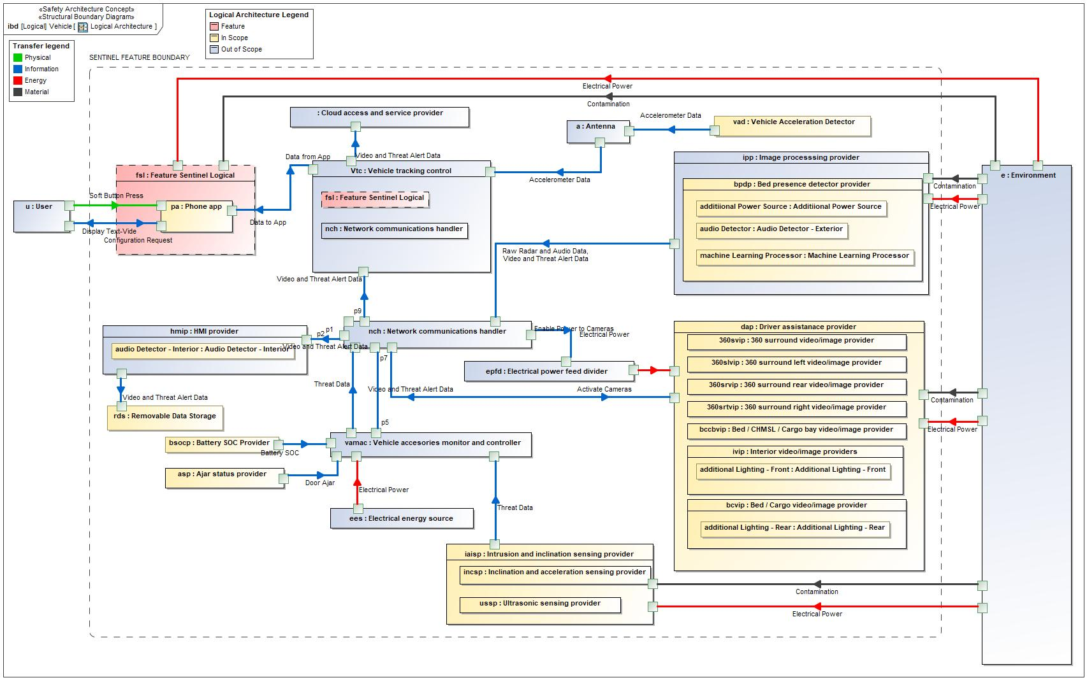

Figure 5: Logical Architecture

### Logical Interfaces

**#Classification:** Functional Safety Analysis only

**#Hint:** Describe the interactions of the feature with other features or elements.

|  |  |  |  |
| --- | --- | --- | --- |
| **Interface** | **Direction** | **Description** | **Value Range** |
| Accelerometer Data | p1 (Antenna) To p4 (Vehicle tracking control) | Vehicle acceleration data, used to detect impact from an accident or intruder activity |  |
| p1 (Vehicle Acceleration Detector) To p2 (Antenna) | Vehicle acceleration data, used to detect impact from an accident or intruder activity |  |
| Activate Cameras | p3 (Network communications handler) To p2 (Driver assistanace provider) | Signal to switch on cameras and any associated lights/microphones |  |
| Battery SOC | p1 (Battery SOC Provider) To p6 (Vehicle accesories monitor and controller) | Signal to provide battery SOC data. Note Sentinel may need to be deactivated if the battery SOC is too low. |  |
| Configuration Request | p2 (User) To p3 (Phone app) | Requests from the user for configuration settings via the Ford Pass App, such as default camera. |  |
| Contamination | p1 (Environment) To p2 (Image processsing provider) | Environmental contamination such as mud and dirt that prevents video image being captured. |  |
| p3 (Environment) To p3 (Driver assistanace provider) | Environmental contamination such as mud and dirt that prevents video image being captured. |  |
| p5 (Environment) To p2 (Intrusion and inclination sensing provider) | Environmental contamination such as mud and dirt that prevents video image being captured. |  |
| p7 (Environment) To p2 (Feature Sentinel Logical) | Environmental contamination such as mud and dirt that prevents video image being captured. |  |
| Data from App | p1 (Phone app) To p1 (Vehicle tracking control) | Information flow to the Sentinel Ford Pass App from Ford Cloud Services |  |
| Data to App | p1 (Vehicle tracking control) To p1 (Phone app) | Information flow from the Sentinel Ford Pass App to Ford Cloud Services |  |
| Display Text-Vide | p3 (Phone app) To p2 (User) | Signal to convey text messages and video images |  |
| Door Ajar | p1 (Ajar status provider) To p3 (Vehicle accesories monitor and controller) | Signal to denote a door is ajar on the vehicle |  |
| Electrical Power | p1 (Electrical energy source) To p2 (Vehicle accesories monitor and controller) | Electrical power supply only. |  |
| p2 (Electrical power feed divider) To p1 (Driver assistanace provider) | Electrical power supply only. |  |
| p2 (Environment) To p3 (Image processsing provider) | Electrical power supply only. |  |
| p4 (Environment) To p4 (Driver assistanace provider) | Electrical power supply only. |  |
| p6 (Environment) To p3 (Intrusion and inclination sensing provider) | Electrical power supply only. |  |
| p8 (Environment) To p1 (Feature Sentinel Logical) | Electrical power supply only. |  |
| Enable Power to Cameras | p2 (Network communications handler) To p1 (Electrical power feed divider) | Signal to enable power to the video cameras. |  |
| Raw Radar and Audio Data | p1 (Image processsing provider) To p6 (Network communications handler) | Data collected and processed from the radar detector. Used to detect intruder activity in cargo bed of vehicle. |  |
| Soft Button Press | p1 (User) To p2 (Phone app) | Input from user to Ford Pass app via a mobile device. |  |
| Threat Data | p1 (Intrusion and inclination sensing provider) To p4 (Vehicle accesories monitor and controller) | Threat identification data, including door ajar signal or ultrasonic signal. |  |
| p1 (Vehicle accesories monitor and controller) To p4 (Network communications handler) | Threat identification data, including door ajar signal or ultrasonic signal. |  |
| Video and Threat Alert Data | p1 (HMI provider) To p2 (Removable Data Storage) | Video data collecetd from cameras along with threat data collected from other sensors such as door open, intruder event detected via ultrasonics, inclination sensor, accelerometer, etc. |  |
| p1 (Image processsing provider) To p6 (Network communications handler) | Video data collecetd from cameras along with threat data collected from other sensors such as door open, intruder event detected via ultrasonics, inclination sensor, accelerometer, etc. |  |
| p1 (Network communications handler) To p2 (HMI provider) | Video data collecetd from cameras along with threat data collected from other sensors such as door open, intruder event detected via ultrasonics, inclination sensor, accelerometer, etc. |  |
| p2 (Driver assistanace provider) To p3 (Network communications handler) | Video data collecetd from cameras along with threat data collected from other sensors such as door open, intruder event detected via ultrasonics, inclination sensor, accelerometer, etc. |  |
| p2 (Vehicle tracking control) To p1 (Cloud access and service provider) | Video data collecetd from cameras along with threat data collected from other sensors such as door open, intruder event detected via ultrasonics, inclination sensor, accelerometer, etc. |  |
| p5 (Network communications handler) To p3 (Vehicle tracking control) | Video data collecetd from cameras along with threat data collected from other sensors such as door open, intruder event detected via ultrasonics, inclination sensor, accelerometer, etc. |  |

Table 11: Feature Interactions

# Open Concerns

**#Hint:** The following list presents open concerns, which have to be discussed or clarified over the course of the on-going requirements engineering.

| ID | Concern Description | e-Tracker / Reference | Responsible | Status | Solution |
| --- | --- | --- | --- | --- | --- |
| 1 |  |  |  |  |  |

Table 12: Open Concerns *(Not supported by MagicDraw report generation)*

# Revision History

**#Hint:** A new version number is assigned to a document with a given revision each time it is checked in to Team Center (TCSE). After release of a revision, the document cannot be edited and no new versions can be created on that revision. When updating the document after that, a new revision has to be created and new versions on that revision will be created upon checking in.

| Rev.  (revision) | Date | Description | Approved by | Responsible |
| --- | --- | --- | --- | --- |
| FD1 | 2020-11-26 | FD V1.0 |  |  |
| FD2.2 | 2021-03-05 | Updates – requirements added |  |  |

## Template Revisions

*#Important: Do not change this section*

|  |  |  |  |  |
| --- | --- | --- | --- | --- |
| Version | Rev. | Date | Description | Responsible |
| *0* | *6* | *2015-05-26* | * *Chapter “Feature Overview” and made a 2nd level heading.* * *Chapter “Feature Modeling” divided into 3 subchapter (“Scenarios”, “Use Cases”, “State Machines”) for different modeling methods* | *Jbaden1* |
| *0* | *7* | *2015-05-27* | * *Table of Content updated* * *Template Revision History chapter added* | *Jbaden1* |
| *0* | *8* | *2015-07-02* | * *Section “Unsettled Issues” added* | *Alevin7* |
| *0* | *9* | *2015-08-04* | * *Section “Feature Variants” added* * *Section “Feature Boundary Diagram” renamed to “Feature Context Diagram”* * *Document Properties adapted to match needs of VBA macros* | *Jbaden1, Awegman1* |
| *1* | *0* | *2015-09-11* | * *Section “Feature Variants” reworked* * *Feature Goals removed. Only “Safety Goals“ chapter remains.* * *Heading 2 formatting issues corrected.* * *Requirements / Use Cases Listing removed from traceability chapter.* * *Formatting of attribute table in Notation chapter corrected* * *Open Topics / Known Issues chapter moved to the end* | *Jbaden1* |
| *1* | *1* | *2015-11-16* | * *Table-Styles removed (for smooth VSEM import)* * *Some clean-up of sections “Purpose” and “Audience”* | *Awegman1, jbaden1* |
| *1* | *2* | *2016-02-26* | * *Minor corrections based on lessons learned from CC and PCL pilot (e.g. section market/regions) and discussion with Functional Safety Team (purpose of feature)* * *Footer corrected* * *Boundary diagram interface chapter renamed to influences.* | *Jbaden1* |
| *1* | *3* | *2016-02-26* | * *Minor corrections after review with Whitney Keith from Functional Safety team* | *Jbaden1* |
| *1* | *4* | *2016-03-10* | * *Some cleanup of meta-data in Word Properties* | *Jbaden1* |
| *1* | *5* | *2016-03-10* | * *Footer formatting corrected (Issue 19)* * *Results from review with Functional Safety Team incorporated (Issue 20).* | *jbaden1* |
| *1* | *6* | *2016-04-18* | * *Scenario Template added* | *Jbaden1* |
| *1* | *7* | *2016-04-18* | * *Chapter “Operation Modes and States” moved before “Use Case” section.* | *Jbaden1* |
| *1* | *8* | *2016-04-18* | * *Broken Wiki links repaired.* | *Jbaden1* |
| *2* | *0* | *2016-05-19* | * *Adapted to Specification_Macros.dotm V2.0* * *Requirements Templates chapter (ch. 1.7.1) no longer has an attribute table, but refers directly to the Wiki..* | *Jbaden1* |
| *2* | *1* | *2016-06-10* | * *Table for Context Diagram modified (lists external entities and Influence Description only)* | *Jbaden1* |
| *2* | *2* | *2016-07-08* | * *Template version added to footer* * *Several hints added to the various sections* * *Findings from Functional Safety Team incorporated.* * *RE_SafetyRequirement style added* | *Jbaden1* |
| *2* | *3* | *2016-09-21* | * *Update from Functional Safety Team incorporated (“Lessons Learned”, “System Behaviors for HARA”)* | *Jbaden1* |
| *2* | *4* | *2016-11-15* | * *Update from Functional Safety Team incorporated (“Lessons Learned”, “System Behaviors for HARA”)* * *Explanatory notes made more formal* | *Jbaden1* |
| *3* |  |  | *Skipped to synchronize with Specification_Macros.dotm* |  |
| *4* |  |
| *5* | *0* | *2017-01-13* | * *Meta data updated for specification macros, version 3.1* * *SW Unit chapter removed for the time being* * *Green boxes added for user hints* | *Jbaden1* |
| *5* | *1* | *2017-01-18* | * *Minor editorial changes* | *Jbaden1* |
| *6* | *0* | *2017-02-03* | * *CR48: Chapter 6 renamed from “Safety” to “Functional Safety”. New sub-chapter “Safety” introduced in Non-Functional Requirements section* | *Jbaden1* |
| *6* | *0* | *2017-04-28* | * *CR7: “RequirementsTraceability” chapter removed* | *Jbaden1* |
| *6* | *0* | *2017-11-15* | * *CR32/53: New Cover Sheet + Disclaimer replaces FAP-150 like ones.* * *CR75: Some rewording -> Terminology to Glossary, Notation -> Document Conventions* * *CR49: Rename “Assumptions & Constraints” to “Assumptions”* * *CR74: Safety Assumptions added to chapter 6.* * *CR58: Add function allocation column to Logical Architecture chapter* | *Jbaden1* |
| *6* | *0* | *2018-01-31* | * *CR63: Updated links to Functional Safety Sharepoint* | *Jbaden1* |
| *6* | *0* | *2018-07-24* | * *CR69: Add FSR to FeatureDoc* * *CR64: Add new section "Design Requirements" to Function Spec and Feature Spec* | *Jbaden1* |
| *6* | *0* | *2018-08-06* | * *CR53: some corrections for metada and formatting* | *Jbaden1* |
| *6* | *0* | *2018-09-28* | * *Broken links to RE Wiki repaired* | *Jbaden1* |
| *6* | *0* | *2018-10-31* | * *Cover sheet and footer more GIS like. Functional Safety team feedback incorporated:*   + *New subsections “Functional Safety Requirements, (Decomposed) FSRs and Parameters / Values*   + *Removal of “Logical Architecture”* | *Jbaden1* |
| *6* | *0* | *2018-12-12* | * *FSR template removed, now as a macro in the Specification_Macros.dotm* | *Jbaden1* |
| *N* |  | *2019-04-03* | * *Updated code for context diagrams, actors and use cases.* * *Updated code structure with all macros at the beginning.* * *Updated code to populate assumptions using element-assumption relationship or hazardous event.* | *snuesch* |
| *N* |  | *2019-04-18* | * *Added structural boundary diagram for FuSa based on TGB discussion.* * *Added operating modes to functional safety requirements.* | *snuesch* |
| *O* |  | *2019-04-25* | * *Improved export of actions and activities on functional boundary diagram.* | *snuesch* |
| *6* | *0b* | *2019-05-23* | * *Re-introduce “Logical Architecture” (for Functional Safety)* | *Jbaden1* |
| *O* |  | *2019-06-17* | * *Aligned “Architecture” section with RE template.* * *Made “Ford Documents” table more flexible.* * *Added template terms to glossary* | *snuesch* |
| *O* |  | *2019-06-25* | * *Improved use cases to handle Primary and Secondary actors.* * *Added Performance Requirements to Uncategorized.* | *snuesch* |

# Appendix

## Definitions

No terms specified.

## Abbreviations

| **Abbr.** | **Stands for** |
| --- | --- |
| CSM | Central Security Module |
| OTA | Over the Air Updates |
| SYNC | In vehicle HMI including in car entertainment etc. |
| TCU | Telematics Control Unit |
| USB | Universal Serial Bus |

Table 13: Abbreviations used in this document

Document ends here.