|  |  |  |  |
| --- | --- | --- | --- |
|  |  | |  |
|  |  | |  |
|  | Sentinel: Phoenix Variant  <<Feature>>  (F003417) | |  |
|  |  | |  |
| Document Type | **Feature Document (FD)** | |  |
| Template Version | **6.1b** | |  |
| SysML Report Template Version | **O Beta (2021/06/09)** | |  |
| Document ID | **sent_fd_20210617a_phoenix.docx** | |  |
| Document Location | [Sentinel_MBSE_Documents](https://azureford.sharepoint.com/:f:/r/sites/Features/Feature%20Owner%20Checklist/TZuraw%20Features%20Section/Sentinel/Modeling%20and%20Feature%20Documents/Documents%20for%20V710%20UPV1%20Gateway?csf=1&web=1) | |  |
| Document Owner | **Ishan Gupta - igupta1 / Michael Wohlfarter - mwohlfah** | |  |
| Document Revision | **FD3.0** | |  |
| Document Status | **Draft** | |  |
| Date Issued | **2021/06/17** | |  |
| Date Revised | **2021/06/17** | |  |
| Document Classification | GIS1 Item Number: | **27.60/35** |  |
| GIS2 Classification: | **Confidential** |
|  | | | |

**Auto-Generated by MagicDraw**

Printed Copies Are Uncontrolled

# Disclaimer

**This document contains Ford Motor Company Confidential information. Disclosure of the information contained in any portion of this document is not permitted without the expressed, written consent of a duly authorized representative of Ford Motor Company, Dearborn, Michigan, U.S.A.**

**Copyright, Ó 2021 Ford Motor Company**

This document contains information developed and accumulated by and for FORD MOTOR COMPANY. As such, it is a proprietary document, which, if disseminated to unauthorized persons, would provide others with restricted information, data, or procedures not otherwise available, exposing the FORD MOTOR COMPANY to potential harm.

Employees and suppliers having custody of this specification or authorized to use it must be cognizant of its proprietary nature and ensure that the information herein is not made available to unauthorized persons.

FORD MOTOR COMPANY reserves the right to protect this work as an unpublished copyrighted work in the event of an inadvertent or deliberate unauthorized publication. FORD MOTOR COMPANY also reserves its rights under copyright laws to protect this work as a published work.

This document or portions thereof shall not be distributed outside FORD MOTOR COMPANY without prior written consent. Refer all questions concerning disclosure to the author(s) or to any duly authorized representative of Ford Motor Company.

**Copyright** © **2021 Ford Motor Company**

# Contents

Disclaimer 2

Contents 3

1 Introduction 5

1.1 Document Purpose 5

1.2 Document Scope 5

1.3 Document Audience 5

1.3.1 Stakeholder List 5

1.4 Document Organization 7

1.4.1 Document Context 7

1.4.2 Document Structure 7

1.5 Document Conventions 7

1.5.1 Classification of Chapters 7

1.5.2 Requirements Templates 8

1.6 References 8

1.6.1 Ford Documents 8

1.6.2 External Documents and Publications 8

1.7 Glossary 8

1.7.1 Definitions 9

1.7.2 Abbreviations 9

1.7.3 Parameters / Values 9

2 Feature Overview 10

2.1 Purpose and Description of Feature 10

2.2 Feature Variants 10

2.2.1 Regions & Markets 11

2.3 Input Requirements/Documents 11

2.4 Lessons Learned 12

2.5 Assumptions 12

3 Feature Context 13

3.1 Feature Context Diagram 13

3.2 List of Influences 13

4 Feature Modeling 16

4.1 Operation Modes and States 16

4.2 Use Cases 16

4.2.1 Use Case Diagram 16

4.2.2 Actors 17

4.2.3 Use Case Descriptions 18

4.3 Driving and Operation Scenarios 22

4.4 Decision Tables 24

5 Feature Requirements 25

5.1 Functional Requirements 25

5.1.1 Error Handling 34

5.2 Non-Functional Requirements 34

5.2.1 Security 34

5.2.2 Reliability 34

5.2.3 Performance 34

5.3 HMI Requirements 34

5.4 Other Requirements 37

5.4.1 Design Requirements 37

5.4.2 Manufacturing Requirements 37

5.4.3 Service Requirements 38

5.4.4 After Sales Requirements 38

5.4.5 Process Requirements 38

6 Functional Safety 39

6.1 System Behaviors for HARA 39

6.2 Functional Safety Assumptions 39

6.3 Safety Goals 39

6.4 Functional Safety Requirements 39

6.4.1 Safety Goal: Prevent Hazard (Example) 39

6.4.2 Derivation of Functional Safety Requirements on Assumptions 40

6.4.3 ASIL Decomposition of Functional Safety Requirements 40

7 CyberSecurity 41

7.1 Security Goals 41

7.2 Cybersecurity Requirements 41

8 Architecture 42

8.1 Functional Decomposition 42

8.1.1 Functions 51

8.2 Logical Architecture 53

8.2.1 Logical Elements 54

8.2.2 Logical Interfaces 59

9 Traceability Matrix 62

10 Open Concerns 65

11 Revision History 66

12 Appendix 67

12.1 Definitions 67

12.2 Abbreviations 67

**List of Figures**

Figure 1: Feature Image Here 10

Figure 2: Feature Context 13

Figure 3: Feature Use Cases 16

Figure 4: Feature Use Cases including FuSa 17

Figure 5: W&RC #1 Diagram – Prevent Hazard (Example) 40

Figure 6: Access recorded videos 44

Figure 7: Be notified of intrusion1 46

Figure 8: Launch tutorial 46

Figure 9: Modify sentinel settings 48

Figure 10: Perform utility operations 50

Figure 11: Logical Architecture 54

**List of Tables**

Table 1: Features described in this FD 5

Table 2: Ford internal Documents 8

Table 3: External documents and publications 8

Table 4: Parameters / Values used in this document 9

Table 5: Feature Variants 11

Table 6: Regions & Markets 11

Table 2‑7: Input Requirements/Documents 12

Table 8: List of Influences 15

Table 9: List of Actors 18

Table 10: System Behaviors for HARA 39

Table 11: Functional Safety Goals 39

Table 12: Cybersecurity Goals 41

Table 13: List of Functions on Access recorded videos 51

Table 14: List of Functions on Be notified of intrusion1 52

Table 15: List of Functions on Launch tutorial 52

Table 16: List of Functions on Modify sentinel settings 53

Table 17: List of Functions on Perform utility operations 53

Table 18: Logical Elements 59

Table 19: Feature Interactions 61

Table 20: Open Concerns *(Not supported by MagicDraw report generation)* 65

Table 21: Definitions used in this document 67

Table 22: Abbreviations used in this document 67

# Introduction

## Document Purpose

A Feature Document (FD) document defines a Feature on [Concept Level](https://bd101001.pd2.ford.com/stages/#/workspace/209/_vv/(process/activity/_Y6ftAPI2VsW5zd82DgHb6g)). It specifies **what** the feature shall do and how it shall behave from customer perspective. It should also provide reasoning and background **why** we have the feature in the vehicle.

The FD also serves as an Item Definition as defined by ISO26262 for those features, which follow the Ford Functional Safety process. Refer [FFSG01.10 Feature Document Guideline](https://azureford.sharepoint.com/sites/GlobalFunctionalSafety/Released%20Templates%20Guidelines%20and%20Examples/Guidelines/FFSG01.10_FeatureDocument_Guideline.pdf) for how to apply the Feature Doc template for Functional Safety.

## Document Scope

This Feature Document (FD) specifies the following features:

|  |  |  |  |
| --- | --- | --- | --- |
| **Feature ID** | **Feature Name** | **Owner** | **Reference** |
| F003417 | Sentinel  (Program(s): CDX747, U71x ) | Ishan Gupta/ Michael Wohlfarter |  |

Table 1: Features described in this FD

## Document Audience

The FD is written by the feature owner of Ishan Gupta/ Michael Wohlfarter. All Stakeholders, i.e., all people who have a valid interest in the feature should read and, if possible, review the FD. It needs to be guaranteed, that all stakeholders have access to the currently valid version of the FD.

### Stakeholder List

For the latest list of stakeholder of the feature and their influence refer to <Put VSEM Link here>.

|  |  |  |  |
| --- | --- | --- | --- |
| **Name** | **CDSID** | **Role** | **Stakeholder Group** |
| Joe Oravec [ Sync ] | joravec4 | System Architect | Systems Engineer |
| Michael Smith [FuSa Engineer] | msmi1203 | System Architect | Systems Engineer |
| Venket Karramreddy [MDV] | vkarramr | Systems Engineer | Systems Engineer |
| Shawn Dean [Chief Eng Features] | sdean44 | System Architect | Systems Engineer |
| Carmen Baldovi Astarloa [ Cameras ] | mbaldovi | System Architect | Systems Engineer |
| Michael Leibovitch [ TCU ] | malievsk | System Architect | Systems Engineer |
| Michael Alievsky [ ECG ] | mleibov1 | System Architect | Systems Engineer |
| TBD - Feature Team to Secure Agreement [ Radar Unit ] | tbe | System Architect | Systems Engineer |
| Mark Porter [ TCU ] | mporter | System Architect | Systems Engineer |
| Dave Orris [ Sync ] | dorris | System Architect | Systems Engineer |
| Stuart Salter [ Power Supply Architecture ] | ssalter | System Architect | Systems Engineer |
| Donald Bilger [SE Features] | dbilger | System Architect | Systems Engineer |
| Andrew Steinman [ Functional Platform Architecture ] | asteinm3 | System Architect | Systems Engineer |
| Jin Kim [ ECG ] | jkim119 | System Architect | Systems Engineer |
| Brian Wolski [ Cameras ] | bwolski1 | System Architect | Systems Engineer |
| Nihan Cakir [ CSM ] | ncakir | System Architect | Systems Engineer |
| Hussein Berry [ Power Supply Architecture ] | hberry11 | System Architect | Systems Engineer |
| Matt Affeldt [ ADAS (DAT 2.2) ] | maffeldt | System Architect | Systems Engineer |
| Ishan Gupta [SE Feature Owner] | igupta1 | System Architect | Systems Engineer |
| Gerald Barr [ feature modeler ] | wbarr5 | Model Architect | Systems Engineer |
| John Popovecz [ BCM ] | jpopovec | System Architect | Systems Engineer |
| Sridhar Chidam [ Functional Platform Architecture ] | schidam | System Architect | Systems Engineer |
| Michael Wohlfahrter | mwohlfah | System Architect | Systems Engineer |
| Tim Zuraw [SE Features] | tzuraw | Systems Engineer | Systems Engineer |
| Nitin Kamboj [ADAS] | nkamboj | Systems Engineer | Systems Engineer |
| Aaron Mills [ ADAS ] | amills2 | System Architect | Systems Engineer |
| Jeffrey Wallat [ CVPP Architecture ] | jwallat | System Architect | Systems Engineer |
| Eric Eaton [ TCU ] | eeaton10 | System Architect | Systems Engineer |
| Kyaw Kyaw Soe [SE Features CV/C2] | ksoe | System Architect | Systems Engineer |
| Ritesh Pandya [ ECG ] | rpandya | System Architect | Systems Engineer |
| Ikhlas Abdulsaid [ BCM ] | iabulsai | System Architect | Systems Engineer |
| Nada Ismail [ TCU ] | nismail6 | System Architect | Systems Engineer |
| Randy Chinoski [ BCM ] | rchinosk | System Architect | Systems Engineer |
| Laura Check [ Sync ] | lburek | System Architect | Systems Engineer |
| Richard Luken [SE] | rluken2 | System Architect | Systems Engineer |
| Stephen Orris [ NetCom ] | sorris1 | System Architect | Systems Engineer |
| Alejandro Becerra [ feature modeler ] | jbecer16 | Model Architect | Systems Engineer |
| Ron Hammond [ SEM ] | rhammo10 | System Architect | Systems Engineer |
| Tarik Safir [ Bed Radar ] | tsafir | System Architect | Systems Engineer |
| Yamen Taleb [FordPass] | ytaleb | Systems Engineer | Systems Engineer |
| Medha Karkare [ R&A Software Architect (and camera service background) ] | mkarkare | System Architect | Systems Engineer |
| Paul Linden [Quality] | plinden6 | System Architect | Systems Engineer |
| Dan Sullivan [ Power Supply ] | dsulli30 | System Architect | Systems Engineer |
| Bruce Williams [ Physical Electrical Architecture ] | bwilli28 | System Architect | Systems Engineer |
| John Ricks [ Body Control ] | jricks7 | System Architect | Systems Engineer |
| Jim Weinfurther [ Body Control ] | jweinfur | System Architect | Systems Engineer |
| John Budaj [ Physical Electrical Architecture] | jbudaj | System Architect | Systems Engineer |
| Stuart Salter [ Power Supply ] | ssalter | System Architect | Systems Engineer |

## Document Organization

### Document Context

Refer to the [Specification Structure page](http://wiki.ford.com/display/RequirementsEngineering/Specification+templates) in the [Ford RE Wiki](http://wiki.ford.com/display/RequirementsEngineering/Requirements+Engineering+for+SW+Enabled+Features) to understand how the FD relates to other Ford Requirements Documents and Specifications.

### Document Structure

The structure of this document is explained below:

Error! Reference source not found. – Explains how to use this document including responsibilities and requisite documents. Explains the terminology. Gives a clarification of the definitions, concepts and abbreviations used in the document.

Error! Reference source not found. – States briefly the background and the purpose of the feature, feature variants and corresponding regions and markets. Also includes input requirements, assumptions and constraints.

Error! Reference source not found. – describes all external entities, which have an influence on the feature.

Error! Reference source not found. – Contains Use Case, Driving Scenarios, State Charts to describe the functional behavior of the feature.

**Feature Requirements** – Lists functional and non-functional requirements of the feature.

**Functional Safety** – Lists System Behaviors, Safety Goals and Safety Requirements of the feature.

Error! Reference source not found. – Lists Security Goals and Security Requirements of the feature.

Error! Reference source not found. – Shows the coarse architecture, which the feature requirements are deployed to. Describes the elements and the boundary of the feature as well as the decomposition and distribution of associated functions.

**Traceability Matrix** – Traceability Matrix.

Error! Reference source not found. – List of Open Concerns

Error! Reference source not found. – Document Change History including a list of new or modified requirements. The requirements in this document are tagged, and this section contains different types of tables listing all, new, or changed requirements by their title and page no.

Error! Reference source not found. – Appendix

## Document Conventions

### Classification of Chapters

A chapter is considered mandatory, unless the chapter or its parent chapter(s) are categorized by using the tag:

**#Classification:** Some Condition

If no requirement/other content is known for a mandatory chapter, leave a statement “Not Applicable”

Some chapters have a follow certain rules in context of specific Ford processes, e.g. Functional Safety. This is indicated at the beginning of the corresponding chapter by the tags:

**#Functional Safety:** Some process specific explanation

**#Cybersecurity:** Some process specific explanation

### Requirements Templates

Refer to “[How to use the Specification Templates](http://wiki.ford.com/display/RequirementsEngineering/How+to+use+the+Specification+Templates?src=contextnavpagetreemode)” on how to use the specification templates and the VBA macros to create/edit the requirements in the specifications.

#### **Requirements Attributes**

The templates provided by *Specification_Macros.dotm* define a list of attributes for each requirement. This helps to classify the requirement. The attributes are explained at [RE Wiki - Requirements Attributes](http://wiki.ford.com/display/RequirementsEngineering/Requirements+Attributes?src=contextnavpagetreemode).

## References

### Ford Documents

List here all Ford internal documents, which are directly related to the feature.

| **Reference** | **Title** | **Doc. ID** | **Document Location** | **Revision** |
| --- | --- | --- | --- | --- |
| Ford GIS Standard | Ford GIS Standard |  |  |  |

Table 2: Ford internal Documents

### External Documents and Publications

The list of external documents could include books, reports and online sources.

| **Reference** | **Document / Publication** | **Document Location** |
| --- | --- | --- |
| European General Data Protection Regulation GDPR (EU) 2016/679 |  |  |
| IEEE Std 1012-2004 IEEE Standard for Software Verification and Validation |  |  |
| ISO/IEC 19500-2:2003 | Information technology -- Open Distributed Processing -- Part 2 |  |
| UML Testing Profile (UTP), v1.2 |  |  |

Table 3: External documents and publications

## Glossary

See Appendix for Definitions and Abbreviations.

### Definitions

### Abbreviations

### Parameters / Values

| **Name** | **Description** | **Range / Resolution** |
| --- | --- | --- |

Table 4: Parameters / Values used in this document

# Feature Overview

## Purpose and Description of Feature

Monitoring of the area around a parked vehicle using onboard sensors. Sensors include :

vehicle tilt, vehicle acceleration, ultrasonic sensors in cabin, microphone in cabin (PHOENIX versions only), interior cameras, external cameras, bed area radar and microphone (Pick-up trucks only).

Videos and threat notifications are sent to the user via the FordPass App. Video and threat data will be stored remotely (cloud) and locally (USB jump-drive).

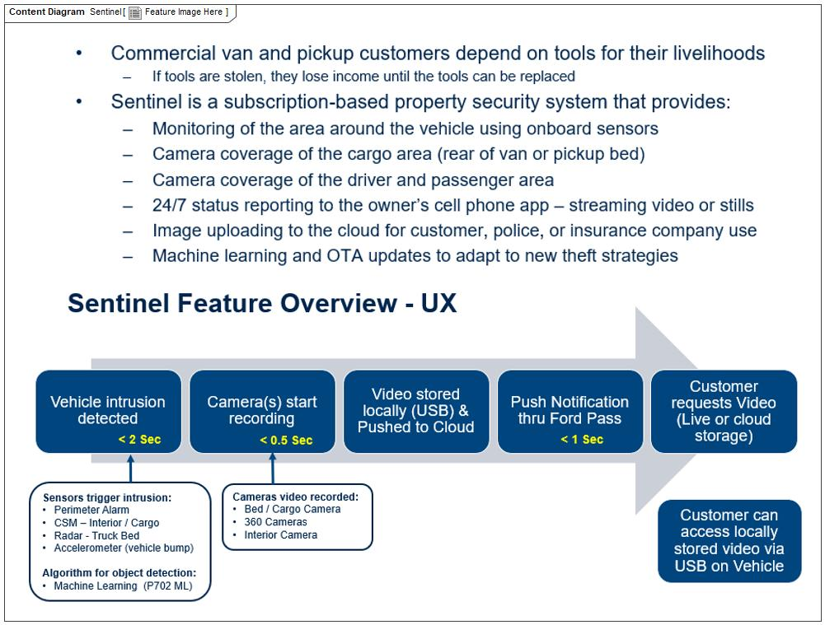

Figure 1: Feature Image Here

## Feature Variants

|  |  |  |
| --- | --- | --- |
| **Variant Name** | **Variant Description** | **Remarks** |
| **Cargo Van with 2 x CSM** | Cargo van version. Bed radar not installed - only for pick-up vehicles. 2 CSM units, one for cab and one for cargo area. 360 degree camera system not fitted. 1 x internal camera for cab area. |  |
| **Cargo Van with 2 x CSM and 360deg Camera** | Cargo van version. Bed radar not installed - only for pick-up truck application. 2 CSM units, one for cab and one for cargo area. 360 degree camera system fitted. 1 x internal camera for cab area. |  |
| **Pick Up Truck with bed radar** | Pick-up truck version. Bed radar used for pick-up vehicles with a cargo load bed. 1 CSM unit in cab area. 360 degree camera system not fitted. 1 x internal camera in cab area. |  |
| **Pick Up truck with bed radar and 360deg Camera** | Pick-up truck version. Bed radar used for pick-up vehicles with a cargo load bed. 1 CSM unit in cab area. 360 degree camera system fitted. 1 x internal camera in cab area. |  |
| **SUV Bus Combi with 1 x Int Camera** | SUV, Bus or Combi type vehicle. Bed radar not installed as no cargo bed area. 1 CSM unit in cab area. 360 degree camera system not fitted. 1 x internal camera in cab area. |  |
| **SUV Bus Combi with 1 x Int Camera and 360deg Camera** | SUV, Bus or Combi type vehicle. Bed radar not installed as no bed cargo area. 1 CSM unit in cab. 360 degree camera system fitted. 1 x internal camera in cab area. |  |
| **SUV Bus Combi with 2 x Int Camera** | SUV, Bus or Combi type vehicle. Bed radar not installed as no bed cargo area. 1 CSM unit in cab. 360 degree camera system not fitted. 2 x internal cameras one for front of cab and one in rear. |  |
| **SUV Bus Combi with 2 x Int Camera and 360deg Camera** | SUV, Bus or Combi type vehicle. Bed radar not installed as no bed cargo area. 1 CSM unit in cab. 360 degree camera system fitted. 2 x internal cameras one for front of cab and one in rear. |  |

Table 5: Feature Variants

### Regions & Markets

|  |  |  |  |  |  |  |
| --- | --- | --- | --- | --- | --- | --- |
| **Market /**  **Region**  Variant Name | **North America** | **South America** | **Europe** | **Middle East/Africa** | **Asia / Pacific** | **China** |
| **Cargo Van with 2 x CSM** | Optional | Optional | Optional | Optional | Optional | Optional |
| **Cargo Van with 2 x CSM and 360deg Camera** | Optional | Optional | Optional | Optional | Optional | Optional |
| **Pick Up Truck with bed radar** | Optional | Optional | No | No | No | No |
| **Pick Up truck with bed radar and 360deg Camera** | Optional | Optional | No | No | No | No |
| **SUV Bus Combi with 1 x Int Camera** | Optional | Optional | Optional | Optional | Optional | Optional |
| **SUV Bus Combi with 1 x Int Camera and 360deg Camera** | Optional | Optional | Optional | Optional | Optional | Optional |
| **SUV Bus Combi with 2 x Int Camera** | Optional | Optional | Optional | Optional | Optional | Optional |
| **SUV Bus Combi with 2 x Int Camera and 360deg Camera** | Optional | Optional | Optional | Optional | Optional | Optional |

Table 6: Regions & Markets

## Input Requirements/Documents

|  |  |  |  |
| --- | --- | --- | --- |
| **Reference**  (Reference as listed in ch. “**Error! Reference source not found.**”) | **Section/Requirement** | **Description** | **Derived Requirement**  (optional – reference to requirement in ch. “**Error! Reference source not found.**”) |
| **Attribute Requirements** | | | |
|  | Improve Security | A feature to improve the security of a vehicle when parked |  |
| **Ford Engineering Standards** | | | |
|  |  |  |  |
| **Legal Regulations** | | | |
|  | Compliance with FMVSS101 | The Feature shall comply with FMVSS101. |  |
| **Industry Standards** | | | |
|  | ISO 26262 | The system should be developed according to Ford's implementation of Functional Safety. |  |
| **Other Sources** | | | |

Table 2‑7: Input Requirements/Documents

## Lessons Learned

1. Quality History Items:
2. Limited to only one smart phone alert
3. Parking in Area with Poor Cellular Coverage
4. Sudden No Power or Lost communication
5. Sudden block or covering of camera lens
6. Cloud Failure no record of theft attack or recording stops prematurely
7. Poor quality image. Dark image, jerky image
8. Poor Detection performance in rain/snow/hail or adverse weather conditions
9. Road salt, grime, dust, foreign objects on Camera
10. Not Able To Connect Live View As It Is Happening
11. Does not power up
12. Does not respond quick enough for Crash Event
13. Difficult to set up Sentinel on my SmartPhone
14. Fleet User with Multiple Vehicles

## Assumptions

No Assumptions specified.

# Feature Context

## Feature Context Diagram

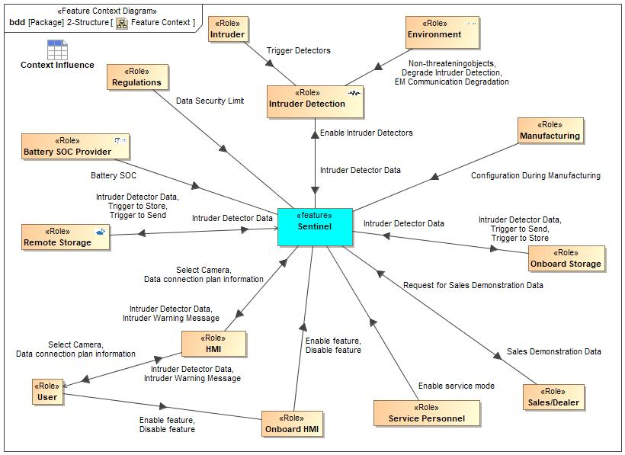

Figure 2: Feature Context

## List of Influences

|  |  |  |
| --- | --- | --- |
| **ID** | **External Entity** | **Influence Description** |
| Battery SOC | Battery SOC Provider To Sentinel | Electrical power is required by the feature. The battery state of charge (SOC) information is required as Sentinel will need to be disabled if the SOC is below a threshold value. |
| Configuration During Manufacturing | Manufacturing To Sentinel | Request to hold the Tilting Angle, unless service personnel enables tilting. |
| Data connection plan information | HMI To Sentinel | Information to allow the data connection plan to be established. Information includes paswords and contact information. |
| User To HMI | Information to allow the data connection plan to be established. Information includes paswords and contact information. |
| Data Security Limit | Regulations To Sentinel | There may be local legal constraints on what data can be collected and how it can be stored and transmitted, and to who. |
| Degrade Intruder Detection | Environment To Intruder Detection | Camera lenses may be obscured preventing clear view. |
| Environment To Sentinel | Camera lenses may be obscured preventing clear view. |
| Disable feature | Onboard HMI To Sentinel | The intruder detectors must be enabled. |
| User To Onboard HMI | The intruder detectors must be enabled. |
| EM Communication Degradation | Environment To Intruder Detection | Signals to the cloud may be attenuated by being in poor signal area on in an enclosed space. |
| Enable feature | Onboard HMI To Sentinel | The intruder detectors must be enabled. |
| User To Onboard HMI | The intruder detectors must be enabled. |
| Enable Intruder Detectors | Sentinel To Intruder Detection | The intruder detectors must be enabled. |
| Enable service mode | Service Personnel To Sentinel | Influence Description from Documentation field. |
| Intruder Detector Data | HMI To User | Data from the various intruder detectors needs to be fed back to the feature. |
| Intruder Detection To Sentinel | Data from the various intruder detectors needs to be fed back to the feature. |
| Onboard Storage To Sentinel | Data from the various intruder detectors needs to be fed back to the feature. |
| Remote Storage To Sentinel | Data from the various intruder detectors needs to be fed back to the feature. |
| Sentinel To HMI | Data from the various intruder detectors needs to be fed back to the feature. |
| Sentinel To Onboard Storage | Data from the various intruder detectors needs to be fed back to the feature. |
| Sentinel To Remote Storage | Data from the various intruder detectors needs to be fed back to the feature. |
| Intruder Warning Message | HMI To User | Intruder warning messages will be fed to the user. |
| Sentinel To HMI | Intruder warning messages will be fed to the user. |
| Non-threateningobjects | Environment To Intruder Detection | Wind etc may move vehicle. |
| Environment To Sentinel | Wind etc may move vehicle. |
| Request for Sales Demonstration Data | Sales/Dealer To Sentinel | Influence Description from Documentation field. |
| Sales Demonstration Data | Sentinel To Sales/Dealer | Electrical power is required by the feature. |
| Select Camera | HMI To Sentinel | The User must select which camera to view. |
| User To HMI | The User must select which camera to view. |
| Trigger | Battery SOC Provider To Sentinel | Influence Description from Documentation field. |
| Trigger Detectors | Intruder To Intruder Detection | Intruder triggers detectors such as: door ajar, accelerometer in vehicle, Ultrasonic detector, radar detector |
| Intruder To Sentinel | Intruder triggers detectors such as: door ajar, accelerometer in vehicle, Ultrasonic detector, radar detector |
| Trigger to Send | Sentinel To Onboard Storage | The storage of data and the streaming of that data after storage remotely must be enabled and disabled. |
| Sentinel To Remote Storage | The storage of data and the streaming of that data after storage remotely must be enabled and disabled. |
| Trigger to Store | Sentinel To Onboard Storage | The storage remotely must be enabled and disabled. |
| Sentinel To Remote Storage | The storage remotely must be enabled and disabled. |

Table 8: List of Influences

# Feature Modeling

## Operation Modes and States

## Use Cases

### Use Case Diagram

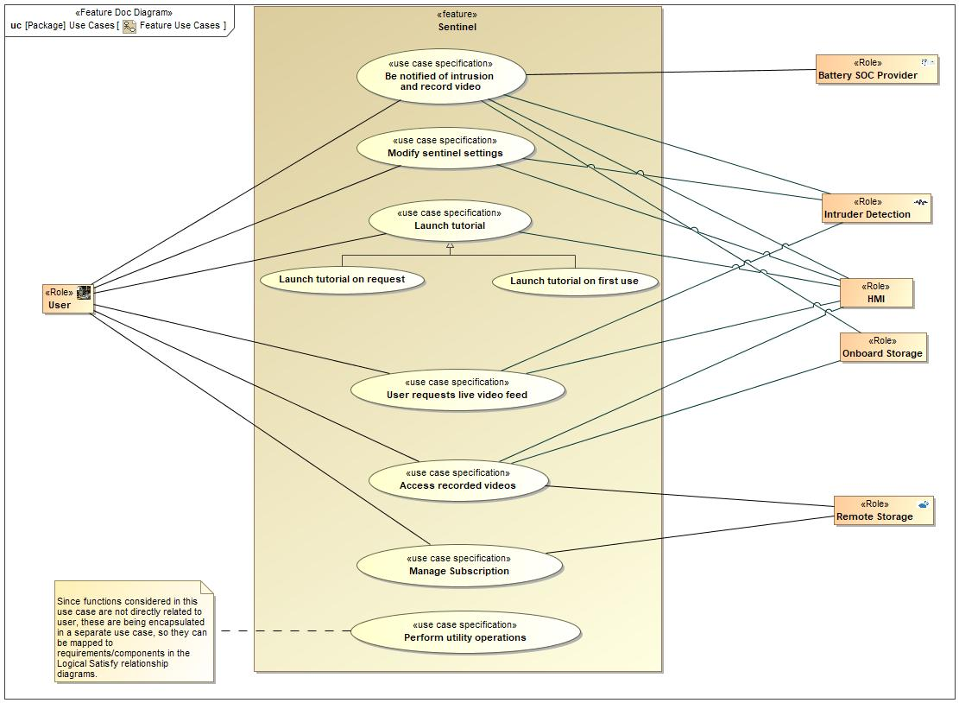

Figure 3: Feature Use Cases

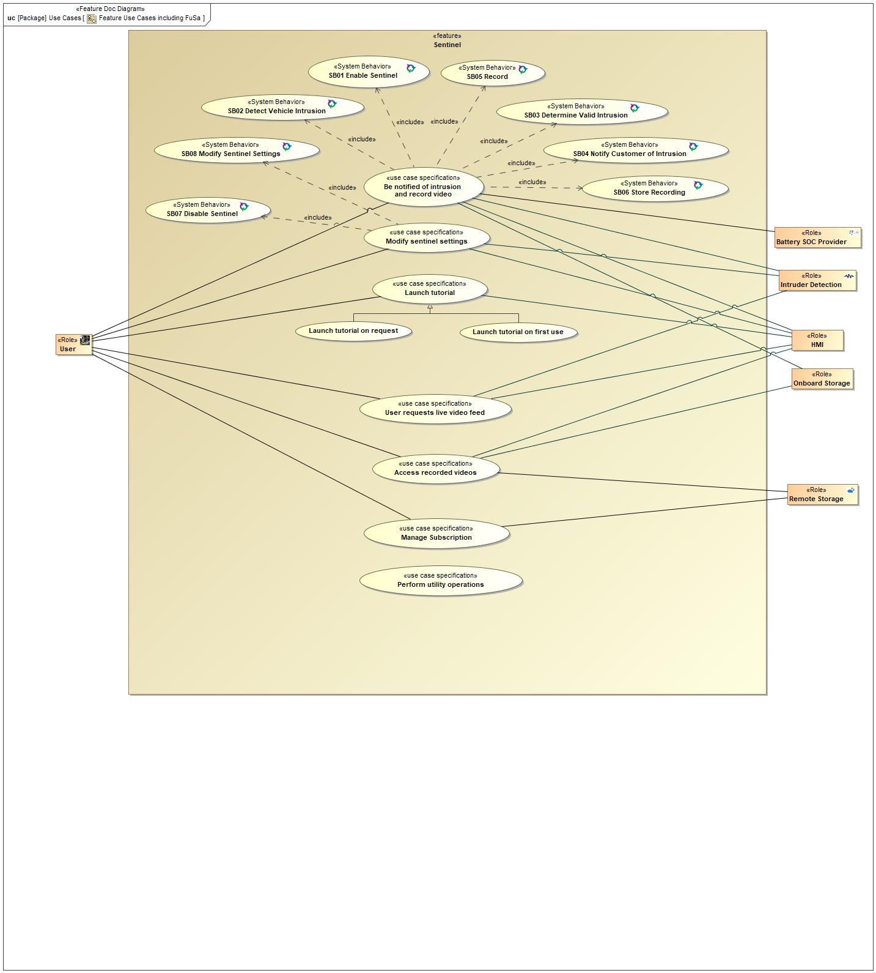

Figure 4: Feature Use Cases including FuSa

### Actors

| **Actor** | **Description** |
| --- | --- |
| Battery SOC Provider | The feature requires an electrical power supply. This is important as the vehicle will be powered off during operation of the feature, thus power will be coming from the vehicle battery - battery drain is an important consideration. |
| HMI | HMI includes on board and remote communication between the feature and the user. |
| Intruder Detection | Intruder detection includes all methods used to detect criminal activity on, in or near the vehicle. Typical detectors may be for door ajar, acceleration/vibration/sound, ultrasonic, radar and video. |
| Onboard Storage | On board storage of intruder detector data for access later by the user. This has limitations versus remote storage, but will not be limited by having good communications to the remote storage site.. |
| Remote Storage | Data from the intruder detectors will be stored remotely. This may allow increased storage capacity and less likelihood of data theft (versus storing in the vehicle). A disadvantage (versus on board storage) is that good communication is required between the vehicle and the remote storage site. |
| User | The user of the system, expected to normally be the driver or owner of the vehicle. Could also be someone involved with operating a commercial fleet of vehicles. |

Table 9: List of Actors

### Use Case Descriptions

1 Be notified of intrusion and record video

|  |  |  |
| --- | --- | --- |
| **Actors** | Primary | HMI |
| Secondary | User |
| **Subject** |  | Sentinel |
| **Description** |  |  |
| **Preconditions** | PreC1 | Sentinel feature activated.  User has activated sentinel feature.  Network signal available (or USB memory device installed)  To exit - user is already viewing live feed through a camera. |
| **Triggers** | T1 | Door ajar signal, accelerometer signal, ultrasonic signal or radar signal. To exit - Request from user to cancel video feed via app |
| **Main Flow** | M1 | Perimeter Alarm records a change in ajar status.  Sentinel begins recording video/ clicking photos. |
| M2 | Sensors record movement around the vehicle.  Sentinel begins recording video/ clicking photos. |
| M3 | Sensors record movement in the truck bed/cargo bay area.  Sentinel begins recording video/ clicking photos. |
| M4 | User exits out of the current camera feed. |
| **Alternative Flow Description** |  | Poor Internet Connection - Driver Moves Vehicle |
| **Alternative Flow Steps** | A1 | Network connection not available or poor quality. |
| A2 | Sentinel Informs driver |
| A3 | Driver decides to move vehicle for better connection or use USB |
| A4 | Sentinel armed and operating |
| **Postconditions** | PostC1 | Sentinel sends notification. To exit - user is already viewing live feed through a camera. |

3 User requests live video feed

|  |  |  |
| --- | --- | --- |
| **Actors** | Primary | Phone app |
| Secondary | User |
| Secondary | Intruder Detection |
| **Subject** |  | Sentinel |
| **Description** |  |  |
| **Preconditions** | PreC1 | User is already viewing live feed through another camera. |
| **Triggers** | T1 | Request from user , via app |
| **Main Flow** | M1 | User exits out of the current camera feed. |
| M2 | User selects another camera to watch live video. |
| **Postconditions** | PostC1 | User is able to change the camera for live video feed. |

4 Manage Subscription

|  |  |  |
| --- | --- | --- |
| **Actors** | Primary | User |
| Secondary | Remote Storage |
| **Subject** |  | Sentinel |
| **Description** |  |  |
| **Preconditions** | PreC1 | Feature available on FordPass App |
| PreC2 | Sentinel hardware and software installed on vehicle |
| **Main Flow Description** |  | Subscription set-up for feature |
| **Main Flow** | M1 | User opens FordPass App and requests feature |
| M2 | User prompted for subscription details |
| M3 | User enters subscription details |
| M4 | Information verified and subscription set-up |
| M5 | User informed that subscription is set-up |
| **Alternative Flow Description** |  | No subscription |
| **Alternative Flow Steps** | A1 | User attempts to use feature |
| A2 | Feature detects no subscription |
| A3 | Message to user "No valid subscrption - to subscribe TBE" |
| **Postconditions** | PostC1 | Subscription enabled |

5 Modify sentinel settings

|  |  |  |
| --- | --- | --- |
| **Actors** | Primary | Phone app |
| Secondary | User |
| **Subject** |  | Sentinel |
| **Description** |  |  |
| **Preconditions** | PreC1 | Vehicle power on and feature enabled. Vehicle is in ignition OFF condition. |
| **Triggers** | T1 | Input from driver via vehicle or mobile HMI |
| **Main Flow Description** |  | Modify Sentinel Settings |
| **Main Flow** | M1 | User changes feature parameter settings. New settings stored.User activates the sentinel feature on ford pass app. |
| M2 | This information from the app is conveyed to the TCU to ensure the activation of the feature. |
| **Postconditions** | PostC1 | Feature parameter settings updated. User can receive notification from phone. |

5 Perform utility operations

|  |  |  |
| --- | --- | --- |
| **Actors** | Primary | User |
| Secondary |  |
| **Subject** |  | Sentinel |
| **Description** |  |  |
| **Preconditions** | PreC1 | Sentinel ON |
| **Main Flow Description** |  | Perform utility operations |
| **Main Flow** | M1 | Inform user of low battery SoC and if feature disabled due to low battery SoC |
| M2 | Detect vehicle parked and inform user to install USB memory device |
| M3 | Feature to operate in Ignition OFF mode |
| M4 | Service Mode to be available |
| M5 | Allow OTA software updates |
| M6 | Allow the user to exit the vehicle without triggering the feature (when feature ON) |
| M7 | Allow one or more user details to be entered |
| M8 | Check subscription is valid |
| M9 | Inform User if USB memory device not installed |
| M10 | Allow management of the subscription of the feature |
| **Postconditions** | PostC1 | Successful completion of utility operation |

6 Access recorded videos

|  |  |  |
| --- | --- | --- |
| **Actors** | Primary |  |
| Secondary |  |
| **Subject** |  | Sentinel |
| **Description** |  |  |
| **Preconditions** | PreC1 | Availability of video stored remotely or on USB. |
| **Triggers** | T1 | Request from user via HMI |
| **Main Flow** | M1 | User requests video view. |
| M2 | Feature presents available videoes to user. |
| M3 | User selects required video. |
| M4 | Feature plays video via HMI. |

7 Launch tutorial

|  |  |  |
| --- | --- | --- |
| **Actors** | Primary | Phone app |
| Secondary | User |
| **Subject** |  | Sentinel |
| **Description** |  |  |
| **Preconditions** | PreC1 | User needs information about the usage of the sentinel feature on app.  App acknowledges the fact that the customer is a first-time user of the feature/app.  Sentinel features acknowledges that the customer is a first-time user of the feature/app. |
| **Triggers** | T1 | First use of feature detected, or request by user. |
| **Main Flow Description** |  | Launch Tutorial Video |
| **Main Flow** | M1 | User requests tutorial by selecting the appropriate option on fordpass app. |
| M2 | App acknowledges the fact that the customer is a first-time user of the feature/app. |
| M3 | User selects the option to skip the tutorial. |
| M4 | Sentinel is showing/playing the tutorial. |
| **Postconditions** | PostC1 | Sentinel feature shows/plays the tutorial.  The tutorial is skipped by the user. |

## Driving and Operation Scenarios

Obtain vehicle camera video feed

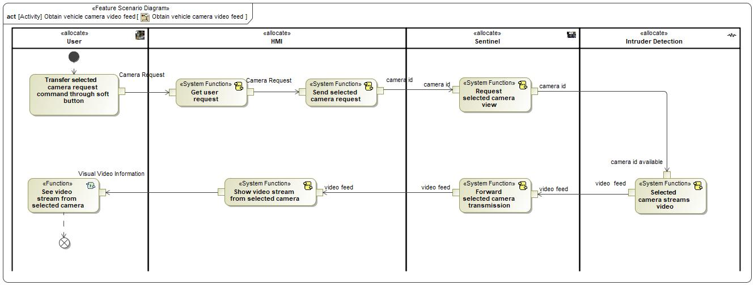

Sentinel Scenarios

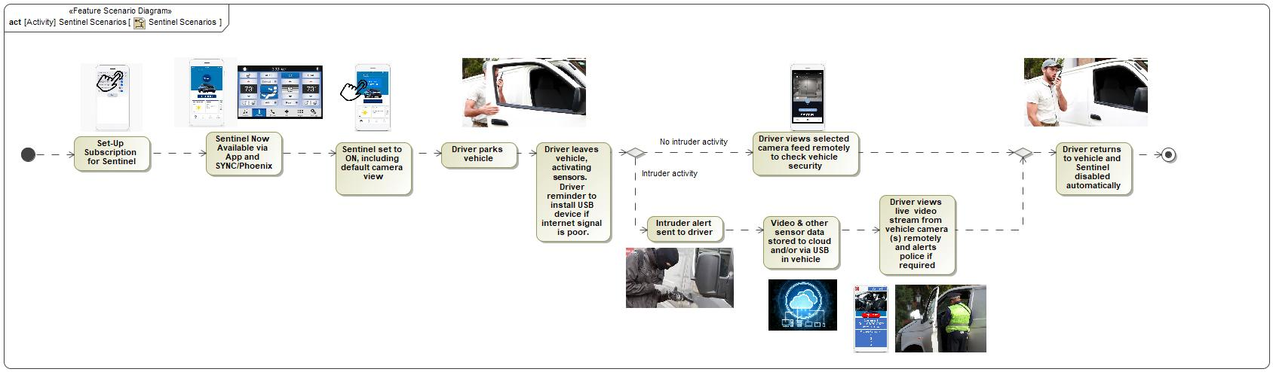

## Decision Tables

*Not supported by MagicDraw report generation.*

# Feature Requirements

## Functional Requirements

R_F_Sentinel_00004 Arm Sentinel

If enabled and no disabling conditions exist, the Sentinel feature shall automatically arm.

|  |  |  |  |  |  |  |  |
| --- | --- | --- | --- | --- | --- | --- | --- |
| Requirement ID: R_F_Sentinel_00004 | | | | | | | |
| **Rationale** | This requirement exists to allow activation and deactivation of the feature automatically when all enabling conditions exist | | | | | | |
| **Acceptance Criteria** | feature getting activated when all enabling conditions exist | | | | | | |
| **Notes** |  | | | | | | |
| **Source** |  | | | | | **Owner** | Ishan Gupta |
| **Source Req.** | * 1788064390.jpg Proj-AR:14 Improve Security | | | | | **V&V Method** |  |
| **Type** |  | | | **Priority** |  | **Status** | In-Progress |
| [Req. Template](http://wiki.ford.com/display/RequirementsEngineering/Requirements+Attributes) Version | | 6.0 | End of Requirement | | | | |

R_F_Sentinel_00006 Intrusion Detection - Perimeter Alarm

If the perimeter alarm is triggered and sentinel feature is armed, sentinel feature shall detect intrusion.

|  |  |  |  |  |  |  |  |
| --- | --- | --- | --- | --- | --- | --- | --- |
| Requirement ID: R_F_Sentinel_00006 | | | | | | | |
| **Rationale** | Sentinel feature receives information from the Door Ajar Modules including the cause of the trigger. | | | | | | |
| **Acceptance Criteria** | intrusion detected in less than 2 seconds | | | | | | |
| **Notes** |  | | | | | | |
| **Source** |  | | | | | **Owner** | Ishan Gupta |
| **Source Req.** | * 1788064390.jpg Proj-AR:14 Improve Security | | | | | **V&V Method** |  |
| **Type** |  | | | **Priority** |  | **Status** | In-Progress |
| [Req. Template](http://wiki.ford.com/display/RequirementsEngineering/Requirements+Attributes) Version | | 6.0 | End of Requirement | | | | |

R_F_Sentinel_00007 Intrusion Detection - Radar (Bed Area)

If the bead radar system detects an intruder, the sentinel feature shall detect intrusion.

|  |  |  |  |  |  |  |  |
| --- | --- | --- | --- | --- | --- | --- | --- |
| Requirement ID: R_F_Sentinel_00007 | | | | | | | |
| **Rationale** | Sentinel feature receives information from the Radar including the cause of the trigger. | | | | | | |
| **Acceptance Criteria** | intrusion detected in less than 2 seconds | | | | | | |
| **Notes** |  | | | | | | |
| **Source** |  | | | | | **Owner** | Ishan Gupta |
| **Source Req.** | * 1788064390.jpg Proj-AR:14 Improve Security | | | | | **V&V Method** |  |
| **Type** |  | | | **Priority** |  | **Status** | In-Progress |
| [Req. Template](http://wiki.ford.com/display/RequirementsEngineering/Requirements+Attributes) Version | | 6.0 | End of Requirement | | | | |

R_F_Sentinel_00008 Intrusion Detection Confirmed - Object in Bed Area

If an object is detected in truck bed area, sentinel feature shall detect intrusion.

|  |  |  |  |  |  |  |  |
| --- | --- | --- | --- | --- | --- | --- | --- |
| Requirement ID: R_F_Sentinel_00008 | | | | | | | |
| **Rationale** | This requirement exists to detect/confirm real threat and reduce false alert | | | | | | |
| **Acceptance Criteria** | intrusion detected in less than 2 seconds | | | | | | |
| **Notes** |  | | | | | | |
| **Source** |  | | | | | **Owner** | Ishan Gupta |
| **Source Req.** | * 1788064390.jpg Proj-AR:14 Improve Security | | | | | **V&V Method** |  |
| **Type** |  | | | **Priority** |  | **Status** | In-Progress |
| [Req. Template](http://wiki.ford.com/display/RequirementsEngineering/Requirements+Attributes) Version | | 6.0 | End of Requirement | | | | |

R_F_Sentinel_00009 Intrusion Detection - Inclination/Acceleration Sensor CSM Based (accelerometer)

If the vibration sensor is triggered, sentinel feature shall detect intrusion. (Usually in CSM)

|  |  |  |  |  |  |  |  |
| --- | --- | --- | --- | --- | --- | --- | --- |
| Requirement ID: R_F_Sentinel_00009 | | | | | | | |
| **Rationale** | This requirement exists to detect intrusion if vehicle inclination is changed | | | | | | |
| **Acceptance Criteria** | intrusion detected in less than 2 seconds | | | | | | |
| **Notes** |  | | | | | | |
| **Source** |  | | | | | **Owner** | Ishan Gupta |
| **Source Req.** | * 1788064390.jpg Proj-AR:14 Improve Security | | | | | **V&V Method** |  |
| **Type** |  | | | **Priority** |  | **Status** | In-Progress |
| [Req. Template](http://wiki.ford.com/display/RequirementsEngineering/Requirements+Attributes) Version | | 6.0 | End of Requirement | | | | |

R_F_Sentinel_00011 Record Video

If triggered (by any detector), sentinel feature shall start recording video in less than 2.5 seconds. Data to be stored on cloud (unless cloud connectivity not allowed). The cameras should cover the required field of view and with the required level of image distortion and image quality.

|  |  |  |  |  |  |  |  |
| --- | --- | --- | --- | --- | --- | --- | --- |
| Requirement ID: R_F_Sentinel_00011 | | | | | | | |
| **Rationale** | This requirement exists to implement video recording | | | | | | |
| **Acceptance Criteria** | recording starts in less than 2.5 seconds when intrusion is detected | | | | | | |
| **Notes** |  | | | | | | |
| **Source** |  | | | | | **Owner** | Ishan Gupta |
| **Source Req.** | * 1788064390.jpg Proj-AR:14 Improve Security | | | | | **V&V Method** |  |
| **Type** |  | | | **Priority** |  | **Status** | In-Progress |
| [Req. Template](http://wiki.ford.com/display/RequirementsEngineering/Requirements+Attributes) Version | | 6.0 | End of Requirement | | | | |

R_F_Sentinel_00012 Store Video - Cloud

Once triggered, the Sentinel Feature shall store videos to cloud storage

|  |  |  |  |  |  |  |  |
| --- | --- | --- | --- | --- | --- | --- | --- |
| Requirement ID: R_F_Sentinel_00012 | | | | | | | |
| **Rationale** | This requirement exists to implement video storage in cloud storage space | | | | | | |
| **Acceptance Criteria** | video stored in cloud storage | | | | | | |
| **Notes** |  | | | | | | |
| **Source** |  | | | | | **Owner** | Ishan Gupta |
| **Source Req.** | * 1788064390.jpg Proj-AR:14 Improve Security | | | | | **V&V Method** |  |
| **Type** |  | | | **Priority** |  | **Status** | In-Progress |
| [Req. Template](http://wiki.ford.com/display/RequirementsEngineering/Requirements+Attributes) Version | | 6.0 | End of Requirement | | | | |

R_F_Sentinel_00015 Allow Remote Start with Sentinel

When Sentinel is armed and the user requests a remote powertrain start, Sentinel shall continue to function.

|  |  |  |  |  |  |  |  |
| --- | --- | --- | --- | --- | --- | --- | --- |
| Requirement ID: R_F_Sentinel_00015 | | | | | | | |
| **Rationale** | Users may need to keep Sentinel armed whilst using the remote start functiionality | | | | | | |
| **Acceptance Criteria** | feature being disabled in KEY OFF and accessory mode operations | | | | | | |
| **Notes** |  | | | | | | |
| **Source** |  | | | | | **Owner** | Ishan Gupta |
| **Source Req.** | * 1788064390.jpg Proj-AR:14 Improve Security | | | | | **V&V Method** |  |
| **Type** |  | | | **Priority** |  | **Status** | In-Progress |
| [Req. Template](http://wiki.ford.com/display/RequirementsEngineering/Requirements+Attributes) Version | | 6.0 | End of Requirement | | | | |

R_F_Sentinel_00016 Power Mode - Ignition Off

At anytime, the Sentinel feature shall be able to work in "ignition off" power mode.

|  |  |  |  |  |  |  |  |
| --- | --- | --- | --- | --- | --- | --- | --- |
| Requirement ID: R_F_Sentinel_00016 | | | | | | | |
| **Rationale** | This requirement specifies condition in which feature can work | | | | | | |
| **Acceptance Criteria** | sentinel feature will be active in ignition off condition. | | | | | | |
| **Notes** |  | | | | | | |
| **Source** |  | | | | | **Owner** | Ishan Gupta |
| **Source Req.** | * 1788064390.jpg Proj-AR:14 Improve Security | | | | | **V&V Method** |  |
| **Type** |  | | | **Priority** |  | **Status** | In-Progress |
| [Req. Template](http://wiki.ford.com/display/RequirementsEngineering/Requirements+Attributes) Version | | 6.0 | End of Requirement | | | | |

R_F_Sentinel_00017 Jump Drive - Fit and Record/Pause/Stop/Resume/ Play Data

Before arming the feature, the user shall be able to plug in a USB drive in a secure vehicle location to store and later access videos. This will include record, pause, stop, play and resume video play. Meta data such as date/time and type of intrusion event will also be recorded and available to the user.

|  |  |  |  |  |  |  |  |
| --- | --- | --- | --- | --- | --- | --- | --- |
| Requirement ID: R_F_Sentinel_00017 | | | | | | | |
| **Rationale** | This requirement allows user to access videos | | | | | | |
| **Acceptance Criteria** | user being able to access videos satisfies this requirement | | | | | | |
| **Notes** |  | | | | | | |
| **Source** |  | | | | | **Owner** | Ishan Gupta |
| **Source Req.** | * 1788064390.jpg Proj-AR:14 Improve Security | | | | | **V&V Method** |  |
| **Type** |  | | | **Priority** |  | **Status** | In-Progress |
| [Req. Template](http://wiki.ford.com/display/RequirementsEngineering/Requirements+Attributes) Version | | 6.0 | End of Requirement | | | | |

R_F_Sentinel_00025 Video Stored on Cloud - Select View

After terminating video streaming, sentinel feature shall allow user to change camera view on the Ford Pass application.

|  |  |  |  |  |  |  |  |
| --- | --- | --- | --- | --- | --- | --- | --- |
| Requirement ID: R_F_Sentinel_00025 | | | | | | | |
| **Rationale** | This requirement allows user to change vehicle camera to watch the video | | | | | | |
| **Acceptance Criteria** | user being able to change the vehicle camera | | | | | | |
| **Notes** |  | | | | | | |
| **Source** |  | | | | | **Owner** | Ishan Gupta |
| **Source Req.** | * 1788064390.jpg Proj-AR:14 Improve Security | | | | | **V&V Method** |  |
| **Type** |  | | | **Priority** |  | **Status** | In-Progress |
| [Req. Template](http://wiki.ford.com/display/RequirementsEngineering/Requirements+Attributes) Version | | 6.0 | End of Requirement | | | | |

R_F_Sentinel_00026 Low Light Capability

Under low light / dark conditions, the Sentinel feature shall be able to record videos

|  |  |  |  |  |  |  |  |
| --- | --- | --- | --- | --- | --- | --- | --- |
| Requirement ID: R_F_Sentinel_00026 | | | | | | | |
| **Rationale** | The feature needs to operate in low abient light conditions, with low light levels in the vehicle in both the cab area, bed area and in an enclosed cargo area in vans | | | | | | |
| **Acceptance Criteria** | Capability of cameras and lumens capability of lighting to see clear video of full length of vehicle interior views. Low light/dark conditions are defined as zero lux level. Clear video conditions to be determined with CX reviews. | | | | | | |
| **Notes** |  | | | | | | |
| **Source** |  | | | | | **Owner** | Ishan Gupta |
| **Source Req.** | * 1788064390.jpg Proj-AR:14 Improve Security | | | | | **V&V Method** |  |
| **Type** |  | | | **Priority** |  | **Status** | In-Progress |
| [Req. Template](http://wiki.ford.com/display/RequirementsEngineering/Requirements+Attributes) Version | | 6.0 | End of Requirement | | | | |

R_F_Sentinel_00027 Video Stream Buffering

When triggered, the Sentinel feature shall allow video storage of at least 35 seconds of digitalized video.

|  |  |  |  |  |  |  |  |
| --- | --- | --- | --- | --- | --- | --- | --- |
| Requirement ID: R_F_Sentinel_00027 | | | | | | | |
| **Rationale** | This requirement specifies the minimum duration of videos that can be buffered | | | | | | |
| **Acceptance Criteria** | videos being buffered for 35 seconds satisfies this requirement | | | | | | |
| **Notes** |  | | | | | | |
| **Source** |  | | | | | **Owner** | Ishan Gupta |
| **Source Req.** | * 1788064390.jpg Proj-AR:14 Improve Security | | | | | **V&V Method** |  |
| **Type** |  | | | **Priority** |  | **Status** | In-Progress |
| [Req. Template](http://wiki.ford.com/display/RequirementsEngineering/Requirements+Attributes) Version | | 6.0 | End of Requirement | | | | |

R_F_Sentinel_00028 Video Stream Stitching - 360 Degree External Cameras

When triggered, the Sentinel feature shall allow streaming of the external 360-degree camera signals into a single video feed.

|  |  |  |  |  |  |  |  |
| --- | --- | --- | --- | --- | --- | --- | --- |
| Requirement ID: R_F_Sentinel_00028 | | | | | | | |
| **Rationale** | This requirement specifies the video stream stiching process of the two cameras | | | | | | |
| **Acceptance Criteria** | demonstrated video stitching capability of video processing system | | | | | | |
| **Notes** |  | | | | | | |
| **Source** |  | | | | | **Owner** | Ishan Gupta |
| **Source Req.** | * 1788064390.jpg Proj-AR:14 Improve Security | | | | | **V&V Method** |  |
| **Type** |  | | | **Priority** |  | **Status** | In-Progress |
| [Req. Template](http://wiki.ford.com/display/RequirementsEngineering/Requirements+Attributes) Version | | 6.0 | End of Requirement | | | | |

R_F_Sentinel_00049 Sentinel Disabled - Low Battery

If vehicle battery state of charge is low, the Sentinel feature shall disable itself and inform user.

|  |  |  |  |  |  |  |  |
| --- | --- | --- | --- | --- | --- | --- | --- |
| Requirement ID: R_F_Sentinel_00049 | | | | | | | |
| **Rationale** | The feature functions in key OFF and battery SOC doesn’t drop to a critical level | | | | | | |
| **Acceptance Criteria** | demonstration of feature disabling when SOC drops below threshold | | | | | | |
| **Notes** |  | | | | | | |
| **Source** |  | | | | | **Owner** | Ishan Gupta |
| **Source Req.** | * 1788064390.jpg Proj-AR:14 Improve Security | | | | | **V&V Method** |  |
| **Type** |  | | | **Priority** |  | **Status** | In-Progress |
| [Req. Template](http://wiki.ford.com/display/RequirementsEngineering/Requirements+Attributes) Version | | 6.0 | End of Requirement | | | | |

R_F_Sentinel_00050 Sentinel Disabled - Module Occupied

If vehicle modules (related to sentinel feature functionality) are not available, the Sentinel feature shall disable itself.

|  |  |  |  |  |  |  |  |
| --- | --- | --- | --- | --- | --- | --- | --- |
| Requirement ID: R_F_Sentinel_00050 | | | | | | | |
| **Rationale** | The correct modules are required for the feature. | | | | | | |
| **Acceptance Criteria** | demonstration during test | | | | | | |
| **Notes** |  | | | | | | |
| **Source** |  | | | | | **Owner** | Ishan Gupta |
| **Source Req.** | * 1788064390.jpg Proj-AR:14 Improve Security | | | | | **V&V Method** |  |
| **Type** |  | | | **Priority** |  | **Status** | In-Progress |
| [Req. Template](http://wiki.ford.com/display/RequirementsEngineering/Requirements+Attributes) Version | | 6.0 | End of Requirement | | | | |

R_F_Sentinel_00052 Sentinel Disabled - If an OTA software update is in progress.

If OTA situation/event is happening, the Sentinel feature shall disable itself.

|  |  |  |  |  |  |  |  |
| --- | --- | --- | --- | --- | --- | --- | --- |
| Requirement ID: R_F_Sentinel_00052 | | | | | | | |
| **Rationale** | The feature cannot operate in parallel with the softweare being updated. | | | | | | |
| **Acceptance Criteria** | demonstration during test | | | | | | |
| **Notes** |  | | | | | | |
| **Source** |  | | | | | **Owner** | Ishan Gupta |
| **Source Req.** | * 1788064390.jpg Proj-AR:14 Improve Security | | | | | **V&V Method** |  |
| **Type** |  | | | **Priority** |  | **Status** | In-Progress |
| [Req. Template](http://wiki.ford.com/display/RequirementsEngineering/Requirements+Attributes) Version | | 6.0 | End of Requirement | | | | |

R_F_Sentinel_00053 Sentinel Disabled - No Sentinel Plan

If no sentinel plan is purchased/available, the Sentinel feature shall disable itself.

|  |  |  |  |  |  |  |  |
| --- | --- | --- | --- | --- | --- | --- | --- |
| Requirement ID: R_F_Sentinel_00053 | | | | | | | |
| **Rationale** | A payment plan is required to access the feature. | | | | | | |
| **Acceptance Criteria** | demonstration during test | | | | | | |
| **Notes** |  | | | | | | |
| **Source** |  | | | | | **Owner** | Ishan Gupta |
| **Source Req.** | * 1788064390.jpg Proj-AR:14 Improve Security | | | | | **V&V Method** |  |
| **Type** |  | | | **Priority** |  | **Status** | In-Progress |
| [Req. Template](http://wiki.ford.com/display/RequirementsEngineering/Requirements+Attributes) Version | | 6.0 | End of Requirement | | | | |

R_F_Sentinel_00056 Over the Air Updates

When user approves OTA updates, the Sentinel feature shall allow OTA updates.

|  |  |  |  |  |  |  |  |
| --- | --- | --- | --- | --- | --- | --- | --- |
| Requirement ID: R_F_Sentinel_00056 | | | | | | | |
| **Rationale** | Improvements to the software can be made remotely without needed visits to service centres/dealerships by customers. | | | | | | |
| **Acceptance Criteria** | demonstration of OTA update of software | | | | | | |
| **Notes** |  | | | | | | |
| **Source** |  | | | | | **Owner** | Ishan Gupta |
| **Source Req.** | * 1788064390.jpg Proj-AR:14 Improve Security | | | | | **V&V Method** |  |
| **Type** |  | | | **Priority** |  | **Status** | In-Progress |
| [Req. Template](http://wiki.ford.com/display/RequirementsEngineering/Requirements+Attributes) Version | | 6.0 | End of Requirement | | | | |

R_F_Sentinel_00057 Machine Learning

When performing any sentinel feature functionality, the Sentinel feature shall have in-vehicle and cloud-machine learning capabilities.

|  |  |  |  |  |  |  |  |
| --- | --- | --- | --- | --- | --- | --- | --- |
| Requirement ID: R_F_Sentinel_00057 | | | | | | | |
| **Rationale** | This will allow improved intruder detection using the available detector inputs. | | | | | | |
| **Acceptance Criteria** | demonstration of ML capability under multiple scenarions, intruder type, vehicle type, environmental conditions | | | | | | |
| **Notes** |  | | | | | | |
| **Source** |  | | | | | **Owner** | Ishan Gupta |
| **Source Req.** | * 1788064390.jpg Proj-AR:14 Improve Security | | | | | **V&V Method** |  |
| **Type** |  | | | **Priority** |  | **Status** | In-Progress |
| [Req. Template](http://wiki.ford.com/display/RequirementsEngineering/Requirements+Attributes) Version | | 6.0 | End of Requirement | | | | |

R_F_Sentinel_00060 Record Data - Date

Upon a detected intrusion, the Sentinel feature shall record date information.

|  |  |  |  |  |  |  |  |
| --- | --- | --- | --- | --- | --- | --- | --- |
| Requirement ID: R_F_Sentinel_00060 | | | | | | | |
| **Rationale** | This may help determine the date of an intruder event | | | | | | |
| **Acceptance Criteria** | demonstration during test | | | | | | |
| **Notes** |  | | | | | | |
| **Source** |  | | | | | **Owner** | Ishan Gupta |
| **Source Req.** | * 1788064390.jpg Proj-AR:14 Improve Security | | | | | **V&V Method** |  |
| **Type** |  | | | **Priority** |  | **Status** | In-Progress |
| [Req. Template](http://wiki.ford.com/display/RequirementsEngineering/Requirements+Attributes) Version | | 6.0 | End of Requirement | | | | |

R_F_Sentinel_00061 Record Data - Time

Upon a detected intrusion, the Sentinel feature shall record time.

|  |  |  |  |  |  |  |  |
| --- | --- | --- | --- | --- | --- | --- | --- |
| Requirement ID: R_F_Sentinel_00061 | | | | | | | |
| **Rationale** | This may help determine the time of an intruder event | | | | | | |
| **Acceptance Criteria** | demonstration during test | | | | | | |
| **Notes** |  | | | | | | |
| **Source** |  | | | | | **Owner** | Ishan Gupta |
| **Source Req.** | * 1788064390.jpg Proj-AR:14 Improve Security | | | | | **V&V Method** |  |
| **Type** |  | | | **Priority** |  | **Status** | In-Progress |
| [Req. Template](http://wiki.ford.com/display/RequirementsEngineering/Requirements+Attributes) Version | | 6.0 | End of Requirement | | | | |

R_F_Sentinel_00062 Record Perimeter Alarm Trigger

Upon a detected intrusion, the Sentinel feature shall record perimeter alarm sensor status (eg. ajar status).

|  |  |  |  |  |  |  |  |
| --- | --- | --- | --- | --- | --- | --- | --- |
| Requirement ID: R_F_Sentinel_00062 | | | | | | | |
| **Rationale** | This may help determine the type of intruder event. | | | | | | |
| **Acceptance Criteria** | demonstration during test | | | | | | |
| **Notes** |  | | | | | | |
| **Source** |  | | | | | **Owner** | Ishan Gupta |
| **Source Req.** | * 1788064390.jpg Proj-AR:14 Improve Security | | | | | **V&V Method** |  |
| **Type** |  | | | **Priority** |  | **Status** | In-Progress |
| [Req. Template](http://wiki.ford.com/display/RequirementsEngineering/Requirements+Attributes) Version | | 6.0 | End of Requirement | | | | |

R_F_Sentinel_00063 Record Data - Radar

Upon a detected intrusion, the Sentinel feature shall record radar status.

|  |  |  |  |  |  |  |  |
| --- | --- | --- | --- | --- | --- | --- | --- |
| Requirement ID: R_F_Sentinel_00063 | | | | | | | |
| **Rationale** | This may help determine the type of intruder event. | | | | | | |
| **Acceptance Criteria** | demonstration during test | | | | | | |
| **Notes** |  | | | | | | |
| **Source** |  | | | | | **Owner** | Ishan Gupta |
| **Source Req.** | * 1788064390.jpg Proj-AR:14 Improve Security | | | | | **V&V Method** |  |
| **Type** |  | | | **Priority** |  | **Status** | In-Progress |
| [Req. Template](http://wiki.ford.com/display/RequirementsEngineering/Requirements+Attributes) Version | | 6.0 | End of Requirement | | | | |

R_F_Sentinel_00065 Access Videos - USB

Upon user request, the Sentinel feature shall allow user to access videos stored in USB drive (local storage).

|  |  |  |  |  |  |  |  |
| --- | --- | --- | --- | --- | --- | --- | --- |
| Requirement ID: R_F_Sentinel_00065 | | | | | | | |
| **Rationale** | To allow viweing of videos - from USB | | | | | | |
| **Acceptance Criteria** | demonstration during test | | | | | | |
| **Notes** |  | | | | | | |
| **Source** |  | | | | | **Owner** | Ishan Gupta |
| **Source Req.** | * 1788064390.jpg Proj-AR:14 Improve Security | | | | | **V&V Method** |  |
| **Type** |  | | | **Priority** |  | **Status** | In-Progress |
| [Req. Template](http://wiki.ford.com/display/RequirementsEngineering/Requirements+Attributes) Version | | 6.0 | End of Requirement | | | | |

R_F_Sentinel_00066 Access Videos - Cloud

Upon user request, the Sentinel feature shall allow user to access videos stored in cloud storage.

|  |  |  |  |  |  |  |  |
| --- | --- | --- | --- | --- | --- | --- | --- |
| Requirement ID: R_F_Sentinel_00066 | | | | | | | |
| **Rationale** | To allow viewing of videos - from the cloud. | | | | | | |
| **Acceptance Criteria** | demonstration during test | | | | | | |
| **Notes** |  | | | | | | |
| **Source** |  | | | | | **Owner** | Ishan Gupta |
| **Source Req.** | * 1788064390.jpg Proj-AR:14 Improve Security | | | | | **V&V Method** |  |
| **Type** |  | | | **Priority** |  | **Status** | In-Progress |
| [Req. Template](http://wiki.ford.com/display/RequirementsEngineering/Requirements+Attributes) Version | | 6.0 | End of Requirement | | | | |

R_F_Sentinel_00067 Cloud Storage - Pause Video

Upon user request, the Sentinel feature shall allow user to pause videos sored in cloud storage.

|  |  |  |  |  |  |  |  |
| --- | --- | --- | --- | --- | --- | --- | --- |
| Requirement ID: R_F_Sentinel_00067 | | | | | | | |
| **Rationale** | The user may want to pause the video, for example to study a still image in more detail. | | | | | | |
| **Acceptance Criteria** | demonstration during test | | | | | | |
| **Notes** |  | | | | | | |
| **Source** |  | | | | | **Owner** | Ishan Gupta |
| **Source Req.** | * 1788064390.jpg Proj-AR:14 Improve Security | | | | | **V&V Method** |  |
| **Type** |  | | | **Priority** |  | **Status** | In-Progress |
| [Req. Template](http://wiki.ford.com/display/RequirementsEngineering/Requirements+Attributes) Version | | 6.0 | End of Requirement | | | | |

R_F_Sentinel_00068 Cloud Storage -Resume Video

Upon user request, the Sentinel feature shall allow user to resume viewing videos stored in cloud storage.

|  |  |  |  |  |  |  |  |
| --- | --- | --- | --- | --- | --- | --- | --- |
| Requirement ID: R_F_Sentinel_00068 | | | | | | | |
| **Rationale** | The user may want to pause the stream, then restart viewing/streaming. | | | | | | |
| **Acceptance Criteria** | demonstration during test | | | | | | |
| **Notes** |  | | | | | | |
| **Source** |  | | | | | **Owner** | Ishan Gupta |
| **Source Req.** | * 1788064390.jpg Proj-AR:14 Improve Security | | | | | **V&V Method** |  |
| **Type** |  | | | **Priority** |  | **Status** | In-Progress |
| [Req. Template](http://wiki.ford.com/display/RequirementsEngineering/Requirements+Attributes) Version | | 6.0 | End of Requirement | | | | |

R_F_Sentinel_00069 Cloud Storage -Delete Video

Upon user request, the Sentinel feature shall allow user to delete videos stored in cloud storage.

|  |  |  |  |  |  |  |  |
| --- | --- | --- | --- | --- | --- | --- | --- |
| Requirement ID: R_F_Sentinel_00069 | | | | | | | |
| **Rationale** | This is required to free-up storage space and to help organise lists of data. | | | | | | |
| **Acceptance Criteria** | demonstration during test | | | | | | |
| **Notes** |  | | | | | | |
| **Source** |  | | | | | **Owner** | Ishan Gupta |
| **Source Req.** | * 1788064390.jpg Proj-AR:14 Improve Security | | | | | **V&V Method** |  |
| **Type** |  | | | **Priority** |  | **Status** | In-Progress |
| [Req. Template](http://wiki.ford.com/display/RequirementsEngineering/Requirements+Attributes) Version | | 6.0 | End of Requirement | | | | |

R_F_Sentinel_00070 Cloud Storage -Filter Videos/Audio (by date/time)

Upon user request, the Sentinel feature shall allow user to filter/list videos (and audio if available) in cloud storage (based on date filters).

|  |  |  |  |  |  |  |  |
| --- | --- | --- | --- | --- | --- | --- | --- |
| Requirement ID: R_F_Sentinel_00070 | | | | | | | |
| **Rationale** | This is to help the user find the most relevant video clip - based on the date of the event. | | | | | | |
| **Acceptance Criteria** | demonstration during test | | | | | | |
| **Notes** |  | | | | | | |
| **Source** |  | | | | | **Owner** | Ishan Gupta |
| **Source Req.** | * 1788064390.jpg Proj-AR:14 Improve Security | | | | | **V&V Method** |  |
| **Type** |  | | | **Priority** |  | **Status** | In-Progress |
| [Req. Template](http://wiki.ford.com/display/RequirementsEngineering/Requirements+Attributes) Version | | 6.0 | End of Requirement | | | | |

R_F_Sentinel_00071 Local Storage -Filter Videos/Audio (by date/time)

Upon user request, the Sentinel feature shall allow user to filter/list videos (and audio if available) in local storage (based on time filters).

|  |  |  |  |  |  |  |  |
| --- | --- | --- | --- | --- | --- | --- | --- |
| Requirement ID: R_F_Sentinel_00071 | | | | | | | |
| **Rationale** | This is to help the user find the most relevant video clip - based on the time of the event. | | | | | | |
| **Acceptance Criteria** | demonstration during test | | | | | | |
| **Notes** |  | | | | | | |
| **Source** |  | | | | | **Owner** | Ishan Gupta |
| **Source Req.** | * 1788064390.jpg Proj-AR:14 Improve Security | | | | | **V&V Method** |  |
| **Type** |  | | | **Priority** |  | **Status** | In-Progress |
| [Req. Template](http://wiki.ford.com/display/RequirementsEngineering/Requirements+Attributes) Version | | 6.0 | End of Requirement | | | | |

R_F_Sentinel_00073 Cloud Storage -Overwrite

When cloud storage is full, the Sentinel feature shall automatically overwrite old videos (based on storage capacity limit reached, date of recording).

|  |  |  |  |  |  |  |  |
| --- | --- | --- | --- | --- | --- | --- | --- |
| Requirement ID: R_F_Sentinel_00073 | | | | | | | |
| **Rationale** | The amount of data collected may exceed the available storage capacity. | | | | | | |
| **Acceptance Criteria** | demonstration during test | | | | | | |
| **Notes** |  | | | | | | |
| **Source** |  | | | | | **Owner** | Ishan Gupta |
| **Source Req.** | * 1788064390.jpg Proj-AR:14 Improve Security | | | | | **V&V Method** |  |
| **Type** |  | | | **Priority** |  | **Status** | In-Progress |
| [Req. Template](http://wiki.ford.com/display/RequirementsEngineering/Requirements+Attributes) Version | | 6.0 | End of Requirement | | | | |

R_F_Sentinel_00074 Live Stream - Pause

Upon user request, the Sentinel feature shall allow user to pause live video streaming.

|  |  |  |  |  |  |  |  |
| --- | --- | --- | --- | --- | --- | --- | --- |
| Requirement ID: R_F_Sentinel_00074 | | | | | | | |
| **Rationale** | The user may want to pause the video, for example to study a still image in more detail. | | | | | | |
| **Acceptance Criteria** | demonstration during test | | | | | | |
| **Notes** |  | | | | | | |
| **Source** |  | | | | | **Owner** | Ishan Gupta |
| **Source Req.** | * 1788064390.jpg Proj-AR:14 Improve Security | | | | | **V&V Method** |  |
| **Type** |  | | | **Priority** |  | **Status** | In-Progress |
| [Req. Template](http://wiki.ford.com/display/RequirementsEngineering/Requirements+Attributes) Version | | 6.0 | End of Requirement | | | | |

R_F_Sentinel_00075 Live Stream - Resume

Upon user request, the Sentinel feature shall allow user to resume live video streaming.

|  |  |  |  |  |  |  |  |
| --- | --- | --- | --- | --- | --- | --- | --- |
| Requirement ID: R_F_Sentinel_00075 | | | | | | | |
| **Rationale** | The user may want to pause the stream, then restart viewing/streaming. | | | | | | |
| **Acceptance Criteria** | demonstration during test | | | | | | |
| **Notes** |  | | | | | | |
| **Source** |  | | | | | **Owner** | Ishan Gupta |
| **Source Req.** | * 1788064390.jpg Proj-AR:14 Improve Security | | | | | **V&V Method** |  |
| **Type** |  | | | **Priority** |  | **Status** | In-Progress |
| [Req. Template](http://wiki.ford.com/display/RequirementsEngineering/Requirements+Attributes) Version | | 6.0 | End of Requirement | | | | |

R_F_Sentinel_00076 Local Storage - Delete Videos

Upon user request, the Sentinel feature shall allow user to delete videos stored in local storage (SYNC).

|  |  |  |  |  |  |  |  |
| --- | --- | --- | --- | --- | --- | --- | --- |
| Requirement ID: R_F_Sentinel_00076 | | | | | | | |
| **Rationale** | This is required to free-up storage space and to help organise lists of data. | | | | | | |
| **Acceptance Criteria** | demonstration during test | | | | | | |
| **Notes** |  | | | | | | |
| **Source** |  | | | | | **Owner** | Ishan Gupta |
| **Source Req.** | * 1788064390.jpg Proj-AR:14 Improve Security | | | | | **V&V Method** |  |
| **Type** |  | | | **Priority** |  | **Status** | In-Progress |
| [Req. Template](http://wiki.ford.com/display/RequirementsEngineering/Requirements+Attributes) Version | | 6.0 | End of Requirement | | | | |

R_F_Sentinel_00077 Local Storage -Overwrite

When local storage is full, the Sentinel feature shall automatically overwrite old videos (based on storage capacity limit reached, date of recording).

|  |  |  |  |  |  |  |  |
| --- | --- | --- | --- | --- | --- | --- | --- |
| Requirement ID: R_F_Sentinel_00077 | | | | | | | |
| **Rationale** | Limited storage space may casue the amount of video data captured to exceed the amount of storage space available | | | | | | |
| **Acceptance Criteria** | demonstration during test | | | | | | |
| **Notes** |  | | | | | | |
| **Source** |  | | | | | **Owner** | Ishan Gupta |
| **Source Req.** | * 1788064390.jpg Proj-AR:14 Improve Security | | | | | **V&V Method** |  |
| **Type** |  | | | **Priority** |  | **Status** | In-Progress |
| [Req. Template](http://wiki.ford.com/display/RequirementsEngineering/Requirements+Attributes) Version | | 6.0 | End of Requirement | | | | |

R_F_Sentinel_00080 Record and Store Date/Time of Video Recordings

The date and time of any video data or threat event data shall be recorded.

|  |  |  |  |  |  |  |  |
| --- | --- | --- | --- | --- | --- | --- | --- |
| Requirement ID: R_F_Sentinel_00080 | | | | | | | |
| **Rationale** | To determine when threat events occurred | | | | | | |
| **Acceptance Criteria** | Demonstration with test | | | | | | |
| **Notes** |  | | | | | | |
| **Source** |  | | | | | **Owner** | Ishan Gupta |
| **Source Req.** | * 1788064390.jpg Proj-AR:14 Improve Security | | | | | **V&V Method** |  |
| **Type** |  | | | **Priority** |  | **Status** | In-Progress |
| [Req. Template](http://wiki.ford.com/display/RequirementsEngineering/Requirements+Attributes) Version | | 6.0 | End of Requirement | | | | |

R_F_Sentinel_00081 Recording Indicator for Video/Audio

The recording of video and audio may require an indicator to warn those near-by. This requirement is market dependent.

|  |  |  |  |  |  |  |  |
| --- | --- | --- | --- | --- | --- | --- | --- |
| Requirement ID: R_F_Sentinel_00081 | | | | | | | |
| **Rationale** | Potenially required for legal reasons in some regions and to inform user or others that recording is in progress | | | | | | |
| **Acceptance Criteria** | Demonstration with test | | | | | | |
| **Notes** |  | | | | | | |
| **Source** |  | | | | | **Owner** | Ishan Gupta |
| **Source Req.** | * 1788064390.jpg Proj-AR:14 Improve Security | | | | | **V&V Method** |  |
| **Type** |  | | | **Priority** |  | **Status** | In-Progress |
| [Req. Template](http://wiki.ford.com/display/RequirementsEngineering/Requirements+Attributes) Version | | 6.0 | End of Requirement | | | | |

R_F_Sentinel_00085 Cloud Storage - Days/GB

The cloud storage shall have a capacity of: TBE days/ TBE GB

|  |  |  |  |  |  |  |  |
| --- | --- | --- | --- | --- | --- | --- | --- |
| Requirement ID: R_F_Sentinel_00085 | | | | | | | |
| **Rationale** | Sufficeint storage is required to store video/audio date etc | | | | | | |
| **Acceptance Criteria** | Demonstration with test | | | | | | |
| **Notes** |  | | | | | | |
| **Source** |  | | | | | **Owner** | Ishan Gupta |
| **Source Req.** | * 1788064390.jpg Proj-AR:14 Improve Security | | | | | **V&V Method** |  |
| **Type** |  | | | **Priority** |  | **Status** | In-Progress |
| [Req. Template](http://wiki.ford.com/display/RequirementsEngineering/Requirements+Attributes) Version | | 6.0 | End of Requirement | | | | |

R_F_Sentinel_00091 SYNC/PHOENIX Playback USB Video

It shall be possible to playback video recorded on the USB memory device via SYNC/PHOENIX

|  |  |  |  |  |  |  |  |
| --- | --- | --- | --- | --- | --- | --- | --- |
| Requirement ID: R_F_Sentinel_00091 | | | | | | | |
| **Rationale** | To view recorded video (and audio) in the vehicle on SYNC/Phoenix | | | | | | |
| **Acceptance Criteria** | Demonstration during testing | | | | | | |
| **Notes** |  | | | | | | |
| **Source** |  | | | | | **Owner** | Ishan Gupta |
| **Source Req.** | * 1788064390.jpg Proj-AR:14 Improve Security | | | | | **V&V Method** |  |
| **Type** |  | | | **Priority** |  | **Status** | In-Progress |
| [Req. Template](http://wiki.ford.com/display/RequirementsEngineering/Requirements+Attributes) Version | | 6.0 | End of Requirement | | | | |

### Error Handling

No Error Handling Requirements specified.

## Non-Functional Requirements

### Security

R_F_Sentinel_00014 Notify User in Under 1s

If intrusion is detected, the Sentinel feature shall notify user in less than 1 second.

|  |  |  |  |  |  |  |  |
| --- | --- | --- | --- | --- | --- | --- | --- |
| Requirement ID: R_F_Sentinel_00014 | | | | | | | |
| **Rationale** | This requirement exists to notify the user of any type of intrusion | | | | | | |
| **Acceptance Criteria** | the user being notified within 1 second of an intrusion being detected will satisfy this requirment | | | | | | |
| **Notes** |  | | | | | | |
| **Source** |  | | | | | **Owner** | Ishan Gupta |
| **Source Req.** | * 1788064390.jpg Proj-AR:14 Improve Security | | | | | **V&V Method** |  |
| **Type** |  | | | **Priority** |  | **Status** | In-Progress |
| [Req. Template](http://wiki.ford.com/display/RequirementsEngineering/Requirements+Attributes) Version | | 6.0 | End of Requirement | | | | |

### Reliability

No Reliability Requirements specified.

### Performance

No Performance Requirements specified.

## HMI Requirements

R_F_Sentinel_00001 Enable Disable from App

When the user requests via mobile device app, the Sentinel feature shall allow the user to enable/disable the sentinel feature

|  |  |  |  |  |  |  |  |
| --- | --- | --- | --- | --- | --- | --- | --- |
| Requirement ID: R_F_Sentinel_00001 | | | | | | | |
| **Rationale** | This requirement exists to allow enabling and disabling of the feature | | | | | | |
| **Acceptance Criteria** | feature enabled and disabled when requested by the user | | | | | | |
| **Notes** |  | | | | | | |
| **Source** |  | | | | | **Owner** | Ishan Gupta |
| **Source Req.** | * 1788064390.jpg Proj-AR:14 Improve Security | | | | | **V&V Method** |  |
| **Type** |  | | | **Priority** |  | **Status** | In-Progress |
| [Req. Template](http://wiki.ford.com/display/RequirementsEngineering/Requirements+Attributes) Version | | 6.0 | End of Requirement | | | | |

R_F_Sentinel_00002 Enable Disable from APIM

When the user requests via vehicle HMI (SYNC), the Sentinel feature shall allow the user to enable/disable the sentinel feature.

|  |  |  |  |  |  |  |  |
| --- | --- | --- | --- | --- | --- | --- | --- |
| Requirement ID: R_F_Sentinel_00002 | | | | | | | |
| **Rationale** | This requirement exists to allow enabling and disabling of the feature | | | | | | |
| **Acceptance Criteria** | feature enabled and disabled when requested by the user | | | | | | |
| **Notes** |  | | | | | | |
| **Source** |  | | | | | **Owner** | Ishan Gupta |
| **Source Req.** | * 1788064390.jpg Proj-AR:14 Improve Security | | | | | **V&V Method** |  |
| **Type** |  | | | **Priority** |  | **Status** | In-Progress |
| [Req. Template](http://wiki.ford.com/display/RequirementsEngineering/Requirements+Attributes) Version | | 6.0 | End of Requirement | | | | |

R_F_Sentinel_00003 Notifications

The user shall enable/disable to receive notifications in the Ford Pass Application.

|  |  |  |  |  |  |  |  |
| --- | --- | --- | --- | --- | --- | --- | --- |
| Requirement ID: R_F_Sentinel_00003 | | | | | | | |
| **Rationale** | This requirement exists to allow the user to receive notifications from Sentinel feature | | | | | | |
| **Acceptance Criteria** | user able to receive or cancel notifications would satisfy this requirement | | | | | | |
| **Notes** |  | | | | | | |
| **Source** |  | | | | | **Owner** | Ishan Gupta |
| **Source Req.** | * 1788064390.jpg Proj-AR:14 Improve Security | | | | | **V&V Method** |  |
| **Type** |  | | | **Priority** |  | **Status** | In-Progress |
| [Req. Template](http://wiki.ford.com/display/RequirementsEngineering/Requirements+Attributes) Version | | 6.0 | End of Requirement | | | | |

R_F_Sentinel_00013 Store Video - Local

When recording and cloud storage not available, or, when recording and sentinel feature not able to store videos in cloud storage, the Sentinel feature shall store videos in local storage.

|  |  |  |  |  |  |  |  |
| --- | --- | --- | --- | --- | --- | --- | --- |
| Requirement ID: R_F_Sentinel_00013 | | | | | | | |
| **Rationale** | This requirement exists to implement a contingency video storage option if cloud is unaccessible | | | | | | |
| **Acceptance Criteria** | video stored in local storage in case of loss of communication with cloud | | | | | | |
| **Notes** |  | | | | | | |
| **Source** |  | | | | | **Owner** | Ishan Gupta |
| **Source Req.** | * 1788064390.jpg Proj-AR:14 Improve Security | | | | | **V&V Method** |  |
| **Type** |  | | | **Priority** |  | **Status** | In-Progress |
| [Req. Template](http://wiki.ford.com/display/RequirementsEngineering/Requirements+Attributes) Version | | 6.0 | End of Requirement | | | | |

R_F_Sentinel_00021 Live Video Stream - Select View

At anytime, the Sentinel feature shall allow user to request video streaming from an available vehicle camera view.

|  |  |  |  |  |  |  |  |
| --- | --- | --- | --- | --- | --- | --- | --- |
| Requirement ID: R_F_Sentinel_00021 | | | | | | | |
| **Rationale** | This requirement allows user to view video stream from desired vehicle camera | | | | | | |
| **Acceptance Criteria** | user being able to select a vehicle camera | | | | | | |
| **Notes** |  | | | | | | |
| **Source** |  | | | | | **Owner** | Ishan Gupta |
| **Source Req.** | * 1788064390.jpg Proj-AR:14 Improve Security | | | | | **V&V Method** |  |
| **Type** |  | | | **Priority** |  | **Status** | In-Progress |
| [Req. Template](http://wiki.ford.com/display/RequirementsEngineering/Requirements+Attributes) Version | | 6.0 | End of Requirement | | | | |

R_F_Sentinel_00023 Stream - Terminate

At anytime, sentinel feature shall allow user to terminate video feed on the Ford Pass application.

|  |  |  |  |  |  |  |  |
| --- | --- | --- | --- | --- | --- | --- | --- |
| Requirement ID: R_F_Sentinel_00023 | | | | | | | |
| **Rationale** | This requirement allows user to close the video stream | | | | | | |
| **Acceptance Criteria** | user being able to close the video | | | | | | |
| **Notes** |  | | | | | | |
| **Source** |  | | | | | **Owner** | Ishan Gupta |
| **Source Req.** | * 1788064390.jpg Proj-AR:14 Improve Security | | | | | **V&V Method** |  |
| **Type** |  | | | **Priority** |  | **Status** | In-Progress |
| [Req. Template](http://wiki.ford.com/display/RequirementsEngineering/Requirements+Attributes) Version | | 6.0 | End of Requirement | | | | |

R_F_Sentinel_00054 Sentinel Disabled - Environmental Contamination

If environmental contamination prevents/stops sentinel feature from working, the Sentinel feature shall disable itself.

|  |  |  |  |  |  |  |  |
| --- | --- | --- | --- | --- | --- | --- | --- |
| Requirement ID: R_F_Sentinel_00054 | | | | | | | |
| **Rationale** | If any detector (such a s acamera) becomes inoperative to to environmental contamination, the feature may be disabled. | | | | | | |
| **Acceptance Criteria** | demonstration during test | | | | | | |
| **Notes** |  | | | | | | |
| **Source** |  | | | | | **Owner** | Ishan Gupta |
| **Source Req.** | * 1788064390.jpg Proj-AR:14 Improve Security | | | | | **V&V Method** |  |
| **Type** |  | | | **Priority** |  | **Status** | In-Progress |
| [Req. Template](http://wiki.ford.com/display/RequirementsEngineering/Requirements+Attributes) Version | | 6.0 | End of Requirement | | | | |

R_F_Sentinel_00055 Allow Exit

When user requests to exit Ford Pass application, the Sentinel feature shall allow user to exit.

|  |  |  |  |  |  |  |  |
| --- | --- | --- | --- | --- | --- | --- | --- |
| Requirement ID: R_F_Sentinel_00055 | | | | | | | |
| **Rationale** | The user will nedd to exit the application | | | | | | |
| **Acceptance Criteria** | demonstration during test | | | | | | |
| **Notes** |  | | | | | | |
| **Source** |  | | | | | **Owner** | Ishan Gupta |
| **Source Req.** | * 1788064390.jpg Proj-AR:14 Improve Security | | | | | **V&V Method** |  |
| **Type** |  | | | **Priority** |  | **Status** | In-Progress |
| [Req. Template](http://wiki.ford.com/display/RequirementsEngineering/Requirements+Attributes) Version | | 6.0 | End of Requirement | | | | |

R_F_Sentinel_00058 Service Mode

Upon user request, the Sentinel feature shall have a service mode available (fault monitoring, repairing, debugging).

|  |  |  |  |  |  |  |  |
| --- | --- | --- | --- | --- | --- | --- | --- |
| Requirement ID: R_F_Sentinel_00058 | | | | | | | |
| **Rationale** | This is to allow determination of any faults with the system | | | | | | |
| **Acceptance Criteria** | demonstration during test | | | | | | |
| **Notes** |  | | | | | | |
| **Source** |  | | | | | **Owner** | Ishan Gupta |
| **Source Req.** | * 1788064390.jpg Proj-AR:14 Improve Security | | | | | **V&V Method** |  |
| **Type** |  | | | **Priority** |  | **Status** | In-Progress |
| [Req. Template](http://wiki.ford.com/display/RequirementsEngineering/Requirements+Attributes) Version | | 6.0 | End of Requirement | | | | |

R_F_Sentinel_00079 Allow Input of User Information

Allow input of multiple users' information and order of notification - via mobile device. Information includes: name, phone number, order to be notified of a threat event, payment details and vehicle identifier.

|  |  |  |  |  |  |  |  |
| --- | --- | --- | --- | --- | --- | --- | --- |
| Requirement ID: R_F_Sentinel_00079 | | | | | | | |
| **Rationale** | For setting-up the subscription so the revenue can be gained from the feature | | | | | | |
| **Acceptance Criteria** | demonstrated during test | | | | | | |
| **Notes** | Allow input of multiple users' information and order of notification - via mobile device. Information includes: name, phone number, order to be notified of a threat event, payment details and vehicle identifier. | | | | | | |
| **Source** |  | | | | | **Owner** | Ishan Gupta |
| **Source Req.** | * 1788064390.jpg Proj-AR:14 Improve Security | | | | | **V&V Method** |  |
| **Type** |  | | | **Priority** |  | **Status** | In-Progress |
| [Req. Template](http://wiki.ford.com/display/RequirementsEngineering/Requirements+Attributes) Version | | 6.0 | End of Requirement | | | | |

R_F_Sentinel_00082 Subscription and Enable

A verified subscription plan will need to be in place before the feature shall operate.

|  |  |  |  |  |  |  |  |
| --- | --- | --- | --- | --- | --- | --- | --- |
| Requirement ID: R_F_Sentinel_00082 | | | | | | | |
| **Rationale** | To gain revenue from the Sentinel Feature/Service | | | | | | |
| **Acceptance Criteria** | Demonstration with test | | | | | | |
| **Notes** |  | | | | | | |
| **Source** |  | | | | | **Owner** | Ishan Gupta |
| **Source Req.** | * 1788064390.jpg Proj-AR:14 Improve Security | | | | | **V&V Method** |  |
| **Type** |  | | | **Priority** |  | **Status** | In-Progress |
| [Req. Template](http://wiki.ford.com/display/RequirementsEngineering/Requirements+Attributes) Version | | 6.0 | End of Requirement | | | | |

R_F_Sentinel_00083 Local Storage - GB

The local (USB) storage shall have a capacity of: TBE GB

|  |  |  |  |  |  |  |  |
| --- | --- | --- | --- | --- | --- | --- | --- |
| Requirement ID: R_F_Sentinel_00083 | | | | | | | |
| **Rationale** | Sufficeint storage is required to store video/audio date etc | | | | | | |
| **Acceptance Criteria** | Demonstration with test | | | | | | |
| **Notes** |  | | | | | | |
| **Source** |  | | | | | **Owner** | Ishan Gupta |
| **Source Req.** | * 1788064390.jpg Proj-AR:14 Improve Security | | | | | **V&V Method** |  |
| **Type** |  | | | **Priority** |  | **Status** | In-Progress |
| [Req. Template](http://wiki.ford.com/display/RequirementsEngineering/Requirements+Attributes) Version | | 6.0 | End of Requirement | | | | |

R_F_Sentinel_00086 Subscription Management

When attempting to use the feature for the first time the user shall be requested to enter subscription information (subsequent subscription management may also be required)

|  |  |  |  |  |  |  |  |
| --- | --- | --- | --- | --- | --- | --- | --- |
| Requirement ID: R_F_Sentinel_00086 | | | | | | | |
| **Rationale** | Financial, security and personal information required | | | | | | |
| **Acceptance Criteria** | Demonstration with test | | | | | | |
| **Notes** |  | | | | | | |
| **Source** |  | | | | | **Owner** | Ishan Gupta |
| **Source Req.** | * 1788064390.jpg Proj-AR:14 Improve Security | | | | | **V&V Method** |  |
| **Type** |  | | | **Priority** |  | **Status** | In-Progress |
| [Req. Template](http://wiki.ford.com/display/RequirementsEngineering/Requirements+Attributes) Version | | 6.0 | End of Requirement | | | | |

R_F_Sentinel_00092 PC (Computer) Playback of USB Video

It shall be possible to playback video recorded on the USB memory device via a PC (computer)

|  |  |  |  |  |  |  |  |
| --- | --- | --- | --- | --- | --- | --- | --- |
| Requirement ID: R_F_Sentinel_00092 | | | | | | | |
| **Rationale** | To allow video recorded on the USB memory device to be played on a PC | | | | | | |
| **Acceptance Criteria** | Demonstration during testing | | | | | | |
| **Notes** |  | | | | | | |
| **Source** |  | | | | | **Owner** | Ishan Gupta |
| **Source Req.** | * 1788064390.jpg Proj-AR:14 Improve Security | | | | | **V&V Method** |  |
| **Type** |  | | | **Priority** |  | **Status** | In-Progress |
| [Req. Template](http://wiki.ford.com/display/RequirementsEngineering/Requirements+Attributes) Version | | 6.0 | End of Requirement | | | | |

## Other Requirements

### Design Requirements

*Not supported by MagicDraw report generation.*

### Manufacturing Requirements

No Manufacturing Requirements specified.

### Service Requirements

No Service Requirements specified.

#### **Cloud Connectivity Data Analytics Requirements**

### After Sales Requirements

No After Sales Requirements specified.

### Process Requirements

No Process Requirements specified.

# Functional Safety

## System Behaviors for HARA

|  |  |  |
| --- | --- | --- |
| **ID** | **Name** | **Description** |
|  | SB04 Notify Customer of Intrusion |  |
|  | SB01 Enable Sentinel |  |
|  | SB05 Record |  |
|  | SB07 Disable Sentinel |  |
|  | SB08 Modify Sentinel Settings |  |
|  | SB02 Detect Vehicle Intrusion |  |
|  | SB06 Store Recording |  |
|  | SB03 Determine Valid Intrusion |  |

Table 10: System Behaviors for HARA

## Functional Safety Assumptions

No Safety Assumptions specified

## Safety Goals

|  |  |  |  |  |
| --- | --- | --- | --- | --- |
| ID | Goal | | | |
|  | **Goal Name** | Prevent Hazard (Example) | | |
| **Description** |  | | |
| **Safety Goal Concept** | Safety Goal Concept:  Warning & Recovery Concept: | | |
| **ASIL** |  | **FTTI** |  |
| **Related FSR IDs** |  | | |

Table 11: Functional Safety Goals

## Functional Safety Requirements

### Safety Goal: Prevent Hazard (Example)

**Name:** Prevent Hazard (Example)

**Purpose:**

**Text:**

**ASIL:**

#### Safety Goal Concept

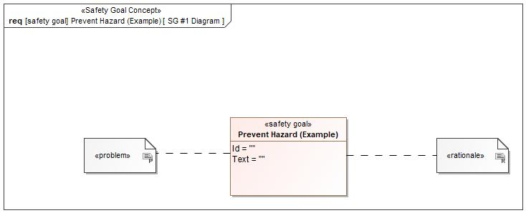

Figure 1: SG #1 Diagram – Prevent Hazard (Example)

*Note: The authoritative source for the Safety Goals is document “FFSD 02 Hazard Analysis* *and Risk Assessment”. The documentation of Safety Goals in this chapter (In the Argumentation for Safety Goal achievement) is for information purposes only.*

*The authoritative source for the Functional Safety Requirements is section 2.1.x.3: of this document. The documentation of Functional Safety Requirements in the following chapter (complete or summarised) is for information purposes only.*

#### Warning and Recovery Concept

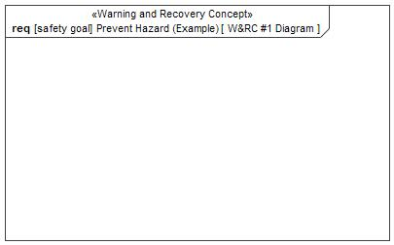

Figure 5: W&RC #1 Diagram – Prevent Hazard (Example)

### Derivation of Functional Safety Requirements on Assumptions

No Functional Safety Requirements tracing to Assumptions specified.

### ASIL Decomposition of Functional Safety Requirements

No Functional Safety Requirements with ASIL Decompositions specified.

# CyberSecurity

## Security Goals

|  |  |
| --- | --- |
| ID | Goal |

Table 12: Cybersecurity Goals

## Cybersecurity Requirements

# Architecture

## Functional Decomposition

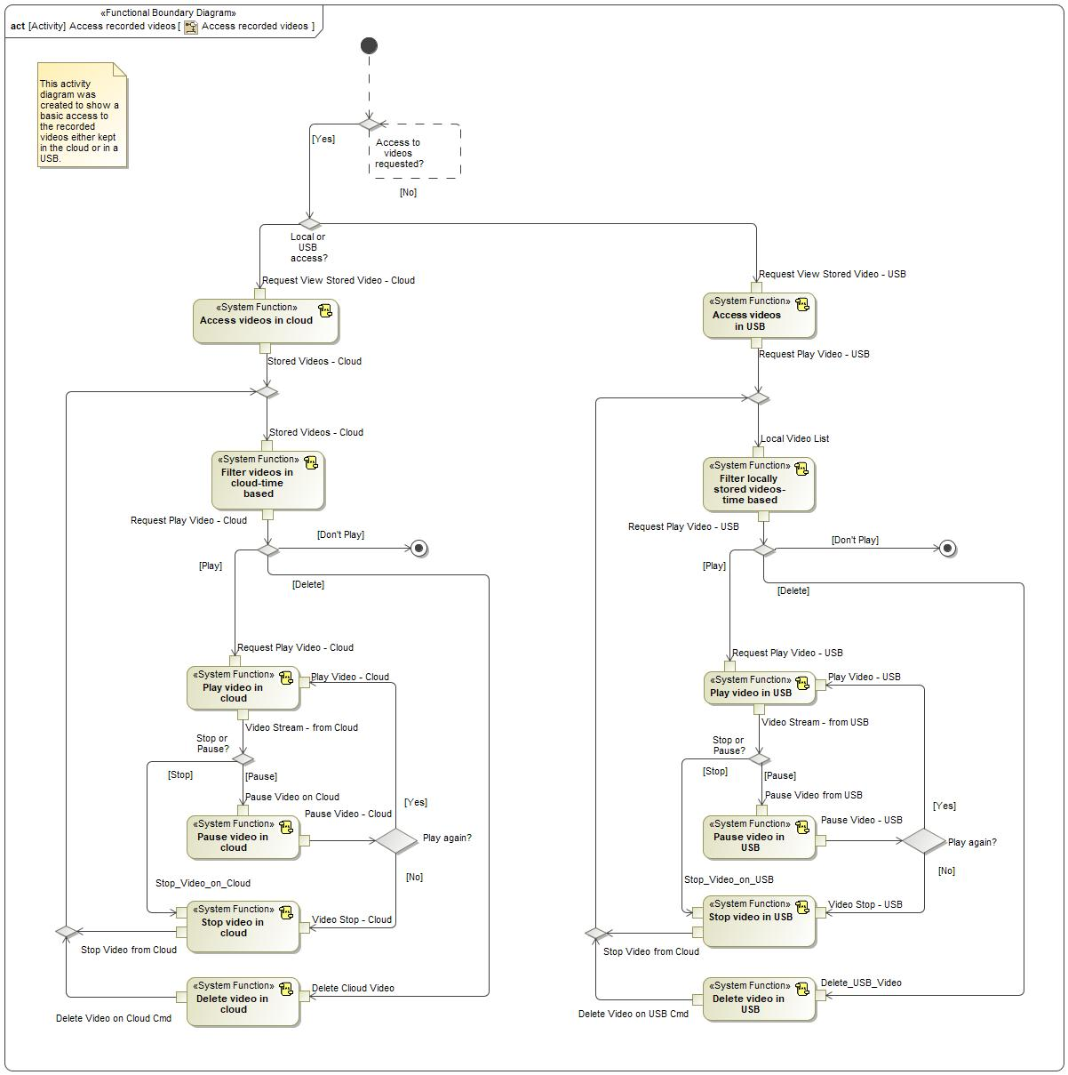

Figure 6: Access recorded videos

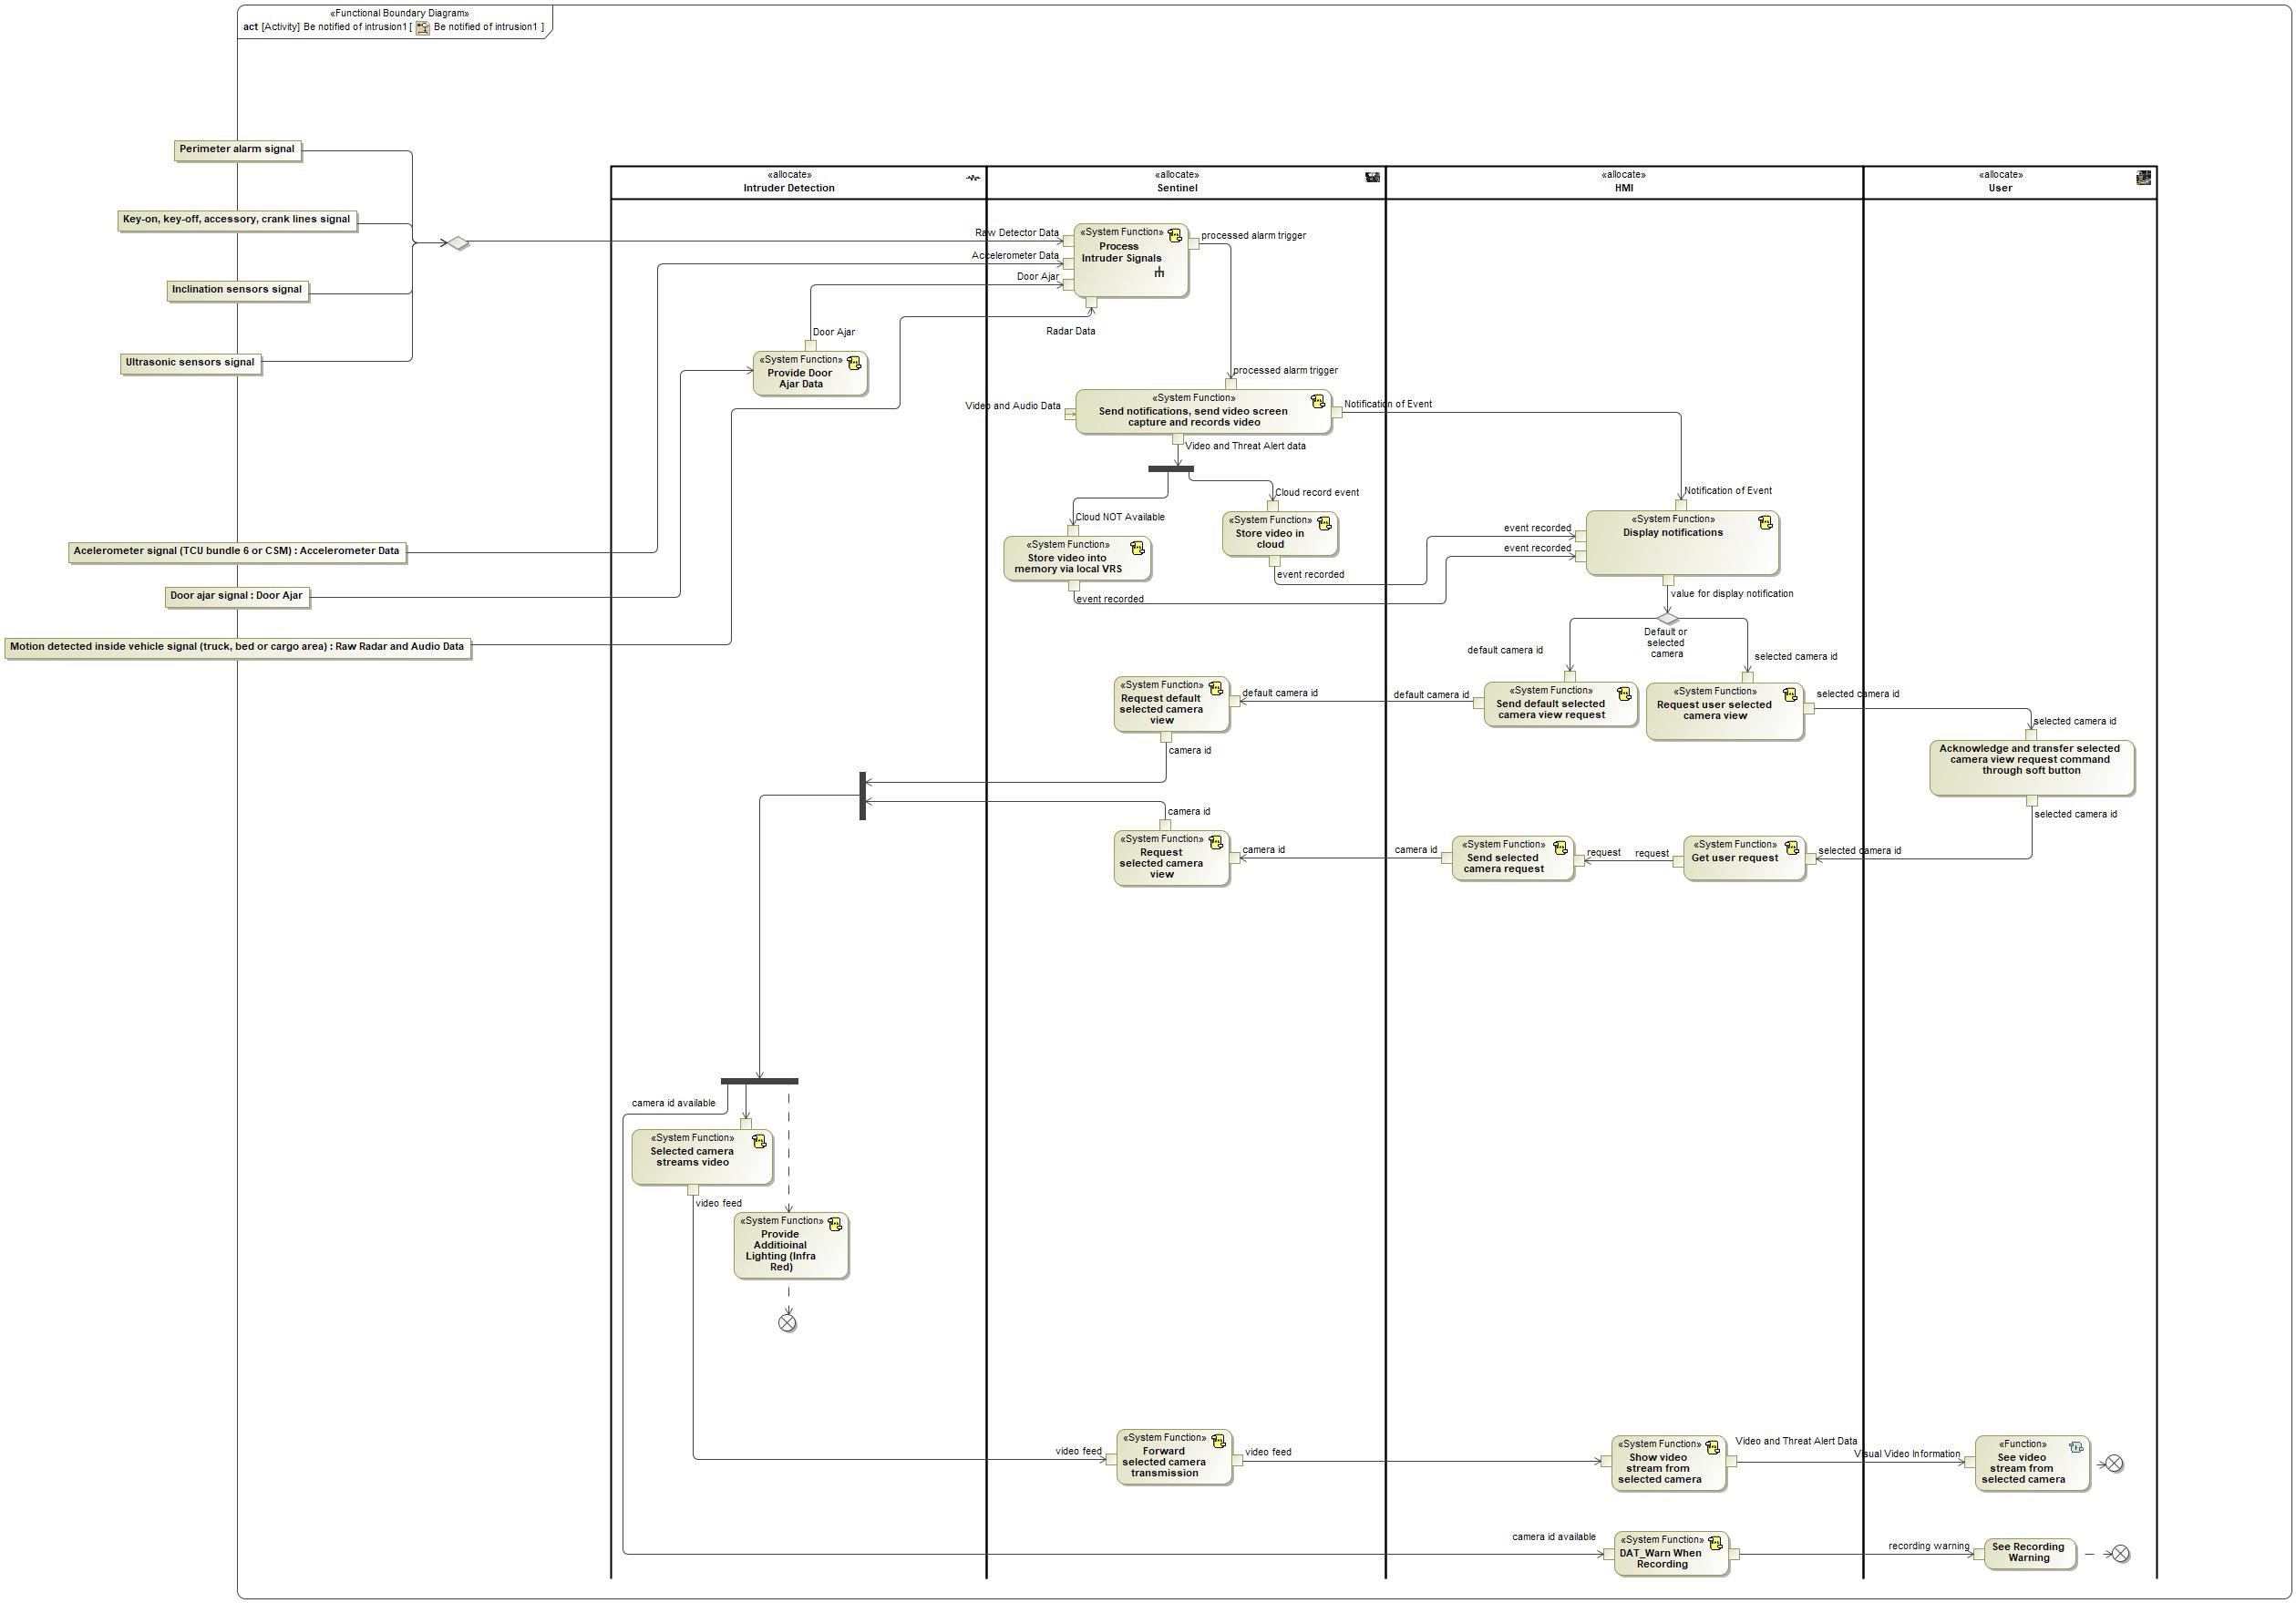

Figure 7: Be notified of intrusion1

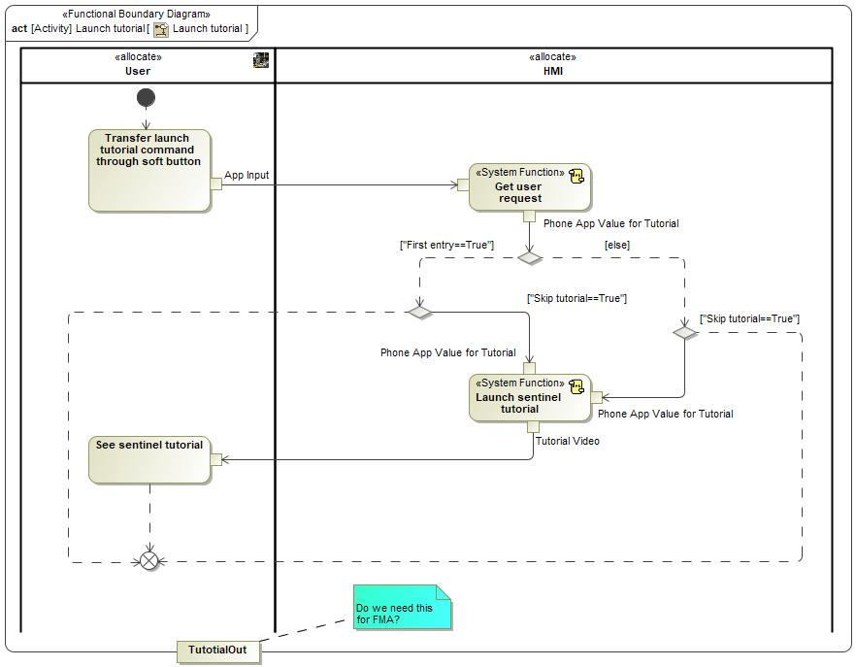

Figure 8: Launch tutorial

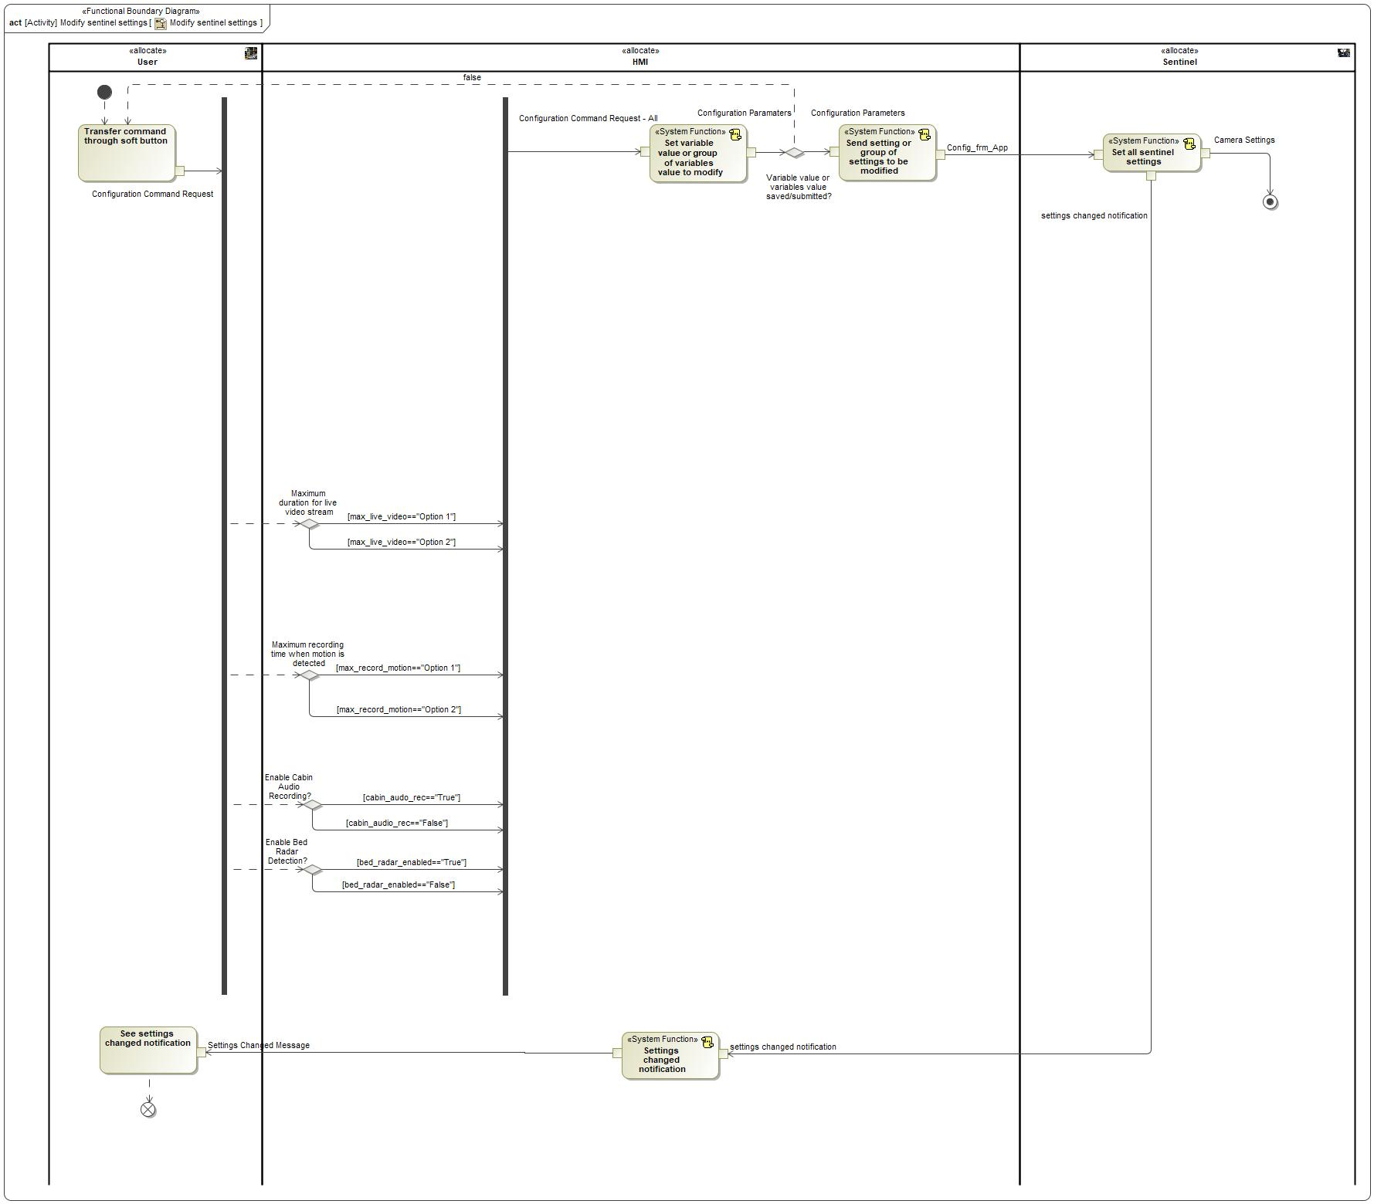

Figure 9: Modify sentinel settings

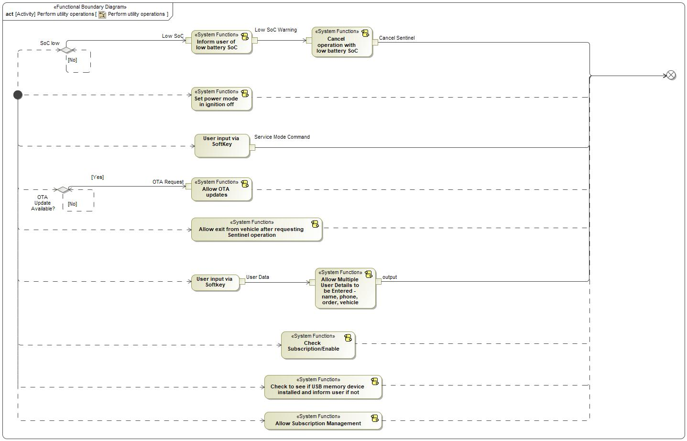

Figure 10: Perform utility operations

### Functions

| **Function Name** | Description | Comments |
| --- | --- | --- |
| *(activity)* Play video in cloud | *(activity)* Allow the user to play videos stored on the cloud |  |
| *(activity)* Pause video in USB | *(activity)* pause video playback for data stored on the jump drive |  |
| *(activity)* Filter videos in cloud-time based | *(activity)* Allow the user to filter videos stored on the cloud by the time of recording |  |
| *(activity)* Stop video in cloud | *(activity)* Allow the user to stop playing videos stored in the cloud |  |
| *(activity)* Play video in USB | *(activity)* Play back videos recorded onto the jump drive attached to the USB hub/SYNC |  |
| *(activity)* Access videos in cloud | *(activity)* Play back videos recorded onto the jump drive attached to the USB hub/SYNC |  |
| *(activity)* Filter locally stored videos-time based | *(activity)* Allow the user to select a locally stored video based on the time/date of the recording |  |
| *(activity)* Delete video in cloud | *(activity)* Allow the user to delete videos stored on the cloud |  |
| *(activity)* Pause video in cloud | *(activity)* Allow the user to pause video playback for videos stored on the cloud |  |
| *(activity)* Delete video in USB | *(activity)* Allow user to delete videos stored on the jump drive |  |
| *(activity)* Stop video in USB | *(activity)* Stop playing video stored on the jump drive |  |
| *(activity)* Access videos in USB | *(activity)* Allow the user to access videos stored on the jump drive |  |

Table 13: List of Functions on Access recorded videos

| **Function Name** | Description | Comments |
| --- | --- | --- |
| *(activity)* Selected camera streams video | *(activity)* Selected camera streams video |  |
| *(activity)* Send notifications, send video screen capture and records video | *(activity)* Send notifications, send video screen capture and records video |  |
| *(activity)* Show video stream from selected camera | *(activity)* Show selected camera video stream |  |
| *(activity)* Provide Additioinal Lighting (Infra Red) | *(activity)* For low ambient light conditions, additional lighting will be required for the interior cameras |  |
| *(activity)* Send default selected camera view request | *(activity)* Send default camera id view request |  |
| *(activity)* See video stream from selected camera | *(activity)* See selected camera video stream |  |
| *(activity)* Store video into memory via local VRS | *(activity)* Store video into memory (local VRS) |  |
| *(activity)* Store video in cloud | *(activity)* Store video in cloud |  |
| *(activity)* Acknowledge and transfer selected camera view request command through soft button | *(activity)* Acknowledge and transfer selected camera video stream request command through soft button |  |
| *(activity)* Request default selected camera view | *(activity)* Request default camera view |  |
| *(activity)* Process Intruder Signals | *(activity)* Process signals( out alarm trigger, alarm trigger ) |  |
| *(activity)* Display notifications | *(activity)* Display notifications (including intrusion warnings, getting image capturing and starting video recording). |  |
| *(activity)* Forward selected camera transmission | *(activity)* Forward selected camera video stream |  |
| *(activity)* Request user selected camera view | *(activity)* Request user camera id view |  |
| *(activity)* Request selected camera view | *(activity)* Request selected camera video stream |  |
| *(activity)* DAT_Warn When Recording | *(activity)* Users/People, must be warned when live recording is taking place (market dependant) |  |
| *(activity)* Get user request | *(activity)* Get user request |  |
| *(activity)* Send selected camera request | *(activity)* Send camera id request |  |
| *(activity)* Provide Door Ajar Data | *(activity)* Provide information on doors being ajar or closed |  |
| *(action)* See Recording Warning | *(action)* Get visual feedback in order to see the recording warning. |  |

Table 14: List of Functions on Be notified of intrusion1

| **Function Name** | Description | Comments |
| --- | --- | --- |
| *(activity)* Launch sentinel tutorial | *(activity)* Launch sentinel tutorial |  |
| *(activity)* Get user request | *(activity)* Read Phone app value( out Phone app value for tutorial ) |  |
| *(activity)* See sentinel tutorial | *(activity)* See sentinel tutorial |  |
| *(activity)* Transfer launch tutorial command through soft button | *(activity)* Transfer launch tutorial command through soft button |  |

Table 15: List of Functions on Launch tutorial

| **Function Name** | Description | Comments |
| --- | --- | --- |
| *(activity)* Settings changed notification | *(activity)* Settings changed notification |  |
| *(activity)* Set all sentinel settings | *(activity)* Set all sentinel settings |  |
| *(activity)* Transfer command through soft button | *(activity)* Transfer command through soft button |  |
| *(activity)* Send setting or group of settings to be modified | *(activity)* Send setting or group of settings to be modified |  |
| *(activity)* Set variable value or group of variables value to modify | *(activity)* Set variable value or group of variables value to modify |  |
| *(activity)* See settings changed notification | *(activity)* See settings changed notification |  |

Table 16: List of Functions on Modify sentinel settings

| **Function Name** | Description | Comments |
| --- | --- | --- |
| *(activity)* Allow exit from vehicle after requesting Sentinel operation | *(activity)* Allow the user to exit the vehicle without triggering Sentinel operation |  |
| *(activity)* Check Subscription/Enable | *(activity)* A verified subscription must be in place before the feature can be used (at least fully) |  |
| *(activity)* Allow Multiple User Details to be Entered - name, phone, order, vehicle | *(activity)* Allow Entering and Monitoring of User Account and Security Information via App. |  |
| *(activity)* Allow OTA updates | *(activity)* Allow the Sentinel software to be updated over-the-air |  |
| *(activity)* Inform user of low battery SoC | *(activity)* The user will be informed of a low vehicle battery state of charge (SoC) |  |
| *(activity)* Set power mode in ignition off | *(activity)* Sentinel shall be able to operate with the ignition switched off |  |
| *(activity)* Cancel operation with low battery SoC | *(activity)* Sentinel operation shall cease if the battery state of charge (SoC) falls below a predefined threshold. |  |
| *(activity)* Allow Subscription Management | *(activity)* When attempting to use the feature for the first time the user shall be requested to enter subscription information (subsequent subscription management may also be required) |  |
| *(activity)* Check to see if USB memory device installed and inform user if not | *(activity)* Check to see if USB memory device installed and inform user if not. |  |
| *(action)* User input via SoftKey | *(action)* Get User input via SoftKey. |  |
| *(action)* User input via Softkey | *(action)* Get User input via SoftKey. |  |

Table 17: List of Functions on Perform utility operations

## Logical Architecture

Description of diagram and content on logical architecture in Documentation field of Structural Boundary Diagram.

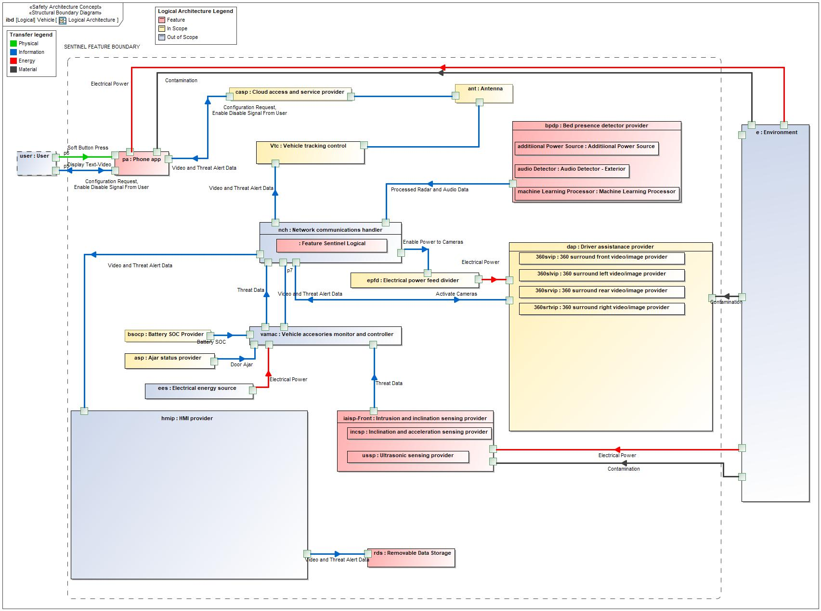

Figure 11: Logical Architecture

### Logical Elements

|  |  |  |  |
| --- | --- | --- | --- |
| **Element Name** | **Description** | **Allocated Functions** | **Comments** |
|  |  |  |  |
| 360 surround front video/image provider | Video camera to provide external view to the front of the vehicle. Image will be combined with 3 other cameras to provide a 360 degree external view around the vehicle. | * Selected camera streams video * Confirm selected camera availability * Terminate selected camera availability * Process Intruder Signals * Determine if Detector is Contaminated |  |
| 360 surround left video/image provider | Video camera to provide external view to the left hand side of the vehicle. Image will be combined with 3 other cameras to provide a 360 degree external view around the vehicle. | * Selected camera streams video * Confirm selected camera availability * Terminate selected camera availability * Process Intruder Signals * Determine if Detector is Contaminated |  |
| 360 surround rear video/image provider | Video camera to provide external view to the rear of the vehicle. Image will be combined with 3 other cameras to provide a 360 degree external view around the vehicle. | * Selected camera streams video * Confirm selected camera availability * Terminate selected camera availability * Process Intruder Signals * Determine if Detector is Contaminated |  |
| 360 surround right video/image provider | Video camera to provide external view to the right hand side of the vehicle. Image will be combined with 3 other cameras to provide a 360 degree external view around the vehicle. | * Selected camera streams video * Confirm selected camera availability * Terminate selected camera availability * Process Intruder Signals * Determine if Detector is Contaminated |  |
| Additiional Power Source | Additional power will be required operate Sentinel cameras etc, due to Sentinel operating when IGN=OFF. | * Supply Power to Radar with IGN=OFF |  |
| Ajar status provider | Door opening will be a trigger for the perimeter alarm system | * Process Intruder Signals * Provide Door Ajar Data |  |
| Antenna | This provides internet communication between the vehicle and the telecoms/internet network | * Process Intruder Signals * Forward selected camera transmission * Allow OTA updates |  |
| Audio Detector - Exterior | A microphone for detecting noise/speach external to the vehicle | * Radar System External Audio Detector |  |
| Battery SOC Provider | System to provide main vehicle SIL battery SoC (state of charge) information to Sentinel | * Selected camera streams video * Inform user of low battery SoC * Cancel operation with low battery SoC |  |
| Bed presence detector provider | System to detect an intruder in the cargo bed of a pick-up truck (current solution is a radar system, combined with an microphone information and Machine Learning) | * Selected camera streams video * Confirm selected camera availability * Terminate selected camera availability * Process Intruder Signals * Provide Radar Image |  |
| Cloud access and service provider | Telecommunication Links and Data Storage/Processing | * Store video in cloud * Store video in cloud * Selected camera streams video * Play video in cloud * Stop video in cloud * Pause video in cloud * Delete video in cloud * Filter videos in cloud-time based * Filter videos in cloud-intrusion method based * Record data in service mode - accelerometer - radar * Access videos in cloud * Check Subscription/Enable * Allow OTA updates * Manage Overwrite of Data on Cloud |  |
| Driver assistanace provider | The ADAS or DAT module - includes video camera functionality and image processing | * Selected camera streams video * Perform machine learning * Provide Diagnostics for IR Lights |  |
| Electrical energy source | The main vehicle SIL battery | * Process Intruder Signals * Selected camera streams video |  |
| Electrical power feed divider | The PDB on the vehicle | * Selected camera streams video |  |
| Environment | The external environment. For this feature the main effects will be from camera lens contamination, but also from vehicle collision events and disturbances to the vehicle from non-threat events , eg the wind moving the vehicle or small animals in the cargo bed of a pick-up. | * Process Intruder Signals |  |
| Feature Sentinel Logical | Sentinel software | * Set Sentinel feature to ON or OFF * Set all sentinel settings * Request selected camera view * Forward selected camera transmission * Report selected camera not available * Request default selected camera view * Send notifications, send video screen capture and records video * Store video in cloud * Store video into memory via local VRS * Forward selected camera video stream terminated * Terminate selected camera video stream * Allow Sentinel Operation with Remote Start * Detect Module Occupied * Allow OTA updates |  |
| HMI provider | Systems such as SYNC/Phoenix | * Store video into memory via local VRS * Play video in USB * Stop video in USB * Pause video in USB * Delete video in USB * Access videos in USB * Inform user of low battery SoC * Record data in service mode - accelerometer - radar * Access videos in cloud * Check to see if USB memory device installed and inform user if not * Audio Deterrent (Loudspeaker) * Intruder Audio Detection in Cabin * Manage Overwrite of USB Memory * Allow USB Video Playback on PC/Computer * Allow USB Video Playback on SYNC/Phoenix * Set Sentinel feature to ON or OFF * Filter locally stored videos-time based |  |
| Inclination and acceleration sensing provider | Accelerometer/Inclinometer functionality to detect a vehicle being moved during a threat event, eg car being jacked-up at one corner or being towed | * Process Intruder Signals |  |
| Intrusion and inclination sensing provider | The CSM functionality to detect intruders inside or outside the vehicle using sensors such as ultrasonic sensors and accelerometers | * Process Intruder Signals |  |
| Machine Learning Processor | Processor to use raw radar and audio information and determine if there is a vehicle threat event. | * Perform machine learning |  |
| Network communications handler | The ECG communications gateway module functionality | * Selected camera streams video * Detect Vehicle Parked |  |
| Phone app | The FordPass App, including Sentinel functionality | * Display feature notifications * Send notifications, send video screen capture and records video * Launch sentinel tutorial * Get user request * Acknowledge and transfer selected camera view request command through soft button * Display enable-disable sentinel feature status * Send enable signal * Send disable signal * Transfer command through soft button * Send setting or group of settings to be modified * Settings changed notification * Show video stream from selected camera * Display selected camera not available [eg contamination] on phone * Transfer selected camera request command through soft button * Send selected camera request * Get selected camera video stream terminated * Get selected camera video steam terminated * Set variable value or group of variables value to modify * Display notifications * Send default selected camera view request * Request user selected camera view * Get user request * Send command to terminate selected camera video stream * Play video in cloud * Stop video in cloud * Pause video in cloud * Delete video in cloud * Filter videos in cloud-time based * Filter videos in cloud-intrusion method based * Inform user of low battery SoC * Cancel operation with low battery SoC * Access videos in cloud * Allow Multiple User Details to be Entered - name, phone, order, vehicle * Check Subscription/Enable * Allow Subscription Management * Cabin Audio Recording - Enable/Disable * Allow OTA updates * Allow Sentinel Operation with Remote Start * Audio Deterrent (Loudspeaker) * Set Sentinel feature to ON or OFF |  |
| Removable Data Storage | A USB memory device to store video (and potentially other recorded) data | * Store video into memory via local VRS * Play video in USB * Stop video in USB * Pause video in USB * Delete video in USB * Access videos in USB * Record data in service mode - accelerometer - radar |  |
| Ultrasonic sensing provider | An ultrasonic detector to detect intruders inside a vehicle cabin | * Process Intruder Signals |  |
| User | The user of the Sentinel feature | * Transfer command through soft button * See video stream from selected camera * See selected camera video not available * Transfer selected camera stop video streaming command through soft button * See selected camera video stream terminated * User notified of sentinel app enabled-disabled * Transfer enable command through soft button * See sentinel tutorial * Transfer launch tutorial command through soft button * See settings changed notification * Play video in USB * Stop video in USB * Pause video in USB * Delete video in USB * Play video in cloud * Stop video in cloud * Access videos in USB * Pause video in cloud * Delete video in cloud * Filter videos in cloud-time based * Filter videos in cloud-intrusion method based * Access videos in cloud |  |
| Vehicle accesories monitor and controller | This incorporates the BCM functionality | * Process Intruder Signals * Allow exit from vehicle after requesting Sentinel operation * Set power mode in ignition off * Inform user of low battery SoC * Cancel operation with low battery SoC |  |
| Vehicle tracking control | The module including the vehicle based modem | * Process Intruder Signals * Check for internet signal * Inform user of poor internet signal * Allow OTA updates * Record data in service mode - accelerometer - radar |  |

Table 18: Logical Elements

### Logical Interfaces

|  |  |  |  |
| --- | --- | --- | --- |
| **Interface** | **Direction** | **Description** | **Value Range** |
| Activate Cameras | p3 (Network communications handler) To p2 (Driver assistanace provider) | Signal to switch on cameras and any associated lights/microphones |  |
| Battery SOC | p1 (Battery SOC Provider) To p6 (Vehicle accesories monitor and controller) | Signal to provide battery SOC data. Note Sentinel may need to be deactivated if the battery SOC is too low. |  |
| Configuration Request | p1 (Phone app) To p4 (Cloud access and service provider) | Requests from the user for configuration settings via the Ford Pass App, such as default camera. |  |
| p5 (User) To p3 (Phone app) | Requests from the user for configuration settings via the Ford Pass App, such as default camera. |  |
| Contamination | p3 (Environment) To p3 (Driver assistanace provider) | Environmental contamination such as mud and dirt that prevents video image being captured. |  |
| p5 (Environment) To p1 (Intrusion and inclination sensing provider) | Environmental contamination such as mud and dirt that prevents video image being captured. |  |
| p5 (Environment) To p2 (Intrusion and inclination sensing provider) | Environmental contamination such as mud and dirt that prevents video image being captured. |  |
| p7 (Environment) To p4 (Phone app) | Environmental contamination such as mud and dirt that prevents video image being captured. |  |
| Data from App | p1 (Phone app) To p4 (Cloud access and service provider) | Information flow to the Sentinel Ford Pass App from Ford Cloud Services |  |
| Data to App | p4 (Cloud access and service provider) To p1 (Phone app) | Information flow from the Sentinel Ford Pass App to Ford Cloud Services |  |
| Display Text-Video | p3 (Phone app) To p5 (User) | Signal to convey text messages and video images |  |
| Door Ajar | p1 (Ajar status provider) To p3 (Vehicle accesories monitor and controller) | Signal to denote a door is ajar on the vehicle |  |
| Electrical Power | p1 (Electrical energy source) To p2 (Vehicle accesories monitor and controller) | Electrical power supply only. |  |
| p2 (Electrical power feed divider) To p1 (Driver assistanace provider) | Electrical power supply only. |  |
| p6 (Environment) To p2 (Intrusion and inclination sensing provider) | Electrical power supply only. |  |
| p6 (Environment) To p3 (Intrusion and inclination sensing provider) | Electrical power supply only. |  |
| p8 To Phone app | Electrical power supply only. |  |
| Enable Disable Signal From User | p1 (Phone app) To p4 (Cloud access and service provider) | Signal from the user to Sentinel via the softkeys on the App on the user's mobile device. This signal is to enable/disable Sentinel. |  |
| p5 (User) To p3 (Phone app) | Signal from the user to Sentinel via the softkeys on the App on the user's mobile device. This signal is to enable/disable Sentinel. |  |
| Enable Power to Cameras | p2 (Network communications handler) To p1 (Electrical power feed divider) | Signal to enable power to the video cameras. |  |
| Processed Radar and Audio Data | p1 (Bed presence detector provider) To p6 (Network communications handler) | Signal from radar unit after machine learning of radar data and audio data has occurred |  |
| Soft Button Press | p6 (User) To p2 (Phone app) | Input from user to Ford Pass app via a mobile device. |  |
| Threat Data | p1 (Intrusion and inclination sensing provider) To p4 (Vehicle accesories monitor and controller) | Threat identification data, including door ajar signal or ultrasonic signal. |  |
| p1 (Vehicle accesories monitor and controller) To p4 (Network communications handler) | Threat identification data, including door ajar signal or ultrasonic signal. |  |
| p3 (Intrusion and inclination sensing provider) To p4 (Vehicle accesories monitor and controller) | Threat identification data, including door ajar signal or ultrasonic signal. |  |
| Video and Threat Alert Data | p1 (HMI provider) To p2 (Removable Data Storage) | Video data collecetd from cameras along with threat data collected from other sensors such as door open, intruder event detected via ultrasonics, inclination sensor, accelerometer, etc. |  |
| p2 (Driver assistanace provider) To p3 (Network communications handler) | Video data collecetd from cameras along with threat data collected from other sensors such as door open, intruder event detected via ultrasonics, inclination sensor, accelerometer, etc. |  |
| p4 (Cloud access and service provider) To p1 (Phone app) | Video data collecetd from cameras along with threat data collected from other sensors such as door open, intruder event detected via ultrasonics, inclination sensor, accelerometer, etc. |  |
| p5 (Network communications handler) To p3 (Vehicle tracking control) | Video data collecetd from cameras along with threat data collected from other sensors such as door open, intruder event detected via ultrasonics, inclination sensor, accelerometer, etc. |  |
| p10 (Network communications handler) To p3 (HMI provider) | Video data collecetd from cameras along with threat data collected from other sensors such as door open, intruder event detected via ultrasonics, inclination sensor, accelerometer, etc. |  |

Table 19: Feature Interactions

# Traceability Matrix

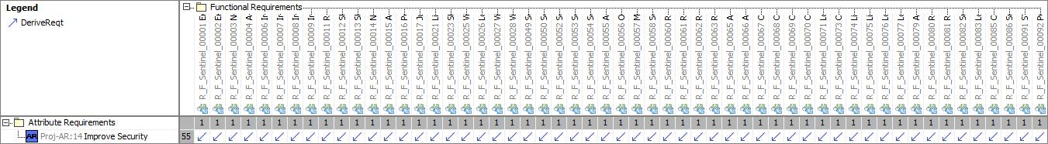

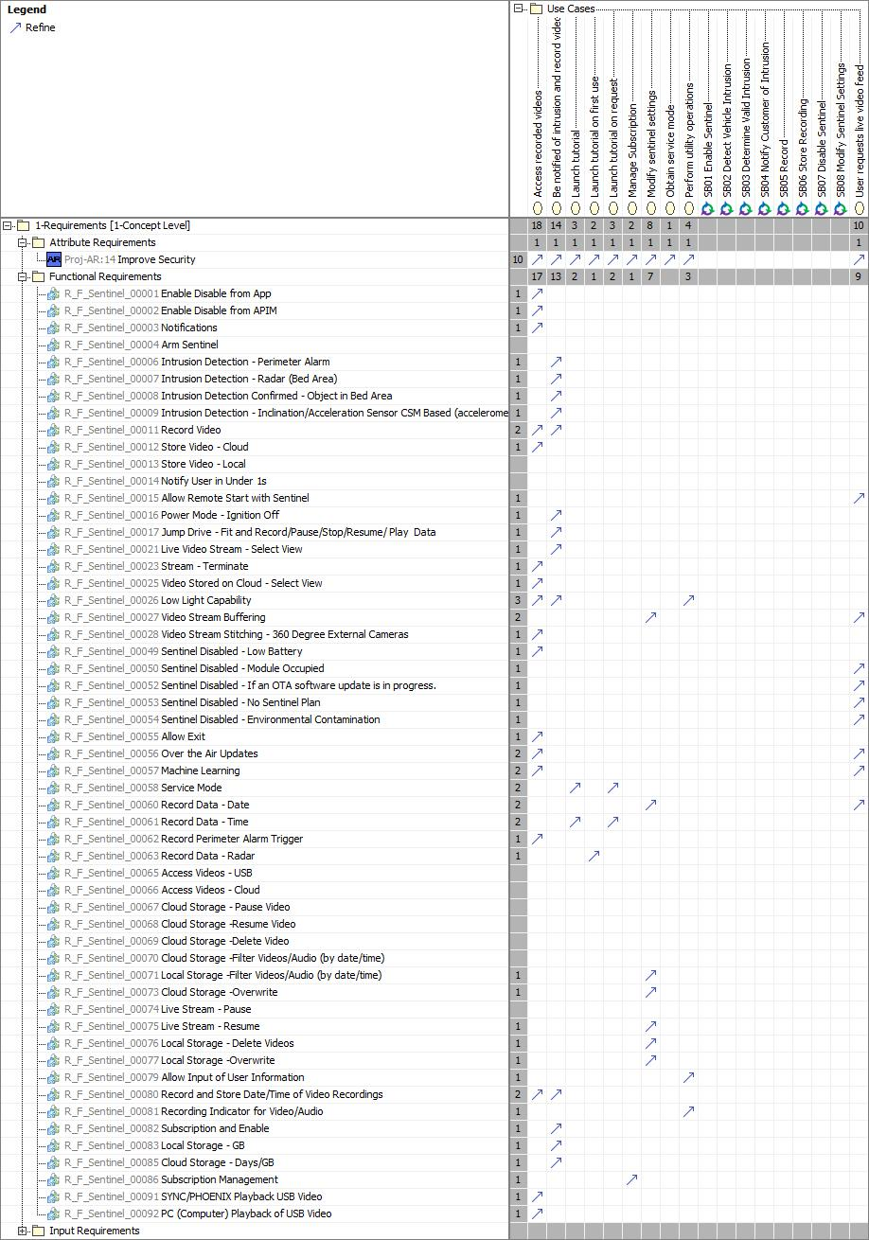

# Open Concerns

| ID | Concern Description | e-Tracker / Reference | Responsible | Status | Solution |
| --- | --- | --- | --- | --- | --- |
| 1 |  |  |  |  |  |

Table 20: Open Concerns *(Not supported by MagicDraw report generation)*

# Revision History

| Rev.  (revision) | Date | Description | Approved by | Responsible |
| --- | --- | --- | --- | --- |
| FD1 | 2020-11-26 | FD V1.0 |  |  |
| FDV2.7 (V710) | 2021-05-20 | Updated requirements etc., especially for camera team |  |  |
| FD3.0 (Phoenix) | 2021-06-17 | Updated for Phoenix. |  |  |

## Template Revisions

|  |  |  |  |  |
| --- | --- | --- | --- | --- |
| Version | Rev. | Date | Description | Responsible |
| 0 | 6 | 2015-05-26 | * Chapter “Feature Overview” and made a 2nd level heading. * Chapter “Feature Modeling” divided into 3 subchapter (“Scenarios”, “Use Cases”, “State Machines”) for different modeling methods | Jbaden1 |
| 0 | 7 | 2015-05-27 | * Table of Content updated * Template Revision History chapter added | Jbaden1 |
| 0 | 8 | 2015-07-02 | * Section “Unsettled Issues” added | Alevin7 |
| 0 | 9 | 2015-08-04 | * Section “Feature Variants” added * Section “Feature Boundary Diagram” renamed to “Feature Context Diagram” * Document Properties adapted to match needs of VBA macros | Jbaden1, Awegman1 |
| 1 | 0 | 2015-09-11 | * Section “Feature Variants” reworked * Feature Goals removed. Only “Safety Goals“ chapter remains. * Heading 2 formatting issues corrected. * Requirements / Use Cases Listing removed from traceability chapter. * Formatting of attribute table in Notation chapter corrected * Open Topics / Known Issues chapter moved to the end | Jbaden1 |
| 1 | 1 | 2015-11-16 | * Table-Styles removed (for smooth VSEM import) * Some clean-up of sections “Purpose” and “Audience” | Awegman1, jbaden1 |
| 1 | 2 | 2016-02-26 | * Minor corrections based on lessons learned from CC and PCL pilot (e.g. section market/regions) and discussion with Functional Safety Team (purpose of feature) * Footer corrected * Boundary diagram interface chapter renamed to influences. | Jbaden1 |
| 1 | 3 | 2016-02-26 | * Minor corrections after review with Whitney Keith from Functional Safety team | Jbaden1 |
| 1 | 4 | 2016-03-10 | * Some cleanup of meta-data in Word Properties | Jbaden1 |
| 1 | 5 | 2016-03-10 | * Footer formatting corrected (Issue 19) * Results from review with Functional Safety Team incorporated (Issue 20). | jbaden1 |
| 1 | 6 | 2016-04-18 | * Scenario Template added | Jbaden1 |
| 1 | 7 | 2016-04-18 | * Chapter “Operation Modes and States” moved before “Use Case” section. | Jbaden1 |
| 1 | 8 | 2016-04-18 | * Broken Wiki links repaired. | Jbaden1 |
| 2 | 0 | 2016-05-19 | * Adapted to Specification_Macros.dotm V2.0 * Requirements Templates chapter (ch. 1.7.1) no longer has an attribute table, but refers directly to the Wiki.. | Jbaden1 |
| 2 | 1 | 2016-06-10 | * Table for Context Diagram modified (lists external entities and Influence Description only) | Jbaden1 |
| 2 | 2 | 2016-07-08 | * Template version added to footer * Several hints added to the various sections * Findings from Functional Safety Team incorporated. * RE_SafetyRequirement style added | Jbaden1 |
| 2 | 3 | 2016-09-21 | * Update from Functional Safety Team incorporated (“Lessons Learned”, “System Behaviors for HARA”) | Jbaden1 |
| 2 | 4 | 2016-11-15 | * Update from Functional Safety Team incorporated (“Lessons Learned”, “System Behaviors for HARA”) * Explanatory notes made more formal | Jbaden1 |
| 3 |  |  | Skipped to synchronize with Specification_Macros.dotm |  |
| 4 |  |
| 5 | 0 | 2017-01-13 | * Meta data updated for specification macros, version 3.1 * SW Unit chapter removed for the time being * Green boxes added for user hints | Jbaden1 |
| 5 | 1 | 2017-01-18 | * Minor editorial changes | Jbaden1 |
| 6 | 0 | 2017-02-03 | * CR48: Chapter 6 renamed from “Safety” to “Functional Safety”. New sub-chapter “Safety” introduced in Non-Functional Requirements section | Jbaden1 |
| 6 | 0 | 2017-04-28 | * CR7: “RequirementsTraceability” chapter removed | Jbaden1 |
| 6 | 0 | 2017-11-15 | * CR32/53: New Cover Sheet + Disclaimer replaces FAP-150 like ones. * CR75: Some rewording -> Terminology to Glossary, Notation -> Document Conventions * CR49: Rename “Assumptions & Constraints” to “Assumptions” * CR74: Safety Assumptions added to chapter 6. * CR58: Add function allocation column to Logical Architecture chapter | Jbaden1 |
| 6 | 0 | 2018-01-31 | * CR63: Updated links to Functional Safety Sharepoint | Jbaden1 |
| 6 | 0 | 2018-07-24 | * CR69: Add FSR to FeatureDoc * CR64: Add new section "Design Requirements" to Function Spec and Feature Spec | Jbaden1 |
| 6 | 0 | 2018-08-06 | * CR53: some corrections for metada and formatting | Jbaden1 |
| 6 | 0 | 2018-09-28 | * Broken links to RE Wiki repaired | Jbaden1 |
| 6 | 0 | 2018-10-31 | * Cover sheet and footer more GIS like. Functional Safety team feedback incorporated:   + New subsections “Functional Safety Requirements, (Decomposed) FSRs and Parameters / Values   + Removal of “Logical Architecture” | Jbaden1 |
| 6 | 0 | 2018-12-12 | * FSR template removed, now as a macro in the Specification_Macros.dotm | Jbaden1 |
| 6 | 0a | 2019-05-23 | * Re-introduce “Logical Architecture” (for Functional Safety) | Jbaden1 |
| 6 | 0b | 2019-06-26 | * Chapter “Logical Elements” in “Logical Architecture” section added (FuSa CR 15136240) | Jbaden1 |
| 6 | 0c | 2019-03-22 | * Chapter “Decomposed FSRs” renamed to “ASIL Decomposition of Functional Safety Requirements” and moved beneath Chapter “Functional Safety Requirements”. Explanatory text improved. | Jbaden1 |
| 6 | 0c | 2019-04-05 | * Some wording in ASIL decomposition table modified. Description of fields in that table improved. | Jbaden1 |
| 6 | 0c | 2019-06-24 | * “Input Requirements” section modified (table approach as for the other RE templates). * “References” and “Glossary” chapter moved to the “Introduction” chapter. | Jbaden1 |
| 6 | 0c | 2019-07-02 | * "Important" box added on cover sheet which points to the macros | Jbaden1 |
| 6 | 0c | 2019-07-02 | * Subsection “Error Handling” removed form chapter “Feature Requirements”->”Functional Requirements” (teams are free to create their own substructure of that section). Note tells author not to forget about error handling. * Hint for chapter “Feature Variants” improved reworded upon request from Functional Safety Team. | Jbaden1 |
| 6 | 0c | 2019-05-11 | * Copyright notice shortened and moved to cover sheet and added to footer (to be compliant [with Ford copyright guidelines](http://www.fgti.ford.com/client/NewFGTI/CopyrightNotice.html)) * Term “Disclaimer” no longer used for what is actually only a copyright notice | Jbaden1 |
| 6 | 0c | 2019-22-11 | * Chapter “Input Requirements/Documentst: minor modifications (examples added), Word comment removed” | Jbaden1 |
| 6 | 0c | 2019-12-05 | * Upstream Documents section added to “Input Requirements/Documents” table * Custom style table formatting removed * Hint on system behaviors modified as requested from FuSa team | Jbaden1 |
| 6 | 0c | 2019-12-09 | * Term “Upstream Documents” replaced by “Attribute Requirements” in “Input Requirements/Documents” table * ASIL Decomposition table replaced by a version, which get not corrupted during VSEM import. | Jbaden1 |
| 6 | 0c | 2019-12-10 | * In ch. “Functional Safety Requirements” Word reference Id by Word reference text replaced.. | Jbaden1 |
| 6 | 1a | 2020-02-12 | * New chapter “Cybersecurity” added. | Jbaden1 |
| 6 | 1a | 2020-03-03 | * All User Hints formatted using style “RE_UserHint” to enable automatic removal by a macro. | Jbaden1 |
| 6 | 1a | 2020-03-04 | * Chapter “Cloud Connectivity Data Analytics Requirements” added upon request by D. Crockett/J. Rawlings | Jbaden1 |
| 6 | 1a | 2020-03-09 | * Missing doc property “LatestSigMappingID” and “LatestAisInterfaceID” added * doc property “CopyrightDate” re-formatted to text and copyright date field in footer corrected * Version numbering re-initialized as 0.1 * Init value of version/revision date set to “yyyy/mm/dd” instead of “yyyy-mm-dd” to be in line with the “Edit Document Property” dialog * type of document property for latest IDs changed to number instead of text | Jbaden1 |
| 6 | 1b | 2020-03-17 | * Chapter “Functional Architecture” renamed to “Functional Decomposition” * New MBSE terminology introduced: “Feature Level”, “Function Level” and “Component Level” renamed to “Concept Level”, “Logical Level” and “Technology Level” | Jbaden1 |
| 6 | 1b | 2020-07-03 | * CR31: Chapter “Traceability Matrix” added. | Jbaden1 |
| 6 | 1b | 2020-23-09 | * CR28: Alignment to [*FFSG01.10 Feature Document Guideline*](https://azureford.sharepoint.com/sites/GlobalFunctionalSafety/Released%20Templates%20Guidelines%20and%20Examples/Guidelines/FFSG01.10_FeatureDocument_Guideline.pdf) for how to apply the Feature Doc template for Functional Safety. New section “Classification of Chapters” added. “Active Tilt Control” Example in section “Logical Architecture” updated based on input from HARA training. | Jbaden1 |
| 6 | 1b | 2020-25-11 | * Reference to process definition in Stages added to “How to Use” section on cover sheet. User hints removed from “Document Purpose” chapter. * RE-Wiki links mostly replaced by Stages links, links to Functional Safety Sharepoint updated | Jbaden1 |

# Appendix

## Definitions

| **Definition** | **Description** |
| --- | --- |
| Kinesis | Amazon Kinesis Data Streams (KDS) is a massively scalable and durable real-time data streaming service. The data collected is available in milliseconds to enable real-time analytics use cases such as real-time dashboards, real-time anomaly detection, dynamic pricing, and more. |
| WebRTC | WebRTC is an open technology specification for enabling real-time communication (RTC) across browsers and mobile applications via simple APIs. |

Table 21: Definitions used in this document

## Abbreviations

| **Abbr.** | **Stands for** |
| --- | --- |
| ADAS | Advanced Driver Assistance Systems |
| APP | Application (ie software application) |
| BCM | Body Control Module |
| CAN | Controller Area Network (CAN bus) |
| CSM | Central Security Module |
| DAT | Driver Assistance Technologies |
| DCM | Door Control Module |
| DDSM | Digital Data Storage Module |
| ECG | Enhanced Central Gateway |
| iPDB | intelligent Power Distribution Box |
| IR | Infra Red, or Implementation Requirement |
| ISC | Integrated Security Camera |
| KDS | Kinesis Data Streams |
| LIN | Local Interconnect Network |
| MDV | Mobile Device Viewer |
| OTA | Over the Air Updates |
| RTC | Real Time Communications |
| SEM | Sensor Extension Module |
| SYNC | In vehicle HMI including in car entertainment etc. |
| TCU | Telematics Control Unit |
| US | Ultra Sonic |
| USB | Universal Serial Bus |
| VPSM | Vehicle Power State Manager |
| VRP | Video Recording and Playback |
| VRS | Video RecordierService |

Table 22: Abbreviations used in this document

Document ends here.