Dimming Interior Illumination Control Mirror – CGEA1.3

Functional Description

The purpose of the Dimming Interior Illumination Control Mirror is to inform the driver of the dimming level to which the interior lamps are set. The Dimming Interior Illumination Control Mirror correlates the EOL Configuration input, the DimmingLvlEvnt_No_Actl signal, the Dimming_Lvl signal, and the Operational_Mode to determine when to display the Dimming Interior Illumination Control Mirror and whether to display the daytime dimming level or the nighttime dimming level. The Dimming Interior Illumination Control Mirror warning should only be displayed when there is a button press for a change to the Dimming Interior Illumination.

This Specification is mutually exclusive with the Warning – Dimming Scroll Bar – CGEA1.3 STSS. If the cluster has the Control Mirror feature, Dimming Interior Illumination should be a Control Mirror item and not a warning.

Interfaces

Interface Context Diagram (I/O Block Diagram)
Figure 1 Dimming Interior Illumination Control Mirror Context Diagram

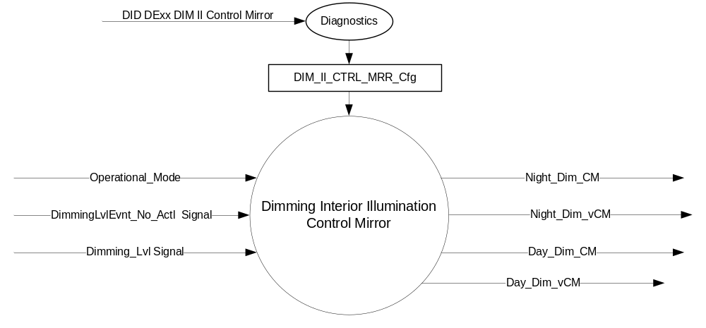

Inputs
      - INTERNAL:

    - Operational_Mode
    - DIM_II_CTRL_MRR_Cfg

- MUX messages on the CAN Bus

- Dimming_Lvl Signal

Signal Name | Size  (bits) | Detail | Units | Res. | Offset | State Encoded | Min. | Max.
Dimming_Lvl | 8 |  | SED | 1 | 0 |  | 0  (0x0) | 253 (0xFD)
 |  | Off |  |  |  | 0x0
 |  | Night_1 |  |  |  | 0x1
 |  | Night_2 |  |  |  | 0x2
 |  | Night_3 |  |  |  | 0x3
 |  | Night_4 |  |  |  | 0x4
 |  | Night_5 |  |  |  | 0x5
 |  | Night_6 |  |  |  | 0x6
 |  | Night_7 |  |  |  | 0x7
 |  | Night_8 |  |  |  | 0x8
 |  | Night_9 |  |  |  | 0x9
 |  | Night_10 |  |  |  | 0xA
 |  | Night_11 |  |  |  | 0xB
 |  | Night_12 |  |  |  | 0xC
 |  | Day_1 |  |  |  | 0xD
 |  | Day_2 |  |  |  | 0xE
 |  | Day_3 |  |  |  | 0xF
 |  | Day_4 |  |  |  | 0x10
 |  | Day_5 |  |  |  | 0x11
 |  | Day_6 |  |  |  | 0x12
 |  | Unknown |  |  |  | 0xFE
 |  | Invalid |  |  |  | 0xFF

- DimmingLvlEvnt_No_Actl Signal

Signal Name | Size  (bits) | Detail | Units | Res. | Offset | State Encoded | Min. | Max.
DimmingLvlEvnt_No_Actl | 2 |  | Unitless | 1 | 0 |  | 0  (0x0) | 3 (0x3)

Output
- Night_Dim_CM (used to control the state of the Nighttime Dimming Control Mirror Display)
- Day_Dim_CM (used to control the state of the Daytime Dimming Control Mirror Display)
- Night_Dim_vCM (used to indicate the variable state of the Nighttime Dimming Control Mirror Display)
- Day_Dim_vCM (used to indicate the variable state of the Daytime Dimming Control Mirror Display)

Function/Performance

Operational Modes

Mode | Differentiating Vehicle Conditions
Sleep Mode | Night_Dim_CM = Inactive ; Day_Dim_CM = Inactive
Limited Mode | Night_Dim_CM = Inactive : Day_Dim_CM = Inactive
Normal Mode | Night_Dim_CM = Inactive/Active ; Day_Dim_CM = Inactive/Active
Crank Mode | Night_Dim_CM = Inactive/Active ; Day_Dim_CM = Inactive/Active

Voltage Levels

Refer to the Cluster Features Table located in the Operational Modes and Voltage Range Strategies Section of this SPSS.

Human-Machine Interface

Visual

Indicator Graphics / Display Format
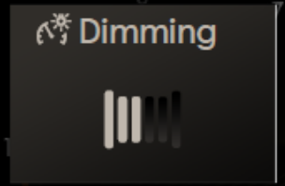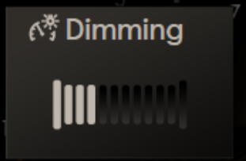
Day_Dim_vCM = 0x3 Night_Dim_vCM = 0x4

Above are example graphics for specific Day_Dim_vCM and Night_Dim_vCM values. The number of segments highlighted is dependent upon the value of those variables.
Actual graphics are to be provided by Ford HMI or Studio and approved by the DI Application for each program.

1.3.3.1.2 Indicator Color Coordinates

Reference Ford HMI or Studio Wallpaper files for the specific program.

Audio

None

Switch Control Logic

None.

System Accuracy

Within 100 msec of receiving a message that results in a change of state the cluster will update the output to the proper state.

Operation: Performance and Functional Subsystem Algorithm Flowchart / State Diagram

Subsystem Algorithm Flowchart / State Diagram
Figure 2 EOL Configuration Flowchart

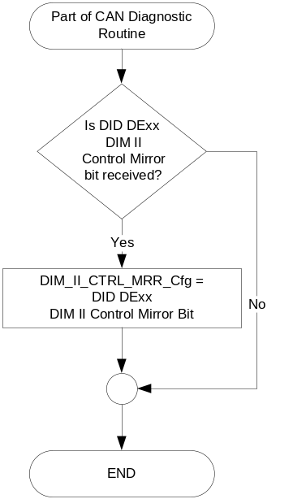

Figure 3 Dimming Interior Illumination Control Mirror Flowchart
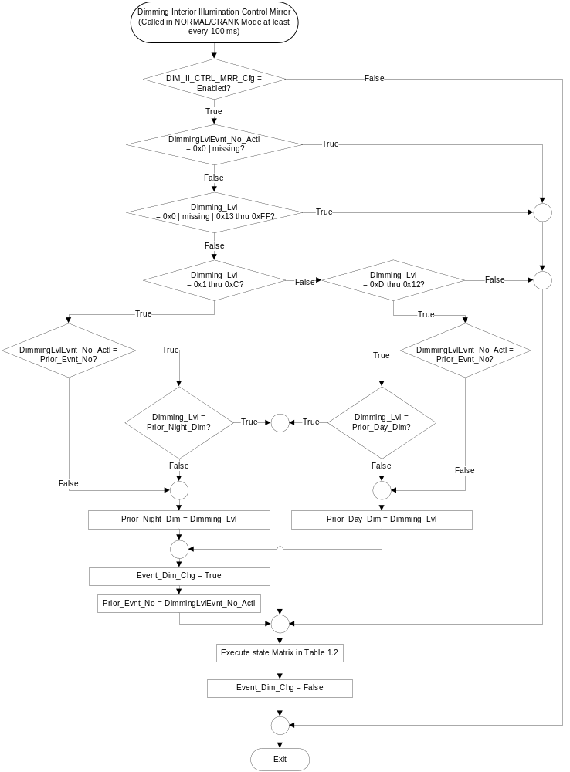

- State Matrix for Night_Dim_CM and Day_Dim_CM
Operational_Mode | Event_Dim_Chg | Dimming_Lvl signal | Night_Dim_CM | Night_Dim_vCM | Day_Dim_CM | Day_Dim_vCM
Normal  or Crank | True | 0x1 – 0xC | Active (0x1) | Dimming_Lvl (0x1-0xC) | Inactive (0x0 | Inactive (0x0)
Normal  or Crank | True | 0xD – 0x12 | Inactive (0x0) | Inactive (0x0) | Active (0x1) | Dimming_Lvl – 0xC (0x1-0x6)
Normal | X | 0x0 | Missing as per 1.4.1 | Inactive (0x0) | Inactive (0x0) | Inactive (0x0) | Inactive (0x0)
All Other Cases |  |  | Inactive (0x0) | Inactive (0x0) | Inactive (0x0) | Inactive (0x0)
Note: Day_Dim_vCM is a subtraction of 0xC from the value of Dimming_Lvl

Operation Description (supports algorithm flowchart /state diagram)

The HMI logic specified in the cluster display logic STSS shall define when to trigger the Dimming Interior Illumination control popups, which should be based upon a request to be displayed.

The logic specified in the Control Mirror Arbitrator STSS shall define the timeout of the popup and any arbitration for requesting the display of the popup, which should be based upon a change in the value of Night_Dim_CM or Day_Dim_CM..

The cluster display logic STSS shall specify the display arbitration when an AHUD is present in the vehicle.

The program specific graphics corresponding to the value of Night_Dim_CM and Day_Dim_CM and their location in the cluster shall be provided by Ford HMI or Studio and approved by the DI Application for each program.

DimmingLvlEvnt_No_Actl is a 2 bit event counter that is incremented at each dim-up and each dim-down button press event only if Dimming_Lvl is not OFF. When Dimming_Lvl = OFF the value will not change. 0x0 is a special value reserved for reset. Any actual event will change the counter to a new non-zero number, where event is a press but not a dimming level change that is a result of a switch hold after the initial press. The Dimming Interior Illumination Control Mirror should only be displayed when there is a button press as indicated by a change in value of DimmingLvlEvnt_No_Actl.

If the lighting changes between Day and Night modes, the Dimming Interior Illumination Control Mirror Displays will not update. They are to only update when the Dimming Button is pressed.

The Dimming Interior Illumination Control Mirror Displays are composed of 12 segments for nighttime and 6 segments for daytime. The left/bottom most segment indicates the lowest lighting level and the right/top most segment indicates the highest lighting level.

A change of Dimming Level due to a hold of the button should result in the same Control Mirror display performance as a press of the button.

Function Safety Classification (EMC)

Class B

Memory Storage
Parameter Name | Description | Value at  Battery Connect | Value at  Module Wake-up
DIM_II_CTRL_MRR_Cfg | EOL Configuration to enable Dimming Interior Illumination Control Mirror display in the IPC. | Use stored value | Use stored value
Day_Dim_CM | Indicates the state of the Day Dim Control Mirror display | 0x0 (Inactive) | 0x0 (Inactive)
Night_Dim_CM | Indicates the state of the Night Dim Control Mirror display | 0x0 (Inactive) | 0x0 (Inactive)
Day_Dim_vCM | Indicates the variable state of the Day Dim Control Mirror display | 0x0 (Inactive) | 0x0 (Inactive)
Night_Dim_vCM | Indicates the variable state of the Night Dim Control Mirror display | 0x0 (Inactive) | 0x0 (Inactive)
Event_Dim_Chg | Used to indicate “Change” Event | False | False
Prior_Day_Dim | Daytime Dimming Level used to determine if latest received value is changed | Off (0x0) | Do Not Init
Prior_Night_Dim | Nighttime Dimming Level used to determine if latest received value is changed | Off (0x0) | Do Not Init
Dimming_Lvl Signal | Input CAN Signal sent | Off (0x0) | Do Not Init
DimmingLvlEvnt_No_Actl Signal | Input CAN Signal sent | (0x0) | Do Not Init
Operational_Mode | 4 state indicator for cluster operational mode | Limited | Limited or Normal  or Crank
Prior_Evnt_No | Dimming Level Event Number from the previous software loop. | 0x0 | Do Not Init

Prove Out
No.

Reconfigurable Telltale

No.

Message Center Msg
None.

Error Handling

Missing Message Strategy

The signals will be declared missing as per the Diagnostics section of this SPSS.

DTCs states and history will be determined as per the Diagnostics section of this SPSS.

Diagnostics

Self Test

None

Engineering Test Mode

Not Applicable

Part II Performance

Supported Diagnostic Trouble Codes (DTCs)
DTC | Description | Condition
C14000 | Lost Communication with Body Control Module (BCM) | Dimming_Lvl Signal OR DimmingLvlEvnt_No_Actl Signal is missing

DID DExx
Bits | State: Description | "0" | "1" | Default | Comments/  Information
1 | Dim II Control Mirror | Disabled | Enabled | Enabled
*Byte and bit location to be identified in Part II Specification for this cluster

Reference Specification

IS-0052 OPERATING VOLTAGES - FUNCTIONAL/PERFORMANCE
IS-0069 FUNCTIONAL IMPORTANCE CLASS
IS-0324 WINDSHIELD & OTHER REFLECTIONS

IL-0017 TELLTALE AND INTERIOR ILLUMINATION – COLOR AND INTENSITY
IL-0019 GENERAL ILLUMINATION DIMMING
IL-0021 CRAFTSMANSHIP – DISPLAYS
IL-0022 GENERAL ILLUMINTATION COLOR
IL-0023 CLARITY/LEGIBILITY/READABILITY/VISUAL CONTRAST
IL -0043 OPERATIONAL ENVIRONMENT FUNCTIONALITY
IL -0045 COLOR
IL -0047 TELLTALE, INDICATOR AND DISPLAY LIGHT INTENSITY
IL -0048 ILLUMINATION ACCEPTABILITY

03-0661 PLACEMENT: CONTROL AND DISPLAY LOCATIONS
03-0662 PLACEMENT: LOGICAL GROUPING FUNCTION AND USAGE
03-0664 PLACEMENT: DOWN VISION TO COMPONENTS WITH HIGH VISUAL DEMAND
03-0665 PLACEMENT: EXPECTED LOCATIONS OF CONTROLS AND DISPLAYS VDS
03-0670 INTERIOR VISIBILITY
03-0671 INTERIOR VISIBILITY: REFLECTIONS FROM COMPONENTS & SURFACES
03-0672 INTERIOR VISIBILITY: REFLECTIONS IN DISPLAYS
03-0673 INTERIOR VISIBILITY: VISUAL OBSCURATIONS
03-0674 INTERIOR VISIBILITY: ILLUMINATION CONTROLS / DISPLAYS
03-0675 INTERIOR VISIBILITY: VEILING GLARE
03-0677 INTERIOR VISIBILITY: SUNLIGHT WASHOUT
03-0681 IDENTIFICATION: CHARACTER AND SYMBOL SIZE
03-0682 IDENTIFICATION: LEGIBILITY
03-0685 IDENTIFICATION: SYMBOLS, ABBREV FOR CONTROL
03-0721 LOGIC OF OPERATION: OPERATIONAL STEREOTYPES
03-0722 LOGIC OF OPERATION: INTERPRETATION
03-0723 LOGIC OF OPERATION: USE OF SYSTEMS WITH VISUAL DISPLAYS

- Control Mirror Arbitrator – CGEA1.3
- Appropriate Message Center Display STSS
- Appropriate Program Specific Text Translation File
- Appropriate Program Specific IPC Menu Structure File
- Appropriate Program Specific Wallpapers

Revision History
SPSS Module Revision History

Revision  Level | Name | Change Description | Date
1.0 | T. Cwik | Initial Release based upon Warning – Dimming Scroll Bar – CGEA1.3_v2.5 | 8/20/2014
2.0 | T. Cwik | Updated to be compatible with the Control Mirror Arbitrator Logic STSS where there is a two state variable for each Control Mirror item.  Section 1.2.1 – Figure 1 – Added Night_Dim_vCM and Day_Dim_vCM  Section 1.2.3 – Added Night_Dim_vCM and Day_Dim_vCM  Section 1.3.3.1.1 added “_Value” in 4 places  Section 1.3.5.1 – Table 1.2 – Updated the Output Columns  Section 1.3.5.2.1 – Rewritten  Section 1.3.5.2.2 – Rewritten  Section 1.3.5.2.3 -- Rewritten  Section 1.3.5.4 – Added Night_Dim_vCM and Day_Dim_vCM  Section 1.6 – Added 5 references | 8/27/2014
3.0 | T. Cwik | This update is due to confusion of how the DimmingLvlEvnt_No_Actl signal changes. The dimming level can change multiple levels if the dimming button is pressed and held. The DimmingLvlEvnt_No_Actl singal only changes when the button is pressed and not when a dimming level change occurs due to a hold of the button. The Control Mirror should display each dimming level change resulting from a button press or hold.  Section 1.3.5.1 –  – Figure 3 – Major rewrite of flowchart  – Table 1.2 – Added “Event_Dim_Chg” columns, corrected two output cells and added a note below the table.  Section 1.3.5.2.5 – Added text of “, where event is a press … initial press.”  Section 1.3.5.2.8 – Added Section  Section 1.5.3.4 – Added Event_Dim_Chg, Prior_Day_Dim and Prior_Night_Dim | 3/23/2015

