- Diesel Exhaust Fluid/AdBlue Level and System Fault Warnings with RTT/Fixed TT – Puma Motor with 1.2x Multiplier Added Back In – 2018.5 U/P375 Specific – CGEA1.3

Functional Description

The purpose of the Diesel Exhaust Fluid Level Warnings with RTT is to inform the vehicle operator that Diesel Exhaust Fluid level is low on diesel vehicles equipped with SCR emissions system.

This feature correlates the VehUreaRnge2_L_DsplyMx signal, UreaLvlTxt_D_RqDsply signal, the UreaQltySys_D_RqDsply, the Display_Units_MC Flag, the DEF Warnings configuration bit, and the Operational Mode to illuminate or extinguish the Diesel Exhaust Fluid Telltale, RTT, message center messages & chime for the specific condition as appropriate.

The Diesel Exhaust Fluid Telltale or RTT shall provide an iconic representation that will illuminate, extinguish to inform the driver of certain DEF system conditions.

This section describes the DEF RTT / Warning / Info Screen function and sets various flags that are used by the Message Center display and Chime Arbitrator (See Message Center Section for details of Message Display Algorithm and Chime arbitrator section).

This feature shall be incorporated on ALL diesel vehicles as per PDL, however, this feature shall be configured OFF for those diesel applications where local market regulations do not require this feature. This feature is not to be implemented on gas engine vehicles.

This STSS adds back in 1.2x multiplier for 2018.5 UP375 PUMA motor that was removed in Diesel Exhaust Fluid/AdBlue Level and System Fault Warnings with RTT/Fixed TT U/P375 Specific – CGEA1.3 v2.0 per direction from powertrain. Per recent discussions with powertrain in 6/9/2017 DI Forum it was identified powertrain decision is to carry forward PUMA ECM to support local market wants, however that ECM only supports 11 bit VehUreaRnge2_L_DsplyMx function. To change the PUMA 11 bit function to the 12 bit function without the 1.2x multiplier was identified to cost significantly more than to modify IPC to add back in the 1.2x multiplier. To meet ECE regrulation a 2400 km range indication must be supported so since the PUMA ECM can only support the 11 bit signal function the 1.2x multiplier must be added back in to the IPC module.

Please note that although only the 11 bit function is supported by the PUMA powerpack the new 12 bit VehUreaRnge2_L_DsplyMx signal will be used for both PUMA and Panther powerpacks.

This STSS is developed from Diesel Exhaust Fluid/AdBlue Level and System Fault Warnings with RTT/Fixed TT U/P375 Specific – CGEA1.3 v1.3 which is the latest version which has the 1.2x multiplier. This direction was approved in 6/15/2017 DI Change Control. Also per 6/15/17 DI Change Control it was agreed to change the repeated warnings for the EU AdBlue STSS from 3 minutes to 5 minutes…..
Important: Per 6/29/17 email from powertrain with Bengtsson, Marcus (M.) and other powertrain representatives it is decided to change the re-occuring warnings to 15 minutes in order to reduce potential TGW and that change is also supported in this release.
Finally, to differentiate from AdBlue Level and System Fault Warnings with RTTorFixed TT EU Specific CGEA1.3 STSS the EOL congiration for this function is updated to 111 for Adblue warning text with 1.2x multiplier and 110 for ARLA32 wanring text with 1.2x multiplier. These values are required to differentiate from the AdBlue and ARLA32 text warnings without the 1.2x multiplier.

Interfaces

Interface Context Diagram (I/O Block Diagram)
Figure 1 Diesel Exhaust Fluid Level Indication
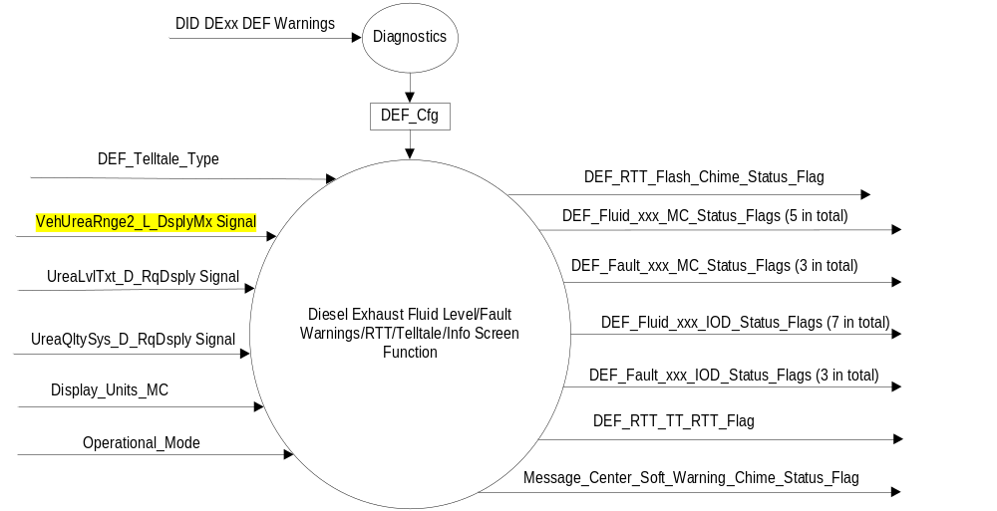

Inputs
      - INTERNAL:
    - Operational_Mode
    - DEF_Telltale_Type

      - MUX From ECU

- VehUreaRnge2_L_DsplyMx Signal
Signal Name | Size  (bits) | Detail | Units | Res. | Offset | State Encoded | Min. | Max.
VehUreaRnge2_L_DsplyMx | 12 |  | km/h | 1 | 0 |  | 0 (0x0) | 2047 (0x7FF)

- UreaLvlTxt_D_RqDsply Signal
Signal Name | Size  (bits) | Detail | Units | Res. | Offset | State Encoded | Min. | Max.
UreaLvlTxt_D  _RqDsply | 4 |  | Unitless | 1 | 0 |  | 0 (0x0) | 15(0xF)
 |  | Over_Half_Full |  |  |  | 0x0
 |  | Under_Half_Full |  |  |  | 0x1
 |  | Range_XX_miles |  |  |  | 0x2
 |  | Range_X_miles |  |  |  | 0x3
 |  | SpdLmt_Y_MPH_Low |  |  |  | 0x4
 |  | Y_MPH_MAX_ON_restart |  |  |  | 0x5
 |  | SpdLmt_Y_MPH_Empty |  |  |  | 0x6
 |  | MaxMPH_Y_ON_restart |  |  |  | 0x7
 |  | SpdLmt_Y_MPH_XMiles |  |  |  | 0x8
 |  | Eng_Idled_on_refuel |  |  |  | 0x9
 |  | Eng_Idles_on_Manual |  |  |  | 0xA
 |  | ZZ Overides available upon Restart |  |  |  | 0xB
 |  | SystemError |  |  |  | 0xC
 |  | Undefined |  |  |  | 0xD–0xF

- UreaQltySys_D_RqDsply
Signal Name | Size  (bits) | Detail | Units | Res. | Offset | State Encoded | Min. | Max.
UreaQltySys_D  _RqDsply | 3 |  | Unitless | 1 | 0 |  | 0 (0x0) | 15(0xF)
 |  | No quality problem or system error |  |  |  | 0x0
 |  | CONTAMINATED exhaust fluid, SPEED LIMITED YY mph in XX mi |  |  |  | 0x1
 |  | YY MPH MAX UPON upon restart, contaminated exhaust fluid |  |  |  | 0x2
 |  | SPEED LIMITED to YY mph, contaminated exhaust fluid |  |  |  | 0x3
 |  | ENGINE IDLE UPON REFUEL, contaminated exhaust fluid |  |  |  | 0x4
 |  | ENGINE IDLED see manual |  |  |  | 0x5
 |  | ZZ OVERRIDES available upon restart |  |  |  | 0x6
 |  | Not used |  |  |  | 0x7

Output
MC Status Flags
- DEF_Fluid_Low_mi_MC_Status_Flag, which is used to control the Warning.
- DEF_Fluid_ Low_km_MC_Status_Flag, which is used to control the Warning.
- DEF_Fluid_VeryLow_mi_MC_Status_Flag, which is used to control the Warning.
- DEF_Fluid_VeryLow_km_MC_Status_Flag, which is used to control the Warning.
- DEF_Fluid_Empty_NoRestart_EngineIdled_MC_Status_Flag, which is used to control the Warning.
- DEF_Fault_NoRestart_EngineIdled_mi_MC_Status_Flag, which is used to control the Warning.
- DEF_Fault_NoRestart_EngineIdled_km_MC_Status_Flag, which is used to control the Warning.
- DEF_Fault_NoRestart_EngineIdled_MC_Status_Flag, which is used to control the Warning.
- Message_Center_Soft_Warning_Chime_Status_Flag, which is used to control the state of the chime to the Chime Arbitrator.
- DEF_RTT_Flash_Chime_Status_Flag, which is used to control the state of the chime to the Chime Arbitrator.

Information On Demand Status Flags:
- DEF_Fluid_Ok_IOD_Status_Flag, which is used to control the Info Screen.
- DEF_Fluid_UnderHalf_IOD_Status_Flag, which is used to control the Info Screen.
- DEF_Fluid_Low_mi_ IOD_Status_Flag, which is used to control the Info Screen.
- DEF_Fluid_ Low_km_IOD_Status_Flag, which is used to control the Info Screen.
- DEF_Fluid_VeryLow_mi_IOD_Status_Flag, which is used to control the Warning Info Screen.
- DEF_Fluid_VeryLow_km_IOD_Status_Flag, which is used to control the Warning Info Screen.
- DEF_Fluid_Empty_NoRestart_EngineIdled_IOD_Status_Flag, which is used to control the Info Screen.
- DEF_Fault_NoRestart_EngineIdled_mi_IOD_Status_Flag, which is used to control the Info Screen.
- DEF_Fault_NoRestart_EngineIdled_km_IOD_Status_Flag, which is used to control the Info Screen.
- DEF_Fault_NoRestart_EngineIdled_IOD_Status_Flag, which is used to control the Info Screen.

RTT Flag
- DEF_RTT_TT_ Flag, which is used to control the state of the RTT/Fixed LED Telltale and is also used as an input to certain warnings in this section. This flag controls either the RTT or Fixed LED Telltale as equipped.

Function/Performance

Operational Modes

Mode | Differentiating Vehicle Conditions
Sleep Mode | Diesel Exhaust Fluid Level Warnings w/RTT/TT Off
Limited Mode | Diesel Exhaust Fluid Level Warnings w/RTT/TT Off
Normal Mode | Diesel Exhaust Fluid Level Warnings w/RTT/TT On / Off
Crank Mode | Diesel Exhaust Fluid Level Warnings w/RTT/TT On / Off

The above table references the setting of the Warning flag as per this section. However, the
actual warning display operational modes are displayed in the Message Center section of this SPSS.

Voltage Levels

Refer to the Cluster Features Table located in the Operational Modes and Voltage Range
Strategies Section of this SPSS.

Human-Machine Interface

Visual

Indicator Graphics / Display Format

For actual symbol definition refer to database # F.27 of the 03-0685 ARL requirement

1.3.3.1.2 Indicator Color Coordinates

Reference section COLOR & ILLUMINATION REQUIREMENTS (GRAPHICS).

Audio

- As Per Table 1.7 and Figure 2 below.

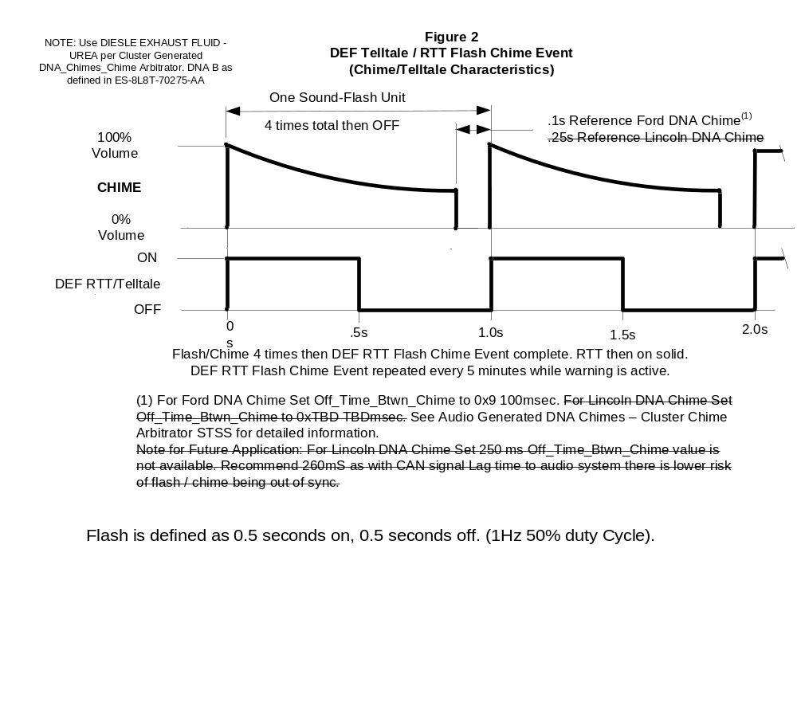

Switch Control Logic

None.

System Accuracy

All Diesel Exhaust Fluid flags shall change within 100msec of a state change as indicated in the state matrix reference 1.3.5.1 Subsystem Algorithm Flowchart/ State Diagram.

Conversions to metric display values shall be as follows:
English Distance (miles) = Metric distance (km) / 1.60934
English speed (MPH) = Metric speed (km/h) / 1.60934

English message text variables are denoted by capitol X or capitol Y. Metric text variables are denoted by lower case x or lower case y. This matches message text list for this feature.

Operation: Performance and Functional

Subsystem Algorithm Flowchart / State Diagram

Figure 3: DID DExx

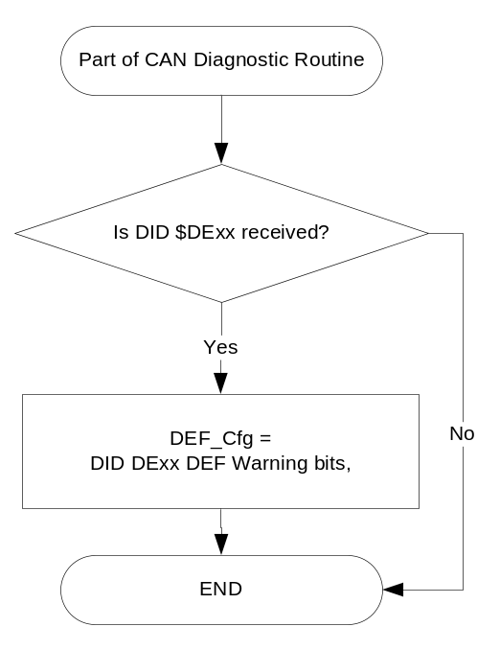

- State Matrix for DEF / AdBlue Fixed LED Telltale
Operational  _Mode | DEF_Telltale_Type | DEF_Cfg | ETM_Bulb  _Check_State |  | DIAG_SESSION_TIMER | Self_Test_Entry _Bulb  _Check_ Timer | DIAG_DID_  61A5,4,6  (all warning lamps) | DEF_RTT_TT_Flag
Normal or Crank | Fixed_LED  (0x0) | != Disabled |  | OFF (0x0) | Active | Active | X | On
Normal or Crank | Fixed_LED  (0x0) | != Disabled |  | OFF (0x0) | Active | X | Active | On
Normal or Crank | Fixed_LED  (0x0) | != Disabled |  | ON(0x1) | Not Active | X | X | On
All Other Cases |  |  |  |  |  |  |  | As Per Figure 4

- DEF_Telltale_Type Internal Bit
DEF_Telltale_Type | DEF Telltale | DEF RTT
Fixed_LED (0x0) | On, Off, Flash as per DEF_RTT_TT_Flag | Off
RTT (0x1) | Off | On, Off, Flash as per DEF_RTT_TT_Flag

Figure 4 DEF RTT / DEF TT: Off, On, Flash - Chime Event Control

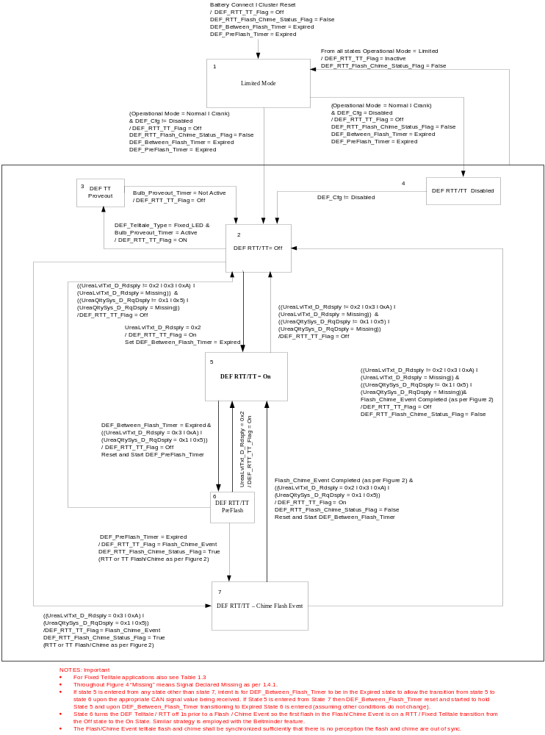

- State Matrix for DEF Level/Fault Warning Flags
Operatinal Mode | Display_Units_MC | UreaLvlTxt_D_RqDsply Signal | UreaQltySys_D_RqDsply | DEF_RTT_TT_ Flag | DEF_Fluid_Low_mi_MC_Status_Flag | DEF_Fluid_ Low_km_MC_Status_Flag | DEF_Fluid_VeryLow_mi_MC_Status_Flag | DEF_Fluid_VeryLow_km_MC_Status_Flag | DEF_Fluid_Empty_NoRestart_EngineIdled_MC_Status_Flag | DEF_Fault_NoRestart_EngineIdled_ mi_MC_Status_Flag | DEF_Fault_NoRestart_EngineIdled_ km_MC_Status_Flag | DEF_Fault_NoRestart_EngineIdled_MC_Status_Flag
Normal or Crank | English (0x0 I 0x1) | (0x2) | 0x0 | X | A | I | I | I | I | I | I | I
Normal or Crank | Metric (0x2 I 0x3) | (0x2) | 0x0 | X | I | A | I | I | I | I | I | I
Normal or Crank | English (0x0 I 0x1) | (0x3) | 0x0 | F | I | I | A | I | I | I | I | I
Normal or Crank | Metric (0x2 I 0x3) | (0x3) | 0x0 | F | I | I | I | A | I | I | I | I
Normal or Crank | X | (0xA) | 0x0 | F | I | I | I | I | A | I | I | I
Normal or Crank | English (0x0 I 0x1) | X | 0x1 | F | I | I | I | I | I | A | I | I
Normal or Crank | Metric (0x2 I 0x3) | X | 0x1 | F | I | I | I | I | I | I | A | I
Normal or Crank | X | X | 0x5 | F | I | I | I | I | I | I | I | A
All Other Cases |  |  |  |  | I | I | I | I | I | I | I | I

I = Inactive, A = Active

F = DEF_RTT_TT_Flag set to Flash_Chime_Event as per Figure 4

X = Don’t Care

- State Matrix for DEF Level/Fault IOD Flags
Operatinal Mode | Display_Units_MC | UreaLvlTxt_D_RqDsply Signal | UreaQltySys_D_RqDsply | DEF_Fluid_Ok_IOD_Status_Flag | DEF_Fluid_UnderHalf_IOD_Status_Flag | DEF_Fluid_Low_mi_ IOD _Status_Flag | DEF_Fluid_ Low_km_ IOD _Status_Flag | DEF_Fluid_VeryLow_mi_ IOD _Status_Flag | DEF_Fluid_VeryLow_km_IOD_Status_Flag | DEF_Fluid_Empty_NoRestart_EngineIdled_ IOD _Status_Flag | DEF_Fault_NoRestart_EngineIdled_ mi_ IOD _Status_Flag | DEF_Fault_NoRestart_EngineIdled_ km_ IOD _Status_Flag | DEF_Fault_NoRestart_EngineIdled_ IOD _Status_Flag
Normal or Crank | X | (0x0) | 0x0 | A | I | I | I | I | I | I | I | I | I
Normal or Crank | X | (0x1) | 0x0 | I | A | I | I | I | I | I | I | I | I
Normal or Crank | English (0x0 I 0x1) | (0x2) | 0x0 | I | I | A | I | I | I | I | I | I | I
Normal or Crank | Metric (0x2 I 0x3) | (0x2) | 0x0 | I | I | I | A | I | I | I | I | I | I
Normal or Crank | English (0x0 I 0x1) | (0x3) | 0x0 | I | I | I | I | A | I | I | I | I | I
Normal or Crank | Metric (0x2 I 0x3) | (0x3) | 0x0 | I | I | I | I | I | A | I | I | I | I
Normal or Crank | X | (0xA) | 0x0 | I | I | I | I | I | I | A | I | I | I
Normal or Crank | English (0x0 I 0x1) | X | 0x1 | I | I | I | I | I | I | I | A | I | I
Normal or Crank | Metric (0x2 I 0x3) | X | 0x1 | I | I | I | I | I | I | I | I | A | I
Normal or Crank | X | X | 0x5 | I | I | I | I | I | I | I | I | I | A
All Other Cases |  |  |  | Blank Screen As Per HMI

- MC Status Flag to MC Warning Message ID
DEF_Cfg | Active MC_Status_Flag | W# | Active Chime_Status_Flag | Ref Text | Message variable values
Disabled | X | None | None |  | Fixed Telltale, RTT, Warnings Message are not active and Info Screens are not Present
111 | DEF_Fluid_Low_mi_MC_Status_Flag | W3264 | Message_Center_  Soft_Warning_  Chime_Status_Flag | AdBlue® Low  Range XXXX mi  Refill Soon | XXXX = VehUreaRnge2_L_DsplyMx (value/1.60934)*1.2
111 | DEF_Fluid_ Low_km_MC_Status_Flag | W3265 | Message_Center_  Soft_Warning_  Chime_Status_Flag | AdBlue® Low  Range xxxx km  Refill Soon | xxxx = VehUreaRnge2_L_DsplyMx (value)*1.2
111 | DEF_Fluid_VeryLow_mi_MC_Status_Flag | W3266 | DEF_RTT_Flash_  Chime_Status_Flag Per Figure 2 | AdBlue® Low  No engine start  in XXXX mi | XXXX = VehUreaRnge2_L_DsplyMx (value/1.60934)*1.2
111 | DEF_Fluid_VeryLow_km_MC_Status_Flag | W3267 | DEF_RTT_Flash_  Chime_Status_Flag Per Figure 2 | AdBlue® Low  No engine start  in xxxx km | xxxx = VehUreaRnge2_L_DsplyMx (value)*1.2
111 | DEF_Fluid_Empty_NoRestart_EngineIdled_MC_Status_Flag | W3268 | DEF_RTT_Flash_  Chime_Status_Flag Per Figure 2 | AdBlue® Level Empty.  Refill to Start Engine
111 | DEF_Fault_NoRestart_EngineIdled_ mi_MC_Status_Flag | W3269 &  W3270 | DEF_RTT_Flash_  Chime_Status_Flag Per Figure 2 | AdBlue®sys Malfunction  Service req’d  Then  AdBlue®sys  No engine start in XXXX mi | XXXX = VehUreaRnge2_L_DsplyMx (value/1.60934)*1.2
111 | DEF_Fault_NoRestart_EngineIdled_ km_MC_Status_Flag | W3269  &  W3271 | DEF_RTT_Flash_  Chime_Status_Flag Per Figure 2 | AdBlue®sys Malfunction  Service req’d  Then  AdBlue®sys  No engine start in xxxx km | xxxx = VehUreaRnge2_L_DsplyMx (value)*1.2
111 | DEF_Fault_NoRestart_EngineIdled_MC_Status_Flag | W3272 | DEF_RTT_Flash_  Chime_Status_Flag Per Figure 2 | AdBlue®sys  Service req’d to start engine
110 | DEF_Fluid_Low_mi_MC_Status_Flag | W3304 | Message_Center_  Soft_Warning_  Chime_Status_Flag | ARNOX32 low  Range  XXXX mi | XXXX = VehUreaRnge2_L_DsplyMx (value/1.60934)*1.2
110 | DEF_Fluid_ Low_km_MC_Status_Flag | W3305 | Message_Center_  Soft_Warning_  Chime_Status_Flag | ARNOX32 low  Range xxxx km  Refill Soon | xxxx = VehUreaRnge2_L_DsplyMx (value)*1.2
110 | DEF_Fluid_VeryLow_mi_MC_Status_Flag | W3306 | DEF_RTT_Flash_  Chime_Status_Flag Per Figure 2 | ARNOX32 low  No engine start  in XXXX mi | XXXX = VehUreaRnge2_L_DsplyMx (value/1.60934)*1.2
110 | DEF_Fluid_VeryLow_km_MC_Status_Flag | W3307 | DEF_RTT_Flash_  Chime_Status_Flag Per Figure 2 | ARNOX32 low  No engine start  in xxxx km | xxxx = VehUreaRnge2_L_DsplyMx (value)*1.2
110 | DEF_Fluid_Empty_NoRestart_EngineIdled_MC_Status_Flag | W3308 | DEF_RTT_Flash_  Chime_Status_Flag Per Figure 2 | ARNOX32 level  empty. Refill to  start engine
110 | DEF_Fault_NoRestart_EngineIdled_ mi_MC_Status_Flag | W3309  & W3310 | DEF_RTT_Flash_  Chime_Status_Flag Per Figure 2 | ARNOX32 sys  Fault  Service req'd  Then  ARNOX32 sys  No engine start  in XXXX mi | XXXX = VehUreaRnge2_L_DsplyMx (value/1.60934)*1.2
110 | DEF_Fault_NoRestart_EngineIdled_ km_MC_Status_Flag | W3309 & W3311 | DEF_RTT_Flash_  Chime_Status_Flag Per Figure 2 | ARNOX32 sys  Fault  Service req’d  Then  ARNOX32 sys  No engine start  in xxxx km | xxxx = VehUreaRnge2_L_DsplyMx (value)*1.2
110 | DEF_Fault_NoRestart_EngineIdled_MC_Status_Flag | W3312 | DEF_RTT_Flash_  Chime_Status_Flag Per Figure 2 | ARNOX32 sys  Service req'd  to start engine

Notes to Table 1.6:
- Text is REFERENCE ONLY to aid applications engineer understand the function of this system. See the Global Text Message List for apprvoved message text. Advise Ford Driver Info Core Group of any mis-match.
- All decimal values are truncated.
- Expected behavior W3269 and W3270 upon DEF_Fault_NoRestart_or_EngineIdled_ mi_MC_Status_Flag becoming active: W3269 displayes for 2s then W3270 displays for 4s (TA timeout) then W3269 displays for 4s (TA Timeout) for 10s to duration of message texts. This behavior is as per message manager and TA warning message definition. This note applies to all cases where multiple TA warnings are triggered off the same MC_Status_Flag.
- The Info Screens shall not cycle multiple warnings. Only one text per Table 1.5 is shown.
- No chimes are associated with the Info Screens. For the MC Soft Warning the chime is tied to the warning message. For the DEF Telltale / RTT Flash Chime Event the chime is synchronized to the Telltale / RTT flash transition from Off to On.

- IOD Status Flag to Ixxx Number
DEF_Cfg | Active MC_Status_Flag | Iod # | Ref Text | Message variable values
Disabled | X | None |  | Fixed Telltale, RTT, Warnings Message are not active and Info Screens are not Present
111 | DEF_Fluid_Ok_IOD_Status_Flag | I523 | AdBlue® Level Ok
111 | DEF_Fluid_UnderHalf_IOD_Status_Flag | I524 | AdBlue® Level Under ½ Full
111 | DEF_Fluid_Low_mi_IOD_Status_Flag | I525 | AdBlue® Low  Range XXXX mi  Refill Soon | XXXX = VehUreaRnge2_L_DsplyMx (value/1.60934)*1.2
111 | DEF_Fluid_ Low_km_IOD_Status_Flag | I526 | AdBlue® Low  Range xxxx km  Refill Soon | xxxx = VehUreaRnge2_L_DsplyMx (value)*1.2
111 | DEF_Fluid_VeryLow_mi_IOD_Status_Flag | I527 | AdBlue® Low  No engine start  in XXX mi | XXXX = VehUreaRnge2_L_DsplyMx (value/1.60934)*1.2
111 | DEF_Fluid_VeryLow_km_IOD_Status_Flag | I528 | AdBlue® Low  No engine start  in xxxx km | xxxx = VehUreaRnge2_L_DsplyMx (value)*1.2
111 | DEF_Fluid_Empty_NoRestart_EngineIdled_IOD_Status_Flag | I529 | AdBlue® Level Empty.  Refill to Start Engine
111 | DEF_Fault_NoRestart_EngineIdled_ mi_IOD_Status_Flag | I531 | AdBlue® sys  No engine start  in XXXX mi | XXXX = VehUreaRnge2_L_DsplyMx (value/1.60934)*1.2
111 | DEF_Fault_NoRestart_EngineIdled_ km_IOD_Status_Flag | I532 | AdBlue® sys  No engine start  in XXXX km | xxxx = VehUreaRnge2_L_DsplyMx (value)*1.2
111 | DEF_Fault_NoRestart_EngineIdled_IOD_Status_Flag | I533 | AdBlue®sys  Service req’d to start engine
110 | DEF_Fluid_Ok_IOD_MC_Status_Flag | I540 | ARNOX32 Level  OK
110 | DEF_Fluid_UnderHalf_IOD_MC_Status_Flag | I541 | ARNOX32 Level  Under 1/2 Full
110 | DEF_Fluid_Low_mi_IDO_Status_Flag | I542 | ARNOX32 low  Range  XXXX mi | XXXX = VehUreaRnge2_L_DsplyMx (value/1.60934)*1.2
110 | DEF_Fluid_ Low_km_IOD_Status_Flag | I543 | ARNOX32 low  Range xxxx km  Refill Soon | xxxx = VehUreaRnge2_L_DsplyMx (value)*1.2
110 | DEF_Fluid_VeryLow_mi_IOD_Status_Flag | I544 | ARNOX32 low  No engine start  in XXX mi | XXXX = VehUreaRnge2_L_DsplyMx (value/1.60934)*1.2
110 | DEF_Fluid_VeryLow_km_IOD_Status_Flag | I545 | ARNOX32 low  No engine start  in xxxx km | xxxx = VehUreaRnge2_L_DsplyMx (value)*1.2
110 | DEF_Fluid_Empty_NoRestart_EngineIdled_IOD_Status_Flag | I546 | ARNOX32 level  empty. Refill to  start engine
110 | DEF_Fault_NoRestart_EngineIdled_ mi_IOD_Status_Flag | I548 | ARNOX32 sys  No engine start  in XXXX mi | XXXX = VehUreaRnge2_L_DsplyMx (value/1.60934)*1.2
110 | DEF_Fault_NoRestart_EngineIdled_ km_IOD_Status_Flag | I549 | ARNOX32 sys  No engine start  in XXXX km | xxxx = VehUreaRnge2_L_DsplyMx (value)*1.2
110 | DEF_Fault_NoRestart_EngineIdled_IOD_Status_Flag | I550 | ARNOX32 sys  Service req'd  to start engine
Notes to Table 1.6:
- Text is REFERENCE ONLY to aid applications engineer understand the function of this system. See the Global Text Message List for apprvoved message text. Advise Ford Driver Info Core Group of any mis-match.
- No chimes are associated with the IOD display.
- All decimal values are truncated.

Operation Description (supports algorithm flowchart /state diagram)
- This feature shall be incorporated on ALL diesel vehicles as per Powertrain direction, however, this feature shall be configured OFF for those diesel applications where local market regulations do not require this feature. This feature is not to be implemented on gas engine vehicles.
- For definition of how the Message Center arbitrates and displays Active warnings, see the Warning / Alert Display Logic Diagram, located in the Message Center – X Display with W Button Interface section of this SPSS (where X and W are appropriate values in this document).
- FNA uses DEF text messages and North American DEF Symbol. This STSS to be updated in the future with North American Strategy.
- EU uses AdBlue Text and AdBlue Symbol. This STSS to be updated in the future with EU strategy.
- FoA uses AdBlue Text and North American symbol.
- FSA Chilie/Argentine markets use ARNOX32 Text and North American DEF symbol.
- If DEF_Telltale_Type = Fixed_LED then DEF_RTT_TT_Flag maps to a fixed LED DEF Telltale. If DEF_Telltale_Type = RTT then DEF_RTT_TT_Flag maps to a DEF RTT.

      - Function Safety Classification (EMC)

Class B

Memory Storage
Parameter Name | Description | Value at  Battery Connect | Value at  Module Wake-up
DEF_Fluid_Low_mi_MC_Status_Flag | Used to control the state of the warning to the Message Center arbitrator | Inactive | Inactive
DEF_Fluid_Low_km_MC_Status_Flag | Used to control the state of the warning to the Message Center arbitrator | Inactive | Inactive
DEF_Fluid_VeryLow_mi_MC_Status_Flag | Used to control the state of the warning to the Message Center arbitrator | Inactive | Inactive
DEF_Fluid_VeryLow_km_MC_Status_Flag | Used to control the state of the warning to the Message Center arbitrator | Inactive | Inactive
DEF_Fluid_Empty_NoRestart_EngineIdled_MC_Status_Flag | Used to control the state of the warning to the Message Center arbitrator | Inactive | Inactive
DEF_Fault_NoRestart_or_EngineIdled_mi_MC_Status_Flag | Used to control the state of the warning to the Message Center arbitrator | Inactive | Inactive
DEF_Fault_NoRestart_EngineIdled_km_MC_Status_Flag | Used to control the state of the warning to the Message Center arbitrator | Inactive | Inactive
DEF_Fault_NoRestart_EngineIdled_MC_Status_Flag | Used to control the state of the warning to the Message Center arbitrator | Inactive | Inactive
DEF_Fluid_Ok_IOD_Status_Flag | Used to control the state of the DEF Info Screen | Inactive | Inactive
DEF_Fluid_UnderHalf_IOD_Status_Flag | Used to control the state of the DEF Info Screen | Inactive | Inactive
DEF_Fluid_Low_mi_IOD_Status_Flag | Used to control the state of the DEF Info Screen | Inactive | Inactive
DEF_Fluid_Low_km_IOD_Status_Flag | Used to control the state of the DEF Info Screen | Inactive | Inactive
DEF_Fluid_VeryLow_mi_IOD_Status_Flag | Used to control the state of the DEF Info Screen | Inactive | Inactive
DEF_Fluid_VeryLow_km_IOD_Status_Flag | Used to control the state of the DEF Info Screen | Inactive | Inactive
DEF_Fluid_Empty_NoRestart_EngineIdled_IOD_Status_Flag | Used to control the state of the DEF Info Screen | Inactive | Inactive
DEF_Fault_NoRestart_EngineIdled_mi_IOD_Status_Flag | Used to control the state of the DEF Info Screen | Inactive | Inactive
DEF_Fault_NoRestart_EngineIdled_km_IOD_Status_Flag | Used to control the state of the DEF Info Screen | Inactive | Inactive
DEF_Fault_NoRestart_EngineIdled_IOD_Status_Flag | Used to control the state of the DEF Info Screen | Inactive | Inactive
DEF_RTT_Flash_Chime_Status_Flag | Used to control the state of the chime to the Chime Arbitrator | Inactive | Inactive
Message_Center_Soft_Warning_Chime_Status_Flag | Used to control the state of the chime to the Chime Arbitrator | Inactive | Inactive
DEF_RTT_TT_Flag | Flag used to control the state of the DEF RTT or TT as equipped. Also input used to enable the re-occurring TA warnings.  States: Off, On, Flash_Chime_Event | Off | Off
DEF_RTT_Flash_Chime_Status_Flag | A state indicator to determine if DIESEL EXHAUST FLUID – UREA chime shall sound in sync with flashing Diesel Exhaust Fluid telltale. | See Audio Generated DNA Chimes – Cluster Chime Arbitrator latest level.
DEF_Telltale_Type | Internal supplier bit that defines type of telltale used. States: Fixed_LED (0x0), RTT (0x1). | Use Stored Value | Use Stored Value
VehUreaRnge2_L_DsplyMx signal | CAN signal sent from the ECM | 0 (0x0) | 0 (0x0)
UreaLvlTxt_D_RqDsply signal | CAN signal sent from the ECM | 0 (0x0) | 0 (0x0)
UreaQltySys_D_RqDsply | CAN signal sent from the ECM | 0 (0x0) | 0 (0x0)
Display_Units_MC | Flag used to indicate English or Metric unit choice. See Display Unit Selection Control Function STSS.
DEF_Cfg | Encoded indicator of feature presence and local market function controlled via CAN at EOL at VO plant. | Use Stored Value | Use Stored Value
Operational_Mode | 4 state indicator for cluster operational mode. | Limited | Limited, Normal, or Crank
Bulb_Provout_Timer | Timer used to control Bulb (telltale) Proveout. States: Not Active or Active | See Bulb Prove Out Function STSS
DEF_Between_Flash_Timer | Timer used to control Flash_Chime_Events and display of TA warnings. | As Per Figure 4
DEF_PreFlash_Timer | Timer used to turn off the DEF telltale 1s prior to a Flash_Chime_Event | As Per Figure 4

Parameter Name | Description | Range | Units | Resolution | Init Value
DEF_Between_Flash_Timer | Timer used as an input to control the DEF_RTT_TT_Flag | 1 – 20 | Minutes | 1 | 15
DEF_PreFlash_Timer | Timer used as an input to control the DEF_RTT_TT_Flag | N/A | Seconds | N/A | 1
DEF_PreFlash_Timer matches current practice Beltminder value.

Prove Out
Fixed LED Telltale - Yes
RTT - No

Reconfigurable Telltale

Fixed or RTT

Message Center Msg

See Table 1.5

Error Handling

Missing Message Strategy

The signals will be declared missing as per the Diagnostics section of this SPSS.

DTCs states and history will be determined as per the Diagnostics section of this SPSS.

Diagnostics

Self Test

None

Engineering Test Mode

Fixed Telltale illumination only as per Table 1.3

Part II Performance

DID $DExx:
Block  Num | Block Description | Byte(s) | Bits | State: Description | "0" | "1" | Default | Comments/  Information
PACKETED BLOCKS
$00 | Option  Content (B&A) | * | * | DEF Warnings | encoded | encoded | 000 | Not Dealer Configurable
 |  |  |  | 000– Disabled | encoded | encoded
 |  |  |  | 001 – AdBlueTxt / DEF Telltale | encoded | encoded |  | FoA and other Far East Markets
 |  |  |  | 010 – ARNOX32 Txt / DEF Telltale | encoded | encoded |  | Chile, Argentina
 |  |  |  | 011 – AdBlue Txt / AdBlue Telltale | encoded | encoded |  | EU Markets Future Applications. Software to be treated as 000
 |  |  |  | 100 – DEF Text / DEF Telltale | encoded | encoded |  | U.S., Canada, Mexico  Future Applications Software to be treated as 000
 |  |  |  | 110 - ANOX32Txt/DEF Telltale with 1.2x Multiplier | encoded | encoded |  | PUMA powertrain which requires 1.2x multiplier and ARLA32 text. 2018.5 UP375.
 |  |  |  | 111 – AdBlue Txt/DEF Telltale with 1.2x Multiplier | encoded | encoded |  | PUMA powertrain whch require 1.2x multiplier. 2018.5 UP375..
*Byte and bit location to be identified in Part II Specification for this cluster

Reference Specification

IS-0001 WARNINGS/INDICATORS/DISPLAYS PROVEOUT
IS-0052 OPERATING VOLTAGES - FUNCTIONAL/PERFORMANCE
IS-0069 FUNCTIONAL IMPORTANCE CLASS
IS-0324 WINDSHIELD & OTHER REFLECTIONS
IS-0327 WARNING INDICATOR EVALUATION
IS-0379 NORTH AMERICAN WARNINGS AND INDICATORS STRATEGY

IL-0017 TELLTALE AND INTERIOR ILLUMINATION – COLOR AND INTENSITY
IL-0019 GENERAL ILLUMINATION DIMMING
IL-0021 CRAFTSMANSHIP – DISPLAYS
IL-0022 GENERAL ILLUMINTATION COLOR
IL-0023 CLARITY/LEGIBILITY/READABILITY/VISUAL CONTRAST
IL -0043 OPERATIONAL ENVIRONMENT FUNCTIONALITY
IL -0045 COLOR
IL -0047 TELLTALE, INDICATOR AND DISPLAY LIGHT INTENSITY
IL -0048 ILLUMINATION ACCEPTABILITY

03-0661 PLACEMENT: CONTROL AND DISPLAY LOCATIONS
03-0662 PLACEMENT: LOGICAL GROUPING FUNCTION AND USAGE
03-0664 PLACEMENT: DOWN VISION TO COMPONENTS WITH HIGH VISUAL DEMAND
03-0665 PLACEMENT: EXPECTED LOCATIONS OF CONTROLS AND DISPLAYS VDS
03-0670 INTERIOR VISIBILITY
03-0671 INTERIOR VISIBILITY: REFLECTIONS FROM COMPONENTS & SURFACES
03-0672 INTERIOR VISIBILITY: REFLECTIONS IN DISPLAYS
03-0673 INTERIOR VISIBILITY: VISUAL OBSCURATIONS
03-0674 INTERIOR VISIBILITY: ILLUMINATION CONTROLS / DISPLAYS
03-0675 INTERIOR VISIBILITY: VEILING GLARE
03-0677 INTERIOR VISIBILITY: SUNLIGHT WASHOUT
03-0681 IDENTIFICATION: CHARACTER AND SYMBOL SIZE
03-0682 IDENTIFICATION: LEGIBILITY
03-0685 IDENTIFICATION: SYMBOLS, ABBREV FOR CONTROL
03-0721 LOGIC OF OPERATION: OPERATIONAL STEREOTYPES
03-0722 LOGIC OF OPERATION: INTERPRETATION
03-0723 LOGIC OF OPERATION: USE OF SYSTEMS WITH VISUAL DISPLAYS

Revision History
SPSS Module Revision History

Revision Level | Name | Change Description | Date
1.3 | ilopez | This Update is to inform which Chime Status Flag is associated with this warning (all changes are highlighted in light blue)  Section 1.2.1 Figure 1 Added - Message_Center_Soft_Warning_Chime_Status_Flag and DEF_RTT_Flash_Chime_Status_Flag  Section 1.2.3 Added- Message_Center_Soft_Warning_Chime_Status_Flag and DEF_RTT_Flash_Chime_Status_Flag and their description.  Section 1.3.3.2  Replaced Table Reference: Table 1.5 with Table 1.7 since this table contains MC Warning IDs and Chime_Status_Flag associated with this this STSS.  Section 1.3.5 Updated Table 1.7  - Changed colum’s title from “Chime” to “Active Chime_Status_Flag”  - Replaced “Soft Warning” with “Message_Center_Soft_Warning_Chime_Status_Flag”  - Add DEF_RTT_Flash_Chime_Status_Flag  Section 1.3.5.4 Added Message_Center_Soft_Warning_Chime_Status_Flag and DEF_RTT_Flash_Chime_Status_Flag to Memory Storage Table. | 1/13/2016
1.0 | J.Blatchford | This update is developed from Diesel Exhaust Fluid/AdBlue Level and System Fault Warnings with RTT/Fixed TT U/P375 Specific – CGEA1.3 v1.3 so as to add back in the DEF range signal 1.2x multiplier previously removed. Please see 1.1 Functional description for a detailed explanation of this change. Change log for v1.3 of referenced STSS is included. Changes highlighted in yellow. | 7/12/17

