Visual, Digital Enigma
Mike Johnson and Matthew Bennett
CSC 592 / Special Topics: Cryptography

This project presents an object oriented implementation of the enigma cryptographic device used by the Axis powers in World War Two. Additionally, a windows-only visual representation of the machine's state is provided. The enigma class may be used with or without the 3d graphics visual component.

The class is designed to be used as a "black box". No information is provided in the interface about the internal workings of the machine.

HISTORY

The enigma is a mechanical device consisting of a keyboard, a series of cypher disks, a special disk known as a reflector, a printer, and a plugboard. The disks each represent a full non-idempotent permutation of the alphabet. Each disks performs a permutation cypher, and the entire machine represents a multi-stage permutation cypher. The stream is entered one character at a time via the keypad. The initial state of the machine is determined by a secret key the same length as the number of disks. Each disk begins rotated into place of that character. After a character is encoded, the disks advance in some deterministic fashion so that the permutation cypher of the machine changes.

USAGE

Be sure to include the header file.

#include "enigma.h"
//place the header files in your include directory

enigma MyEnigma("rotor_file_name.txt");

MyEnigma.setkey("drowssap");

char [10] cyphertext = MyEnigma.encode("Secret Message");

The result can be checked by creating another machine with identical state and passing the ciphertext in. This is because the enigma cypher is symmetric.

enigma YourEnigma("rotor_file_name.txt");

YourEnigma.setkey("drowssap");

char [10] plaintext = YourEnigma.encode(cyphertext);

The plugboard is provided as part of the enigma reference implementation. This swaps any set of letter-pairs as the characters enter and exit the machine. Once a plug is completed, pairing either of them with another letter has no effect.

MyEnigma.plug('A','E');
MyEnigma.unplug('A','E');

ROTOR FILE

A rotor file is a text file consisting of the following: Line 1 is an integer representing the number of disks (N), followed by N lines of permutations of the Roman alphabet, as comma separated capital letters. A program is provided to produce such a file. It can be found in rotorgen.cpp or as a windows console executable rotors.exe.

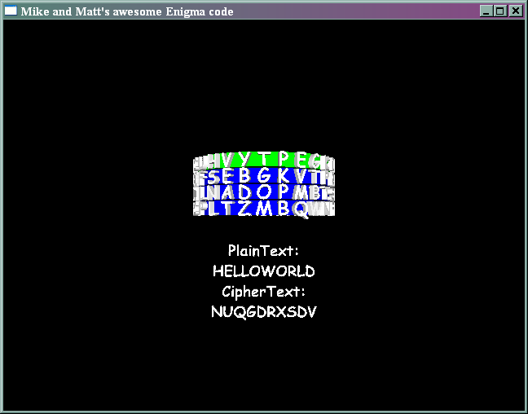

VISUALIZATION

An OpenGL / SDL graphical front end is provided, implemented in main.cpp. This compiles in windows under Dev-C++ 4.9.9.2, but may be easily ported to other environments such as linux. A windows executable is provided as-is (enigma.exe). The primary function of this is a proof of concept and could be used as an educational tool.

