Protégé is formally an ontology editor for managing large amounts of information in an intuitive object oriented fashion, using the principles of classes, class instances, and inheritance. The data presented for the rocket science assignment is suitable for input into an object oriented ontology editor such as protégé, but the constraints defined in the specs, and the capabilities of protégé do not match, leaving a gap. The best ways to manage this requirement complexity are to change the specs where they are nonsensical, and to implement some of the requirements in a traditional RDMS, after the protégé phase of development is completed. I have found Protégé great for prototyping, but not flexible enough to be suitable for real-world large RDMS projects.
Since most of the interest in the Rocket Science assignment deals with missions and experiments, those classes are available at the most basic subclass level (they inherit from Thing). A subclass of THING, basic_type, includes four abstract subclasses equipment, data, staff, and atomic. An abstract class is one which can have no direct instances, but instances of some subclass of an abstract class may occur.
The basic_type superclass keeps track of NASA data which is of interest to the missions and experiments, but not of primary observational interest in looking up mission data and in processing the given queries. Examples of instances are NASA collateral, such as staff members, research scientists, equipment (including rockets, shuttles, satellites, and mobile laboratories), etc. This is basically where the tangible parts of NASA are stored.
Atomic has two subclasses that were developed for convenience of the developer: mission_crew and date. For instance, the date class allows grouping of a month, numerical day of month, year, and optional day of the week. All classes are structured so that the data entered must make sense to the individual class to which it is relevant. For instance, if any dates before 1950 are entered for a mission launch date, a constraint will be violated, and the date will be marked RED to indicate that it is possibly invalid. This is generally more effective than disallowing data entry, as future data might not always fit the requirements imposed at development time, even if it is sane. Similar constraints are allowing only cardinality of one Mission Commander per shuttle crew, allowing experiments to be associated with only one mission, and allowing a shuttle to take off no less than three weeks after it has returned from its previous mission.
Here are the specification changes I would like to make (in addition to the requirements specified):
1. Each mission should also have a brief description (string), list of cargo, return cargo, crew, return date, and list of experiments performed.
3. Shuttles do not have a crew associated with them or particular singleton dates for mission launch and return. Instead, missions should each contain the crew associated with them. Missions also contain their dates of mission launch and return. If an inverse relationship is defined between mission::launch_vehicle and (shuttle’s superclass) equipment::used_on_mission, then after mapping to a relational database schema, a constraint can be defined that limits the launch dates of new missions based upon the used_on_mission return dates.
Such a constraint might be as follows
CONSTRAINT saneLaunchDates ( FOR ALL NEW mission nm)
ON CREATE nm
If nm.launch_vehicle.used_on_mission.return_date > nm.launch_date – (3 weeks)
THROW CONSTRAINT saneLaunchDates ON nm.launch_date

It is very difficult to program such a complicated constraint directly into protégé without using some type of plugin, but very easy to implement it in a standard database package such as Oracle.
5. Shuttle booster rockets (SRBs) are not the traditional capsule payload rockets such as SATURN V, ATLAS, etc. They are manufactured by Thiokol Corporation and have names SRB-NNN, where NNN is a 3-digit number. A booster rocket should be associated with a shuttle, as they are changed out regularly and refurbished along with the shuttle. All equipment should have a ‘retired’ flag. Furthermore, all staff and data can also be required, so ‘retired’ migrated up to basic_type.
6. An experiment is an intangible thing, so it is not of basic type. It is of primary interest to our data entry purposes, so it inherits directly from THING. It should not have space or mass information associated with it. Instead, it should be associated with equipment, which does have mass and space requirements. This way, after making a relational schema, constraints can be added to assure that all the equipment required for an experiment is available on the shuttle when the mission is formulated, and also assure that there is enough space and power available on the shuttle for all experiments.
An example:

CONSTRAINT equipment_available ( FOR ALL experiment ne)
ON CREATE MODIFY ne
FOR ALL i IN ne.equipment_used DO
IF NOT (i IN ne.associated_mission.cargo)
THROW CONSTRAINT equipment_available ON
ne.associated_mission.cargo
ne.equipment_used

The same type of thing can be used to make sure that the Principal Investigators for an experiment are also on that mission. Again it is difficult if not impossible to do this in Protégé without using some plug in such as ezPAL.
9. I tried to keep the data in my database as realistic as possible, but I cannot get things such as Social Security numbers and astronaut telephone numbers, of course.
10. The assignment is a database assignment, not a simulation and modeling assignment, so no effort was made to provide some way of simulating data transfer between satellites. Each experiment has data associated with it, and such data can be accessed by conventional means.
12. Mission_Crew was designed as a class which inherits from atomic_type. This is because each individual staff member may have a different title on each mission. Therefore, astronauts were instances of a generic class astronaut, with a subclass “principal investigator” (since a PI must be on the crew of a given mission for a given experiment). This way, each crew has a required slot Mission Commander, a required Multislot [1..2] Pilot, a multislot Mission Specialist, a multislot Payload Specialist, and a multislot Others. This way, each mission has one crew associated with it, and such a crew’s slots will take care of the invariance of crew member titles between missions.

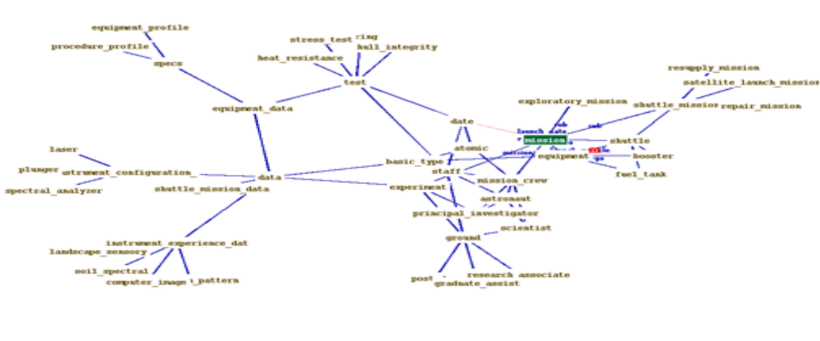A semantic web representation of my class ontology, centered at mission.

All queries were successful, but some of the required semantics are nonsensical. For instance, one asks for “missions involving Japanese, French, Russian, and Japanese scientists.” Another asks for missions involving Terry Willcutt, but the only astronaut that roughly matches that description is Terry Wilcutt. The queries were changed appropriately, and the results are attached.

The relational schema mapping chosen was RDF, since protégé comes equipped with a plug-in to export directly to RDF. This format is supported in Oracle 10.2g as an object-relational database model. Support for this format has been forthcoming from Oracle, and was originally supposed to be in version 8. However, Oracle did not support RDF until 10.2g, and requires extra licensing for this feature. I did not try my RDF schema in Oracle because I did not have a 10.2g license available. The RDF and RDFS files are provided, and total at almost 2 MB of entered instances data. I encourage you to look at them. The schema files are attached.

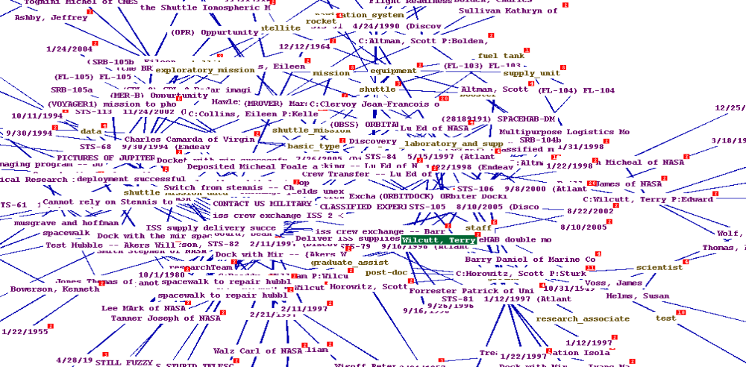 A semantic instances web of radius 6 about astronaut Terry Wilcutt.
Works Cited

- http://protege.stanford.edu/doc/users.html
Protégé User’s guide

- http://protege.stanford.edu/doc/tutorial/tables/index.html
Protégé Table Widget How-to

- http://protege.stanford.edu/publications/ontology_development/ontology101.html
Ontology Development 101

- Object Oriented Analysis and Design
Grady Booch, et al
Publisher: Addison-Wesley Professional (September 30, 1993)

- http://smi-web.stanford.edu/pubs/SMI_Abstracts/SMI-2001-0872.html
Creating Semantic Web Ontologies with Protégé

- http://www.picklematrix.net/archives/000979.html
“Oracle 10g supports RDF”

- http://en.wikipedia.org
Wikipedia: The Free Encyclopedia
(This is where I got most of the data with which I populated the database)

