# Lu Xin (lx108) - Comp Finance Coursework 1

Friday 24th February 2012

### Question 1: Price-Yield Curve

|  |  |  |  |
| --- | --- | --- | --- |
| **λ** | **Bond A** | **Bond B** | **Bond C** |
| 0 | 160 | 200 | 220 |
| 1 | 147.3565 | 185.2417 | 204.1843 |
| 2 | 135.9303 | 171.8607 | 189.8259 |
| 3 | 125.5906 | 159.7114 | 176.7718 |
| 4 | 116.2218 | 148.6654 | 164.8872 |
| 5 | 107.7217 | 138.6087 | 154.0521 |
| 6 | 100 | 129.4403 | 144.1605 |
| 7 | 92.9764 | 121.0707 | 135.1179 |
| 8 | 86.5798 | 113.4202 | 126.8403 |
| 9 | 80.747 | 106.4177 | 119.253 |
| 10 | 75.4217 | 100 | 112.2891 |
| 11 | 70.5538 | 94.1108 | 105.8892 |
| 12 | 66.0987 | 88.6996 | 100 |
| 13 | 62.0163 | 83.7213 | 94.5738 |
| 14 | 58.2711 | 79.1355 | 89.5678 |
| 15 | 54.8311 | 74.9062 | 84.9437 |
| 16 | 51.6677 | 71.0006 | 80.6671 |
| 17 | 48.7554 | 67.3898 | 76.707 |
| 18 | 46.071 | 64.0473 | 73.0355 |
| 19 | 43.5938 | 60.9496 | 69.6275 |
| 20 | 41.3054 | 58.0753 | 66.4602 |

a)

|  |  |  |  |
| --- | --- | --- | --- |
| **Bond** | **A** | **B** | **C** |
| Coupon Rate | 6% | 10% | 12% |
| Maturity (Years) | 10 | 10 | 10 |
| Face Value (£) | 100 | 100 | 100 |

The price-yield curve of each bond with annual compound and range of yields from 0≤λ≤20 are as follows:

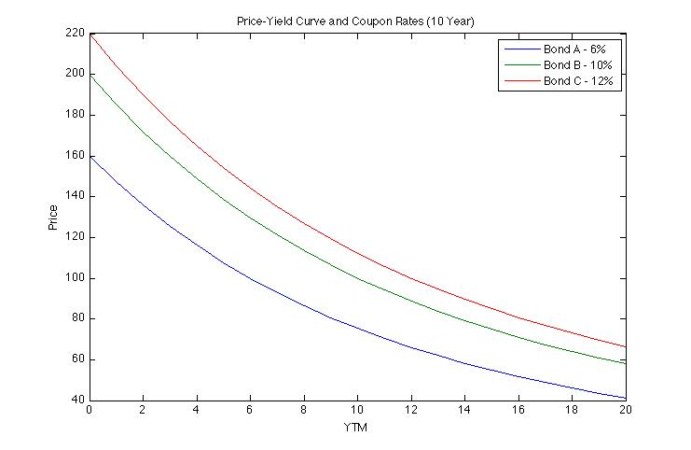

We notice that the higher the YTM, the lower the price. When YTM = 0, there is no discounting, thus price is the undiscounted sum of all coupon payments and face value.

b)

Current Date: Mar 2012

|  |  |  |  |
| --- | --- | --- | --- |
| **Bond** | **A** | **B** | **C** |
| Coupon Rate | 6% | 10% | 12% |
| Maturity Date | Sep 2012 | Mar 2013 | Sep 2014 |
| Face Value (£) | 100 | 100 | 100 |

The price-yield curve of each bond with semi-annual compound and range of yields from 0≤λ≤20 are as follows

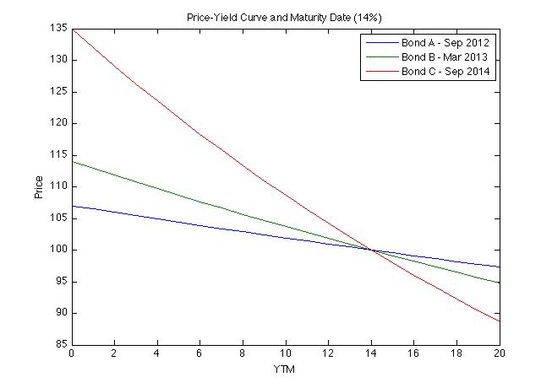

The price-yield relation in tabular form is as follows:

|  |  |  |  |
| --- | --- | --- | --- |
| **λ** | **Bond A** | **Bond B** | **Bond C** |
| **0** | 107 | 114 | 135 |
| **1** | 106.4677 | 112.9031 | 132.0181 |
| **2** | 105.9406 | 111.8224 | 129.1206 |
| **3** | 105.4187 | 110.7574 | 126.3045 |
| **4** | 104.902 | 109.7078 | 123.5673 |
| **5** | 104.3902 | 108.6734 | 120.9062 |
| **6** | 103.8835 | 107.6539 | 118.3188 |
| **7** | 103.3816 | 106.6489 | 115.8027 |
| **8** | 102.8846 | 105.6583 | 113.3555 |
| **9** | 102.3923 | 104.6817 | 110.9749 |
| **10** | 101.9048 | 103.7188 | 108.659 |
| **11** | 101.4218 | 102.7695 | 106.4054 |
| **12** | 100.9434 | 101.8334 | 104.2124 |
| **13** | 100.4695 | 100.9103 | 102.0778 |
| **14** | 100 | 100 | 100 |
| **15** | 99.5349 | 99.1022 | 97.9771 |
| **16** | 99.0741 | 98.2167 | 96.0073 |
| **17** | 98.6175 | 97.3433 | 94.089 |
| **18** | 98.1651 | 96.4818 | 92.2207 |
| **19** | 97.7169 | 95.6319 | 90.4007 |
| **20** | 97.2727 | 94.7934 | 88.6276 |

We notice that when the YTM value is 14%, equal to the coupon rate, the price is equal to the face value as expected.

### Question 2: Portfolio Optimization with a Twist

a)

i. The Markowitz model for an investment horizon of one month in optimizing the portfolio with the highest expected return is the following:

minimize: $-\sum_{i=1}^{n}{w_{i}\overline{r_{i}}}$

subject to: $\sum_{i=1}^{n}{w_{i}}=1$

$w_{i} ≥0 for i=1, 2, …, n$

ii. The Markowitz model for an investment horizon of one month in optimizing the portfolio with the smallest variance is the following:

minimize: $\frac{1}{2}\sum_{i, j=1}^{n}{w_{i}{\text{σ}}_{ij}w_{j}}$

subject to: $\sum_{i=1}^{n}{w_{i}}=1$

$w_{i} ≥0 for i=1, 2, …, n$

b) The true frontier for the given set of values is the following:

|  |  |  |  |  |  |  |
| --- | --- | --- | --- | --- | --- | --- |
| **Std Dev** | **Return** | **w1** | **w2** | **w3** | **w4** | **w5** |
| ***0.0588*** | ***0.0126*** | **0.2403** | **0.3006** | **0.1507** | **0.1911** | **0.1172** |
| ***0.0591*** | ***0.0136*** | 0.1856 | 0.2732 | 0.1546 | 0.2226 | 0.164 |
| ***0.0601*** | ***0.0147*** | 0.1309 | 0.2458 | 0.1585 | 0.254 | 0.2107 |
| ***0.0617*** | ***0.0157*** | 0.0763 | 0.2184 | 0.1624 | 0.2855 | 0.2575 |
| ***0.0639*** | ***0.0168*** | 0.0216 | 0.1909 | 0.1663 | 0.3169 | 0.3043 |
| ***0.0668*** | ***0.0178*** | 0 | 0.127 | 0.1579 | 0.3502 | 0.3649 |
| ***0.0706*** | ***0.0189*** | 0 | 0.0391 | 0.1416 | 0.3847 | 0.4346 |
| ***0.0755*** | ***0.0199*** | 0 | 0 | 0.0603 | 0.4029 | 0.5368 |
| ***0.084*** | ***0.021*** | 0 | 0 | 0 | 0.2617 | 0.7383 |
| ***0.1*** | ***0.022*** | **0** | **0** | **0** | **0** | **1** |

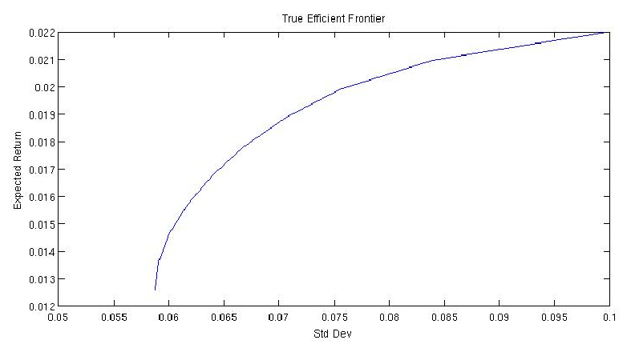

c) Simulate a situation experimentally by using random number generator for multivariate normal distributions provided by matlab for a 24 month period.

* The **random returns** are generated via matlab as such:
  + randomReturns = mvnrnd(mu, covMatrix, months);
    - Where mu is the true returns, covMatrix is the covariance matrix, and months = 24.
* The **mean** returns are the mean of the random returns that we generated from before:
  + estMu = mean(randomReturns);
* The **covariance** matrix is calculated using the set of generated random returns
  + covMatrix = cov(randomReturns);
* The **rmin** and **rmax** are the calculated using the same method mentioned above in part 2a)
* The **weights** for the efficient frontier of the estimated random returns are then stored and used later

|  |  |  |  |  |  |  |
| --- | --- | --- | --- | --- | --- | --- |
| **Estimated Frontier over 24 months** | | | | | | |
| **Std Dev** | **Return** | **w1** | **w2** | **w3** | **w4** | **w5** |
| 0.0477 | -0.0006 | 0.2356 | 0.522 | 0.2388 | 0.0036 | 0 |
| 0.0492 | 0.003 | 0.1963 | 0.4546 | 0.2453 | 0 | 0.1038 |
| 0.0521 | 0.0066 | 0.1633 | 0.3812 | 0.2446 | 0 | 0.2109 |
| 0.0563 | 0.0101 | 0.1303 | 0.3078 | 0.244 | 0 | 0.3179 |
| 0.0615 | 0.0137 | 0.0973 | 0.2345 | 0.2433 | 0 | 0.4249 |
| 0.0674 | 0.0172 | 0.0643 | 0.1611 | 0.2426 | 0 | 0.532 |
| 0.074 | 0.0208 | 0.0313 | 0.0877 | 0.242 | 0 | 0.639 |
| 0.0809 | 0.0243 | 0 | 0.0128 | 0.2406 | 0 | 0.7466 |
| 0.089 | 0.0279 | 0 | 0 | 0.1274 | 0 | 0.8726 |
| 0.0989 | 0.0314 | 0 | 0 | 0 | 0 | 1 |

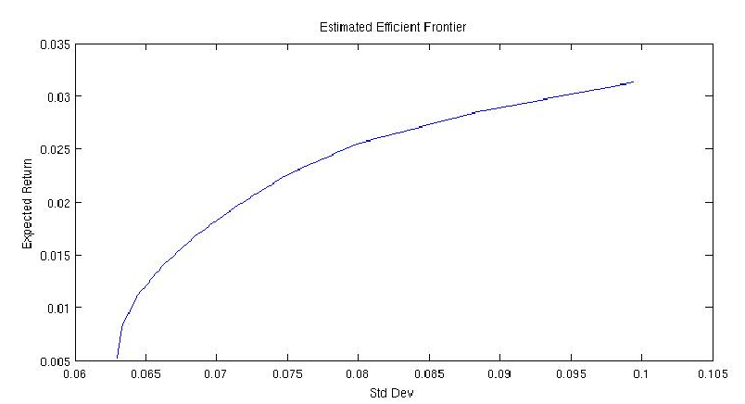

d) Using the estimated weights from before, we use them with the true mean values, variances, and covariances give before. Thus yielding the actual frontier.

* The values of the **actual returns** are calculated by using the efficient frontier’s weights we obtained from our estimated frontier, and multiplying them with the true returns:
  + actualReturns = estWeights * mu';
* The **actual** **variance** is calculated using the estimated weights we obtained and the true covariance matrix:
 $σ^{2}= w^{T}Σ w$

 + We then square root this to obtain the **actual standard** **deviation**

|  |  |  |  |  |  |  |
| --- | --- | --- | --- | --- | --- | --- |
| **Actual Frontier over 24 months with Estimated Weights** | | | | | | |
| **Std Dev** | **Return** | **w1** | **w2** | **w3** | **w4** | **w5** |
| 0.0634 | 0.01 | 0.2356 | 0.522 | 0.2388 | 0.0036 | 0 |
| 0.0619 | 0.0114 | 0.1963 | 0.4546 | 0.2453 | 0 | 0.1038 |
| 0.0619 | 0.0129 | 0.1633 | 0.3812 | 0.2446 | 0 | 0.2109 |
| 0.0637 | 0.0143 | 0.1303 | 0.3078 | 0.244 | 0 | 0.3179 |
| 0.0671 | 0.0157 | 0.0973 | 0.2345 | 0.2433 | 0 | 0.4249 |
| 0.0719 | 0.0171 | 0.0643 | 0.1611 | 0.2426 | 0 | 0.532 |
| 0.0779 | 0.0185 | 0.0313 | 0.0877 | 0.242 | 0 | 0.639 |
| 0.0847 | 0.0199 | 0 | 0.0128 | 0.2406 | 0 | 0.7466 |
| 0.0916 | 0.021 | 0 | 0 | 0.1274 | 0 | 0.8726 |
| 0.1 | 0.022 | 0 | 0 | 0 | 0 | 1 |

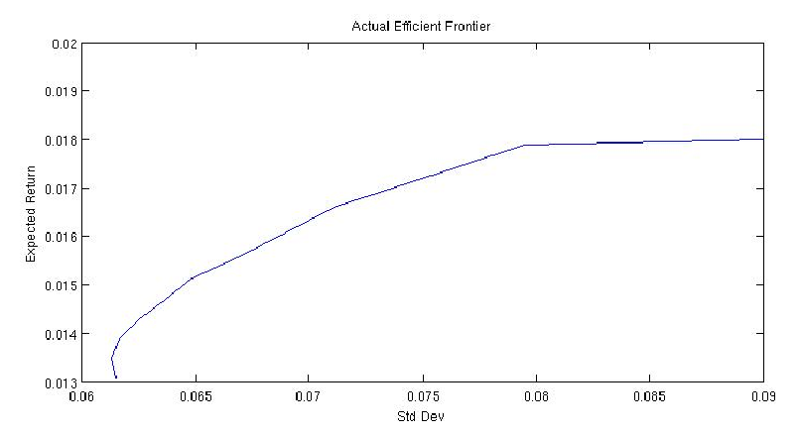

e, f) Simulating this process with 10,000 runs, and taking the average for horizons of 24 months, 360, and 1800 respectively, we get the following:

**24 Months – Averaged Frontiers:**

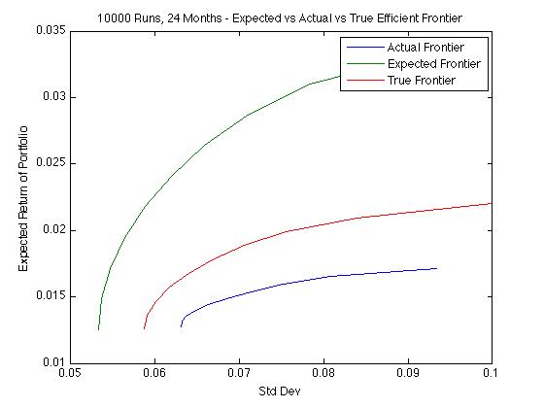

|  |  |
| --- | --- |
| **Std Dev** | **Returns** |
| 0.0631 | 0.0128 |
| 0.0631 | 0.0131 |
| 0.0637 | 0.0135 |
| 0.0648 | 0.014 |
| 0.0663 | 0.0144 |
| 0.0685 | 0.0149 |
| 0.0713 | 0.0154 |
| 0.0751 | 0.0159 |
| 0.0808 | 0.0165 |
| 0.0934 | 0.0171 |

**360 Months – Averaged Frontiers:**

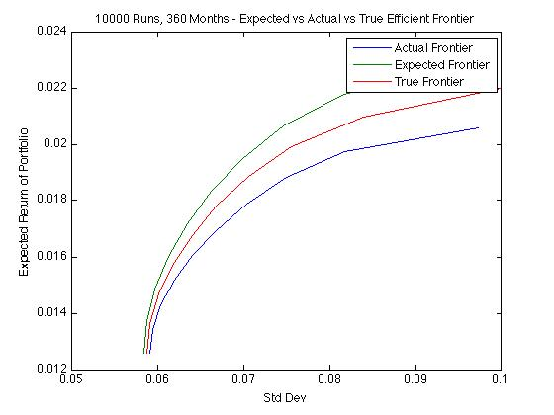

|  |  |
| --- | --- |
| **Std Dev** | **Returns** |
| 0.0591 | 0.0126 |
| 0.0594 | 0.0134 |
| 0.0603 | 0.0143 |
| 0.0619 | 0.0152 |
| 0.064 | 0.0161 |
| 0.0667 | 0.0169 |
| 0.0703 | 0.0179 |
| 0.075 | 0.0188 |
| 0.0818 | 0.0197 |
| 0.0973 | 0.0206 |

**1800 Months – Averaged Frontiers:**

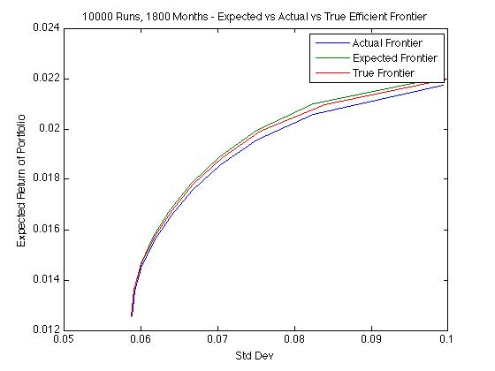

|  |  |
| --- | --- |
| **Std Dev** | **Returns** |
| 0.0588 | 0.0126 |
| 0.0591 | 0.0136 |
| 0.0601 | 0.0146 |
| 0.0617 | 0.0156 |
| 0.0639 | 0.0166 |
| 0.0667 | 0.0176 |
| 0.0703 | 0.0186 |
| 0.0751 | 0.0196 |
| 0.0825 | 0.0206 |
| 0.0994 | 0.0217 |

As we can observe, the estimated and the actual frontiers get closer and closer to the true frontier as the time series data we have increases. As we can see, when we use data of 150 years, or 1800 months, the frontiers are almost identical. Even though this method seems to work well with large historical data, but in the real world, it is very hard to obtain 150 years of historical data for a given company, because we do not have this data and also because very few companies last for 150 years.

Furthermore, this model works under the assumption that the returns for companies follow a normal distribution which is probably wrong. This is why big investment firms, investment banks, and other investors look at more than just historical data when making investment decisions. They take into account many other factors such as the finances of the company, the current CEO, the current economic outlook, world events, government regulations, people’s confidence in the company, and many other factors. Thus basing our portfolio building strategy purely on technical analysis is insufficient and unwise in the long run.