**Module-1(Software Testing)**

1. **What is SDLC**

Software development lifecycle is the cost-effective and time-efficient process that development teams use to design and build high-quality software.

1. **What is software testing?**

Software testing isthe process of evaluating and verifying that a software product or application does what it's supposed to do*.*

1. **What is agile methodology?**

Agile methodology is a project management and product development approach that prioritizes flexibility, collaboration, and customer satisfaction.

1. **What is SRS**

Software requirement specification (SRS) includes information about all the functional and non-functional requirements for a given piece of software.

1. **What is oops**

OOPS is a programming paradigm based on the concept of objects, which can contain of data and code, data in the form of fields and code is the form of procedures.

1. **Write Basic Concepts of oops**

* Object
* Class
* Encapsulation
* Abstraction
* Inheritance
* Polymorphism

1. **What is object**

It is represent entity of class. It is instance of the class.

1. **What is class**

It is a blueprint of the object and collection of the object.

1. **What is encapsulation**

Encapsulation is refer to integrating code and method into single entity.

1. **What is inheritance**

Inheritance is ability to adapt behavior of parent class into child class.

1. **What is polymorphism**

Polymorphism is a single class into a different form.

1. **Draw Usecase on Online book shopping**

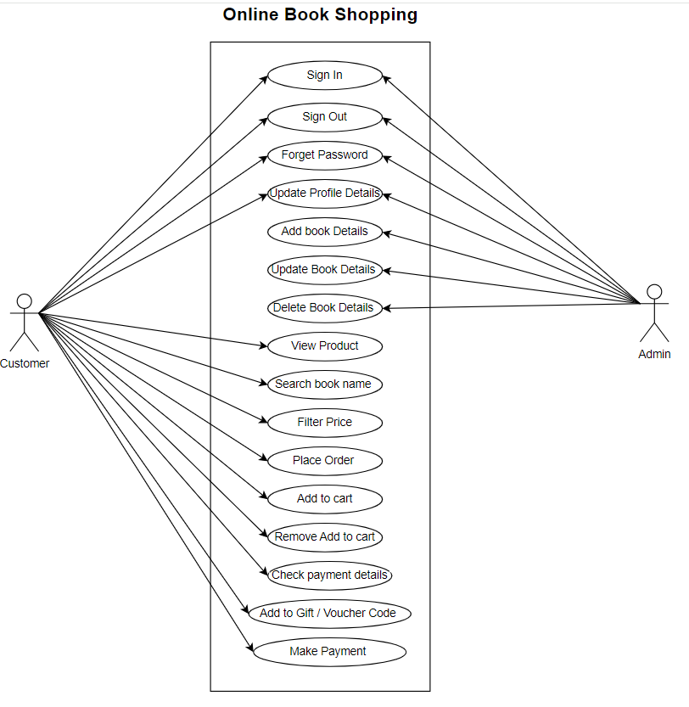

1. **Draw Usecase on online bill payment system (paytm)**

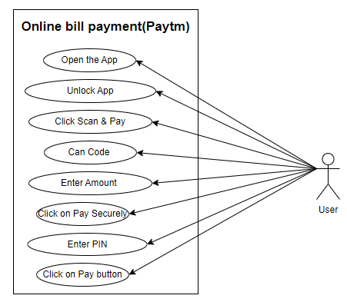

1. **Write SDLC phases with basic introduction**

SDLC is a structure imposed on the development of a software product that defines the process for planning, implementation, testing, documentation, deployment, and ongoing maintenance and support.

1. Requirement Gathering
2. Analysis
3. Designing
4. Implementation
5. Testing
6. Maintenance
7. [**Requirements gathering and analysis:**](https://www.geeksforgeeks.org/requirements-gathering-introduction-processes-benefits-and-tools/) This phase involves gathering information about the software requirements from stakeholders, such as customers, end-users, and business analysts.
8. **Design:** In this phase, the software design is created, which includes the overall architecture of the software, data structures, and interfaces.
9. **Implementation or coding:** The design is then implemented in code, usually in several iterations, and this phase is also called as Development.
10. **Testing:** The software is thoroughly tested to ensure that it meets the requirements and works correctly.
11. **Deployment:** After successful testing, the software is deployed to a production environment and made available to end-users.
    * 1. **Maintenance:** This phase includes ongoing support, bug fixes, and updates to the software
12. **Explain Phases of the waterfall model**

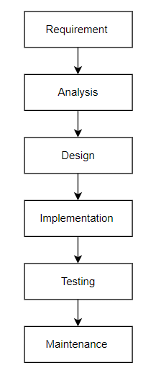

* **Requirement Gathering and analysis** − All possible requirements of the system to be developed are captured in this phase and documented in a requirement specification document.
* **System Design** − the requirement specifications from first phase are studied in this phase and the system design is prepared. This system design helps in specifying hardware and system requirements and helps in defining the overall system architecture.
* **Implementation** − with inputs from the system design, the system is first developed in small programs called units, which are integrated in the next phase. Each unit is developed and tested for its functionality, which is referred to as Unit Testing.
* **Integration and Testing** − All the units developed in the implementation phase are integrated into a system after testing of each unit. Post integration the entire system is tested for any faults and failures.
* **Deployment of system** − Once the functional and non-functional testing is done; the product is deployed in the customer environment or released into the market.
* **Maintenance** − There are some issues which come up in the client environment. To fix those issues, patches are released. Also to enhance the product some better versions are released. Maintenance is done to deliver these changes in the customer environment.

1. **Write phases of spiral model**
   1. Planning
   2. Risk analysis
   3. Engineering
   4. Customer evaluation
2. **Write agile manifesto principles**
   1. Individual interaction
   2. Working software
   3. Customer collaboration
   4. Response in to change
3. **Explain working methodology of agile model and also write pros and cons.**

* Agile methodology is project management and product development approach that prioritises development approach that prioritize flexibility, collaboration and customer satisfaction.
* Agile Methods break the product into small incremental builds.
* These builds are provided in iterations.

**Pros:**

* Is a very realistic approach to software development
* Promotes teamwork and cross training?
* Functionality can be developed rapidly and demonstrated.

**Cons:**

* Not suitable for handling complex dependencies.
* More risk of sustainability, maintainability and extensibility.
* An overall plan, an agile leader and agile PM practice is a must without which it will not work.

1. **Draw usecase on Online shopping product using COD.**

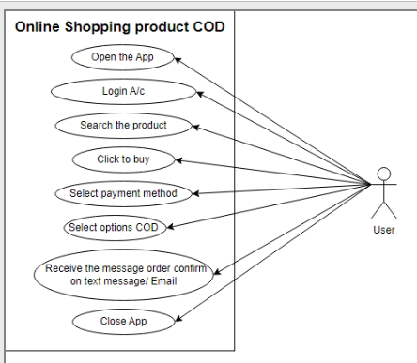

1. **Draw usecase on Online shopping product using payment gateway.**

