What is npm?
npm is the package manager for Node.js.
It helps you install and manage third-party packages (libraries) to add more features to your apps.
command installs the popular Express web framework. ::: npm install express
const express = require('express');
const app = express();
app.get('/', (req, res) => res.send('Hello World!'));
app.listen(3000);

What is Express.js?
- Popular Node.js web application framework, designed for building web applications and APIs.
- Library of node.js
  - Rapid development
  - Less number of coding line
  - Easier routing
  - Middleware functionalities
  - Integrated environment
- Based on connect middleware and used template for HTML
- FEATURE
  - Middleware to respond to HTTP req
  - Routing table
  - Render HTML pages

Express provides a thin layer of fundamental web application features without obscuring Node.js features.

Basic Routing
- Routing refers to how an application responds to client requests to specific endpoints (URIs) using different HTTP methods (GET, POST, PUT, DELETE, etc.).
- Express provides simple methods to define routes that correspond to HTTP methods:
- app.get() - Handle GET requests
- app.post() - Handle POST requests
- app.put() - Handle PUT requests
- app.delete() - Handle DELETE requests
- app.all() – Not derived from HTTP method(used for loading middleware at a path)
RouePAth:
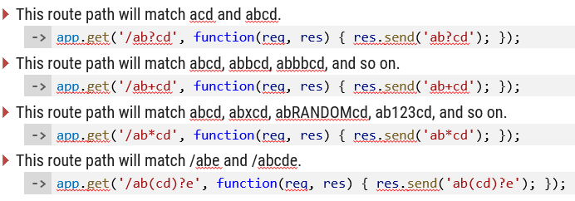

Route Parameters : Route parameters are named URL segments that capture values at specific positions in the URL.
Query Parameters: Query parameters are key-value pairs that appear after the ? in a URL.

Middleware in Express
Middleware functions are the backbone of Express applications.
They have access to:
- The request object (req)
- The response objecssst (res)
- The next middleware function in the stack (next)
Middleware can:
- Execute any code
- Modify request and response objects
- End the request-response cycle
- Call the next middleware in the stack
- 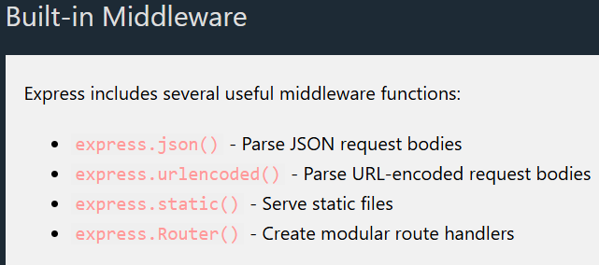
- 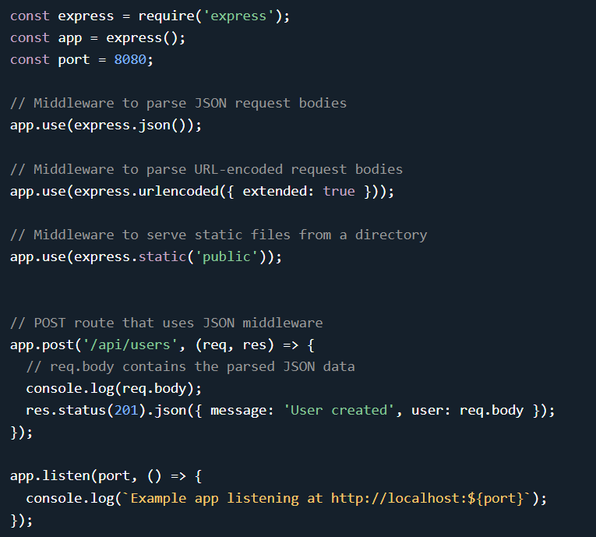
Error Handling in Express
Error handling in Express is done through special middleware functions that have four arguments:
(err, req, res, next).
Key Points:
- Error-handling middleware must have four arguments
- It should be defined after other app.use() and route calls
- You can have multiple error-handling middleware functions
- Use next(err) to pass errors to the next error handler

Routing in Separate Files
For better organization, you can define routes in separate files using Express Router:
Building a RESTful API
Express is commonly used to build RESTful APIs. That is covered in our Node.js Express REST API chapter.
Follow these best practices to build robust, maintainable Express applications:
- Project Structure: Organize your code by feature or component
- Environment Variables: Use dotenv for configuration
- Error Handling: Centralize error handling
- Logging: Use a logging library like morgan or winston
- Security: Implement security best practices (helmet, rate limiting, etc.)
- Validation: Validate input using libraries like express-validator
- Testing: Write tests using jest, mocha, or similar
Performance Best Practices
- Use compression middleware to compress responses
- Implement proper caching strategies
- Consider using a reverse proxy (like Nginx) in front of your Express app
- Use clustering to take advantage of multi-core systems
- Optimize database queries

