**Exercise 1: Configuring a Basic Spring Application**

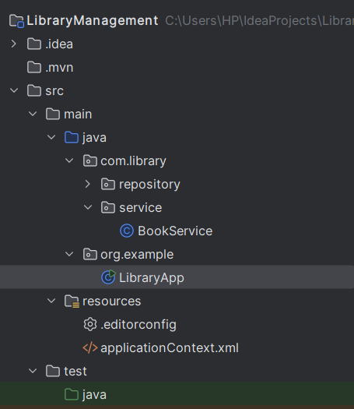

|  |
| --- |
| BookRepository.java  package com.library.repository;  public class BookRepository {  public void saveBook(String title) {  System.*out*.println("Book title : " + title);  } }  BookService.java  package com.library.service; import com.library.repository.BookRepository;  public class BookService {  private BookRepository bookRepository;   public void setBookRepository(BookRepository bookRepository) {  this.bookRepository = bookRepository;  }   public void addBook(String title) {  System.*out*.println("Adding another book: " + title);  bookRepository.saveBook(title);  } }  LibraryApp.java  package org.example;  import com.library.service.BookService; import org.springframework.context.ApplicationContext; import org.springframework.context.support.ClassPathXmlApplicationContext;  public class LibraryApp {  public static void main(String[] args) {  ApplicationContext context = new ClassPathXmlApplicationContext("applicationContext.xml");  BookService bookService = context.getBean("bookService", BookService.class);  bookService.addBook("The Alchemist");  } }  applicationContext.xml  <?xml version="1.0" encoding="UTF-8"?> <beans xmlns="http://www.springframework.org/schema/beans"  xmlns:xsi="http://www.w3.org/2001/XMLSchema-instance"  xsi:schemaLocation="  http://www.springframework.org/schema/beans  https://www.springframework.org/schema/beans/spring-beans.xsd">   <!-- Repository Bean -->  <bean id="bookRepository" class="com.library.repository.BookRepository"/>   <!-- Service Bean with DI -->  <bean id="bookService" class="com.library.service.BookService">  <property name="bookRepository" ref="bookRepository"/>  </bean> </beans>  pom.xml  <?xml version="1.0" encoding="UTF-8"?> <project xmlns="http://maven.apache.org/POM/4.0.0"  xmlns:xsi="http://www.w3.org/2001/XMLSchema-instance"  xsi:schemaLocation="http://maven.apache.org/POM/4.0.0 http://maven.apache.org/xsd/maven-4.0.0.xsd">  <modelVersion>4.0.0</modelVersion>   <groupId>org.example</groupId>  <artifactId>LibraryManagement</artifactId>  <version>1.0-SNAPSHOT</version>   <properties>  <maven.compiler.source>17</maven.compiler.source>  <maven.compiler.target>17</maven.compiler.target>  <project.build.sourceEncoding>UTF-8</project.build.sourceEncoding>  </properties>   <dependencies>  <!-- adding spring dependency -->  <dependency>  <groupId>org.springframework</groupId>  <artifactId>spring-context</artifactId>  <version>5.3.33</version>  </dependency>  </dependencies>   </project> |

**OUTPUT -:**



**Exercise 2: Implementing Dependency Injection**

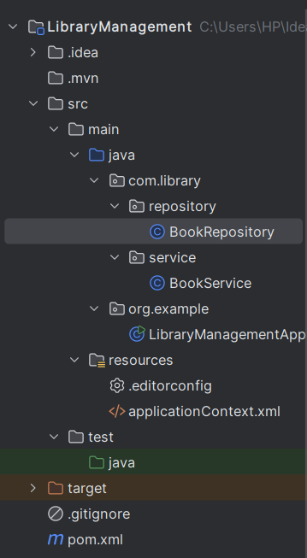

|  |
| --- |
| BookRepository.java  package com.library.repository;  public class BookRepository {  public void saveBook(String title) {  System.*out*.println("Book title : " + title);  } }  BookService.java  package com.library.service;  import com.library.repository.BookRepository;  public class BookService {  private BookRepository bookRepository;   public void setBookRepository(BookRepository bookRepository) {  this.bookRepository = bookRepository;  }   public void addBook(String title) {  System.*out*.println("Adding another book title : " + title);  bookRepository.saveBook(title);  } }  LibraryManagementApplication.java  package org.example;  import com.library.service.BookService; import org.springframework.context.ApplicationContext; import org.springframework.context.support.ClassPathXmlApplicationContext;  public class LibraryManagementApplication {  public static void main(String[] args) {  ApplicationContext context = new ClassPathXmlApplicationContext("applicationContext.xml");   BookService bookService = context.getBean("bookService", BookService.class);   bookService.addBook("The 5a.m. Club by Robin Sharma");  } }  applicationContext.xml  <?xml version="1.0" encoding="UTF-8"?> <beans xmlns="http://www.springframework.org/schema/beans"  xmlns:xsi="http://www.w3.org/2001/XMLSchema-instance"  xsi:schemaLocation="  http://www.springframework.org/schema/beans  https://www.springframework.org/schema/beans/spring-beans.xsd">   <!-- Bean for BookRepository -->  <bean id="bookRepository" class="com.library.repository.BookRepository" />   <!-- Bean for BookService with DI -->  <bean id="bookService" class="com.library.service.BookService">  <property name="bookRepository" ref="bookRepository" />  </bean>  </beans> |

**OUTPUT -:**



**Exercise 4: Creating and Configuring a Maven Project**

|  |
| --- |
| pom.xml  <project xmlns="http://maven.apache.org/POM/4.0.0"  xmlns:xsi="http://www.w3.org/2001/XMLSchema-instance"  xsi:schemaLocation="http://maven.apache.org/POM/4.0.0  http://maven.apache.org/xsd/maven-4.0.0.xsd">   <modelVersion>4.0.0</modelVersion>   <groupId>com.library</groupId>  <artifactId>LibraryManagement</artifactId>  <version>1.0-SNAPSHOT</version>   <!-- adding Java version -->  <properties>  <maven.compiler.source>1.8</maven.compiler.source>  <maven.compiler.target>1.8</maven.compiler.target>  <project.build.sourceEncoding>UTF-8</project.build.sourceEncoding>  </properties>   <!-- adding Spring Dependencies -->  <dependencies>  <!-- adding Spring Core and Context -->  <dependency>  <groupId>org.springframework</groupId>  <artifactId>spring-context</artifactId>  <version>5.3.33</version>  </dependency>   <!-- adding Spring AOP -->  <dependency>  <groupId>org.springframework</groupId>  <artifactId>spring-aop</artifactId>  <version>5.3.33</version>  </dependency>   <!-- adding Spring Web MVC -->  <dependency>  <groupId>org.springframework</groupId>  <artifactId>spring-webmvc</artifactId>  <version>5.3.33</version>  </dependency>  </dependencies>   <!-- Maven Compiler Plugin for Java 8 -->  <build>  <plugins>  <plugin>  <groupId>org.apache.maven.plugins</groupId>  <artifactId>maven-compiler-plugin</artifactId>  <version>3.8.1</version>  <configuration>  <source>1.8</source>  <target>1.8</target>  </configuration>  </plugin>  </plugins>  </build> </project> |