**Creating Microservices for account and loan**

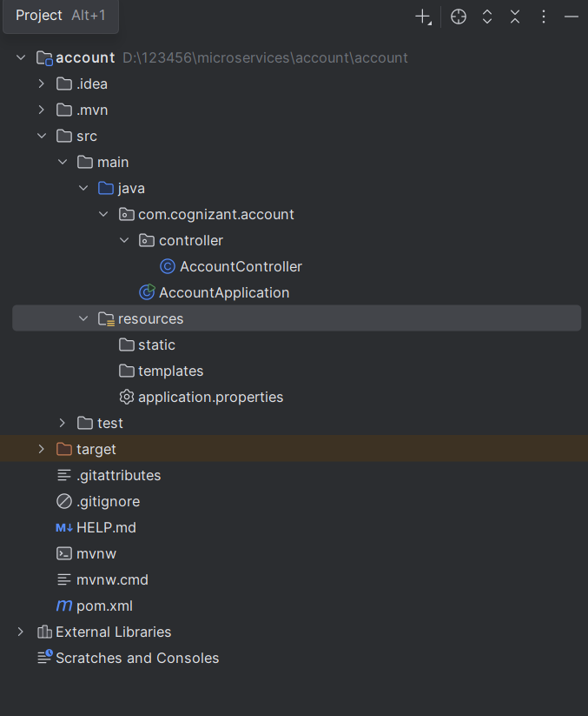

|  |
| --- |
| AccountController.java  package com.cognizant.account.controller;  import org.springframework.web.bind.annotation.*;  import java.util.Map;  @RestController @RequestMapping("/accounts") public class AccountController {   @GetMapping("/{number}")  public Map<String, Object> getAccountDetails(@PathVariable String number) {  return Map.*of*(  "number", number,  "type", "savings",  "balance", 234343  );  } }  AccountApplication.java  package com.cognizant.account;  import org.springframework.boot.SpringApplication; import org.springframework.boot.autoconfigure.SpringBootApplication;  @SpringBootApplication public class AccountApplication {   public static void main(String[] args) {  SpringApplication.*run*(AccountApplication.class, args);  }  }  application.properties  spring.application.name=account server.port=8082 |

**OUTPUT-:**

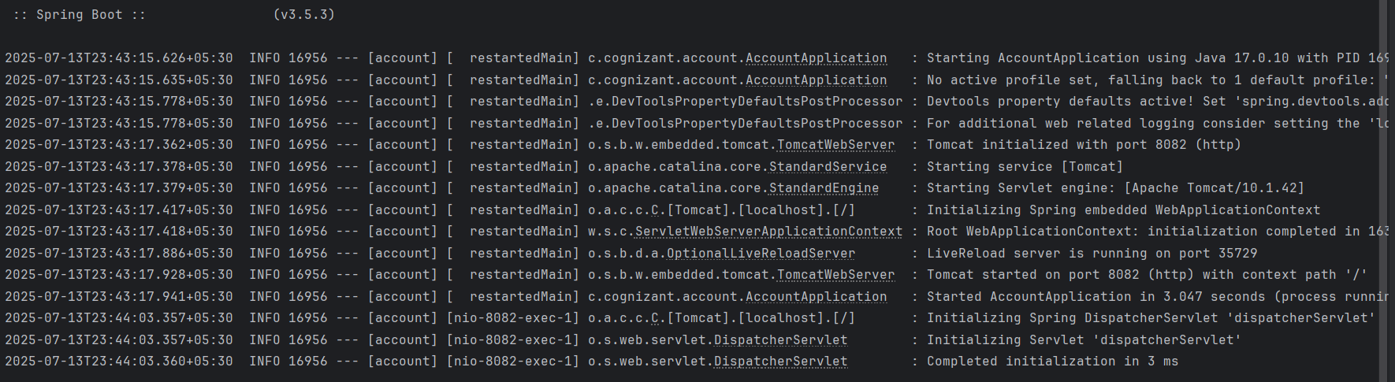

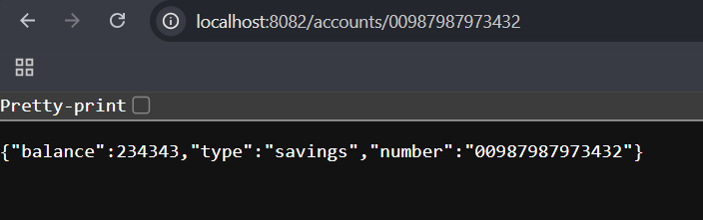

**Microservice for loan**

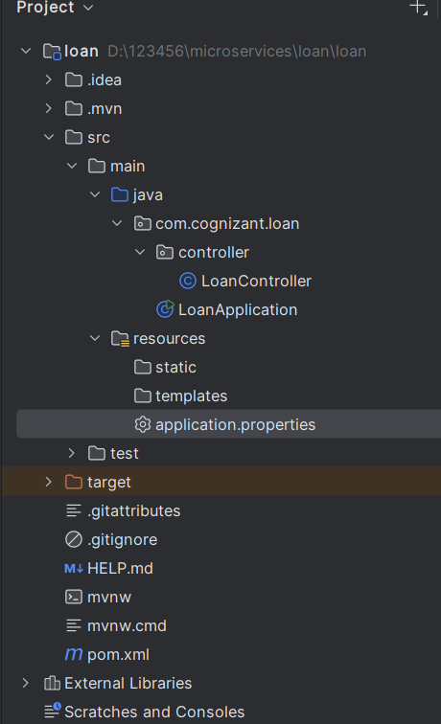

|  |
| --- |
| LoanController.java  package com.cognizant.loan.controller;  import org.springframework.web.bind.annotation.*;  import java.util.Map;  @RestController @RequestMapping("/loans") public class LoanController {   @GetMapping("/{number}")  public Map<String, Object> getLoanDetails(@PathVariable String number) {  return Map.*of*(  "number", number,  "type", "car",  "loan", 400000,  "emi", 3258,  "tenure", 18  );  } }  LoanApplication.java  package com.cognizant.loan;  import org.springframework.boot.SpringApplication; import org.springframework.boot.autoconfigure.SpringBootApplication;  @SpringBootApplication public class LoanApplication {   public static void main(String[] args) {  SpringApplication.*run*(LoanApplication.class, args);  }  }  application.properties  spring.application.name=loan server.port=8083 |

**OUPUT-:**

