MailChimp:

API-3

<https://github.com/mailchimp/APIv3-examples/wiki>

API-2

<https://github.com/twinkle023020/MailChimp.NET>

Some Sample Code :

<https://github.com/twinkle023020/MailChimpSampleCode>

<https://github.com/twinkle023020/MailChimpSampleCode/wiki>

\* How to get API key:

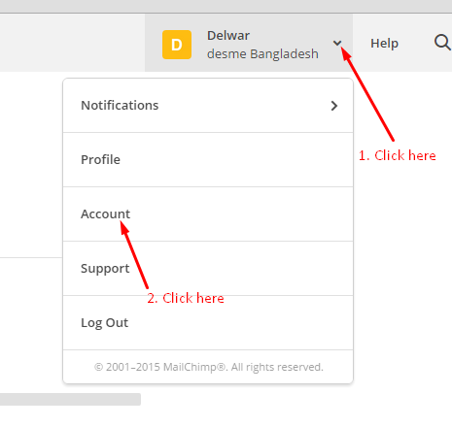

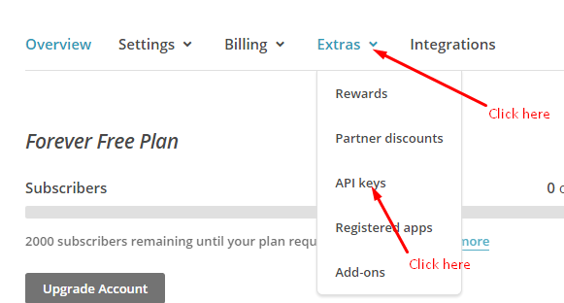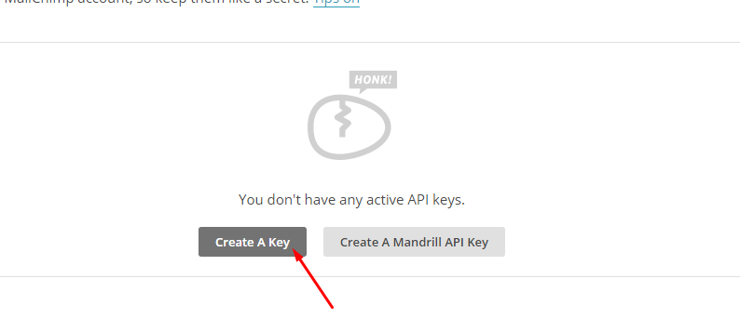

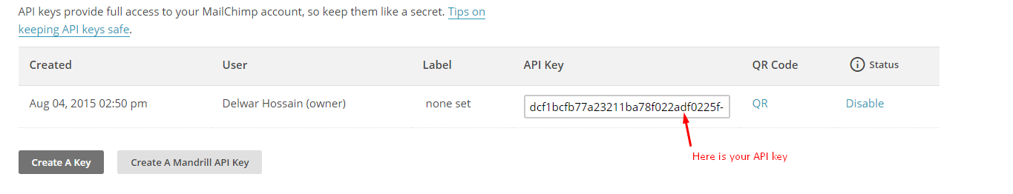

\* How to define variable tag

