**Introduction**

Nokia Corporation, stylised as NOKIA, is a [Finnish](https://en.wikipedia.org/wiki/Finland) [multinational](https://en.wikipedia.org/wiki/Multinational_corporation) communications and [information technology company](https://en.wikipedia.org/wiki/Information_technology_company), founded in 1865. Nokia is headquartered in [Espoo](https://en.wikipedia.org/wiki/Espoo), [Uusimaa](https://en.wikipedia.org/wiki/Uusimaa), in the greater [Helsinki](https://en.wikipedia.org/wiki/Helsinki) metropolitan area. In 2014, Nokia employed 61,656 people across 120 countries, did business in more than 150 countries and reported annual revenues of around €12.73 billion. Nokia is a [public limited-liability company](https://en.wikipedia.org/wiki/Public_limited_company) listed on the [Helsinki Stock Exchange](https://en.wikipedia.org/wiki/Helsinki_Stock_Exchange) and [New York Stock Exchange](https://en.wikipedia.org/wiki/New_York_Stock_Exchange). It is the world's 274th-largest company measured by 2013 revenues according to the [*Fortune Global 500*](https://en.wikipedia.org/wiki/Fortune_Global_500). The company is a component of the [Euro Stoxx 50](https://en.wikipedia.org/wiki/Euro_Stoxx_50) [stock market index](https://en.wikipedia.org/wiki/Stock_market_index).

The company has had various industries in its 150-year history, originally founded as a [pulp mill](https://en.wikipedia.org/wiki/Pulp_mill), and currently focuses on large-scale [telecommunications infrastructures](https://en.wikipedia.org/wiki/Telecommunications_equipment), and technology development and licensing. Nokia is also a major contributor to the [mobile telephony](https://en.wikipedia.org/wiki/Mobile_telephony) industry, having assisted in development of the [GSM](https://en.wikipedia.org/wiki/GSM) and [LTE](https://en.wikipedia.org/wiki/LTE_(telecommunication)) standards, and was, for a period, the largest vendor of [mobile phones](https://en.wikipedia.org/wiki/Mobile_phone) in the world. Nokia's dominance also extended into the [smartphone](https://en.wikipedia.org/wiki/Smartphone) industry through its [Symbian](https://en.wikipedia.org/wiki/Symbian) platform, but was soon overshadowed by competitors. Nokia eventually entered into a pact with [Microsoft](https://en.wikipedia.org/wiki/Microsoft) in 2011 to exclusively use its [Windows Phone](https://en.wikipedia.org/wiki/Windows_Phone) platform on future smartphones. Its mobile phone business was eventually bought by Microsoft in an overall deal totaling €5.44 billion (US $7.17 billion). [Stephen Elop](https://en.wikipedia.org/wiki/Stephen_Elop), Nokia's former CEO, and several other executives joined the new [Microsoft Mobile](https://en.wikipedia.org/wiki/Microsoft_Mobile) subsidiary of Microsoft as part of the deal, which was completed on April 25, 2014.

Since the sale of its mobile phone business, Nokia began to focus more extensively on its telecommunications infrastructure business, marked by the divestiture of its [Here Maps](https://en.wikipedia.org/wiki/Here_Maps) division, its foray in [virtual reality](https://en.wikipedia.org/wiki/Virtual_reality), and the acquisitions of French telecommunications company [Alcatel-Lucent](https://en.wikipedia.org/wiki/Alcatel-Lucent) and digital health maker [Withings](https://en.wikipedia.org/wiki/Withings) in 2016.

# History

# 1865-1967

The predecessors of the modern Nokia were the Nokia Company (Nokia Ab), [Finnish Rubber Works Ltd](https://en.wikipedia.org/wiki/Nokian_Footwear) (Suomen Gummitehdas Oy) and [Finnish Cable Works Ltd](https://en.wikipedia.org/wiki/Kaapelitehdas) (Suomen Kaapelitehdas Oy). The company's name came from the [Nokia](https://en.wikipedia.org/wiki/Nokia,_Finland) town and the [Nokianvirta](https://en.wikipedia.org/wiki/Nokianvirta)river.

Nokia Company's history started in 1865 when mining engineer [Fredrik Idestam](https://en.wikipedia.org/wiki/Fredrik_Idestam) established a [groundwood pulp mill](https://en.wikipedia.org/wiki/Pulp_mill) on the banks of the [Tammerkoski](https://en.wikipedia.org/wiki/Tammerkoski) rapids in the town of [Tampere](https://en.wikipedia.org/wiki/Tampere), in southwestern Finland (then, part of the [Russian Empire](https://en.wikipedia.org/wiki/Russian_Empire)).In 1868, Idestam built a second mill near the town of [Nokia](https://en.wikipedia.org/wiki/Nokia,_Finland), fifteen kilometers (nine miles) west of Tampere, by the [Nokianvirta](https://en.wikipedia.org/wiki/Nokianvirta) river, which had better [hydropower](https://en.wikipedia.org/wiki/Hydropower) resources. In 1871, Idestam, with the help of close friend and statesman [Leo Mechelin](https://en.wikipedia.org/wiki/Leo_Mechelin), renamed and transformed his firm into a share company, thereby founding Nokia Ab.

Towards the end of the 19th century, Mechelin sought to expand into the electricity business, but his aspiration was initially thwarted by Idestam's opposition. However, Idestam's retirement in 1896 allowed Mechelin to become the company's chairman (from 1898 until 1914), and he subsequently convinced shareholders. In 1902, Nokia added [electricity generation](https://en.wikipedia.org/wiki/Electricity_generation) to its business activities.

At the end of the 1910s, shortly after World War I, the Nokia Company was nearing bankruptcy. To ensure the continuation of electricity supply from Nokia's [generators](https://en.wikipedia.org/wiki/Electrical_generator), Finnish Rubber Works acquired the business of the insolvent company.

In 1912, Arvid Wickström founded [Finnish Cable Works](https://en.wikipedia.org/wiki/Kaapelitehdas) (Suomen Kaapelitehdas Oy), producer of [telephone](https://en.wikipedia.org/wiki/Telephone_cable), [telegraph](https://en.wikipedia.org/wiki/Telegraphy) and [electrical cables](https://en.wikipedia.org/wiki/Electrical_cables) and the foundation of Nokia's cable and electronics businesses. Ten years later, in 1922, the company was acquired by Finnish Rubber Works.In 1937, [Verner Weckman](https://en.wikipedia.org/wiki/Verner_Weckman), a [wrestler](https://en.wikipedia.org/wiki/Wrestler) and Finland's first [Olympic Gold medalist](https://en.wikipedia.org/wiki/Wrestling_at_the_1908_Summer_Olympics_%E2%80%93_Men%27s_Greco-Roman_light_heavyweight), became president of Finnish Cable Works, after 16 years as its technical director. After [World War II](https://en.wikipedia.org/wiki/World_War_II), Finnish Cable Works supplied cables to the [Soviet Union](https://en.wikipedia.org/wiki/Soviet_Union) as part of [war reparations](https://en.wikipedia.org/wiki/War_reparations). This gave the company a foothold for later trade.

Although these three companies—Nokia Ab, Suomen Gummitehdas, Suomen Kaapelitehdas—were not formally merged, as the law did not allow it at the time, Polón continued to create a successful conglomerate that later became Nokia PLC. Polòn was the chairman, managing director, and the largest owner of the group for 30 years.

The three companies, jointly owned since 1922, were merged to form a new industrial conglomerate, Nokia Corporation, in 1967. The new company was involved in many industries, producing at various times paper products, car and bicycle tires, footwear (including [rubber boots](https://en.wikipedia.org/wiki/Wellington_boot)), communications cables, televisions and other consumer electronics, personal computers, electricity generation machinery, robotics, capacitors, m[ilitary technology and equipment](https://en.wikipedia.org/wiki/Military_technology_and_equipment) , plastics, aluminum and chemicals.

1967-1990

The electronics section of the cable division was founded in 1960 and the production of its first electronic devices began in 1962: a pulse analyzer designed for use in nuclear power plants. In the 1967 fusion, that section was separated into its own division, and began manufacturing telecommunications equipment. In the late 1960s and early 1970s Westerlund encouraged researchers to work on their own projects, which one top executive directly linked to the company's later expertise in mobile communications technologies.

### Network equipment

In the 1970s, Nokia became more involved in the telecommunications industry by developing the [Nokia DX 200](https://en.wikipedia.org/wiki/Nokia_DX_200), a digital switch for telephone exchanges. The DX 200 became the workhorse of the network equipment division. Its architecture enabled it to be developed into various switching products.In 1984, development of a version of the exchange for the [Nordic Mobile Telephony](https://en.wikipedia.org/wiki/Nordic_Mobile_Telephone) network was started.For a while in the 1970s, Nokia's network equipment production was separated into *Telefenno*, a company jointly owned by the parent corporation and by a company owned by the Finnish state. In 1987, the state sold its shares to Nokia and in 1992 the name was changed to Nokia Telecommunications.

In 1998, [Check Point](https://en.wikipedia.org/wiki/Check_Point) established a partnership with Nokia, bundling Check Point's Software with Nokia's computer [Network Security Appliances](https://en.wikipedia.org/wiki/Security_appliance).

### Pre-cellular systems

The technologies that preceded modern cellular mobile telephony systems were the various pre-cellular [mobile radio telephony](https://en.wikipedia.org/wiki/Mobile_radio_telephone) standards. Nokia had been producing commercial and some military mobile radio communications technology since the 1960s, although this part of the company was sold some time before the later company rationalization. Since 1964, Nokia had developed [VHF](https://en.wikipedia.org/wiki/Very_high_frequency) radio simultaneously with [Salora Oy](https://en.wikipedia.org/wiki/Salora_(Finnish_company)). In 1966, Nokia and Salora started developing the [ARP](https://en.wikipedia.org/wiki/Autoradiopuhelin) standard (which stands for Autoradiopuhelin, or *car radio phone* in English), a car-based mobile radio telephony system and the first commercially operated public mobile phone network in Finland. It went online in 1971 and offered 100% coverage in 1978.

### Involvement in NMT (1G)

In 1979, the merger of Nokia and Salora resulted in the establishment of Mobira Oy. Mobira began developing mobile phones for the [NMT](https://en.wikipedia.org/wiki/Nordic_Mobile_Telephone) (Nordic Mobile Telephony) network standard, the [1G](https://en.wikipedia.org/wiki/1G), Finland's, as wells as world's first fully automatic cellular phone system that went online in 1981.In 1982, Mobira introduced its first [car phone](https://en.wikipedia.org/wiki/Car_phone), the Mobira Senator for NMT-450 networks.

Nokia bought Salora Oy in 1984 and changed the company's telecommunications branch name to Nokia-Mobira Oy. The Mobira Talkman, launched in 1984, was one of the world's first transportable phones. In 1987, Nokia introduced its first mobile phone, the [Mobira Cityman 900](https://en.wikipedia.org/wiki/Mobira_Cityman_900) for NMT-900 networks (which, compared to NMT-450, offered a better signal, yet a shorter roam). While the Mobira Senator of 1982 had weighed 9.8 kg (22 lb) and the Talkman just under 5 kg (11 lb), the Mobira Cityman weighed only 800 g (28 oz) with the battery and had a price tag of 24,000 [Finnish marks](https://en.wikipedia.org/wiki/Finnish_markka) (approximately 7,200 in 2014 euros). Despite the high price, the first phones were almost snatched from the sales assistants' hands. Initially, the mobile phone was a "[yuppie](https://en.wikipedia.org/wiki/Yuppie)" product and a [status symbol](https://en.wikipedia.org/wiki/Status_symbol).

### Involvement in GSM (2G)

Nokia was a key developer of [GSM](https://en.wikipedia.org/wiki/GSM) ([2G](https://en.wikipedia.org/wiki/2G)) (Global System for Mobile Communications),the [second-generation](https://en.wikipedia.org/wiki/2G) mobile technology that could carry data as well as voice traffic. [NMT](https://en.wikipedia.org/wiki/Nordic_Mobile_Telephone) (Nordic Mobile Telephony), the world's first mobile telephony standard to allow international [roaming](https://en.wikipedia.org/wiki/Roaming), provided expertise for Nokia in developing GSM.

Nokia delivered its first GSM network to Finnish operator [Radiolinja](https://en.wikipedia.org/wiki/Radiolinja) in 1989. The world's first commercial GSM call was made on July 1, 1991 in [Helsinki](https://en.wikipedia.org/wiki/Helsinki), over a Nokia-supplied network, by then-[Prime Minister of Finland](https://en.wikipedia.org/wiki/Prime_Minister_of_Finland) [Harri Holkeri](https://en.wikipedia.org/wiki/Harri_Holkeri), using a prototype Nokia GSM phone.The Nokia 1011 did not yet employ Nokia's characteristic [ringtone](https://en.wikipedia.org/wiki/Ringtone), the [Nokia tune](https://en.wikipedia.org/wiki/Nokia_tune), which was introduced as a ringtone in 1994 with the [Nokia 2100 series](https://en.wikipedia.org/wiki/Nokia_2000_series).

GSM's high-quality voice calls, easy international roaming and support for new services like [text messaging](https://en.wikipedia.org/wiki/Text_messaging) ([Short Message Service](https://en.wikipedia.org/wiki/Short_Message_Service)) laid the foundations for a worldwide boom in mobile phone use. GSM came to dominate mobile telephony in the 1990s, by mid-2008 accounting for about three billion subscribers, with more than 700 mobile [operators](https://en.wikipedia.org/wiki/Mobile_network_operator) across 218 countries and territories. Connections were growing at the rate of 15 per second, or 1.3 million per day.

, entrepreneurial decisions taken at the right time ,i.e when they were at the peak (late 1990s) may have changed the course of history for the company.

**THE DECISIVE STAGE(1990-2000s)**

**Introduction to GSM technology and growth of Nokia during 1990 - 2000:**

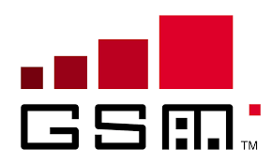

**GSM (Global System for Mobile communication)** is a [digital](http://searchcio-midmarket.techtarget.com/definition/digital) mobile telephony system that is widely used in Europe and other parts of the world. The origin of GSM technology can be traced back to year 1982 where the conference of the committee CEPT established a GSM group to widen the standards for a cellular mobile network system. However before the inception of GSM as a technology, there existed cellular systems like the AMPS(Advanced Mobile Phone Service) and the NMT(Nordic Mobile telephone) which flourished in the US and Sweden respectively. Networks based on these two set of specifications account for the great majority of mobile networks throughout the world in the early 1990’s. Another type of network TACT was derived from AMPS which was also deployed during the same period. These networks used the prevalent analog systems technology. These networks (also called as 1G networks) had limited bandwidth capacity and could be used for limited purposes including voice calls and sms. Maximum speed obtained from them would be 14.4 Kbps. Due to the limitation of the existing analog system and the incompatibility between TACT and NMT by mean a TACT server cannot access a NMT server and vice versa.

This led to the need of a new concept with a new standard which needed a common bandwidth and common standard. the first cellular telecommunications systems represented a huge leap in capabilities. The first cell phone systems that were developed used analogue technology. Two of the major systems that were in existence were the AMPS (Advanced Mobile Phone System) that was used in the USA and many other countries and TACS (Total Access Communications System) that was used in the UK as well as many other countries .

**BEGINNING OF GSM TECHNOLOGY:**

To achieve the basic definition of a new system a meeting was held in 1982 under the auspices of the Conference of European Posts and Telegraphs (CEPT). They formed a study group called the Groupe Special Mobile ( GSM ) to study and develop a pan-European public land mobile system. Several basic criteria that the new cellular technology would have to meet were set down for the new GSM system to meet. These included: good subjective speech quality, low terminal and service cost, support for international roaming, ability to support handheld terminals, support for range of new services and facilities, spectral efficiency, and finally ISDN compatibility.

With the levels of under-capacity being projected for the analogue systems, this gave a real sense of urgency to the GSM development. Although decisions about the exact nature of the cellular technology were not taken at an early stage, all parties involved had been working toward a digital system. This decision was finally made in February 1987. This gave a variety of advantages. Greater levels of spectral efficiency could be gained, and in addition to this the use of digital circuitry would allow for higher levels of integration in the circuitry. This in turn would result in cheaper handsets with more features. Nevertheless the GSM system had been started.

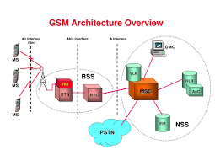

Over the next few years GSM became a funnel for ideas from every R&D Lab in Europe. Great institutions like CNET, CSELT and BTRL, key Industrial Labs (Ericsson, Alcatel etc) and many Universities were all drawn into this exciting new opportunity – to digitalise Europe’s mobile networks. 1987 was GSM’s Pivotal MomentOver a very turbulent period in 1987 Europe produced the very first agreed GSM Technical Specification (February). Ministers from the 4 big EU countries cemented their political support for GSM with the Bonn Minister’s Declaration (May) and the GSM MoU was tabled for signature (September). The MoU drew-in mobile operators from across Europe to pledge to invest in new GSM networks to an ambitious common date. It got GSM up and running fast. In a breathtaking 37 weeks the whole of Europe (countries and industries) had been brought behind GSM in a rare unity and speed.

**CREATION OF GSM**

In this pivotal moment the guiding hands shaping the outcome of all three critical events were Armin Silberhorn Germany), Stephen Temple (UK), Philippe Dupuis (France) and Renzo Failli (Italy). The very first GSM call was made by the Finnish Prime Minister (Harri Holkeri) in Helsinki to the Mayor of Tampere (Kaarina Suonio) who was in front of the Rosendahl Hotel in Tampere in Finland.

The future success of GSM then passed into the hands of hundreds of engineers from all the major mobile radio operators and the large systems companies. The result was a common cellular radio network right across Europe to serve the needs of the business community – an early triumph for the new European Single Market.But the future destiny of GSM was not to stay rooted in the business market. Something happened that took it off this path and onto one that was to lead GSM to become the most successful communications network in history – with over 6 billion users. The mobile industry was to move out of its base of professional electronics and into a new world of consumer electronics. The point of origin for this transformation was the seminal publication by the UK DTI called Phones on the Move”.

**PHONES ON THE MOVE COLLAGE**

This was the first public consultation by any government to set out the new visions of Personal Communications as a consumer industry driven by widening the scope for network competition, opening up the 1800 MHz bands, adding 38 GHz microwave links to reduce the cost of back-haul and adding fresh energy to GSM’s scale economies. **“Phone on the Move”** was conceived and written by Stephen Temple who also proposed and wrote the GSM MoU.Industry embraced the vision. The mobile revolution was born. Early long term research work has resulted in Nokia's advantage in the GSM development. Nokia today has a wide range of GSM products and the most advanced wireless data solutions in the market.

According to the Foundation, The Digital Cellular Telephone System (GSM) is among the most innovative and succesful telecommunications achievements globally. Nokia is one of the global pioneers, having actively cooperated in the development of GSM from its cradle to its current platform with users in more than 100 countries world-wide.

"Digital cellular radio standardization started in 1982 when the CEPT (The European Conference of Postal and Telecommunications Administrations) formed the Groupe Special Mobile (GSM, nowadays known as Global System for Mobile Communications) .Standardization was done through ETSI (European Telecommunications Standards Institute) and its GSM working groups. Nokia has participated in all these activities,"

**GSM - A SUCCESS STORY OF CO-OPERATION**

"It is evident that no single person or even one team can be identified as the father or the inventor of GSM. The development has been one of cooperation and evaluation as well as selection of technology between theoretical possibilities and practical operational solutions agreed upon to become a common specification," says Heikki Huttunen.Nokia´s GSM research work started in the early 1980s with the study of digital FDMA (Frequency Division Multiple Access), continuing then on narrow-band TDMA (Time Division Multiple Access) based systems. In

**Active participation of Nokia in shaping GSM technology:**

1986, Nokia delivered its first digital test system based on narrow-band TDMA technology to the Paris tests. Following that, the narrow-band TDMA concept was adopted by ETSI in 1987.

"The early investment on narrowband TDMA technology proved to offer a great advantage to us. Nokia has since often been the first company out with a ground-breaking, world-first solution or equipment," states Heikki Huttunen.In 1987, Nokia established Nokia Cellular Systems which concentrated on GSM infrastructure research and development. GSM-based mobile phones, as well as the Nokia 9000 Communicator development has taken place in Nokia Mobile Phones. In addition, Nokia Research Center, the corporate research unit established in 1986, has closely interacted with all Nokia units in exploring new technologies and product concepts as well as exploiting those in the actual product development of the Nokia business units.

* Nokia also actively participated in several ETSI working groups to develop the first GSM specification in 1987-1990 and has continued its efforts to support GSM evolution thereafter.
* The Nokia "World First" list includes the following industry GSM firsts:
* First GSM order (Radiolinja, Finland, 1989)
* First GSM mobile phone network (1991) and the first genuine GSM call in this Radiolinja network, supplied by Nokia.
* First company to begin GSM phone large scale production (1992)
* First DCS/GSM 1800 order (Orange, UK, 1991)
* First SMSC (Short Message Service Center) into commercial use (in Europolitan's
* First Personal Communications Network based on GSM 1800 standard delivery (1993).
* First company to offer GSM data products (1994)
* First PCS/GSM 1900 order for the US market (1995)
* First all-in-one communications tool, Nokia 9000 Communicator (1996)
* First GSM dual band base station (1997)

**NOKIA’S BIGGEST BLUNDERS**

1. **It never jumped on the flip-phone bandwagon:**

One of Nokia's earliest and biggest mistakes was the failure to capitalize on the flip-phone trend that was sweeping the U.S. in the early 2000s. Prior to that Nokia enjoyed a lofty position in the U.S. Nearly everyone had a candy-bar-style phone from Nokia.

The Motorola Razr helped propel the flip-phone craze. But a number of high-profile handsets from competitors began to push U.S. consumers towards the flip-phone model. Most notably, of course, was the original Motorola Razr, which became a runaway success and had Motorola actually challenging Nokia for market share at one point.

Nokia's response: make more candy-bar phones. Its dominant position -- the company at one time controlled two-thirds of the handset market -- meant it could afford to sell identical phones around the world, rather than customizing them for specific markets.. Nokia had its own application store, but it was a pale imitation of what developers could do with iOS. At that point it was clear Nokia had lost a lot of the buzz that sustained its brand. Its still-strong position was a legacy of its past strength, and as a result, it began to see its market share slowly deteriorate.

1. **It clung to Symbian too long:**

Cracks started to appear in the Symbian Os when Google's Android took center stage. Android gave other handset manufacturers a modern operating system they could use to compete with against the iPhone, and many were quick to jump on the bandwagon.Nokia's N97 was a cool phone, but saddled with an old operating system.

Nokia, however, stubbornly clung to Symbian. Indeed, the company opted to double down on Symbian, initially acquiring the operating system with the intent to distribute it as an open-source license. In 2008, the company released Symbian as part of the Symbian Foundation, an effort to form a coalition of vendors and companies supporting the platform. It didn't work, and Nokia was forced to re-absorb the foundation two years later.

**INNOVATIONS IN DESIGN AND MARKETING STRATEGIES(1990-2000s)**

In the 1980s under CEO [Kari Kairamo](https://en.wikipedia.org/wiki/Kari_Kairamo), Nokia expanded into new fields, mostly by acquisitions. In the late 1980s and early 1990s, the corporation ran into serious financial problems, partly due to heavy losses in its television manufacturing division.

In 1990–1993, Finland underwent a severe [recession](https://en.wikipedia.org/wiki/Early_1990s_recession), which also struck Nokia. Under Vuorilehto's management, Nokia was severely overhauled. The company responded by streamlining its telecommunications divisions and by divesting itself of the television and PC divisions.[[42]](https://en.wikipedia.org/wiki/History_of_Nokia#cite_note-42)

Probably the most important strategic change in Nokia's history was made in 1992, however, when the new CEO [Jorma Ollila](https://en.wikipedia.org/wiki/Jorma_Ollila" \o "Jorma Ollila) made a crucial strategic decision to concentrate solely on telecommunications.

The decision to focus on telecommunications over other businesses along with landmark design innovations led to the rise of Nokia as the leading phone manufacturing company.

**MOVING AWAY FROM OTHER BUSINESSES**

The company decided to exit consumer electronics in the 1990s and focused solely on the fastest growing segments in [telecommunications](https://en.wikipedia.org/wiki/Telecommunications).[[43]](https://en.wikipedia.org/wiki/History_of_Nokia#cite_note-Jorma_Ollila-43) [Nokian Tyres](https://en.wikipedia.org/wiki/Nokian_Tyres" \o "Nokian Tyres), manufacturer of tires, split from Nokia Corporation in 1988[[48]](https://en.wikipedia.org/wiki/History_of_Nokia#cite_note-48) and two years later [Nokian Footwear](https://en.wikipedia.org/wiki/Nokian_Footwear" \o "Nokian Footwear), manufacturer of rubber boots, was founded.[[6]](https://en.wikipedia.org/wiki/History_of_Nokia#cite_note-Nokian_Footwear-6) In 1989, Nokia also sold the original paper business; currently this company (*Nokian Paperi*) is owned by [SCA](https://en.wikipedia.org/wiki/Svenska_Cellulosa_Aktiebolaget). During the rest of the 1990s, Nokia divested itself of all other businesses.[[43]](https://en.wikipedia.org/wiki/History_of_Nokia#cite_note-Jorma_Ollila-43)

Until the new millennium, Nokia had a few remaining industries other than the core mobile phones, such as [CRT](https://en.wikipedia.org/wiki/Cathode_ray_tube) displays for PCs (until 2000, acquired by [ViewSonic](https://en.wikipedia.org/wiki/ViewSonic" \o "ViewSonic)), [DSL modems](https://en.wikipedia.org/wiki/DSL_modem), digital and analog [set-top boxes](https://en.wikipedia.org/wiki/Set-top_box), PC equipment and cards, and [televisions](https://en.wikipedia.org/wiki/Television). Most of these were gradually ended in the 2000s**.**

**LOGISTICAL CRISIS**

 As late as 1991, more than a quarter of Nokia's turnover came from sales in Finland. However, after the strategic change of 1992, Nokia sales to North America, South America and Asia became significant. The worldwide popularity of mobile telephones, beyond even Nokia's most optimistic predictions, created a [logistical](https://en.wikipedia.org/wiki/Logistical) crisis in the mid-1990s, prompting Nokia to overhaul its entire supply chain. Between 1996 and 2001,they overhauled the process, Nokia's turnover increased almost fivefold from 6.5 billion euros to 31 billion euros. Logistics continued to be a major advantages over rivals, along with greater [economies of scale](https://en.wikipedia.org/wiki/Economy_of_scale).

**FOCUS ON PHONES**

Nokia's first fully portable mobile phone (after the Mobira Senator car phone of 1982) was the [Mobira Cityman 900](https://en.wikipedia.org/wiki/Mobira_Cityman_900" \o "Mobira Cityman 900) in 1987. Nokia assisted in the development of the [GSM](https://en.wikipedia.org/wiki/GSM) mobile standard in the 1980s, and developed the first GSM network with [Siemens](https://en.wikipedia.org/wiki/Siemens) (predecessor of [Nokia Siemens Network](https://en.wikipedia.org/wiki/Nokia_Siemens_Network)). The world's first GSM call was made by Finnish prime minister [Harri Holkeri](https://en.wikipedia.org/wiki/Harri_Holkeri" \o "Harri Holkeri) on July 1, 1991 using Nokia equipment, on the 900 MHz band network built by Nokia and operated by [Radiolinja](https://en.wikipedia.org/wiki/Radiolinja" \o "Radiolinja). In November 1992 the [Nokia 1011](https://en.wikipedia.org/wiki/Nokia_1011) was the first commercially available mobile phone. In 1998 Nokia overtook [Motorola](https://en.wikipedia.org/wiki/Motorola) and became the best-selling mobile phone brand.

**DESIGN OF NOKIA PHONES -HOW THEY EVOLVED**

Nokia moved into GSM with commitment. Ollila realised that GSM would eventually eclipse analogue. Early GSM phones were upgrades of analogue designs, but a distinctive Nokia feel emerged with two classic designs, the 2110 business phone and the 1610 consumer phone. Both achieved a long production run and a loyal following.

## **SOME LANDMARK PHONES OF NOKIA**

**The Nokia Cityman 1320 -(1987)**

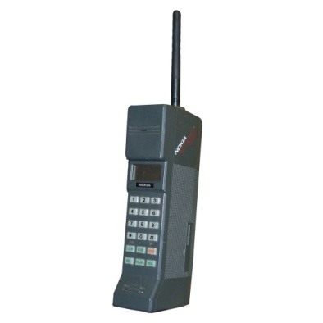

Figure :Nokia1320

* Nokia's first hand portable phone.
* High end phone combining the best Finnish design with Nokia's technical savvy.
* Nokia gained a massive publicity when Soviet leader Mikhail Gorbachev used a Cityman to make a call from Helsinki to his communications minister. Perhaps the first celebrity endorsement of a mobile phone.
* Nokia was taking around 10% of the UK cell phone market in 1988. However, their products included car phones and transportable phones as well as the sleek Cityman. Like most phones in the 80s, after a year or so the Cityman started to lose its appeal.

**The Nokia 101 -(1992)**

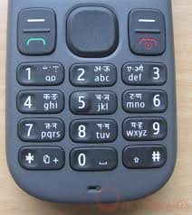

Figure :Colour coding in 101

* The Nokia 101 was the first phone which showed Nokia's distinctive approach to mobile phone design –easy usage.
* Layout of the keys was critical - well spaced and placed for easy and natural use.
* Colour coding to distinguish function - The green and red keys for answer and reject became an industry standard.  Keys were also well sized and responsive.
* Backlit keyboard for easy use in the dark.
* The Nokia 101 was designed to put the mouth and earpieces at a comfortable distance.
* Featured in the movie – The Matrix.
* The menu system in the 101 was designed to be intuitive and easy to learn.
* . Nokia provided a choice of three batteries, a slim-line standard battery and two high capacity options. There was also a range of chargers, including a travel charger that could restore the phone to full power in 30 minutes.

**The Nokia 1011 – GSM phone**

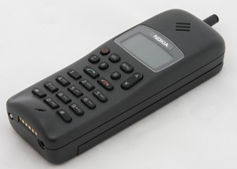

Figure :Nokia 1011

* The Nokia 1011 was Nokia's first GSM phone.
* Was available in the UK with Vodafone's EuroDigital tariff. EuroDigital was the more expensive package, aimed at high end users.
* The 1011 was a bridge between Nokia's analogue and digital phones. After 1994 Nokia focused almost exclusively on GSM, whereas rival Motorola continued with analogue.
* The Nokia 1011 can be used today.

**The Nokia 2110 –First phone with the ringtone -(1994)**

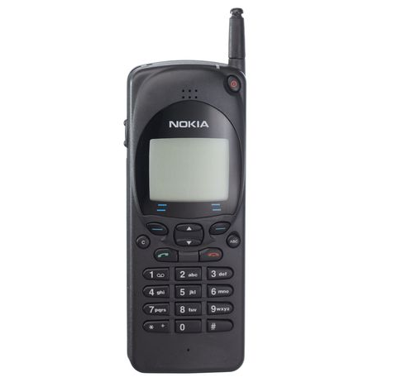

Figure :Nokia 2110

* It was the smallest GSM phone on the market.
* It was also the first mobile phone with the Nokia tune.
* The Nokia 2110 was Nokia's second generation of GSM phone - the first one designed purely for the digital network rather than a reworking of an existing analogue phone.
* A variant of this design, the 2140 became the first Orange phone.

**The Nokia 8110 –The first sliding phone- (1996)**

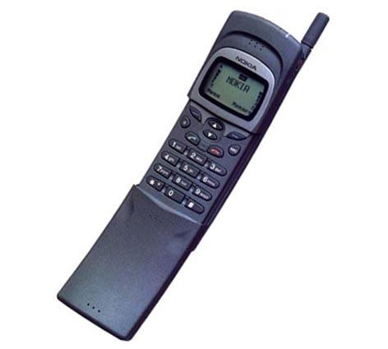

Figure :Nokia 8110

* The Nokia 8110 re-defined what a mobile phone should look like. It was smaller and lighter than other Nokia phones, but the curved profile, which gave it the nickname, 'the banana' and sliding mouth piece. The design reflected the way people used a phone.
* Answering a call was easy with the Nokia 8110, you just opened the slider to accept the call and closed it to end the call. You could adjust the slider to so that the mouth piece was in exactly the right position for your mouth.

**The Nokia 3110- Navigation key introduced ---(1997)**

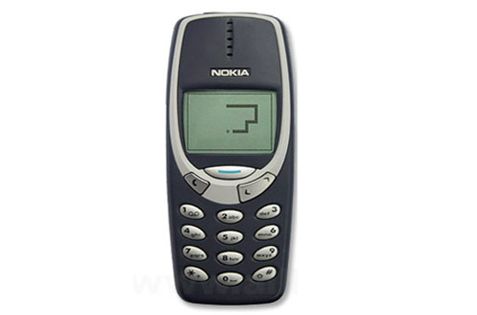

Figure :Nokia 3110

* It came with a new set of ringtones: Jingle Bells, William Tell, Mozart's Symphony Number 40 and The Liberty Bell composed by John Philip Sousa, known by most people as the theme tune to Monty Python's Flying Circus.
* It introduced the now familiar Navi Key, making scrolling through Nokia's menu system a breeze.

## **MARKETING STRATEGY- PRODUCT CATEGORIZATION**

Product categories were a key part of Nokia's marketing strategy by 1998. The main categories were Expression (basic phones with customisable fascias and ringtones), Classic (business phones), Fashion (top range consumer phones emphasising coolness and style) and Premium (top range business phones emphasising status). It is hard to be certain when Nokia first started using these terms internally and the categories were fluid, with some phones moving down a category as they got older and less desirable.

Nokia added more categories in the early 2000s, Entry and Active. Entry was all about cheap phones for first time users or people who wanted 'just a phone'. Active phones were tough phones for sporty users or builders.

### Premium category (8800 series)

* Were the the very best that Nokia could offer - Brought the status of luxury watches and sports cars to mobile phones.
* They were meant for top executives and wealthy individuals.
* The first true premium phone was the 8810 which brought a shiny chrome look to the black and grey phones of the era. It was no co-incidence that the model number began with 88, given the significance of 8 in Asian culture. The range included a gold plated version aimed at the Hong Kong market.

### Fashion category (7000 series from 2002)

* Were about style and coolness.
* They were top end consumer phones with the latest features, but chic rather than geek.
* Slanted more towards women.

|  |  |  |  |
| --- | --- | --- | --- |
|  |  |  |  |
|  |  |  |  |
|  |  |  |  |

### Classic category (6000 series)

* Business phones offering conservative styling and advanced business features such as tri-band GSM and infra red and Bluetooth connectivity.
* Targeted business users who valued efficiency, productivity and compatibility with older phones.
* The 6310 inspired a loyal customer base who wanted to continue using this phone long after other designs had surpassed it.

### Expression (3000 series from 1999)

* Expression phones were about simplicity and personalisation.
* They were targeted at a market segment Nokia called 'Balancers'. Balancers valued family and the important things in life. They wanted phones that were easy to use and quick to master, but offered some amount of personalisation.
* The 3110 from 1997 - introduced the intuitive Navi-key

**POSSIBLE MISTAKES**

1. It never jumped on the flip-phone bandwagon**:** One of Nokia's earliest and biggest mistakes was the failure to capitalize on the flip-phone trend that was sweeping different parts of the world in the early 2000s. Prior to that Nokia enjoyed a lofty position . Nearly everyone had a candy-bar-style phone from Nokia.

The Motorola Razr helped propel the flip-phone craze.

But a number of high-profile handsets from competitors began to push U.S. consumers towards the flip-phone model. Most notably, of course, was the original Motorola Razr, which became a runaway success and had Motorola actually challenging Nokia for market share at one point.

Nokia's response: make more candy-bar phones. Its dominant position -- the company at one time controlled two-thirds of the handset market -- meant it could afford to sell identical phones around the world, rather than customizing them for specific markets. Its reluctance to move into flip-phones early cost the company the U.S. market, a place where it hasn't had a major presence for more than a decade.

2. It continued to ignore the U.S. market**:** Nokia's inability to make custom phones for the U.S. market didn't win itself many allies among the local carriers, further accelerating its market share declines here. Nokia's "my way or the highway" approach with its handsets didn't sit well with the carriers, who were entertaining more nimble players like Motorola.

In addition, Samsung Electronics and LG Electronics were more than happy to bend over backwards to accommodate the carriers, and it's no surprise their influence in the industry grew over the last decade.

Nokia instead receded into a niche brand with a few loyal fans. The company set up its own shops in major cities such as New York, selling its phones directly to consumers without a contract, which meant a high non-subsidized price that only a small set of hardcore devotees were willing to pay.

More importantly, Nokia's minimal presence in the U.S. meant it wasn't tapped into the market when it shifted to the modern smartphone.

**CONCLUSION**

Nokia as a company is often seen as a pioneer in design and development of the handheld mobile phone.It was known for its innovative modelling ,for the first time developing phones according to the customers’ ease of usage.

Inspite of enjoying a dream run as far as phone manufacturing is concerned ,the above mistake of not adapting itself to the to the changing design trends and market requirements significantly laid the seeds of their downfall.It is important to note that though they went on to be more successful in the early 2000s , entrepreneurial decisions taken at the right time ,i.e when they were at the peak (late 1990s) may have changed the course of history for the company.

**The 2000s – The Golden Era**

Although Nokia was the world leader in the mobile phones market, the new decade brought along a new set of challenges for the company. The wireless and Internet technologies were converging, and the 3rd generation of wireless technology - that promised enhanced multimedia capability - was evolving. With the introduction of 3G in wireless networking in 1998, radical changes were required to keep up with the increasing demands of the people for mobile devices with improved multimedia capabilities.

Responding to the changes, the Finnish company started churning out both sophisticated multimedia handsets as well as low-end devices.

### 2001

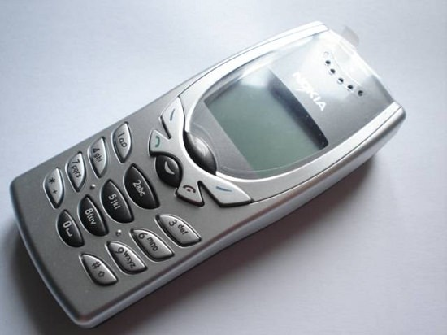

2001 was the birth year of the world’s first monochromatic display cell phone, and with that we wave goodbye to the old and boring black display. The image shows a Nokia 8250, which had a single colour display, for example the background was not the same grey background anymore, it had backgrounds of different colours like blue, which along with the compact design made this phone a great choice for everyone.

.

In 2002, technology made another huge change in the history of mobile phones, putting a great full colour display and integrating camera to mobile phones, producing the world’s first camera cell phone. The Nokia 7650 shown here is on sliding mode, features a great colour display and a 0.3MP camera allowing you to snap pictures on the move. This was followed by the launch of its (as well as the world’s) first 3G phone, [the Nokia 6650](http://www.gsmarena.com/nokia_6650-348.php),in 2002.

The same year, the company also launched the Nokia 3650, the first Symbian Series 60 device to appear in the US market. It was also Nokia’s first phone to feature a video recorder.

In 2003, the company launched [the Nokia 1100](http://www.gsmarena.com/nokia_1100-512.php), a budget-friendly phone that sold around a whopping 250 million units, making it the best selling phone as well as the best selling consumer electronics product in the world. Incidentally, it was also the company’s billionth phone sold later in 2005.

The following year, [the Nokia 7280](http://www.gsmarena.com/nokia_7280-884.php) "lipstick" phone was launched. Part of the company’s "Fashion Phone" line, the device was listed as one of the best products of the year by Fortune Magazine. It also featured in the Pussycat Dolls' "Beep" music video.

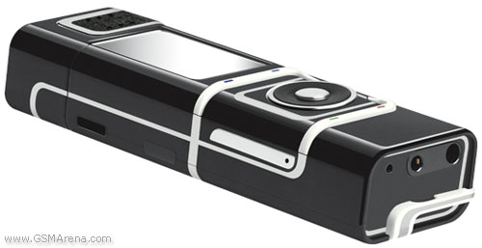

Midway through the decade, the company launched its N-series of phones, with [the N70](http://www.gsmarena.com/nokia_n70-1153.php), [N90](http://www.gsmarena.com/nokia_n90-1155.php), and [N91](http://www.gsmarena.com/nokia_n91-1154.php) being the first members of the series. The flagship [N8](http://www.gsmarena.com/nokia_n8-3252.php) was launched later in 2010.

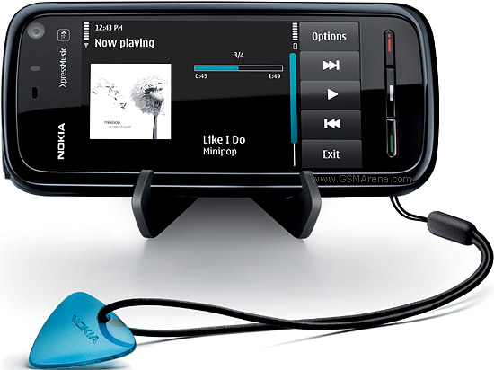

With Apple launching its [first-generation iPhone](http://www.gsmarena.com/apple_iphone-1827.php) in 2007 and the growing popularity of touch-screen phones, Nokia outed its first all touch smartphone in 2008. Dubbed [the 5800 Xpress Music](http://www.gsmarena.com/nokia_5800_xpressmusic-2537.php), the device was also the first to run the touch-driven Symbian v9.4 (S60 5th Edition). It was decently successful as the company managed to sell around 8 million units of the device, but it didn't manage to create die-hard following as it touch-experience was sub-par.

Nokia only got into Mobiles in 1987 and today 1 in 5 people on the planet have got a Nokia.

Mobile Phones started this decade behind fixed landlines, levelled with them in 2003, and by 2010 wireless connections outnumbered fixed lines by so much that there were more Nokia branded Mobiles in use than there were fixed lines.

# Our Interpretation

From 2000, much to the surprise of the market, the Nokia bandwagon veered off the road – only slightly, at first, and then much more seriously. In August 2000, the value of the Nokia brand was deemed to be £21.9 billion (€30.7 billion), according to Interbrand. By 2004, the brand value had collapsed to £13.7 billion (€19.2 billion) – a reduction of 37.5%.

In the early 2000s, Nokia just concentrated on developing the high-end mobile phones and the complicated software tending to supply the technologically advanced products and surpass the competitors, while paying insufficient attention to external developments.Focusing on internal rather than market benefits, Nokia were guilty of taking their eyes off the market place, and failed to read and monitor the growing demand for colour phones, inbuilt cameras and clamshell models. Other, smaller, hungrier, more market-focused competitors saw the way the market was going much more accurately. They built up value by offering the above features to the market. Nokia, on their own admission, focused on functional features like size, stability and ease of use. They also restricted the range of their models, mainly to reap the rewards of manufacturing cost reduction. However, important segments of the market wanted more variation than Nokia was giving them.

Over time, Nokia realised the importance of the design element in mobile phones. Moreover, they realised that the phone would no longer play for just a functional role, but would also become fashion symbols. Since the company first broke new ground and launched its differentiating and innovative handset the 8210 instead of the popular bulky and bricklike device, the company helped shape the customer needs and led the market change. For Nokia, it not only achieved the ‘first mover advantage and increased its income, but also established a strong brand name in the mobile phone industry and gained an extensive lead over competitors in this area. Furthermore, based on the successful innovations from its employees, such as text message, Nokia’s Navikey, internal antennae design and so on, Nokia constantly updated its competence and gradually became the market leaders. Obviously, this transition required both an inside-out capability to produce the custom products, different from the competitor’s, as well as theoutside-in capability of understanding the evolving requirements of customers and energizing the organization to cater to them. Meanwhile, it also implied that market-led strategy and resource-based strategy have a reciprocal relationship, indeed, they complement each other. Following these successes, Nokia solidified its market position based on its strong internal resource along with the company’s ability to be sensitive towards market trends.

**Marketing Strategy**

In the mobile phone industry, there is no recognized segment definition. However, Nokia, the No.1 player in the world at the time used an outstanding marketing strategy by segmenting their user base as follows :

**Hi-fliers** - Corporate executives who use a mobile phone to increase productivity at work. Aged between 25-45. The company sponsors the handset; hence price is not a major consideration. **Trendsetters** - The first segment to adopt an emerging technology (the early adopters). For Nokia, these early adopters are 'Trendsetters' who are most receptive to advanced models.

**Social contact -**  The third segment for Nokia is the upwardly mobile, socially conscious segment that uses a mobile to stay in touch. Today's youth and affluent housewives constitute two major chunks of the segment.

**Assured** - High-profile celebrities, industrialists and other high "net worth" individuals. The fact that the segment cannot do without a mobile phone makes it the 'assured' segment.

They banked on these following features as the cornerstone of their marketing blueprint :

**Brand Knowledge**

• Brand Awareness - Nokia has the highest top of the mind recall compared to its competitors. Hence it has high brand salience. The aided recall (brand recognition) for Nokia is also higher compared to its competitors

• Brand Image - Nokia has significant positive brand associations compared to neutral or negative associations. Customers acknowledge Nokia for its reliability. The perception of the customers towards the brand is also positive.

**Brand Loyalty**

Customers who already have a Nokia mobile phone are ready to re- purchase a Nokia mobile phone by paying a price premium. This means that Nokia users are loyal towards their brand. The loyalty factor of customers having other brands is less as compared to Nokia. Loyalty factor helps in attracting new customers by creating awareness and reassurance in the brand (Aaker, 1991). Nokia can also use this factor to respond to threats posed by competitors.

**Brand Awareness** We already have mentioned that Nokia has the highest brand awareness in the market. Another factor that buttresses our stand of Nokia’s high brand awareness is that a significant number of non-Nokia users are ready to switch over to Nokia brand in their next mobile phone purchase.

**Perceived Quality** Nokia is positioned at the top of the mobile phone category in terms of perceived quality factor. The brand-positioning map positions Nokia high both in terms of Price and Quality (refer Graph 5 in the Nokia Brand Equity Analysis appendix). This factor differentiates Nokia from its competitors and affects purchasing decisions of potential customers as well as builds positive associations with its channel members.

**Brand Associations** As already mentioned by us, Nokia has positive brand associations to its credit. This factor would work as a significant parameter for potential customers for their purchasing decisions towards Nokia.

**Other Proprietary Brand Assets** Nokia has over 100 small and large patents in the area of technology and research. This factor helps the company with a competitive advantage by restricting competitors to capture its customer base and loyalty. It is more of a strategic branding strategy to face the competition.

**Brand Personality** As a person, Nokia stands for competence, which means reliable, intelligent and successful. It also stands for sincerity, which means down-to-earth, honest, wholesome and cheerful.

**Brand Elements** Logo of the brand is `Nokia` which is short and easy to remember as a brand name. It has a punch line ``Connecting People`` which fits very well with the business that Nokia is into and the strategic direction that it wants to see for itself in the future.

**SWOT analysis of the golden era**

**Strengths**

* Having the advanced technology over the competitors in the mobile phone industry
* Decentralized company structure, innovative and creative employees and Charismatic strong leader, such as: JormaOllila.
* The market leadership in the mobile industry.
* Strong brand name and company image in the global market
* Has its own manufacture and network.
* Economy of scale

**Weaknesses**

* Complacency and arrogance.
* Few alliances, company sticks to its standing in the market, do not want to cooperate with the operators.For instance, Vodafone did a deal with Sharp, who designed and badged a handset just for them. Nokia believed that customers would stay loyal to handset makers, and paid less attention to their channel partners.

**Opportunities**

* The emerging market in developing countries, such as China, India.
* The emerging market for high-end mobile phone such as business user phone.

**Threats**

* Facing more new competitors, especially from Asia.
* Strong competition in mobile industry
* Lost market share
* The market becomes saturated
* Stronger buyer power from the network operators.

[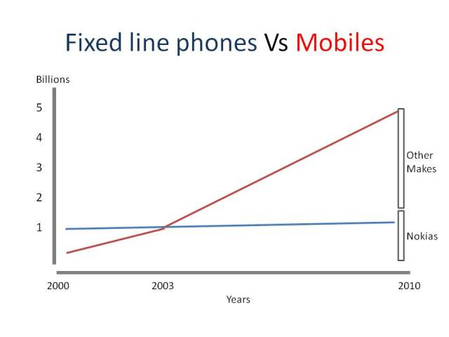](https://3gdoctor.files.wordpress.com/2010/01/slide2.jpg)

By the end of the decade both SMS and MMS (Picture) messaging had become more popular than PC internet messaging. We are nearly at a level where there are more people messaging via Nokia mobiles than there are accessing the internet!

[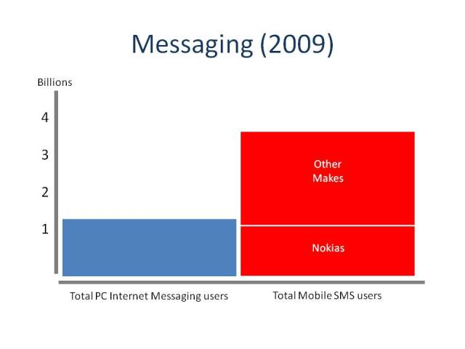](https://3gdoctor.files.wordpress.com/2010/01/slide3.jpg)

Nokia became the leading manufacturer of personal music devices, selling 4 times as many devices as managed by nearest rival Apple (with the iconic iPod that began shipping 2 years earlier)

[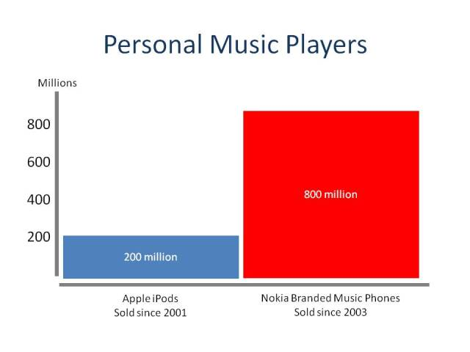](https://3gdoctor.files.wordpress.com/2010/01/slide4.jpg)

Nokia became the biggest manufacturer of watches – overtaking Seiko by 120 million units in 2008.

[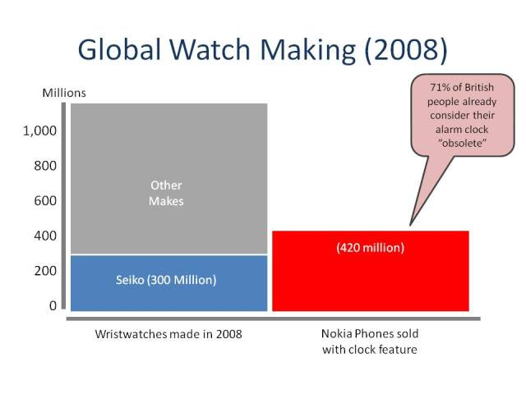](https://3gdoctor.files.wordpress.com/2010/01/slide5.jpg)

Nokia Snake became the most popular game, coming supplied on 1.5 billion more devices than the PC game Solitaire managed.[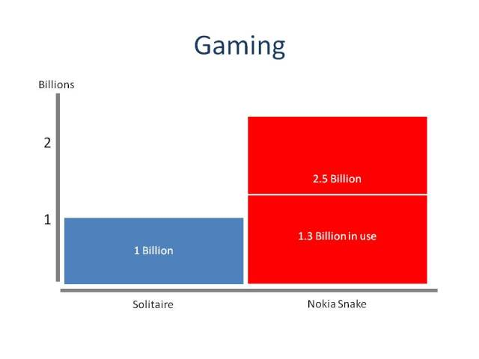](https://3gdoctor.files.wordpress.com/2010/01/slide6.jpg)

Nokia became the biggest producer of Calculators, taking only 7 years to catch up with the volume sold by the previous market leader CASIO.

[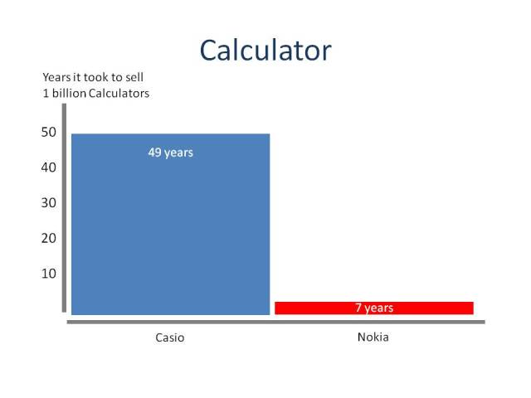](https://3gdoctor.files.wordpress.com/2010/01/slide71.jpg)

Nokia shipped 3.8 Billion Camera phones, in one decade surpassing the total global market of both digital and film based cameras ever sold!

[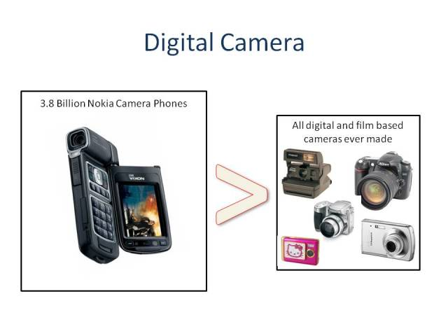](https://3gdoctor.files.wordpress.com/2010/01/slide8.jpg)

Proving high tech muscle, they also produced 72 million “smartphone” computers, exceeding the volumes of the largest PC manufacturer HP by nearly 20 million units.

[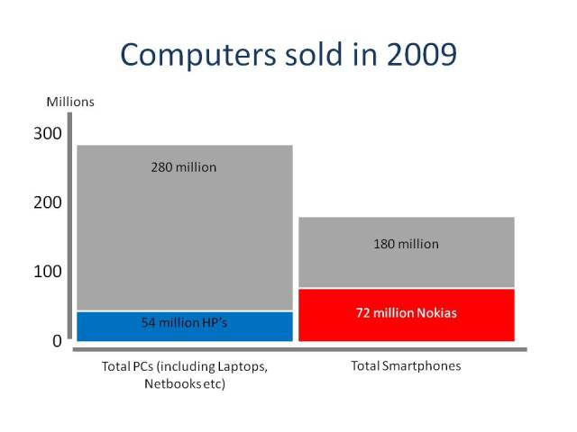](https://3gdoctor.files.wordpress.com/2010/01/slide9.jpg)

After that, Nokia’s success rocketed and in the next few years, it became the world’s largest mobile phone manufacturer. Nokia kept the position for fourteen consecutive years and only lost this position recently to Samsung in 2012. Nokia’s best selling phones, Nokia 1100, Nokia 3310 (jokingly known as the most powerful phone on Earth) and etc were also made during this time. Many other innovations were introduced and some others were made common by Nokia in its ‘Golden Age’ (a ‘duty’ which now Apple performs).

Nokia has experienced declined sales over the past five years with the introduction of more superior OSes(Operating Systems) than it’s Symbian OS such as the Android OS and iOS. As a result, the share price of Nokia has also dropped from $40 in 2007 to a measly $3 in 2012. Nokia’s hardware quality has always been far superior (in my opinion) to all other smartphone and mobile manufacturers such as Apple and Samsung; it has been let down by the old Symbian OS. Before 2007, Symbian was quite advanced for its age but as time passed, it was not changed much and software is a major letdown for Nokia. As a fact, Nokia decided to change the OS for its mobiles and struck a deal with Microsoft in February 2011 to only produce smartphones with Microsoft’s Windows Phone platform. The result was the successful Lumia series which sold “well above 1 million” and although very less than the sale numbers of Apple’s iPhone and Google’s Android OS based smartphones; it still shows that Nokia is not dead and could rise again to its former glory.

**Conclusion:**

At the dawn of the mobile era, Nokia was the emergent star. The simplicity of the handsets opened the doors of mobile communication and sucked the world in.

Easily navigable buttons and uncluttered menus made popular practices such as texting and storing phone numbers a breeze.

The popularity of the brand meant that charger compatibility was hardly an issue. Every household could be relied upon to have a Nokia charger lurking in a corner.

It was a golden era. Old and young alike texted each other, emoticons emerged, vowels were dropped, Snake was played, and people snatched care-free minutes in conversation despite being on pay-as-you go contracts.

However, success does not continue forever until you do not work hard to meet the current generation standards. The same happened with Nokia which lost it’s edge due to the introduction of Apple’s iPhone and Google’s Android OS based smart phones.

**What led to the downfall of Nokia?**

**Early hiccups**

It was the year 2001, when Nokia’s profits first crumbled after becoming the top phone maker in the world. This was primarily due to a slowdown in mobile phone market. That downfall turned out to be short-lived, but three years later, in 2004, the company again reported that it’s market share is sliding, despite still leading with the solid 35%.

Another hiccup came in 2007, when the company had to recall a whopping 46 million faulty cell-phone batteries. What’s even worse was that the batteries - which were manufactured between 2005-end and 2006-end - appeared in a wide range of Nokia phones, which meant that a large part of the company’s device portfolio was affected.

In 2008 - the same year when the Android version 1.0 was launched - Nokia’s Q3 profits nosedived 30%, while sales decreased 3.1%. On the other hand, iPhone sales sky-rocketed by around 330% during the same period.

**Ignored The Market**

In 1998, Nokia over threw Motorola as the World’s biggest mobile phone vendor. Nokia continued to dominate and went on to become the largest mobile vendor for straight 14-years. The year 2009 saw Nokia, the struggling Finnish company finally acknowledge that it was slow to react to the change in the market, which was now slowly being taken over by the likes of Apple and BlackBerry, and influenced by newcomers like Samsung, HTC, and LG.

The following year, Stephen Elop - who was previously head of Microsoft's business software division - was appointed as Nokia’s new CEO. He was also the first non-Finnish leader of the company. Although 2010 saw a rise in profits for the company, job cuts continued.

**Not Dumping Symbian**

Nokia owns the Symbian OS which simply explains why they were literally stuck with the OS for so long. In 2007 when the original iPhone was released, it showed the weakness of the Symbian OS. Desperate to come out of the ongoing crisis and better compete with competitors, Nokia announced a strategic partnership with software giant Microsoft to make the latter’s Windows Phone its primary mobile OS.

Meanwhile, Apple overtook Nokia in smartphone sales in Q2, 2011.

The first fruit the partnership between Nokia and Microsoft bore were [the Lumia 800](http://www.gsmarena.com/nokia_lumia_800-4240.php) and [Lumia 710](http://www.gsmarena.com/nokia_lumia_710-4276.php) smartphones, which were announced later in 2011. While the former targeted the higher end of the market, the latter was aimed at lower end-customers.

Although the company managed to beat market expectations by selling over a million units of these devices in just a few months, job cuts continued. Meanwhile, in an effort to save more expenses, the company also announced that it will close its oldest factory in Finland and shift its manufacturing to Asia, which had become its largest market by then - all of this happened in early 2012.

Despite decent sales, the new Windows Phone devices couldn’t do much for Nokia in Q1, 2012, when the company suffered an operating loss of a whopping €1.3 billion. This was followed by another round of job cuts, affecting around 10,000 employees this time.

Later that year, the company launched Windows Phone 8-powered [Lumia 920](http://www.gsmarena.com/nokia_lumia_920-4967.php) flagship, which received mixed reviews - mainly criticized for its large size and bulkiness. In November 2012, the smartphone became best-selling phone of the week on Amazon, and also topped Expansys' chart in the UK during the same period - still it never quite reached the blockbuster sales the company needed to return to profitability.

Finally, the year 2013 brought some good news as Nokia returned to profit six quarters of bleeding money. However, revenue dropped considerably owing to the company’s failure to make any dent in the smartphone market.

In September that year, Nokia announced it’s selling its Devices & Services division to Microsoft.

The deal, which saw CEO Stephen Elop return to Microsoft, also included the Finnish company's patents and mapping services, although it excluded the Nokia’s Chennai factory in India as well as the Masan factory in South Korea. The sale [officially completed](http://www.gsmarena.com/nokia__microsoft_deal_completes_on_april_25-news-8338.php) in April 2014.

The company took way too long to embrace the smartphone revolution and when it finally did it made way too many errors in its strategy.

First, Nokia tried to compete by simply adding touch to the legacy Symbian - a patch that failed to deliver the fluid user experience of its rivals at the time. Then the switch to Windows Phone was announced way before there was actual hardware ready - a move that Elop hoped will boost developer interest, but ended up mostly killing Symbian sales 7 months before Nokia had an alternative to offer. Two mistakes of that magnitude, combined with the great delay in jumping to touchscreen were enough to cost the company's dominant position in the quickly moving market.

**Apple's smartphone revolution**

Contrary to public misperception, Apple did not invent the smartphone. Before Steve Jobs' touchscreen powerhouse came on the scene, Nokia was the leader in the smartphone business, owning roughly half the market.

But what the iPhone brought to the market was a new sense of what a smartphone could do, and who could benefit from such a device: virtually everything and everyone. Apple led the charge in turning the smartphone into a consumer device from one primarily used in a corporate setting, a notion that then-Research in Motion had scratched at the year before with its compact and consumer friendly BlackBerry Pearl.

Apple's slick iOS touchscreen-based software revolutionized how people interacted with their phones. In comparison, the slew of smartphones in the market worked on older, clunky operating systems. Nokia's Symbian software was no different, and it was starting to show its age just as the iPhone, and later Google's [Android](http://www.cnet.com/android-update/) operating system, began to take off.

Still, Nokia refused to jump on the touchscreen bandwagon, again showing its inability to adapt to new trends. It waited a year after the original iPhone launched to [unveil its first touchscreen phone, the Nokia 5800](http://online.wsj.com/news/articles/SB122245489204479599). Unfortunately, it was less a smartphone and more a handset optimized to play music.

Just as important was Apple's success in popularizing the concept of an app store. Nokia actually had a fairly robust app store, but it was geared to more technically savvy users, and not as easy to use as the iOS App Store. The app ecosystem is credited with locking customers into Apple's operating systems, firming its lead in the smartphone business.

To many of the executives in Nokia, it wasn't just arrogance that kept them rooted in Symbian, but the inability to take risks.

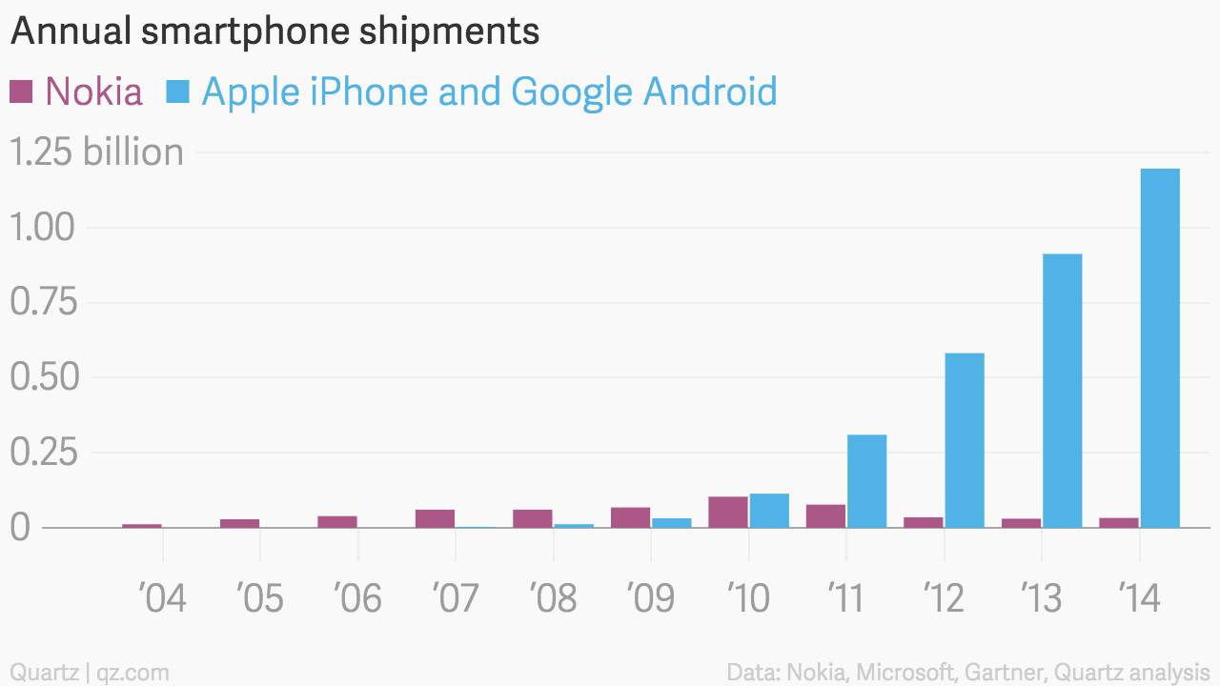

It’s more accurate to say that Nokia was, at its heart, a hardware company rather than a software company—that is, its engineers were expert at building physical devices, but not the programs that make those devices work. In the end, the company profoundly underestimated the importance of software, including the apps that run on smartphones, to the experience of using a phone. Nokia’s development process was long dominated by hardware engineers; software experts were marginalized. Executives at Apple, in contrast, saw hardware and software as equally important parts of a whole; they encouraged employees to work in multidisciplinary teams to design products.

It wasn’t just that Nokia failed to recognize the increasing importance of software, though. It also underestimated how important the transition to smartphones would be. And this was, in retrospect, a classic case of a company being enthralled (and, in a way, imprisoned) by its past success. Nokia was, after all, earning more than fifty per cent of all the profits in the mobile-phone industry in 2007, and most of those profits were not coming from smartphones. Diverting a lot of resources into a high-end, low-volume business (which is what the touch-screen smartphone business was in 2007) would have looked risky. In that sense, Nokia’s failure resulted at least in part from an institutional reluctance to transition into a new era.

And there was another mistake. Nokia **overestimated the strength of its brand**, and believed that even if it was late to the smartphone game it would be able to catch up quickly. Long after the iPhone’s release, in fact, Nokia continued to insist that its superior hardware designs would win over users. Even today, there are people who claim that if Nokia had stuck with its own operating systems, instead of embracing the Windows Phone in 2011, it could have succeeded. But even though the Windows Phone has been a flop, the truth is that, by 2010, Nokia had already introduced too many disappointing phones, and its operating system had already proven too buggy, clunky, and unintuitive to win consumers over. In 2008, Nokia was said to have one of the most valuable brands in the world. But it failed to recognize that brands today aren’t as resilient as they once were. The high-tech era has taught people to expect constant innovation; when companies fall behind, consumers are quick to punish them. Late and inadequate: for Nokia, it was a deadly combination.

The Finnish company’s **unwillingness to embrace drastic change** when it was required the most was probably the biggest reason that brought the mobile giant down.

**NOKIA AND MICROSOFT**

The journey of partnership between Nokia and Microsoft began in February 2011 when Nokia’s CEO Stephen Elop announced the new strategy for Nokia, which included the discontinuation of both of their in-house mobile operating systems (Symbian and MeeGO), shifting its smartphone strategy to Microsoft's largely untested Windows Phone platform, in an attempt to revive its fortunes in North America and compete against the threat from Google Android and Apple’s iPhone.

One of the dominant operating systems in 2011 was Android owned by Google and Nokia emphasizing on differentiating themselves from the rest of the phone manufacturers made the decision to switch to Windows OS instead of Android. This move was later regretted by the company.

In September,2011 Nokia had released its one and only mobile phone running on MeeGo Nokia N9. The phone had a huge critical success, with some implying that it was the best device that the company created. However, Elop stuck with the Microsoft deal, saying that MeeGo development will not continue even with the N9's success, a move that was widely criticised. Later that year Nokia released its first smartphone running on Windows operating system the Nokia Lumia 800.

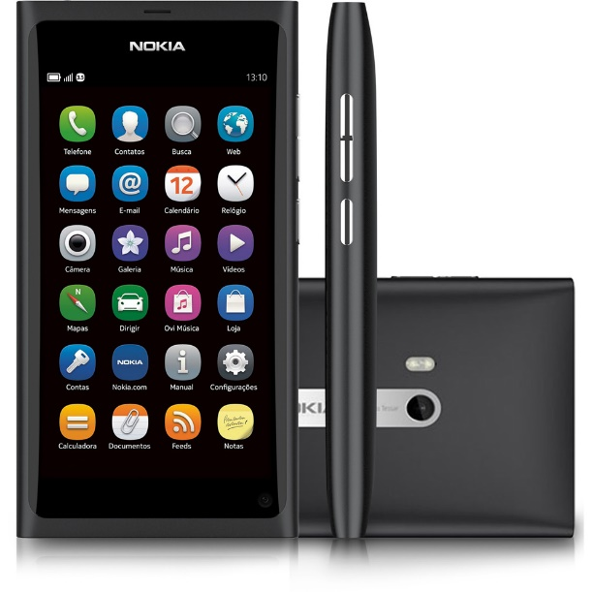(Pic 1: Nokia N9)

Between 2010 and 2013 Nokia released a wide range of mobile phones running on Windows platform which included some popular phones like Nokia Lumia 930 which helped it to gain some market share.

In Q2 of 2010 Nokia was the leading phone manufacturer with 34.2% of the mobile device market being owned by it. Nokia couldn’t hold this position for too long as shown in Figure 2.

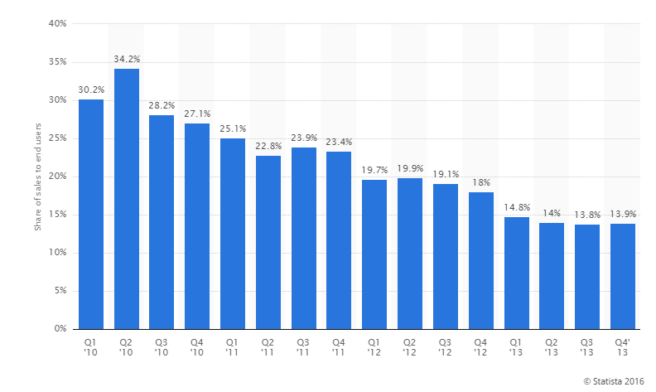

Figure 2: Nokia's global market share

During the tenure of Elop from 2010-2013 Nokia’s market value fell from €17bn to €11bn while net sales nearly halved from €10.3bn to €5.7bn. Operating profit dropped by 70 per cent to €118m from the third quarter of 2010 when he took over to the third quarter of 2013, just after he stepped down on September 3, and the company suffered a cumulative €4.9 billion loss.

In May 2013, after the two years that he had been granted for the transition to the Windows Phone platform, Elop was pressed by Nokia's shareholders about the lack of results compared to the competitors and the insufficient sales figures to secure the company's survival. During the annual general meeting, several shareholders voiced that they were running out of patience with Elop's efforts in putting Nokia back to the smartphone race. Elop replied that there was no turning back on his decision of adopting Windows Phone, while some analysts criticized Elop for closing doors to alternative strategies and going all-in with Microsoft's operating system. Some analysts speculated that Nokia had already lost the smartphone race to Samsung and Apple, and that if they were to regain their position in the market, it would have to be by means of low-end devices such as the Asha.

Although Nokia's smartphone market share recovered in 2013, it was still not enough to improve the dire financial situation. The company had already been making huge losses for two years and accepted the offer made by Microsoft to buy mobile phone and device business for 5.4 billion euros and that Elop would stand down as Nokia's CEO to become Executive Vice President of the Microsoft Devices Group business unit on 3rd September,2013.

Controversy arose around Elop receiving a €18.8 million (US$25 million) bonus after Nokia sold its mobile phone business to Microsoft and he stepped down as the CEO. The controversy was further fuelled after it was revealed that his contract had been revised on the same day as the deal was announced. [1] This move made many people believe that Elop who previously worked in Microsoft was a Trojan horse inserted by Microsoft in Nokia to acquire one of the best phone manufacturers and an esteemed brand name at a low price. Criticism even spread through politics, with Prime Minister of Finland Jyrki Katainen telling Finnish television that the payoff was "quite outrageous", and that is cannot be justified given the country's difficult economic times.

The sale was positive for Nokia to stop further disastrous financial figures, and was also good for Microsoft's CEO Steve Ballmer, who wanted Microsoft to produce more hardware and turn it into a 'devices and services' company. The sale was completed in April 2014, with Microsoft Mobile becoming the successor to Nokia's mobile devices division.

A SWOT(Strength-Weakness-Opportunities-Threat) Analysis will provide a better understanding of the Nokia Microsoft deal.

**STRENGTHS**

Nokia-Microsoft deal is a win-win situation for both the companies. This deal will provide Microsoft a strong platform for its OS. Microsoft will be able to make more money from each windows phone sold and it can provide a better integration between hardware and software. For Nokia this deal is very important as it may help to save their sinking mobile device share globally.

**WEAKNESS**

Both the companies are facing a shrink in their market share. Microsoft is a market leader in computer OS but in the smartphone section it only owns 4% of the market. The problem faced by Microsoft is like the Chicken/egg problem- “Microsoft needs market share to attract apps developers but they need developers to build market share.”

**OPPORTUNITIES**

This deal has great opportunity if both companies utilise their resources in optimum way. Microsoft can change their hardware in order for it to function well with the software and they have to utilise the full power of Nokia’s smartphone camera to garner market share.

**THREATS**

Microsoft faces threat from companies like Apple and Samsung using iOS and Android respectively. Smartphone manufacturers using Android are able to prove high spec phones at a low price which is a major threat for the Lumia phones.

Following the Nokia Microsoft Deal, Rajeev Suri became the CEO of Nokia. Microsoft initially released phones under the Nokia Lumia series and the phones weren’t a great hit among the youth who want the latest tech at the lowest price possible. Due to the buggy nature of their ambitious project Windows 10, the phones running on Windows wasn’t a massive hit either and hey lost all their market shares as shown in Figure 3.

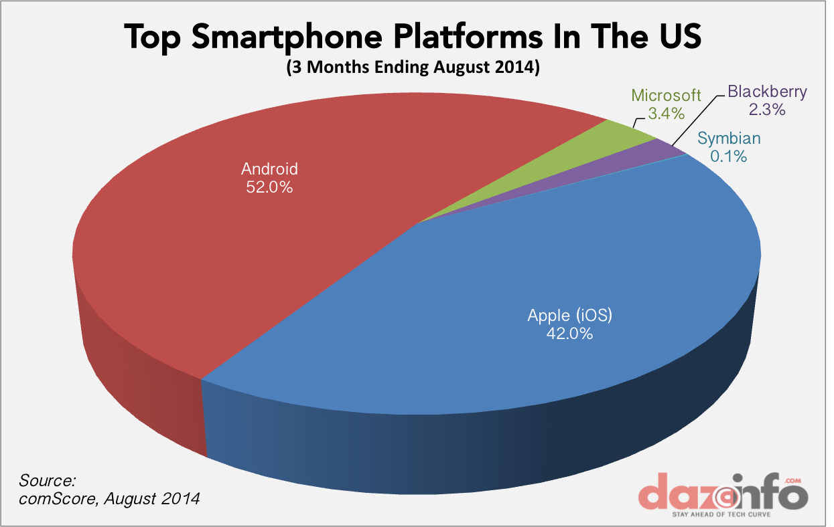

*Figure 3: Microsoft market share in US*

This point can further be proved with the planned cuts of 18000 employees by Microsoft, with 12,500 of those cuts coming from employees Microsoft acquired as part of its acquisition of Nokia's handset and service business in 2014.

Microsoft has wasted at least $8 billion on its failed Nokia experiment, including the costs of restructuring and severance payments for thousands of employees. Microsoft originally hired 25,000 Nokia employees as part of its $7.2 billion acquisition of Nokia's phone business, but a series of layoffs over the past two years has triggered the end of Microsoft's mobile subsidiary.

Microsoft's Nokia phone business acquisition was always tricky and risky, but it was a deal organized by former CEO Steve Ballmer. It has been clear from the start that Satya Nadella, Microsoft's new CEO, wasn't interested in running a phone business. Nadella announced a strategy shift away from a "devices and services" focus just a couple of months after the Nokia acquisition finalized, and last year the strategy shifted even further away from producing multiple handsets.

Many will argue Microsoft had no choice, as Nokia controlled more than 90 percent of the Windows Phone market and had been rumoured to be considering switching to Android. Google's experiment with making its own Android phones resulted in the search giant selling Motorola to Lenovo for $2.91 billion, less than two years after paying $12.5 billion to acquire it. While Google's investment was primarily driven by the need to obtain key patents, it's not clear how Microsoft has benefited from its Nokia deal.

We might not ever know the true reasons for Microsoft's Nokia phone business acquisition, but right now it's clear the company has wasted billions of dollars on a failed experiment to try and claw its way back into the mobile market. Microsoft might be preparing a Surface phone, but if it ever debuts it will only cater to the very few who are interested in phone versions of Windows, and it's not going to be enough to reverse Windows Phone's decline. For everyone else, Microsoft's phone making experiment is truly over.

**DIVERSIFICATION**

Diversification is an **Organizational Strategy** for *sustainability and growth*. It’s not a new strategy by any means but it is a *necessary* one. In 2014, Nokia, the leading consumer mobile phone producer had taken the same step again towards creating new markets with new products and services using diversification.

**Prediction by analysts about Nokia** (July, 2013):

Analysts predicted that by 2014, 80% of mobile phone sales were to come from New-Growth Markets. New-Growth Markets consisted of high-income consumers capable of purchasing expensive handsets, and low-income consumers that had thus far been unable to afford cellular phones. The business potential in Nokia as a market was massive, but challenging due to the different socio-economic classes in the region. In conclusion, analysts had expected that by focusing on a dual-strategy, where Nokia had continued to create products for the high-income consumer while diversifying into the Community Phone Arena, it would be able to reap benefits from consumers who fall on both sides of the economic spectrum. Following this strategy would allow Nokia to defend its position as the world leader in the industry.

**Factors for Nokia’s Diversification**

The reasons for implementing a diversification strategy could be *the direct response to market decline of a company, the spreading of risks, because of an increased competitive environment or to extent its business operations internationally for achieving higher market shares.*

Usually, diversification is a direct result of **competition**. This can occur at many different levels – Competitors in the same space can offer the same product at different price points, or they offer different features and functionality in their products, or they offer value added services and brand loyalty programs. Given that one live in the Age of Now – consumer demand is fickle and fast- companies must be able to adapt and react quickly to the changing needs of the consumer before the next trend comes along. In 2013, Nokia had owned about 40% market share of the consumer mobile phone market however profit margins appeared to be dropping as Apple and RIM gained greater profits in the Business Smart Phone sector. If Nokia were to maintain at status quo – one would have eventually seen them shrink and disappear.

**Diversification of Nokia**.

* Smartphones Nokia released were the N97/N900 Fully featured Smartphones to compete with Apple iPhone and RIM BlackBerry in the corporate market. An area where Nokia is practically unknown and traditionally very weak.
* Nokia has been also looking to expand its reach in the US markets.
* Online Services – Nokia Xpress/X3/X6 – comes with Music, offers users services in the same breath as Apple iTunes, Lifecasting (Social Networking) – allows users to post locations in Facebook.
* Nokia Booklet 3G – A completely new product to combine the world of computing mobility and connectivity with online and offline communication.
* Nokia Money -It enabled consumers to send money, pay for goods, services and bills, and recharge their prepaid SIM cards.
* Nokia Messaging – Push email services. Operating in the vast India market – Nokia had partnered with telco carriers to email on their phones similar to how Rim offered enterprise email on the Blackberry.
* Nokia had joined forces with Microsoft Office Mobile to offer Microsoft software on Nokia Phones.
* Nokia Maemo platform on the N900 – A simple Operating system developed by Nokia and used on their N900 device.

Overall, this was a hugely aggressive move by Nokia to reinvent themselves. They were looking at all the latest technology trends and jumping on the bandwagon -with Social Media, Mobile payments, Computing, Software, Email and Entertainment were steps into the unknown. The risk was obvious for Nokia but by investing in these offerings they hoped that the consumers would continue to follow the Nokia brand. Microsoft, Google, Apple, Ebay , Oracle, Amazon are all examples of successful Organizations that have diversified and diversified again.

**Nokia’s comeback**

On 7 August 2013, the company completed the acquisition of Siemens' stake and renamed as *Nokia Networks*. After this acquisition NSN became fully owned by Nokia .On 29 April 2014, Nokia Corporation announced that NSN would henceforth be known as the *Nokia Networks*. It was announced that [Rajeev Suri](https://en.wikipedia.org/wiki/Rajeev_Suri), the CEO of NSN would be appointed as President and CEO of Nokia Corporation, effective May 1, 2014. In October 2014, Nokia and [China Mobile](https://en.wikipedia.org/wiki/China_Mobile) signed a $970 million framework deal for delivery between 2014 and 2015

On November 17, 2014, Nokia technologies head Ramzi Haidamus disclosed that the company planned to re-enter the consumer electronics business by licensing in-house hardware designs and technologies to third-party manufacturers. The next day, Nokia unveiled the [N1](https://en.wikipedia.org/wiki/Nokia_N1), an Android [tablet](https://en.wikipedia.org/wiki/Tablet_computer) manufactured by [Foxconn](https://en.wikipedia.org/wiki/Foxconn" \o "Foxconn), as its first product following the [Microsoft](https://en.wikipedia.org/wiki/Microsoft) sale. Haidamus emphasized that devices released under these licensing agreements would be held to high standards in production quality, and would "look and feel just like Nokia built it." According to Robert Morlino, the spokesman of Nokia Technologies, Nokia would most probably follow the [brand-licensing](https://en.wikipedia.org/wiki/Brand_licensing) model for its revival as the company was not in the position of making and selling mobile phones on its own due to the selling of its mobile phone division to Microsoft.

**Nokia’s acquisition with** [**Alcatel-Lucent**](https://en.wikipedia.org/wiki/Alcatel-Lucent)

On April 14, 2015, Nokia confirmed that it was in talks with the French telecommunications equipment company [Alcatel-Lucent](https://en.wikipedia.org/wiki/Alcatel-Lucent) regarding a potential merger. The next day, Nokia officially announced that it had agreed to purchase Alcatel-Lucent for €15.6 billion in an all-stock deal. The acquisition aimed to create a stronger competitor to the rival firms [Ericsson](https://en.wikipedia.org/wiki/Ericsson) and [Huawei](https://en.wikipedia.org/wiki/Huawei" \o "Huawei), whom Nokia and Alcatel-Lucent had surpassed in terms of total combined revenue in 2014. The acquisition was expected to be completed in early 2016, and subjected to regulatory approval. At completion, Nokia shareholders would hold 66.5% while Alcatel-Lucent shareholders will hold 33.5% of the new combined company. The [Bell Labs](https://en.wikipedia.org/wiki/Bell_Labs) division were to be maintained, but the Alcatel-Lucent brand would be replaced by Nokia’s of October 2015, following approval of the deal by China's Ministry of Commerce. Despite the initial intents of selling the submarine cable division separately, Alcatel-Lucent later declared that it would not sell this strategic business unit separately. This had provided Nokia with a good hold over the global internet connection business after the completion of the acquisition. Supporting his move further, Nokia's CEO said that the acquisition will ensure greater scopes for Nokia to engage in upcoming 5G revolution. In November 2015, Nokia announced it expects to complete its transaction to acquire a majority share in Alcatel-Lucent in early 2016.The merger was made effective on January 14, 2016

**Nokia and OZO**

On July 28, 2015, Nokia announced OZO, a futuristic 360-degrees [virtual reality](https://en.wikipedia.org/wiki/Virtual_reality) camera, with eight [2K resolution](https://en.wikipedia.org/wiki/2K_resolution) optical image sensors. The division behind the product, Nokia Technologies, said that OZO will be the most advanced VR filmmaking platform. Nokia's press release stated that OZO would be "the first in a planned portfolio of digital media solutions", so more technologic products were expected in the future. The OZO was fully unveiled on November 30 in [Los Angeles](https://en.wikipedia.org/wiki/Los_Angeles). The OZO had retailed for $60,000 and was designed for professional use. Massive steps were taken by Nokia for its comeback, evident through its hiring of software experts, testing of new products, and seeking of sales partners, On July 14, 2015, CEO Rajeev Suri confirmed that the company would make a return to the mobile phones market in 2016.

**Nokia’s 2016 and future plans**

Nokia CEO Rajeev Suri had stated that the company planned to re-enter the mobile phone business in this manner in 2016, following the expiration of its non-compete clause with Microsoft. Nokia's comeback at least will be very soon if some brand new details about its Android ambitions are to be believed. The news had been that before Nokia has plans to re-enter the smartphone space using Google's Android platform but there's been a lot of vague back-and-forth on what to expect until then. On July 18, a new leak has revealed some interesting snippets about Nokia's non-Microsoft, non-Windows, and non-Lumia plans. Two phones are in the works, both running Android and apparently coming in late 2016 or early 2017.

**INNOVATIONS**

On 15 April 2015, a new press release arrived: Nokia and Alcatel-Lucent would merge to “create an innovation leader in next generation technology and services for an IP connected world”. The acquisition helps us shape the connectivity and digitalization revolution before us – the Programmable World – in which many billions of people, devices, and sensors are connected in a way that opens up a world of possibilities. These can make our planet safer, cleaner, healthier, more sustainable, more efficient and more productive.

Nokia is committed to innovating for people and developing new technologies and solutions for the world we live in.

Nokia’s long history is marked by change and reinvention. Nokia has always been excited by where technology will lead as they seek to expand the human possibilities of a connected world. They will continue to innovate, reimagining how technology works for us discreetly while blending into, and enriching, our daily lives.

# Technology Vision 2020

Nokia is implementing a hands-on innovation approach to enable mobile broadband networks to profitably deliver gigabytes of personalized data per user per day by 2020. With their Technology Vision 2020 for future mobile networks, Nokia aims at helping operators deal with extreme traffic growth, simplify network operations and provide the ultimate personal gigabyte experience.

The industry not only faces a massive increase in data demand, it also needs to boost profitability and a personalized experience at the same time. To meet this challenge, Nokia is implementing the following six pillars of its Technology Vision 2020, which have been defined in cooperation with operators globally:

1. Support up to 1000 times more capacity: To support the 1000 fold growth expected to happen by end of 2020, Nokia Networks drives three technology evolution steps: pushing the efficiency of HSPA and LTE to their limits, utilizing all spectrum between 700 - 3600 MHz for the LTE macros and increasing density by having smart additions to operators’ assets for more coverage and capacity.
2. Teach networks to be self-aware: Automation will play a major role in managing the scale and complexity, reduce cost, reduce resolution time and ensure quality.
3. Reduce latency to milliseconds: Low latency is the key to instant satisfaction for mobile broadband users.
4. Reinvent Telcos for the cloud: Providing a great network experience for subscribers is extremely important and will become critical as a principal driver of revenue.
5. Flatten total energy consumption: Just 15% of the energy currently consumed by the network is used for forwarding bits, which means that 85% of the energy pumped in does not contribute to revenue generation.
6. Personalize network experience: Big data analytics and AI technologies introduced with the Cognitive Networks will be the foundation for advanced customer experience metrics. The ability to deal with arbitrary amounts of data in real time will allow a much more detailed sensing of network conditions and the resulting user experience in real time.

**5G**

Driven by the enormous increase in mobile data traffic and flourishing user demands, we need to look beyond 4G.

Mr. Rajeev Suri, president & CEO of Nokia, at the Mobile World Congress held in Barcelona in February declared, “We are planning to dramatically increase our investment in 5G this year and unleash the power of our massive innovation engine. We are already at the forefront of making 5G a reality and enabling massive capacity and massive connectivity – this is an integral part of our vision.”

Nokia will lead the way in creating a world where its slogan *‘connecting people’* gains a whole new meaning. The future of the internet is also the future of Nokia, and vice versa.

Every industry will be affected by 5G. Network speeds as high as 10Gbps and with extremely low latency are a driving force for new applications that use massive broadband capabilities. 5G will be the platform enabling growth in many industries, ranging from the IT industry to the car, entertainment, agriculture and manufacturing industries.

In a nutshell, 5G networks will be programmable, software driven and managed holistically. Essentially, communication systems beyond 2020 will need to be flexible enough to accommodate a huge range of use cases without increasing management complexity.

By 2030 there is likely to be as much as 10,000 times more wireless data traffic criss-crossing networks than there was in 2010. With the right approach this can be done in an economically feasible way: growing in line with traffic demand while leveraging existing investments. Nokia Networks has done extensive deployment studies in Chicago, Madrid, New York and Tokyo to find the most efficient deployment strategies.

# Internet of Things (IoT)

Nokia's demonstrations at Mobile World Congress 2016 show how IoT will open up opportunities in connected mobility, smart cities, public safety and healthcare, the connected home, and many other areas. For operators, Nokia's complete portfolio simplifies the management of IoT connections and the development of IoT applications. Nokia's IoT Community is designed to engage organizations from multiple industries in collaborating on new business models for IoT use cases.

Nokia IoT solution at a glance:

* Nokia's IoT portfolio brings a flexible, secure and scalable multi-tenant platform that is device-agnostic and helps operators and enterprise customers to rapidly develop, roll out and support new applications and business models.
* The Connectivity Management feature helps operators manage the rapidly growing number of connections from sensors and devices.
* Application Platforms let operators create customized IoT applications and services quickly and cost-effectively.
* Device management capabilities are designed for rapid, remote deployment of any device, sensor, meter, or module and Nokia supports all current IoT device management standards.
* Nokia's IoT services provide the expertise to design, integrate and customize connectivity management platforms and application layers to cater to the specific needs of different verticals.
  1. IoT for automotive

Nokia Internet of Things (IoT) innovations provides the scale, connectivity, security and control that can shape the future of the automotive fleet industry.Automotive fleets are essential to many businesses. Many of these processes can be inconvenient and expensive. Nokia’s IoT solution is secure, reliable and efficient keeping fleets updated and on the road as much as possible.

# IoT for smart cities

Nokia brings the Internet of Things (IoT) to life for smart cities, creating the seamless fabric that stimulates economic growth and enables a more liveable and better connected society.Nokia’s solutions combine the IoT, cloud and security technologies with shared connectivity and data.

# IoT for service providers

Nokia IoT innovations give service providers the capabilities they need to transform business models, to change the way their customers live and work, while providing them with a better experience. It brings proven innovations built from real-world market trials and an ecosystem of partners representing some of the world’s most successful brands.

# Cloud

Nokia innovations help you use the cloud to boost capacity, automate processes, and get more value from your network. Nokia’s cloud solutions target at making businesses more agile, efficient and profitable.Building a dynamic network that is easy to scale and manage, users can use Nokia’s virtualized networks and software solutions to deliver flexible, high-quality, reliable services.

# Cloud for cable operators

Unlock a network’s potential, drive new revenue, and create opportunities with the power of the cloud. Nokia Cloud for Cable Operators can help achieve these benefits:

* Improve the customer experience
* Accelerate time to market
* Reduce cost
* Create personally relevant services quickly and more profitably

# Cloud for enterprises

Nokia Enterprise Cloud innovations help to add capacity and build more automation into networks and processes. Nokia’s solutions deliver the reliability, performance, and scalability that enterprise networks demand. They enable you to:

* Meet diverse, fast-changing user needs in a “bring your own” environment
* Handle massive traffic volumes
* Keep data private and secure

They offer an open approach that lets you deploy the technologies you want, on any multi-vendor platform.

# Cloud for Telco cloud

Telco cloud is expanding the human possibilities of technology to match a world of unpredictable traffic patterns and a continuous stream of new apps and services. It provides unlimited network capacity to manage unpredictable data growth and offer a superior customer experience.