Superstore sales story
Sample Superstore data, 2014 to 2017 (9,994 order lines). Prepared by: Vaishnavi B.Gawande
Project repository: https://github.com/twinklegawande169-sketch/superstore-capstone
Headline: Sales are growing, but discounts above 20% are wiping out profit.
Order lines discounted 21% or more lost $135K in total, while undiscounted lines earned $321K.
Business questions
- Which sub-categories and regions make money, and which lose money?
- Does the discount level explain the losses? (headline question)
- How did sales change from 2014 to 2017, and which months are strongest?
- Which regional manager's region earns the most profit, and at what margin?

Chart 1: Profit by discount band

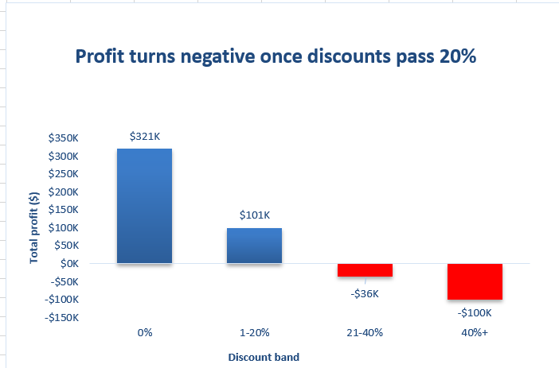
Profit turns negative once discounts pass 20%: the 1,393 order lines discounted above 20% lost $135K, while all other lines earned $422K.
So what: Cap discounts at 20% and require approval for anything higher, starting with Tables, the biggest loss-maker.
This is the clearest place to recover profit without hurting sales growth.

Supporting evidence
Chart 2: Profit by sub-category
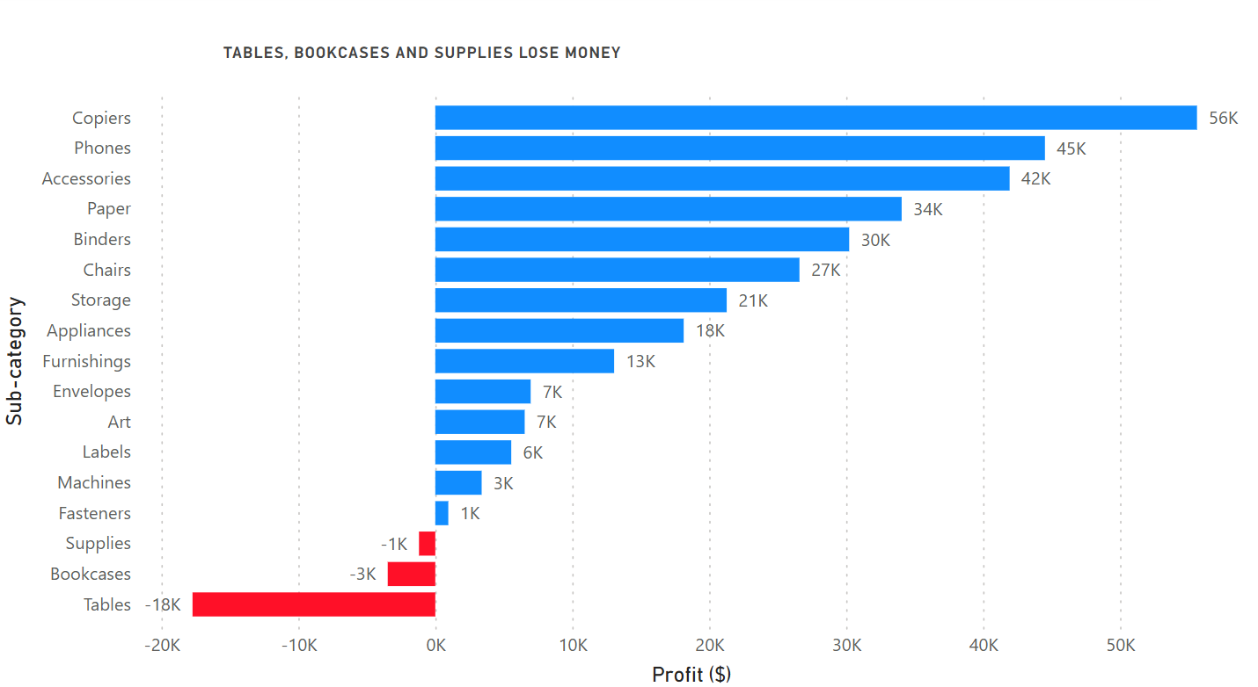
Three sub-categories lose money, led by Tables at -$17.7K, while Copiers earn the most at $56K.
Chart 3: Sales by year
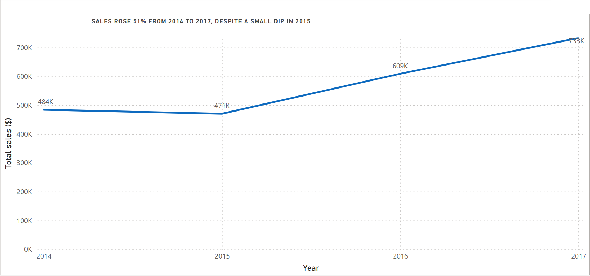
Sales rose 51%, from $484K in 2014 to $733K in 2017, with a small dip in 2015.
Chart 4: Sales by region
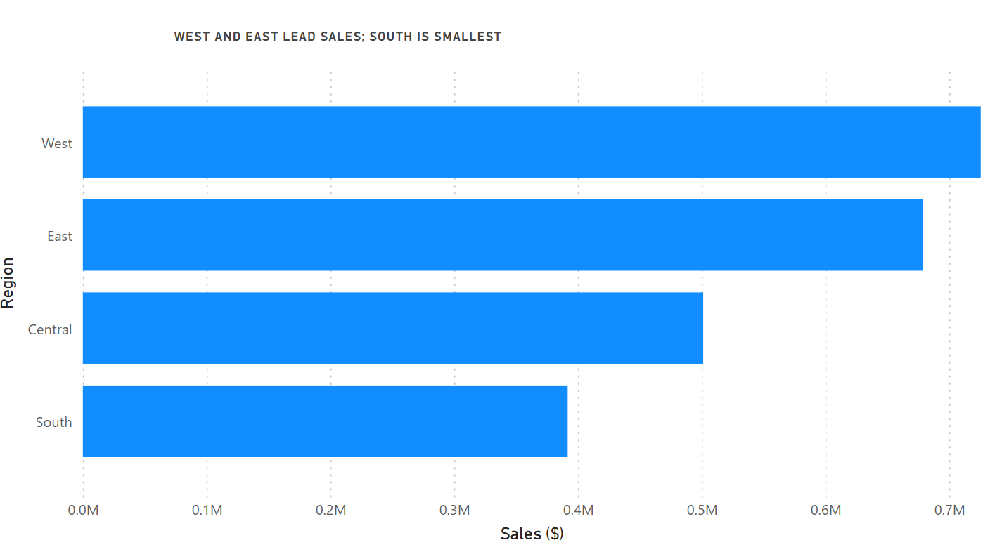
West ($725K) and East ($679K) lead sales and South ($392K) is smallest. Central keeps about 8 cents of profit per sales dollar, versus 12 to 15 cents in the other regions.

Caveats
- This is a sample dataset covering 2014 to 2017, not live company data.
- 5,201 rows had dates corrected (month and day were swapped in some order dates and ship dates). After the fix, every shipping time is 0 to 7 days.
- Counts by discount band are order lines (9,994 rows), not unique orders (5,009).
- The data shows heavy discounts and losses occurring together. It does not prove discounts alone cause the losses; product mix may also play a part.
Honesty check
Total profit reported: $286,397. Raw data check: SUM(Profit) on the cleaned dataset is 286,397.02, and the four discount bands in the PivotTable also add up to 286,397.02. The numbers match.

Data Profiling (Phase 1)
Dataset: Sample Superstore, 2014-2017. 9,994 order lines, 5,009 unique orders, 26 columns after cleaning. No missing values; 1 possible duplicate pair (see note below the table).

Column | Type | Missing | Distinct | Issues found
Row_ID | Integer | 0 | 9,994 | Unique, none
Order_ID | Text | 0 | 5,009 | Repeats by design (several lines per order)
Ship_Mode | Text | 0 | 4 | None
Customer_ID / Customer_Name | Text | 0 | 793 | Odd non-breaking spaces in some names
Segment | Text | 0 | 3 | None
Country / City / State | Text | 0 | 1 / 531 / 49 | None
Postal_Code | Text | 0 | 631 | 449 codes lost their leading zero
Region | Text | 0 | 4 | None
Product_ID / Product_Name | Text | 0 | 1,862 / 1,850 | Odd spaces in names
Category / Sub_Category | Text | 0 | 3 / 17 | None
Sales | Decimal | 0 | 5,825 | Range 0.44 to 22,638
Quantity | Integer | 0 | 14 | Range 1 to 14
Discount | Decimal | 0 | 12 | Range 0% to 80%
Profit | Decimal | 0 | 7,287 | 1,871 lines are negative (loss-making)
Order_Date / Ship_Date | Date | 0 | 1,237 / 1,334 | Mixed formats, month and day swapped
Table 1: Profiling of the raw data.

Duplicate check: 1 possible duplicate pair (order US-2014-150119, different Row_IDs). It was kept because it could be the same item ordered twice, and its effect on the totals is negligible.

Cleaning log (Phase 2)
Problem | What I did | Rows affected
Mixed date formats: some dates were read day-first, so month and day were swapped | Swapped them back on real-date cells and read text dates as month/day/year | 5,201 rows (4,042 order-date and 3,898 ship-date cells)
Shipping days wrong (up to 214 days) because of the swap | Recalculated after the fix; every shipping time is now 0 to 7 days | All 9,994 rows
Postal codes lost the leading zero (e.g. 6824) | Stored as text and padded to 5 digits | 449 rows
Non-breaking spaces in customer and product names | Replaced with normal spaces | 225 rows
Stray blank rows and a check value at the bottom of the file | Removed | 2 rows
Column names with spaces and hyphens | Renamed with underscores (e.g. Sub-Category to Sub_Category) | 9 columns
Analysis columns missing | Added Shipping_Days, Order_Year, Order_Month, Profit_Margin, Discount_Band | All rows
Table 2: Cleaning log (problem, action, rows affected).
Verification after cleaning and loading into MySQL: 9,994 rows, total profit $286,397.02, shipping days 0 to 7, order dates from 2014-01-03 to 2017-12-30, and orders per year of 1,993 / 2,102 / 2,587 / 3,312.

Before and after: 5 date rows
Row ID | Raw order | Raw ship | Fixed order | Fixed ship | Shipping days
1 | 11-08-2016 | 11-11-2016 | 2016-11-08 | 2016-11-11 | 3
2 | 11-08-2016 | 11-11-2016 | 2016-11-08 | 2016-11-11 | 3
19 | 8/27/2014 | 09-01-2014 | 2014-08-27 | 2014-09-01 | 5
3 | 06-12-2016 | 6/16/2016 | 2016-06-12 | 2016-06-16 | 4
13 | 4/15/2017 | 4/20/2017 | 2017-04-15 | 2017-04-20 | 5
Table 3: Before and after for 5 date rows. Raw dates in dd-mm-yyyy form were read in the wrong order; m/d/yyyy ones were text.

SQL JOIN (Phase 3)
Question: Which regional manager's region earns the most profit, and at what margin?
A small reference table, regional_managers (Region, Manager), was created to demonstrate a JOIN across two tables. The manager names are placeholders.

SELECT m.Manager,
o.Region,
ROUND(SUM(o.Sales), 2) AS total_sales,
ROUND(SUM(o.Profit), 2) AS total_profit,
ROUND(SUM(o.Profit) / SUM(o.Sales) * 100, 1) AS margin_pct
FROM orders o
JOIN regional_managers m ON o.Region = m.Region
GROUP BY m.Manager, o.Region
ORDER BY total_profit DESC;

Manager | Region | Total sales ($) | Total profit ($) | Margin (%)
Manager D | West | 725,457.82 | 108,418.45 | 14.9
Manager B | East | 678,781.24 | 91,522.78 | 13.5
Manager C | South | 391,721.91 | 46,749.43 | 11.9
Manager A | Central | 501,239.89 | 39,706.36 | 7.9
Total |  | 2,297,200.86 | 286,397.02
Table 4: JOIN result. The profit total matches the honesty check ($286,397.02), so the join lost and duplicated no rows.

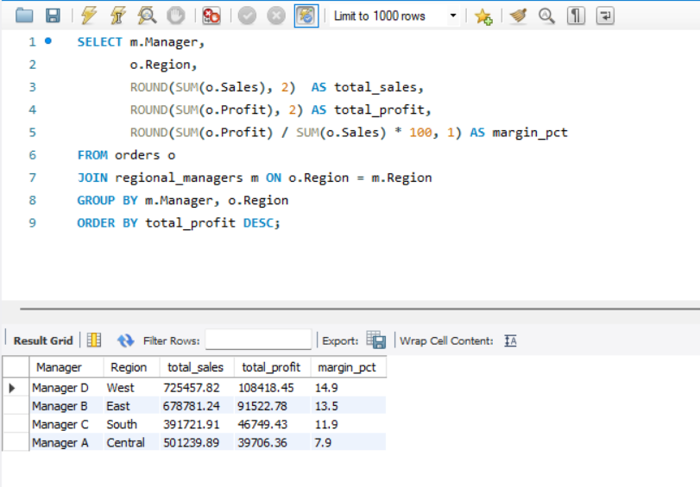

Figure: JOIN query and result in MySQL Workbench. The four profit values add up to $286,397.02.
Reading the result: Central has the second-highest sales but the lowest margin (7.9%), while West earns 14.9%. Central also has the heaviest discounting: an average discount of 24.0% and 27.7% of its order lines discounted above 20%, against 3.7% in West. This fits the discount finding, but it shows correlation, not proof of cause.

When SQL was easier than Excel: one query linked two tables and totalled 9,994 rows, where Excel would need a lookup column plus a pivot. The query can also be re-run unchanged if the data is refreshed.

Seasonality
Sales are strongly seasonal. November ($352K), December ($325K) and September ($308K) are the strongest months across the four years, and Q4 (October to December) brings in about 38% of all sales. January ($95K) and February ($60K) are the weakest. Four years of sample data show the pattern but not its cause.

Explore next
Do Bookcases and Supplies lose money for the same reason as Tables (heavy discounting), and what discount level is the break-even point for each sub-category?

The story
Sales grew 51% between 2014 and 2017, so the business looks healthy at first glance. But growth is not the same as profit. Across the dataset, order lines with no discount earned $321K and lines with a 1 to 20% discount earned $101K, while lines discounted more than 20% lost $135K. The same pattern shows up by product: Tables, the biggest loss-maker, lost $17.7K. Regional differences are smaller than the discount effect, so the recommendation is to cap discounts rather than to change regional strategy.

Why each chart
Insight | Question it answers | Number behind it | Chart and why
1. Discounts vs profit | Does heavy discounting hurt profit? | Lines discounted above 20% lost $135K; undiscounted lines earned $321K | Column chart of profit by discount band: compares groups and shows negative values clearly.
2. Sub-category profit | Which products lose money? | Tables -$17.7K, Bookcases -$3.5K, Supplies -$1.2K | Sorted bar chart: 17 long labels, negatives visible, ranking obvious.
3. Yearly sales | Is the business growing? | $484K (2014) to $733K (2017), +51% | Line chart: a trend over time is best shown as a line.
4. Regions | Which regions lead? | West $725K, East $679K, Central $501K, South $392K | Bar chart: a simple comparison of four categories.

Write-up: chart comparisons

Wrong chart vs right chart
Wrong: pie of profit by sub-category  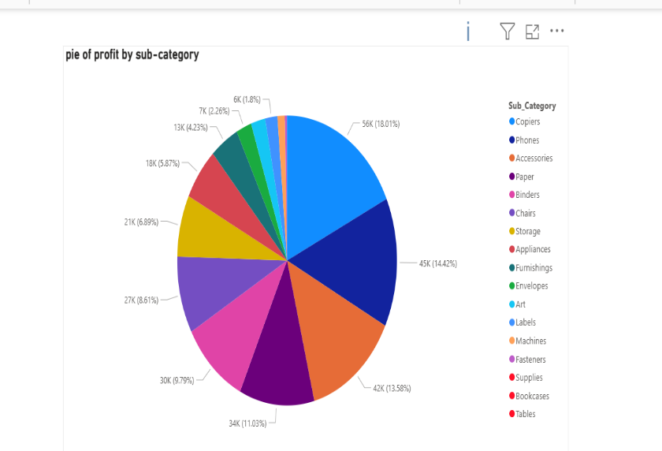 |  | Right: sorted bar of profit by sub-category  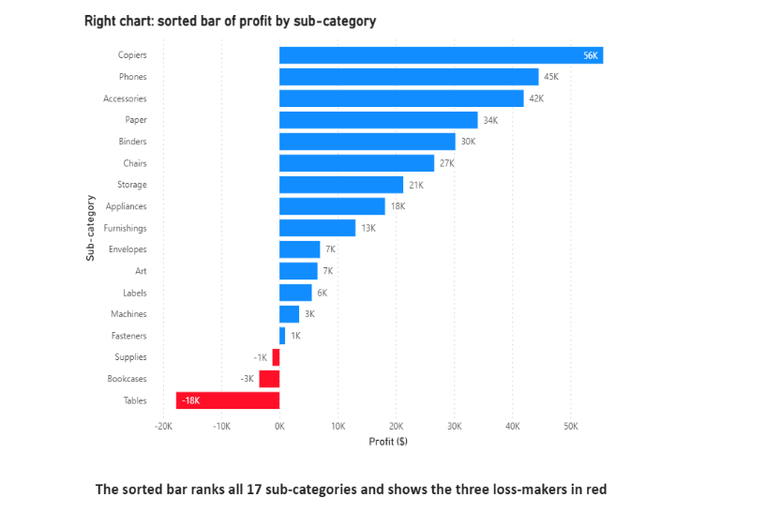
The pie can't show negative profit, so it silently drops the three loss-making sub-categories, and 14 slices are hard to rank. |  | The sorted bar ranks all 17 sub-categories and shows the three losses: Tables (-$18K), Bookcases (-$3K) and Supplies (-$1K).

Bad vs honest chart
Bad: truncated axis (starts at $350K)  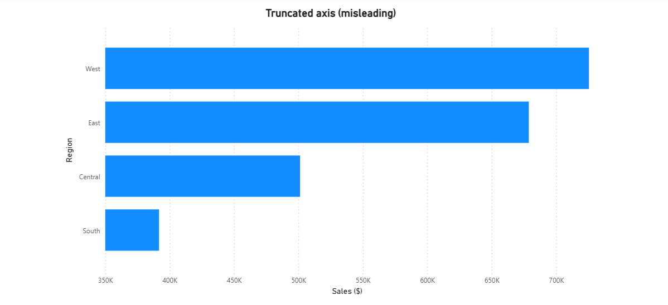 |  | Honest: axis starts at zero  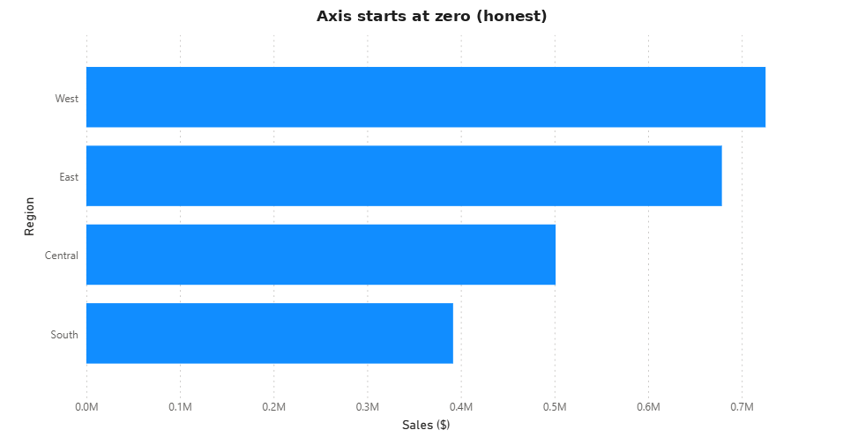
Truncated axis: South looks about nine times smaller than West. |  | Zero-based axis: West ($725K) is about 1.85 times South ($392K).

Two rules for an honest chart
- Start bar-chart axes at zero. Bar length is read as size, so cutting the axis exaggerates differences.
- Label everything so the chart stands alone. Give it a title that states the finding, axis titles, and units.

Outlier check
The 5 biggest-loss order lines (losses from $2,929 to $6,600) are all Machines or Binders sold at 50-80% discount. Quantities and sales values are normal, so these are real business losses caused by deep discounting, not data errors. Together they lost $20,471, about 7% of total profit ($286,397). This supports the recommendation to cap discounts at 20%.

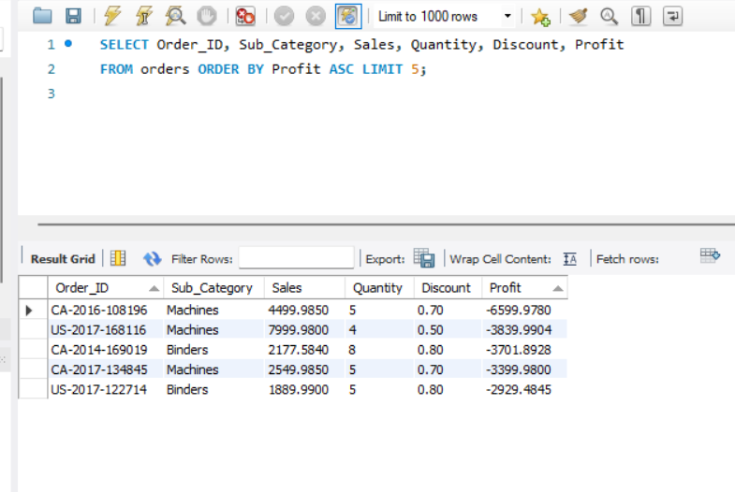
The 5 biggest-loss order lines, found with ORDER BY Profit ASC.

Dashboard interactivity (slicer)

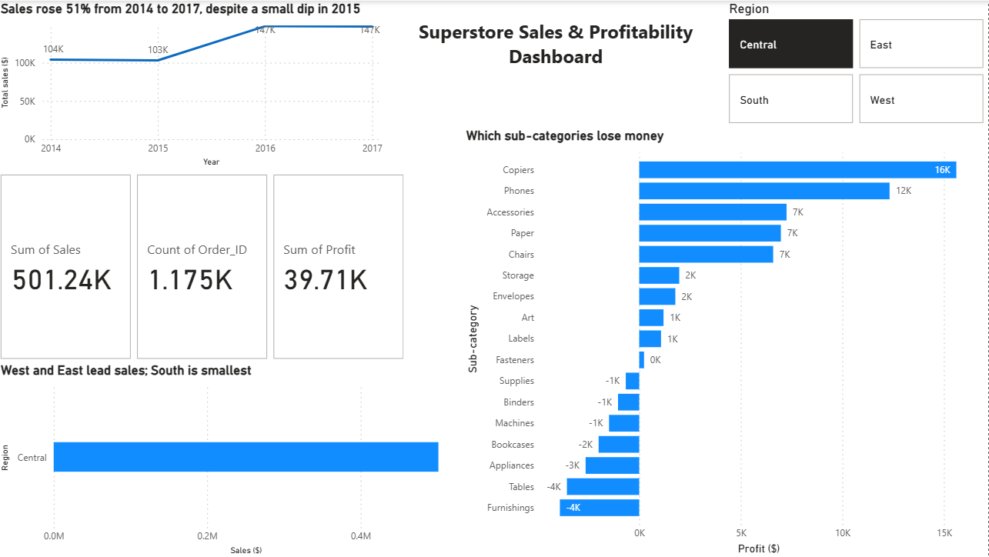
Dashboard filtered to Region = Central, showing the slicer is interactive. Bars to the left of zero are loss-making sub-categories. Chart titles describe the full dataset; the numbers update with the filter.
Written answers
1. Choosing the right chart type
Start with the message, then match the chart to it:
- Comparison: bar or column chart. Salesforce's design guidelines call the bar chart the workhorse of analytics, because our eyes quickly see differences in length.
- Trend: line chart. Qlik's guidance lists line charts for comparing trends over time.
- Composition: pie, donut or stacked bar, used only for a few parts. Qlik describes pie and donut charts as suited to the static composition of a value.
- Relationship: scatter plot, which shows how two or three measures relate.
The Salesforce guidelines also warn that the wrong chart type risks misrepresenting the data and confusing or misleading the audience.
Sources: Salesforce Lightning Design System, "Charts" guidelines (lightningdesignsystem.com/guidelines/charts); Qlik Support, "Best practices for choosing visualization types" (support.qlik.com/articles/000057453).
2. Two ways charts can mislead
Truncated axis. If a bar chart's axis starts at $350K instead of $0, a small difference looks huge. Fix: start bar axes at zero and label them.
Misleading pie chart. Pies with many slices, similar sizes or negative values are hard to read, and a pie cannot show a loss. In this project it dropped Tables, Bookcases and Supplies entirely. Fix: use a sorted bar chart, and keep pies for a few parts that add up to 100%.
3. What makes data storytelling effective
Showing charts just displays data and leaves the reader to work out what matters. Effective storytelling has one clear message the reader can repeat, a logical order (headline first, then evidence, then what to do), insight written in words (titles like "Profit turns negative once discounts pass 20%" instead of "Sum of Profit by Band"), focus with clutter removed, and a clear so-what for a specific audience.
4. Why lead with the main insight (manager note)
Managers are short on time and decide based on what matters, not how you got there. Leading with the main insight lets them understand the point in seconds and judge whether it needs action. It also makes the rest of the report easier to follow, since every chart then reads as evidence for a conclusion they already know. Starting with methodology forces a busy reader to wade through detail before learning why it matters, and they may stop reading before the key finding. The methodology still belongs in the report, but as a supporting appendix for anyone who wants to check it. In short: answer first, evidence next, method last.

