Customer & Sales Analytics: Findings and Method
Project SG/PRJ/DA-02 | Vaishnavi B. Gawande | Sample Superstore data, 2014-2017

1. Summary
Sales grew 51% in four years, but discounts above 20% lose money, and a fifth of revenue sits with customers who are drifting away. This report explains how I reached three findings and three recommendations using a star-schema database, SQL, RFM segments, cohort analysis, a forecast and a Power BI report.

Key findings
- Sales are growing and strongly seasonal: $484K in 2014 to $733K in 2017 (up 20% in 2017). September, November and December are the strongest months every year, and Q4 brings in about 38% of sales.
- Customers are loyal, but 22% of sales sit with customers who have gone quiet. 98.5% of customers reorder, about every 188 days. Champions and Loyal customers (329 people) bring 53% of sales; the 146 At Risk customers hold $495K and have not ordered for about 7 months. Only 11 customers were new in 2017.
- Deep discounts destroy profit: order lines discounted above 20% lost $135K while undiscounted lines earned $321K. Central discounts the most (24% average) and has the lowest margin (7.9%, against 14.9% in West).

Recommendations
- Cap discounts at 20% and require approval above it, starting with Tables and the Central region.
- Win back the 146 At Risk customers now, and follow up new customers within 60 days.
- Plan stock and staff around September to December, and plan with a forecast range: Q1 2018 sales about $148K, likely between $89K and $207K.

2. Data and model
The data is the Sample Superstore dataset: 9,994 order lines, 5,009 orders and 793 customers. I reshaped the flat file into a star schema, with one fact table and four dimensions. I chose this dataset because customers buy repeatedly (781 of 793 reorder), which RFM and cohort analysis need.
Table | One row per | Rows | Key
fact_sales | order line | 9,994 | Row_ID
dim_customer | customer | 793 | customer_key
dim_product | product (ID and name) | 1,894 | product_key
dim_geography | location | 632 | geo_key
dim_date | day, 2014 to Jan 2018 | 1,492 | date_key
Table 1: Star schema tables.
Three data-quality findings shaped the model:
- 32 Product IDs have more than one product name, so a product is the pair of ID and name. Joining on the ID alone would duplicate revenue.
- One postal code appears with two city, state and region combinations, so a location is the full combination.
- Ship dates run to 5 January 2018, so the date table extends to 31 January 2018.

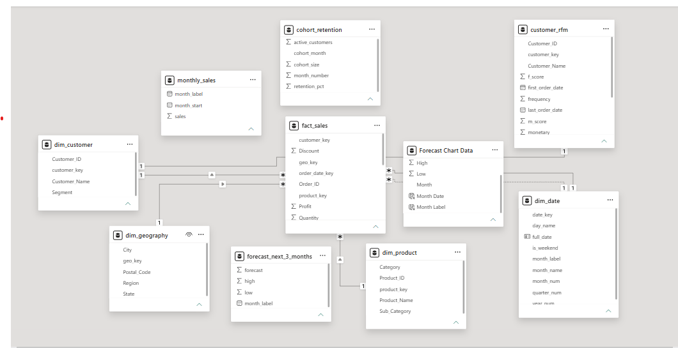
Figure 1: Data model in Power BI. fact_sales sits in the centre with four dimensions.

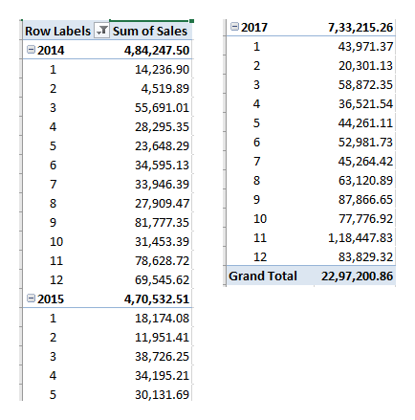
Excel PivotTable of sales by year and month. Excel groups digits in the Indian style, so 22,97,200.86 = 2,297,200.86 and 1,18,447.83 = 118,447.83, matching SQL.

Checks
Measure | SQL | Power BI | Excel
Total sales | 2,297,200.86 | 2,297,200.86 | 2,297,200.86
Total profit | 286,397.02 | 286,397.02 | -
Orders | 5,009 | 5,009 | -
Customers | 793 | 793 | -
Sales, November 2017 | 118,447.83 | - | 118,447.83
Sales, February 2014 | 4,519.89 | - | 4,519.89
Table 2: Results reconciled across SQL, Power BI and Excel. The star-schema integrity check found no fact row without a matching customer, product, location or date.

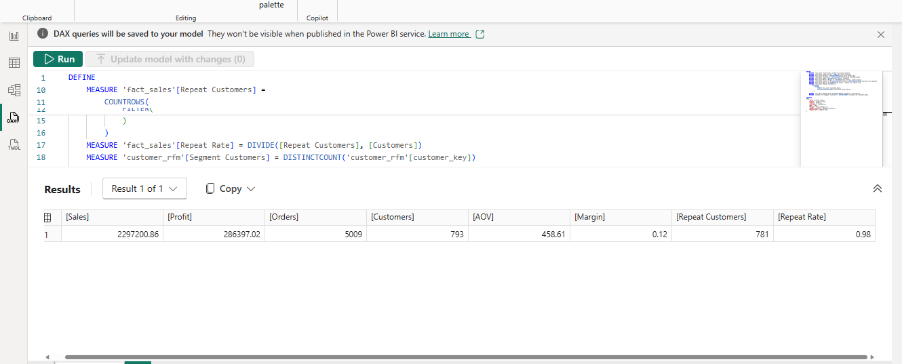
Figure 2: Power BI measures checked against SQL.

3. Method and results

3.1 SQL
Ten labelled queries use inner and left joins, GROUP BY with HAVING, CTEs, subqueries and window functions. Examples: a join with HAVING finds the three sub-categories that lose money (Tables, Bookcases and Supplies); a CTE finds the strongest months (November 2017 first, at $118,447.83); LAG gives month-over-month growth; a running total, RANK and a left join (customers with no 2017 order: 100) complete the set. Results were checked against Power BI and Excel.

3.2 Customer segments (RFM)
Each customer is scored from 1 to 5 on recency (days since last order, scored in reverse), frequency (orders) and monetary value (sales) using NTILE. Segments combine the scores.
Segment | Rule | Customers | Share of sales | Action
Champions | recency 4-5, frequency 4-5 | 165 | 29.1% | Reward, early access, referrals
Loyal | recency 3-5, frequency 3-5 | 164 | 23.5% | Upsell and bundle offers
At Risk | recency 1-2, frequency 3-5 | 146 | 21.6% | Win-back offer before they are lost
Promising | recency 3-5, frequency 1-2 | 140 | 12.9% | Encourage the next purchase
Lost | recency 1-2, frequency 1-2 | 167 | 12.5% | Low-cost reactivation
New | first order in 2017 | 11 | 0.3% | Follow up within 60 days
Table 3: RFM segments. Promising is a sixth segment added so that recent customers with few orders have a home.

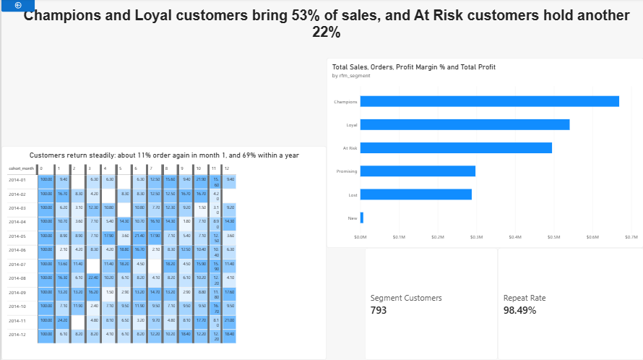
Figure 3: Segment sales and the 2014 cohort retention heatmap. Right-clicking a segment drills through to its customers (At Risk: 146).

3.3 Cohorts and retention
Customers are grouped by the month of their first order. About 11% of a cohort orders again in month 1, 24% within 3 months, 43% within 6 and 69% within 12; only 2 of the 595 customers who started in 2014 never ordered again. Customers return steadily rather than dropping off sharply, and month 2 is the weakest (6.6%), so a follow-up offer in the first 60 days is the best chance to speed up the second order. The heatmap shows the 2014 cohorts only, because 75% of customers started in 2014 and later cohorts are too small to read.

3.4 Forecast
Sales are strongly seasonal, so I tested three simple methods on the last three months of data (October to December 2017), training on the earlier months.
Method | Error (MAPE) | Rank
3-month moving average | 27.5% | 3
Same month last year | 24.0% | 2
Same month last year x growth | 21.7% | 1
Table 4: Forecast accuracy on the test months. MAPE is the average percentage by which the forecast missed.
Three test months are few, so I re-ran the best method on 22 earlier months. The average error was 26.3%, and about 68% of forecasts landed within 40% of the actual. I therefore show the forecast as a range of plus or minus 40%:
Month | Forecast | Range
January 2018 | $52,922 | $31,753 to $74,091
February 2018 | $24,434 | $14,660 to $34,208
March 2018 | $70,856 | $42,514 to $99,198
Q1 2018 total | about $148K | about $89K to $207K
Table 5: Forecast for Q1 2018 with its range.

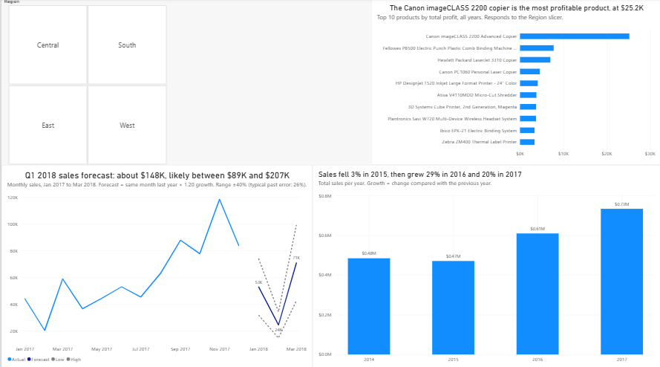Figure 4: Forecast with range, top products by profit, and yearly growth.

3.5 Power BI report
The report is built on the star schema, not a flat table. Eleven DAX measures cover sales, profit, orders, customers, average order value, margin, year-over-year growth, repeat rate and customers by segment. Three pages (Executive summary, Customers with a drill-through to a customer list, and Products and forecast) use slicers, and chart titles state the finding.

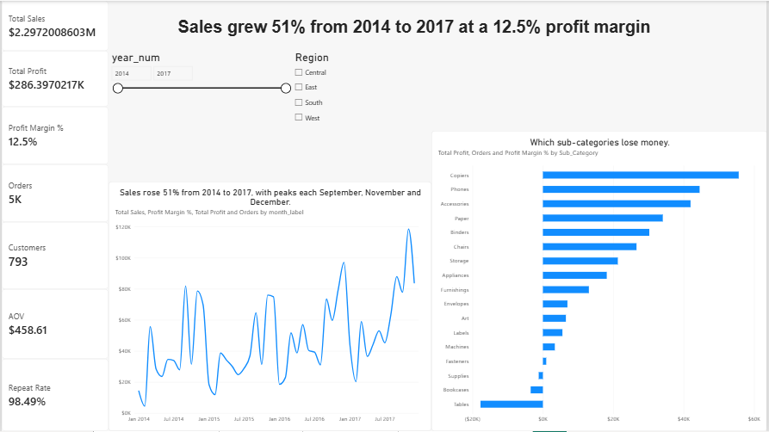Figure 5: Executive summary page, all regions.

4. Limits

- This is sample data, not live company data, and covers four years.
- Discounts and losses occur together. This shows correlation, not proven cause.
- The forecast is wide (typical error 26%), so use the range, not a single number.
- Most customers began in 2014, so conclusions about new customers rest on few people (11 in 2017).
- The repeat rate is high (98.5%) because customers in this dataset average about 6 orders over four years; I would expect a lower rate on live data.

