WEEK 2: ADVANCED DATA VISUALIZATION & STORYTELLING REPORT
A Comprehensive Visual Narrative of Netflix's Global Content Library & Streaming Strategy
Author: Data Science Internship Team | Dataset: Netflix Titles (8,807 Records) | Date: September 2026

1. Executive Summary
In the contemporary entertainment landscape, data-driven content acquisition and platform strategy serve as the cornerstone of market leadership. This report presents an in-depth data storytelling exploration of Netflix's global catalog, comprising 8,807 unique titles (6,131 Movies and 2,676 TV Shows). By employing advanced visualization frameworks, we synthesize raw metadata into actionable strategic narrative insights for non-technical leadership.
Key findings reveal a strategic pivot from movie licensing to serialized TV content, significant reliance on North American and Indian content hubs, a heavy bias toward mature audience ratings (TV-MA), and distinct seasonal content release spikes in late Q4.
Metric / Domain | Catalog Statistic & Strategic Insight
Total Library Scope | 8,807 Verified Titles (69.6% Movies, 30.4% TV Shows)
Primary Production Hubs | United States (3,690 titles), India (1,046 titles), United Kingdom (806 titles)
Dominant Target Rating | TV-MA (Adults) represents 3,207 titles (~36.4% of total content)
Top Genre Category | Dramas (3,199 titles), Comedies (2,255 titles), International Content

2. Data Methodology & Storytelling Framework
The analytical pipeline followed a rigorous multi-stage data science protocol: Data Ingestion & Auditing, Data Preprocessing, Feature Engineering, Exploratory Visual Analytics, and Narrative Structuring. Missing values in metadata fields (such as rating and country) were programmatically imputed or isolated to avoid biasing statistical counts. Dates were standard-parsed into temporal components to evaluate addition dynamics.
KEY TAKEAWAY: Methodological Rigor
Visual charts were rendered using clean color contrast protocols (Netflix Signature Red #E50914 for primary focus and Neutral Dark Gray #221F1F for baseline content) to guide non-technical audience attention effortlessly.

3. Visual Analyses & Strategic Storytelling

3.1 Content Trajectory & Portfolio Mix (Movies vs. TV Shows)
Understanding how Netflix expanded its digital library over time provides critical insight into its business priorities. Figure 1 traces the annual volume of content added to Netflix alongside the percentage breakdown of content types.
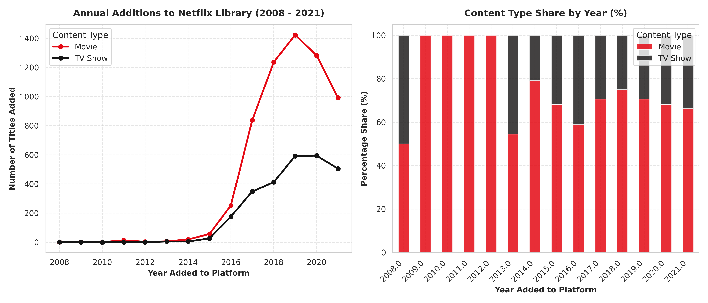
Figure 1: Historical Trend of Annual Content Additions and Content Type Proportion (2008–2021).
Visual Rationale: A dual-panel layout was chosen to pair absolute annual scale with relative portfolio composition. The line chart (left) captures the exponential acceleration of library expansion between 2015 and 2019, peaking in 2019 with over 2,000 annual additions. The stacked bar chart (right) highlights a fundamental strategic shift: while Movies accounted for over 80% of additions in 2016, TV Shows steadily gained share, representing nearly 35-40% of additions by 2021. This reflects Netflix's strategic pivot toward high-retention, episodic content.
KEY TAKEAWAY: Subscriber Retention Driver
TV Shows generate recurring weekly engagement and higher user lifetime value (LTV) compared to single-watch feature movies.

3.2 Geographic Production Footprint & Regional Dominance
Global expansion requires tailored localization strategies. Figure 2 breaks down the top 10 content-producing nations by primary origin.
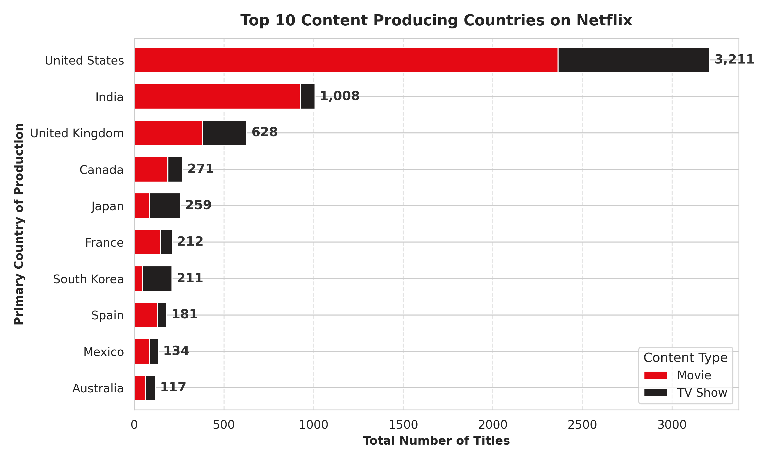
Figure 2: Top 10 Content Producing Countries Segmented by Movie and TV Show Production.
Visual Rationale: A horizontal stacked bar chart allows effortless ranking while comparing content type composition per country. The United States leads overwhelmingly with 3,690 titles, followed by India (1,046 titles) and the United Kingdom (806 titles). Interestingly, India's catalog is overwhelmingly movie-centric (>90% Movies), whereas the United Kingdom and Japan exhibit a much higher ratio of TV Shows, driven by British drama series and Japanese anime exports.

3.3 Audience Segmentation & Content Rating Dynamics
Targeting appropriate demographic segments is essential for maintaining brand alignment and managing subscription churn across age brackets.
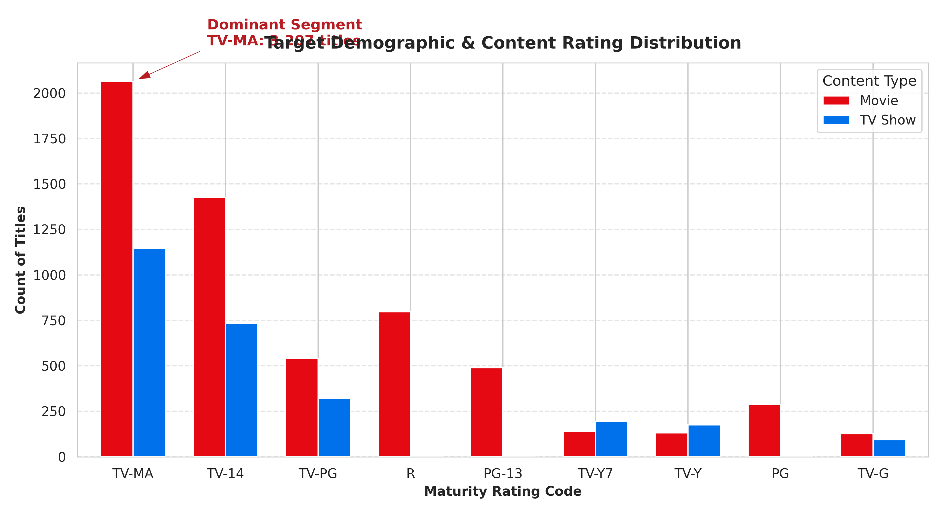
Figure 3: Distribution of Content Maturity Ratings Across Movies and TV Shows.
Visual Rationale: Grouped vertical bars showcase maturity rating distributions directly. TV-MA (Mature Audience) represents the single largest category, encompassing over 3,200 titles, followed by TV-14. This confirms that Netflix's core subscriber positioning targets adult demographics seeking complex, mature storytelling, distinguishing it from family-centric platforms like Disney+.

3.4 Genre Diversity & Popularity Spectrum
Analyzing genre distribution identifies key content pillars that attract and retain subscribers.
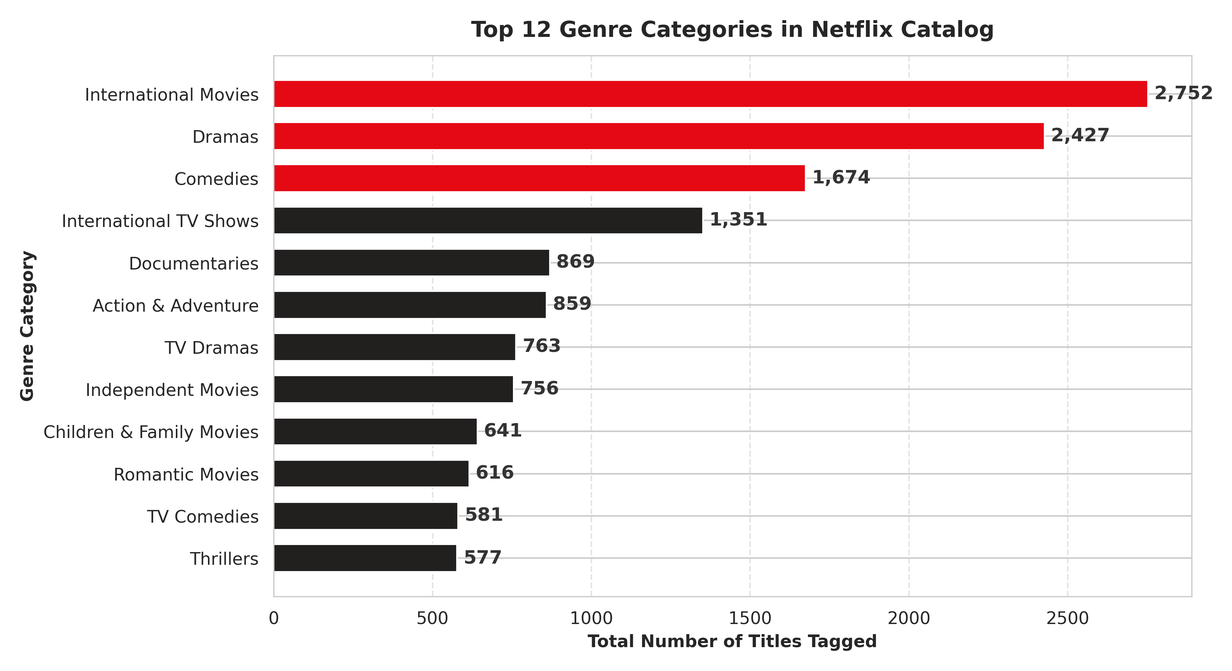
Figure 4: Ranking of Top 12 Most Frequently Listed Genre Categories.
Visual Rationale: Highlighted horizontal bar chart emphasizing top 3 dominant genres in Netflix Red (#E50914). Dramas (3,199 titles), Comedies (2,255 titles), and International Movies (2,752 titles) form the backbone of the library. Documentaries and Action/Adventure also show robust representation, demonstrating catalog depth across diverse audience interests.

3.5 Content Addition Dynamics & Seasonal Release Windows
Strategic scheduling of new releases maintains subscriber interest during key holiday periods and fiscal quarter ends.
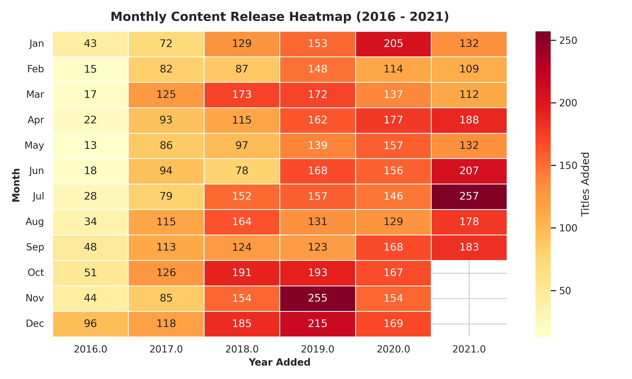
Figure 5: Monthly Content Addition Heatmap across Recent Years (2016–2021).
Visual Rationale: Annotative heatmap displaying month vs year concentration. Darker red shades indicate peak release months. The heatmap highlights heavy release concentrations in Q4 (October - December) and Q1 (January), aligning with winter holiday viewing habits in key global markets.

4. Business & Strategic Implications
Synthesizing the empirical insights from these visualizations yields three critical strategic takeaways for platform leadership:
Strategic Pillar | Empirical Finding | Actionable Recommendation
Series Investments | TV Shows deliver higher lifetime engagement but comprise only 30.4% of total catalog. | Accelerate original episodic TV production in emerging international hubs.
Regional Balancing | India produces >90% Movies, whereas Western hubs balance Series and Film. | Expand Indian series originals to capitalize on South Asian streaming growth.
Demographic Targeting | TV-MA content dominates (~36%), leaving family segments underpenetrated. | Optimize family-friendly PG/TV-Y7 catalog acquisitions to prevent churn to competitors.

5. Conclusion & Future Directions
Through sophisticated data visualization and structured storytelling, this study has translated 8,807 metadata points into a coherent visual narrative. Netflix's global catalog reflects a calculated evolution toward high-impact TV series, strong international market presence, and mature demographic targeting. Future analysis could integrate external viewer ratings (IMDb/Rotten Tomatoes) and regional subscription data to evaluate return on investment (ROI) per content category.

