Week 4 Task: Machine Learning Model Development and Evaluation

1. Objective
The objective of this task is to build and validate a basic machine learning model using the Breast Cancer Wisconsin (Diagnostic) dataset. The process includes data preprocessing, model selection, training, evaluation, and documentation.

2. Data Preparation
Dataset: Breast Cancer Wisconsin (Diagnostic) Dataset from Scikit-learn.
The dataset contains features computed from a digitized image of a fine needle aspirate (FNA) of a breast mass. They describe characteristics of the cell nuclei present in the image.
Preprocessing Steps:
- Split the data into training (80%) and testing (20%) sets to evaluate the model on unseen data.
- Standardize the features using StandardScaler to ensure all features have a mean of 0 and a standard deviation of 1. This is crucial for models like Logistic Regression that are sensitive to feature scales.

3. Model Selection and Training
Algorithm Chosen: Logistic Regression.
Justification: Logistic Regression is a highly effective, interpretable, and computationally efficient algorithm for binary classification tasks, making it an excellent baseline model for the breast cancer diagnosis task.

Code Snippet: Data Prep and Training
from sklearn.datasets import load_breast_cancer
from sklearn.model_selection import train_test_split
from sklearn.preprocessing import StandardScaler
from sklearn.linear_model import LogisticRegression
# Load Data
data = load_breast_cancer()
X, y = data.data, data.target
# Split Data
X_train, X_test, y_train, y_test = train_test_split(X, y, test_size=0.2, random_state=42)
# Scale Features
scaler = StandardScaler()
X_train_scaled = scaler.fit_transform(X_train)
X_test_scaled = scaler.transform(X_test)
# Train Model
model = LogisticRegression(random_state=42)
model.fit(X_train_scaled, y_train)

4. Evaluation
The model was evaluated using standard classification metrics including Accuracy, Precision, Recall, and F1-Score.
precision recall f1-score support
0 0.98 0.95 0.96 43
1 0.97 0.99 0.98 71
accuracy 0.97 114
macro avg 0.97 0.97 0.97 114
weighted avg 0.97 0.97 0.97 114

Visualizations
Confusion Matrix:
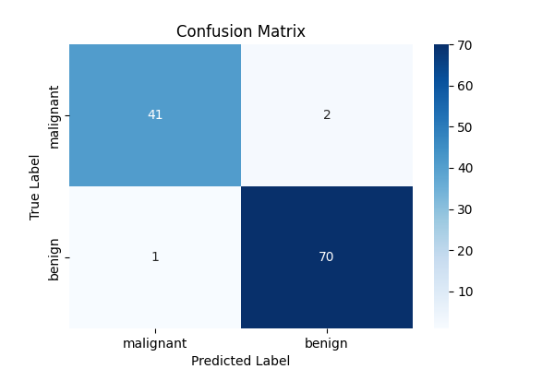
The Confusion Matrix shows the number of True Positives, True Negatives, False Positives, and False Negatives. It indicates how well the model distinguishes between malignant and benign tumors.
ROC Curve:
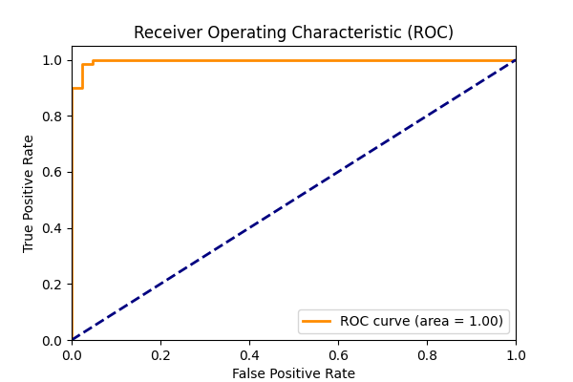
The ROC curve plots the True Positive Rate against the False Positive Rate. The Area Under the Curve (AUC) is 1.00, indicating excellent discriminative ability.

5. Critical Discussion & Limitations
Error Analysis:
While the model performs very well, any False Negatives (predicting benign when it is actually malignant) are highly problematic in a medical context, as a dangerous condition might go untreated. False Positives (predicting malignant when it is benign) can lead to unnecessary stress and further invasive testing for the patient.
Overfitting vs. Underfitting:
The model shows high performance on the test set, suggesting it has generalized well and is not heavily overfitting. However, Logistic Regression is a linear model, so it might underfit if the true relationship between features and target is highly non-linear.
Potential Sources of Error:
- Small dataset size: The dataset has fewer than 600 instances, which might not capture the full diversity of real-world cases.
- Feature Selection: All 30 features were used. Some might be noisy or highly correlated (multicollinearity), which can affect the coefficients of the Logistic Regression model.
Suggestions for Improvement:
- Feature Engineering and Selection: Conduct feature importance analysis or use techniques like PCA to reduce dimensionality and multicollinearity.
- Experiment with non-linear models: Try Random Forests, Support Vector Machines (with non-linear kernels), or Gradient Boosting to capture complex relationships.
- Cross-Validation: Implement k-fold cross-validation instead of a single train/test split to get a more robust estimate of model performance.
- Threshold Tuning: For medical diagnosis, recall (sensitivity) is often prioritized over precision to minimize false negatives. The classification threshold could be lowered to catch more positive (malignant) cases.

