Week 4: Machine Learning Model Development
Author: Twinkle Manoj Ghangare
Data Science Internship Task

1. Model Objective & Data Preparation
The objective is to train a predictive classification model to determine passenger survival based on demographic attributes. Categorical variables (Sex, Embarked) were numerically encoded and one-hot encoded. The data was split into 80% training and 20% testing sets.

2. Algorithm Selection
Logistic Regression was selected as the baseline model. It offers high interpretability for binary classification tasks, allowing us to examine feature coefficients (log-odds) without the 'black-box' nature of complex ensembles.

3. Model Evaluation: Confusion Matrix
The confusion matrix reveals the model's true positive and true negative rates. It highlights false negatives (predicting death when they survived) and false positives.
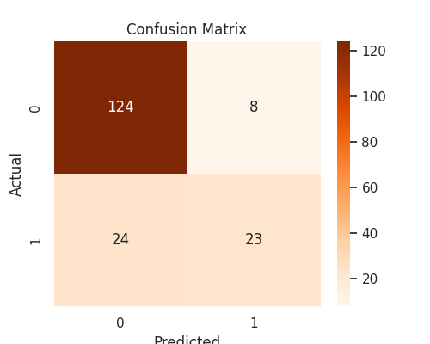

4. Model Evaluation: ROC Curve
The Receiver Operating Characteristic (ROC) curve evaluates the tradeoff between sensitivity and specificity. The Area Under the Curve (AUC) is 0.87, indicating strong predictive power well above random guessing (0.5).
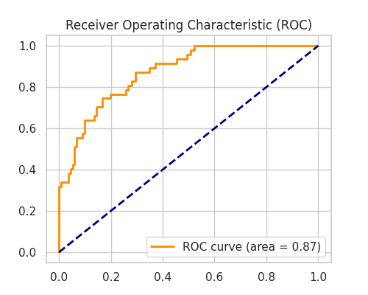

5. Limitations and Improvements
While Logistic Regression performs adequately, it assumes linear boundaries between features and log-odds. Future improvements could include implementing Random Forest to capture non-linear relationships or utilizing SMOTE if the survival class was heavily imbalanced.

