**Cognizant Deep Skilling Week-2**

1. NUnit Hands-On:

**Meaning of Unit Testing and Its Difference from Functional Testing**

**Unit Testing**:

* Unit testing is a type of software testing where individual components or functions of a software are tested in isolation.
* It focuses on the **smallest testable part** of the code like a method or function.
* Mocking is often used to **simulate dependencies**, so the unit being tested is isolated from external systems like databases or APIs.

**Functional Testing**:

* Functional testing is a **higher-level** test that validates the software system against the functional requirements/specifications.
* It tests **end-to-end scenarios** including integration between components.

**Types of Testing**

· **Unit Testing**: Tests individual methods or components.

· **Functional Testing**: Validates the system works as intended (business logic).

· **Automated Testing**: Uses tools or scripts to run tests automatically.

· **Performance Testing**: Checks system performance under load (e.g., response time, throughput).

**Understand the benefit of automated testing.**

· **Speed**: Tests run faster than manual tests.

· **Repeatability**: Can run frequently and consistently.

· **Coverage**: Tests can cover a large codebase efficiently.

· **Early Bug Detection**: Catches regressions early in development.

· **Cost-Effective**: Saves time and resources in the long term.

**Explain what is loosely coupled & testable design.**

**Loosely Coupled**:

* Components do **not heavily depend** on one another.
* We can **swap dependencies** (e.g., with mock objects) easily.

**Testable Design**:

* Code is structured in a way that makes it easy to test.
* **Interfaces**, **dependency injection**, and **mocking frameworks are used**.

**Write your first testing program to validate a calculator addition operation.**

using NUnit.Framework;

[TestFixture]

public class CalculatorTests

{

[Test]

public void Add_TwoNumbers_ReturnsSum()

{

var calc = new SimpleCalculator();

double result = calc.Addition(3, 4);

Assert.AreEqual(7, result);

}

}

**Understand the need of [SetUp], [TearDown] & [Ignore] attributes.**

· [SetUp]: Runs **before** each test. Good for initializing resources.

· [TearDown]: Runs **after** each test. Good for cleanup.

· [Ignore]: Temporarily skip a test (e.g., if the feature isn’t ready).

**Explain the benefit of writing parameterized test cases.**

· Reduces **code duplication**.

· Allows testing **multiple input-output combinations** easily.

· Increases **test coverage** with minimal code.

**Test for Calculator:**

**CODE:-**

using CalcLibrary;

using Microsoft.VisualStudio.TestTools.UnitTesting;

using NUnit.Framework;

using System;

namespace CalcLibrary.Tests

{

[TestFixture]

public class CalculatorTests

{

private SimpleCalculator _calculator;

[SetUp]

public void Setup()

{

_calculator = new SimpleCalculator();

}

[TearDown]

public void TearDown()

{

_calculator = null;

}

[TestCase(10, 5, 15)]

[TestCase(0, 0, 0)]

[TestCase(-3, -6, -9)]

[TestCase(8, 12, 20)]

public void Addition_ValidInputs_ReturnsCorrectResult(double a, double b, double expected)

{

double result = _calculator.Addition(a, b);

NUnit.Framework.Assert.That(result, Is.EqualTo(expected));

}

}

}

**OUTPUT:-**

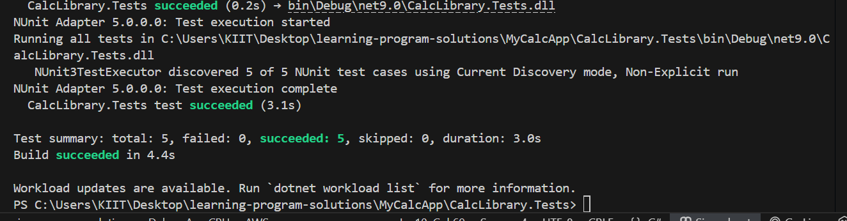

1. Moq Hands-On:

#### ****File: CustomerCommService.cs****

namespace CustomerCommLib.Core

{

public interface IMailSender

{

bool SendMail(string toAddress, string message);

}

public class MailSender : IMailSender

{

public bool SendMail(string toAddress, string message)

{

return true; // Simulated email sending

}

}

public class CustomerCommService

{

private readonly IMailSender _mailSender;

public CustomerCommService(IMailSender mailSender)

{

_mailSender = mailSender;

}

public bool SendMailToCustomer()

{

return _mailSender.SendMail("cust123@abc.com", "Some Message");

}

}

}

**Project 2: CustomerComm.Tests:**

**File: CustomerCommTests.cs**

**using NUnit.Framework;**

**using Moq;**

**using CustomerCommLib.Core;**

**namespace CustomerComm.Tests;**

**{**

**[TestFixture]**

**public class CustomerCommTests**

**{**

**private Mock<IMailSender>? _mockMailSender;**

**private CustomerCommService? _customerComm;**

**[OneTimeSetUp]**

**public void Init()**

**{**

**_mockMailSender = new Mock<IMailSender>();**

**_mockMailSender.Setup(m => m.SendMail(It.IsAny<string>(), It.IsAny<string>())).Returns(true);**

**_customerComm = new CustomerCommService(_mockMailSender.Object);**

**}**

**[Test]**

**public void SendMailToCustomer_ShouldReturnTrue_WhenMailIsSent()**

**{**

**Assert.That(_customerComm!.SendMailToCustomer(), Is.True);**

**}**

**}**

**}**

**OUTPUT :-**

