**Cognizant Deep Skilling Week-5**

1. **Web API Microservices:-**

### Project Setup in Visual Studio :-

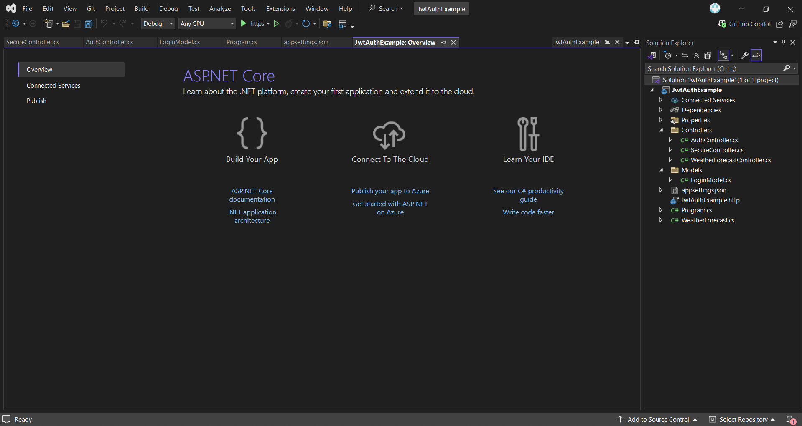

### **Installed NuGet Package :-**

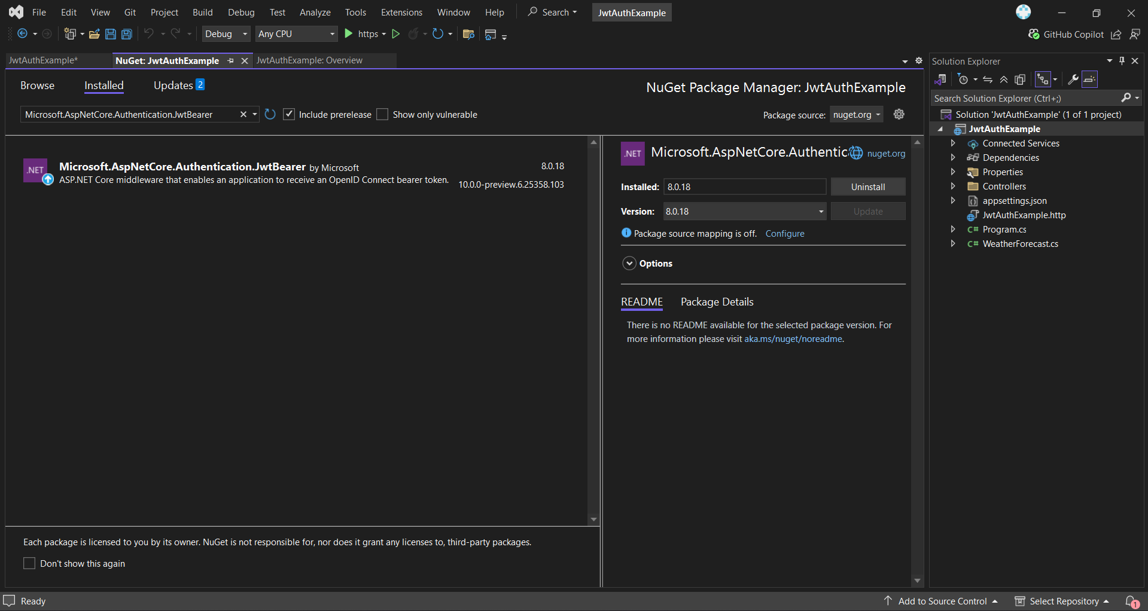

### appsettings.json :-

**CODE:-**

{

"Logging": {

"LogLevel": {

"Default": "Information",

"Microsoft.AspNetCore": "Warning"

}

},

"AllowedHosts": "*",

"Jwt": {

"Key": "ThisIsASuperLongSecretKeyWith32Chars!",

"Issuer": "MyAuthServer",

"Audience": "MyApiUsers",

"DurationInMinutes": 60

}

}

### Program.cs Configuration :-

**CODE:-**

using Microsoft.AspNetCore.Authentication.JwtBearer;

using Microsoft.IdentityModel.Tokens;

using System.Text;

var builder = WebApplication.CreateBuilder(args);

builder.Services.AddControllers();

builder.Services.AddEndpointsApiExplorer();

builder.Services.AddSwaggerGen();

builder.Services.AddAuthentication(JwtBearerDefaults.AuthenticationScheme)

.AddJwtBearer(options =>

{

options.TokenValidationParameters = new TokenValidationParameters

{

ValidateIssuer = true,

ValidateAudience = true,

ValidateLifetime = true,

ValidateIssuerSigningKey = true,

ValidIssuer = builder.Configuration["Jwt:Issuer"],

ValidAudience = builder.Configuration["Jwt:Audience"],

IssuerSigningKey = new SymmetricSecurityKey(

Encoding.UTF8.GetBytes(builder.Configuration["Jwt:Key"]))

};

});

builder.Services.AddAuthorization();

var app = builder.Build();

if (app.Environment.IsDevelopment())

{

app.UseSwagger();

app.UseSwaggerUI();

}

app.UseHttpsRedirection();

app.UseAuthentication();

app.UseAuthorization();

app.MapControllers();

app.Run();

### **Login Endpoint - AuthController.cs :-**

**CODE:-**

using JwtAuthExample.Models;

using Microsoft.AspNetCore.Mvc;

using Microsoft.IdentityModel.Tokens;

using System.IdentityModel.Tokens.Jwt;

using System.Security.Claims;

using System.Text;

[ApiController]

[Route("api/[controller]")]

public class AuthController : ControllerBase

{

[HttpPost("login")]

public IActionResult Login([FromBody] LoginModel model)

{

if (IsValidUser(model))

{

var token = GenerateJwtToken(model.Username);

return Ok(new { Token = token });

}

return Unauthorized();

}

private bool IsValidUser(LoginModel model)

{

return model.Username == "admin" && model.Password == "password";

}

private string GenerateJwtToken(string username)

{

var claims = new[]

{

new Claim(ClaimTypes.Name, username)

};

var key = new SymmetricSecurityKey(Encoding.UTF8.GetBytes("ThisIsASecretKeyForJwtToken"));

var creds = new SigningCredentials(key, SecurityAlgorithms.HmacSha256);

var token = new JwtSecurityToken(

issuer: "MyAuthServer",

audience: "MyApiUsers",

claims: claims,

expires: DateTime.Now.AddMinutes(60),

signingCredentials: creds);

return new JwtSecurityTokenHandler().WriteToken(token);

}

}

### SecureController.cs :-

**CODE :-**

using Microsoft.AspNetCore.Authorization;

using Microsoft.AspNetCore.Mvc;

namespace JwtAuthExample.Controllers

{

[ApiController]

[Route("api/[controller]")]

public class SecureController : ControllerBase

{

[Authorize]

[HttpGet("data")]

public IActionResult GetData()

{

return Ok("This is protected data. JWT worked!");

}

}

}

### Getting JWT Token via Postman :-

**OUTPUT:-**

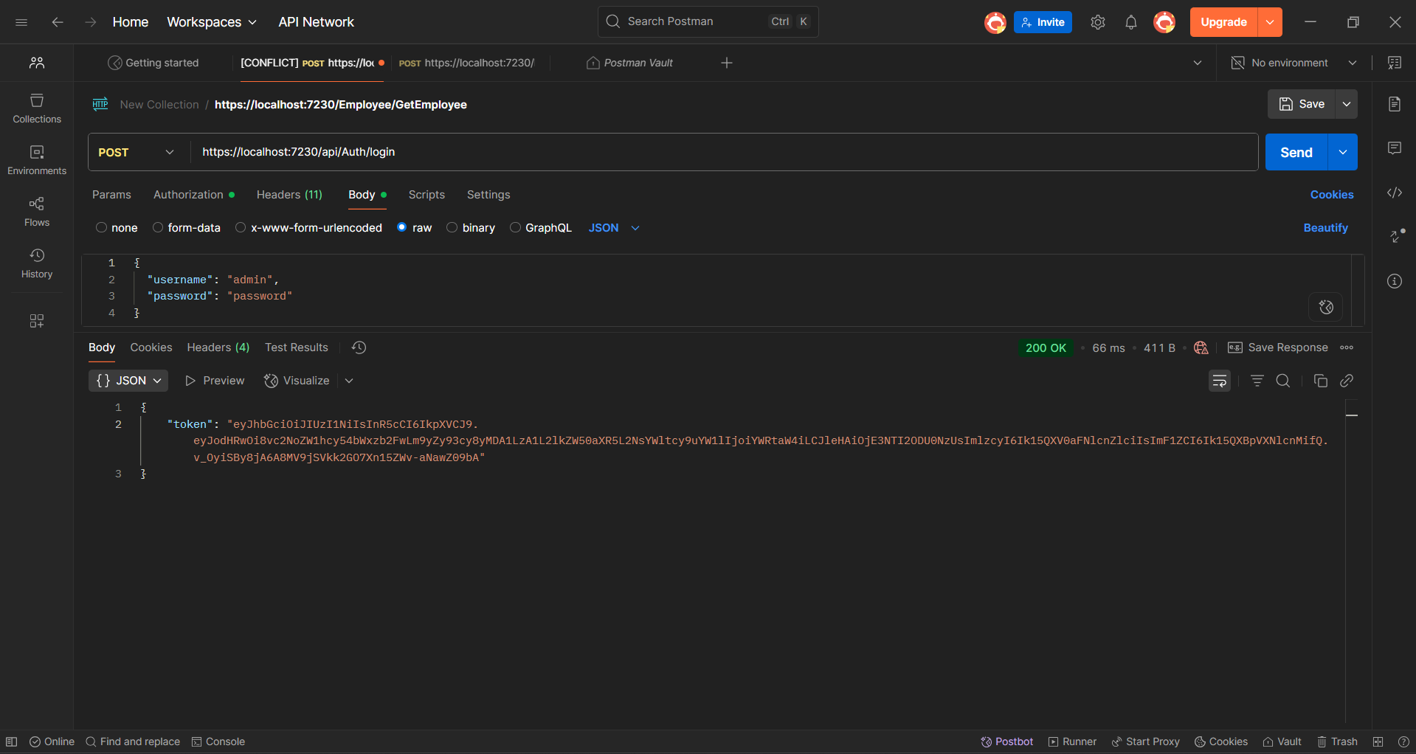

### Accessing Protected Endpoint :-

**OUTPUT :-**

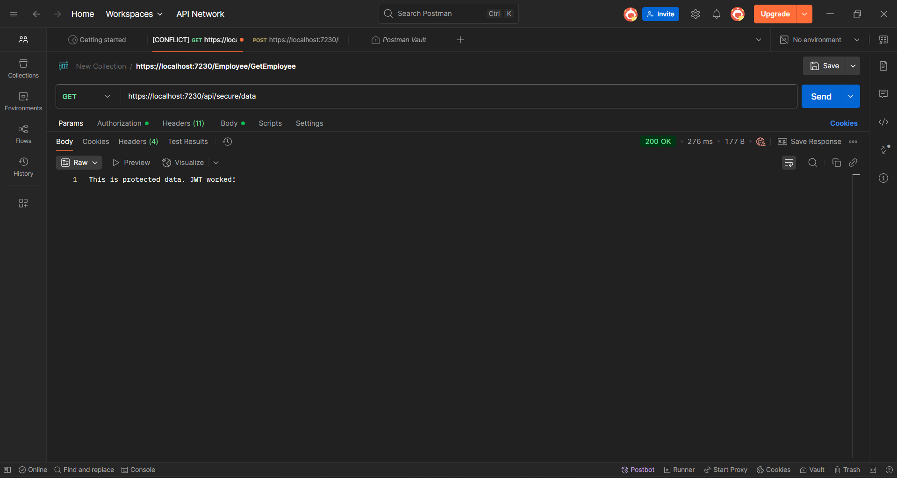

**Testing in Swagger UI :-**

**OUTPUT :-**

