Task 2 — Data Visualization with Matplotlib & Seaborn
Titanic Dataset

Objective
Create informative charts from a real-world dataset using Matplotlib and Seaborn, including a histogram, box plot, correlation matrix heatmap, and categorical chart.

Libraries Used
Python, Pandas, NumPy, Matplotlib, Seaborn

1. Histogram — Passenger Age
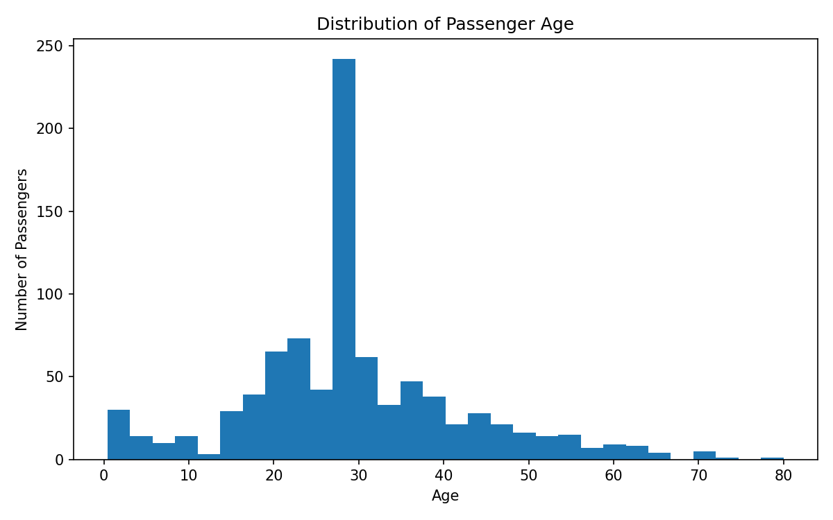
Analysis: The histogram shows the passenger age distribution, concentrated mainly in younger and middle-aged ranges.

2. Box Plot — Fare by Passenger Class
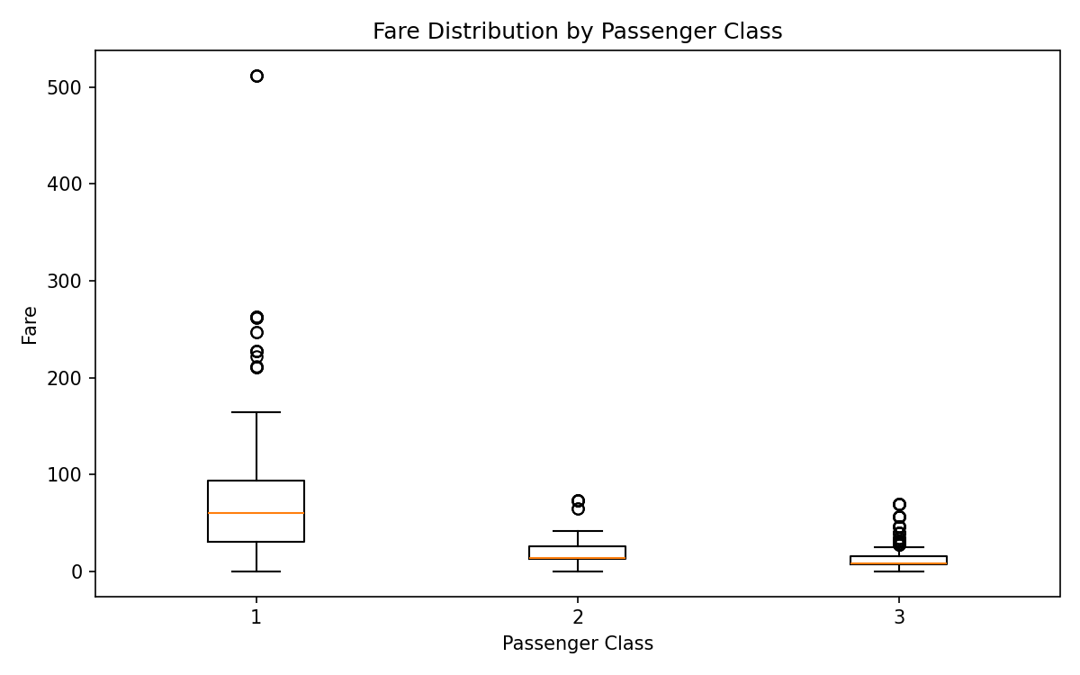
Analysis: Fare distributions vary across passenger classes; first-class fares are generally higher and high-value outliers are visible.

3. Correlation Matrix Heatmap
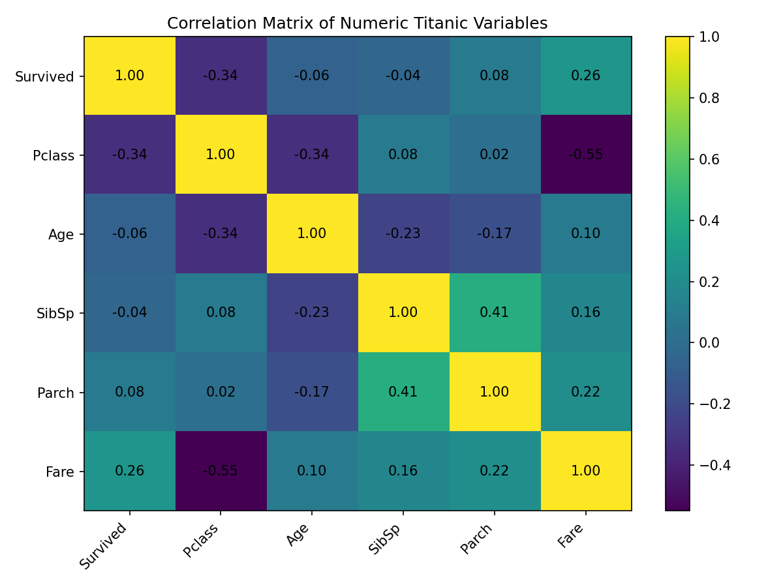
Analysis: The heatmap summarizes linear relationships among numeric variables. Pclass and Fare have a noticeable negative correlation. Correlation represents association, not causation.

4. Count Plot — Survival by Passenger Class
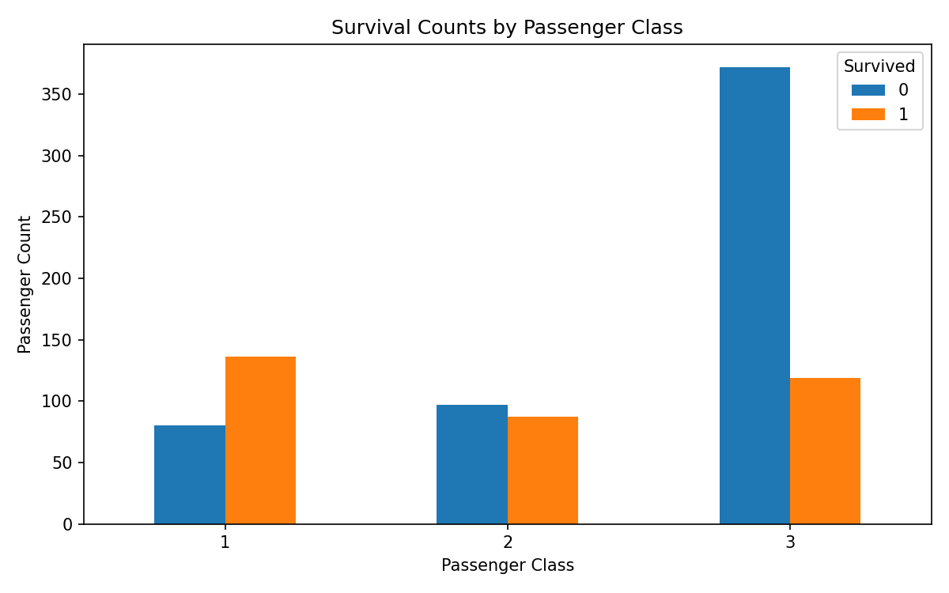
Analysis: Survival and non-survival counts differ across passenger classes, making class useful for further analysis.

Key Findings
- Passenger ages are concentrated in younger and middle-aged ranges.
- Fare distributions vary substantially by passenger class.
- The correlation matrix reveals relationships among survival, class, age, family-related variables, and fare.
- Survival counts differ across passenger classes.
- Visualizations make patterns and distributions easier to interpret.

Conclusion
Matplotlib and Seaborn provide effective tools for visual exploratory data analysis. These visualizations complement the statistical and cleaning work completed in Task 1.

