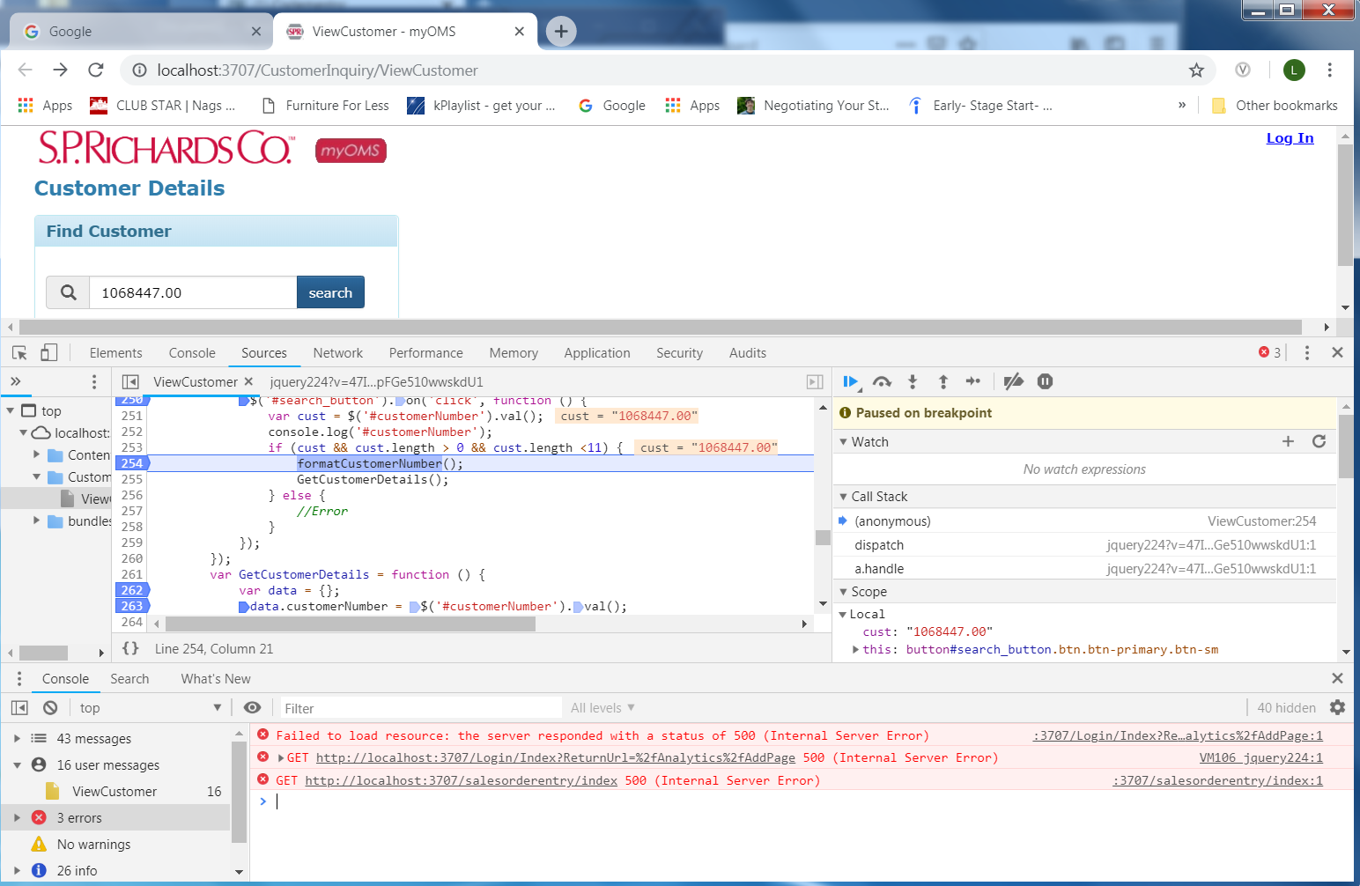

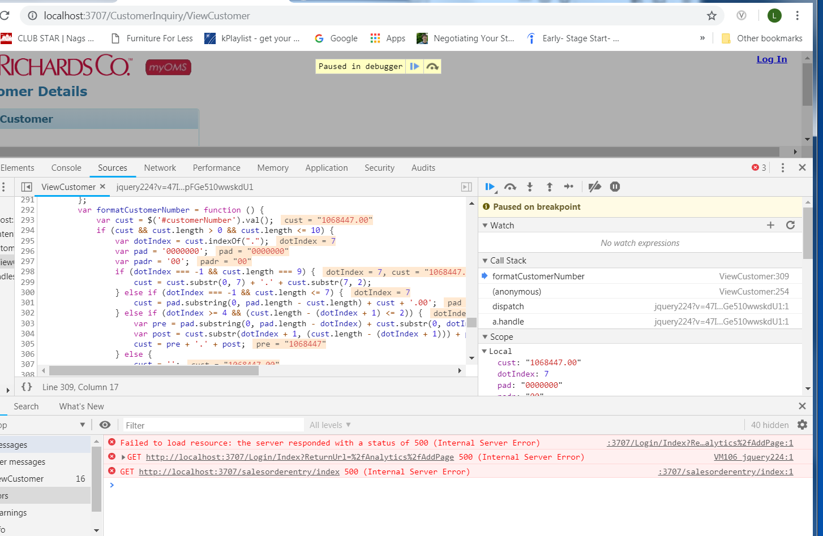

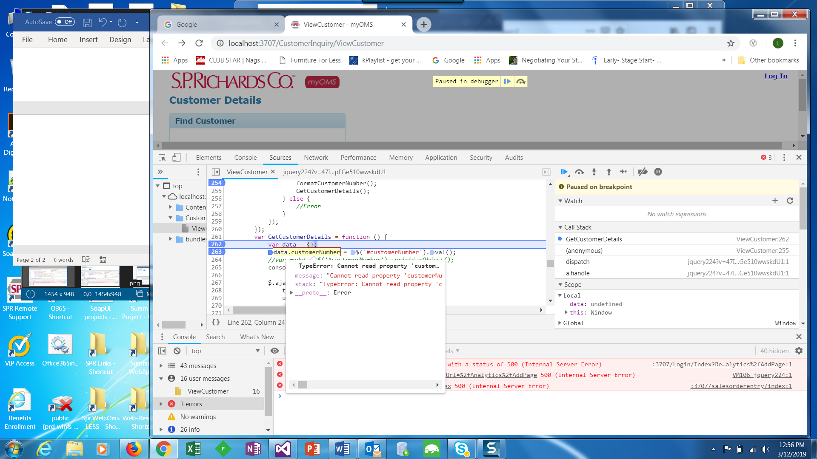

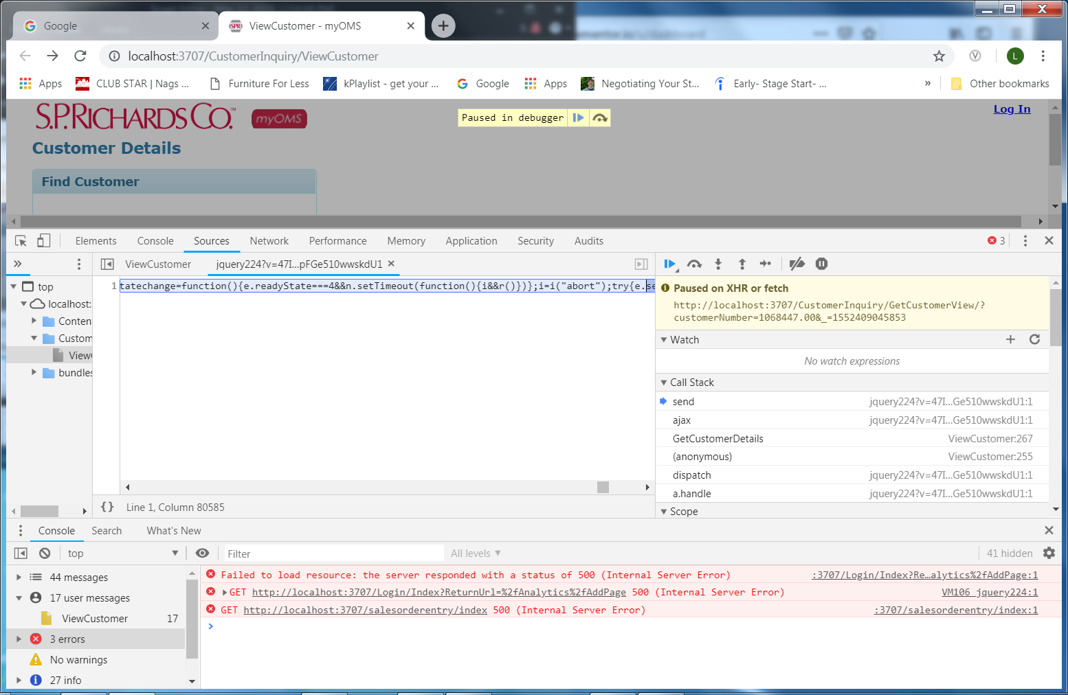

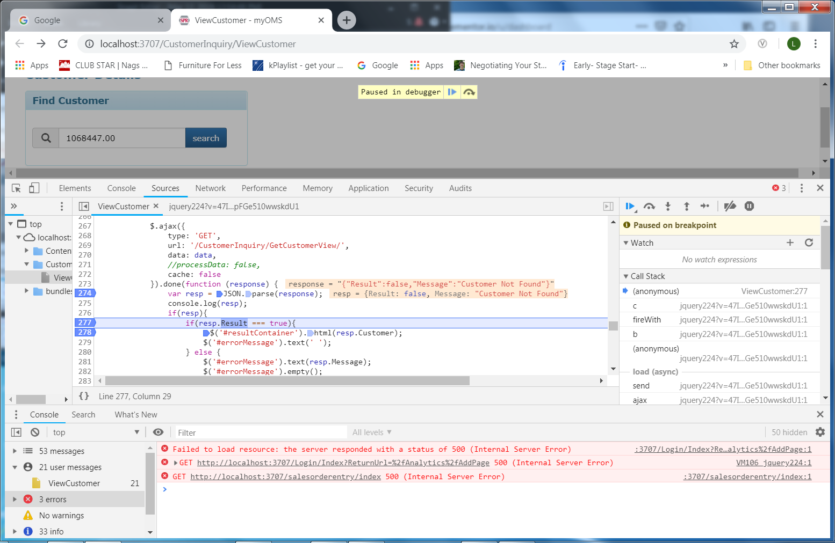

This is the controller that we did over.

[HttpGet]

public ActionResult ViewCustomer()

{

return View();

}

public JsonResult GetCustomerView(string customerNumber)

{

try

{

var cookie = this.GetUserCookie();

if (CustomerInquiryManager.IsUserAuthorizedAccount(cookie.LoginUserID, customerNumber))

{

var mgr = new CustomerInquiryManager();

var cust = mgr.CustomerDetail(new CustomerDetailRequest()

{

CustomerNumber = customerNumber,

UserId = cookie.LoginUserID

});

if(cust != null && !string.IsNullOrWhiteSpace(cust.BuyerOrganizationCode))

{

var result = RenderHelper.PartialView(this, "_CustomerView", cust);

return Json(JsonConvert.SerializeObject(new { Result = true, Customer = "" }), JsonRequestBehavior.AllowGet);

}

else

{

return Json(JsonConvert.SerializeObject(new { Result = false, Message = "Customer Not Found" }), JsonRequestBehavior.AllowGet);

}

}

else

{

return Json(JsonConvert.SerializeObject(new { Result = false, Message = "Customer Not Found" }), JsonRequestBehavior.AllowGet);

}

}

catch (System.Exception)

{

return Json(JsonConvert.SerializeObject(new { Result = false, Message = "A Server Error occurred" }), JsonRequestBehavior.AllowGet);

}

}

Here is the source code for the view in case you need it. It’s still pretty similar to what we did yesterday.

@{

ViewBag.Title = "ViewCustomer";

Layout = "~/Views/Shared/_CleanLayout.cshtml";

}

@section styles{

<style>

#errorContainer {

display: inline-block;

margin-left: 15px;

}

#headerSearchPanel{

margin-left: -15px;

margin-right:-15px;

}

#headerTitleContainer {

display: inline-block;

margin-right: 25px;

}

#searchContainer {

display: inline-block;

padding: 5px;

width: 300px;

}

#searchContainer > form > .form-group{

margin-top: 0px;

margin-bottom: 0px;

padding-right: 15px;

}

.badge-title {

font-weight: bold;

margin-left: 20px;

}

#headerTitle{

margin-top: 15px;

margin-bottom: 15px;

}

.pageheader-container {

margin-top: -10px;

margin-bottom: 10px;

}

.panel-info > .panel-heading .badge {

margin-left: 5px;

}

.panel-info > .panel-heading .badge.badge-highvis {

background-color: #ffd700;

color: #000;

}

.panel-info > .panel-heading .badge.badge-warning {

background-color: #ffd700;

color: #000;

}

.panel-info > .panel-heading > label {

margin-bottom: 0px;

margin-left: 20px;

}

.panel-title{

font-weight: bold;

}

</style>

}

<div class="container-fluid">

<div class="row pageheader-container">

<div class="col-md-12">

<div id="headerTitleContainer">

<h3 id="headerTitle">Customer Details</h3>

<div class="panel panel-info">

<div class="panel-heading">

<h3 class="panel-title">Find Customer</h3>

</div>

<div class="panel-body">

<div id="searchContainer" class="">

<div class="form-group required">

<label class="control-label"></label><br />

<div class="input-group" id="startDatePicker">

<span class="input-group-addon" id="customerLookupButton">

<span class="glyphicon glyphicon-search"></span>

</span>

<input id="customerNumber" maxlength="10" class="form-control input-sm" />

<span class="input-group-btn">

<button type="button" class="btn btn-primary btn-sm" id="search_button">search</button>

</span>

</div>

</div>

@*<div class="form-group">

<input type="submit" class="btn btn-primary btn-sm" id="search_button" value="Search" style="margin-top:15px;" />

</div>*@

</div>

<div id="errorContainer">

<span id="errorMessage" style="font-weight: bold; color: red;"></span>

</div>

<div class="container-fluid" id="resultContainer">

</div>

</div>

</div>

</div>

</div>

</div>

</div>

@section scripts{

<script>

$(document).ready(function () {

$('#search_button').on('click', function () {

var cust = $('#customerNumber').val();

console.log('#customerNumber');

if (cust && cust.length > 0 && cust.length <11) {

formatCustomerNumber();

GetCustomerDetails();

} else {

//Error

}

});

});

var GetCustomerDetails = function () {

var data = {};

data.customerNumber = $('#customerNumber').val();

//var model = $('#customerNumber').serializeObject();

console.log(data)

$.ajax({

type: 'GET',

url: '/CustomerInquiry/GetCustomerView/',

data: data,

//processData: false,

cache: false

}).done(function (response) {

var resp = JSON.parse(response);

console.log(resp);

if(resp){

if(resp.Result === true){

$('#resultContainer').html(resp.Customer);

$('#errorMessage').text(' ');

} else {

$('#errorMessage').text(resp.Message);

$('#errorMessage').empty();

}

}

else

{

//error

}

});

};

var formatCustomerNumber = function () {

var cust = $('#customerNumber').val();

if (cust && cust.length > 0 && cust.length <= 10) {

var dotIndex = cust.indexOf(".");

var pad = '0000000';

var padr = '00';

if (dotIndex === -1 && cust.length === 9) {

cust = cust.substr(0, 7) + '.' + cust.substr(7, 2);

} else if (dotIndex === -1 && cust.length <= 7) {

cust = pad.substring(0, pad.length - cust.length) + cust + '.00';

} else if (dotIndex >= 4 && (cust.length - (dotIndex + 1) <= 2)) {

var pre = pad.substring(0, pad.length - dotIndex) + cust.substr(0, dotIndex);

var post = cust.substr(dotIndex + 1, (cust.length - (dotIndex + 1))) + padr.substring(0, padr.length - (cust.length - (dotIndex + 1)));

cust = pre + '.' + post;

} else {

cust = '';

}

$('#customerNumber').val(cust);

}

};

</script>

}

Here is the partial view:

@model SPR.DomainModels.CustomerInquiry.CustomerDetailResponse

<div class="row">

<table>

<tr>

<th>Customer Name</th>

<th>Customer Number</th>

</tr>

<tr>

<td>@Model.BillTo.Company</td>

<td>@Model.BuyerOrganizationCode</td>

</tr>

</table>

</div>

al view: