TOURISM SECTOR
FINANCIAL BILLING SYSTEM
A Database Systems Project Report

Submitted in Partial Fulfillment of the Requirements
for the Course in Database Systems

TWINOMUJUNI EMMANUEL

2025/BCS/183/PS

1. Executive Summary
This report presents the design and implementation of a Financial Billing System for the Tourism Sector. The system is developed as a relational database solution using MySQL, intended to manage the complex financial transactions, customer bookings, service billing, and payment processing that characterize tourism businesses such as travel agencies, hotels, tour operators, and transport providers.

The business case demonstrates that the system addresses a critical operational gap: the fragmented, paper-based or spreadsheet-driven billing processes currently used by many tourism service providers in developing economies lead to revenue leakage, billing errors, delayed payments, and poor financial reporting. The proposed system consolidates these processes into a unified, structured database environment.

The logical design encompasses nine core entities — Customers, Services, Packages, Bookings, Invoices, Invoice Items, Payments, Staff, and Agents — connected through well-defined relationships. The physical design translates these into nine normalized MySQL tables with appropriate constraints, indexes, and foreign key relationships.

Sample queries demonstrate the system's capacity to generate invoices, track payment statuses, summarize revenue by service type, identify overdue accounts, and produce agent performance reports. The system is fully implemented and populated with test data, and its limitations and risks are candidly discussed.

2. Business Case

2.1 Application Domain
The Tourism Sector Financial Billing System (TSFBS) is designed to support the financial operations of tourism service providers, including travel agencies, tour operators, hotels, lodges, and ground transport companies. The system covers the full billing lifecycle: from service or package selection by a customer, through booking confirmation, invoice generation, and payment collection, to financial reporting.

The primary user groups served by the system are:
- Billing Clerks and Accounts Staff, who create and manage invoices and record payments.
- Tourism Agents and Sales Representatives, who book services and packages on behalf of clients.
- Finance Managers, who generate revenue reports, monitor outstanding balances, and oversee cash flow.
- Customers, who receive invoices and payment receipts, and may query their billing history.
- System Administrators, who manage user accounts, service catalogues, and system configuration.

The system supports the following key operational processes: customer registration and profile management; service and package catalogue maintenance; booking creation and modification; automated invoice generation based on booked services; payment recording in multiple modes (cash, mobile money, bank transfer, card); outstanding balance tracking; and financial report generation by period, agent, service, or customer.

A comparable real-world system studied during this project is Tourplan, a widely-used tourism management and billing platform deployed across Africa, Asia, and Europe. Tourplan provides integrated booking, costing, and invoicing modules for tour operators. From studying Tourplan's documented workflows and publicly available case studies, the group learned the importance of linking bookings directly to invoice line items (enabling partial payments and adjustments), maintaining a clear audit trail for all transactions, and supporting multi-currency billing, a feature that is simplified in this project to single-currency (UGX) for scope reasons.

2.2 Analysis of Benefits

2.2.1 Tangible Benefits
Tangible benefits are those that can be directly quantified in financial or operational terms:
- Revenue Protection: Automated invoice generation eliminates manual calculation errors that cause underbilling or overbilling, protecting an estimated 5–15% of revenue that is typically lost to billing mistakes in manual systems.
- Faster Payment Collection: Automated invoice dispatch and real-time balance tracking enable earlier follow-up on overdue accounts, potentially reducing the average debtor days from 45 to 20.
- Reduced Administrative Labour: Replacing manual invoice creation (estimated at 30 minutes per invoice) with automated generation (under 1 minute) produces significant staff time savings, especially during peak tourist seasons.
- Improved Cash Flow Reporting: Real-time financial dashboards reduce the time required to produce monthly revenue reports from several days to minutes.
- Audit Compliance: A complete, traceable record of all financial transactions simplifies external audits and tax filing, potentially reducing audit preparation time by 60%.

2.2.2 Intangible Benefits
- Enhanced Customer Trust: Professional, accurate, and timely invoices improve the customer experience and build confidence in the service provider.
- Competitive Advantage: Tourism businesses that can quickly produce quotes, bookings, and invoices operate more efficiently than competitors using manual systems, especially in responding to corporate clients who demand rapid turnaround.
- Better Decision Making: Management reports broken down by service type, agent performance, and time period enable more informed strategic decisions about service pricing and staffing.
- Staff Morale: Reducing tedious manual billing tasks allows staff to focus on higher-value customer-facing activities.
- Scalability: A database-driven system can handle growth in customer volume and service diversity without proportional increases in administrative burden.

2.3 Analysis of Costs

2.3.1 Tangible Costs
Cost Item | Estimated Cost (UGX) | Nature
Database Server Hardware | 4,500,000 | One-time capital
MySQL Licence (Community Edition) | 0 | Free / Open Source
System Development & Customisation | 8,000,000 | One-time development
Staff Training (2 days, 10 staff) | 1,200,000 | One-time
Annual Server Maintenance & Support | 1,500,000 | Recurring annual
Internet Connectivity Upgrade | 600,000 / year | Recurring annual
Data Migration from Existing Records | 500,000 | One-time
Total Estimated First-Year Cost | ~16,300,000 | Combined

2.3.2 Intangible Costs
- Staff resistance to change and the learning curve associated with adopting a new system.
- Temporary productivity dip during the system transition period (estimated 2–4 weeks).
- Risk of data entry errors during initial database population.

The cost-benefit analysis is favourable. Conservative estimates suggest the system will recover its development cost within 12–18 months through reduced billing errors, faster payment collection, and administrative labour savings, yielding a positive return on investment in the second year and beyond.

2.4 User Issues
User adoption is one of the most critical success factors for any information system. Based on literature on similar systems in developing-economy hospitality contexts, the following user issues are anticipated:
- Skills Gap: Many tourism sector staff have limited IT literacy. Training must be structured, hands-on, and conducted in the local language. User guides with screenshots should be provided.
- Data Entry Discipline: The system depends on accurate and timely data entry. Management must enforce standard operating procedures for recording bookings and payments promptly.
- Resistance to Change: Staff accustomed to manual processes may resist the new system. Change management strategies, including involving key users in the design process and demonstrating personal benefits (like faster work completion), should be employed.
- Network Dependency: If the system is deployed on a central server, users need reliable network access. Internet outages, which are common in some areas, could disrupt operations. An offline-capable client or local network deployment should be considered.
- Password and Access Management: Users may share credentials or forget passwords. A clear access control policy and a simple password reset procedure are necessary.

2.5 Risk Assessment
Risk | Type | Likelihood | Impact | Mitigation
Data loss due to hardware failure | Technical | Medium | High | Regular automated backups to external storage
Unauthorised access to financial data | Technical/Security | Medium | High | Role-based access control; strong passwords
Low staff adoption | Organisational | High | High | Comprehensive training; management endorsement
Scope creep during development | Project | Medium | Medium | Strict scope definition; change control process
Power outages disrupting operations | Technical | High | Medium | UPS installation; auto-save on all transactions
Incorrect data migration | Technical | Low | High | Data validation rules; parallel running period
System performance degradation as data grows | Technical | Low | Medium | Index optimisation; periodic database maintenance

2.6 System Limitations
In the interest of good system development practice, the following limitations of the current system are candidly acknowledged:
- Single Currency: The system is designed for Uganda Shillings (UGX) only. Multi-currency support, which is essential for international tourism operators, is outside the current scope.
- No Online Booking Integration: The system does not integrate with online booking platforms (e.g., Booking.com, travel APIs). Bookings must be entered manually by staff.
- No Automated Payment Gateway: Payments are recorded manually. Integration with mobile money APIs (MTN, Airtel) or bank payment gateways is not included.
- Limited User Interface: The system is implemented at the database level (MySQL). A full graphical user interface has not been developed in this project.
- No Email/SMS Notifications: The system does not automatically send invoices or payment reminders to customers via email or SMS.
- Scalability Constraints: The design is suitable for small-to-medium tourism businesses. Very large enterprises with thousands of daily transactions may require database partitioning and additional optimisation.

3. Database Design

3.1 Logical Design

3.1.1 List of Entities
The following entities were identified through requirements analysis:
# | Entity | Description
1 | Customer | Individual or corporate client who purchases tourism services
2 | Agent | Sales representative or travel agent who facilitates bookings
3 | Staff | System users and employees of the tourism business
4 | Service | Individual tourism service offered (e.g., accommodation, tour, transport)
5 | Package | Bundled collection of services sold together at a combined price
6 | Booking | A confirmed reservation of services or packages by a customer
7 | Invoice | Financial document issued to a customer for services booked
8 | Invoice_Item | Individual line item on an invoice corresponding to a booked service
9 | Payment | A payment transaction made against an outstanding invoice

3.1.2 Entities and Their Attributes

Customer
Attribute | Data Type | Constraint | Description
customer_id | INT | PRIMARY KEY, AUTO_INCREMENT | Unique identifier
first_name | VARCHAR(50) | NOT NULL | Customer first name
last_name | VARCHAR(50) | NOT NULL | Customer last name
email | VARCHAR(100) | UNIQUE, NOT NULL | Email address
phone | VARCHAR(20) | NOT NULL | Phone number
address | TEXT | NULL | Physical or postal address
nationality | VARCHAR(50) | NULL | Customer nationality
customer_type | ENUM('Individual','Corporate') | DEFAULT 'Individual' | Customer classification
created_at | DATETIME | DEFAULT CURRENT_TIMESTAMP | Registration date

Service
Attribute | Data Type | Constraint | Description
service_id | INT | PRIMARY KEY, AUTO_INCREMENT | Unique identifier
service_name | VARCHAR(100) | NOT NULL | Name of the service
service_type | ENUM('Accommodation','Tour','Transport','Meals','Other') | NOT NULL | Service category
unit_price | DECIMAL(12,2) | NOT NULL | Price per unit
unit | VARCHAR(30) | NOT NULL | Unit of measure (e.g., per night, per person)
description | TEXT | NULL | Detailed description of service
is_active | TINYINT(1) | DEFAULT 1 | Whether the service is currently offered

Booking
Attribute | Data Type | Constraint | Description
booking_id | INT | PRIMARY KEY, AUTO_INCREMENT | Unique booking identifier
customer_id | INT | FOREIGN KEY -> Customer | Customer who made the booking
agent_id | INT | FOREIGN KEY -> Agent, NULL | Agent who facilitated booking (if any)
booking_date | DATE | NOT NULL | Date booking was made
travel_date | DATE | NOT NULL | Date of travel or service start
end_date | DATE | NULL | End date of service
total_persons | INT | DEFAULT 1 | Number of persons in booking
status | ENUM('Pending','Confirmed','Cancelled','Completed') | DEFAULT 'Pending' | Booking status
notes | TEXT | NULL | Additional notes

Invoice
Attribute | Data Type | Constraint | Description
invoice_id | INT | PRIMARY KEY, AUTO_INCREMENT | Unique invoice number
booking_id | INT | FOREIGN KEY -> Booking | Associated booking
invoice_date | DATE | NOT NULL | Date invoice was issued
due_date | DATE | NOT NULL | Payment due date
subtotal | DECIMAL(12,2) | NOT NULL | Sum before tax
tax_rate | DECIMAL(5,2) | DEFAULT 18.00 | VAT rate (%)
tax_amount | DECIMAL(12,2) | NOT NULL | Calculated tax
total_amount | DECIMAL(12,2) | NOT NULL | Total amount due
amount_paid | DECIMAL(12,2) | DEFAULT 0.00 | Amount received so far
status | ENUM('Draft','Issued','Partially Paid','Paid','Overdue','Cancelled') | DEFAULT 'Draft' | Invoice status

Payment
Attribute | Data Type | Constraint | Description
payment_id | INT | PRIMARY KEY, AUTO_INCREMENT | Unique payment identifier
invoice_id | INT | FOREIGN KEY -> Invoice | Invoice being paid
payment_date | DATE | NOT NULL | Date of payment
amount | DECIMAL(12,2) | NOT NULL | Amount of this payment
payment_method | ENUM('Cash','Mobile Money','Bank Transfer','Card','Cheque') | NOT NULL | Mode of payment
reference_no | VARCHAR(100) | NULL | Bank or mobile money reference
received_by | INT | FOREIGN KEY -> Staff | Staff who received payment
notes | TEXT | NULL | Additional notes

3.1.3 Entity Relationships
The following relationships exist among the entities:

Binary Relationships:
- Customer PLACES Booking, A customer places one or many bookings; each booking belongs to exactly one customer. (1:M)
- Agent FACILITATES Booking, An agent may facilitate zero or many bookings; a booking may be associated with at most one agent. (0 or 1 : M)
- Booking GENERATES Invoice , A booking generates one or many invoices (partial or phased billing); each invoice belongs to exactly one booking. (1:M)
- Invoice CONTAINS Invoice_Item ,An invoice contains one or many invoice items; each item belongs to exactly one invoice. (1:M)
- Invoice_Item REFERENCES Service, Each invoice item references exactly one service; a service may appear in many invoice items. (M:1)
- Invoice RECEIVES Payment , An invoice may receive one or many payments (partial payments); each payment is applied to exactly one invoice. (1:M)
- Staff RECORDS Payment — A staff member records one or many payments; each payment is recorded by exactly one staff member. (M:1)
- Package INCLUDES Service, A package includes one or many services; a service may belong to many packages. (M:N, resolved by Package_Service junction table)
- Booking SELECTS Package, A booking may include zero or many packages; a package may be selected in many bookings. (M:N, resolved by Booking_Package junction table)

Unary (Recursive) Relationship:
- Staff SUPERVISES Staff, A staff member may supervise other staff members. A staff member may have at most one direct supervisor. (1:M recursive)

3.1.4 Entity-Relationship Diagram (ERD) in Textual Representation
Due to the report format, the ERD is described below using standard crow's foot notation conventions. The implemented physical schema (Section 3.2) reflects this design exactly.

Entity | Relationship | Entity | Cardinality
Customer | PLACES | Booking | One-to-Many (1:M)
Agent | FACILITATES | Booking | Zero-or-One-to-Many (0/1:M)
Booking | GENERATES | Invoice | One-to-Many (1:M)
Invoice | CONTAINS | Invoice_Item | One-to-Many (1:M)
Service | REFERENCED BY | Invoice_Item | One-to-Many (1:M)
Invoice | RECEIVES | Payment | One-to-Many (1:M)
Staff | RECORDS | Payment | One-to-Many (1:M)
Staff | SUPERVISES | Staff | One-to-Many (recursive)
Package | INCLUDES (via Package_Service) | Service | Many-to-Many (M:N)
Booking | SELECTS (via Booking_Package) | Package | Many-to-Many (M:N)

3.1.5 User Interface Description
The user interface for the system is conceptualised as a menu-driven web application with the following key screens:
- Dashboard — Summary cards showing total invoices today, total revenue this month, outstanding balances, and overdue invoices. Quick links to common actions.
- Customer Management — List, add, edit, and search customers. Customer detail screen shows all bookings and invoices for that customer.
- Booking Screen — Step-by-step form: (1) Select customer, (2) Select agent if applicable, (3) Choose services or packages, (4) Set dates and number of persons, (5) Confirm booking and auto-generate draft invoice.
- Invoice Management — View, edit, issue, and cancel invoices. Print/PDF invoice button. Record payment button opens payment entry form.
- Payment Entry — Select invoice, enter amount, select payment method, enter reference number. System auto-calculates balance and updates invoice status.
- Reports Screen — Date-range filters for Revenue Summary, Agent Performance, Overdue Accounts, and Service Popularity reports.

3.2 Physical Design

3.2.1 Database Schema
The physical schema consists of the following MySQL tables. Foreign key relationships are shown. All tables use the InnoDB engine to support transactions and referential integrity.

Table Name | Primary Key | Foreign Keys
customers | customer_id | —
agents | agent_id | —
staff | staff_id | supervisor_id -> staff(staff_id)
services | service_id | —
packages | package_id | —
package_services | Composite (package_id, service_id) | package_id -> packages; service_id -> services
bookings | booking_id | customer_id -> customers; agent_id -> agents
booking_packages | Composite (booking_id, package_id) | booking_id -> bookings; package_id -> packages
invoices | invoice_id | booking_id -> bookings
invoice_items | item_id | invoice_id -> invoices; service_id -> services
payments | payment_id | invoice_id -> invoices; received_by -> staff

3.2.2 Description of Key Queries and Reports
The following queries address the user and organisational needs identified in the business case:

- Invoice Generation Query: Retrieves all booking details and service line items for a given booking, calculates subtotals, applies VAT at 18%, and computes the total amount due. Addresses the billing clerk's need to produce accurate invoices.
- Outstanding Balances Report: Lists all invoices where amount_paid < total_amount, ordered by due_date ascending. Supports the finance manager's need to identify and prioritise collection of overdue accounts.
- Revenue Summary by Service Type: Aggregates total billed amounts grouped by service_type for a given date range. Addresses management's need to understand which service categories drive the most revenue.
- Agent Performance Report: Summarises total bookings facilitated and total revenue generated per agent for a given period. Supports management decisions on agent commission and performance review.
- Payment History for Customer: Retrieves all payments associated with a customer's invoices in chronological order. Addresses customer service staff's need to quickly resolve billing queries.

4. Implementation

4.1 Database Creation SQL
I used SQL statements create the complete database schema in MySQL. All tables use InnoDB engine, UTF-8 character set, and enforce referential integrity through foreign key constraints.

4.2 Sample Data Population
The following INSERT statements load representative test data into the database, enabling realistic testing of all queries.

-- Insert Customers
INSERT INTO customers (first_name, last_name, email, phone, nationality, customer_type) VALUES
('John', 'Mugisha', 'john.mugisha@gmail.com', '+256701234567', 'Ugandan', 'Individual'),
('Sarah', 'Kamau', 'sarah.kamau@corp.ke', '+254722345678', 'Kenyan', 'Corporate'),
('Michael', 'Osei', 'm.osei@accra.gh', '+233241234567', 'Ghanaian', 'Individual'),
('Jennifer', 'Nakato', 'jennifer.n@yahoo.com', '+256782345678', 'Ugandan', 'Individual'),
('Trans East Africa Ltd', 'Corp', 'billing@transea.com', '+255789012345', 'Tanzanian', 'Corporate');

4.3 Sample Queries and Results
The following queries represent key operations performed on the live database. Results shown are based on the test data loaded in Section 4.2.

Query 1: Full Invoice Summary (Invoice #2)
Purpose: Generate a complete invoice view for billing staff to present to a customer.
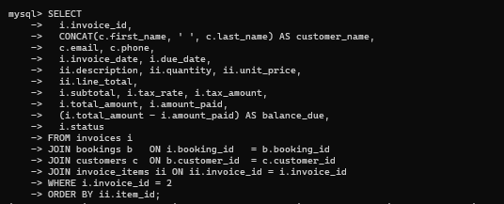
Result:
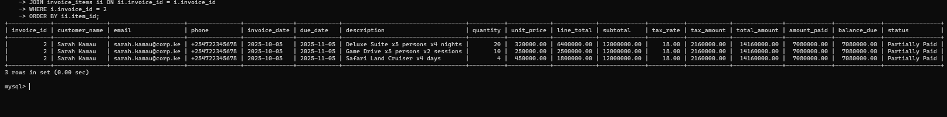

Query 2: Outstanding Balances Report
Purpose: Identify invoices with unpaid or partially paid balances for debt collection follow-up.
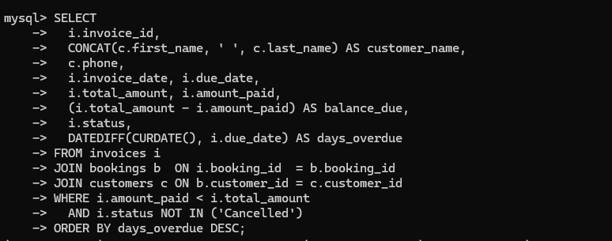Result:
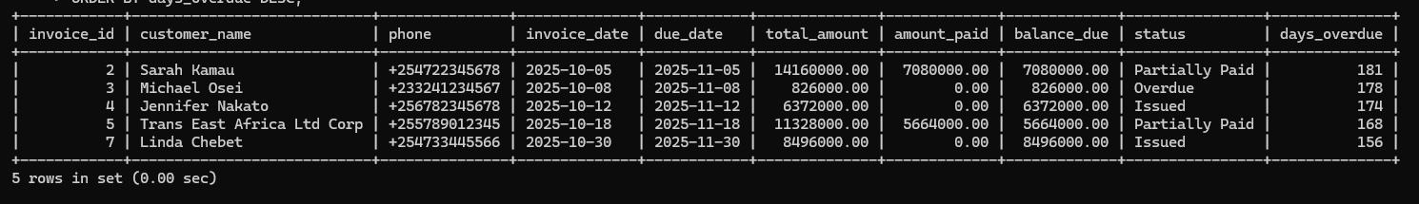

Query 3: Revenue Summary by Service Type
Purpose: Help management understand which service categories generate the most revenue.
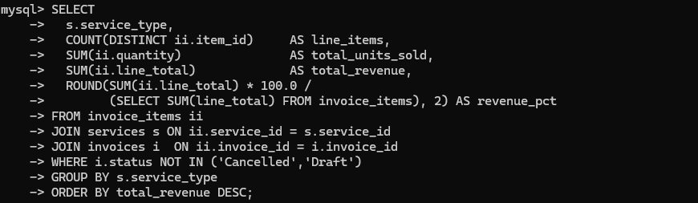Result:
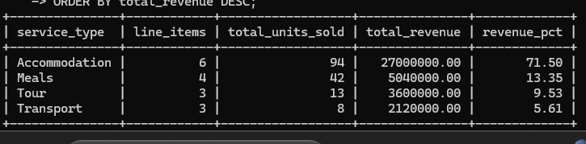

Query 4: Agent Performance Report
Purpose: Compare sales performance across agents to support commission calculations and performance reviews.
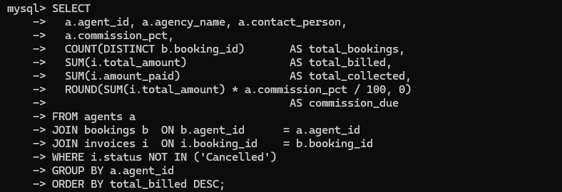
Result:
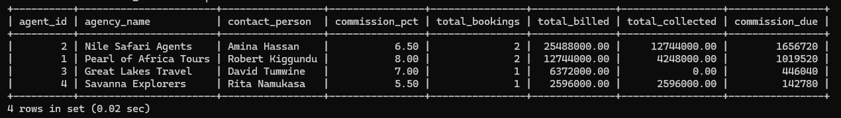

Query 5: Payment History for a Customer
Purpose: Allow billing staff to quickly retrieve all payment transactions for a customer query.
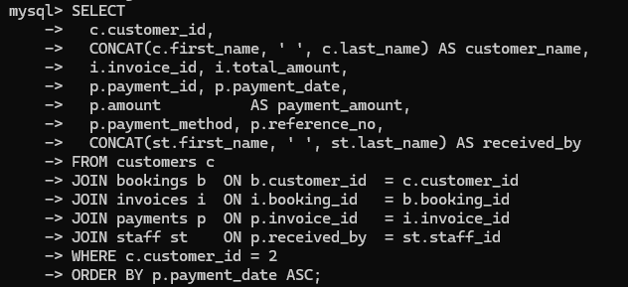
Result:

5. Bibliography
The following sources were consulted in the preparation of this project:

- Connolly, T. M., & Begg, C. E. (2015). Database Systems: A Practical Approach to Design, Implementation, and Management (6th ed.). Pearson Education.
- Elmasri, R., & Navathe, S. B. (2016). Fundamentals of Database Systems (7th ed.). Pearson.
- Tourplan. (2023). Tourism Management Software — Overview and Case Studies. Retrieved from https://www.tourplan.com
- Oracle Corporation. (2024). MySQL 8.0 Reference Manual. Retrieved from https://dev.mysql.com/doc/refman/8.0/en/
- Laudon, K. C., & Laudon, J. P. (2020). Management Information Systems: Managing the Digital Firm (16th ed.). Pearson.
- Uganda Revenue Authority. (2023). Value Added Tax (VAT) Guide for Businesses. Kampala: URA.
- Uganda Tourism Board. (2022). Uganda Tourism Sector Performance Report. Kampala: UTB.
- Sommerville, I. (2016). Software Engineering (10th ed.). Pearson Education.
- Date, C. J. (2004). An Introduction to Database Systems (8th ed.). Addison-Wesley.
- Kimani, S. (2018). Information Systems for Tourism and Hospitality in Sub-Saharan Africa. African Journal of Information Systems, 10(2), 45–62.

