Adaptive Resource Management for Real-Time Data Pipelines
Progress Report — Implementation, Challenges, and Preliminary Results
Prepared for: Cloud Infrastructure and Architecture Course Project — First Review
Twisha Panseriya (25BCE1062) · Tanushree Desai (25BCE1409)

1. Overview
This report documents the implementation phase of our project, scoped down from the 4-month, journal-track proposal in our literature review to a course-deliverable pilot study, as agreed for this review cycle. We built a working Kafka-based real-time pipeline on a single machine and implemented and compared three resource management strategies: static allocation, reactive threshold-based scaling, and lightweight predictive scaling. This document covers what we built, the concrete problems we ran into while building it, how each was resolved, our experimental results so far, and what remains for the next review.

2. System Implementation

2.1 Architecture
The pipeline consists of: a synthetic workload producer that emits events to Kafka at a variable, bursty rate (a steady baseline with periodic spikes, simulating real-world traffic patterns); a Kafka broker (single-node, KRaft mode, running in Docker) with a 3-partition topic; a pool of worker processes that consume and process events, simulating a fixed per-message processing cost; and a controller layer that monitors the pipeline and adjusts the number of active workers according to one of three strategies.

2.2 The three strategies implemented
Strategy | Scaling signal used | Behavior
Static | None | Fixed worker count (3) for the entire run — the control group
Reactive | Consumer lag (backlog) | Scales up/down once lag crosses a threshold
Predictive | Forecasted arrival rate | Forecasts near-future load via a moving average and sizes the worker pool for the forecast, rather than waiting for backlog to build up

All three controllers share identical monitoring and CSV-logging code; only the scaling decision logic differs between them, so that the comparison isolates the effect of the strategy itself rather than incidental implementation differences.

3. Problems Faced and How We Overcame Them
Building this pipeline surfaced a number of real-world issues typical of cloud infrastructure work — environment setup problems, dependency breakage, and, most usefully, genuine behavioral bugs in our own scaling logic that we had to diagnose from data. Each is documented below with its cause and resolution.

3.1 Environment and dependency issues

Bitnami Kafka image no longer freely available
Our initial docker-compose.yml used the bitnami/kafka image. Bitnami restructured its Docker catalog and moved free rolling tags behind a paid subscription ("Bitnami Secure Images"), so `docker compose up` failed with a "reference not found" error.
Resolution: switched to the official apache/kafka image, running in KRaft mode (broker + controller combined, no separate Zookeeper container needed). This was arguably an improvement — it is the canonical upstream image and a more accurate citation for the report.

kafka-python incompatible with modern Python
The kafka-python package failed to import on our system (Python 3.14, a very recent release) with ModuleNotFoundError: No module named 'kafka.vendor.six.moves'. This is a known issue: kafka-python has been effectively unmaintained for several years and has a bug in how it bundles the six compatibility library, which breaks on Python 3.12 and later.
Resolution: switched to kafka-python-ng, an actively maintained community fork that is a drop-in replacement (same `from kafka import ...` syntax), resolving the issue without any code changes to our scripts.

Virtual environment broke after being moved
A Python venv was accidentally created in the wrong directory, then moved into the correct project folder. This broke pip and python entirely, because venv activation scripts and binaries hard-code an absolute path to their original location at creation time.
Resolution: deleted the broken venv (`rm -rf venv`) and recreated it fresh in the correct location — venvs are cheap to regenerate and not meant to be moved.

GitHub password authentication rejected
`git push` failed with "Password authentication is not supported for Git operations," since GitHub disabled plain password auth for git operations some time ago.
Resolution: generated a GitHub Personal Access Token (PAT) with repo scope and used it in place of a password, with `git config credential.helper store` to avoid re-entering it on every push.

3.2 Experimental methodology issues

Stale backlog contaminating results
Early test runs showed enormous consumer lag (hundreds of messages) within the first few seconds of starting a controller — far more than could have been produced in that time. Diagnosis: the Kafka topic had accumulated leftover, unconsumed messages across many earlier ad hoc testing sessions, and this stale backlog was being inherited by whichever run happened to start next.
Resolution: adopted a clean-slate protocol — delete and recreate the Kafka topic (`kafka-topics.sh --delete` / `--create`) before every timed experimental run, ensuring every strategy starts from zero backlog.

Reactive controller scaled up but never back down
In an early run, the reactive controller correctly scaled from 1 to 3 workers during a burst, but never scaled back down afterward, even during long quiet periods. Diagnosis: the scale-down lag threshold (5 pending messages) was set lower than the steady-state quiet-period lag baseline actually observed (roughly 16–19), so the "scale down" condition was never satisfied once the system reached that state.
Resolution: raised the scale-down threshold to 25, which is above the observed quiet-period baseline. Re-running confirmed proper bidirectional scaling (workers stepping both up during bursts and down during quiet periods).

Predictive controller underestimated burst intensity
The predictive controller's forecasted arrival rate during bursts topped out around 22 messages/second, well below the producer's actual burst rate of 40 messages/second — causing it to under-provision (rarely scaling past 2 workers) and accumulate high lag.
Diagnosis: the controller polled every 5 seconds, the same duration as the burst window itself, so a single poll frequently captured a mix of burst and quiet-period traffic, diluting the measured rate to roughly half its true value.
Resolution: reduced the polling interval to 2 seconds for all three controllers (kept identical across strategies for a fair comparison). This corrected the forecasted rate to 30–39 messages/second during bursts, much closer to the true value.

New issue uncovered: predictive controller's lag grows unbounded
Fixing the polling-resolution issue above exposed a second, more fundamental problem, visible only once the first was corrected: the predictive controller's average lag nearly triples between the first and last third of a run (99 → 273), while static and reactive both improve over the same period (see Section 5). This is a genuine limitation of the current design, not a data artifact — see the Discussion in Section 6.

4. Experimental Setup
All three strategies were evaluated under matched conditions to keep the comparison fair:
- Identical synthetic workload: baseline rate 5 messages/sec, bursting to 40 messages/sec for 5 seconds out of every 30-second cycle.
- Identical polling interval (2 seconds) across all three controllers.
- Identical Kafka topic configuration: 3 partitions, replication factor 1, clean-slate reset before every run.
- Identical run duration (~240 seconds) for each strategy.
- Identical simulated per-message processing cost in worker.py (0.08 seconds), giving each worker a capacity of approximately 12.5 messages/second.

5. Results

5.1 Consumer lag over time
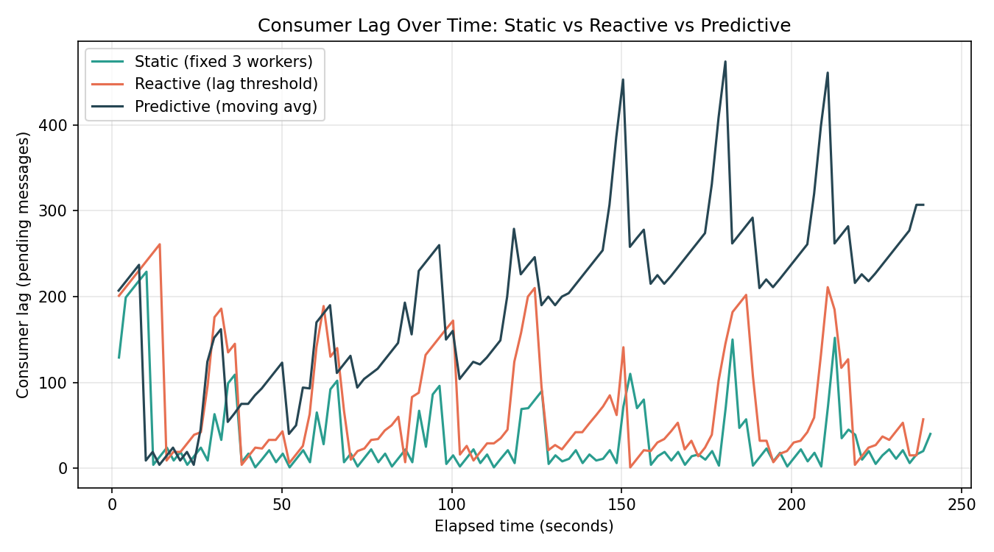
Figure 1: Consumer lag (pending messages) across the full run for all three strategies.

5.2 Worker count over time
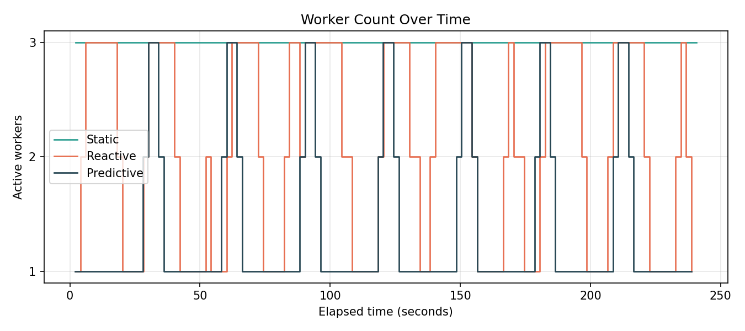
Figure 2: Active worker count over time, showing static's fixed allocation versus reactive's and predictive's dynamic adjustments.

5.3 Summary statistics
Strategy | Avg. lag | Peak lag | Avg. workers | Lag trend (1st third → last third)
Static | 35.2 | 229 | 3.00 (fixed) | 47.5 → 27.4 (improving)
Reactive | 75.4 | 261 | 2.08 | 91.9 → 65.5 (improving)
Predictive | 194.8 | 474 | 1.35 | 99.0 → 273.3 (worsening)

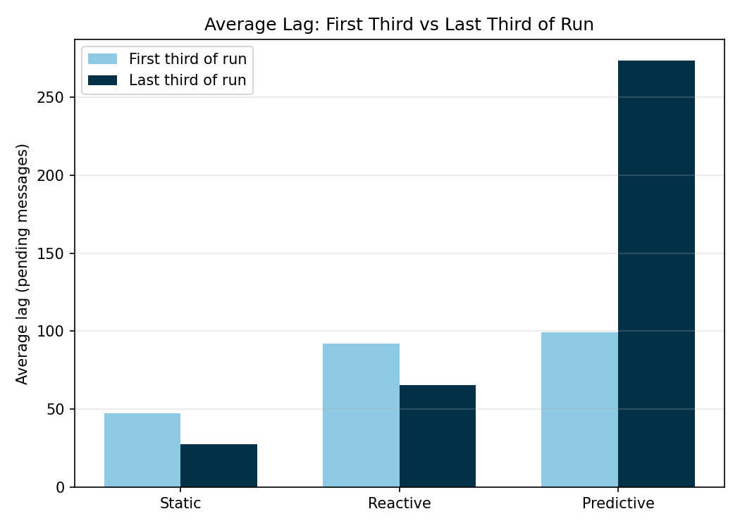
Figure 3: Average lag in the first third versus the last third of each run. Static and reactive both stabilize; predictive diverges.

6. Discussion
The static baseline achieves the lowest and most stable lag, which is expected: it pays for peak capacity (3 workers) continuously, regardless of actual demand. Its cost is that this capacity is wasted during the majority of each cycle when load is low.
The reactive strategy sits in between on both lag and resource usage, and — critically — remains stable over time: lag oscillates within a bounded range and does not trend upward across the run. This matches the expected behavior of a correctly tuned threshold-based controller.
The predictive strategy uses the fewest average workers, which would normally be read as an efficiency win, but its lag grows without bound over the course of the run rather than stabilizing. The root cause is a design gap in the scale-down rule: the controller's decision to reduce worker count is based only on the forecasted incoming rate, with no awareness of how much backlog currently exists. The instant a burst ends and the arrival rate returns to baseline, the controller releases workers immediately — even while substantial backlog from that burst remains unprocessed. Because the quiet window between bursts is not long enough for a single remaining worker to fully clear this residual backlog, each cycle leaves behind a growing remainder, compounding over successive cycles.
This directly addresses RQ2 from our literature review (whether lightweight, non-ML predictive scaling can outperform reactive threshold scaling): under the current implementation, it does not — but the reason is specific and mechanistic rather than a vague shortfall of the forecasting approach itself. The forecasting component works correctly (as shown by the improved rate estimates after the polling fix); the flaw is in how the forecast is translated into a scale-down decision.

7. Limitations and Planned Fix for Next Review
We are deliberately presenting the predictive controller's current unbounded-lag behavior as a documented finding rather than a hidden bug, since diagnosing it was itself a substantive part of this phase of the work. The planned fix for the next review cycle is to change the scale-down condition so that it requires both a low forecasted rate and a low current lag before releasing a worker — preventing the controller from abandoning a backlog that is still being drained. We also plan to:
- Add centralized p50/p95/p99 latency logging (currently only logged per-worker to stdout, not aggregated centrally for comparison).
- Compute a formal resource-cost metric (worker-seconds consumed) for each strategy, to quantify the cost/latency trade-off shown qualitatively in Section 6.
- Repeat each experiment 2–3 times to report variance, rather than relying on a single run per strategy.
- Run a brief sensitivity analysis over the reactive threshold and predictive moving-average window size.

8. Conclusion
At this stage, we have a fully working, reproducible three-way comparison pipeline (Kafka in Docker, a bursty synthetic workload, and static/reactive/predictive controllers sharing identical monitoring code), version-controlled on GitHub. The results so far show a clear and explainable cost/latency trade-off across the three strategies, and — more importantly — a specific, diagnosed limitation in our predictive strategy's scale-down logic that gives us a concrete, well-understood target for the next phase of work.

