Adaptive Resource Management for Real-Time Data Pipelines
Final Review Report: Implementation, Experiments, and Findings
Cloud Infrastructure and Architecture Course Project
Twisha Panseriya (25BCE1062) · Tanushree Desai (25BCE1409)

Abstract
Real-time stream pipelines face bursty load, so fixed provisioning either wastes resources or breaches latency targets. We built a reproducible single-machine testbed (a Kafka topic with three partitions, a pool of consumer workers, and a bursty synthetic workload) and compared three resource-management strategies: static allocation, reactive lag-threshold scaling, and a lightweight predictive strategy that forecasts the arrival rate with a moving average. Each strategy was run three times under matched conditions.
Static allocation gave by far the lowest latency (p95 of 0.85 s) at the highest cost (714 worker-seconds). The two adaptive strategies cut cost by 28% (reactive) and 38% (predictive) relative to static, but their p95 latency was about 9 to 10 s. Predictive scaling matched reactive scaling on mean latency while using about 15% fewer worker-seconds, but only after we diagnosed and fixed a flaw in its scale-down rule that otherwise let backlog grow without bound. We also document how an experimental version mix-up was detected from the logs and corrected.

1. Introduction and Scope
Stream processing pipelines built on systems such as Apache Kafka and Apache Flink must cope with arrival rates that spike and dip unpredictably. Provisioning for the worst case wastes money in quiet periods, while provisioning for the average case causes backlog and delay during bursts. Adaptive resource management addresses this by changing the resources allocated to a pipeline as load changes.
Our literature review (submitted earlier) identified a gap: most work on predictive autoscaling is evaluated on cloud-scale clusters, often with heavy machine-learning forecasters, and little is said about how much of the benefit survives when the forecaster is deliberately kept lightweight and the environment is resource-constrained. This report describes the pilot study we implemented for the course, scoped down from the four-month proposal in the literature review to a single machine and a two-to-three week build.

1.1 Research questions
- RQ1: How do static, reactive, and predictive approaches compare in responsiveness, resource efficiency, and implementation complexity?
- RQ2: Can a lightweight, statistically driven predictive method outperform a standard reactive (threshold-based) method on bursty workloads, without heavy infrastructure?
- RQ3: What are the measurable trade-offs in latency, throughput, and resource cost between the three strategies under identical workloads?

1.2 Progress since the first review
- Fixed the predictive controller's scale-down rule so it no longer ignores existing backlog (Section 4.2.4).
- Added per-message latency logging and an analysis script that computes p50/p95/p99 latency, throughput, and a resource-cost metric (worker-seconds).
- Repeated every strategy three times, interleaved, under matched conditions, and re-ran two runs that were contaminated by a controller version mix-up (Section 4.2.5).
- Built a log checker that identifies which controller version produced a run, and a live dashboard for demonstration.

2. System Design and Implementation

2.1 Architecture
A producer writes events at a bursty rate into a Kafka topic with three partitions. A pool of worker processes, all in one consumer group, consume and process the events. A controller process observes the pipeline and starts or stops worker processes. Because Kafka splits partitions across the members of a consumer group, adding or removing a worker is the scaling action. With three partitions, at most three workers can do useful work.
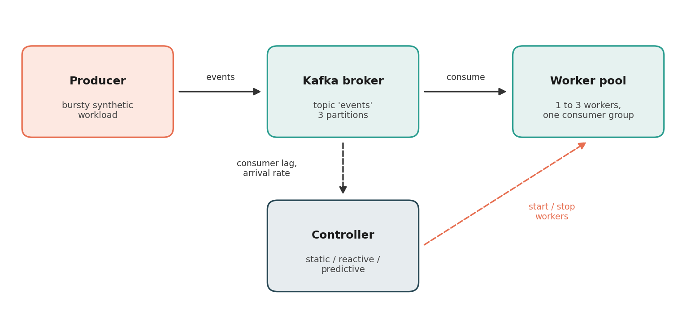
Figure 1: Pipeline architecture. Only the controller differs between the three strategies.

2.2 Workload, workers, and parameters
Component | Setting
Producer workload | Baseline 5 messages/s; bursts to 40 messages/s for 5 s out of every 30 s cycle. A run starts inside a burst.
Kafka | Official apache/kafka image, single node in KRaft mode (no Zookeeper); topic with 3 partitions, replication factor 1.
Worker | Simulates 0.08 s of processing per message, so about 12.5 messages/s per worker. One consumer group, 1 to 3 workers.
Controller polling | Every 2 s, identical for all three strategies.
Software | Python 3.14, kafka-python-ng 2.2.2, Docker on Arch Linux, a single machine.

2.3 The three strategies
All three controllers share the same monitoring and CSV-logging code. Only the scaling decision differs, so differences in results can be attributed to the strategy.
Strategy | Signal | Decision rule
Static | None | Start 3 workers and never change them.
Reactive | Consumer lag (pending messages) | Add a worker (up to 3) when lag exceeds 40; remove one (down to 1) when lag falls below 25. One change per poll.
Predictive | Forecast arrival rate | Forecast = mean of the last 2 arrival-rate samples. Target workers = ceil(forecast / 12.5), clamped to 1 to 3. Scale up to the target immediately. Scale down one worker per poll, and only if the target is lower AND lag is below 25.

The predictive controller's per-worker capacity (12.5 messages/s) is set from the known simulated processing time. A real deployment would have to measure this, which we note as a limitation.

2.4 Metrics and tooling
- End-to-end latency: the time a worker finishes processing a message minus the time the producer created it (same machine clock). It includes waiting in the queue plus the 0.08 s service time. Percentiles use the nearest-rank method.
- Throughput: messages processed divided by the time between the first and last processed message.
- Worker-seconds (cost proxy): the number of active workers at each poll multiplied by the poll interval, summed over the first 240 s. Because processing is simulated with a sleep, this stands in for the CPU-seconds proposed in the literature review.
- Lag: the consumer group's committed offsets subtracted from the topic's end offsets, summed over partitions, every 2 s. Committed offsets update only periodically, so lag can overstate the true backlog (see Section 8).
Tooling: worker.py writes every message's latency to a per-worker file; analyze_run.py turns a run into the metrics above and appends them to run_summary.csv; check_scaling.py reports the lag at every scale-down event; dashboard.py shows a live lag and worker-count chart during demonstrations.

3. Experimental Methodology
- Clean start: the Kafka topic was deleted and recreated before every run, so no run inherits backlog.
- Matched conditions: same workload, same 2 s polling, same topic configuration, and about 240 s per run for every strategy.
- Repetition: three runs per strategy. Within each round the strategies were run in turn (static, reactive, predictive) so that drift in machine speed does not favour one strategy.
- Unique run names: each run used its own name (for example env RUN_NAME=reactive_1 python controller_reactive.py), so latency logs from different runs never mix.
- Valid-run policy: a run counts only if the controller version that produced it is confirmed from its log (Section 4.2.5). Excluded runs are kept and listed in Appendix A.

4. Problems Encountered and How We Resolved Them

4.1 Infrastructure and tooling
Problem | Cause | Resolution
Kafka image failed to pull | bitnami/kafka free tags moved behind a paid subscription. | Switched to the official apache/kafka image in KRaft mode.
ModuleNotFoundError: kafka.vendor.six.moves | kafka-python is unmaintained and breaks on Python 3.12 and later (we run 3.14). | Switched to the maintained fork kafka-python-ng, a drop-in replacement.
Python tools failing after moving a venv | A virtual environment stores absolute paths and cannot be moved. | Deleted and recreated it in place.
git push rejected | GitHub no longer accepts passwords for git operations. | Used a personal access token.
Missing dependency in a fresh environment | requirements.txt omitted kafka-python-ng, and a different virtual environment was active. | Corrected requirements.txt; checked the active environment before running scripts.
NoBrokersAvailable from the producer | The Kafka container was not running after a restart. | Check with docker compose ps, start the container, and recreate the 3-partition topic before use.

4.2 Algorithm and experiment issues

4.2.1 Stale backlog contaminated early runs
Early runs showed hundreds of pending messages within seconds of starting, far more than the producer could have created. Messages left over from earlier ad hoc sessions were still in the topic. We now delete and recreate the topic before every timed run.

4.2.2 The reactive controller never scaled down
In an early run the reactive controller scaled from 1 to 3 workers during a burst but never scaled back. The scale-down threshold (5 pending messages) was below the quiet-period lag actually observed (about 16 to 19), so the condition could never be met. Raising it to 25 gave proper two-way scaling, with the worker count moving between 1 and 3 each burst cycle.

4.2.3 The predictive controller underestimated bursts
Forecast arrival rates peaked near 22 messages/s although bursts run at 40. The controller polled every 5 s, the same length as a burst, so a single poll often covered half a burst and half quiet traffic, diluting the measured rate. Shortening the poll interval to 2 s, applied to all three controllers for fairness, brought forecasts up to 30 to 39 messages/s.

4.2.4 Rate-only scale-down let backlog grow without bound
With the polling fix in place, a new problem became visible: average lag in the predictive run rose from 99 in the first third of the run to 273 in the last third, while static and reactive both improved. The cause was the scale-down rule. It looked only at the forecast, so the moment a burst ended and the rate fell to baseline, the controller released workers even though the burst's backlog had not been processed. The quiet gap before the next burst was too short for the remaining worker to clear it, so a residual accumulated each cycle.
The fix makes scale-down backlog-aware: a worker is released only when the forecast allows it and the lag is below 25, one worker per poll. Table 1 shows the effect.
Version | Avg lag | Peak lag | Avg workers | Lag, first to last third | Mean / p95 latency (s)
Unfixed (Review 1 run) | 194.8 | 474 | 1.35 | 99.0 to 273.3 | not logged
Unfixed (predictive_3, accidental) | 209.5 | 532 | 1.39 | not computed | 14.14 / 33.42
Fixed (first re-run) | 86.8 | 236 | 1.94 | 84.5 to 79.6 | not logged
Fixed (runs 1, 2, 3b, mean) | 76.8 | 269 | 1.85 | not computed | 3.83 / 9.11
Table 1: Effect of the backlog-aware scale-down fix. Each row is one run except the last, which is a mean of three. Rows differ in which metrics had been logged at the time.
The fix removed the unbounded growth, at the cost of more workers (1.35 to about 1.9 on average), because workers are now kept until the backlog clears. The accidental run with the unfixed controller is a useful before-and-after pair on the same workload, but it is a single run and we treat it as a supporting observation, not a measurement.

4.2.5 A controller version mix-up in the third round
In the third round, two runs looked wrong. Predictive had mean latency of 14.1 s and average lag of 209.5, close to the unfixed behaviour. Reactive used 2.79 workers on average with a p95 of 3.1 s, unlike its other runs. We wrote check_scaling.py, which reports the lag at every scale-down event, because the fixed predictive controller can only release a worker when lag is below 25.
Run | Scale-down events | Lag at those events | Reading
predictive_1 | 16 | 1 to 20 | Fixed controller
predictive_2 | 16 | 2 to 19 | Fixed controller
predictive_3 | 16 | 58 to 532 (all 25 or above) | Unfixed controller
reactive_1 | 23 | 4 to 24 | Threshold 25
reactive_2 | 23 | 3 to 21 | Threshold 25
reactive_3 | 1 | 4 | Threshold 5
Table 2: Lag observed at each scale-down event, used to identify the controller version behind each run.
Listing the controller files confirmed it: run 3 had used the superseded predictive controller (no lag check) and the superseded reactive controller (threshold 5 and a 5 s polling interval). Both runs were excluded from the comparison and repeated as reactive_3b and predictive_3b with new run names, and each controller now has one canonical file name. The lesson is that the version and parameters of the system under test must be controlled and recorded alongside results; a future improvement is to write each controller's parameters into its own log.

5. Results
All numbers below use the nine valid runs: static runs 1 to 3, reactive runs 1, 2 and 3b, and predictive runs 1, 2 and 3b. Values are mean ± sample standard deviation over three runs.
Metric | Static | Reactive | Predictive
Mean latency (s) | 0.28 ± 0.01 | 3.72 ± 0.29 | 3.83 ± 0.10
p95 latency (s) | 0.85 ± 0.04 | 9.85 ± 0.34 | 9.11 ± 0.20
p99 latency (s) | 1.30 ± 0.18 | 13.14 ± 0.16 | 12.61 ± 0.35
Throughput (messages/s) | 10.39 ± 0.27 | 10.52 ± 0.06 | 10.32 ± 0.11
Average workers | 3.00 | 2.17 ± 0.05 | 1.85 ± 0.03
Worker-seconds | 714 | 517 ± 11 | 441 ± 6
Cost saving vs static | 0% | 28% | 38%
Average lag | 35.7 ± 0.7 | 75.0 ± 4.3 | 76.8 ± 3.2
Peak lag | 229 | 249 ± 1 | 269 ± 6
Table 3: Summary over three valid runs per strategy.
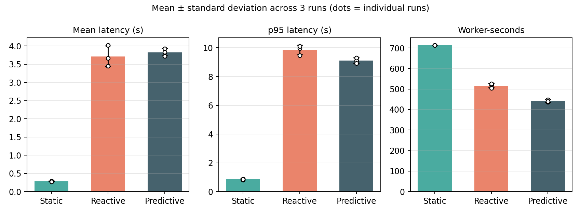
Figure 2: Mean ± standard deviation for latency and cost. White dots are the individual runs.
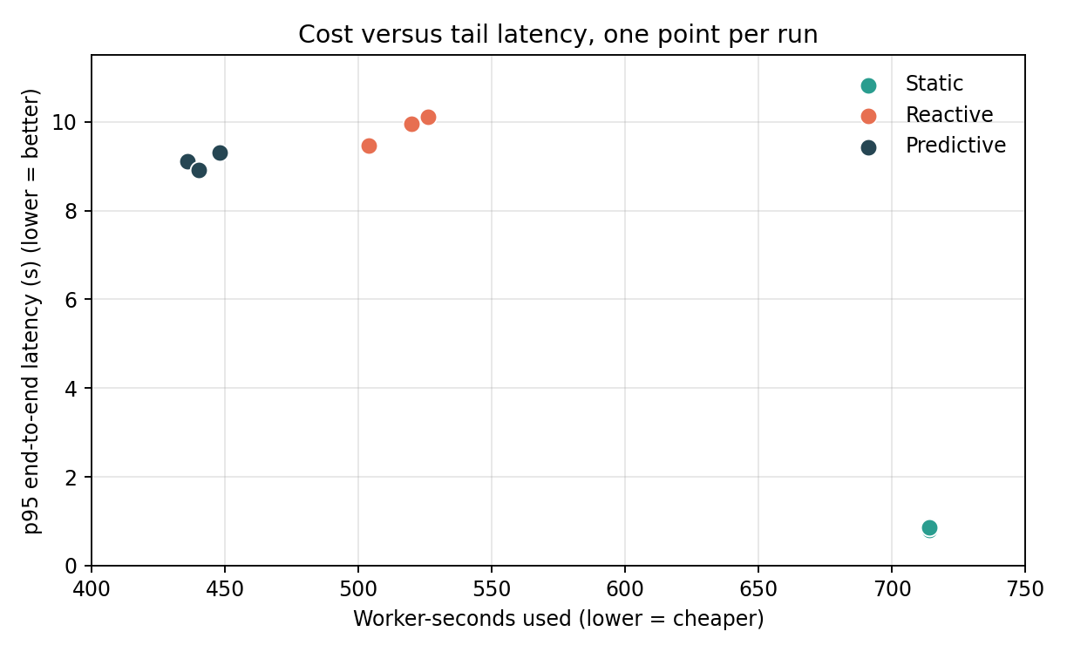
Figure 3: Cost versus p95 latency. Static sits at high cost and low latency; the adaptive strategies cluster at lower cost and higher latency.

5.1 Reactive versus predictive
We compared the two adaptive strategies with Welch's t-test. With only three runs per group and no correction for testing several metrics, these p-values are indicative, not conclusive.
Metric | Reactive | Predictive | Difference | Welch p
Worker-seconds | 517 | 441 | 15% lower | 0.002
p95 latency (s) | 9.85 | 9.11 | 7.5% lower | 0.04
Mean latency (s) | 3.72 | 3.83 | 3% higher | 0.58
Peak lag | 249 | 269 | 8% higher | 0.03
Table 4: Reactive versus predictive. Every predictive run used fewer worker-seconds (436 to 448) than every reactive run (504 to 526).

6. Discussion

Static wins on latency; adaptive wins on cost
Static allocation had a p95 about 11 times lower and a mean latency about 13 times lower than either adaptive strategy, with identical throughput. It also used 38% more worker-seconds than reactive and 62% more than predictive. If a pipeline needs end-to-end latency near one second, only static met that in our setup. If a p95 of about 9 to 10 s is acceptable, the adaptive strategies save 28% to 38% of the cost.

Predictive matches reactive on latency at lower cost
Once its scale-down was made backlog-aware, the moving-average predictive controller was statistically indistinguishable from reactive on mean latency, slightly better on tail latency, and consistently cheaper. Its peak lag was somewhat higher. This answers RQ2 modestly: the lightweight forecaster matches the reactive baseline and saves cost, but it does not clearly beat it on latency, and the cost advantage comes with a dependence on knowing the per-worker capacity.

Why the adaptive latency gap is larger than lag suggests
Average lag is only about twice as high for the adaptive strategies, yet latency is 11 to 13 times higher. We have not established why. Candidate explanations are (a) brief pauses in processing each time a worker joins or leaves the consumer group, which static avoids after startup; (b) starting with one worker just as the producer's opening burst arrives; and (c) lag being measured from committed offsets and therefore being a delayed proxy. None of these has been tested. We recommend treating latency, not lag, as the primary metric.

Answers to the research questions
- RQ1: Static has no responsiveness and no implementation cost but the highest resource use. Reactive is simple and adapts after backlog appears. Predictive adds a forecast window and a capacity estimate, and needs a backlog guard to be stable.
- RQ2: In this setup, a lightweight forecast with a backlog-aware scale-down roughly equals the reactive method on latency and uses about 15% fewer worker-seconds. Without the backlog guard it performed much worse.
- RQ3: Table 3 and Figure 3 quantify the trade-off: lowest latency costs the most, and each step down in cost brought a large increase in latency.

7. Positioning Relative to Related Work
A search for closely related work found several relevant items. We have so far reviewed excerpts only and will read the full texts before relying on their claims.
- A study of consumer group autoscaling in message brokers (arXiv 2402.06085) discusses threshold-based scaling with Kubernetes HPA and KEDA and refers to prior work that forecasts the production rate to estimate the number of consumers needed [2]. This is close to our predictive controller.
- A study of proactive autoscaling for edge systems with Kubernetes (arXiv 2112.10127) notes that proactive autoscalers for edge environments are rare [3]. It targets Kubernetes and CPU metrics rather than Kafka lag.
- A paper on predictive autoscaling in Kubernetes with KEDA and time-series forecasting compares predictive against reactive scaling driven by Kafka consumer lag [4].
- Grab's engineering write-up on predictive autoscaling for Flink [1] and two industry blogs, one noting that every scale event triggers a Kafka rebalance that pauses processing [5] and one describing blending real-time and predicted metrics [6], are relevant context. The blogs are not peer reviewed.
Given this, forecasting the production rate to size a consumer group, and blending real-time with predicted signals, are existing ideas, and we do not claim them as new. Our contribution is a controlled, reproducible single-machine comparison of the three strategies with latency and cost metrics, and a documented failure mode of rate-only scale-down together with its fix. We cannot confirm that no earlier study has done exactly this comparison.

8. Limitations
- Three runs per strategy, on one machine, with one synthetic workload shape and 240 s per run. Standard deviations from three runs are rough.
- Processing is simulated with a sleep, so workers use almost no CPU and scale perfectly up to the partition limit. Worker-seconds is a proxy, not measured CPU-seconds.
- The predictive controller uses a hard-coded per-worker capacity. Measuring it online would be harder and might change the result.
- Lag comes from committed offsets and can overstate the real backlog. In the first seconds of every run measured lag is high (150 to 230) even on a clean topic; we suspect missing committed offsets before the first commit, but have not verified it.
- Every run opens with a burst at time zero, which penalises the adaptive strategies that start with one worker.
- The latency gap between static and adaptive strategies is unexplained (Section 6).
- Threshold values, window size, and polling interval were chosen from preliminary runs and no sensitivity analysis was done.

9. Future Work
- Test the latency-gap explanations using the existing per-message logs: find stretches where no worker processed anything, and recompute latency excluding the first 30 s.
- Run a sensitivity analysis over the reactive thresholds and the predictive window size and polling interval.
- Try a slightly richer but still lightweight forecaster, such as an exponentially weighted average or a linear trend.
- Use more partitions, other burst shapes, and measured CPU load; compare with Flink's reactive mode.
- Record each controller's parameters in its own log, so a run's configuration is always traceable.

10. Conclusion
We built a working, version-controlled testbed and a controlled three-way comparison. Static allocation gives the best latency at the highest cost. The adaptive strategies save 28% to 38% of worker-seconds but pay with a roughly eleven-fold increase in p95 latency. A lightweight moving-average predictor, once its scale-down rule respects existing backlog, matches reactive scaling on latency while using about 15% fewer worker-seconds. The path to that result, including a diagnosed scale-down flaw and a detected version mix-up, is documented in full, and the main open question is why adaptive latency is so much higher than lag suggests.

References
[1] Grab Engineering. Machine-learning predictive autoscaling for Flink. https://engineering.grab.com/ml-predictive-autoscaling-for-flink
[2] Multi-Objective Optimization of Consumer Group Autoscaling in Message Broker Systems. arXiv:2402.06085. https://arxiv.org/pdf/2402.06085
[3] Proactive Autoscaling for Edge Computing Systems with Kubernetes. arXiv:2112.10127. https://arxiv.org/pdf/2112.10127
[4] Predictive Autoscaling in Kubernetes Microservices with KEDA and Time Series Forecasting. ResearchGate. https://www.researchgate.net/publication/399608825
[5] NearForm. The hidden complexities of Kubernetes autoscaling: Beyond the basics. https://nearform.com/digital-community/the-hidden-complexities-of-kubernetes-autoscaling-beyond-the-basics/
[6] Kedify. Predictive autoscaling for Kubernetes: Scale before traffic spikes. https://kedify.io/resources/blog/predictive-autoscaling/
[7] Apache Flink. FLIP-271: Autoscaling. https://cwiki.apache.org/confluence/display/FLINK/FLIP-271:+Autoscaling
[8] T. Panseriya and T. Desai. Literature Review: Adaptive Resource Management for Real-Time Data Pipelines (course submission).

Appendix A: All Runs
Runs marked excluded were produced by superseded controller versions (Section 4.2.5) and are not in Tables 3 and 4.
Run | Status | Mean (s) | p95 (s) | p99 (s) | Avg workers | Worker-s | Avg lag | Peak lag
static_1 | valid | 0.293 | 0.876 | 1.465 | 3.00 | 714 | 36.1 | 229
reactive_1 | valid | 3.669 | 9.965 | 13.29 | 2.18 | 520 | 76.3 | 249
predictive_1 | valid | 3.728 | 9.108 | 12.996 | 1.83 | 436 | 74.7 | 268
static_2 | valid | 0.276 | 0.804 | 1.319 | 3.00 | 714 | 34.9 | 229
reactive_2 | valid | 4.027 | 10.113 | 12.973 | 2.21 | 526 | 78.6 | 248
predictive_2 | valid | 3.929 | 9.310 | 12.302 | 1.88 | 448 | 80.5 | 276
static_3 | valid | 0.276 | 0.864 | 1.112 | 3.00 | 714 | 36.2 | 229
reactive_3 | excluded: old reactive (threshold 5, 5 s poll) | 0.571 | 3.114 | 4.469 | 2.79 | 655 | 34.8 | 203
predictive_3 | excluded: old unfixed predictive | 14.142 | 33.418 | 54.144 | 1.39 | 332 | 209.5 | 532
reactive_3b | valid (re-run) | 3.457 | 9.468 | 13.17 | 2.12 | 504 | 70.2 | 250
predictive_3b | valid (re-run) | 3.834 | 8.917 | 12.53 | 1.85 | 440 | 75.2 | 264

Appendix B: Repository and Reproduction
Code: github.com/twishapanseriya/Adaptive-resouce-management-for-real-time-data-pipelines
One experimental run, after starting Kafka with docker compose up -d:
# 1. clean topic
docker exec -it kafka /opt/kafka/bin/kafka-topics.sh --delete --topic events --bootstrap-server localhost:9092
docker exec -it kafka /opt/kafka/bin/kafka-topics.sh --create --topic events --bootstrap-server localhost:9092 --partitions 3 --replication-factor 1
# 2. tab 1: workload | tab 2: controller under test
python producer.py
env RUN_NAME=reactive_1 python controller_reactive.py
# 3. after about 240 s, stop both, then analyse
python analyze_run.py reactive_1 reactive_scaling_log.csv --trim 240
python3 check_scaling.py reactive_scaling_log.csv

