Instruction manual light model

General model description

The light model can be used by: performing **scene rendering** at <https://agroforestry.ugent.be/> ideally run in a chrome browser, and by **converting** this scene rendered to light intensity with an R script at <https://github.com/wcoudron/Lightmodel_Conversion>. The source code for the model scene rendering can be accessed at GitHub (<https://github.com/twist-numerical/agroforestry>).

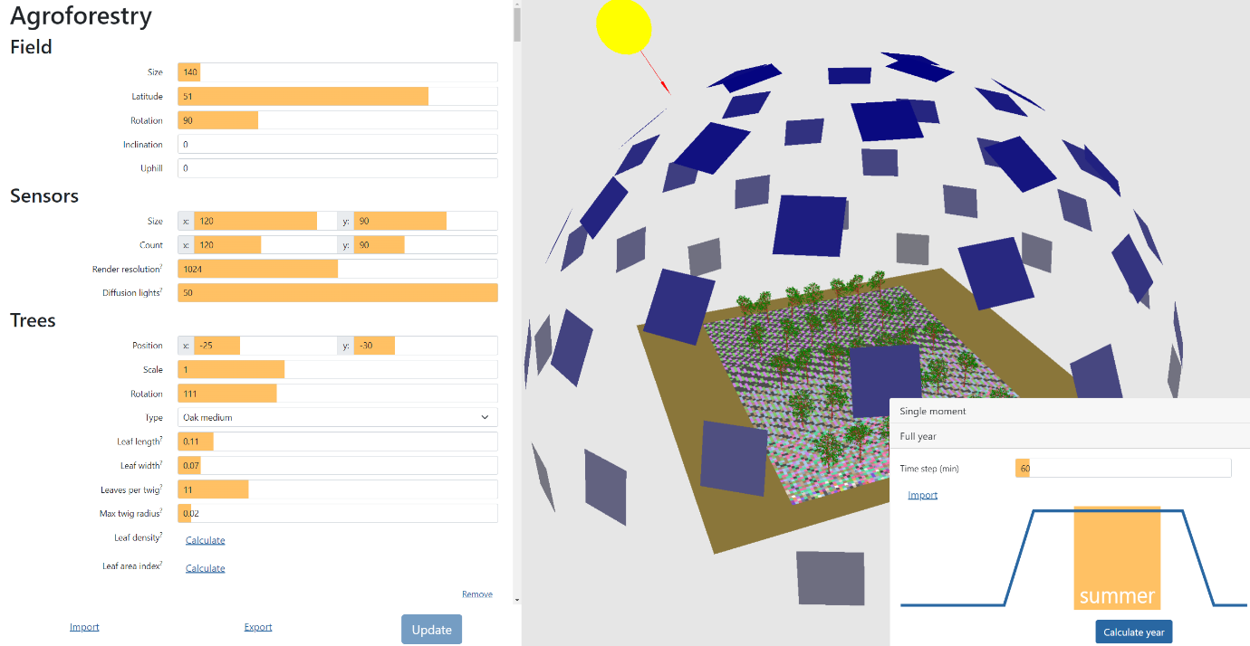Figure 1: Web-based interface of the agroforestry light model at agroforestry.ugent.be with an agroforestry setup containing medium Quercus robur trees.

The basic principle of the light model is that the diffuse and direct sources take snapshots of the sensor field and detect the number of pixels which are visible from each of the “sensors” placed in the field (Figure 2). The number and size of the sensors define the spatial resolution of the light simulation output in combination with the parameter “Render resolution”. The parameter “Render resolution” indicates the camera quality of the direct and diffuse light. Increasing this parameter results in more accurate output but also increases computation time.

For example, a sensor field of size 90 m by 120 m with the parameter “resolution” put on “2048” would consist of 4194304 (2048 x 2048) pixels. Thus, 1 pixel seen by the cameras of the diffuse and direct components would correspond to a surface area of 25.75 cm2. The number of pixels counted for each sensor will be dependent on the angle of the light sources and if any canopy blocks the view.

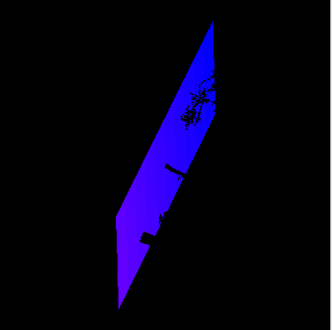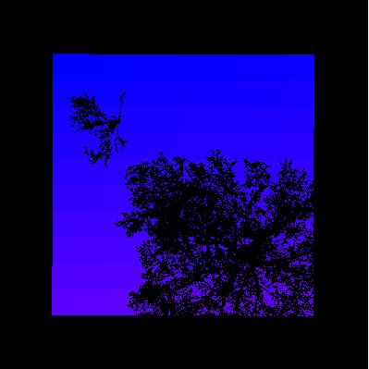

Figure 2: A sensorfield as seen by the direct light component when sun is almost directly overhead (left) or when the direct light is at a low position (right). The number of pixels counted for each field sensor tile is determined by the angle of the sun and if trees obstruct the view.

In the light model, an AF scene can be designed and contains the following components (Figure 1):

* Direct light source: yellow sphere.
* Diffuse light sources arranged in hemisphere: blue tiles.
* Sensors: floor tiles.
* Trees from LiDAR scans.

The direct light source tracks the position of the sun as a function of latitude, day of the year and time of the day.

The diffuse light sources are positioned on a hemisphere based on equal solid angle. To calculate the incoming diffuse light, our model calculates many different views from the sky to the field. The importance of each view is weighted with the formula (1+2 sin α)/3 (Moon and Spencer, 1942) where α is the angle of the view above the horizon.

The AF field, containing sensors and trees, is positioned within the half-dome, at the center of the scene. The field is designed by the user, selecting the number and size of the sensors and the number, positioning, species, structure and size of the trees.

The exported data will contain the surface area from each sensor as seen by the direct component and the average weighted value for the diffuse components. To make it as general as possible we have chosen to express this as m². For example, a sensor of 1 m by 1 m will receive at most 1 m² of direct light (when the sun is right overhead if nothing is blocking its direct view to each part of the sky). A user can now scale these values to the units they want to work with, based upon real world measurements of incoming light.

Run simulations with the online tool

After building the desired agroforestry scene the user may choose to perform simulations at a single moment or for a full year (Figure 3).

During single moment simulations, the user can specify the time of the day and the day in the year for which a simulation needs to be performed (starting from 21 December). Additionally, the development of the leaves on the tree can be specified and ranges from 0 (no leaves) to 1 (completely developed leaves).

During full year simulations the user can specify the desired time step of the simulation. Also a text file can be uploaded describing the phenological development of the leaves. This file should contain 366 values between 0 and 1 describing leaf development starting from 21 December (Figure 4).

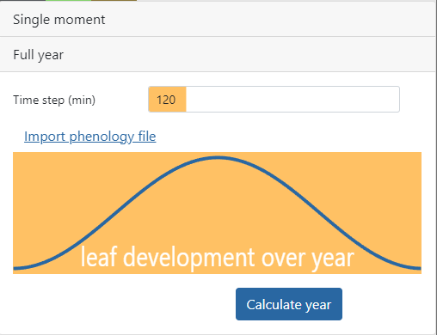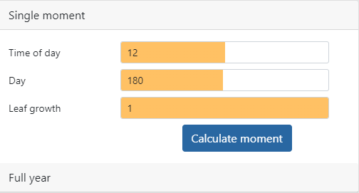

Figure 3: Simulations can be performed for a “Single moment” or a “Full year”.

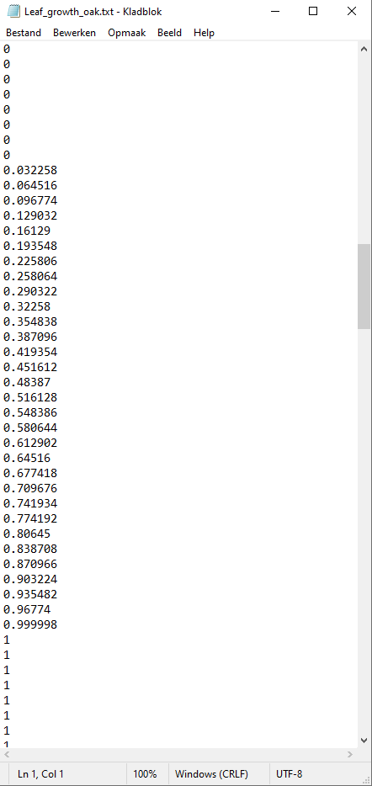

Figure 4: Example of a file containing daily values for leaf development.

What to do with the output from the rendered scene?

Since the output of the online tool is expressed in m2 as seen by the diffuse and direct modules, it needs to be converted to units of light intensity per unit area (e.g., MJ m-2). Therefore, the following workflow can be followed (Figure 5):

1. Run the simulation in the online tool with the desired agroforestry setup.
2. Run a reference simulation without trees in the online tool, leaving all other settings (tile size and number, filed inclination and orientation, light modules) unaltered.
3. Collect incoming solar radiation on a horizontal plane at the required temporal resolution for the location of the field under study.
4. Derive conversion factors for each time point from the direct and diffuse outputs from the light model (step 2), which are expressed per unit area, and the diffuse and direct component as computed by the Spitters equations, expressed in MJ m-2 (step 3).
5. Convert diffuse and direct outputs from the light model (step 1) with the conversion factors derived in step 4 for every time step.
6. Sum the diffuse plus direct component per sensor and every time interval to obtain the total radiation intensity.

All our R code for conversion to light intensity is available at GitHub (<https://github.com/wcoudron/Lightmodel_Conversion>).

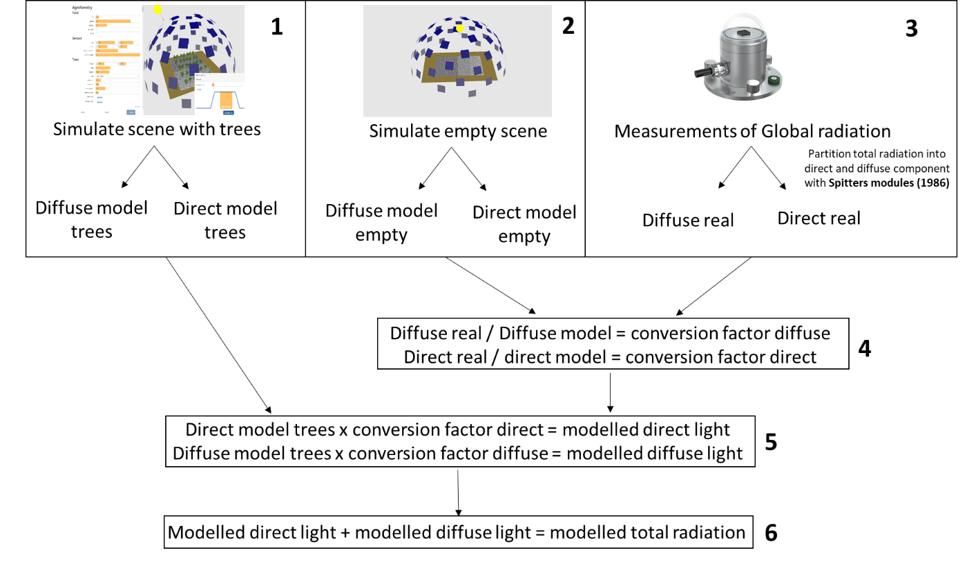

*Figure 5: Steps to take for converting the light model output to light intensity*