SMAI Project Report

Goal: To build a deep learning mechanism to predict the dense optical flow of every pixel in a given static image. In this work a Convolutional neural network based approach is presented for motion prediction.The current CNN model takes no underlying assumptions about the scene, and hence can predict future optical flow on a diverse set of scenarios.

History: The most common approach to this prediction problem is to use a planning-based agent-centric approach: an object or a patch is modeled as an agent that performs actions based on its current state and the goal state. The two main problems with this approach were that , firstly , the predictions were sparse, and the motion is modelled as a trajectory. Secondly, and the more imp , these approaches have been shown to perfoem only in restrcitve domains such as streets etc, i.e. the lack of generalisation was a major drawback.

Method:
We use a standard seven-layer architecture (alexnet) , the network acrchitecture can be described as :
C(96,11)→LRN→P→C(256,5)→LRN→P→C(384,3)→C(34,3)→C(256,3)→P→F(4096)→F(4096)->SpatialSoftMax
Where,
C(k,s) is a convolutional layer with k kernels , each with size s * s.
local response normalization layer as LRN, and the max-pooling layer as MP.
F(n) denotes fully connected layers with n neurons.

Maxpooling stride is 2, the maxpooling size is 3x3.
All conv strides are 1, except for the first layer which is 4.
Input image size: 200x200.

//Write a bit about spatial softmax
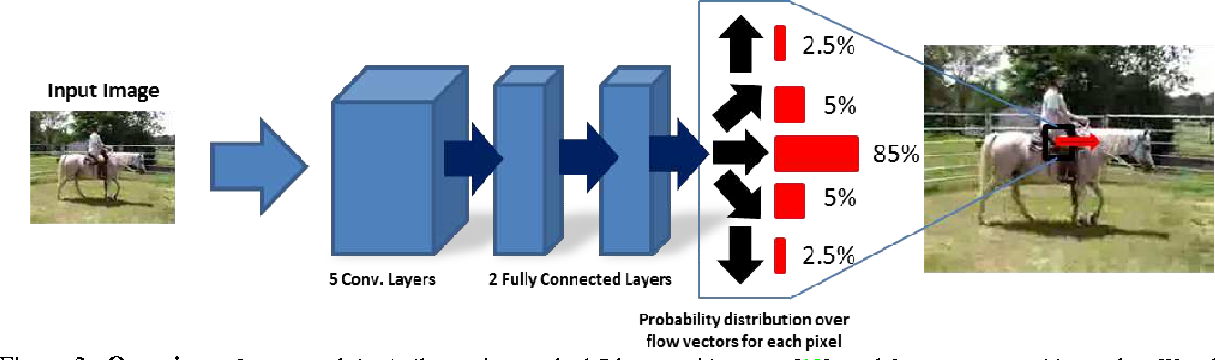
Regression vs classification: Since we want to predict real values (2 real values actually, direction and magnitude) for each pixel, it is natural to think of regression. The paper claims that the problem with regression is "and output space which is smoothens results to the mean". (I think; isn't that where GANs shine?) The paper notes the other regression problem of "surface normal estimation" where researches have proposed reformulating structured regression as a classification problem. Hence the optical flow vectors have been classified into 40 clusters by k-means. For the classification problem a spatial soft-max loss is used.
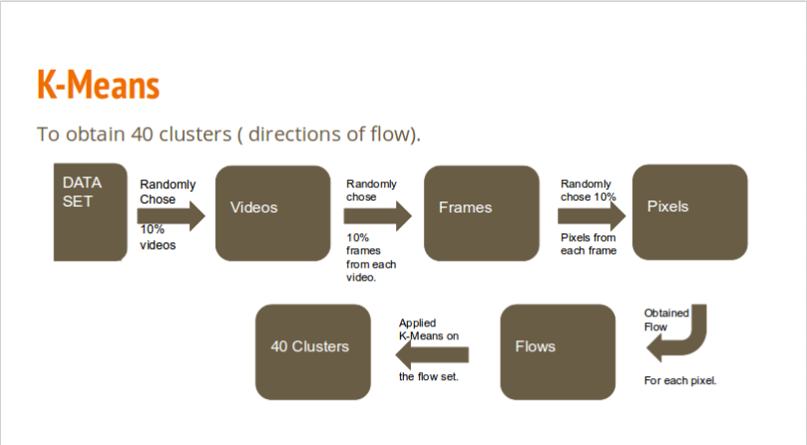

Pipline:

Datasets : UCF-101 and HMDB-51, datasets with thousands of videos are used for training , for generating the groud truth labels , we use DEEPFLOW . To reduce noise , we take the average optical flow of the next 5 frames for each frame selected. To reduce the computational complexity , we compute a coarse 20*20 output.

Video Dataset(select frames from the videos)
| (200*200*3)
|
V
DEEPFLOW (to get the optical flow)
| (20*20*2)
|
V
Labelling after using K-means to find the clusters.
| (20*20*1)
|
V
Training the CNN.

