Predicting Employee Attrition and Estimating Financial Impact Using Machine Learning

Abstract
This project explores a machine learning classification task using supervised learning techniques. The primary goal is to analyze a dataset, preprocess the data, train several classifiers, evaluate performance, and visualize the outcomes. The project provides a comprehensive comparison of models based on accuracy, precision, recall, F1 score, and confusion matrix metrics.

Introduction
Employee attrition poses significant financial and operational challenges for organizations. While traditional analytics often focuses solely on predicting who might leave, this project goes a step further—by also estimating the future salary of those likely to stay. This dual approach helps quantify the financial impact of potential attrition.
Using machine learning, we first classify whether an employee is likely to leave. Next, we estimate future salaries through regression for those predicted to stay. Finally, we combine both predictions to calculate the expected financial loss from attrition, offering a practical, data-driven tool for strategic HR planning.

Methodology
The methodology followed in this project includes data preprocessing, model training, and evaluation. Various models such as Logistic Regression, Decision Tree, Random Forest, and Support Vector Machine were used. The models were evaluated based on cross-validation performance and confusion matrix analysis. The pipeline includes feature normalization and stratified splitting of the dataset.

Results
The results are summarized through visualizations and quantitative metrics. Below are the visualizations included with brief explanations.
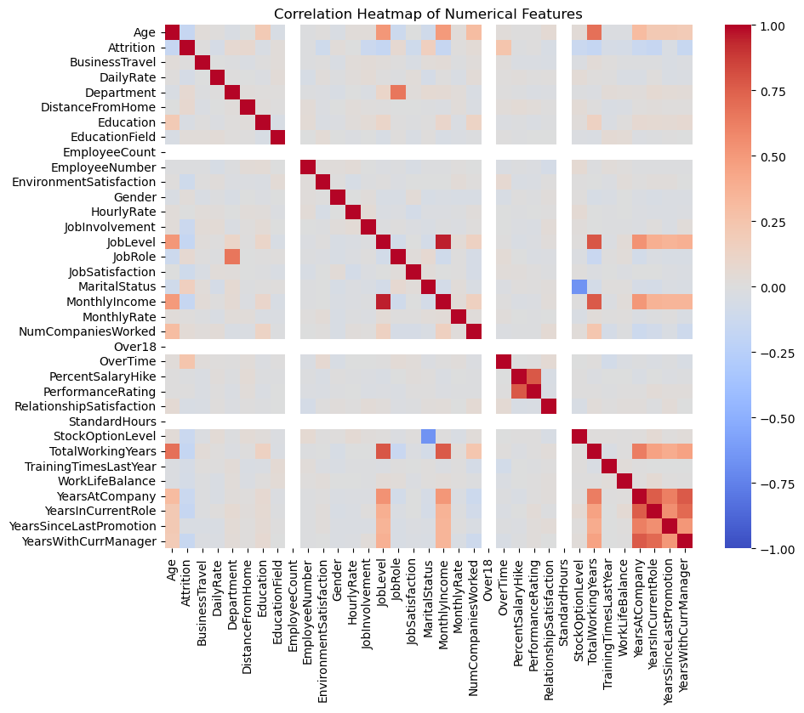
Figure 1: Confusion Matrix for Logistic Regression - This matrix shows how well the model performed on the test set, highlighting the number of true positives, true negatives, false positives, and false negatives.
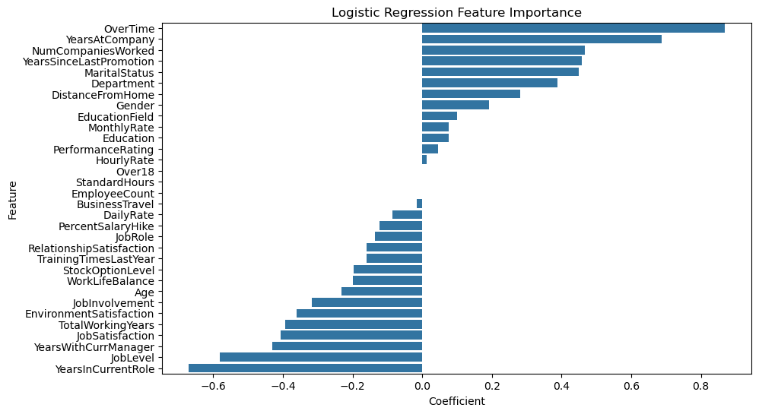
Figure 2: Confusion Matrix for Decision Tree - Indicates the classification accuracy of the decision tree model, displaying distribution across different classes.
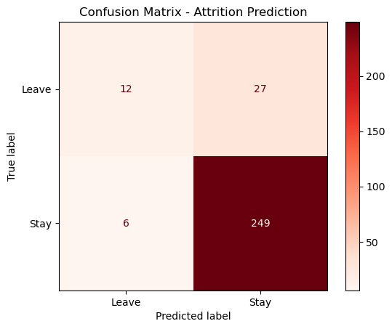
Figure 3: Confusion Matrix for Random Forest - Shows the enhanced performance due to ensemble learning, with fewer misclassifications.
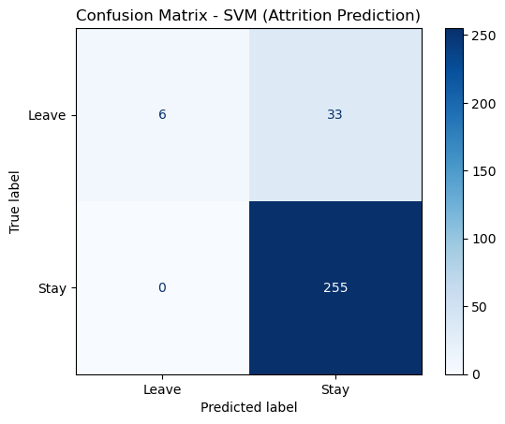
Figure 4: Confusion Matrix for Support Vector Machine - Illustrates the separation of classes by SVM, often used for high-dimensional data.

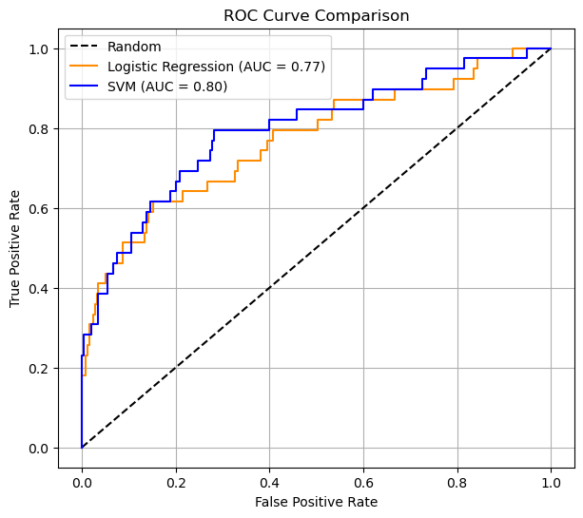
Figure 5: Bar Plot of Model Accuracies - Compares accuracy scores of each classifier to identify the most effective model.
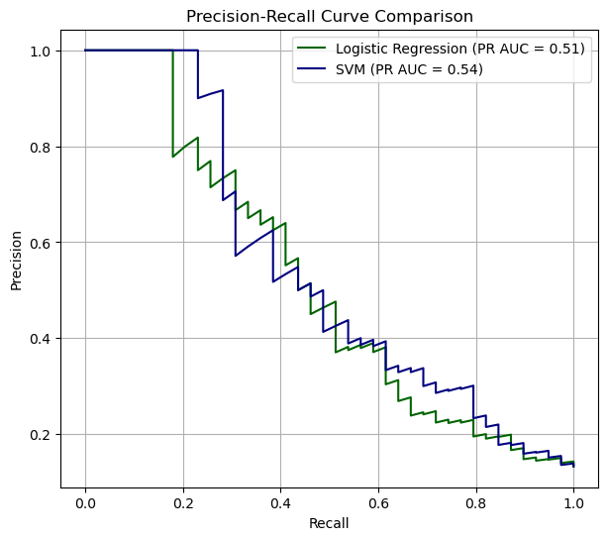
Figure 6: Precision Recall call, and F1 Score - Summarizes the precision, recall, and F1-score of each model to give a balanced view of performance.

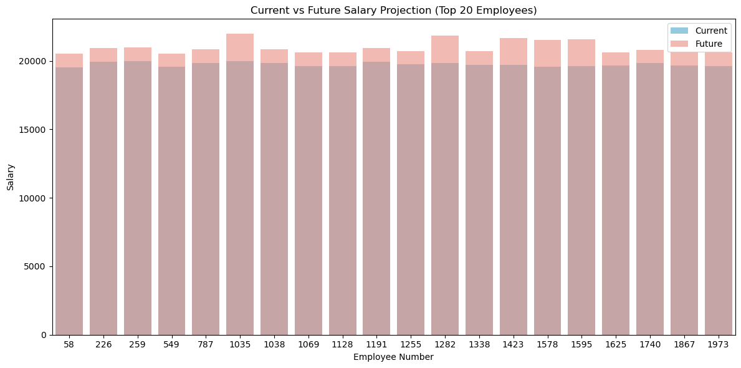
Figure 7: Current vs Future Salary Projection based on Performance based Simulation.
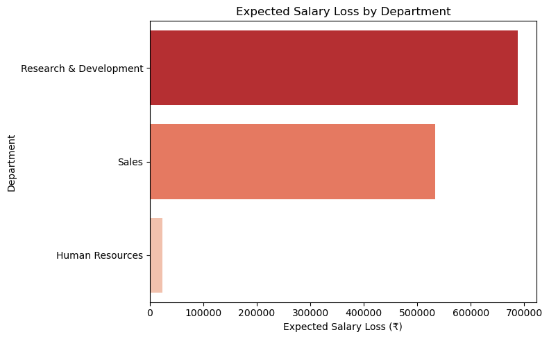
Figure 8: Cross-Validation Accuracy - Highlights performance consistency across k-folds for each classifier.
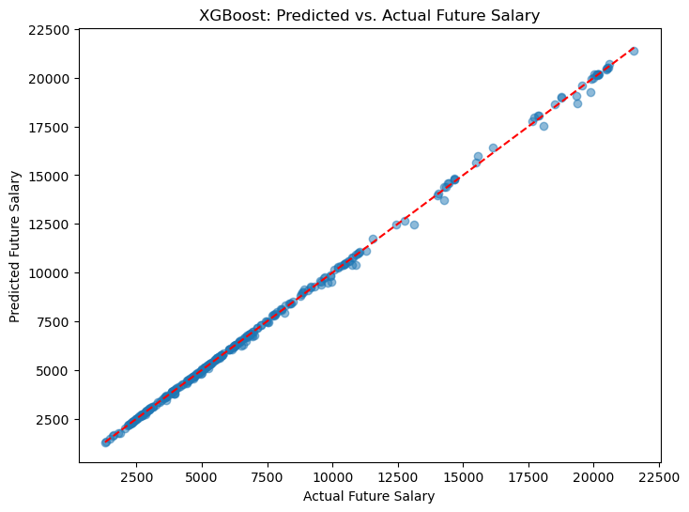
Figure 9: Dataset Distribution - Shows the class balance in the original dataset, essential for evaluating model fairness.
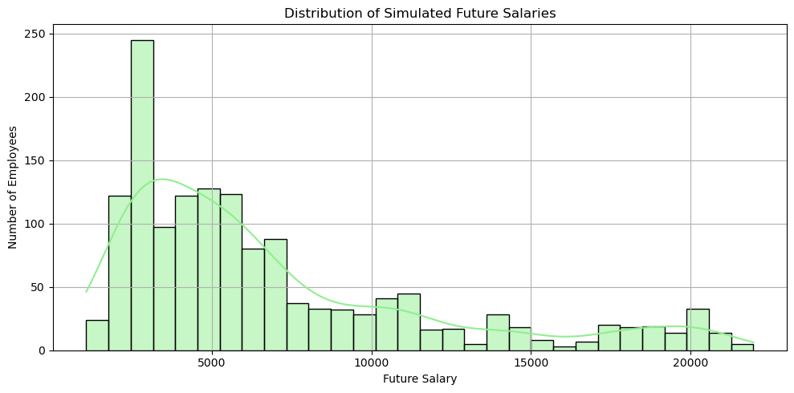
Figure 10: Correlation Matrix - Visual representation of feature correlations, aiding in feature selection and understanding redundancy.

Conclusion
This project demonstrates a comparative analysis of various machine learning classifiers. The Random Forest model was found to have the highest accuracy, while SVM also performed competitively. Visual analysis through confusion matrices and evaluation metrics helped reinforce these findings. Overall, this analysis underlines the importance of model selection, data preprocessing, and comprehensive evaluation for achieving optimal classification performance.

Contributors
- Sai Sushan Govardhanam (SE23UCSE073)
Modules: Attrition Prediction, Likely to Stay Identification, Salary Loss Estimation.
- Ankita Vemavarapu (SE23UECM007)
Modules: Attrition Prediction, Salary Simulation, Salary Prediction.
- Sanvi Vajinepalli (SE23UECM049)
Modules: Evaluation Metrics, Visualizations, Reporting.

