ALAGA: A Full Stack Pet Supplies E-Commerce System



In Partial Fulfilment of the Requirements of the Courses:
IT112 – Advanced Database System & IT113 – Event Driven Programming

Tamera, Twixt Jasley J.
Pagalan, Jhon Querino L.
Agato, Kenneth A.
Apas, Christel Grace C.
Butad, Keneth L.

John Louis Mercaral, MIS
Courses Instructor

December 2025
Table of Contents
I. PROBLEM STATEMENT 1
II. LOGICAL DESIGN 2
Requirements Analysis 2
Entities: 2
Attributes: 2
Relationship & Cardinality: 4
Data Model (ER Diagram): 5
III. PHYSICAL DESIGN 6
SQL Queries: 6
API: 6
IV. Ecommerce: 7
Features: 7
Objectives: 7
Scope and Limitation: 7
Reference 8

- PROBLEM STATEMENT

Pet owners today face increasing difficulty in finding quality pet products suited to their pets’ specific needs
A lot of pet owners nowadays are experiencing many difficulties in finding pet products suited to their pets’ particular needs. Local pet-supply stores offer only limited selections making it a challenge for owners to have access to reliable brands and essential products such as food, medicine, grooming items, and pet accessories. This lack of products often leads to inefficiencies in purchasing, as owners have to spend more time comparing prices and quality from various physical and online sources. Moreover, the absence of a specialized and centralized platform dedicated to only pet-related items limits the consumers’ ability to make informed decisions based on product reviews, availability, and legitimacy. In turn, the process of acquiring pet supplies becomes inconvenient, inconsistent, and time-consuming [1]–[3].
In many areas of the country, the lack physical stores that cater to the essential needs of pet owners are running scarce. Without any access to nearby suppliers, the customers are forced to travel to distant locations just to find basic pet care items that cater to their pets’ needs. [4]. Their geographic situation restricts accessibility most especially for those who rely generally on convenience and affordability. This lack of a nearby marketplace to cater these pet-related transactions discourages responsible pet owners as they may reconsider essential purchases due to the inconvenience of travelling far distances. These challenges may raise the demand for a digital platform that could serve as a bridge to close the gap between product accessibility and consumer convenience [5].
Moreover, there lacks an integrated system that would, effectively, consolidate three major functions: (i) cataloging of products, (ii) inventory tracking, and (iii) consumer order management. In the absence of such integrated systems, complicated processes with regard to stock monitoring, user preference tracking, and transactions recording between consumers and vendors occur. Some pet owners use general e-commerce applications to locate pet products. These applications do not offer focused recommendations, are not transparent in supplier information, and lack consistencies in product-quality assurance issues [6]–[8]. Specialized digital systems for pet supplies would, therefore, enable the processes for enhanced access, reliable product sourcing, and better customer experience.

LOGICAL DESIGN

Requirements Analysis

The demands for pet supplies are ever growing alongside the increasing reliance on online commerce or shopping. It has made efficient management systems essential for e-commerce platforms, especially those that aims to cater centralized digital environment for a particular field like pet supplies commerce.

Based on the normalization, we will delve deeper into the requirements analysis for the ALAGA: Pet Supplies E-store system, identifying entities, attributes, and cardinality.

Entities:
- Users: Represents the customers and admins of the pet supplies services.
- Products: Represents the collection of products available in the pet supplies e-store.
- Carts: Represents the repository of the carted items by the customer type users.
- Cart Items: Represents the collection of items carted by the customer type users.
- Orders: Represents the finalized checkout objects made by the customer type users.
- Order Item: Represents the collection of items purchased by the customer type users under the order object.
- Inventory Log: Represents the audit of inventory changes.
- Sales Report: Represents the logical artifacts produced by the admins.

Attributes:
- User:
- ID: The numerical primary key of the user entity.
- Username: The username of the user entity.
- Password Hash: The encrypted password of the user entity.
- E-mail: The e-mail of the user entity.
- Role: The role of the user (Customer or Admin).
- Date Joined: The date in which the user joined.
- Product:
  - ID: The numerical primary key of the product entity.
  - Name: The name of the product entity.
  - Description: The description of the product entity.
  - Category: The category of the product entity.
  - Price: The price of the product.
  - Stock Quantity: The remaining amount of the product
  - Image URL: The URL that points to the product image.

- Cart:
  - ID: The numerical primary key of the cart entity.
  - User ID: The foreign key that references the user entity.
  - Created At: The date in which the cart is created.
  - Updated At: The date in which the cart entity was last updated.
- Cart Item:
- ID: The numerical primary key of the cart item entity.
- Cart ID: The foreign key that references the cart entity.
- Product ID: The foreign key that references the product entity.
- Quantity: The amount of products purchased by the customer type user.
- Order:
  - ID: The numerical primary key of the order entity.
  - User ID: The foreign key that references the user entity.
  - Order Date: The date in which the order was made.
  - Total Amount: The total computed price of the order.
  - Status: The status of the order. (Pending, Processing, Completed, Cancelled)
- Order Item:
  - ID: The numerical primary key of the order item entity.
  - Order ID: The foreign key that references the order entity.
  - Product ID: The foreign key that references the product entity.
  - Quantity: The amount of products ordered.
  - Price At Purchase: The price of the item at the time of purchase.
- Inventory Log:
  - ID: The numerical primary key of the inventory log entity.
  - Product ID: The foreign key that references the product entity.
  - Change Type: The type of alteration to the inventory. (Restock, Sale, Adjustment)
  - Quantity Changed: The quantified change of the amount of products based on the change type.
  - Timestamp: The time in which the inventory log is created.
- Sales Report:
  - ID: The numerical primary key of the sales report entity.
  - Generated By: The foreign key that references the user entity.
  - Date Generated: The date in which the sales report is generated.
  - Total Sales: The total amount of sales made.
  - Total Orders: The total number of orders made.
  - Top Selling Products: The list of products with the most sales.

Relationship & Cardinality:
- User – Cart:
  - One-to-One: A user can have only one cart, and a cart can only be handled by one user.
- Cart – Cart Item:
  - One-to-Many: A cart can have many cart items, and these cart items can only be under one cart.
- Product – Cart Items:
  - One-to-Many: A product can be referenced by multiple cart items, while a cart item only references one product.
- User – Order:
  - One-to-Many: The user can place many orders, while an order is only accredited to one user.
- Order – Order Item:
  - One-to-Many: One order can contain many items, while these items are only under one order.
- Product – Order Item:
  - One-to-Many: A product can be referenced by many order items, while an order item only refers to one product.
- Product – Inventory Log:
  - One-to-Many: A product can be in multiple inventory logs, while an inventory log refers to only one product.
- User – Sales Report:
  - One-to-Many: A user can generate many sales reports while a sales report is generated by only one user.

Data Model (ER Diagram):
Chen’s Notation Diagram:
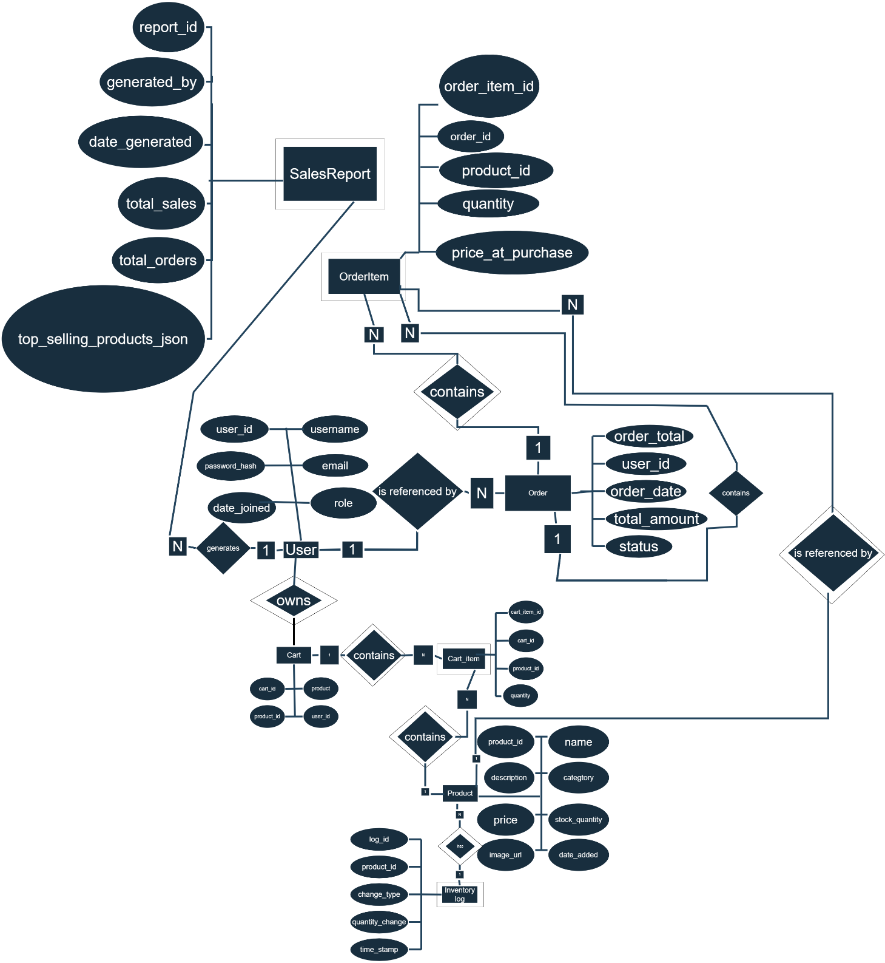

Crow’s Foot Diagram:
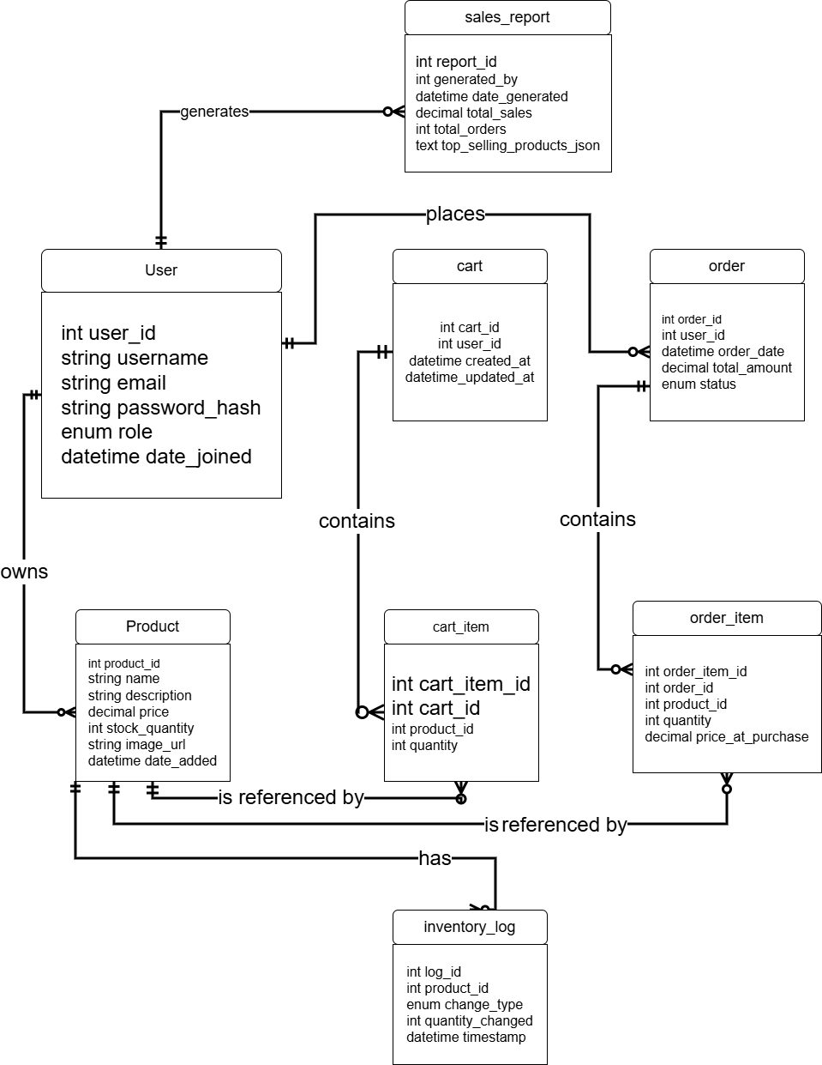

PHYSICAL DESSIGN

SQL Queries:
- Create tables (DDL) [minimum of 5 tables applying constraints]
CREATE TABLE users (
user_id INT AUTO_INCREMENT PRIMARY KEY,
username VARCHAR(80) NOT NULL UNIQUE,
password_hash VARCHAR(255) NOT NULL,
email VARCHAR(120) NOT NULL UNIQUE,
role ENUM('admin','customer') NOT NULL DEFAULT 'customer',
date_joined DATETIME DEFAULT CURRENT_TIMESTAMP
);

CREATE TABLE products (
product_id INT AUTO_INCREMENT PRIMARY KEY,
name VARCHAR(150) NOT NULL,
description TEXT,
category VARCHAR(80),
price DECIMAL(10,2) NOT NULL,
stock_quantity INT NOT NULL DEFAULT 0,
image_url VARCHAR(255),
date_added DATETIME DEFAULT CURRENT_TIMESTAMP
);

CREATE TABLE carts (
cart_id INT AUTO_INCREMENT PRIMARY KEY,
user_id INT NOT NULL,
created_at DATETIME DEFAULT CURRENT_TIMESTAMP,
updated_at DATETIME DEFAULT CURRENT_TIMESTAMP ON UPDATE CURRENT_TIMESTAMP,
FOREIGN KEY (user_id) REFERENCES users(user_id) ON DELETE CASCADE
);

CREATE TABLE cart_items (
cart_item_id INT AUTO_INCREMENT PRIMARY KEY,
cart_id INT NOT NULL,
product_id INT NOT NULL,
quantity INT NOT NULL DEFAULT 1,
FOREIGN KEY (cart_id) REFERENCES carts(cart_id) ON DELETE CASCADE,
FOREIGN KEY (product_id) REFERENCES products(product_id) ON DELETE RESTRICT
);

CREATE TABLE orders (
order_id INT AUTO_INCREMENT PRIMARY KEY,
user_id INT NULL,
order_date DATETIME DEFAULT CURRENT_TIMESTAMP,
total_amount DECIMAL(12,2) NOT NULL,
status ENUM('Pending','Processing','Completed','Cancelled') DEFAULT 'Pending',
FOREIGN KEY (user_id) REFERENCES users(user_id) ON DELETE SET NULL
);

CREATE TABLE order_items (
order_item_id INT AUTO_INCREMENT PRIMARY KEY,
order_id INT NOT NULL,
product_id INT NOT NULL,
quantity INT NOT NULL,
price_at_purchase DECIMAL(10,2) NOT NULL,
FOREIGN KEY (order_id) REFERENCES orders(order_id) ON DELETE CASCADE,
FOREIGN KEY (product_id) REFERENCES products(product_id) ON DELETE RESTRICT
);

CREATE TABLE inventory_logs (
log_id INT AUTO_INCREMENT PRIMARY KEY,
product_id INT NOT NULL,
change_type ENUM('Restock','Sale','Adjustment') NOT NULL,
quantity_changed INT NOT NULL,
timestamp DATETIME DEFAULT CURRENT_TIMESTAMP,
FOREIGN KEY (product_id) REFERENCES products(product_id) ON DELETE CASCADE
);

CREATE TABLE sales_reports (
report_id INT AUTO_INCREMENT PRIMARY KEY,
generated_by INT NULL,
date_generated DATETIME DEFAULT CURRENT_TIMESTAMP,
total_sales DECIMAL(12,2),
total_orders INT,
top_selling_products JSON,
FOREIGN KEY (generated_by) REFERENCES users(user_id) ON DELETE SET NULL
);

- Insert sample data into tables [minimum of 3, with 3 ways of insertion]
-- users
INSERT INTO users (username, password_hash, email, role)
VALUES ('owner1','$hash1','owner@example.com','admin'),
('customer1','$hash2','alice@example.com','customer');

INSERT INTO users (username, password_hash, email, role)
VALUES
('owner3', '$2b$12$Mk3c4DeF5GhI6JkL7MnOpQ8RsT9UvWxYzA123456789abcdef0', 'owner3@example.com', 'admin'),
('customer1', '$2b$12$Na4d5EfG6HiJ7KlM8NoPqR9StU0VwXyZaB23456789abcdef01', 'customer1@example.com', 'customer'),
('bob', '$2b$12$Oa5e6FgH7IjK8LmN9OpQrS0TuV1WxYzAbC3456789abcdef012', 'bob@example.com', 'customer'),
('carol', '$2b$12$Pb6f7GhI8JkL9MnO0PqRsT1UvW2XyZaBcD456789abcdef0123', 'carol@example.com', 'customer'),
('dave', '$2b$12$Qc7g8HiJ9KlM0NoPqRsTuV2WxY3ZaBcDeF56789abcdef01234', 'dave@example.com', 'customer'),
('eve', '$2b$12$Rd8h9IjK0LmN1OpQrStUvW3XyZ4aBcDeFg6789abcdef012345', 'eve@example.com', 'customer'),
('frank', '$2b$12$Se9i0JkL1MnO2PqRsTuVwX4yZaB5cDeFgH789abcdef0123456', 'frank@example.com', 'customer'),
('grace', '$2b$12$Tf0j1KlM2NoP3QrStUvWxY5zAbC6dEfGhI890abcdef01234567', 'grace@example.com', 'customer');

-- products
INSERT INTO products (name, description, category, price, stock_quantity, image_url)
VALUES ('Dog Food - 5kg', 'Premium kibble for adult dogs', 'Food', 1250.00, 20, '/images/dogfood5kg.jpg'),
('Cat Toy - Feather Wand', 'Interactive feather toy', 'Toys', 150.00, 50, '/images/feather_wand.jpg');

-- cart (for alice)
INSERT INTO carts (user_id) VALUES (2);

-- cart_items
INSERT INTO cart_items (cart_id, product_id, quantity) VALUES (1, 1, 2), (1,2,1);

-- simulate checkout -> create order
INSERT INTO orders (user_id, total_amount, status) VALUES (2, 2650.00, 'Pending');
INSERT INTO order_items (order_id, product_id, quantity, price_at_purchase) VALUES (1,1,2,1250.00),(1,2,1,150.00);

-- inventory_logs
INSERT INTO inventory_logs (product_id, change_type, quantity_changed) VALUES (1,'Sale',2),(2,'Sale',1);

-- sales_reports (example)
INSERT INTO sales_reports (generated_by, total_sales, total_orders, top_selling_products)
VALUES (1, 2650.00, 1, JSON_ARRAY(1,2));
- Update existing data (e.g., change borrowing status)
-- Update a product's stock quantity after restocking
UPDATE products
SET stock_quantity = stock_quantity + 10
WHERE product_id = 1;

-- Update order status from 'Pending' to 'Processing'
UPDATE orders
SET status = 'Processing'
WHERE order_id = 1;
- Delete data (e.g., remove outdated records)
-- Delete an inactive user (for example, customer with no orders)
DELETE FROM users
WHERE user_id NOT IN (SELECT DISTINCT user_id FROM orders);

-- Delete old inventory logs older than 6 months
DELETE FROM inventory_logs
WHERE timestamp < DATE_SUB(NOW(), INTERVAL 6 MONTH);
- Select data using various criteria (e.g., retrieve overdue books) [minimum of 5, with GROUP BY, AGGREGATORs]
-- a) Total sales per product
SELECT
p.name AS product_name,
SUM(oi.quantity * oi.price_at_purchase) AS total_sales
FROM order_items oi
JOIN products p ON oi.product_id = p.product_id
GROUP BY p.product_id
ORDER BY total_sales DESC;

-- b) Average product price by category
SELECT
category,
AVG(price) AS avg_price
FROM products
GROUP BY category;

-- c) Number of orders per user
SELECT
u.username,
COUNT(o.order_id) AS total_orders
FROM users u
LEFT JOIN orders o ON u.user_id = o.user_id
GROUP BY u.user_id
HAVING total_orders > 0;

-- d) Total quantity sold per category
SELECT
p.category,
SUM(oi.quantity) AS total_quantity_sold
FROM order_items oi
JOIN products p ON oi.product_id = p.product_id
GROUP BY p.category;

-- e) Monthly total revenue
SELECT
DATE_FORMAT(order_date, '%Y-%m') AS month,
SUM(total_amount) AS total_revenue
FROM orders
WHERE status = 'Completed'
GROUP BY month
ORDER BY month DESC;

- Join tables to retrieve related information (e.g., member information along with borrowing records) [minimum of 3 types of JOINS]
-- a) INNER JOIN: show order details with products
SELECT
o.order_id,
u.username,
p.name AS product_name,
oi.quantity,
oi.price_at_purchase
FROM orders o
INNER JOIN users u ON o.user_id = u.user_id
INNER JOIN order_items oi ON o.order_id = oi.order_id
INNER JOIN products p ON oi.product_id = p.product_id;

-- b) LEFT JOIN: list all users and their orders (including those with none)
SELECT
u.username,
o.order_id,
o.status
FROM users u
LEFT JOIN orders o ON u.user_id = o.user_id
ORDER BY u.username;

-- c) RIGHT JOIN: show all products and any linked inventory logs
SELECT
p.name AS product_name,
i.change_type,
i.quantity_changed,
i.timestamp
FROM inventory_logs i
RIGHT JOIN products p ON i.product_id = p.product_id
ORDER BY p.name;

API:
Admin Endpoints 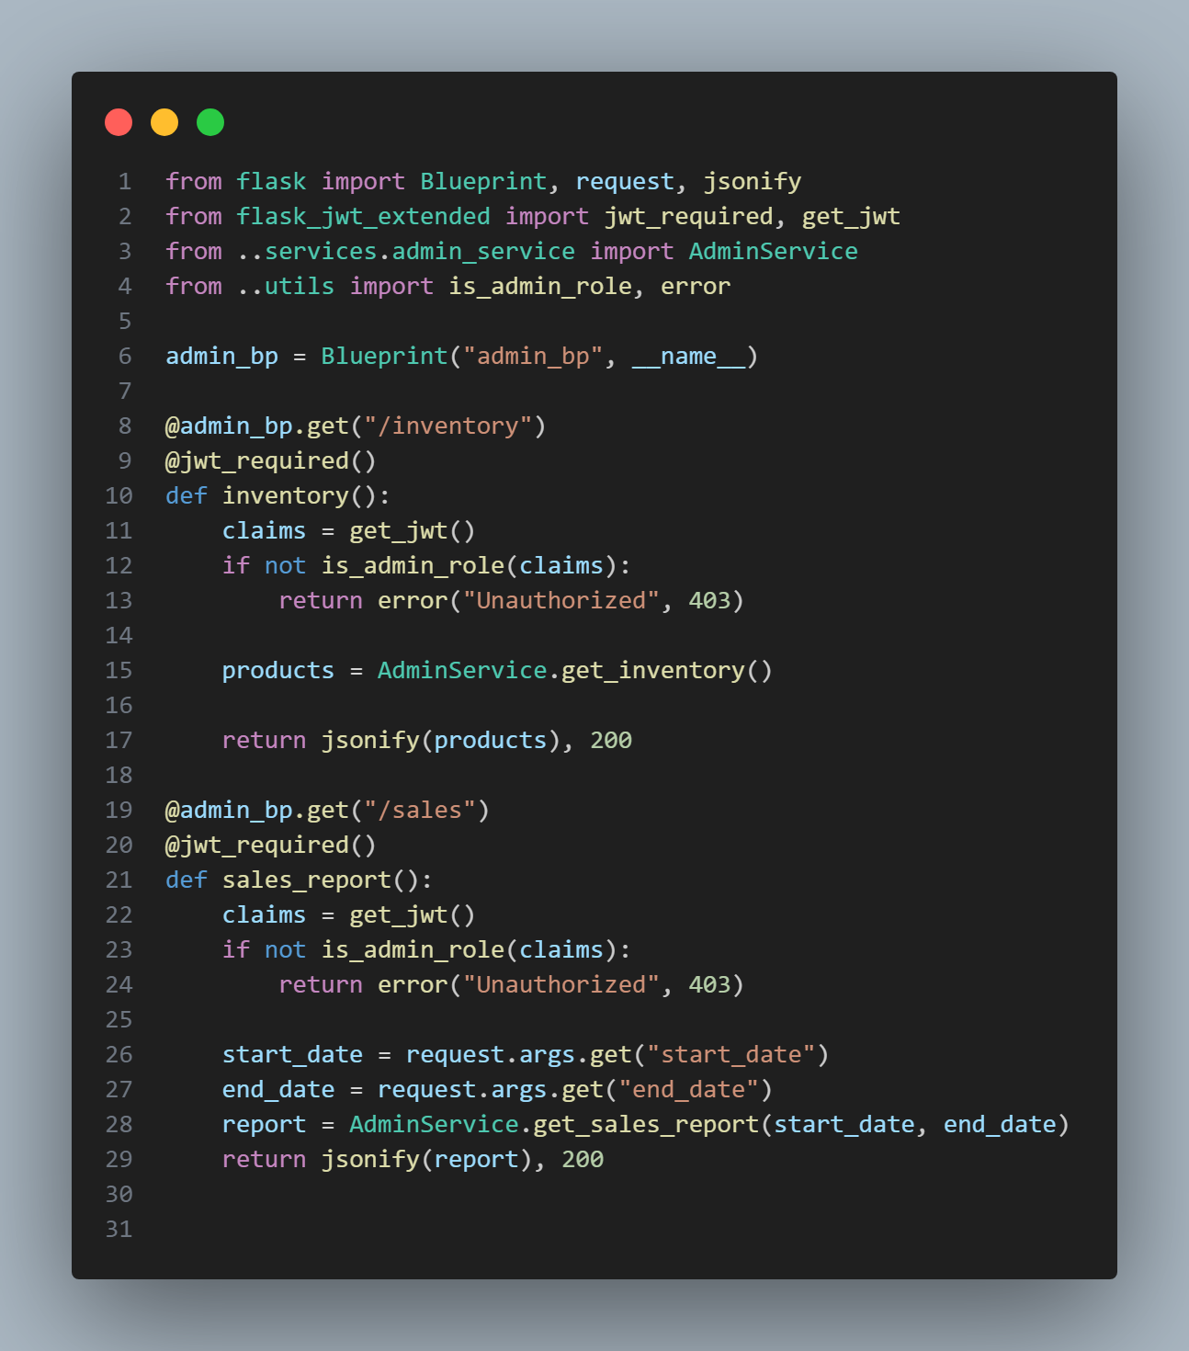Auth Endpoints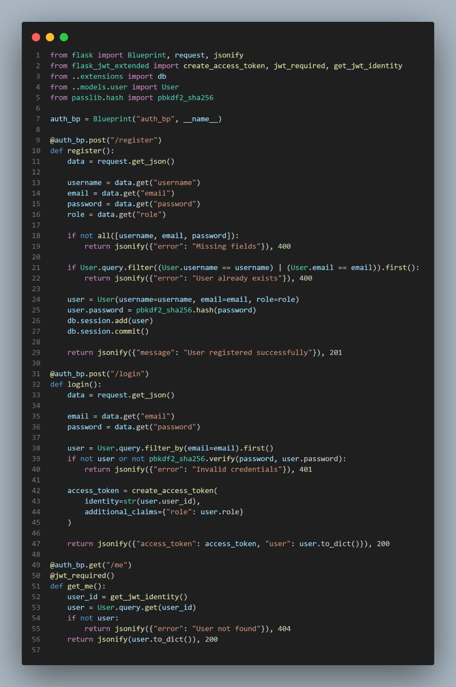
Cart Endpoints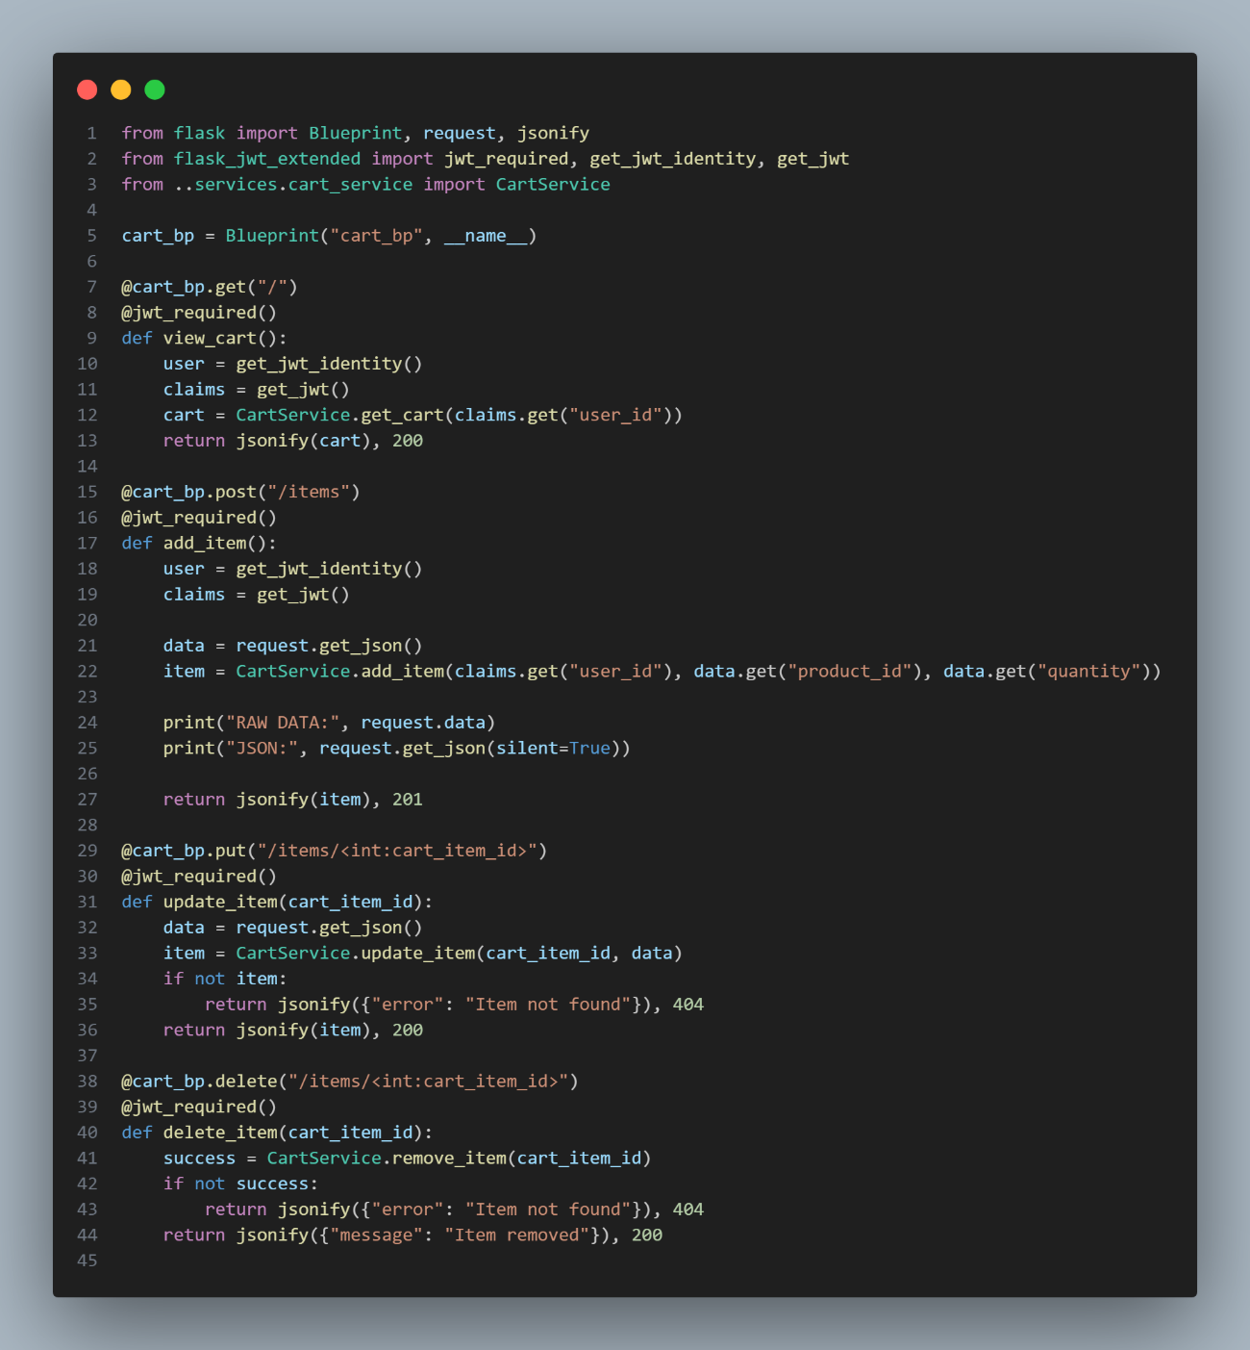

Order Endpoints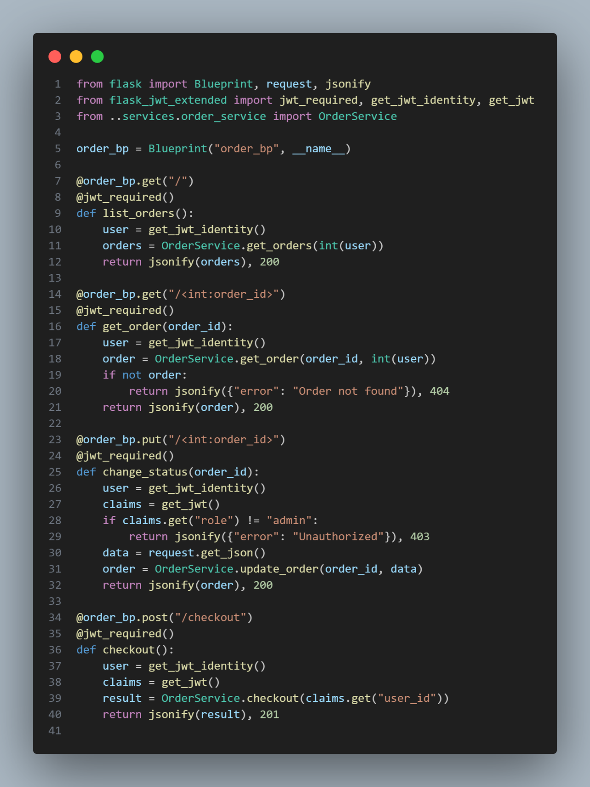

Product Endpoints
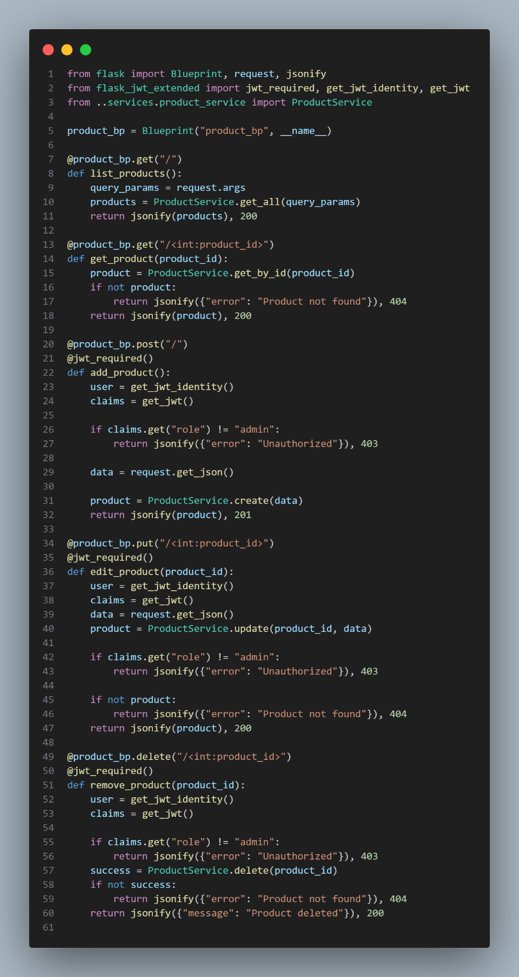

API Endpoints Table
endpoints |  |  |  | method | description | request | response | query parameters | allowed
api |  |  |  |  | Root endpoint
 | auth |  |  |  | Auth endpoints
 |  | register |  | POST | User Creation | username, email  password, role |  |  | all
 |  | login |  | POST | User Authentication | email, password | access_token, user |  | all
 |  | me |  | GET | Get Authenticated User |  | id, username, email, role |  | all
 | admin |  |  |  | Administrative endpoints
 |  | inventory |  | GET | Detailed Products View | products |  |  | all
 |  | sales |  | GET | Sales Report Generation |  |  | start_date  end_date | admin
 | products |  |  |  | Product endpoints
 |  | index |  | GET | All Products List |  | products | Search  Category  Page  Limit | all
 |  | {id} |  | GET | Get Product by ID |  | product |  | all
 |  | index |  | POST | Product Creation | Name  description  Category  price  quantity  image_url |  |  | admin
 |  | {id} |  | PUT | Alter Product | ?name  ?description  ?category  ?price  ?quantity  ?image_url |  |  | admin
 |  | {id} |  | DELETE | Delete Product |  |  |  | admin
 | cart |  |  |  | Cart endpoints
 |  | index |  | GET | Get Current Cart |  | cart |  | customer
 |  | items |  |  | Cart item endpoints
 |  |  | index | POST | Add Cart Item |  |  | product_id, quantity | customer
 |  |  | {cart_item_id} | PUT | Update Cart Item | cart_item |  |  | customer
 |  |  | {cart_item_id} | DELETE | Remove Cart Item |  |  |  | customer
 | orders |  |  |  | Order endpoints
 |  | index |  | POST | Create, Recount, Validate |  |  |  | customer
 |  | {id} |  | GET | All Orders List |  | orders |  | customer
 |  | {id} |  | GET | Get Order by ID |  | order |  | customer
 |  | checkout |  | PUT | Alter Order by ID |  |  |  | customer

Ecommerce:

Features:
- User authentication system for registration and login (Admin and Customer roles).
- Product catalog displaying detailed descriptions, images, and pricing.
- Search and filter functionality to easily locate specific pet products.
- Shopping cart management that allows users to add, edit, or remove items.
- Secure checkout process and order tracking feature.
- Admin dashboard for product, inventory, and sales report management.
- Real-time inventory updates through an integrated inventory log.
- Data-driven sales reporting and analytics for business insights.

Objectives:
General Objective

To develop and implement a full-stack e-commerce platform that centralizes pet supply transactions, improving accessibility, efficiency, and user satisfaction among pet owners and admins.

Specific Objectives

- To achieve a functional registration and login system that supports both admin and customer roles.
- To provide a product catalog with complete details like name, description, price, image, and category.
- To implement search and filter functions that return the list of searched and filtered products.
- To design a shopping cart and checkout system capable of processing, editing, and confirming orders without any critical errors during testing.
- To integrate an inventory management feature that updates stock levels in each transaction.
- To generate sales reports and analytics that communicate calculated insights.

Scope and Limitation:

Scope:

The system covers the main e-commerce functionalities such as user management, product cataloging, cart operations, order processing, and inventory tracking.

It includes both customer and admin interfaces with role-based functionalities.

Sales reports and data analytics are included to support administrative decisions.

Limitations:

The system does not include a built-in payment gateway integration (simulated transactions only).

Delivery and logistics management are outside the project’s current implementation scope.
Reference
[1] T. Chihsiang, C. Chinlien, L. Chen, L. Zhang, Y. Xia and Z. Ding, “Exploration of the Quality Process of Pet E-commerce Logistics Service,” Academic Journal of Business & Management, vol. 5, no. 25, pp. 77-81, 2023.
[2] R. Sankar Ganesh and S. Saadhika, “A Study on Customer Experience and Satisfaction with E-Commerce Platforms for Pet Food,” IJRASET Journal for Research in Applied Science & Engineering Technology, 2025.
[3] R. Relao and P. Delos Santos, “Paws and Reflect: Assessing the Impact of User Reviews and Ratings on Pet Food E-commerce Purchase Decisions,” SEISENSE Business Review, vol. 4, no. 1, 2024.
[4] “Pet Care E-commerce Market Size and Facts Report, 2033,” Business Research Insights, 2024.
[5] Y. Gao and J. Yang, “Challenge and Opportunity for Development of Start-up in Pet Economy Through E-commerce Channel,” in Proceedings of the 2022 7th International Conference on Financial Innovation and Economic Development (ICFIED 2022), 2022, pp. 93-98.
[6] “Optimizing E-commerce Operational Efficiency and Customer Experience Through Data Analytics and Technological Innovation,” in Advances in Economics, Management and Political Sciences, 2024.
[7] “The Development Status of Global Cross border E-commerce for Pet Supplies and the Response Strategies of Chinese Sellers,” International Research Platform, 2023.
[8] “Gaining an edge in e-commerce,” Pet Food Processing, March 2022.

