The Max

Inventory System User Manual



**Overview**

The Max Inventory System is a Microsoft Access database that allows managers and employees the ability to track inventory. The abilities the system provides includes allowing users to pull inventory, add inventory, create and find invoices, and check inventory levels. The system also allows users to add new brands or types of inventory like different wines, beer, or liquor that The Max starts to serve. The system will also allow new employees and new vendors to be added to the system. The system also allows three separate reports to be created from the database including inventory reports, invoice reports, and pull-inventory reports.

This manual has all of the necessary information for users to fully understand and use the inventory system. The information this manual features are procedures to fill out forms, how to generate reports, and some errors that a user might encounter while using the system. The purpose of this manual is to help end-users set up the inventory system, along with directions for new users to be able to fully understand the system.

**Table of Contents**

Registration…………………………………………………………..………………………….......................4

Login………………………………………………………………………………………………………………..4

Managing Account…………………………………………………………………………………………….5

Utilizing Database……………………………………………………………………………………………..5

Adding New or Updating Vendor Information…………………………………………………….5

Adding New Brand…………………………………………………………………………………………….6

Adding New Type………………………………………………………………………………………………6

Adding New Inventory………………………………………………………………………………..……...7

Creating New Invoice…………………………………………………………………………………..……..7

Pulling Inventory……………………………………………………………………………………………….8

Inventory Report……………………………………………………………………………………………….9

Invoice Report………………………………………………………………………………...………….……10

Pull Inventory Report……………………………………………………………………….………………10

Errors………………………………………………………………………………………….......………………10

Installation……………………………………………………………………………………...……………….10

Back-up and Recovery……………………………………………………………………...……………….10

**Getting Started**

**Registration**

1. Click on the Employee Entry Form

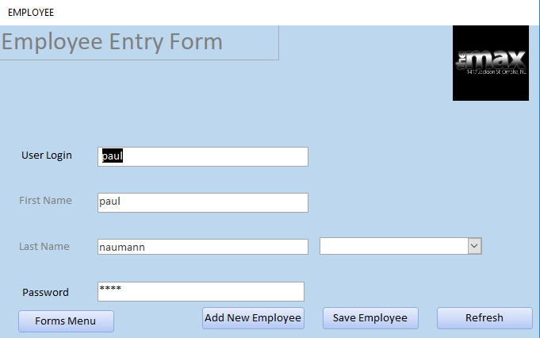

1. Click add new employee
2. Fill in appropriate information for new employee
3. Allow new employee to enter their password
4. Click save employee
5. Click refresh

**Login**

1. Open the Microsoft Access database
2. Click on your employee Username from the login name drop down box

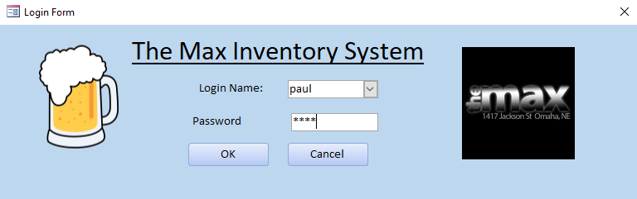

1. Enter password
2. Click the OK button

**Managing Account**

**Resetting Password**

If a user forgets their password, then another user of the system will need to login first.

1. After another user logs in, enter the employee entry form
2. Choose the user that forget their password from the drop down box
3. User that forgot password will then enter their new password
4. Click save employee
5. Click refresh

**Updating User Login Name, First Name, or Last Name**

If a user wants to change their username, first name, or last name login to the system

1. Once logged in, enter the employee entry form
2. Choose the user that wants to change the username, first name or last name from the drop down box
3. In the correlating field, change it to the newly updated information
4. Click save employee
5. Click refresh

**Utilizing the Database**

**Adding a New or Updating Vendor Information**

1. Navigate to the vendor form from the forms menu

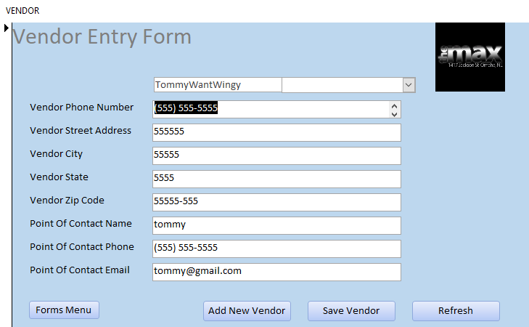

1. Click add new vendor button
2. Add all vendor information in correlating text boxes
3. Click save vendor button
4. Click refresh button to save update vendor table

**Adding New Brand**

1. Navigate to the brand form from the forms menu

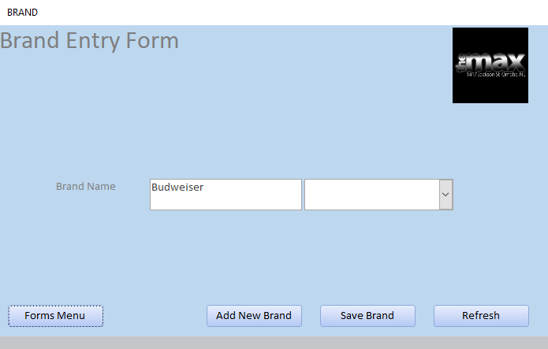

1. Click add new brand
2. Type in the new brand name in the text box
3. Click save brand
4. Click refresh button to update the brand table

**Adding New Type**

1. Navigate to the type form from the forms menu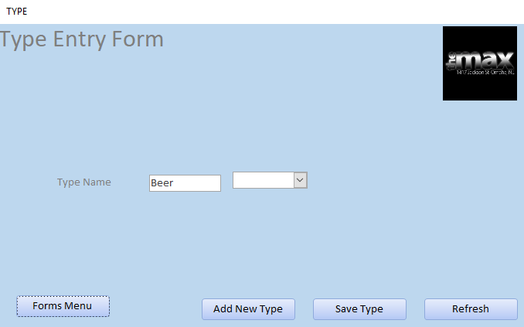
2. Click add new type
3. Type in the new type name in the text box
4. Click save type
5. Click the refresh button to update the type table

**Adding New Inventory**

1. Navigate to the type form from the forms menu

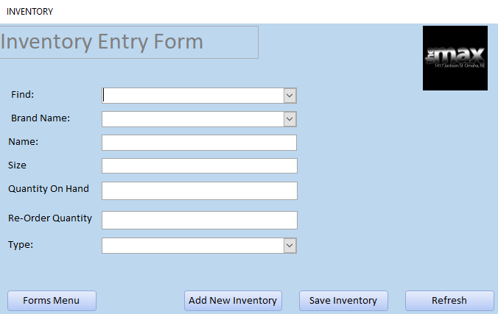

1. Click add new inventory
2. Type in the new inventory item attributes in the correlating text boxes
3. Click save inventory
4. Click the refresh button to update the inventory table

**Creating New Invoice**

1. Navigate to the invoice form from the forms menu

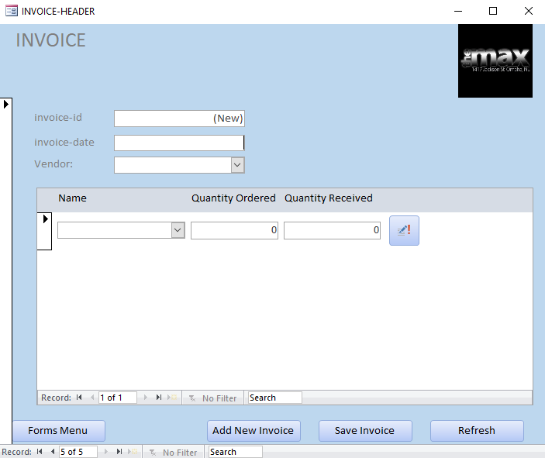

1. Click add new invoice button
2. Type in the todays (current) date
3. Select the vendor from the drop down menu
4. Enter in information regarding ordered items
5. Click save invoice
6. Click the refresh button to add the invoice to the system

**Pulling Inventory**

1. Navigate to the invoice form from the forms menu

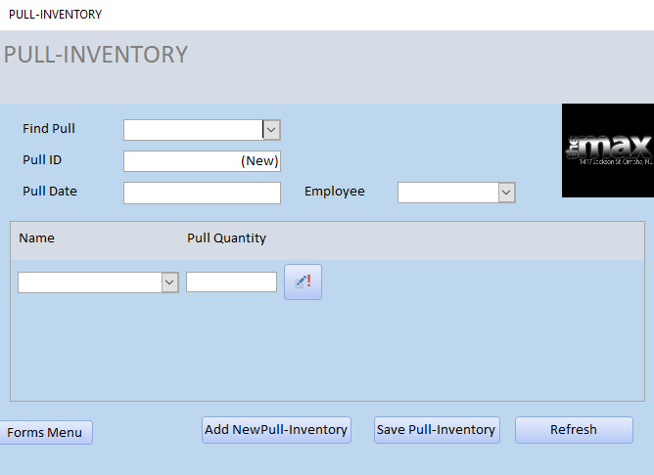

1. Click the add new pull-inventory button
2. Type in todays (current) date
3. Select yourself from the employee drop down box
4. Select pulled inventory from the drop down box in the sub-menu
5. Enter the amount of bottles pulled in the pull quantity box
6. Click on the save pull-inventory button
7. Click on the refresh button to update the system

**Inventory Report**

1. Navigate to the inventory report from the reports menu

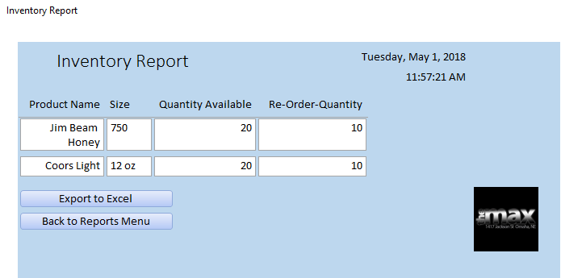

1. All inventory will be displayed
2. Filter inventory until desired inventory is displayed on the report
3. Click export to excel to create an excel spreadsheet of report

**Invoice Report**

1. Navigate to the invoice report from the reports menu

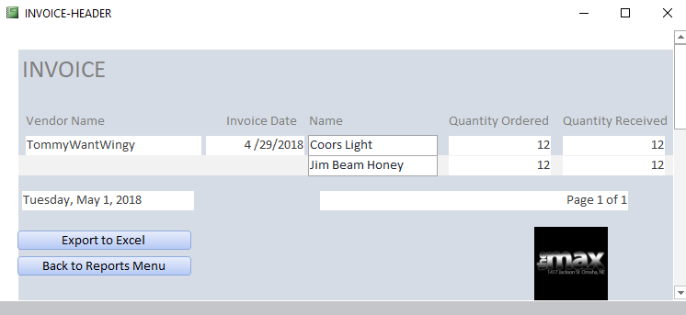

1. All invoices will be displayed
2. Filter the screen until the desired invoices are displayed
3. Click the export to excel button to get an excel spreadsheet of the report

**Pull Inventory Report**

1. Navigate to the pull inventory report from the reports menu

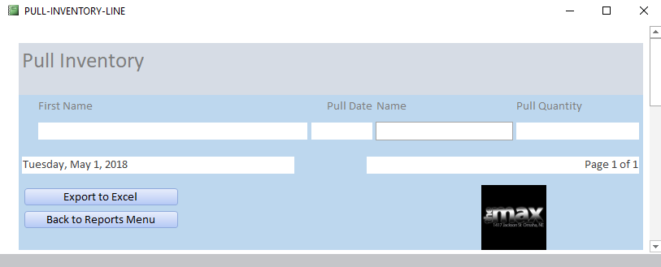

2. All inventory pulls will be displayed on the screen

3. Filter the screen until the desired invoices are displayed

4. Click Click the export to excel button to get an excel spreadsheet of the report

**Error Messages**

1. In case of error messages from the system such as this one displayed

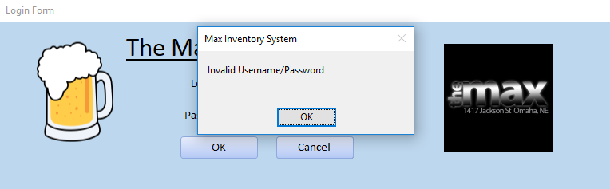

1. The reason for the error message popping up will be displayed
2. Click ok to get back to the screen that was previously displayed
3. Correct the information that gave the error message
4. Navigate as needed after correcting error

**Installation**

Installation will be taken care of by the development team. Users will not be required to install any of the necessary software packages.

**Back Up & Recovery**

The manager will be responsible for backing up the database every Sunday night to the external hard drive that was requested by the development team to be purchased. In the event of a disaster, the hard drive with the back-ups that is in a locked and fire proof safe will be mounted to a newly purchased laptop.