**ARISS**

**Moderator Script for**

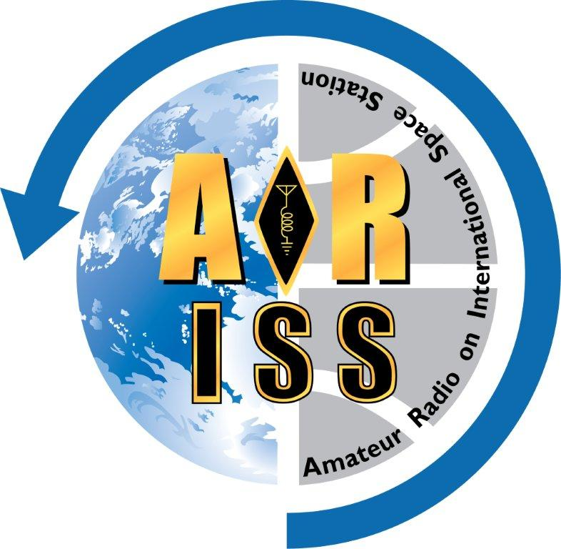**Tele-bridge ISS Contact**

**For: Madison High School**

**Contact Date: 2025-03-26**

**Version: 1**

Made Using Python ARISS Moderator Script Generator Version 3.0.1

Based on ARISS Moderator Script Master Template Universal - Version N3FZX_20241130

**Event Schedule Outline**

All times are local school time (24hr), event durations & times to ISS rise are in minutes (m).

Conference start time........ 2025-03-26 03:00

ISS Rise Time................... 2025-03-26 04:00

Tele-bridge station............. K6DUE, Greenbelt. MD, USA

Pre-contact preparation..... ~20m

School/group program....... ~21m

ARISS program/contact..... ~32m

Total event duration........... ~73m

| **Time** | **Dur.\*** | **Rise** |  | **Event Block Description** |
| --- | --- | --- | --- | --- |
| **03:00** | **3m** | **60m** |  | **Start conference** |
| 03:03 | 2m | 57m |  | Moderator ground station checklist |
| 03:05 | 5m | 55m |  | Contact preparation checklist |
| 03:10 | 10m | 50m |  | Practice run through with all students and ground station |
| **03:20** | **21m** | **40m** |  | **S****chool/group program, or slack time** |
| **03:41** | **1m** | **19m** |  | **Start ARISS program** |
| 03:42 | 4m | 18m |  | ARISS introduction |
| 03:46 | 6m | 14m |  | Optional video from student perspective - **Yes** |
| 03:52 | 3m | 8m |  | Optional video from the ISS perspective - **Yes** |
| 03:55 | 3m | 5m |  | Introduce the ground station |
| 03:58 | 1m | 2m |  | Handover to ground station |
| 03:59 | 1m | 1m |  | ISS rise and Acquisition of Signal (AOS) |
| **04:00** | **11m** | **0m** |  | **ISS Contact!** |
| 04:11 | - | - |  | ISS set and Loss of Signal (LOS) |
| 04:11 | 3m | - |  | Closing remarks & end of ARISS program |

*\* Events with 0 minute duration have been eliminated from the program, but not the report.*

Based on conference call start time at 03:00, ISS rise time at , and ARISS portions (prep and program), the school/group program time, or slack time, is estimated to be no more than 21 minutes starting at 03:20.

**Event Timeline**

School/group name: **Madison High School**

ISS contact date/time: **2025-03-26**

**NOTE THAT ALL EVENT TIMES ARE IN SCHOOL/GROUP LOCAL TIME**

|  |
| --- |
| **03:00 3m Duration 60m to ISS Rise**  **CALL IN CHECKLIST**  Everyone should be on-time at **01:00** UTC & **03:00** local time for the school.  [ ] Moderator dialed in.  [ ] If using Verizon, moderator should greet the Verizon operator and ask  for their name. Verizon Operator Name: _________________  [ ] Ground station dialed in.  [ ] Mentor dialed in.  [ ] School/group dialed in.  [ ] Live stream operator dialed in.  → |
| **03:03** **2m Duration 57m to ISS Rise**  **MODERATOR GROUND STATION CHECKLIST**  Verify the ground station is ready to go with the checklist below.  Moderator to Ground Station:  [ ] Tracked ISS recently?  [ ] Antenna slews in azimuth and elevation?  [ ] Flip mode enabled if required?  [ ] Time check (synchronize).  [ ] Are your Keps up-to-date?  [ ] Check ISS AZ/EL and rise (AOS) time.  [ ] Check and confirm the uplink frequencies the ISS will be using.  [ ] Telebridge Station is ready to provide a brief overview just before the contact.  [ ] Telebridge Station to open squelch to check audio levels.  → |
| **03:05 Duration: 5m Duration 55m to ISS Rise**  **CONTACT PREPARATION CHECKLIST**  Verify the following with school/group, ground station and moderator.  Moderator:  [ ] Verify moderator script version. Make sure everyone is using same version.  [ ] Work out how the school will cue the moderator after the school program and the end of  the videos. Note that the moderator can not rely on a live stream feed for such cues.  [ ] Final checks for any video streaming from the ground station.  [ ] Final coordination discussion with mentor, moderator, ground station, and live stream  operator (if used).  [ ] If using Verizon, coordinate when the recording will start.  → |
| **03:10 10m Duration 50m to ISS Rise**  **PRACTICE** **RUN THROUGH WITH ALL STUDENTS AND GROUND STATION**  All students should be present at this time. Note that this is where audio problems can surface. The sooner this can be completed the better.  [Make this duration longer if school/group program is shorter than the time made available.]  [Can increase the D04 duration in the ARISS moderator script form file to recalculate times.]  Moderator:  [ ] Verify the school can hear the moderator clearly.  [ ] Verify school can hear ground station audio clearly.  [ ] Verify ground stations can hear school/student audio clearly.  [ ] Verify no feedback issues.  [ ] Remind students to speak clearly and directly into the microphone, and to say “OVER”  at end of each question.  [ ] Have each student ask at least one question, in order, and have ground station  simulated astronaut report on audio quality. Adjust as needed.  **Do not change any audio settings once this has been completed.**  → |
| **03:20 ~21m Duration 40m to ISS Rise**  **SCHOOL/GROUP PROGRAM, OR SLACK TIME**  School/group program is an optional event. If there is no program, then this is slack time.  The program should have a hard cutoff time to start the ARISS portion.  School/group:  [ ] School/group host hands off to ARISS moderator at the end of the their program.  → |
| **03:41 ~1m Duration 19m to ISS Rise**  **START ARISS PROGRAM**  This needs to start on-time.  Moderator:  “Before we get started, I want to remind everyone, that this contact will be recorded.”  [Adjust the lines below depending on arrangements.]  [ ] If using Verizon, moderator requests Verizon Operator starts recording.  [ ] Live stream goes live: audio from conference call; video from Zoom.  Moderator:  “Hello everyone, this is **Margaret Davis**, callsign **KM1DAV**, your ARISS moderator for today for our ISS contact with **Madison High School** in **Springfield, USA**.”  → |
| **03:42 ~4m Duration 18m to ISS Rise**  **ARISS INTRODUCTION**  Moderator:  “Through the help of amateur radio volunteers and the crew on the ISS we soon hope to establish radio contact with the International Space Station as it flies more than 250 miles (400km) above the Earth over **Greenbelt. MD, USA**. This is all accomplished through ARISS, Amateur Radio on the International Space Station. The ISS is currently approaching today’s ARISS ground station traveling along at around 18,000 miles per hour (28,000km/h).”  “The contact for today will be performed using the ARISS telebridge network, a world-wide network of amateur radio ground stations that enable students to contact the ISS. ARISS is an International consortium of volunteers from several nations that assist to develop and operate the amateur radio equipment on board the International Space Station.”  “Some of those agencies that support ARISS are, The American Radio Relay League, The worldwide AMSAT Amateur Radio Satellite Corporations, The Canadian Space Agency, The European Space Agency, The Japanese Space Agency (JAXA), Roscosmos, the Russian Space Agency and NASA.”  Our linkup today will be with the student participants at **Madison High School** in **Springfield, USA**, now let’s check in with the group. We’ve asked teacher **Miss Brooks** to please tell us about the students that are taking part today.  School:  [ ] Usually ad-lib about student events, where are the students from, how many visitors  do you have at the venue, etc. for no more than 2 minutes.  Moderator:  Thank you **Miss Brooks**.  → |
| **03:46 ~6m Duration 14m to ISS Rise**  **VIDEO OF AN ARISS CONTACT FROM THE STUDENT PERSPECTIVE**  [Optional event. If not used (0m Duration), delete this row. Keep? **Yes**]  Moderator:  “We will now take a look at a video presentation produced by the American Radio Relay League which shows students what to expect during our upcoming contact with the ISS.”  School/group:  [ ] School/group plays video for auditorium, run time ~5 minutes 25 seconds.  <https://www.youtube.com/watch?v=EH688q92AjY&t=68s>  [ ] At end of video, school/group host hands back to the ARISS moderator.  → |
| **03:52 ~3m Duration 8m to ISS Rise**  **VIDEO OF AN ARISS CONTACT FROM THE ISS PERSPECTIVE**  [Optional event. If not used (0m Duration), delete this row. Keep? **Yes**]  Moderator:  “We will now look at a short video showing how an ARISS contact looks from the perspective of Astronaut Tim Peake.”  School/group:  [ ] School/group plays video in auditorium, run time ~3 minutes.  <https://www.youtube.com/watch?v=Z-yHD9lVbH8>  [ ] At end of video school/group host hands back to the ARISS moderator.  Moderator:  “Now that we have seen what a contact looks like from the ground side and what it looks like on-board the ISS, now comes the most exciting part, your contact with astronaut **Major Tom** on the ISS!”  → |
| **03:55 ~3m Duration 5m to ISS Rise**  **INTRODUCE THE GROUND STATION**  Moderator:  “Our contact for today is with astronaut **Major Tom**, amateur radio callsign **KM5TOM**, who will be using the ISS amateur radio callsign **NA1SS**.”  “The amateur radio ground station that will establish radio contact with the ISS today is ARISS Ground Station **K6DUE** located at **Greenbelt. MD, USA** and operated by **Harriet Conklin**, **KH3CON.**  “**Harriet Conklin**, please tell us a little bit about the **K6DUE** station and how you will handle today’s contact with the ISS.”  Ground Station:  [ ] Mention any additional people assisting at ground station.  [ ] Ground station describes station. Limit to ~2 minutes.  [ ] Ground station reports time to ISS rise and predicted AOS.  [ ] Ground station hands back to the ARISS moderator.  Moderator:  [ ] Moderator should be prepared with filler material if ahead of the timeline.  → |
| **03:58 ~1m Duration 2m to ISS Rise**  **HANDOVER TO GROUND STATION**  Moderator:  “We are now about **2** Minutes before the planned acquisition of signal from ISS. With the time for the ARISS contact quickly approaching, we want to remind all to please mute your cell phones and be as quiet as possible when not asking Astronaut **Major Tom** a question.”  “Remember, what we are doing on ISS is an experiment, so we can never tell the results, positive or negative until the experiment is over. And students, please don’t forget to say OVER at the end of your question.”  “The International Space Station will soon come into radio range of the **K6DUE** ARISS ground station in **Greenbelt. MD, USA** so, **Harriet Conklin**, it’s all yours. Good luck!, OVER!”  Moderator:  [ ] Handover to ground station at least one minute before ISS ride time.  → |
| **03:59 ~1m Duration 1m to ISS Rise**  **ISS CONTACT!**  This is done by the ground station.  Ground Station:  [ ] Open squelch, rushing noise is heard.  [ ] Ground station calls ISS. This may take a few minutes.  [ ] Confirm that contact is solid and say “Over to the school for first question.”  → |

**School Questions**

[Copy the list of school/group questions from ARISS Ops Uplink file here.]

1. Ashley (Grade 11): What implications could the recent circadian rhythm studies aboard the ISS have for our use of artificial light fixtures?

2. Annalina (Grade 10): How do you overcome the language barrier when working with astronauts from other countries? Do you ever use sign language?

3. Brandt (Grade 10): What did it take in High school that led to you becoming a Astronaut?

4. Cecilia (Grade 10): When you go to sleep, what position do you fall asleep to and when you wake up, have you ever woken up upside down?

5. Matthew (Grade 10): How does being in space change your perspective on life on Earth?

6. Johnathan (Grade 11): How often do you see meteoroids close to the international space station?

7. Ella (Grade 11): How closely does your training mimic the actual conditions of space?

8. Sarah (Grade 11): What do you miss most about earth when you're in space?

9. Catherine (Grade 10): Have you ever experienced a communication blackout with mission control while in space?

10. Kellen (Grade 10): What personal items did you choose to bring with you and why?

11. Bryce (Grade 11): Hypothetically, if you could show an alien any item from earth, what would it be and why?

12. Gabriel (Grade 10): What was the biggest challenge you had to face on the ISS?

13. Nathanael (Grade 10): Did looking at the infinite void of space every single day ever affect your mental health?

14. Victoria (Grade 10): What is something or someone that you miss that you didn't know you would miss when you went into outer space?

15. Liam (Grade 10): What are your thoughts on Nasa awarding Space X the contract to build the vehicle that will bring the ISS out of orbit in a few years?

16. Gavin (Grade 11): How did your view on life change from before you went to space from after you went to space?

17. Oliver (Grade 10): If you could bring a new space food item to be sent on future missions, what would it be and why?

18. Veronica (Grade 12): Have your dreams or sleep patterns changed since being in space, and have you noticed any interesting themes or experiences in your dreams?

19. Jack (Grade 10): How has being in space altered your sense of home or comfort, and what do you do to create a sense of familiarity while living in space?

20. Molly (Grade 10): How does your perception of time differ while in space?

|  |
| --- |
| Ground Station:  [ ] IF TIME PERMITS, thank astronaut and invites all attendees to cheer in appreciation.  [ ] IF TIME PERMITS, asks astronaut for any additional comments.  [ ] Contact ends at LOS, ground station signs off.  → |

|  |
| --- |
| **04:11 ~3m Duration Post LOS**  **CLOSING REMARKS AND** **END OF ARISS PORTION OF THE PROGRAM**  Moderator:  “Ladies and Gentlemen we have just shared a “wow” moment of history. Amateur radio ground station **K6DUE** located at **Greenbelt. MD, USA** and operated by **Harriet Conklin**, **KH3CON**, contacted astronaut **Major Tom** (**KM5TOM**) aboard the International Space Station, and spoke with students at the **Madison High School** in **Springfield, USA**.”  “Now, for the international volunteer team of ARISS, including the Amateur Radio Satellite Corporations around the world, the American Radio Relay League, The Canadian Space Agency, The European Space Agency, the Japanese Space Agency, Roscosmos, and NASA, this is **Margaret Davis**, **KM1DAV** your ARISS moderator, sending my salutation to all of you in amateur radio terms, 73’s, which means best wishes.”  Moderator:  [ ] If using Verizon, moderator requests Verizon Operator stop recording.  [ ] If using Verizon, moderator thanks Verizon Operator for the help.  [ ] Any live stream from the moderator and tele-bridge station is stopped.  [ ] Moderator releases ground station from conference or asks them to standby.  [ ] ARISS moderator hands off to school/group.  → |

**Logistics**

**Important Dates and Times**

Date of Contact (YYYY-MM-DD): **2025-03-26**

Start of Conference (HH:mm): **01:00** UTC / **03:00** school local time

ISS Rise time (HH:mm): **02:00** UTC / **04:00** school local time

**School/Group Information**

School/group name: **Madison High School**

School/group location: **Springfield, USA**

Coordinator/teacher at venue: **Walter Denton**

School principal name: **Osgood Conklin**

School teacher name: **Miss Brooks**

**ISS Information**

Astronaut name and callsign: **Major Tom**, **KM5TOM**

ISS callsign to be used: **NA1SS**

**ARISS Mentor Information**

Mentor name, callsign: **Philip Boynton**, **KP2BOY**

Mentor will be On-site or Remote for the contact: **Remote**

**ARISS Moderator Information**

Moderator name, callsign: **Margaret Davis**, **KM1DAV**

Moderator will be On-site or Remote for the contact: **On-site**

**ARISS Tele-bridge Ground Station**

Station callsign & location: **K6DUE**, **Greenbelt. MD, USA**

Operator name and callsign: **Harriet Conklin**, **KH3CON**

Audio interface (Verizon/Zoom dial-in/Zoom client): **Verizon**

Video interface: **Zoom**

**Live Streaming**

Live streaming planned (Yes/No): **Yes**

Live stream operator name, callsign: **Fabian "Stretch" Snodgrass**, **No Call**

**Miscellaneous**

None. [Manually edit any items here.]

[Delete this page for the final version of the script.]

**Instructions for Mentor & Moderator**

Event times are in school/group local time (24hr format). The version number should be incremented with each distributed version. The completed script should be provided to the mentor, the school/group, and telebridge station a few days prior to the contact.

**Event Block Format**

The script events are captured in a table with rows that prevent page breaks in the middle of an event block. A row is limited to one page. It is very helpful to turn on the "view table gridlines" feature to see the hidden boarders. Below is the anatomy of an event block.

|  |
| --- |
| **Event time ~1m Duration Time to ISS Rise** <-- Times filled in by Python tool**!**  **EVENT BLOCK NAME** (Do not change name.)  Event notes, if needed, go here. Arial font, 12pt, spacing is 1.5.  [blank line]  Moderator:  “Quoted text to be read by moderator. Arial font, 12pt, spacing is 1.5.”  [blank line]  [ ] Steps to be completed at this event in chronological order. Arial font, 12pt, spacing is 1.5.  [Notes for customizing the script are in red text with brackets, to be deleted in final version.]  → [done time] |

**Moderator Script Development Checklist**

Moderator and mentor should use this checklist as a guide to prepare this script.

[ ] Complete the “Logistics”, or the ARISS Moderator Script Form (preferred).

[ ] Decide if and how the ARISS videos will be used and when to start the conference call.

[ ] Generate script outline with timeline summary (can automate with Python script tool).

[ ] Review the script outline and adjust as needed.  
[ ] Update the script template file as needed and remove [Notes for customizing the script].

[ ] Add list of student questions from ARISS Ops web page Uplink file to script template file.

[ ] Run Python script to generate moderator script document from the template.

[ ] Review script with school/group, mentor, and ground station.

[ ] Verify name pronunciations. Make notes as needed.

[ ] Review the script for completeness. Adjust as needed.

[ ] Create final PDF version, minus this last page.