**ARISS**

**Moderator Script for**

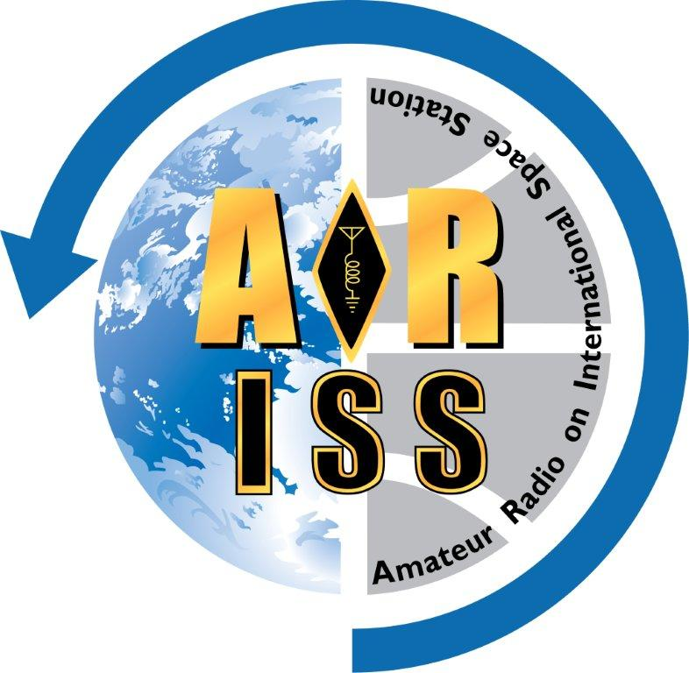**Tele-bridge ISS Contact**

**Instructions and Checklist for**

**Mentors and Moderators**

Version 20241130

**Instructions for Mentor & Moderator**

Event times are in school/group local time (24hr format). The version number should be incremented with each distributed version. The completed script should be provided to the mentor, the school/group, and telebridge station a few days prior to the contact.

**Event Block Format**

The script events are captured in a table with rows that prevent page breaks in the middle of an event block. A row is limited to one page. It is very helpful to turn on the "view table gridlines" feature to see the hidden boarders. Below is the anatomy of an event block.

|  |
| --- |
| **Event time ~1m Duration Time to ISS Rise** <-- Times filled in by Python tool**!**  **EVENT BLOCK NAME** (Do not change name.)  Event notes, if needed, go here. Arial font, 12pt, spacing is 1.5.  [blank line]  Moderator:  “Quoted text to be read by moderator. Arial font, 12pt, spacing is 1.5.”  [blank line]  [ ] Steps to be completed at this event in chronological order. Arial font, 12pt, spacing is 1.5.  [Notes for customizing the script are in red text with brackets, to be deleted in final version.]  → [done time] |

**Moderator Script Development Checklist**

Moderator and mentor should use this checklist as a guide to prepare this script.

[ ] Complete the “Logistics”, or the ARISS Moderator Script Form (preferred).

[ ] Decide if and how the ARISS videos will be used and when to start the conference call.

[ ] Generate script outline with timeline summary (can automate with Python script tool).

[ ] Review the script outline and adjust as needed.  
[ ] Update the script template file as needed and remove [Notes for customizing the script].

[ ] Add list of student questions from ARISS Ops web page Uplink file to script template file.

[ ] Run Python script to generate moderator script document from the template.

[ ] Review script with school/group, mentor, and ground station.

[ ] Verify name pronunciations. Make notes as needed.

[ ] Review the script for completeness. Adjust as needed.

[ ] Create final PDF version, minus this last page.